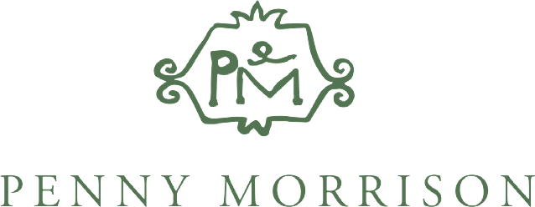

Penny Morrison Ltd,

9 Langton Street,

London, SW10 0JL

**Job Title: Digital Marketing Manager**

**Company Description:**

Penny Morrison Ltd is a world-leading homeware company specialising in Home Accessories, Fabrics & Wallpapers. The Company has a showroom and offices in Chelsea, London, as well as over 30 representative showrooms globally distributing its products. The company also has a strong online presence with a broad global client base across both trade / interior design and retail clientele.

**Job Description:**

Penny Morrison Ltd is seeking a candidate for the newly created role of Digital Marketing Manager who can execute and develop the company’s digital marketing strategies across key channels. The candidate will be responsible for working in tandem with senior stakeholders to develop a coherent and innovative marketing strategy.

This position will report directly into the Managing Director of Penny Morrison Ltd.

**Areas of Focus will include, but are not limited to:**

* Collaborate with the wider Business Development team to devise and implement an omnichannel marketing strategy to support our Sales objectives.
* Support the delivery of a social media strategy designed to share our narrative with target audiences across core channels including Meta, Pinterest, Linkedin, our website, and other appropriate platforms.
* Devise and implement a content distribution strategy across digital channels.
* Work with Social media content creator to develop engaging assets suitable for social consumption through both paid and organic social media channels, including video, audio and photography.
* Keep up to date with the interiors market and PM Ltd’s positioning; social media trends and innovations; actively seeking out knowledge sharing opportunities; feeding insights back to the team and advising on inspiration for new approaches.
* Devise, implement and manage a performance marketing strategy to facilitate paid distribution of our content, creating conversion led ads that maximise ROI (or work with external agencies to continue existing successes in this sphere).
* Use analytical tools to continuously monitor and improve our digital content marketing strategy, driving ROI and revenue growth
* Implement management reporting as required
* Monitor and respond to social media interaction across all digital channels
* Report and continuously improve on agreed Marketing KPIs

**Requirements:**

**Skills Required (Technical)**

* Product led digital marketing experience - ideally in an industry such as home interiors, furniture, or similar
* Clear understanding of performance marketing techniques with demonstrable experience building and managing successful ad campaigns (i.e. Meta, PPC & other, e.g. Pinterest)
* Demonstrable experience using digital marketing techniques to build an online brand working collaboratively as part of a wider commercial team
* Ability to lead the digital marketing function, work on their own initiative and guide management
* Demonstrable experience of implementing digital marketing campaigns from briefing to inception and launch
* A specialist in digital advertising across meta and PPC.
* 5+ years experience in similar companies / sector / role.

**Skills Required (Behavioural)**

* Passionate and genuinely committed to sharing the Penny Morrison narrative via digital channels
* Ability to tackle and solve problems
* Positive, approachable and fun
* An honest, authentic and collaborative approach to life
* Excellent written and verbal communication
* Be a self-starter and someone who is excited about taking the leadership in a core department of the business, with the ability to work autonomously and as part of a wider team.
* Technical experience and desire to implement is key. This is a hands-on role.
* Able to work as part of a geographically distributed team
* Passionate and genuinely committed to building a first-class experience for every single customer and collaborative partner of the Company

Salary will be dependent on experience. If you would like to apply for this position, please email your CV and cover letter to [careers@pennymorrison.com](mailto:careers@pennymorrison.com)