Supplier Premier Login Process

- Visit https://premierinc.com/ click on Login

- Register
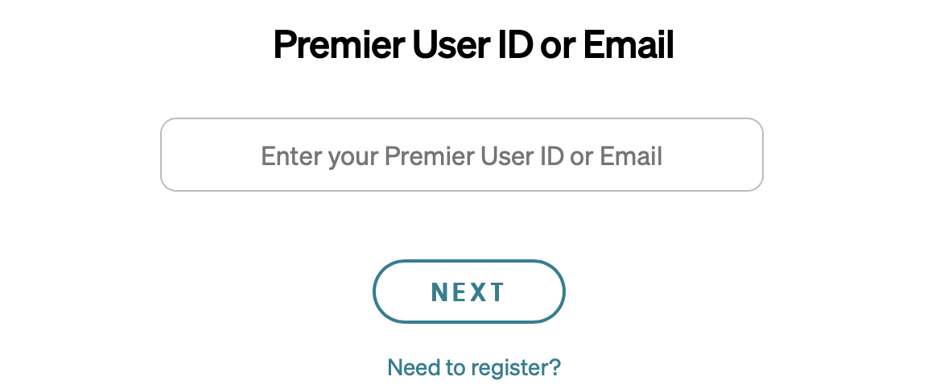

- Select I AM A SUPPLIER
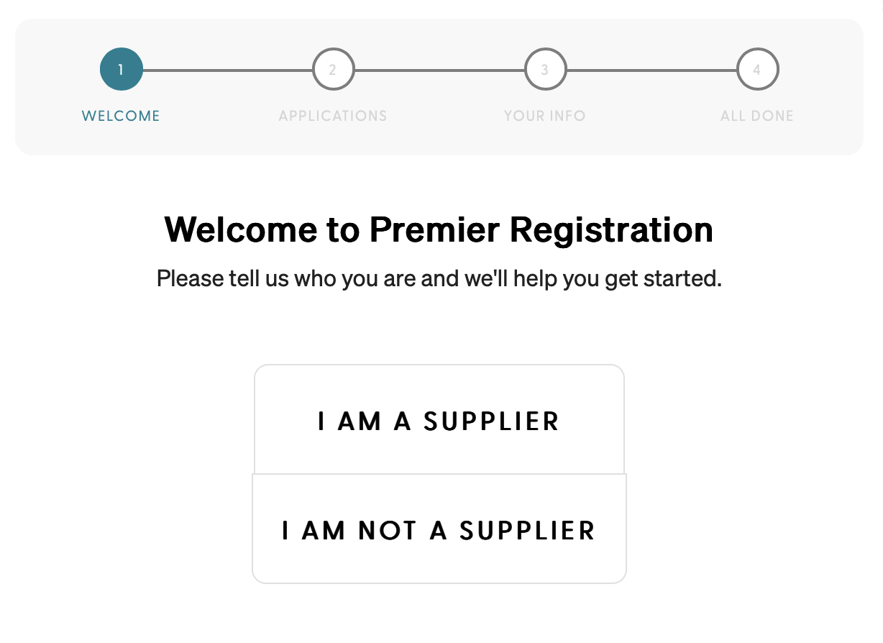

- Select Applications, click next.
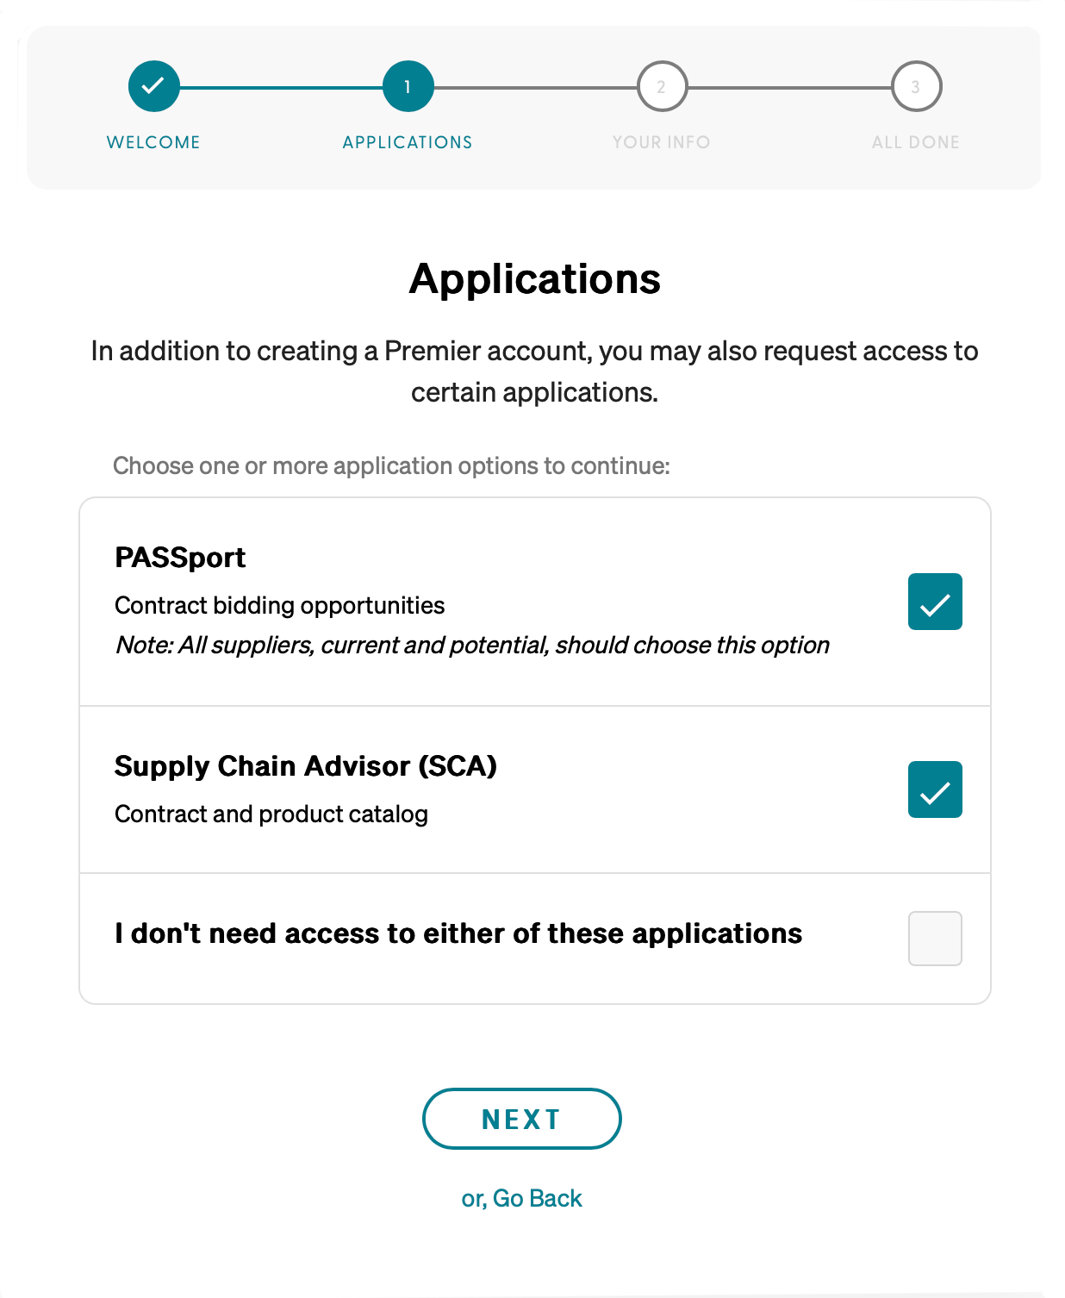

- Complete questionnaire, hit submit.
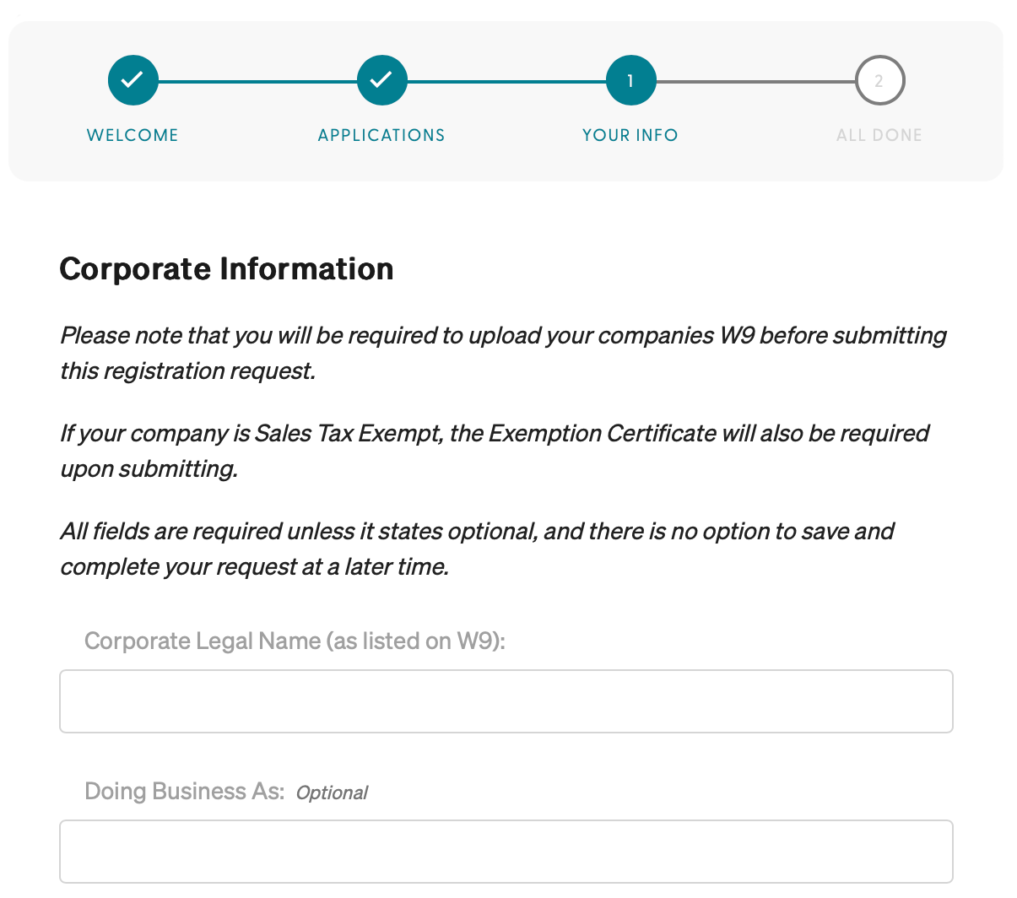

After you submit you will receive a tracking number on your screen; keep this number for your records. You will receive a conformation email with your login information and a temporary password when your Premier access has been granted. If you do not receive your Premier registration confirmation within 7 business days, please call the Premier Solution Center at 877-777-1552 to check the status of your registration.

You will also receive a subsequent confirmation email when PASSport is available to access.

