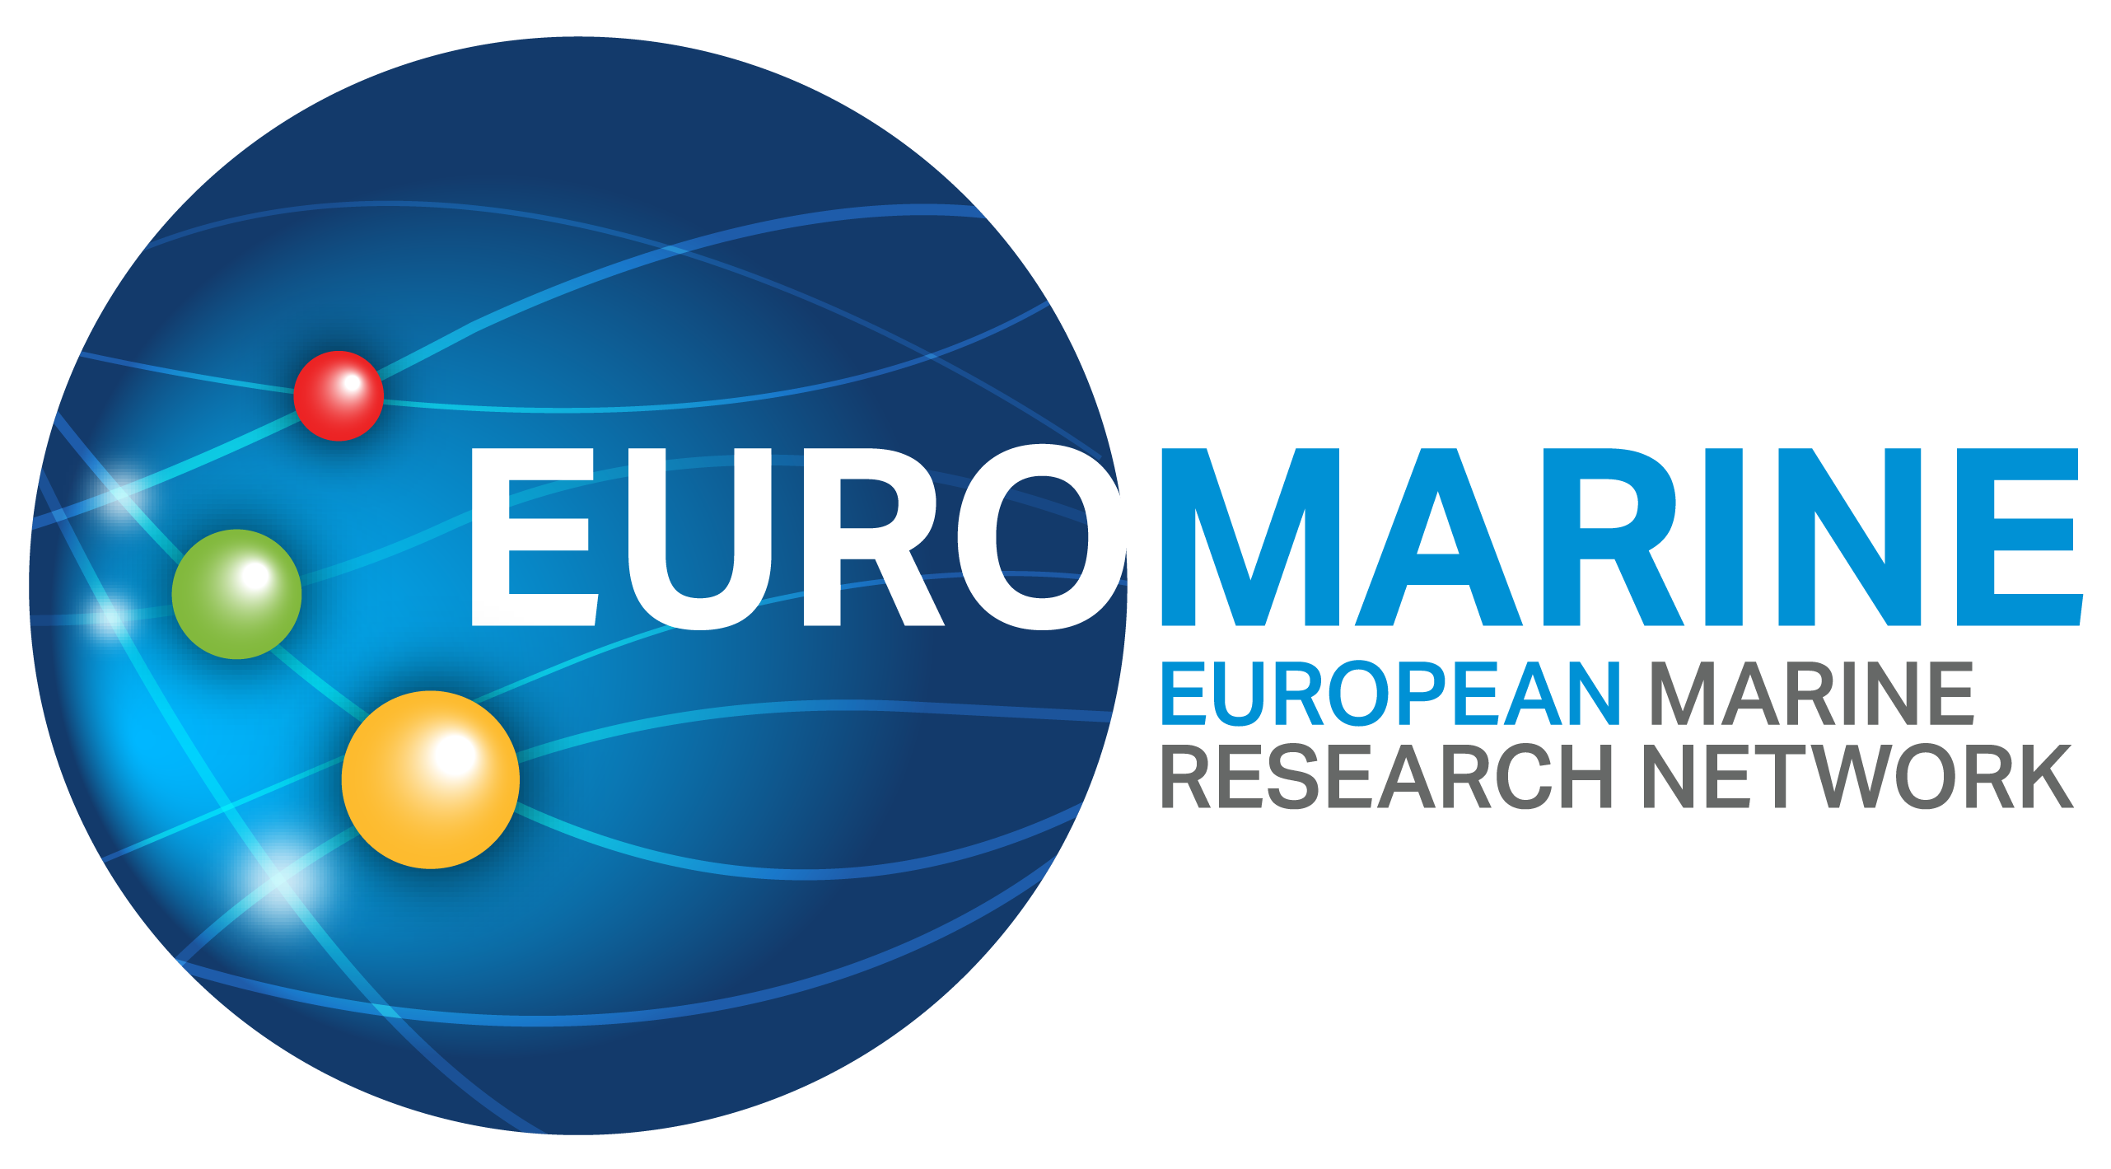

EuroMarine Long Term Scientific Working Groups

Application Form (July 2022 call)
Following the guidance and criteria outlined in the EuroMarine Long Term Scientific Working Groups Call Text and EuroMarine funding terms and conditions 2022 documents, please complete the full application form below.
For each section, type your responses within the boxes provided. Applications that exceed the stated page limit will not be considered. Font size for responses should be 11pt. Please respond to each section. Incomplete applications will be excluded.
Within each section, the information in italics indicates what should be included. This text can be deleted in the submitted application.
Please submit your completed application by email to secretariat@euromarinenetwork.eu and director@euromarinenetwork.eu before 14/10/2022 at 23.59 CET. Applications submitted after the deadline will not be accepted.

PART A: Proposal Summary and Applicant Details
Proposal Summary
Proposal Title
Acronym
Key Words

This proposal is for the following LTSWG:
☐ | Working Group 1: Ocean Decade, Mission Ocean and other international initiatives
☐ | Working Group 2: Emerging and important topic requiring European-wide coordination

Main scientific disciplines
Please check the broad categories that best correspond to your proposal (no more than 3 - 4 under each column).
Broad categories of scientific disciplines / fields | Other categories (tools, transverse expertise, possible domains of EuroMarine services or activities....)
☐Physics and climate of the Ocean  ☐Changing Ocean  ☐Marine Biogeochemistry  ☐Marine Biology  ☐Marine Biodiversity  ☐Marine Ecology  ☐Marine Ecosystems functioning  ☐Marine Bio-resources  ☐Marine Biotechnology  ☐Fisheries and Aquaculture  ☐Coastal Systems and marine spatial planning  ☐Economics, Law, Sociology  ☐Ecosystem Services  ☐Social Sciences | ☐Science  ☐Training / Capacity Building  ☐Mobility  ☐Communication  ☐Knowledge Transfer  ☐Networking  ☐Scientific Project Management  ☐Data  ☐Infrastructures  ☐Expertise (provision of)  ☐Marine policies / Science-governance interface  ☐Modelling  ☐High-throughput approaches  ☐Interdisciplinarity

Short Summary (Maximum length: 1/2 page)

Applicant Details
Lead Applicant Details
The Lead applicant must be affiliated to a Full Member of EuroMarine. Please specify email address(es) and telephone number(s) of the person(s) to whom any questions should be addressed and who should be informed of the outcome of the call.
Name of Lead Applicant:
Email address of Lead Applicant:
Phone number:
Organisation affiliation of Lead Applicant:

Working Group Co-Proposers Details
Proposals need to involve Working Group Members from at least five different EuroMarine Full Member organisations in at least four different countries. A list of 2022 EuroMarine Members is available at https://euromarinenetwork.eu/members-directory/?page=1.
Name Surname | Gender (F/M) | Organisation | Country (of org.)

Part B: EuroMarine Long Term Scientific Working Groups Details
1. Excellence (Maximum length: 5 pages)
1.1 Objectives (Maximum length: 1 page)
Please describe the objectives of your proposed EuroMarine Long Term Scientific Working Group. This should include main outcomes and the Key Performance Indicators (KPIs) that you will use to measure the impact and achievement of the EuroMarine Long Term Scientific Working Group.

1.2 EuroMarine Long Term Scientific Working Group Description (Maximum length: 2.5 pages)
Please provide a full description of your EuroMarine Long Term Scientific Working Group proposal. Indicate how and why the proposed topics are innovative and/or relevant to the call.

1.3 Expected Outcomes (Maximum length including the summary table: 1.5 pages)
Please provide a full description of the expected outcomes of the EuroMarine Long Term Scientific Working Group. Please note that well-defined and significant outcomes are required (e.g., synthesis paper, position paper, recommendations for the EuroMarine Community, peer-review publication, etc.).

Summary of Expected Outcomes
Please indicate the type of outcome (e.g., synthesis paper, peer-publication (please indicate the target journal), position paper recommendations for the EuroMarine Community), date of achievement and brief description in the table below. Please expand the table as needed.
Outcome | Type of outcome | Expected date of achievement | Brief description
O1
O2
O3

2. Impact (Maximum length: 3 pages)
2.1 Added Value to EuroMarine (Maximum length: 1 page)
Please describe how the EuroMarine Long Term Scientific Working Group addresses EuroMarine priorities and favours the integration of the EuroMarine community. Please refer how it will contribute to the EuroMarine objectives and priorities as stated in the Ocean Frontiers manifesto. How will the EuroMarine Long Term Scientific Working Group benefit existing members and promote collaboration within the network? How will the EuroMarine Long Term Scientific Working Group enhance the visibility of EuroMarine at EU and international scale?

2.2 Wider Impact (Maximum length: 1 page)
Please indicate how and to which SDGs the proposal relates (see https://sustainabledevelopment.un.org/sdgs) or how it can contribute to the UN Decade of Ocean Science (www.oceandecade.org) plans. Please highlight links / synergies / added value with respect to existing programmes or projects.

2.3 Other Foreseen Members (Maximum length including summary table: 1 page)
Please fill in the below table with the other members that are not co-proposers but that will be a part of the working group. Organisation: the legal entity employing a member; Membership status: FM (Full Member), IM (Invited Member), NM (non-member). A list of 2022 EuroMarine Members is available at https://euromarinenetwork.eu/members-directory/?page=1.
Please note that proposers should give a chance to interested / qualified EuroMarine scientists to become a member of the Working Group; please refer to the text of the call and terms of funding for details.
Name | Gender (F/M) | Organisation | EuroMarine membership status (FM / IM / NM) | Participation status (potential / invited / confirmed)

Summary Table Expected Members
(a) Number of initial members (total from PART A)
(b) Number of other potential members (as identified in above table):
(c) Max number of other (yet-unidentified) participants
Of which, (within (c)), number of slots for potential qualified applicants from EuroMarine Full Members
Total (max) number of participants (a+b+c)

3. Implementation (Maximum length: 4 pages)
3.1 Implementation Plan (Maximum length: 3 pages)
Please give a complete overview of the organisation of the EuroMarine Long Term Scientific Working Group, including:
- Duration
- Date(s) and timing of the activities that will be carried out in the Working Group
- Location
- Measures to reach and support participants from both the EuroMarine network and other organisations.

3.2 Allocation of Resources (Maximum length including the budget table: 1 pages)
Please explain why you are applying for EuroMarine funding and how you intend to use EuroMarine funds.

Budget Table
Please provide an estimation of the costs of the organisation of the EuroMarine Long Term Scientific Working Group. Please refer to the Call Text and EuroMarine funding terms and conditions for details about eligible costs. Please include in the table below any in-kind contribution, e.g., a free venue. Status for other funding = Please qualify each income line as: confirmed; requested; to be requested.
Cost Category | Amount | Requested to EuroMarine | Other funding (including in-kind) | Status for other funding
TOTAL

