Summer School for Interdisciplinary Ocean Transformation (InterDis) in Palma de Mallorca from 29th May to 2nd June 2023
Challenges in management and conservation of the seas increasingly call for interdisciplinary and collaborative research. Early career researchers (ECRs) are the next generation of marine scientists, and therefore have an important role to play in solving challenges in complex ocean systems. It is therefore important that marine scientists are equipped with interdisciplinary skills and cross-institutional networks in the early stages of their career. To this end, two early-career networks, the Strategic Initiative on the Integration of Early Career Scientists (SIIECS) from ICES and Orienting Young ScienTists of EuromaRine (OYSTER) from EuroMarine, are running a joint summer school on Interdisciplinary Ocean Transformation (InterDis) for early-career ocean professionals.
The InterDis Summer School offers 25 participants a five-day, interactive combination of instructional lectures and hands-on activities. InterDis will train participants in network building, interdisciplinary methods, and proposal writing. Among other topics, lectures will cover the principles of cross-, trans-, multi-, and interdisciplinary work as well as diversity and inclusion, data management and transparency, scientific communication and how to ensure compliance with funding requirements. Teaching will be enriched with discussion sessions and networking activities, as well as visiting potential stakeholders or partners of research projects (e.g., startup company, ocean data centre, educators and conservationists at the local aquarium and illustrators). Using the tools and methods learned, participants from diverse marine science disciplines will collaborate on a realistic proposal that addresses key concerns under the Sustainable Development Goal 14 and the EU Mission to Restore Ocean and Waters.

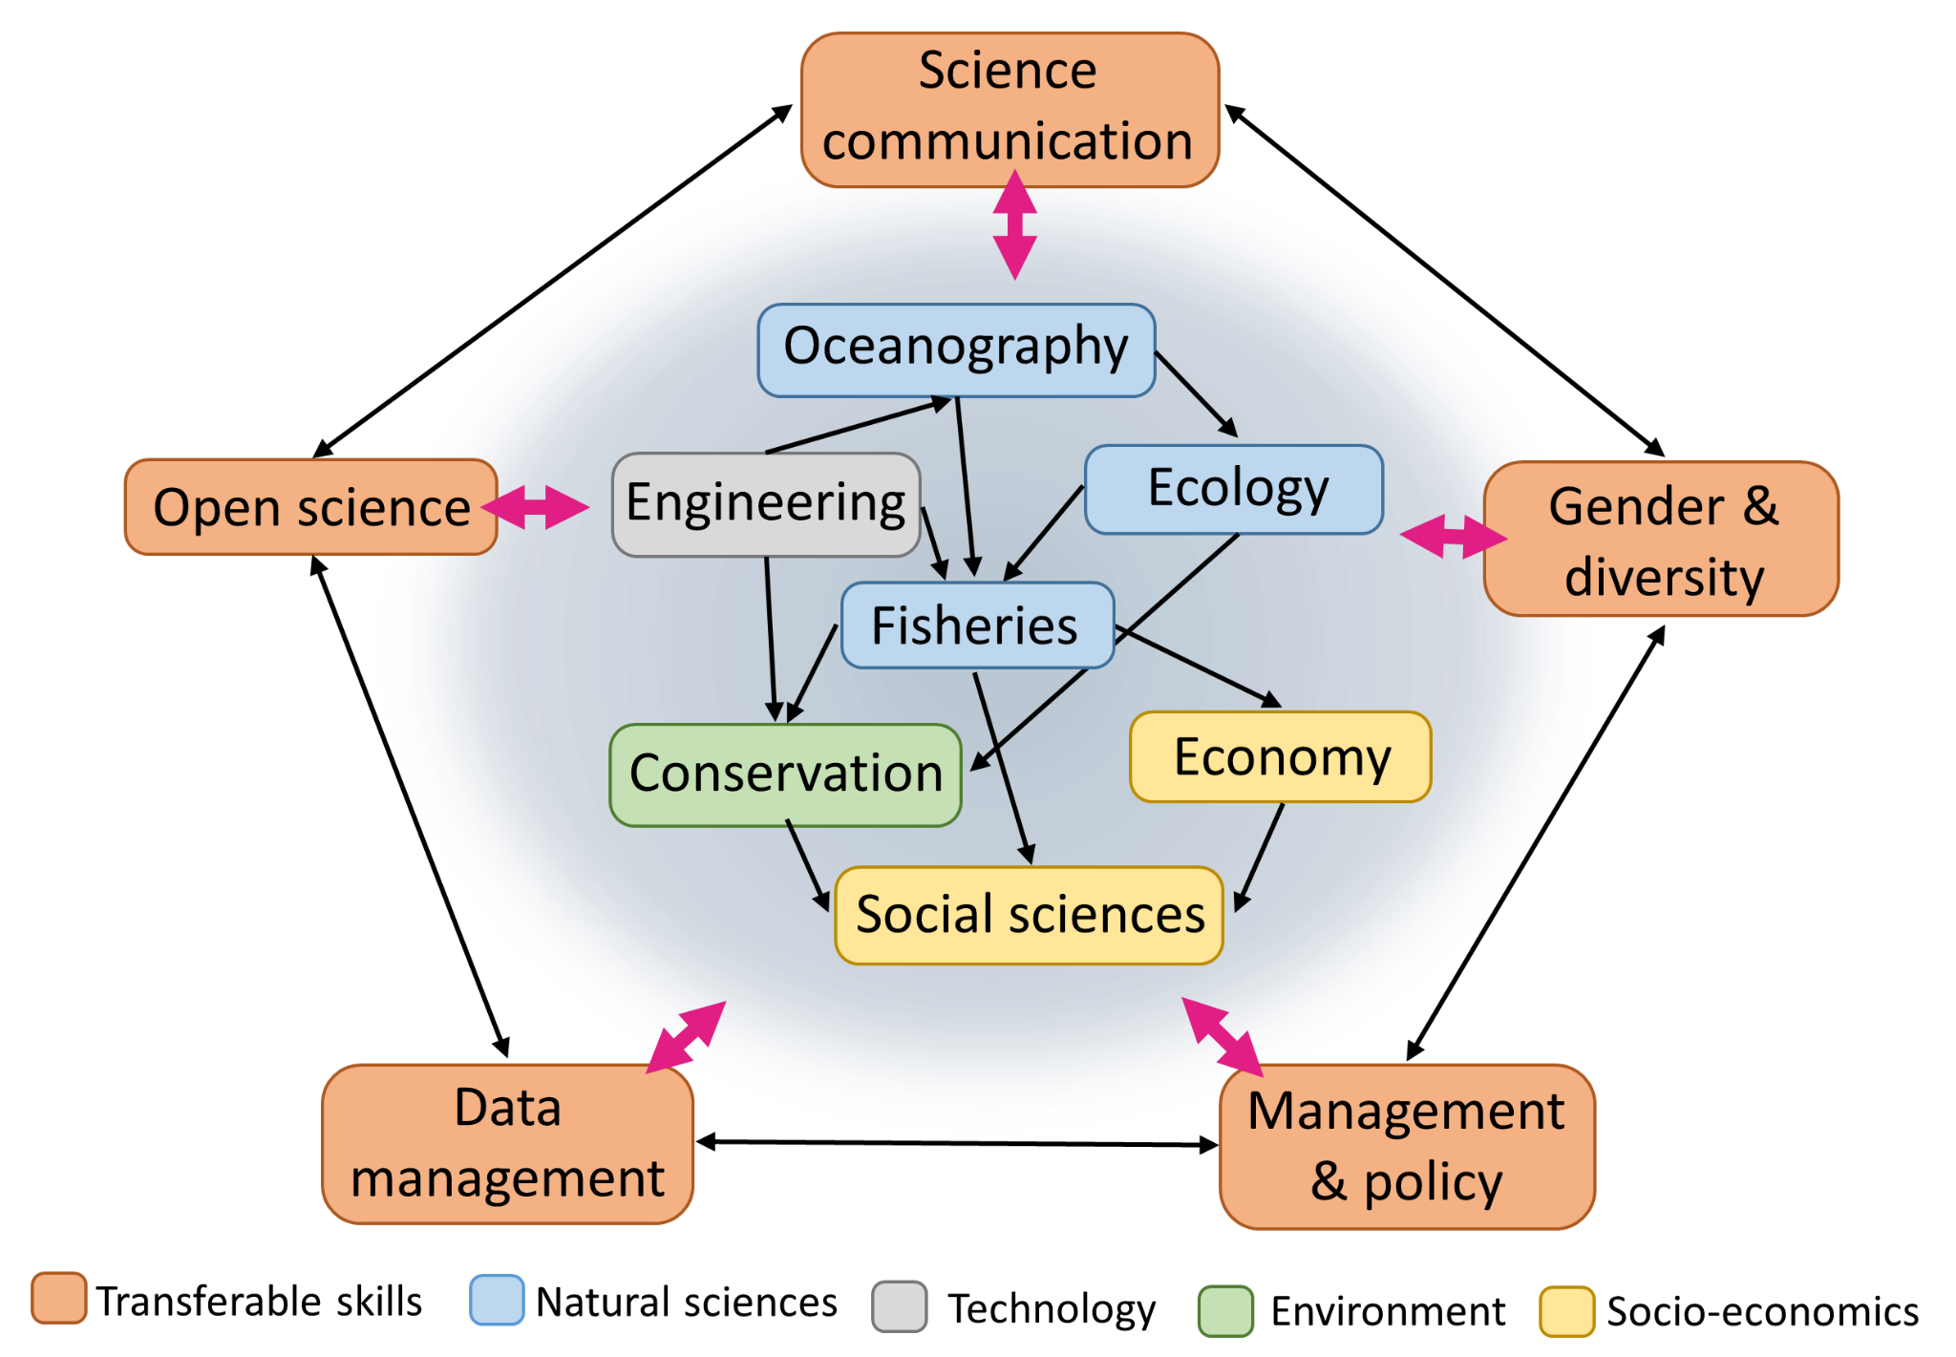
InterDis summer school aims to create interdisciplinarity beyond natural sciences.

Topics covered:
- Effective networking
- Designing an interdisciplinary research project
- Proposal writing
- Diversity, Equity & Inclusion
- Open science & data management
- Involving stakeholders as project partners
- Managing interdisciplinary teams
- Communicating and disseminating project outcomes
- Leadership in young ocean professionals
Invited lecturers and local partners:
- Patricia Reglero: Researcher at IEO-CSIC & Leader of Planet Tuna
- Francisco Alemany: Coordinator at ICCAT
- Pepe Martínez: CEO of FishingTrip
- Joaquín Tintoré: Director of SOCIB
- Aina García: Science and ICOM at SOCIB
- Debora Morrison: Head of Wildlife Foundation at the Palma Aquarium:
- Alejandra Aponte: Head of education at the Palma Aquarium
- Nikolaos Nikolioudaksi: Coordinator at the FAO-NANSEN programme
Cost:
InterDis will be hosted in Palma de Mallorca, Spain, from Monday May 29th to Friday June 2nd. Course fees, accommodation, breakfast, and lunch will be supported by EuroMarine and OYSTER. Participants are expected to cover travel costs, with a small supplementary fund (up to 300 euros) available to some attendees.
Application:
Applications are due by 28th of February 2023 at midnight. All early-career ocean professionals are eligible to apply. Early-career is defined according to the SIIECS resolution, namely having conferred their most recent college degree within the last 10 years. For more detail see p.11 in the SIIECS resolution.
The selection committee will prioritise i) those whose institution is listed in the EuroMarine network, and/or ii) applicants who volunteer in an ECR network, and/or iii) applicants whose expertise contributes to fostering diversity of disciplines among the course participants.
To apply, please fill in the following information in the form here: https://mws.onlinesurveys.ac.uk/interdis-summer-school-2023
- Name
- Country of residence
- Institute (indicate if it is a EuroMarine member)
- Email address
- Discipline
- Career stage (e.g. MSc, PhD, postdoc, traineeship, manager)
- Are you a member of any early-career networks?
- Will you need funding support to cover travel costs?
- Please write a short (max 300 words) motivation about why you would like to attend this Summer School
Contact Details:
Robert Mussgnug: RobertMussgnug@gmail.com
Daniel Ottmann: daniel.ottmann.riera@gmail.com

