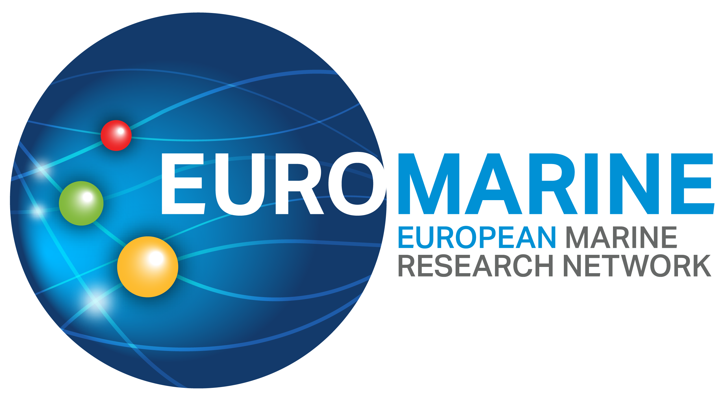

EuroMarine Application Form

Foresight Workshops

To participate, please complete this application form in full, following the guidance provided in the documents:
- EuroMarine Call for Proposals: Foresight Workshops
- EuroMarine Funding Terms and Conditions
Please type your responses directly into the boxes provided in the template using 11pt fonts. All sections must be completed. Applications that are incomplete or exceed the specified page limit will not be considered.
Please send your completed application in PDF format to: secretariat@euromarinenetwork.eu. Late submissions will not be accepted.
Deadline for submissions: 31 August 2026

PART A: Summary and Applicant Details
Project name
Proposal Title
Acronym

Short Summary (Maximum length: 150 words)

Lead Applicant Details
Name of Lead Applicant:
Email address:
Phone number:
EuroMarine member organisation:
The Lead applicant must be affiliated with an EuroMarine Member organisation. The full list of these can be consulted here: https://euromarinenetwork.eu/members-directory.

Co-organisers and other participants
Proposals must be co-organised by scientists affiliated with at least five EuroMarine member organisations. Workshops should also invite other leading experts in the relevant fields. At least two thirds of all participants must be EuroMarine members. Please add rows as necessary.

Name | SURNAME | ORGANISATION
EuroMarine members
Other participants

Number of confirmed participants
Total number of expected participants
Please note that the organisers should announce the workshop and give a chance to interested EuroMarine researchers to apply for participation.

Part B: Foresight Workshop Details
Be concise. Do not repeat information in different sections. Note maximum words.
1. Synthesis and relevance (Maximum length: 1,000 words)
Please describe the scientific topic and why it is worth investigating.

2. Workshop description (Maximum length: 2 pages)
Please describe the Foresight Workshop proposal, including its activities, and schedule, location, suggested dates (2026), and added value for the EuroMarine Network, including measures to engage and support participants.

3. Expected outcomes and impact (Maximum length: 1 page)
Please describe the expected results of the workshop, its contribution to marine science, and measures to increase visibility and impact, including relevant KPIs. Please note that EuroMarine Foresight Workshops should pave the way to advance research topics further, aim to produce a publication (e.g., position paper), and ideally lead to a funding proposal (e.g., Horizon Europe).

4. Expertise of participants (Maximum length: 2 pages)
Please give a brief overview of the expertise of the organisers and invited scientists, including links to publications (e.g. Google Scholar).

5. Will your proposal enhance the visibility of EuroMarine? Will it benefit its members and promote collaboration within the network? (Maximum length: 500 words)

6. Budget
Please provide an estimate of the costs associated with organizing the Foresight Workshop. Refer to the Call Text and EuroMarine Funding Terms and Conditions for guidance on eligible expenses. In the table below, please indicate any additional funding, and whether this has been Secured, Requested, or To be requested. Please add rows as necessary.
Cost Category | Amount | Requested to EuroMarine | Other funding (including in-kind) | Status for other funding
TOTAL

Additional information
What are the main scientific and transversal categories that best represent your proposal? (Please check up to five per column.)
Broad categories  of scientific disciplines |  |  | Broad categories  of transversal disciplines
 | physics |  |  | coastal management
 | chemistry |  |  | applied research
 | geology |  |  | planning and management
 | biology |  |  | networking and collaboration
 | climate |  |  | policy and governance
 | biodiversity and ecology |  |  | training and education
 | biological resources |  |  | communication
 | biotechnology |  |  | research infrastructures
 | non-biological resources |  |  | data management
 | monitoring and observation |  |  | innovation
 | technology and engineering |  |  | product and service development
 | data science |  |  | business
 | social sciences |  |  | ocean change
 | law |  |  | conservation
 | economy |  |  | social impact
 | modelling and computer science |  |  | arts and heritage

What keywords would be most useful to frame and promote your workshop? (Please type in up to six)
Keywords

Can you tell us more about the participants? (Please insert the total number according to your current plan)
Women |  | Senior researchers |  | Organisations
Men |  | Early Career Researchers |  | Countries

How did you learn about this call? (Please check one)
From my organisation’s EuroMarine representative
EuroMarine website
EuroMarine Newsletter
EuroMarine Social Media
Other (please specify)

Does your proposal stem from any previous EuroMarine activity? (If so, please indicate which)

Is your proposal directly connected to other wider efforts? (If so, please indicate how)
UN Decade of Ocean Science
EU Mission - Restore our Oceans and Waters
EuroMarine’s Ocean Frontiers manifesto
Other (please specify)

https://oceandecade.org/
https://research-and-innovation.ec.europa.eu/funding/funding-opportunities/funding-programmes-and-open-calls/horizon-europe/eu-missions-horizon-europe/restore-our-ocean-and-waters_en
https://euromarinenetwork.eu/scientific-strategy-plan/

