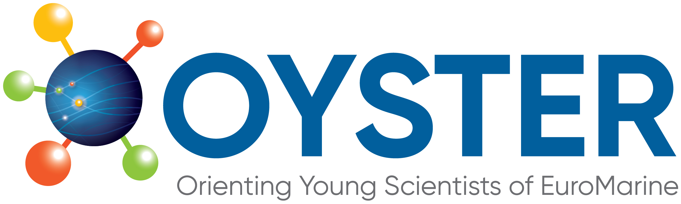 | 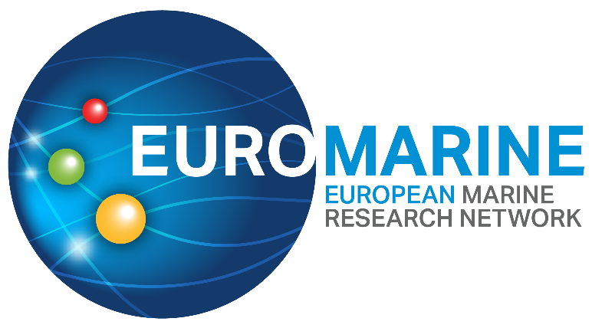

OYSTER 5th Call for Proposals for

Marine ECR Cooperation Project

Application Form
Following the guidance and criteria outlined in the 5th OYSTER Call for Proposals Marine ECR Cooperation Project Call Description, please complete the full application form below.
This application form has these two following sections:
PART A: Proposal Summary and Applicants Details
PART B: Technical proposal
For each section, please type your responses within the boxes provided and ensure all sections are completed. Applications exceeding the stated word limits will not be considered. The font size for responses should be 11 pt. Within each section, the text in italics indicates the information that should be included.
Additional documents (to be included in the final submission PDF): Applicants must also provide a CV for each applicant. CVs will not be formally evaluated but will be used to assess the alignment between the applicants’ background and the proposed project. CVs may follow any format, with a maximum length of 2 pages per CV.
All documents (Declaration form, Application form – Parts A and B, and CVs) must be combined and submitted as a single PDF before the submission deadline. The email subject and file name should be “OYSTER_ECR_COOP_2026_ lead applicant surname”. Incomplete applications will be excluded.
Please submit your completed application as one single PDF to oyster.secretariat@euromarinenetwork.eu before 02/07/2026 at 23:59 CET. Applications submitted after the deadline will not be accepted.

PART A: Proposal Summary and Applicants Details

- Proposal Summary
Proposal title
Acronym
Keywords

1.1 Main scientific disciplines
Please check the broad categories that best correspond to your proposal (up to 4 categories per column).
Broad categories of scientific disciplines / fields | Other categories (tools, transverse expertise, possible domains of EuroMarine services or activities....)
☐Physics and climate of the Ocean  ☐Changing Ocean  ☐Conservation  ☐Marine Biogeochemistry  ☐Marine Biology  ☐Marine Biodiversity  ☐Marine Ecology  ☐Marine Ecosystems functioning  ☐Marine Bio-resources  ☐Marine Biotechnology  ☐Fisheries and Aquaculture  ☐Coastal Systems and marine spatial planning  ☐Economics, Law, Sociology  ☐Ecosystem Services  ☐Social Sciences | ☐Science  ☐Training / Capacity Building  ☐Mobility  ☐Communication  ☐Knowledge Transfer  ☐Networking  ☐Scientific Project Management  ☐Data Analysis  ☐ Data Management  ☐Infrastructures  ☐Expertise (provision of)  ☐Marine policies / Science-governance interface  ☐Modelling  ☐High-throughput approaches  ☐Interdisciplinarity

1.2 Short Summary (Maximum length: 250 words)

- Applicants Details
2.1 Lead Applicant Details
Even if all the co-applicants will have the same responsibilities, one of the ECRs should take the lead for communication with the funding organisation. The ECR leading the application should be the one affiliated to the EuroMarine 2026 Full Member Organisation or Invited Member Organisation that will manage the funds (in case that option is selected).
Name of Lead Applicant:
Email address of Lead Applicant:
Organisation affiliation of Lead Applicant:
Current position:

2.2 Co-Proposers Details
Proposals should include at least two and no more than three ECRs (counting with the lead applicant), with at least two affiliated with EuroMarine 2026 Full Member Organisation or Invited Member Organisation and located in at least two different countries. An optional third ECR may be affiliated with a EuroMarine Full Member, an Invited Member Organisation, or a non-member organisation.
Name of Co-proposer 1:
Email address of Co-proposer 1:
Organisation affiliation of Co-proposer 1:
Current position 1:

Name of Co-proposer 2 (optional):
Email address of Co-proposer 2:
Organisation affiliation of Co-proposer 2:
Current position 2:

2.3 Consortium Summary (Maximum length: 500 words)
Please describe the overall rationale of the consortium, including a brief summary of the academic careers (highlighting research topics, key achievements, and relevant expertise), their individual contribution to the proposed project, and the added value of bringing this consortium together. Clearly describe the role of each applicant and how their expertise complements one another to successfully deliver the project.

- Organisation Managing the Budget
Please choose one of the options below.
EuroMarine Association | ☐
EuroMarine will manage the budget (in terms of administration) | ☐
Other | ☐
Include the name of lead applicant’s EuroMarine Institution Member Organisation that will manage the budget

Part B: Technical Proposal
1. Excellence
1.1 Project Description (Maximum length: 600 words, excluding references).
Please provide a full description of your project. You may include research background/context, objectives, implementation plan, main methodologies, expected outcomes and impact. Indicate how and why the proposed topics are innovative and/or relevant to the call and describe the main research questions, objectives and methodologies to be addressed within your project. If including citations and references, only use (First author, year) in text and provide the publication DOI below.

1.2 Summary of Expected Outcomes (Maximum length: 200 words)
Please indicate the type of outcome (e.g., peer-reviewed publication and target journal, datasets and publishing repositories, training workshops webinars, events, recommendations for the EuroMarine Community or other stakeholders), and brief description in the table below. Please expand the table as needed.
Outcome | Type of outcome | Brief description
O1
O2
O3

2. Impact
2.1 Added Value to the involved ECRs and to the objectives of OYSTER and EuroMarine (Maximum length: 200 words)
Please describe how the project will have an impact on the ECRs involved. Also indicate how it will contribute to both OYSTER and EuroMarine objectives and priorities.

2.2 Wider Impact (Maximum length: 200 words)
Please, indicate how the project addresses EuroMarine priorities and favours the integration of the EuroMarine community and how it can contribute to the UN Decade of Ocean Science (www.oceandecade.org) plans and the EU Mission Restore our Oceans and Waters. OYSTER encourages submissions addressing Ocean Frontiers themes relevant to the UN Decade of Ocean Science for Sustainable Development (2021-30), in general, and particularly on the interdependences of Sustainable Development Goals (as pointed out in the GSDR 2019 report).

2.3 Measures to Maximise the Impact (Maximum length: 200 words)
Please indicate the communication and dissemination activities that you will carry out to develop the impact of the project results and outcomes. Describe the type of communication, expected audiences, number of ECRs reached, engagement with other institutions, stakeholders, media, social media strategy and other forms of impact-building initiatives.

3. Implementation
3.1 Implementation Plan (Maximum length: 300 words)
Please give a complete overview of how you will implement your project, including:
- Brief presentation of the overall structure of the work plan
- Milestones denoting the estimated timing of activities and outcomes (Gantt chart or similar can be added at the end of the document)
- Detailed description of each task and expected outcomes

3.2 Risks and Mitigation Measures (Maximum length: 200 words)
Please complete the table below with a list of critical risks, relating to project implementation and potential mitigation measures. Please expand the table as needed.
Description of risk | Level of (i) likelihood, and (ii) severity: Low/Medium/High) | Proposed risk-mitigation measures

3.3 Allocation of Resources (Maximum length 200 words)
Please provide an estimation of the costs of the project (refer to the Call Text for details about eligible costs). Please expand the table as needed and explain funds covered by external sources if available, indicating source and amount.
Cost Category | Total Amount | Amount requested to OYSTER | Amount from another funder  (if any)
TOTAL

Additional documents: applicants CVs
Please provide the CV of each applicant. CVs will not be formally evaluated but will be used to assess the alignment between the applicants’ background and the proposed project. CVs may follow any format, with a maximum length of 2 pages per CV.
The final application must be submitted as a single PDF, including the Declaration Form, Application form (Parts A and B), and applicants’ CVs. Applications not complying with this format may be excluded.

