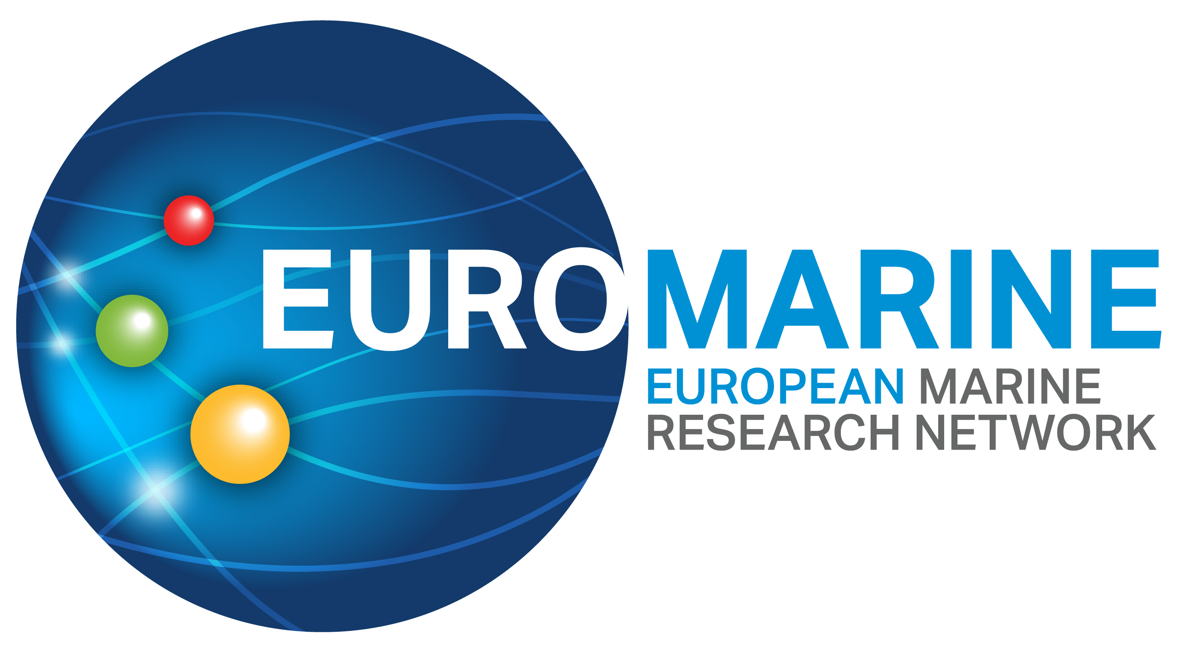

EuroMarine Co-Chairing Offer

Following the guidance and criteria outlined in the EuroMarine Co-Chair Call Text and, please complete the full application form below.
For each section, type your responses within the boxes provided. Font size for responses should be 11pt. Please respond to each section. Incomplete applications will be excluded.
Within each section, the information in italics indicates what should be included. This text can be deleted in the submitted application.
Please submit your completed application by email to secretariat@euromarinenetwork.eu and director@euromarinenetwork.eu before 01/10/26. Applications submitted after the deadline will not be accepted.

PART A: Applicant Details
Proposal Summary
Short Summary (Maximum length: 1/2 page)
Please provide a short summary of the coordination offer for the EuroMarine consortium, including the members that will be involved and their role, and how the EuroMarine Association will be managed.

Details
Coordinator 1 Details
The Coordinator must be affiliated to a Full Member of EuroMarine. Please specify email address(es) and telephone number(s) of the person(s) to whom any questions should be addressed and who should be informed of the outcome of the call.
Name of Coordinator 1:
Email address of Coordinator 1:
Phone number:
Organisation affiliation of Coordinator 1:

Coordinator 2 Details
The Coordinator must be affiliated to a Full Member of EuroMarine. Please specify email address(es) and telephone number(s) of the person(s) to whom any questions should be addressed and who should be informed of the outcome of the call.
Name of Coordinator 2:
Email address of Coordinator 2:
Phone number:
Organisation affiliation of Coordinator 2:

Part B — Motivation and Vision
- Motivation for applying
Please explain why you wish to take on the EuroMarine co-chair role.

- Vision for EuroMarine 2027 onwards
Please describe your vision for the future of the EuroMarine Network, including strategic priorities, scientific positioning, membership development and long-term sustainability.

- Contribution to EuroMarine’s strategic development
Please explain how you would support EuroMarine’s scientific roadmap, European and international positioning, and contribution to major ocean initiatives.

- Governance and ways of working
Please describe how you would work with the Secretariat, Steering Committee and General Assembly.

- Institutional support and added value
Please describe any in-kind support, expertise, facilities, networks or other resources your organisations would make available to EuroMarine.

- Availability and commitment
Please confirm that the proposed co-chairs can dedicate approximately two days per month to the role, with additional availability around key EuroMarine meetings and events.

- European added value
Please explain how your joint proposal reflects EuroMarine’s European, interdisciplinary and collaborative character.

