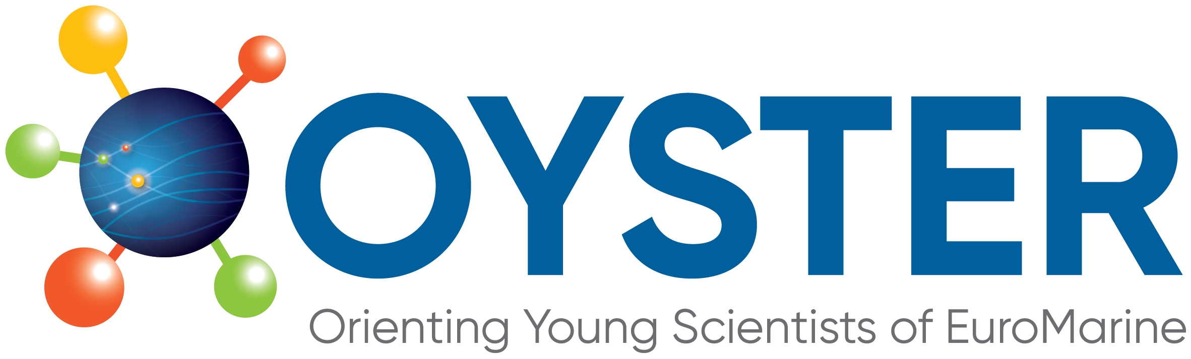 | 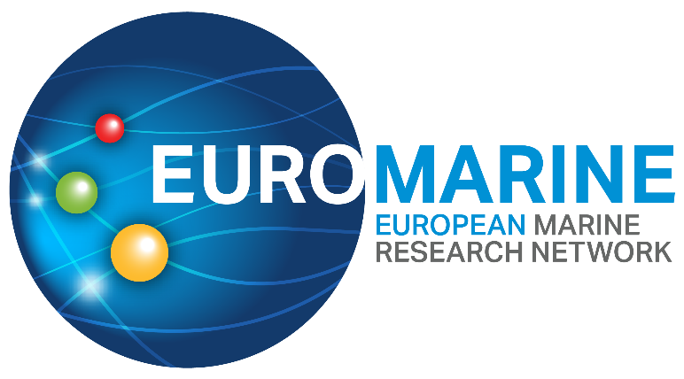

OYSTER 4th Call for Proposals for

Marine ECR Cooperation Project

Application Form (August 2025 call)
Following the guidance and criteria outlined in the 4th OYSTER Call for Proposals Marine ECR Cooperation Project Call Text, please complete the full application form below.
The application form has the following sections and page limits:
PART A: Proposal Summary and Applicants Details
PART B: Technical proposal
PART C: CVs of the Applicants
For each section, type your responses within the boxes provided. Applications that exceed the stated word limit will not be considered. Font size for responses should be 11pt. Please respond to each section. Incomplete applications will be excluded.
Within each section, the information in italics indicates what should be included. This text can be deleted in the submitted application.
Please submit your completed application by email to fellowships@euromarinenetwork.eu and secretariat@euromarinenetwork.eu before 10/10/2025 at 23.59 CET. Applications submitted after the deadline will not be accepted.

PART A: Proposal Summary and Applicants Details
Proposal Summary
Proposal Title
Acronym
Key Words

Main scientific disciplines
Please check the broad categories that best correspond to your proposal (up to 4 categories per column).
Broad categories of scientific disciplines / fields | Other categories (tools, transverse expertise, possible domains of EuroMarine services or activities....)
☐Physics and climate of the Ocean  ☐Changing Ocean  ☐Marine Biogeochemistry  ☐Marine Biology  ☐Marine Biodiversity  ☐Marine Ecology  ☐Marine Ecosystems functioning  ☐Marine Bio-resources  ☐Marine Biotechnology  ☐Fisheries and Aquaculture  ☐Coastal Systems and marine spatial planning  ☐Economics, Law, Sociology  ☐Ecosystem Services  ☐Social Sciences | ☐Science  ☐Training / Capacity Building  ☐Mobility  ☐Communication  ☐Knowledge Transfer  ☐Networking  ☐Scientific Project Management  ☐Data  ☐Infrastructures  ☐Expertise (provision of)  ☐Marine policies / Science-governance interface  ☐Modelling  ☐High-throughput approaches  ☐Interdisciplinarity

Short Summary (Maximum length: 250 words)

Applicants Details
Lead Applicant Details
Even if all the co-applicants will have the same responsibilities, one of the ECRs should take the lead for communication with the funding organisation. The ECR leading the application should be the one affiliated to the Full Member of EuroMarine that will manage the funds (in case that option is selected).

Name of Lead Applicant:
Email address of Lead Applicant:
Organisation affiliation of Lead Applicant:
Career position:

Co-Proposers Details
Proposals need to involve ECRs from two to three different EuroMarine Full Member organisations in at least two different countries. A list of 2025 EuroMarine Members is available at https://euromarinenetwork.eu/members-directory/?page=1. Please add as up to two co-proposers.
Name of Co-proposer 1:
Email address of Co-proposer 1:
Organisation affiliation of Co-proposer 1:
Career position 1:

Name of Co-proposer 2 (optional):
Email address of Co-proposer 2:
Organisation affiliation of Co-proposer 2:
Career position 2:

Consortium Summary (Maximum length: 500 words)
Please describe the overall rationale of the consortium, including a brief summary of the academic career highlighting the applicants’ research topic, professional achievements, and personal contribution to the proposed project, the main objectives of the proposed activity, and the role of each applicant.

Organisation Managing the Budget
Please choose one of the options below.
EuroMarine Association | ☐
Name of the individual who will manage the funds
EuroMarine member organisation | ☐
Name of the organisation that will manage the funds

Part B: Technical Proposal
1. Excellence
1.1 Project Description (Maximum length: 600 words, excluding references).
Please provide a full description of your project. You may include research background/context, objectives, implementation plan, main methodologies, expected outcomes and impact. Indicate how and why the proposed topics are innovative and/or relevant to the call and describe the main research questions, objectives and methodologies to be addressed within your project. If including citations and references, only use (First author, year) in text and provide the publication DOI below.

Summary of Expected Outcomes (Maximum length: 200 words)
Please indicate the type of outcome (e.g., peer-reviewed publication (indicate target journal if known), outcomes may also include training workshops webinars, events, recommendations for the EuroMarine Community or other stakeholders), and brief description in the table below. Please expand the table as needed.
Outcome | Type of outcome | Brief description
O1
O2
O3

2. Impact
2.1 Added Value to the involved ECRs and to the objectives of OYSTER and EuroMarine (Maximum length: 200 words)
Please describe how the project will have an impact on the ECRs involved. Also indicate how it will contribute to both OYSTER and EuroMarine objectives and priorities.

2.2 Wider Impact (Maximum length: 200 words)
Please, indicate how the project addresses EuroMarine priorities and favours the integration of the EuroMarine community and how it can contribute to the UN Decade of Ocean Science (www.oceandecade.org) plans and the EU Mission Restore our Oceans and Waters.

2.3 Measures to Maximise the Impact (Maximum length: 200 words)
Please indicate the communication and dissemination activities that you will carry out to develop the impact of the project results and outcomes. Describe the type of communication, expected audiences, number of ECRs reached, engagement with other institutions, stakeholders, media, social media strategy and other forms of impact-building initiatives.

3. Implementation
3.1 Implementation Plan (Maximum length: 300 words)
Please give a complete overview of how you will implement your project, including:
- Brief presentation of the overall structure of the work plan
- Milestones denoting the estimated timing of activities and outcomes (Gantt chart or similar can be added as separate file).
- Detailed description of each task and expected outcomes

3.2 Risks and Mitigation Measures (Maximum length: 200 words)
Please complete the table below with a list of critical risks, relating to project implementation and potential mitigation measures. Please expand the table as needed.
Description of risk | Level of (i) likelihood, and (ii) severity: Low/Medium/High) | Proposed risk-mitigation measures

3.3 Allocation of Resources (Maximum length 200 words)
Please provide an estimation of the costs of the project (refer to the Call Text for details about eligible costs). Please expand the table as needed and explain funds covered by external sources if available, indicating source and amount.
Cost Category | Total Amount | Amount requested to OYSTER | Amount from other funder  (if any)
TOTAL

Part C: Applicants Curriculum Vitae (Maximum length: 2 pages per applicant)
Please provide the CV of each applicant. The CVs will not be evaluated, but they will be used to understand the link between the applicants’ background and the proposed project. The CVs may be in any style with a maximum of 2 pages per CV.

