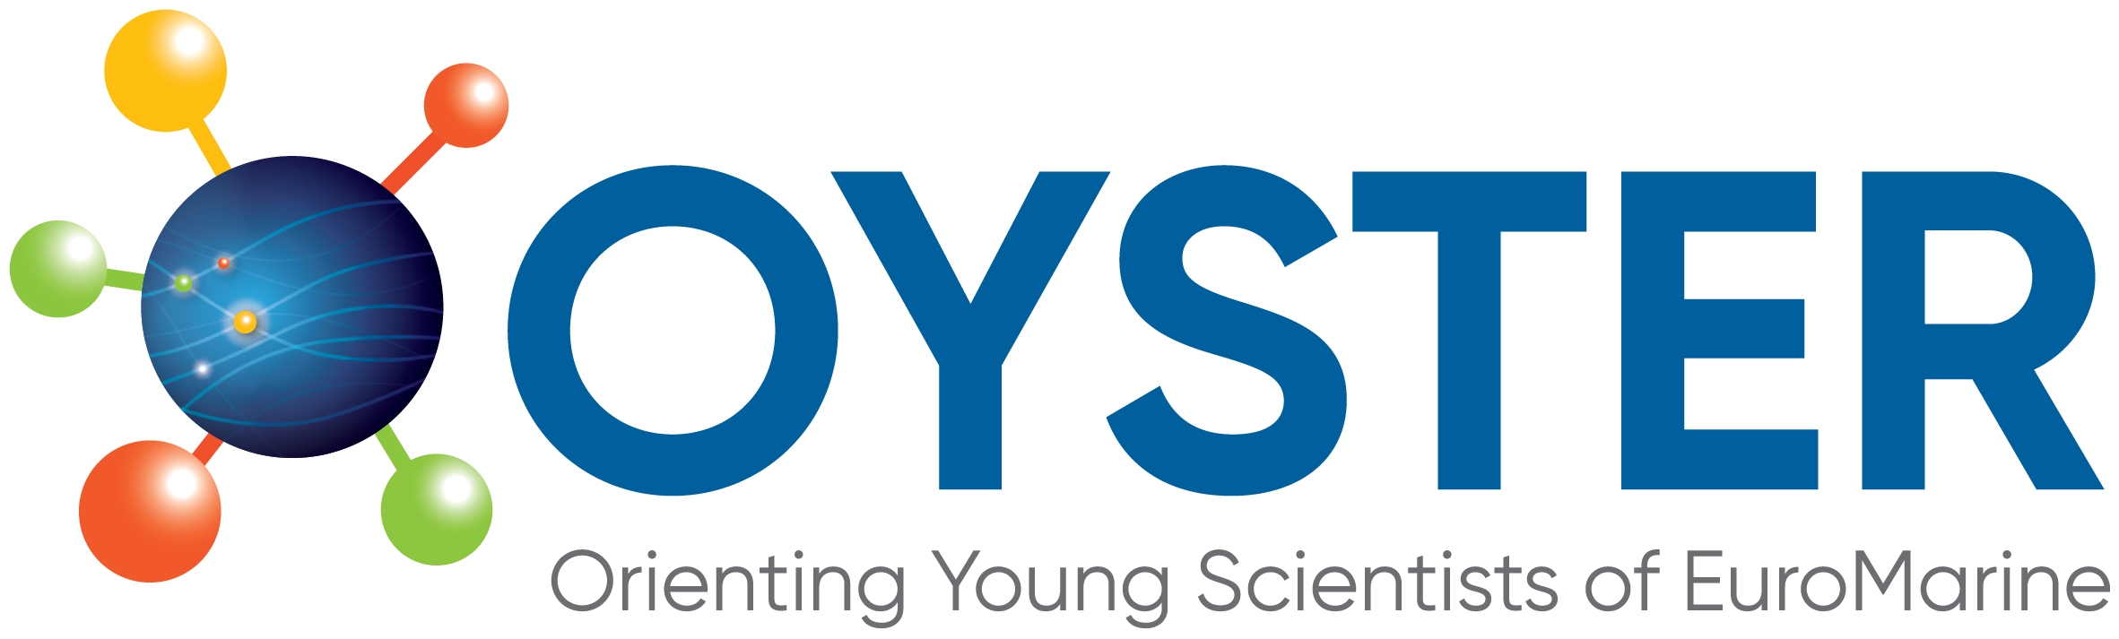 | 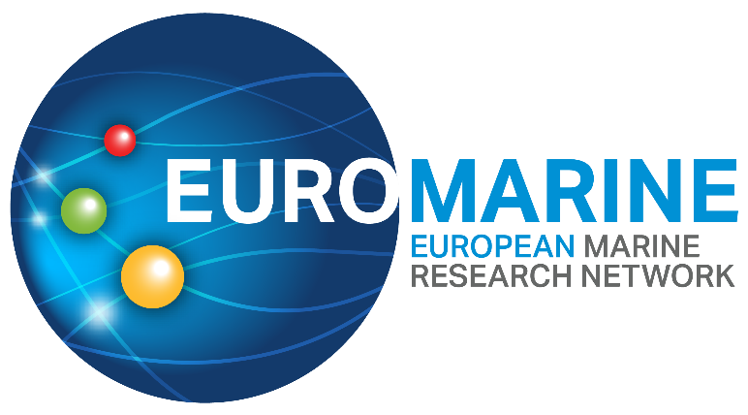

OYSTER 2nd Call for Proposals for

Marine ECR Cooperation Projects

Background: EuroMarine and OYSTER
EuroMarine is a European, marine science network launched in 2014 and designed as a bottom-up organisation to raise the voice of the European marine scientific community. It is intended as a durable organisation and a legal entity placed under the control of the consortium that gathers all members and was established in 2018 as a support structure. As of May 2023, EuroMarine counts 57 member organisations (MOs), 49 of which are ‘full voting’ members contributing to the budget.
The two primary goals of EuroMarine are:
- To support the identification and initial development of important emerging scientific topics and methodologies in marine sciences;
- To foster new services relevant to the marine scientific community.
EuroMarine achieves these goals through internal competitive calls for proposals, within the available budget. EuroMarine advocates for marine science and contributes to improving the science-governance interface, providing expertise and transferring knowledge.
EuroMarine considers supporting capacity building for young scientists a key priority. For this, EuroMarine currently funds the OYSTER (Orienting Young Scientist of EuroMarine) Working Group. OYSTER is an independent working group dedicated to promoting and supporting opportunities for Early Career Researchers (ECRs) in marine science. As such, OYSTER has opened the current 2nd Call for Marine ECR Cooperation Projects.
This call for proposals offers funding to ECRs from EuroMarine Full Member and Invited Member Organisations to undertake an original and collaborative research and innovation project. The objective is to build networks within EuroMarine, bringing together ECRs through collaborative research projects.

Eligibility criteria for the Marine ECR Cooperation Projects
For the 2023 Call, OYSTER will fund 2 Marine ECR Cooperation Projects with a maximum funding of €7,500 per project.

Applicants
Only Early Career Researchers (ECRs) are eligible for funding. Please see the box below for the definition of Early Career Researcher in the framework of this call.
Definition of Early Career Researcher (ECR) for this call
PhD students or individuals holding a postdoctoral position within 5 years of their PhD degree award (discounting any time spent on maternity, illness or similarly extensive non-holiday leave) at the time of call deadline.
Proposals should involve two or three ECRs (students or employees - under an employment contract or equivalent appointing act) of an EuroMarine 2023 Full Member or Invited Member Organisation from at least two different countries.

Eligible topics
The research topic should concern an out of the box idea, an additional research topic that was initially not foreseen in the applicants’ research, but that would add an extra value to the ongoing research. It should be in line with EuroMarine’s bottom-up ethos to favour the emergence of new ideas and approaches. This call is widely open in terms of topics but only activities that single organisations could not tackle alone are supported. Proposals with a multidisciplinary or discipline-specific nature are both welcome.
In 2018, EuroMarine published an Ocean Frontiers for Sustainable Development Manifesto, which “advocates for the increased understanding, protection and management of the Ocean to support the health and wellbeing of present and future generations.” It is structured around the following four themes:
- Manage Ocean Complexity;
- Secure Coastal Areas;
- Target Ocean and Human Health;
- Protect Ocean Commons.
OYSTER encourages submissions addressing the Ocean Frontiers Manifesto themes and/or relevant to the UN Decade of Ocean Science for Sustainable Development (2021-30), in general, and particularly on the interdependences of Sustainable Development Goals (as pointed out in the GSDR 2019 report). Additionally, support to initiatives within the EU Mission: Restore our Ocean and Waters are welcome.

Maximum duration of the project
The maximum duration of the project should be 1 year (12 months) starting on the 1st of January 2024.

Eligibility of Costs
Eligible Costs
All direct costs incurred in connection with the development of the project activities are eligible. These costs can include:
- Research supplies
- Sample analysis in the awarded institution or external laboratory facilities
- Travel costs, which cannot amount to more than 50% of the grant

Ineligible Costs
The following costs are ineligible under this call:
- Overheads
- Personnel costs
- Purchase of small equipment, such as computers, phones, etc.

Award Criteria and Selection Procedure
OYSTER limits its financial contribution to successful activities to the above-specified maximum amount of €7,500 per project. Applicants are asked to ensure co-funding when necessary.
Each proposal will be assessed by a minimum of two members of the OYSTER Working Group and one senior EuroMarine scientist. The reviewers will be assigned ensuring no conflict of interests.
Each application will be allocated a total score out of 15, with a maximum of 5 marks available for each of the following three criteria.
- Excellence: Merit and innovative nature of the proposal topic and objectives. Scientific relevance of the proposed project outcomes.
- Impact: Added value to the ECRs participating in the project. Added value to OYSTER and EuroMarine (i.e., to which degree a proposal addresses EuroMarine priorities and favours the integration of the EuroMarine community and the expected outcomes). Contribution to the UN SDGs and UN Decade of Ocean Science plans and the EU Mission Ocean.
- Implementation: Capacity and role of each applicant, and the extent to which the application team as a whole brings together the necessary expertise. Quality and effectiveness of the project implementation and use of resources.
Each criterion will be scored between 0.0 and 5.0, in multiples of half (0.5) points. The final score is calculated by the sum of the individual scores of each criterion, with a final maximum score of 15.
A ranking list of recommended proposals based on the scores from the individual assessments will be prepared by the OYSTER Group. The EuroMarine Steering Committee and OYSTER co-chairs will make the final decision. The applicants will be informed of the outcomes of the evaluation in mid-December 2023.

Budget Management
The grant can be managed directly by EuroMarine or transferred to the applicant institution/s. Applicants must state the management decision in the declaration form signed by their EuroMarine Member Organisation GA representative.

Submission of proposals
To apply, please fill in the following documents and return them to both fellowships@euromarinenetwork.eu & secretariat@euromarinenetwork.eu emails:
- The Proposal Template (provided on the call webpage)
- The Declaration Form (provided on the call webpage)
All documents must be sent in pdf before the submission deadline (the reception of proposals will be acknowledged). The email subject should be “OYSTER_ECR_COOP_2023-Last name of the leaders”.
Please note that applicants are required to contact their EuroMarine GA representative to approve their application prior to submission and countersign the Declaration Form. The official EuroMarine GA representatives and their contact details can be found on: https://euromarinenetwork.eu/members-directory/?page=1
Applicants are requested to keep proposals brief (under the limits specified in the template).

Reporting Project Results
At the end of the project, a technical report should be sent to OYSTER and EuroMarine Secretariat. The template of this report will be sent to the Lead Applicant of the proposal approved for funding. A financial report should also be submitted together with evidence of all expenses. In addition to this, the successful applicants will be invited to present their work at the following OYSTER workshop and the 2025 General Assembly of EuroMarine, or other EuroMarine-related conferences.

Acknowledgement of the fundings
By accepting the Marine ECR cooperation project, OYSTER and EuroMarine must be credited in all publications (including conferences) arising from work undertaken during the Marine ECR cooperation project with the following wording:
“This study was supported by EuroMarine (EM) and the Orienting Young Scientists of EM Working Group (OYSTER) via the Marine ECR cooperation project.”

Timeline
12 May 2023: Call preannouncement
7 September 2023: Publication of the call
15 November 2023: Deadline for proposal submission
16 November to 15 December 2023: Review process
After 15 December 2023: Notification of the results

Contact
Please do not hesitate to contact the OYSTER WG for information or assistance in the production of a proposal.

E-mail: fellowships@euromarinenetwork.eu

Further information and references
Please refer to the call webpage (https://euromarinenetwork.eu/pilot-call/), which includes links to the following call documents:
  - The call text;
  - Instructions and a template to apply (Word file);
  - The Declaration Form

Other relevant links:
  - List of 2023 members and corresponding General Assembly Representatives
  - EuroMarine 2018 Ocean Frontiers for Sustainable Development manifesto
  - UN Ocean Decade
  - EU Mission Restore our Oceans and Waters

