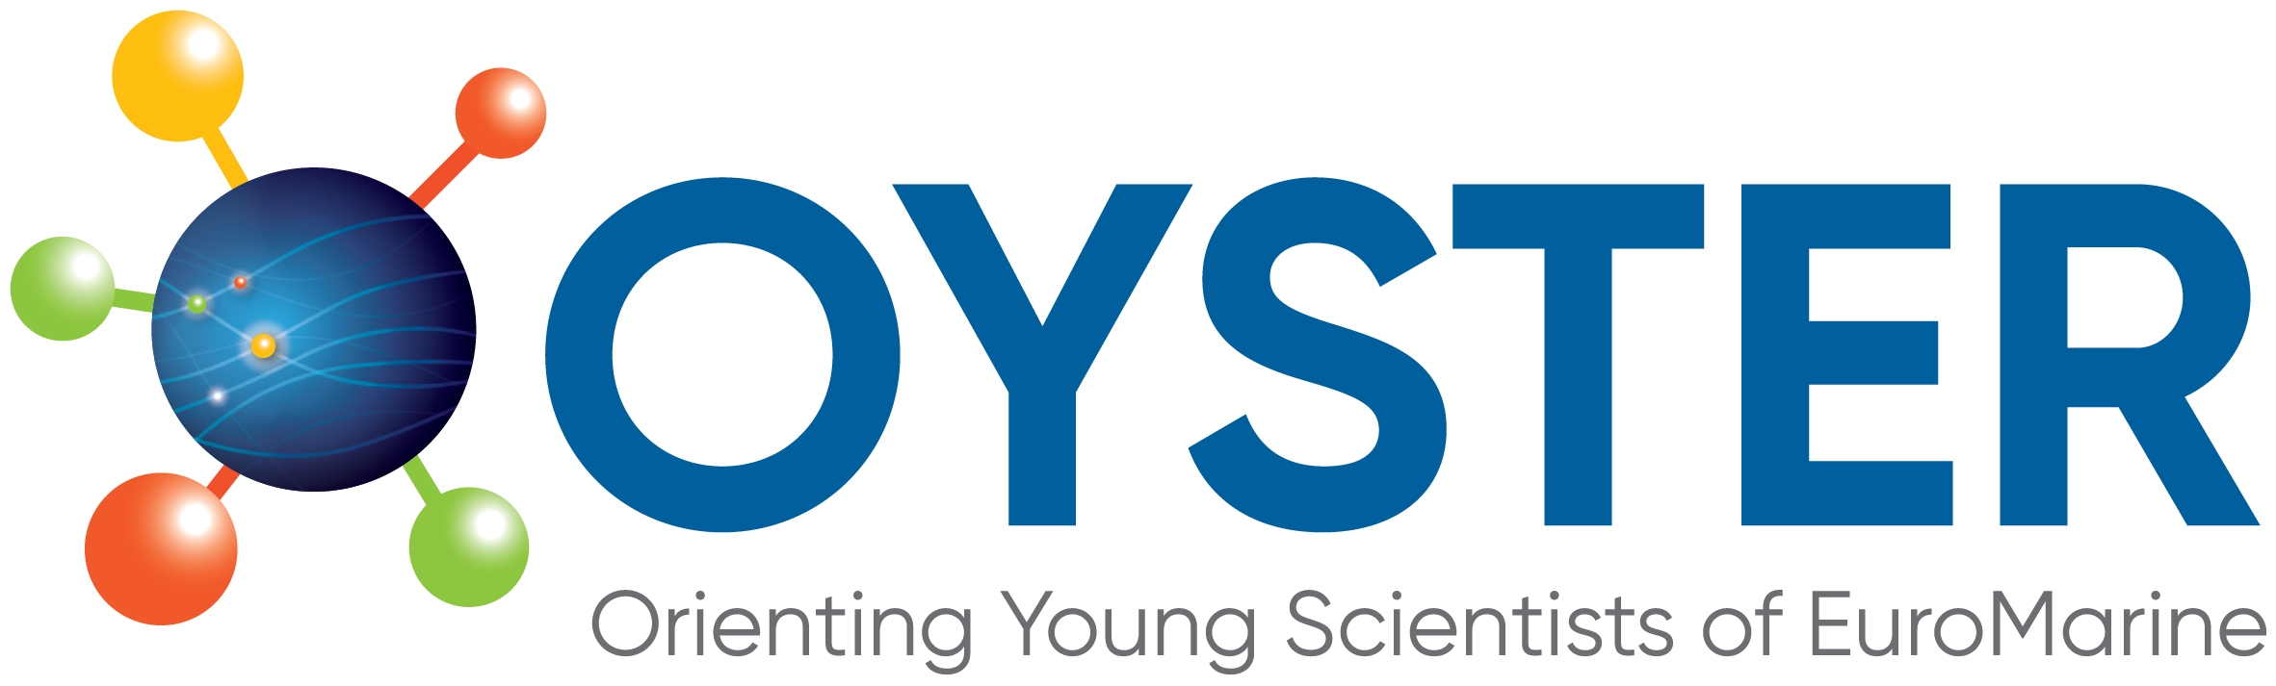 | 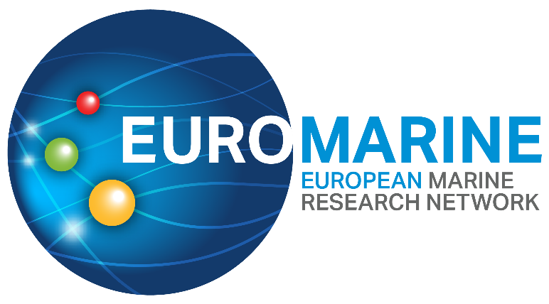

OYSTER Pilot Call for Proposals for

Marine ECR Cooperation Project

(OYSTER ECR Pilot)

Application Form (September 2022 call)
Following the guidance and criteria outlined in the OYSTER Pilot Call for Proposals Marine ECR Cooperation Project Call Text, please complete the full application form below.
The application form has the following sections and page limits:
PART A: Administrative details and project summary (No page limits)
PART B: Technical proposal (Maximum 6 pages)
For each section, type your responses within the boxes provided. Applications that exceed the stated page limit will not be considered. Font size for responses should be 11pt. Please respond to each section. Incomplete applications will be excluded.
Within each section, the information in italics indicates what should be included. This text can be deleted in the submitted application.
Please submit your completed application by email to fellowships@euromarinenetwork.eu and secretariat@euromarinenetwork.eu before 31/10/2022 at 23.59 CET. Applications submitted after the deadline will not be accepted.

PART A: Proposal Summary and Applicant Details
Proposal Summary
Proposal Title
Acronym
Key Words

Main scientific disciplines
Please check the broad categories that best correspond to your proposal (no more than 3 - 4 under each column).
Broad categories of scientific disciplines / fields | Other categories (tools, transverse expertise, possible domains of EuroMarine services or activities....)
☐Physics and climate of the Ocean  ☐Changing Ocean  ☐Marine Biogeochemistry  ☐Marine Biology  ☐Marine Biodiversity  ☐Marine Ecology  ☐Marine Ecosystems functioning  ☐Marine Bio-resources  ☐Marine Biotechnology  ☐Fisheries and Aquaculture  ☐Coastal Systems and marine spatial planning  ☐Economics, Law, Sociology  ☐Ecosystem Services  ☐Social Sciences | ☐Science  ☐Training / Capacity Building  ☐Mobility  ☐Communication  ☐Knowledge Transfer  ☐Networking  ☐Scientific Project Management  ☐Data  ☐Infrastructures  ☐Expertise (provision of)  ☐Marine policies / Science-governance interface  ☐Modelling  ☐High-throughput approaches  ☐Interdisciplinarity

Short Summary (Maximum length: 1/2 page)

Applicant Details
Lead Applicant Details
Even if all the co-applicants will have the same responsibilities, one of the ECRs should take the lead for communication with the funding organisation. Ideally, the ECR leading the application should be the one affiliated to the Full Member of EuroMarine that will manage the funds (in case that option is selected).
Name of Lead Applicant:
Email address of Lead Applicant:
Phone number:
Organisation affiliation of Lead Applicant:
Co-Proposers Details
Proposals should involve two or three ECRs (students or employees - under an employment contract or equivalent appointing act) of an EuroMarine 2022 Full Member Organisation or Invited Member Organisation from at least two different countries.
A list of 2022 EuroMarine Members is available at https://euromarinenetwork.eu/members-directory/?page=1. Please add as many co-proposer as needed.

Name of Co-proposer 1:
Email address of Co-proposer 1:
Phone number:
Organisation affiliation of Co-proposer 1:

Name of Co-proposer 2:
Email address of Co-proposer 2:
Phone number:
Organisation affiliation of Co-proposer 2:

Organisation Managing the Budget
Please choose one of the options below.
EuroMarine Association | ☐
Other | ☐
If you choose other, please indicate the name of the organisation that will manage the funds

Part B: OYSTER Pilot Call for Proposals Marine ECR Cooperation Project – Technical Proposal
1. Excellence (Maximum length: 2 pages)
1.1 Objectives
Please describe the objectives of your proposed project. This section should include the Key Performance Indicators (KPIs) that you will use to measure the impact and achievement of the project.

1.2 Project Description, Methodology and Expected outcomes
Please provide a full description of your project. Indicate how and why the proposed topics are innovative and/or relevant to the call and provide a brief description of the expected outcomes.

Summary of Expected Outcomes
Please indicate the type of outcome (e.g., synthesis paper, peer-publication (please indicate the target journal), position paper recommendations for the EuroMarine Community), date of achievement and brief description in the table below. Please expand the table as needed.
Outcome | Type of outcome | Expected date of achievement | Brief description
O1
O2
O3

2. Impact (Maximum length: 2 pages)
2.1 Added Value to the involved ECRs and the OYSTER Group
Please describe how the project will have an impact on the ECRs involved. Also indicate how it will contribute to the OYSTER objectives and priorities.

2.2 Wider Impact
Please indicate how the project addresses EuroMarine priorities and favours the integration of the EuroMarine community and how it can contribute to the UN Decade of Ocean Science (www.oceandecade.org) plans.

2.3 Measures to Maximise the Impact
Please indicate the communication and dissemination activities that you will carry out to promote the project and its results.

3. Implementation (Maximum length: 2 pages)
3.1 Implementation Plan
Please give a complete overview of how you will implement your project, including:
- Brief presentation of the overall structure of the work plan
- Timing of the different activities and their components (Gantt chart or similar)
- Detailed description of each task and expected outcomes

3.2 Risks and Mitigation Measures
Please complete the table below with a list of critical risks, relating to project implementation and potential mitigation measures.
Description of risk | Level of (i) likelihood, and (ii) severity: Low/Medium/High) | Proposed risk-mitigation measures

3.3 Allocation of Resources
Please provide an estimation of the costs of the project. Please refer to the Call Text for details about eligible costs. Please include in the table below any in-kind contribution.
Cost Category | Amount | Requested to OYSTER | In-kind contribution (if any)
TOTAL

