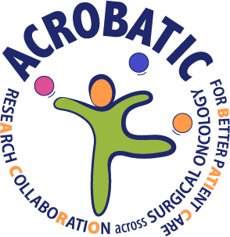ACROBATIC

Dansk Forskningscenter for Kræftkirurgi

Palle Juul-Jensens Boulevard 99

8200 Aarhus N

**Consent Form – Use of Name and Image Material**

I hereby grant permission for ACROBATIC – Danish Research Center for Cancer Surgery to use my name and image material, including portrait photos and other visual representations featuring me, in printed and digital media as illustrative material for ACROBATIC.

I may withdraw my consent at any time, except for materials that have already been printed. Requests for withdrawal must be submitted in writing to marihl@rm.dk.

I acknowledge that some search engines index images from websites. This means that even if ACROBATIC removes images from the center’s website, image material may still be retrievable via a search engine in some cases.

By signing this consent form, I accept that ACROBATIC stores and processes the personal data I provide. My personal data will be stored until it has been processed and will then be deleted.

Name: ______________________________________________

Date: ______________________________________________

Signature: _________________________________________