Ode to the Midlands
Call for Organisations
Open to visual arts organisations located in or programming across the East Midlands & West Midlands to foster cross-regional connectivity and sustained artistic development
Applicant Q&A: Tuesday 9 December, 2pm (online, via Zoom)
Contact Colette Griffin at colette@cvaneastmidlands.co.uk to book onto the open Ode to the Midlands information session, or to request an online 1-2-1 conversation. This is an opportunity to discuss queries relating to the project or application process.

Deadline: Monday 12 January 2026, 10am
Responses: Tuesday 3 February 2026, 5pm
Contents
Page 1: Project Overview
Page 2: Who are CVAN EM & CVAN WM?
Page 3: What are organisations applying for?
Page 3: Overview of support for commissioned organisations and commissioned artists
Page 4: Who can apply?
Page 5: Eligibility map
Page 6: Selection Process
Page 6: How to apply
Page 7: Application Form
Project Overview
Ode to the Midlands (OttM) is an ambitious, cross-regional programme delivered over 18 months by Contemporary Visual Arts Network East Midlands (CVAN EM) and Contemporary Visual Arts Network West Midlands (CVAN WM) to enrich cultural life in the Midlands by investing in local talent and publics.
Rooted in equity, collaboration, and digital innovation, OttM builds cross-regional connectivity by fostering relationships between artists, organisations, and audiences across the East and West Midlands. OttM is seeking up to 10 partner organisations, split across both regions to commission up to 10 Global Majority, Disabled, d/Deaf, and/or Neurodivergent mid-career artists to produce digital

works that explore, celebrate, and reflect the Midlands’ rich cultural and geographical identity. Central to the programme is a unique pairing process that will see visual arts organisations (large or small) work with artists from their neighbouring region to strengthen collaboration and exchange.
OttM champions sustainable artist development through commissions, mentoring, peer learning, and professional support, while also investing in organisational development, helping partners build the confidence, skills, and frameworks needed for inclusive digital commissioning.
With the East and West Midlands historically underrepresented in the national visual arts narrative, low in creative employment, and among the least funded regions in the UK, OttM responds to sector needs by supporting artists to create and present new digital artworks. Presenting artworks online, in galleries, and in public spaces, it expands access for rural, Disabled, and time-poor audiences, creating lasting connectivity and a legacy of inclusive digital arts across the region.
Grounded in the core work of our Network hosts, New Art Exchange and DASH, OttM ensures creatives from marginalised backgrounds and historically excluded from immersive and digital practice gain visibility, resources, and networks. An Advisory Group of Midlands-based audiences, artists and arts workers will help guide the programme and selection process, embedding inclusive practice and shared decision-making.
Through collaborations with regional universities, OttM will deliver a free public workshop series designed to share digital skills, foster experimentation, and build sector confidence. These workshops, led by locally based artists and technicians, will support both artists and wider publics to engage meaningfully with new technologies and inclusive creative practice.
In partnership with Corridor8, OttM will also platform critical and creative writing from Midlands-based arts writers, offering reflective responses to the commissioned works and further amplifying regional voices.
Ode to the Midlands is supported using public funding by the National Lottery through Arts Council England.
Who are CVAN EM & CVAN WM?
CVAN EM & CVAN WM are the free-to-access Contemporary Visual Arts Networks for the East and West Midlands, working as part of the national CVAN network. We advocate for contemporary visual arts in the regions by supporting artists, arts workers, and organisations through paid opportunities, critical programming, and partnership working, while driving policy change to ensure a sustainable and vibrant sector. Both networks are guided by diverse Steering Groups of arts professionals including artists, technicians, writers, curators, producers, academics and access support workers.
Since 2023, CVAN EM has been hosted by New Art Exchange (NAE). NAE is a ground-breaking creative space in the heart of Hyson Green, Nottingham and the UK’s largest gallery dedicated to contemporary visual arts from the Global Majority. NAE is dedicated to promoting excellence in culturally diverse contemporary arts through exhibitions, events and engagement initiatives. The organisation champions a citizen-led model to programming, commissioning and decision making.

Since 2023, CVAN WM has been hosted by DASH. DASH is a Disabled-led, visual arts charity with a vision for a world where Disability Art is equally valued. The organisation’s mission is to affect sector change, to remove barriers to access, establishing Disability Arts practice as part of the mainstream. Across core activities, DASH tackles systemic inequalities to create space for extraordinary artists to make work and be heard. Talent development is at the core of what DASH does, supporting Disabled, D/deaf and Neurodivergent creatives.
What are organisations applying for?
This is an opportunity to apply to be an OttM Commissioning Organisation, joining a network of up to 10 partners who will collaboratively deliver this ambitious cross-regional programme.
Selected organisations will work in partnership with CVAN EM & CVAN WM to commission and support one Global Majority, Disabled, d/Deaf, and/or Neurodivergent mid-career artist each. Each organisation will be paired with an artist from their neighbouring region (East or West Midlands, depending on your organisation’s location).
An open call for artists will run in early 2026, with partner organisations working with the OttM Advisory Group to select an artist to develop and present a new digital artwork that explores, celebrates, and reflects the Midlands’ rich cultural and geographical identity.
Artworks can be presented online, in galleries, and in public spaces and could be exhibition, event, performance, intervention or activity based.
For OttM, digital artwork refers to creative works that use digital technology as an essential element of their concept, production, or presentation. This may include, but is not limited to:
- Moving image, animation, or video art
- Interactive or participatory works
- Audio or sound-based works using digital tools
- Virtual, augmented, or mixed reality projects
- Digital installations or projections in physical spaces
- Online or web-based artworks
- Creative coding, generative art, or data-driven projects
- Extended reality (XR), projection mapping, and multi-sensory platforms.
If you would like to discuss or get further clarification regarding the definitions provided above relating to eligible practice, please contact Colette Griffin at colette@cvaneastmidlands.co.uk.
Overview of support for commissioned organisations and commissioned artists
Each selected commissioning organisation, working in partnership with their commissioned artist, will receive the following support from OttM:
- A commissioning budget contribution of £8,000 to support the commissioned artist’s fee, production, and presentation costs.
- Access funds as required for their commissioned artist, drawn from a total artist access budget of £10,000 across the programme.
- Access to a total project travel and accommodation budget of £5,500, to support cross-regional collaboration and exchange.
- A written review, article, or feature on the commissioned artwork written by a Midlands-based arts writer, commissioned and published by Corridor8.
- Bespoke mentoring, consultation, and skill development opportunities for their artist through a combination of group sessions and 1-2-1 support with freelance arts professionals, including artists, curators, and specialist technicians.
- An Organisational Development Day, designed to strengthen partners’ confidence and capacity for inclusive digital commissioning.
- Documentation of the presentation of commissioned artwork, ensuring a lasting record and legacy.
- 2.5 technician days (at £180 per day) to support the development and/or delivery of the commissioned work.
- Visibility and promotion through OttM’s communications and its partnership with Corridor8, which will provide editorial and critical coverage of the commissions.
In return, organisations are expected to:
- Contribute £2000 to the artist fee, production and presentation costs.
- Demonstrate a commitment to equity, inclusion, and regional collaboration in both artistic and organisational practice.
- Work with the OttM Advisory Group to support the selection of participating artists with an openness to this collaborative selection and commissioning approach.
- Work with an ambitious mid-career artist from the neighbouring region to support the development of a new digital artwork, ensuring access, inclusion, and sustainability throughout the process.
- Participate in the OttM professional development programme, including shared learning sessions, evaluation, and public-facing workshops.
- Contribute to OttM’s regional legacy by embedding new skills, frameworks, and networks within their organisation.
We acknowledge that the £2000 contribution to artist fee, production and presentation costs will be a barrier for many organisations. CVAN EM & WM can provide in-kind support by way of time and skills to assistant in applying for additional funding to support access to this opportunity.
Please Colette Griffin at colette@cvaneastmidlands.co.uk if you would like more information.
Who can apply?
This call welcomes applications from visual arts organisations of all scales and models, including artist-led initiatives, community arts organisations, galleries, festivals, and digital platforms, provided they can demonstrate the experience and capacity to support and nurture a commissioned artist.
Organisations should be able to demonstrate the experience required to support and nurture a commissioned artist and capacity to host a digital commission between April 2026 – March 2027, and a clear commitment to collaboration and inclusive practice.

Organisations must be based in or deliver work across the East or West Midlands as defined by CVAN EM & CVAN WM. The regions encompass the counties of Derbyshire, Leicestershire, Lincolnshire (not NE), Northamptonshire, Nottinghamshire & Rutland (East Midlands) and Herefordshire, Shropshire, Staffordshire, Warwickshire, West Midlands & Worcestershire (West Midlands).
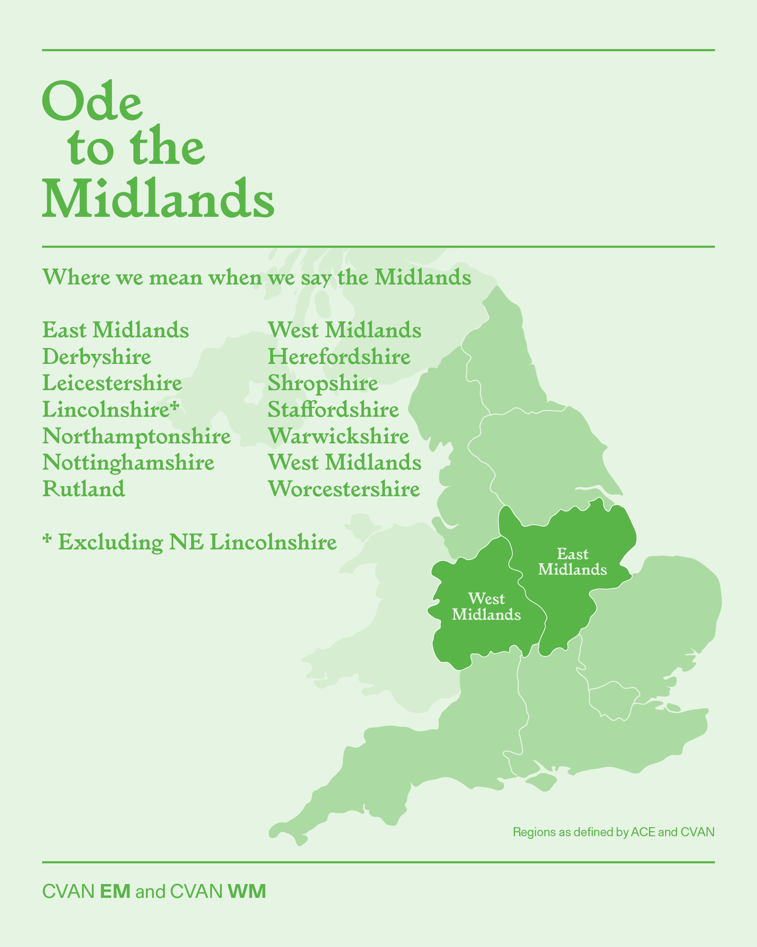
Selection Process
Applications will be reviewed and selected by the OttM Advisory Group, a group of Midlands-based artists, arts workers, and audience representatives with diverse expertise and lived experience across the East and West Midlands.
The Advisory Group will assess applications against the following criteria:
- Relevance and alignment with OttM values of equity, collaboration, digital innovation, and regional connectivity.
- Commitment to inclusion, particularly in relation to supporting Global Majority, Disabled, d/Deaf, and/or Neurodivergent artists.
- Capacity and readiness of the organisation to host and support a digital commission during March 2026 – February 2027.
- Approach to partnership and artist support, demonstrating care, accessibility, and mutual learning.
- Potential for public engagement and legacy, including how the project will connect with Midlands communities and audiences.
In addition to the above criteria, the Advisory Group will also seek to ensure a balanced spread of organisations across the wider Midlands geography and a diversity of organisational types and scales, including artist-led spaces, community organisations, festivals, and established institutions. This approach will help ensure the commissions reflect the breadth and richness of visual arts practice across the region.
All decisions will be made collectively by the Advisory Group, ensuring a fair, transparent, and regionally representative selection process. Shortlisted organisations may be invited to an informal conversation or online meeting before final selections are confirmed.
Applicants will be notified of outcomes by Tuesday 3 February 2026, 5pm.

How to Apply
Organisations interested in becoming a commissioning partner for Ode to the Midlands are invited to submit an expression of interest outlining their vision, capacity, and commitment to the aims of the programme.
Your application should include:
- About your organisation: An overview of your mission, key activities, and audiences, including your location and the areas you serve.
- Why you want to be involved: How participation in OttM aligns with your organisation’s values, priorities, and current or future programming.
- Your approach to collaboration and inclusion: How you embed equity, accessibility, and care in your practice.
- Capacity and facilities: Details of the resources, space, or support you can offer, and any past experience with digital or hybrid projects.

Applications can be submitted in written (up to 800 words total), audio (up to 6 minutes total), or video (up to 6 minutes total) format. Word count/duration can be split across the four response sections of the application however you like.
Applicants should all submit an equal opportunities monitoring form here.
We accept applications submitted as .doc, .docx or PDF attachments, in the body of an email, via Google Drive, video, or audio recording. All applications must still respond to the criteria above and address all sections of the application form in their responses.
Please send your application to Colette Griffin at colette@cvaneastmidlands.co.uk by Monday 12 January 2026, 10am.
If you require this information in an alternative format or would like to discuss general queries or access requirements in advance of applying, please contact Colette Griffin on colette@cvaneastmidlands.co.uk.
All applicants will receive an acknowledgment of submission. Outcomes will be shared by Tuesday 3 February 2026, 5pm.
Application Form

Organisation Details
Organisation Name: | Organisation Address:
Applicant Lead Name: | Organisation Address:
Applicant Lead Email: | Organisation Address:
Organisation Website & / or Social Media Account(s): | Organisation Address:

Application
About your organisation: An overview of your mission, key activities, and audiences, including your location and the areas you serve.
Why you want to be involved: How participation in OttM aligns with your organisation’s values, priorities, and current or future programming.
Your approach to collaboration and inclusion: How you embed equity, accessibility, and care in your practice.
Capacity and facilities: Details of the resources, space, or support you can offer, and any past experience with digital or hybrid projects.

