

New Art West Midlands
Organisational & Steering Group Review
March 2025

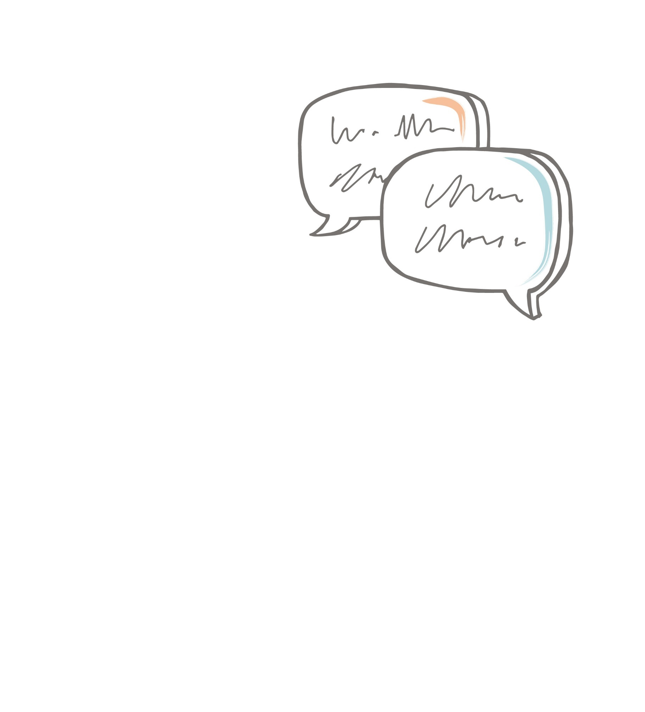
Contents
Introduction 3
Methodology 3
Research findings 4
Respondents’ priorities for developing work 4
Future functions of NAWM 6
NAWM’s brand identity 9
NAWM’s online content 9
NAWM’s Steering Group membership 10
Steering Group working practices 12
About the respondents 12
Conclusions 14
Recommendations 14
Appendix I – Sample Description 15
Appendix II – List of organisations 21

Introduction

About New Art West Midlands
New Art West Midlands (NAWM) is the contemporary visual arts network organisation for the West Midlands region. This area encompasses the counties of Herefordshire, Shropshire, Staffordshire, Warwickshire, West Midlands and Worcestershire and is home to 6.1 million residents. It has one of the largest arts and cultural sectors in the UK, including over 10,000 cultural and heritage assets.
The network aims to advocate for the contemporary visual arts, deliver opportunities for artists and artworkers and champion the work taking place across the region. As part of the national Contemporary Visual Arts Network (CVAN), NAWM is one of nine regional networks that work together to campaign for policy change within the visual arts sector.
From its inception in 2010 until 2020, NAWM was hosted by a consortium of six Higher Education institutions in the West Midlands. Central to NAWM’s work during this period was a graduate exhibition programme which benefitted more than 200 artists.
In 2023, NAWM joined host organisation DASH, a disability-led visual arts organisation based in Shropshire. The network is currently undergoing a period of renewal under a new director and is seeking to appoint a new Steering Group and co-chairperson in early 2025.

About the Project
Earthen Lamp was commissioned by NAWM to conduct research within the visual arts community in the West Midlands in order to deepen NAWM’s understanding of the priorities for development within the sector and guide decision making around the essential functions and priorities of the network over the next three years. NAWM also sought to gather information about which organisations and groups of individuals should be represented on the new Steering Group.
NAWM was interested in finding out the views of a diverse range of individuals across the sector, with a particular focus on those who have not previously engaged with NAWM, independent artists who are new to the sector, and individuals working for smaller arts organisations.

Methodology
Earthen Lamp followed a mixed method approach for this project.
During the first phase, an online survey was sent out via email, newsletters and social media posts to artists and arts organisations in the region. A targeted approach was used to ensure that the survey reached a wide range of individuals from across the region, with a particular emphasis on reaching those groups mentioned above. In total, 123 survey responses were collected in January and February 2025.
In the second phase, Earthen Lamp conducted eight online interviews with independent artists and individuals working for arts organisations, who had completed the survey. The sample was chosen to gain greater insight into the perspectives of individuals with various demographical backgrounds and who live and work in different geographical areas within the West Midlands region.

Analysis approach
Demographic information about survey respondents was analysed to provide an understanding of the characteristics of those who had engaged with the survey. An overview of this analysis is presented in the report. A detailed breakdown of the quantitative data can be found in Appendix I – Sample Description.
Survey and interview data were analysed to identify current priorities for the sector, suggested priorities and functions for NAWM and recommendations for the composition and working practices of the Steering Group. Across the range of individual artists and organisations that were consulted several common themes emerged that were important to those surveyed irrespective of geographical location, job role or career stage. As a result, findings are presented here thematically, with distinctions made between respondents’ income type, location and demographic profile only when relevant.
An alphabetical list of organisations that respondents would like to see represented on the Steering Group of NAWM is provided in Appendix II – List of organisations.

Terminology
Within this report the term ‘independent artist’ is used in a broad sense to refer to all those who indicated within the survey that they receive at least part of their income from independent work as a visual artist, maker, designer, photographer, writer or technician. The term ‘independent curator’ is used to describe all of those who indicated within the survey that they receive at least part of their income from independent work as a curator, producer or facilitator.

Research findings

Respondents’ priorities for developing work
When considering their priorities for developing work over the next three years, a number of common themes emerged amongst respondents. Whilst some of these themes are shared across all respondents, others are more specific to the nature of their specific role within the sector.

Artists aim to prioritise making and exhibiting new work
Amongst those who earn their income as independent artists and/or curators making and exhibiting new work are the top priorities. Developing new projects and commissions, experimenting with new techniques and skills and displaying their artwork in exhibitions are all important aims for these respondents.
“[I want to] continue to develop professional practice and continue to exhibit both nationally and internationally.” (Independent artist)
Another important priority for these respondents is increasing the income they can generate with their artwork. For some, their hope is that they will make more money from selling their own work and being able to spend less time working for employers. For others the priority is to diversify their income sources in order to increase their overall income. When considered alongside the high number of respondents who already have multiple income sources, this highlights the financial difficulties that many of those working in the sector are currently facing.
“[I aim] to expand reach and opportunity, and make more work, and have more income from work without major compromise.” (Independent artist)
Increasing audience reach through further promotion and marketing, as well as getting funding to complete new projects, are other ways in which both artists and arts organisations hope to increase their financial stability in the coming years.
“[I want] to continue to build and engage increasingly diverse audiences with historic, modern and contemporary art… To survive in an increasingly challenging context, drawing in additional funding and further developing partnership working.” (ACE NPO)

Co-creating with communities and increasing access to art is a priority for many
An important theme amongst respondents was a desire to work with community groups on funded projects to create art and increase access to the arts for underrepresented groups. This aspect was important to respondents working for arts organisations and educational establishments wishing to engage with a wider audience.
“[I would like to] work with employers and arts organisations to enhance the visibility and accessibility of arts and culture in communities where there is limited funding or support.”
Work with local communities is also a priority for many independent artists and curators. They too are motivated by working with new audiences to create new work.
“Commissioning new photography that is socially engaged and involves community collaborations.”

Collaboration and networking are important for creating new opportunities
Another priority for respondents is to find ways to work in partnership. Many respondents consider meeting new artists, establishing partnerships and working on collaborative projects a high priority in the coming years. There is also a desire to network and learn from new people.
“Collaborative work with other agencies focusing on accessibility to visual arts for those on the margins of society” (Independent curator/producer/facilitator)
“I want to network with peers to discuss how to do this better.” (Independent artist)

Respondents aim to give and receive support to develop
Amongst many respondents working for arts organisations there is a commitment to supporting and providing opportunities for artists. Many organisations hope to support new and/or underrepresented artists by providing spaces for them to work in and commissioning new projects.
“To provide rewarding opportunities for artists and creative practitioners, including development opportunities.” (ACE NPO)
Likewise, many artists also prioritise finding studio spaces for themselves and others. They hope to receive support from and greater representation within the arts community.
“To have space to share work professionally, creating an independent community. Effectivity devising the environments for mediums to develop and mix… More needs to be done for artists that chose art as a career, we are here yet nothing is here for us.” (Independent artist)

Future functions of NAWM

NAWM should consider multiple functions to develop and support the visual arts sector in the region
In line with respondents’ multiple and varied priorities for their own careers and the development of the organisations they are involved with, there is a similar thought that NAWM should serve several functions, as can be seen in the graph below.
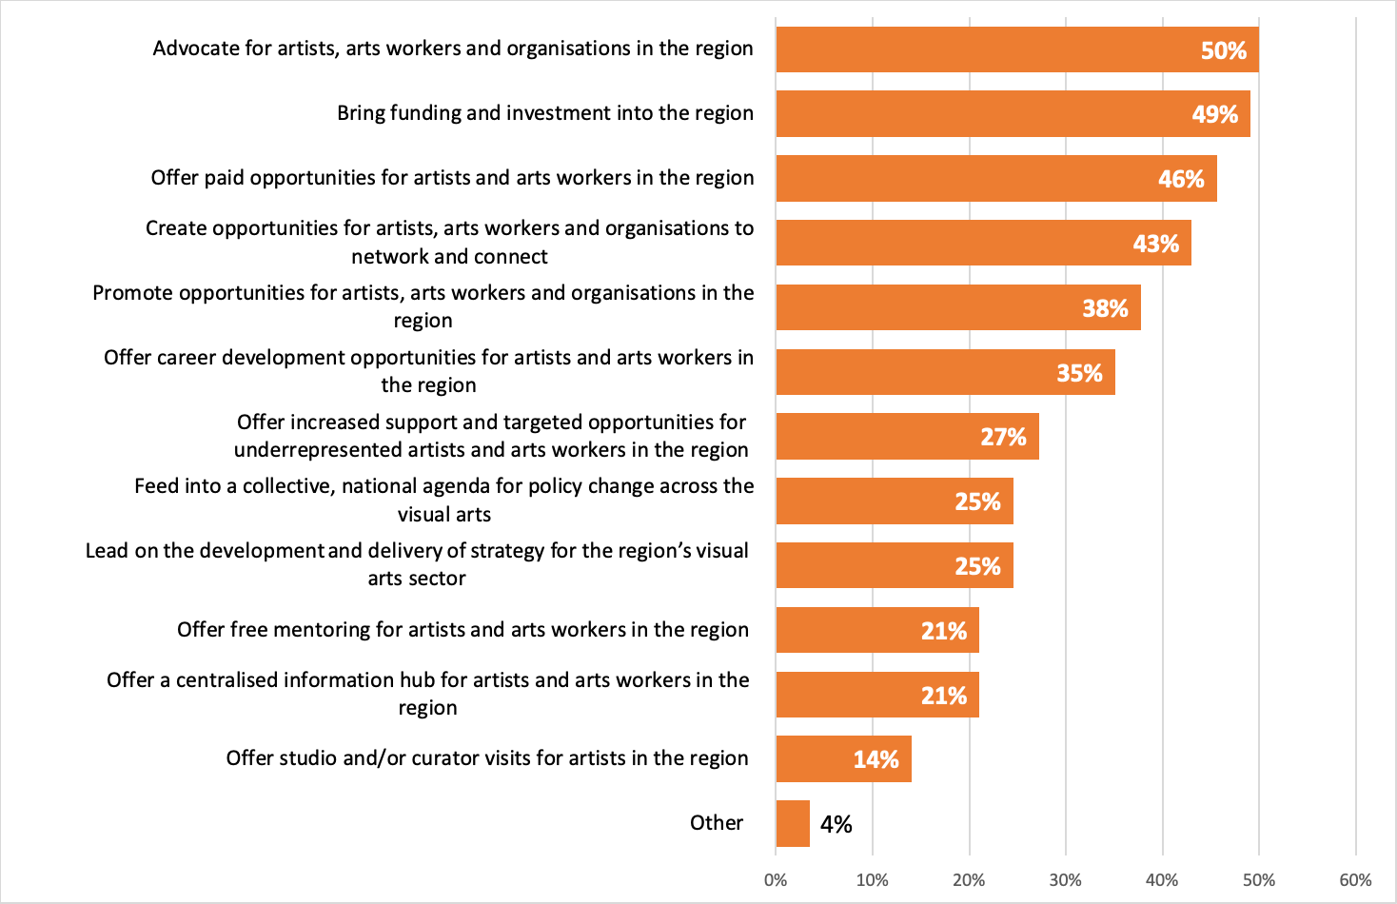
Figure 1 Key priorities for NAWM in the next 3 years
(Note: respondents could select more than one option)

NAWM should prioritise advocacy and investment
Principal amongst the priorities for NAWM is the task of advocating for artists, arts workers and organisations in the region and bringing in funding and investment. Around half of all respondents identified these as key priorities for the network with no distinction between respondents of different geographical locations, job roles or amount of time spent working in the sector. One respondent, who works in multiple roles both independently and as an employee felt strongly that advocacy and lobbying should be the key focus for NAWM.
“That NAWM are able to lobby for the visual arts, especially with the Combined Authority and the various local authorities, and with private sector developers. That NAWM is able to leverage private sector support and opportunities for artists and arts organisations.”
Advocacy work should include increasing the reach of visual arts work so that artists and art workers are more visible across the region.
“The key priority for NAWM should be for a platform or project which is wide-reaching for participants/audiences and creates profile and visibility for artists and their work across the region. Strategic outcomes to support artists and visual arts workers will be generated from such a platform.” (Independent curator/producer/facilitator)
Several interviewees also told us that NAWM should be promoting visual arts work and initiatives outside of the arts sector to bring investment and new opportunities. Suggestions included linking with scientific organisations and horticultural and nature-based organisations, as well as commercial businesses.
“Attract funders who might support exhibitions, they could be businesses that are not art focused.”
NAWM should also play a role in advocating for the West Midlands’ arts community beyond the region – both by encouraging artists from elsewhere to come and work and exhibit in the region, and by supporting those in the West Midlands to find opportunities elsewhere.

NAWM can provide and facilitate new work opportunities
Respondents wish for NAWM to have a mandate to provide and facilitate new opportunities within the region. This includes offering opportunities for paid work for sector workers (46%), to network (43%) and promote work (38%). This links strongly with respondents’ own priorities of increasing their or their organisations’ financial stability through new work opportunities and stronger connections. Offering paid work opportunities was particularly important to independent workers in the sector (34 out of 63).
Several artists that were interviewed mentioned how valuable the opportunities NAWM offered in the past had been for them and their career. One disabled artist felt that NAWM now had a role to play in creating opportunities targeted specifically at disabled or minority artists, to help them gain greater representation within the region’s arts community.
“The West Midlands is a diverse region, and it’s not represented in the art that is receiving funding. It could be good to have a disability focus, or minority focus for new opportunities.”
Networking opportunities were a priority for many respondents, but particularly those working for arts organisations (21 out of 46). One respondent who works both as an independent artist and for an NPO highlighted the benefits the network could provide in creating opportunities for collaboration.
“I think the region really needs a hub to encourage networking and create opportunities for freelancers and independents and larger organisations/ museums and galleries to communicate, meet up, collaborate and get to know each other. NAWM has the potential to bring us together and make things happen!”
There was a consensus amongst those respondents interviewed that many people value opportunities to network with others. They suggested that putting on events with a specific focus, such as exhibition openings or panel discussions, or combining networking with career development workshops would make them both useful and enjoyable. Access needs also need to be considered when organising events to ensure that they are inclusive for all.

Respondents would value career support from NAWM
Targeted and universal support in the form of career development opportunities and mentoring are important to around a quarter of respondents, particularly amongst independent workers and those who work in a combination of roles within and outside of organisations. Respondents would like NAWM to support artists and art workers at various stages in their careers, including students, new entrants and more mature artists, as well as providing support for disabled and underrepresented artists.
Specific suggestions for support included help with grant applications, training workshops giving artists practical advice on how to become freelance and/or run their own business and what to expect when working with different types of organisations such as community-based charities.
“I'm undiagnosed neurodivergent and I just find grant applications really hard to understand what they want. I've got all the answers, but it's channelling what you need out of all this information. So, because neurodiversity is so common, especially amongst creatives, it would be good to offer us help with applications.”
One interviewee who works for a small organisation would value support and guidance with reporting and evaluation work for funders, as in small teams this work is often done by non-specialists. Help translating funding requirements into practical steps would be very useful.
“When you're talking about work with deprived communities, you have to have someone who is translating what that means in terms of governance and evaluation and reporting.”
Another suggestion was that by bringing the arts community together, NAWM could facilitate opportunities for artists and arts workers to help each other. This could include working together to map out all of the current opportunities available and then using a buddy system to encourage people to work together, creating a culture of support.
“The network could provide support for different organisations, different individuals, maybe matching people together; those who have been successful helping those who haven't, to give them support… And all the time trying to create a culture in which people feel they're in it together rather than they're competing against each other, which actually, I think that's quite a difficult thing.”

Respondents hope NAWM will take the lead on strategy and policy change
Some respondents would like to see NAWM leading on arts strategy for the region, improving conditions for workers and influencing policy around development within the arts sector more broadly, as well as working collaboratively with other networks and strategic bodies to bring about change.
“Work proactively to connect with other interdisciplinary networks such as Cultural Compacts to develop a strategy for culture across the West Midlands.” (Volunteer director of small arts organisation)

NAWM needs to be visible and transparent in its activities and priorities
Respondents emphasised the need for NAWM’s activities to be visible to all, through good communication and social media presence, and for there to be a high level of transparency to their actions.
“Transparent and regular communication with artists and arts organisations. Up to date website with access to minutes of meetings, key decisions, business plans/goals.”
Moreover, there needs to be balance of activity across the region, to include rural areas as well as the larger urban centres.
“The role of NAWM needs to further expand into the rest of the West Midlands and not just be heavily based around Birmingham. Certain areas are neglected for the larger cities.”

NAWM’s brand identity
Respondents did not express strong opinions on whether NAWM has a recognizable name and brand identity that accurately represents its work in the region. Around a third of respondents (31%) agreed or strongly agreed that the network does have a strong name and identity. Amongst those who had not engaged with NAWM before, the proportion was slightly lower at 24%.
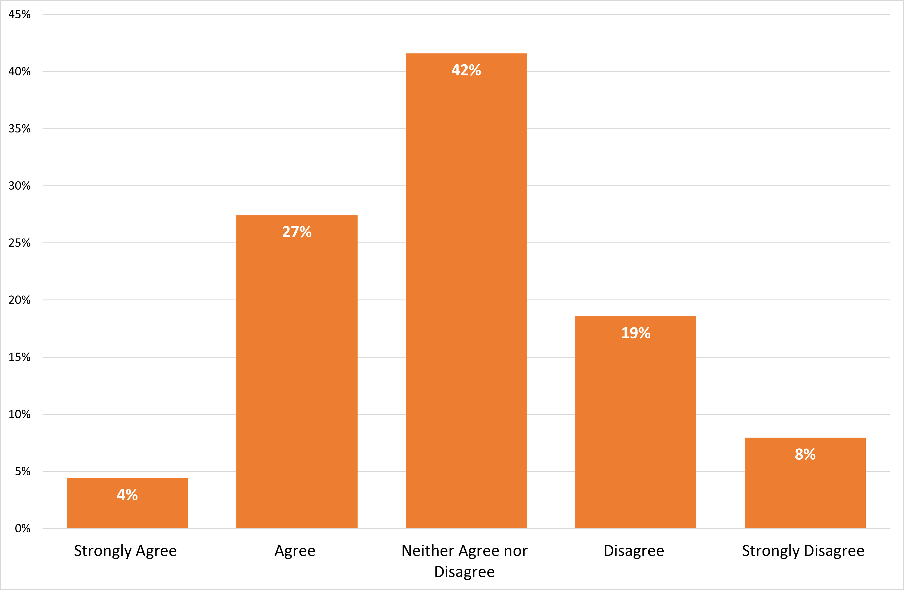
Figure 2 The extent to which respondents agree that NAWM has a strong name and brand identity that reflects the work it does
One respondent expressed confusion over the name and the significance of the term ‘New Art’.
“The name New Art West Midlands always feels like a misnomer to me. Are you about new talent so you support artists; are you about what is new in the arts in the region; or are you about bringing new art into the region?” (Educational institution)

NAWM’s online content
The primary focus of NAWM’s online content should be in providing listings of jobs, opportunities and events and exhibitions. Around 4 out of 5 respondents would value this service. They would like NAWM to become a ‘one-stop-shop’ or information hub for those working in the visual arts sector in the region. This could include a website with online resources and templates as well as a regular newsletter.
Other features of online content that would also be popular include regional arts news, a map and a directory of organisations and artists working across the region, and features such as spotlights and insights into advocacy work being done.
“Include insights into how you are trying to influence national policy and strategy for the arts and culture.”
Several respondents who were interviewed stressed the particular importance of using the NAWM’s website to share content and felt this should be more of a focus than social media, where new content can easily be missed or difficult to find.
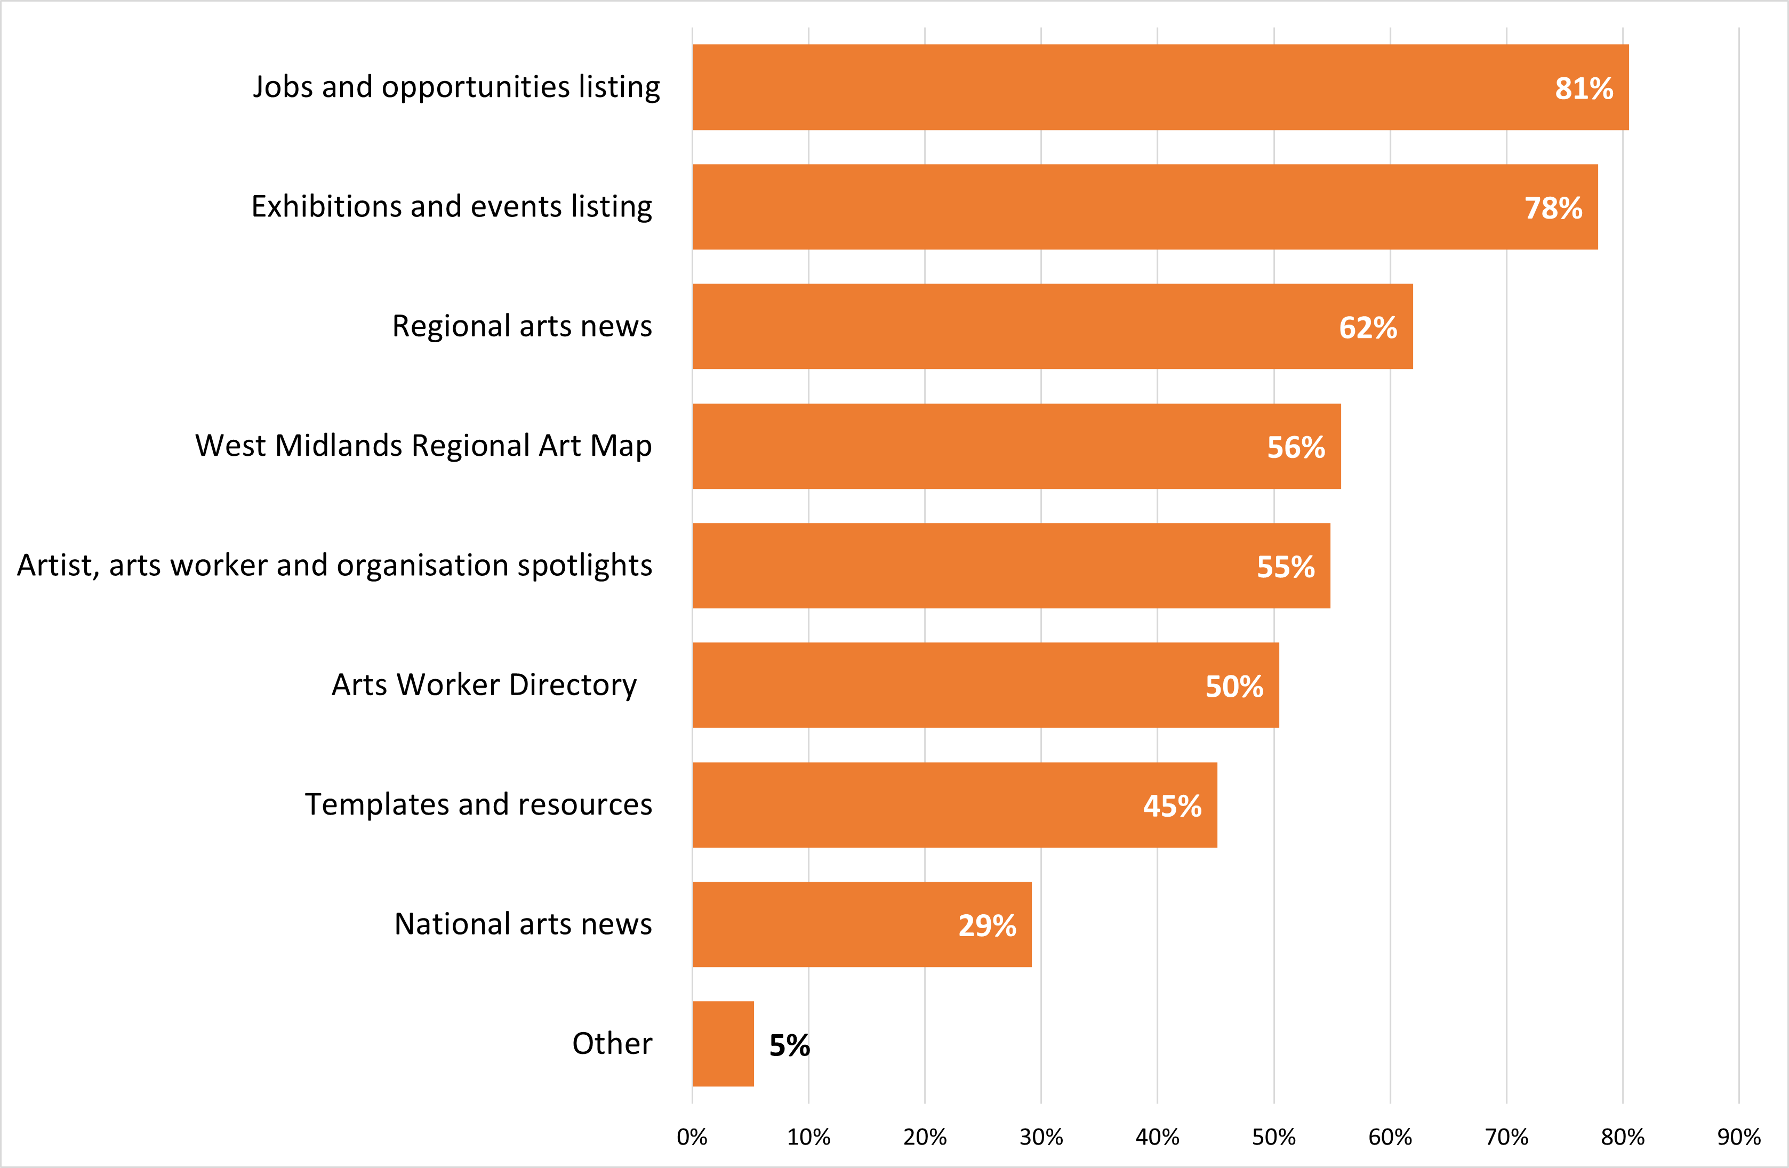
Figure 3 Type of online content respondents wish to see included and shared by NAWM
Several respondents mentioned that they used the previous website a lot and are looking forward to NAWM launching a new site. Keeping the website up to date with opportunities and resources would make it a valuable tool for all.
“I think a lot of the time; artists want a pack of reading material…. ‘These are galleries that all accept applications’ or anything like that. Just so in any spare time they get, they’re not having to search for all this stuff that takes up so much time.
It's just there.”

NAWM’s Steering Group membership
NAWM’s Steering Group needs to include a wide range of individuals from across the sector. Almost all respondents (91%) agree that artists need to be part of the Steering Group and around three quarters (71%) would also like arts organisations to be represented. Smaller but still significant numbers would like other professions within the sector such as curators, producers, technicians and educationalists to also be represented (Figure 4).
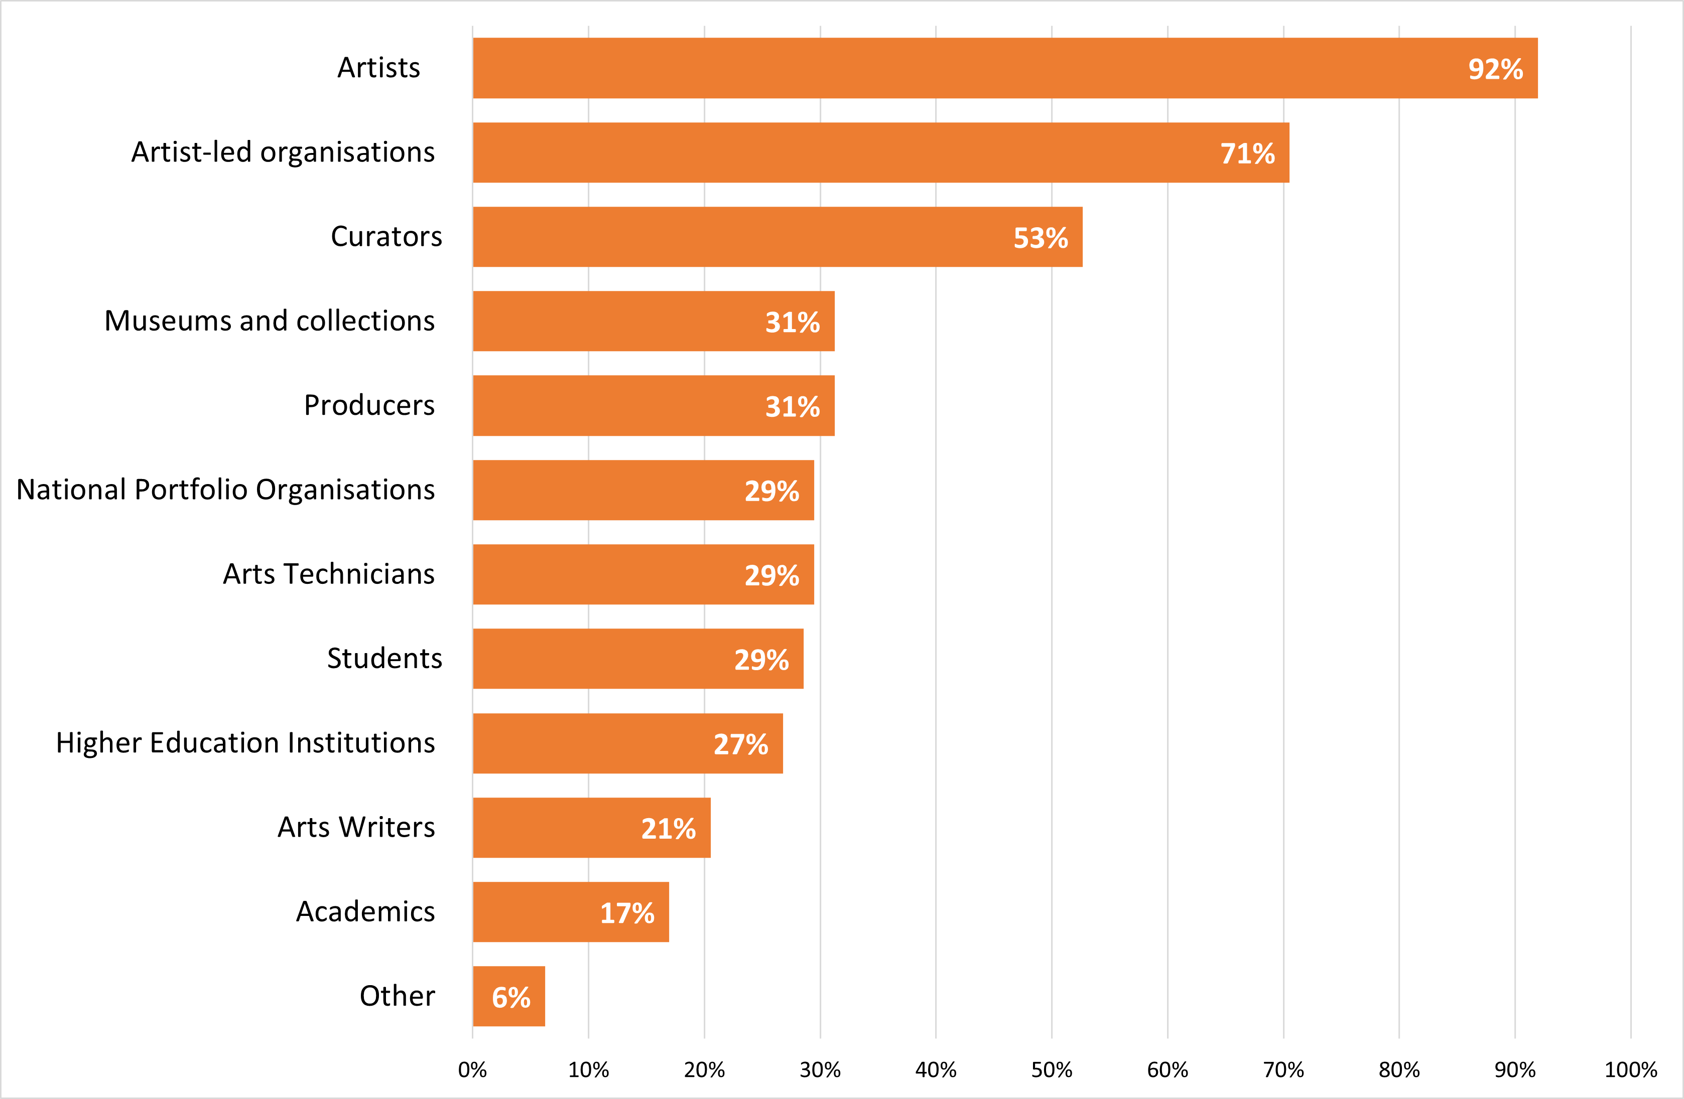
Figure 4 Stakeholder types respondents would like to be represented on Steering Group

The Steering Group should be diverse and representative of the region
Many respondents highlighted the importance of ensuring that underrepresented artists and artworkers are included in the Steering Group to give these people a voice and ensure the Steering Group is fully representative of the visual arts community.
“Representation from people who have been strategically undervalued, i.e. those from the global majority, disabled people, LGBTQIA+, working class. Diversity of ages too.”
Many different groups of artists and artworkers should be represented including those at different stages of their careers, those working in different locations, those with a range of protected characteristics, and representatives from organisations of different sizes. Several respondents also reported that community members from areas with low cultural engagement should be included on the Steering Group, and also individuals from organisations outside of the sector.
“There should be some kind of integration with organisations that are considered outside of the typical creative industries and collaborations with these places should happen to encourage new development that represents all of the region.”

Organisations that should be represented on the Steering Group
A large number of organisations located across the region were suggested by respondents to be represented on the Steering Group. This included art galleries, artist collectives and studios, community arts organisations, museums, network organisations, educational institutions and public bodies. A full list of these organisations is included in Appendix II.

Steering Group working practices

Transparency is important when selecting members
The importance of transparency when selecting members was highlighted by several respondents and a suggestion made that membership should rotate on a biannual basis. It is important that Steering Group members are bold and “make some noise” to ensure that there is action as well as discussion. One respondent suggested that an open meeting should take place annually which anyone can attend in order to ensure transparency and enable feedback to be given and responded to.
“There should be a regular (annual?) open assembly that anyone can attend so the group's focus is steered by the wider community. It needs to be inclusive - freelancers should be compensated financially.”

Meeting format needs to be inclusive
Meetings need to be easily accessible by public transport and the Steering Group should consider using a hybrid model to allow members to attend online if needed to ensure inclusivity. It is also important that Steering Group members are paid for their time, as recognition of the work they are doing and the skills and expertise they bring to the role.

About the respondents

Respondents hold a range of jobs within the sector
Survey respondents earn their income in a wide range of roles within the visual arts sector (Figure 5). Around two thirds of respondents (67%) earn at least part of their income as independent artists. Over a quarter of respondents (27%) work for arts organisations that are either in receipt of frequent grants or are directly funded by Arts Council England as a National Portfolio Organisations (ACE NPO).
Many survey respondents have multiple job roles and/or also work outside of the sector to earn their living. It is notable that over 40% respondents indicated that they have more than one source of income, and around a quarter of respondents make their income both from independent work and as an employee for an organisation. The majority of respondents (63%) also work outside of the visual arts sector and do not rely solely on their work in this sector for their income. Over a quarter or respondents (28%) gain less than a quarter of their income from their work within the visual arts (Figure 6).

Respondents represent a range of experience and time spent working in the sector
There was a roughly equal spilt between individuals with more than ten years’ experience of working in the visual arts sector in the region (47%), and those who are newer to the sector (53%). Nearly a third of respondents (30%) have worked in the sector for five years or less (Figure 7).
Around three quarters of respondents (73%) consider themselves to be working at a mid-career level or below, including one in five respondents (19%) who are at an early or entry-level stage in their career (Figure 4).

Respondents have a range of demographic profiles
Respondents include those from a range of different age groups, genders, ethnicities and sexual orientations as well as a significant minority who consider themselves as D/deaf, Disabled, Neurodivergent or having a long-term health condition.
With regards to age, there were responses from individuals ranging from under 25 to over 75. Ages 45 to 55 and 55 to 65 were the two largest groups represented by the survey respondents (Figure 9). The majority of respondents (70%) identify as female and a further 21% identified as male (Figure 10).
The largest ethnic group represented within the survey responses was White English, Welsh, Scottish, Northern Irish or British (65%). Smaller numbers of respondents identified as other ethnic groups, including other White backgrounds (15%), Mixed or multiple ethnic backgrounds (7%), Black or Black British backgrounds (5%) and Asian or Asian British backgrounds (5%) (Figure 11).

Over a third of respondents (39%) identify as D/deaf, Disabled, Neurodivergent or having a long-term health condition (Figure 12). NAWM’s host organisation, DASH, is a disability-led arts organisation which may explain the relatively large proportion of respondents who identify in this way, when compared to the England average of 18% of the population according to the 2021 census. This figure is also in line with reporting from Creative Industries Policy and Evidence Centre from this year, with 20% of the workforce in the arts, culture and heritage sector identifying as disabled and 19% in a 2021 CVAN England report.
Respondents described their sexual orientation in a number of different ways. The largest proportion (58%) identified as heterosexual or straight. Almost 1 in 5 respondents (18%) did not wish to disclose this information (Figure 13).
Respondents come from a wide spectrum of socio-economic backgrounds, as represented by the occupation of the main household earner when they were aged 14 (Figure 14). The two largest occupation groups were traditional occupations such as teacher, accountant and solicitor (18%) and technical and craft occupations such as motor mechanics, plumbers and electricians (15%).

Respondents reside across the region
Respondents reside in local authority areas across the region (Figure 15). All local authorities are represented in the data except for Telford and Wrenkin. The two largest groups of respondents are based in Birmingham (25%) and Shropshire (12%). NAWM’s host organisation, DASH, is based in Shropshire, which may explain the relatively large number of responses from this part of the region. The smallest numbers of respondents are based in the north of the region in the local authorities of Staffordshire and Stoke on Trent (6%).

Many respondents have not previously engaged with NAWM
Respondents are evenly split between those who have engaged with NAWM before and those who have not (Figure 16). Less than half of respondents (45%) have a clear memory of engaging with NAWM on previous occasions.

Concluding thoughts and recommendations

Respondents’ priorities for developing work
Overall respondents across the board prioritised developing their work and income as future priorities. Working with communities and networking were also identified as priorities and, in some cases, finding space.

Future functions of NAWM
Many future functions have been identified in the report however advocacy for artists and the sector to develop better opportunities and investment for the region, appears to the most important. Some of the functions from previous years that respondents valued the most related to the organisations’ role as an authoritative voice and source of information about the sector and those function (either through the website or live events/interactions) need to be maintained. The function of training provider and capacity developer were also important.
The role of the organisation as a facilitator of collaboration is important. This includes collaboration between counties/areas in the region, between regions i.e. West Midlands with others, and also between the visual arts and other sectors. The organisation could facilitate links with other sectors and bring opportunities from sectors such as health, regeneration and other corporates, building on the role of promoting visual arts to other sectors. NAWM could help to bring new people from outside the West Midlands area and show them what’s happening in the visual arts sector in the region.
Transparency is seen as important so why the organisation is doing what they are should be communicated.

NAWM’s Brand Identity
Interestingly the majority of respondents were either neutral or felt positively about the current brand. The rationale for the change of brand name and identity needs to be clearly communicated in the event of changes made to them.

NAWM’s online content
The online content showcased on the website was highly valued by the sector and it is recommended that more focus is placed on making the current website more comprehensive.
Respondents who knew NAWM in the previous form miss it and indicated that they got a lot from it. The website especially was a very really useful place to find information. It was seen as a comprehensive repository – to go, read and do. The information also appeared to have a badge of authority as it appeared on the NAWM website.

NAWM Steering Group membership
There are a few areas to note. The current plans of updating the membership appear in line with the opinions presented by respondents. There needs to be a balance between early career and more established sector practitioners as they both bring valuable inputs to the group. In addition to artists and organisations, other individuals that work as curators, producers or in more logistical roles in the visual arts sector should be included in the steering group.

Appendix I – Sample Description
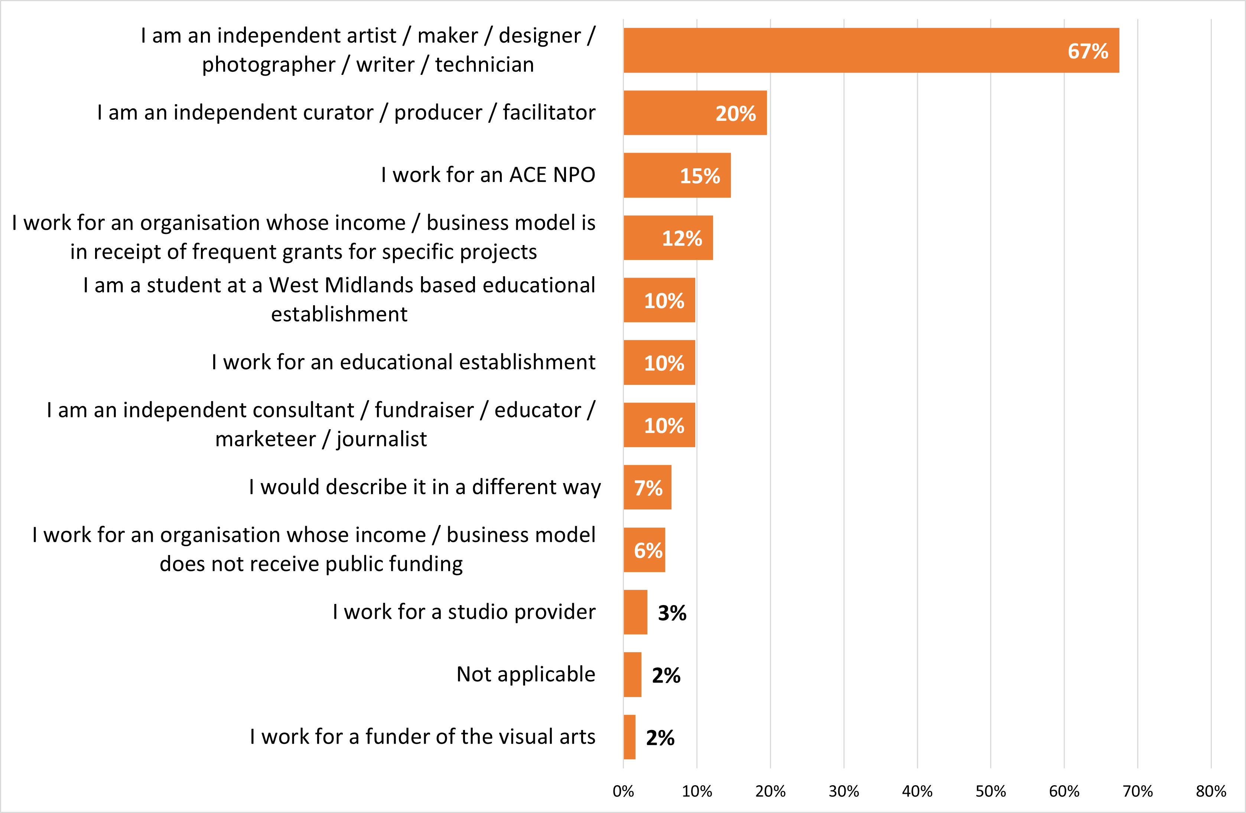
Figure 5 Respondents’ main source of employment or income within the visual arts sector in the West Midlands (Note: Respondents could select more than one option)
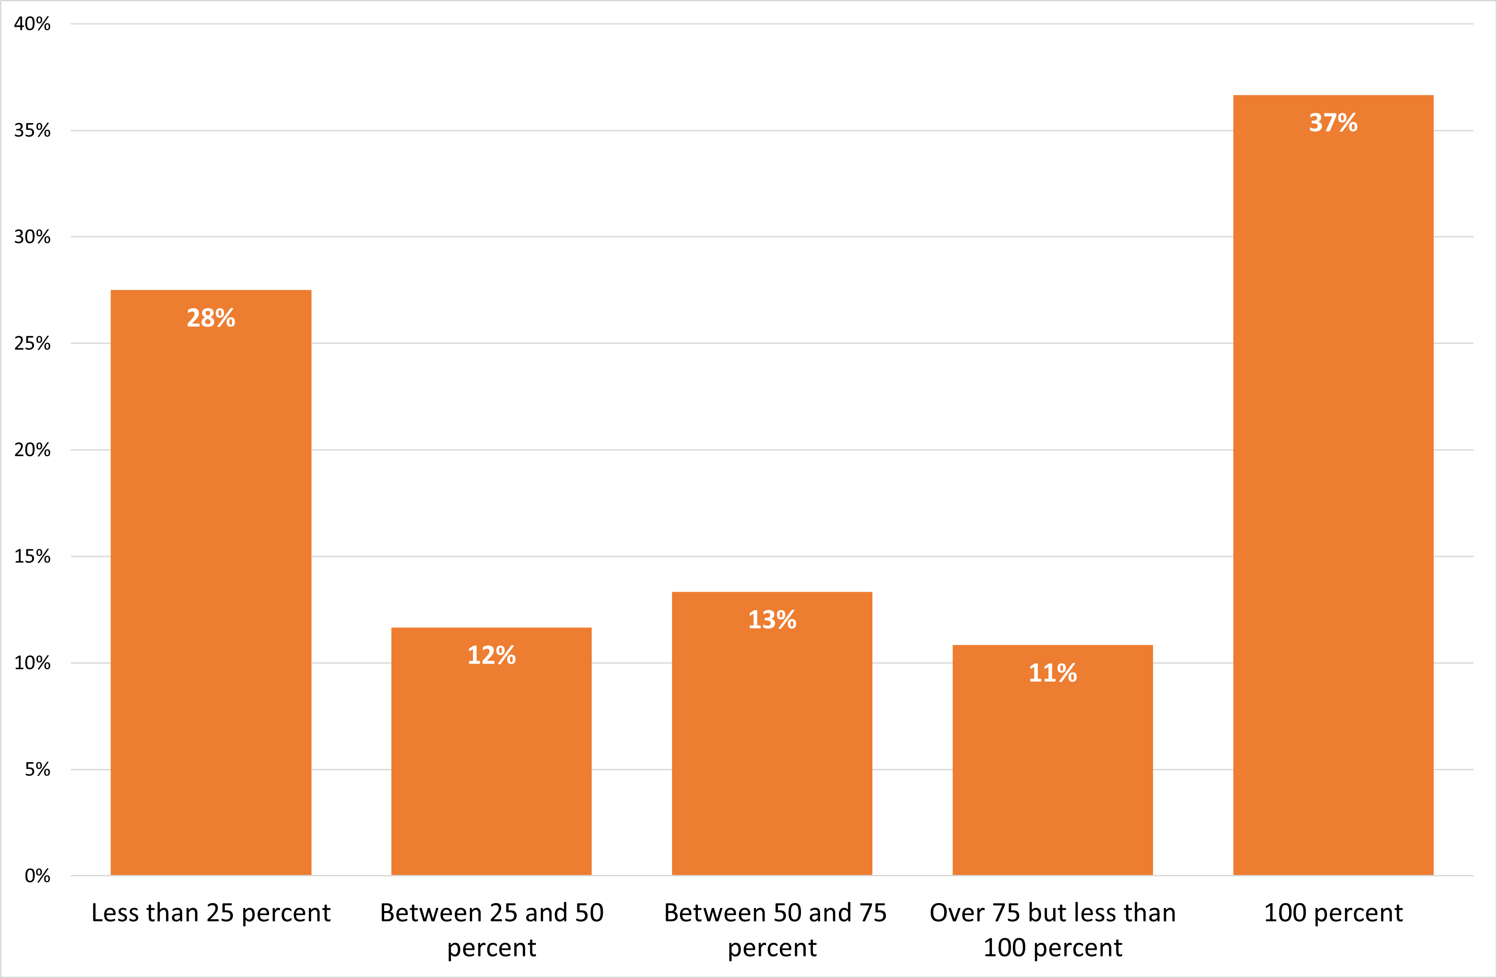
Figure 6 Percentage of respondents’ overall livelihood that is dependent on the visual arts sector
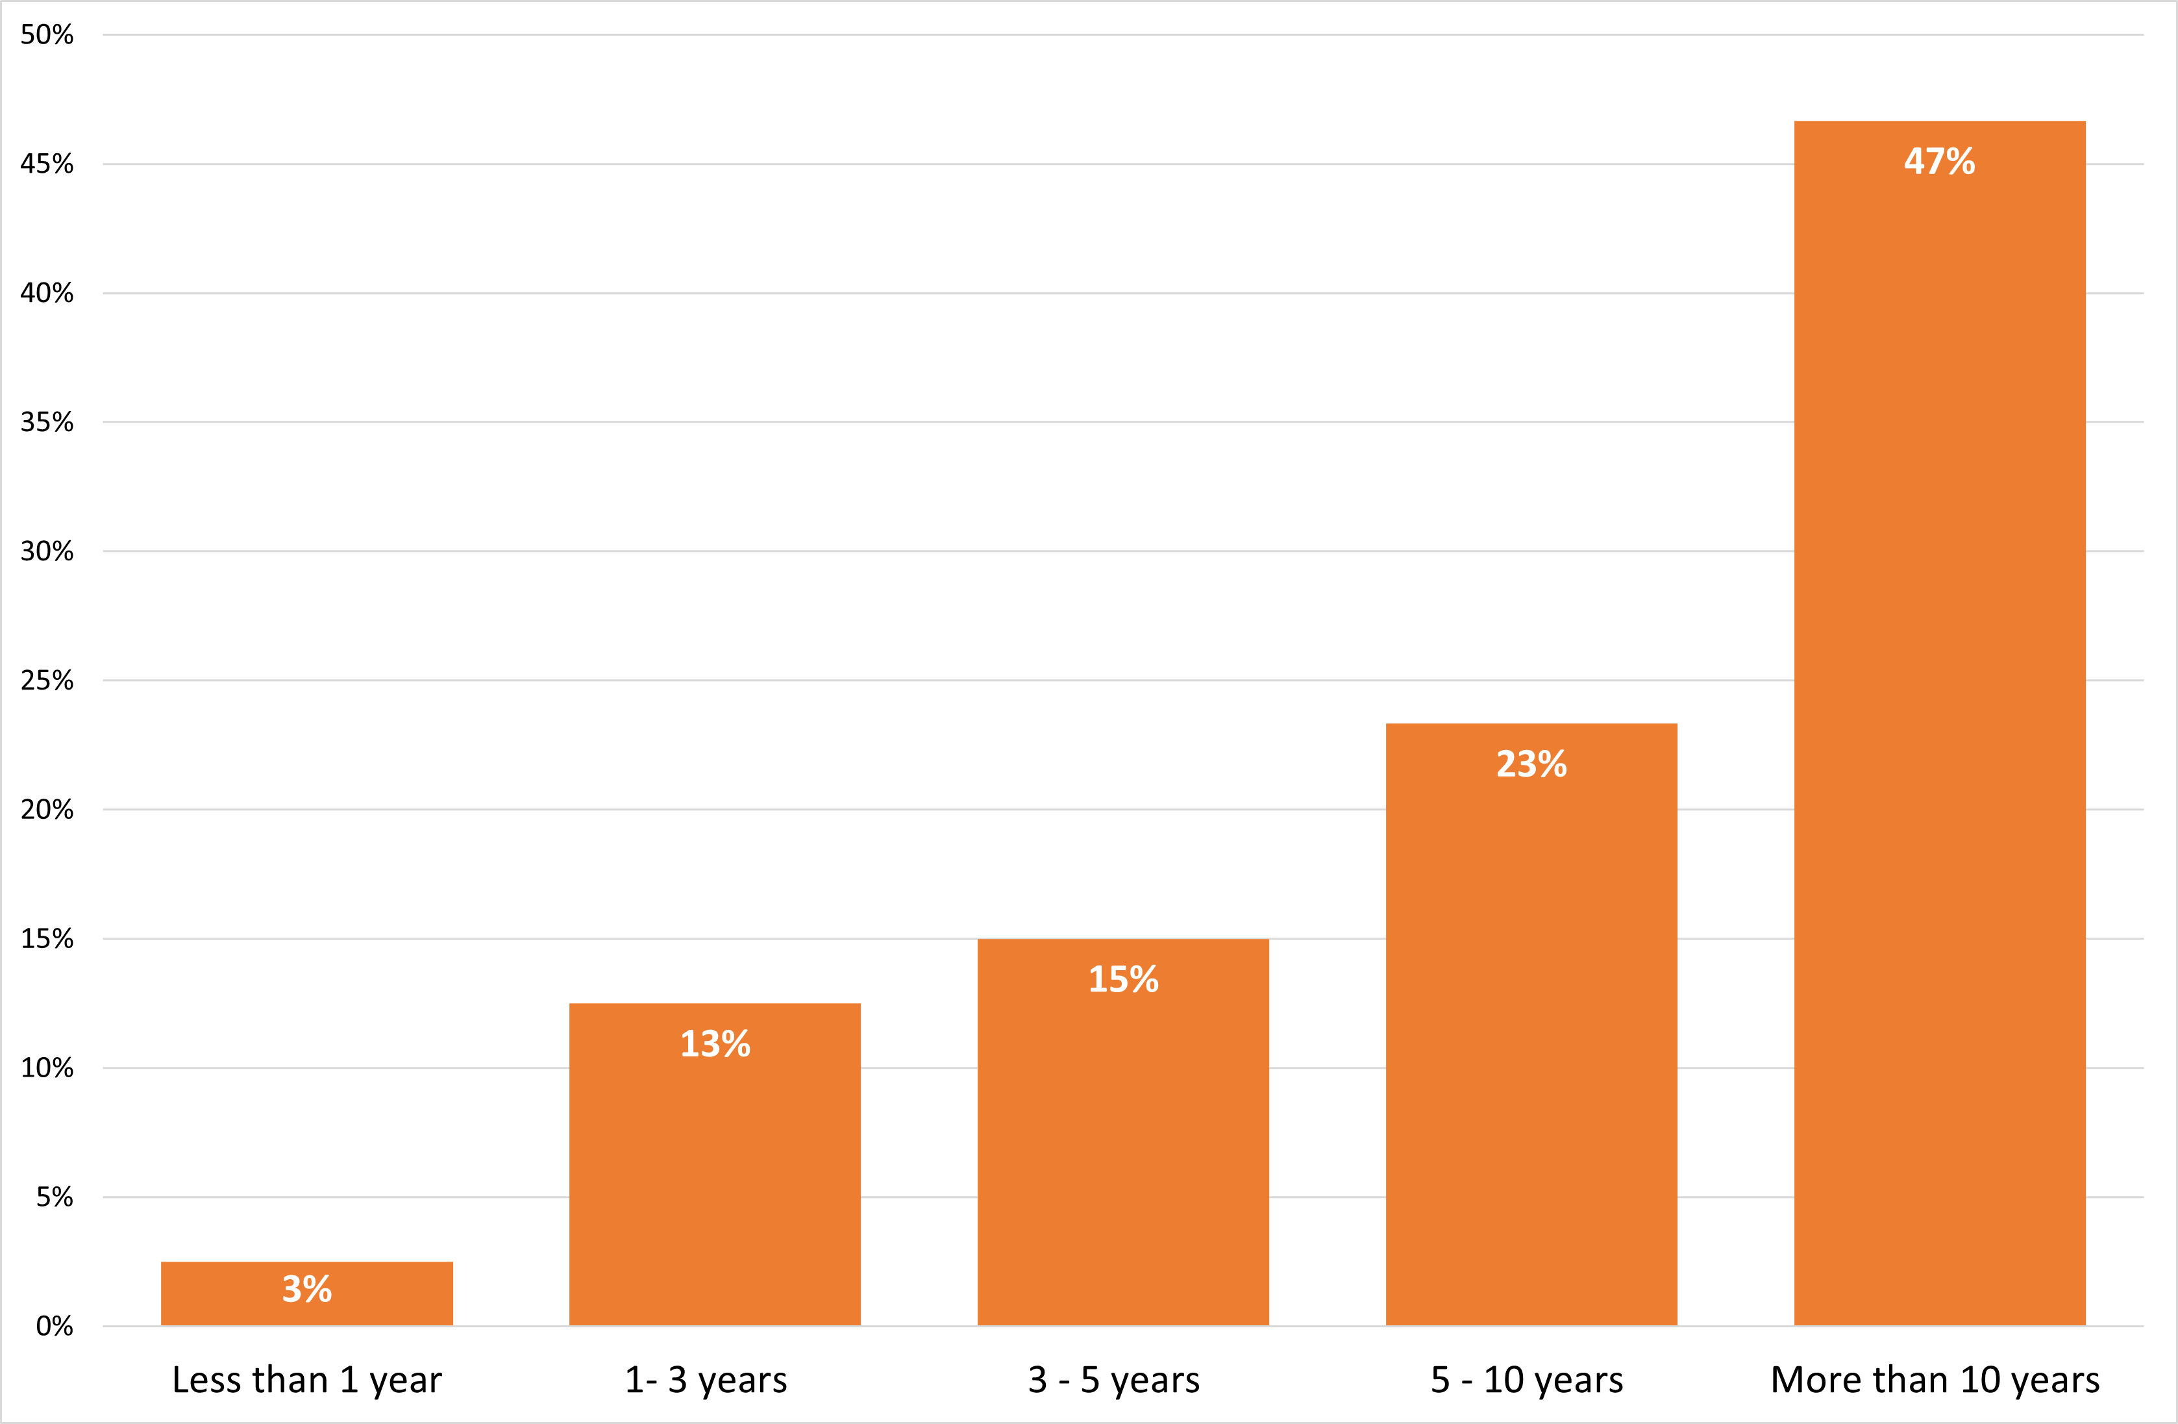
Figure 7 Number of years respondents have worked or been involved in the visual arts sector in the West Midlands
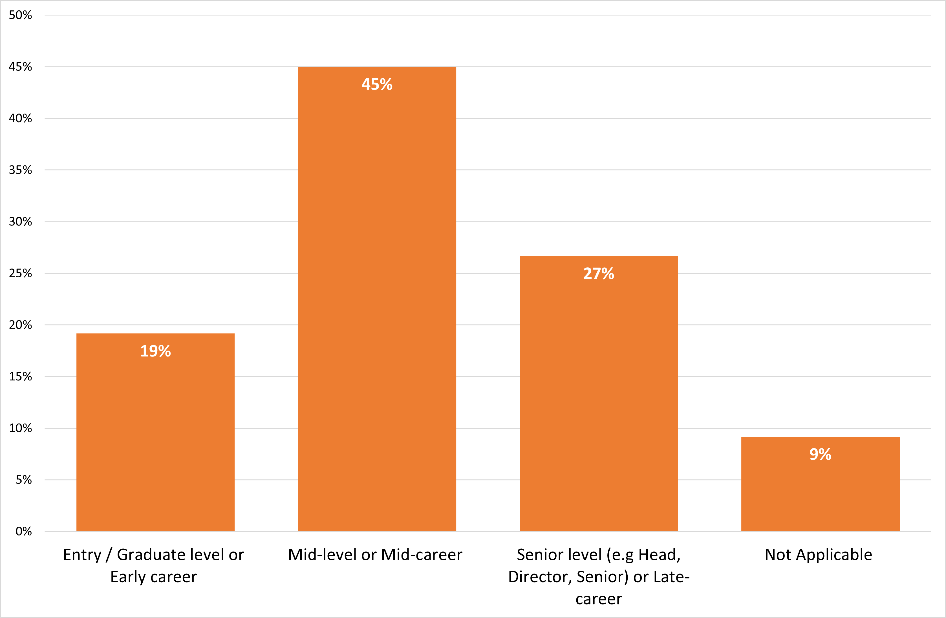
Figure 8 Respondents’ current role in the visual arts sector
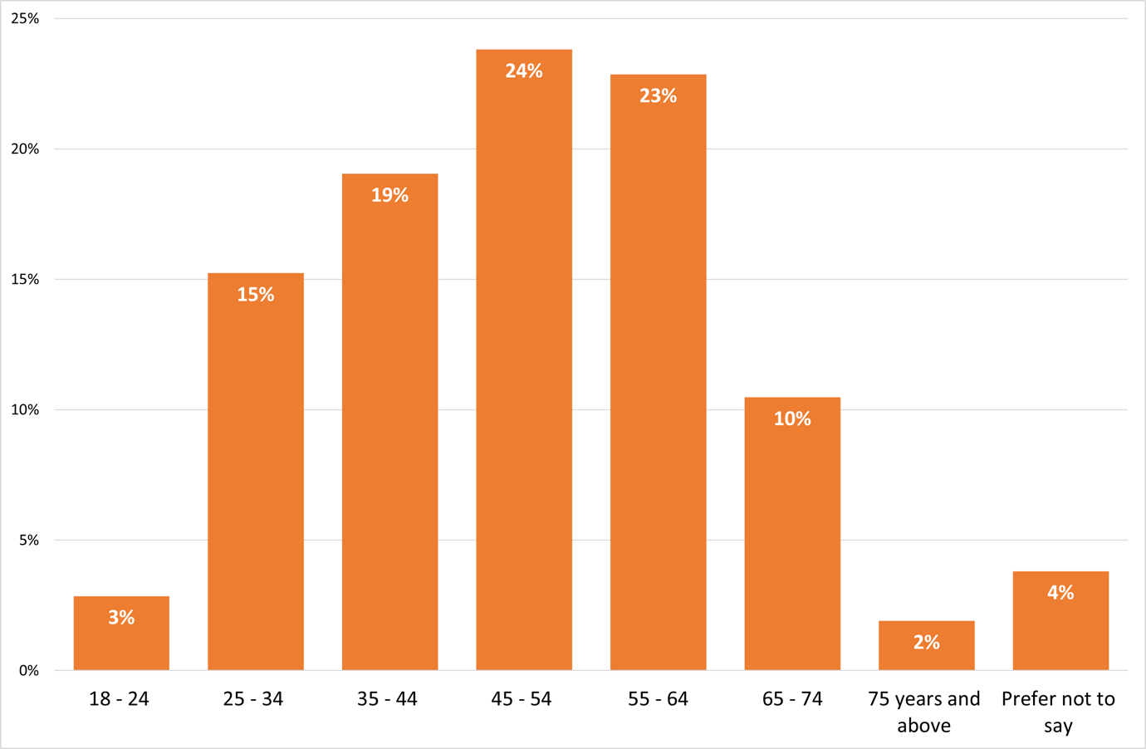
Figure 9 Respondents’ age group
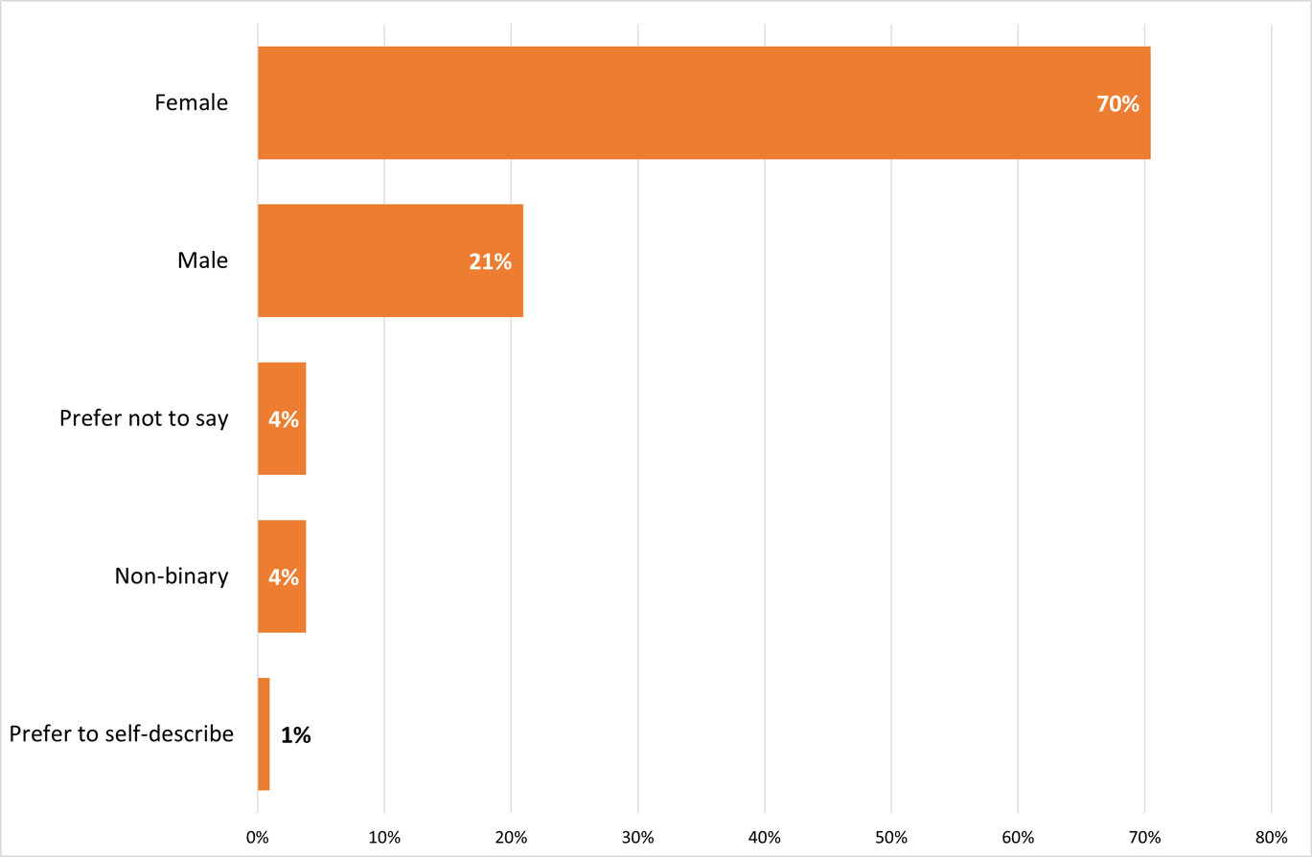
Figure 10 Respondents’ gender identity
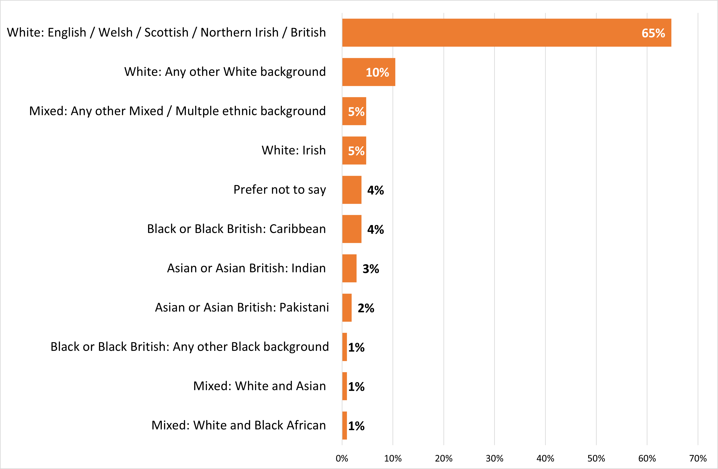
Figure 11 Respondents’ ethnic identity
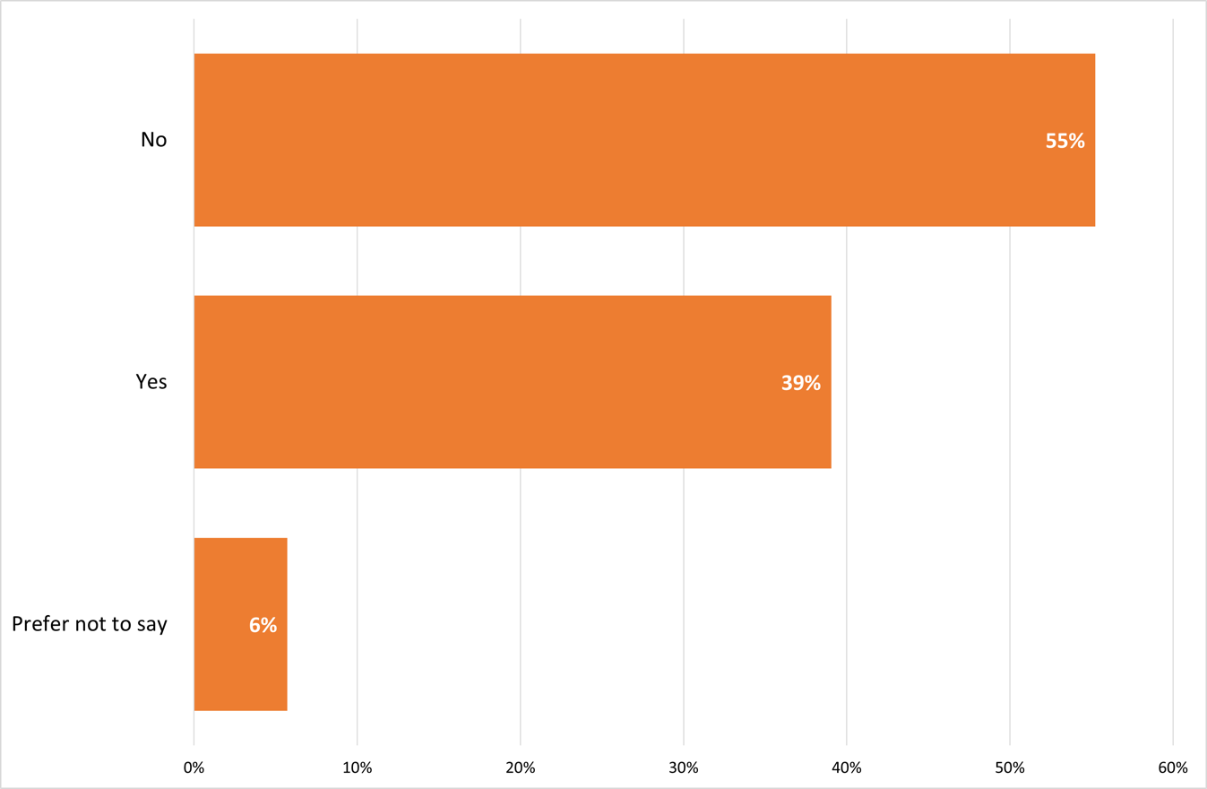
Figure 12 Respondents who identify as D/deaf, Disabled, Neurodivergent or having a long-term health condition
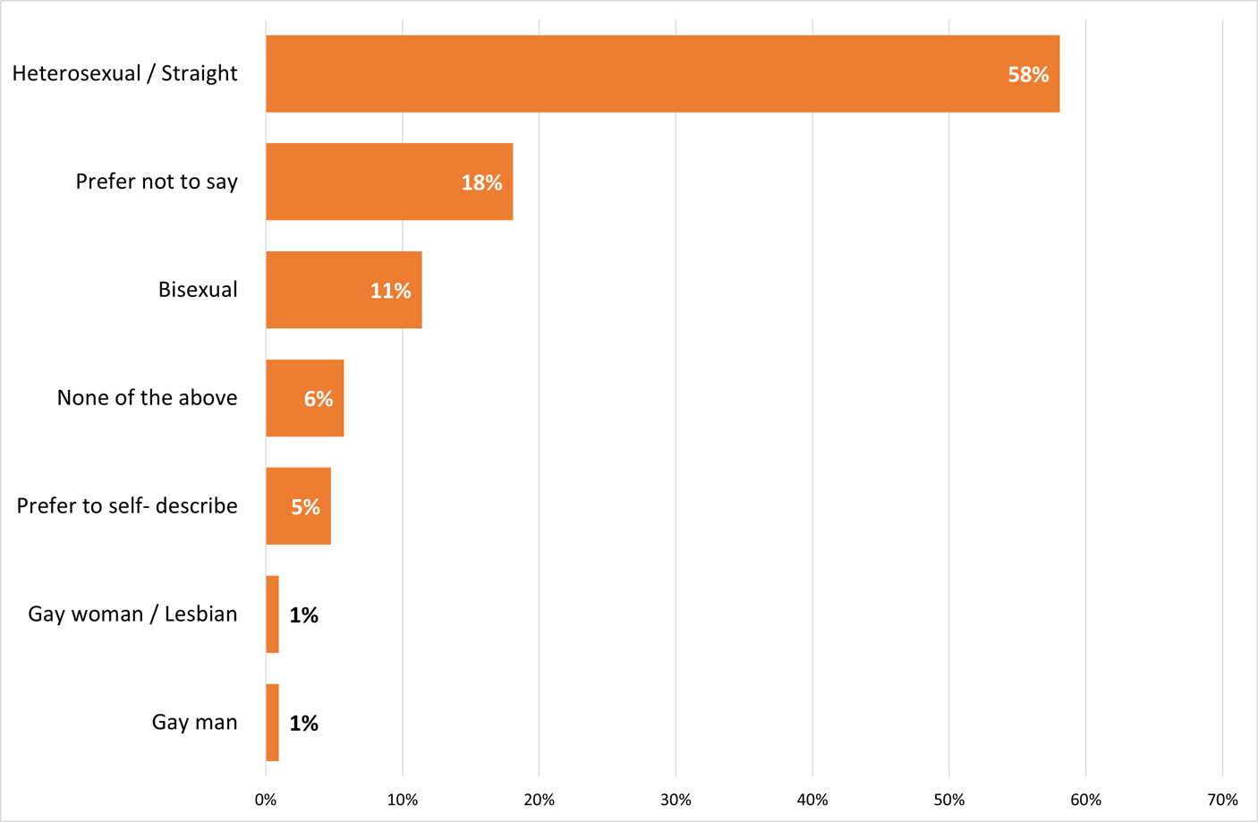
Figure 13 Respondents’ sexual orientation
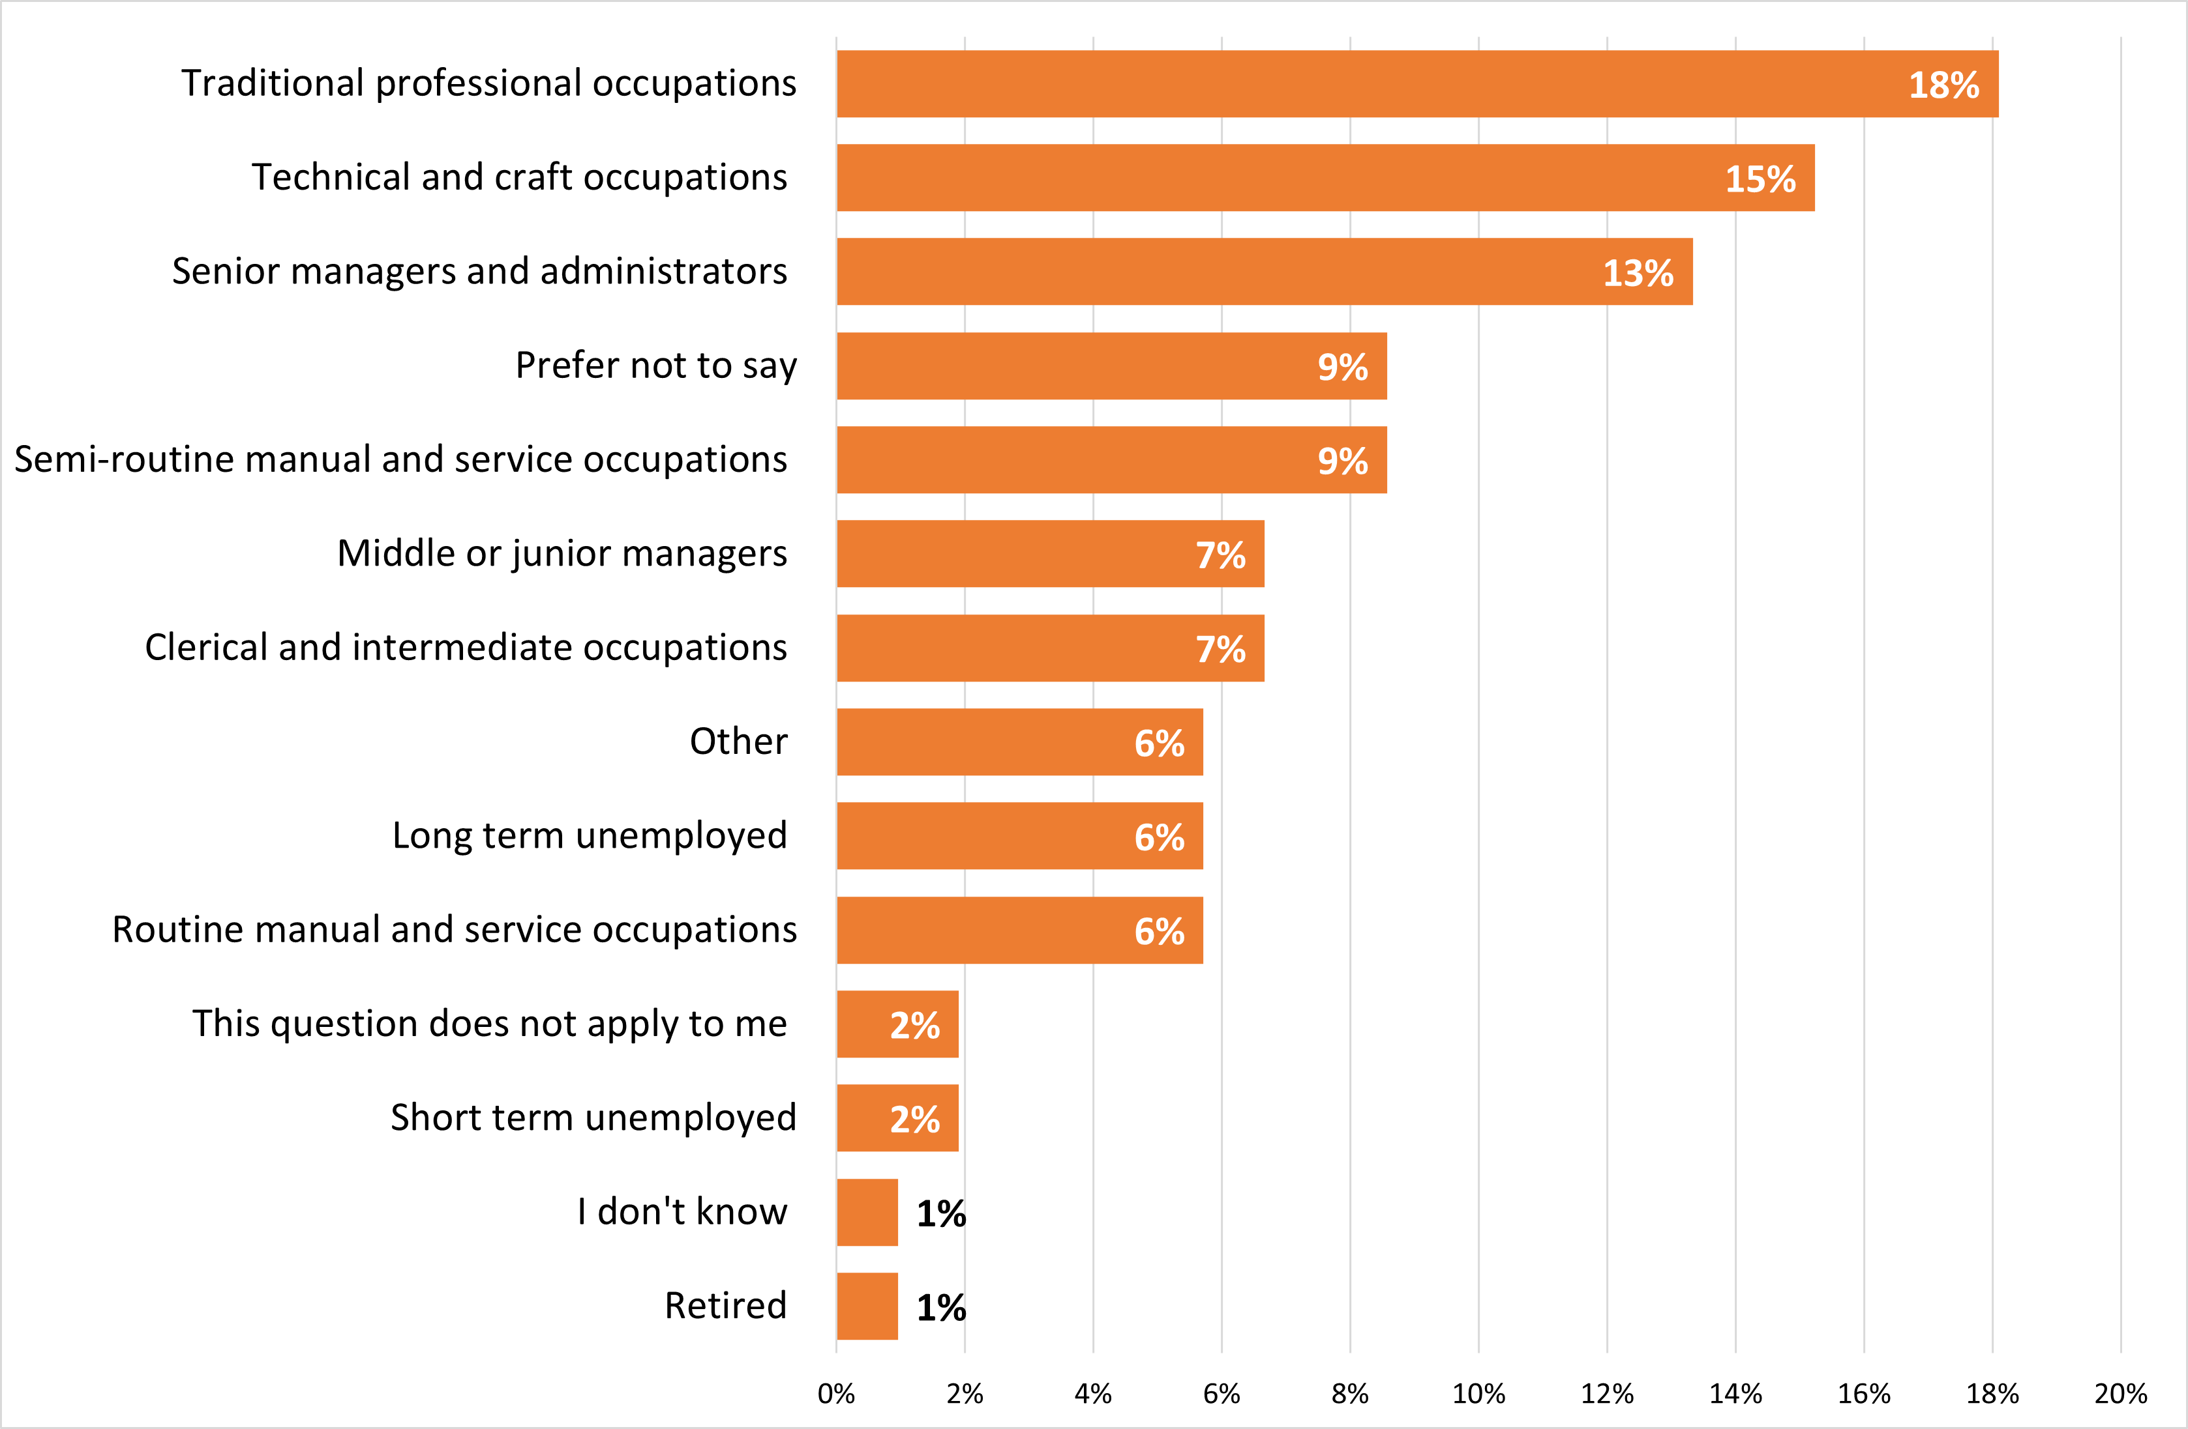
Figure 14 Occupation of main household earner when respondent was aged 14
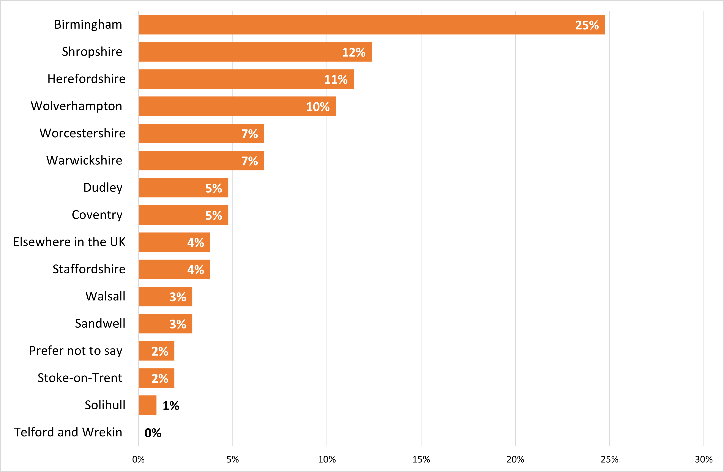
Figure 15 Local authority in which respondents are based
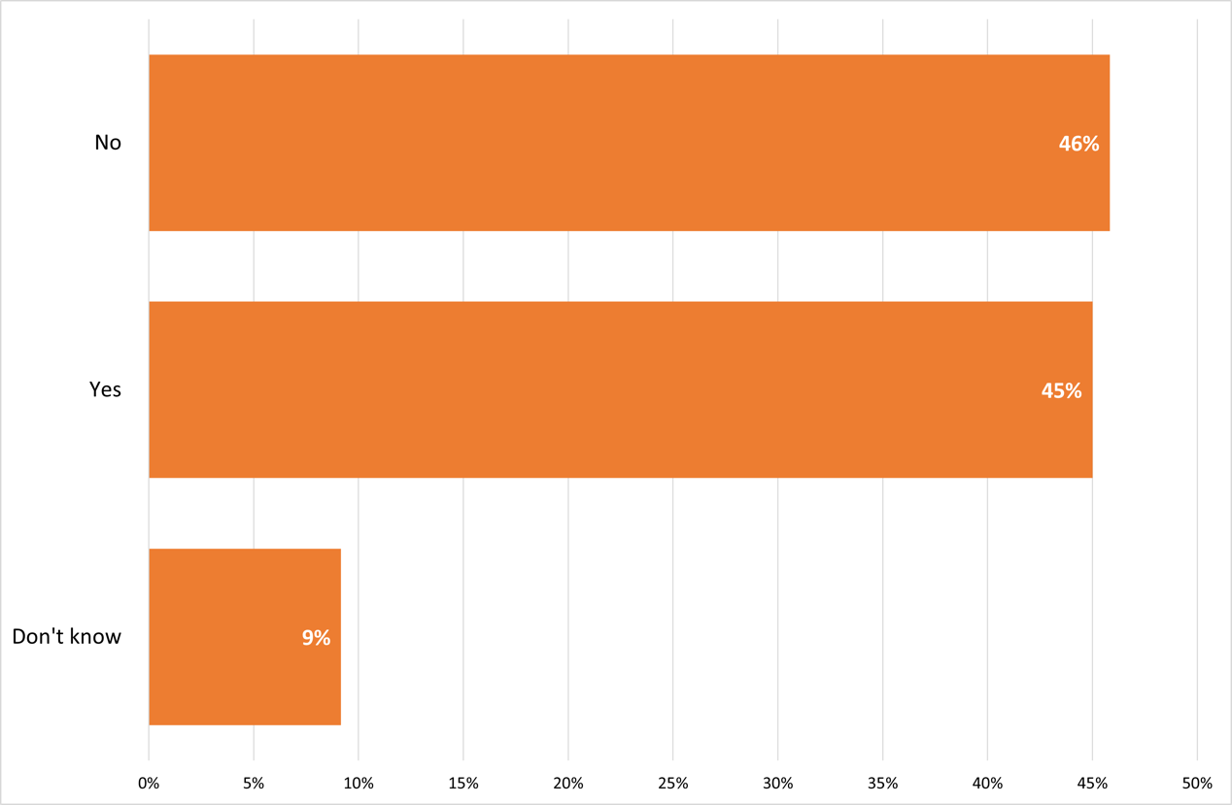
Figure 16 Respondents who have previously engaged with NAWM

Appendix II – List of organisations
Alphabetical list of named visual arts organisations to be represented on the Steering Group.
(NB- Numbers in brackets indicate how many times this organisation was listed by survey respondents)
- Access to Heritage, Art and Culture (ATHAC CIC)
- Air Space Gallery (3)
- The Art House
- Art Riot Collective
- Art UK
- Arts All Over The Place
- Arts Connect
- Arts Council England (3)
- Artsite3
- ArtWorks Alliance
- Apple Store Gallery
- Asylum Art Gallery
- BFI West Midlands
- Birmingham Museum and Art Gallery
- Birmingham School of Art (3)
- Birmingham City Council
- Birmingham Open Studios
- Capsule
- Civic Square (3)
- Craftspace
- Creative Black Country (3)
- The Core, Solihull
- Compton Verney (2)
- Coventry Biennial (2)
- Crafts Council
- Culture Central
- CUP ceramics
- Disability Arts Online
- Eastside Projects (7)
- Friction Arts
- GRAIN Photography (2)
- Grand Union (6)
- The Herbert Art Gallery and Museum (3)
- Hereford College of Arts (3)
- Holyhead Studios
- Ikon Gallery (5)
- Leamington Studio Artists
- Lighthaus Arts (2)
- Ludic Rooms
- Midland Arts Centre (MAC) (8)
- MAIA (3)
- Market Arts Studios
- Meadow Arts (5)
- More Than A Moment
- Multistory (5)
- New Art Gallery Walsall (9)
- Newhampton Arts Centre (2)
- Number 11 Arts
- Onyx Magazine
- Ort Gallery
- Parrabbola
- Partners in Creative Learning (PiCL)
- The Portland Inn Project
- Prayer Room Gallery
- Rugby Art Gallery and Museum
- Raven Studios
- Ridgebank Gallery
- Royal Birmingham Society of Artists Gallery (2)
- Rural Media
- Ruskin Mill Trust
- Sense Arts
- Severn Arts
- Shrewsbury Arts Trail
- Shrewsbury Flaxmill Maltings
- Shropshire Visual Art Network
- Sitting Rooms of Culture
- The Space
- Stryx Gallery (2)
- United Artists of South Birmingham (3)
- Vivid Projects
- Warwick Arts Centre (2)
- Warwickshire Open Studios
- Wolverhampton Art Gallery (3)
- Wolverhampton Voluntary Sector Council


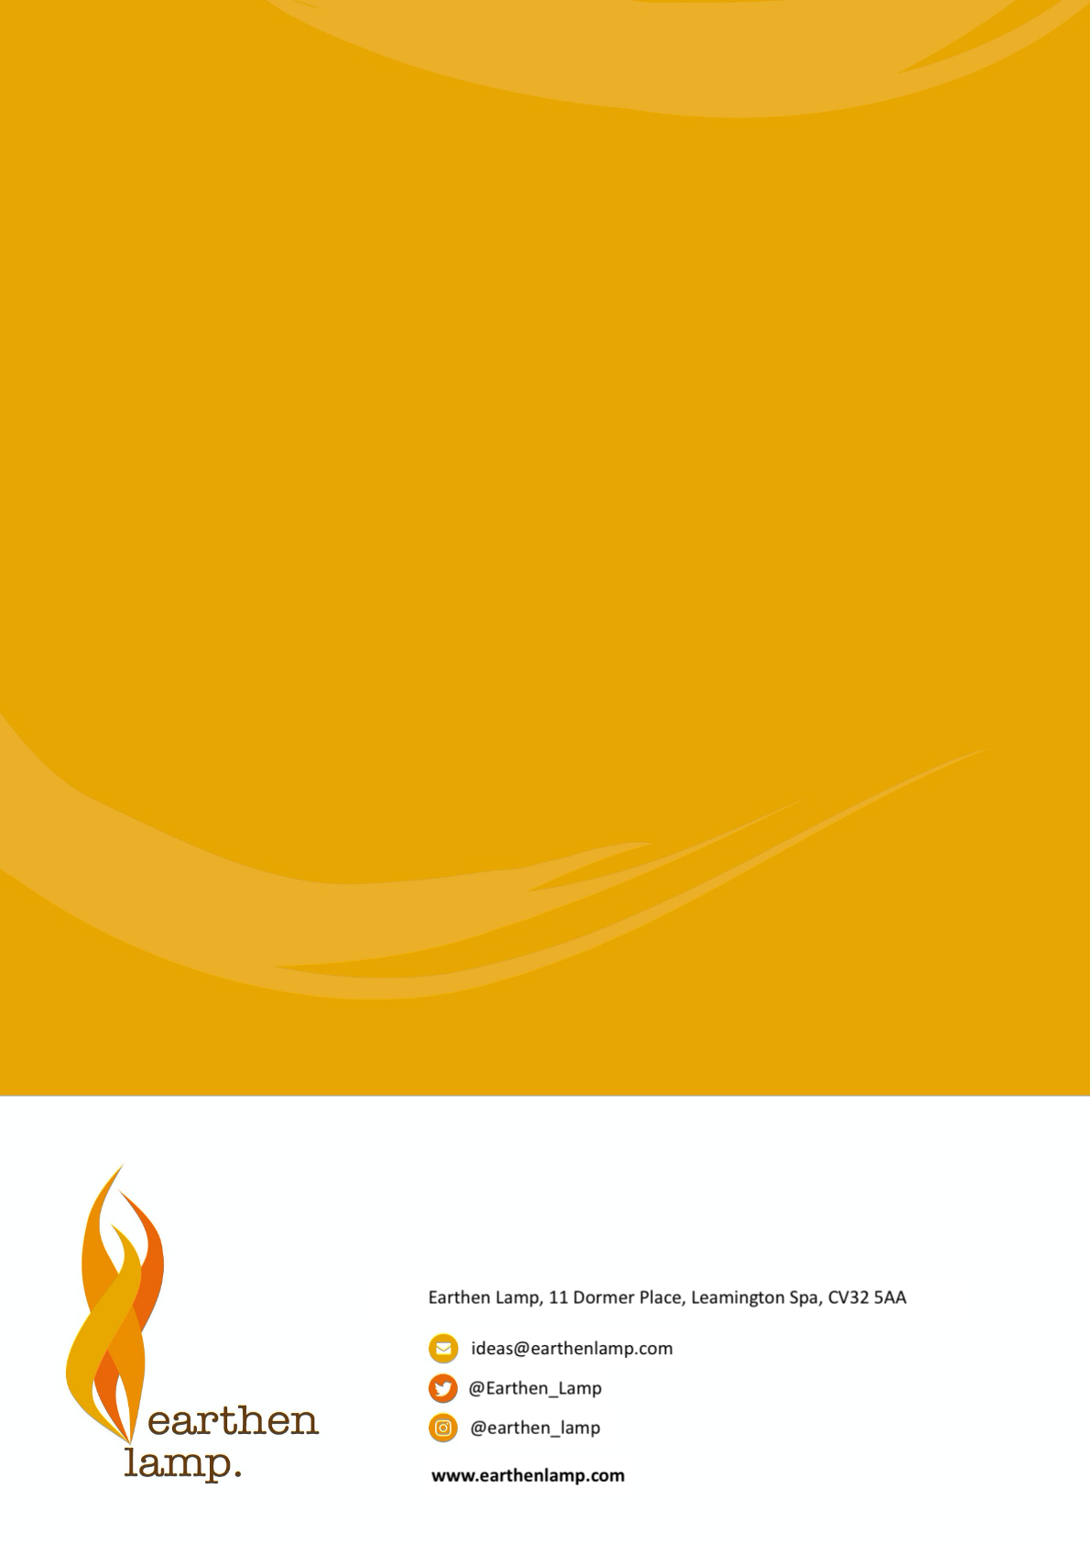
Earthen Lamp exists to bring bright thinking to cultural and heritage organisations and creative businesses. What sets us apart is our straight talking approach, our experience, and attitude to tackle any challenge with gusto. We believe that simple ideas and solutions can light up the darkest corners and solve complex issues.
If you would like to discuss the dark corners in your organisation or business, or just fancy a chat to see
how we can help, drop us a line.

https://www.wmca.org.uk/documents/culture-digital/west-midlands-arts-and-culture/west-midlands-arts-and-culture/
Disability, England and Wales - Office for National Statistics
Arts, culture and heritage: Recent trends in UK workforce and engagement in England
Impact of the Pandemic on the Livelihood of Visual Arts Workers

