
DYK WORKSHEET by BİLGE.SİMURG / UNIT 3 - IN THE KITCHEN
SECTION 1: VOCABULARY & STRUCTURES
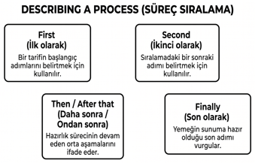
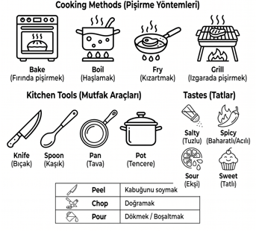

Word | Turkish Meaning | Synonym / Antonym* | Example Sentence
Bake | Fırında pişirmek | Syn: Roast | I bake cookies for my buddies every Sunday.
Chop | Doğramak | Syn: Cut into pieces | First, chop the onions into small pieces.
Ingredients | Malzemeler | Syn: Materials | What are the ingredients for the pasta?
Peel | Soymak | Ant: Cover | Peel the potatoes before you boil them.
Pour | Dökmek | Syn: Tip, empty | Pour the mixture into the hot pan.
Salty | Tuzlu | Ant: Sweet / Sugar | This soup is too salty; I need some water.
Spicy | Baharatlı / Acılı | Syn: Hot, peppery | I love spicy food like Adana Kebab.
Tasty | Lezzetli | Syn: Delicious, Yummy | This apple pie is very tasty, thank you!
Whisk | Çırpmak | Syn: Mix quickly | Whisk the eggs and sugar in a bowl.
Healthy | Sağlıklı | Ant: Unhealthy / Greasy | Steaming vegetables is a healthy method.
*Ant: zıt; syn: eş anlam
Useful Structures from Unit 3:
• Describing a Process: First, Second, Then, After that, Finally.
• Expressing Preferences: I prefer cooking pizza to pasta. / I’d rather bake than fry.
• Asking for Details: How much sugar do I need? / What should I use to cook soup?
• Inquiry/Clarification: What do you mean by that? / Can you repeat that?
Find The Given Structures Below in the Sample Dialogues and then Underline them

Sample Dialogues:
🍳 Dialogue 1: Preparing Pizza in the Kitchen
Leo: Mom, I’m hungry! What are we having for dinner? Can we make pasta?
Sally: Actually, I prefer cooking pizza to pasta. What do you think?
Leo: Oh, I love pizza! I’d rather bake than fry our dinner anyway, so pizza is perfect. How do we make it?
Sally: It's very easy. First, we make the dough. Second, we roll it out. Then, we spread the tomato sauce over it. After that, we add the ingredients like cheese, olives, and peppers. Finally, we bake it in the oven for twenty minutes.
Leo: Sounds tasty! What should I use to cook soup as a starter, though?
Sally: You should use a large pot and a wooden spoon.
Leo: Got it. And how much sugar do I need for the sauce?
Sally: Just a teaspoon of sugar to block the sour taste of the tomatoes.
Leo: What do you mean by that?
Sally: I mean, tomatoes can taste too sour sometimes. Sugar makes the sauce taste sweet and delicious.
Leo: Oh, I see! Can you hand me the flour?
Sally: Oh, wait. Can you repeat that? I didn't hear you.
Leo: Sure! I said, can you hand me the flour so we can start?
Sally: Of course, here you go. Let's get to work!

🍋 Dialogue 2: Making Fresh Lemonade
Tom: It is very hot today! I want to drink something cold. I prefer drinking lemonade to cola.
Meg: Me too! Actually, I prefer making homemade lemonade to buying it. It is healthier.
Tom: Great idea! How do we make it?
Meg: It is so simple. First, we squeeze the lemons. Second, we pour the lemon juice into a big jar. Then, we add water and sugar. After that, we mix it well. Finally, we put some fresh mint leaves and ice cubes.
Tom: Perfect! What should I use to cook soup for dinner later, by the way?
Meg: You should use a large pot and a spoon.
Tom: Okay. Back to the lemonade, how much sugar do I need for this jar?
Meg: Just half a cup of sugar.
Tom: What do you mean by that? Is it too much?
Meg: I mean, lemons are very sour, so we need enough sugar to make them sweet.
Tom: Ah, okay, I understand now. Can you pass me the knife to slice the lemons?
Meg: Oh, sorry. Can you repeat that? I didn't listen to you.
Tom: No problem! I said, can you hand me the knife, please?
Meg: Sure, here it is. Be careful with your fingers!

SECTION 2: CONTEXTUAL GAP FILLING
Read the text and fill in the blanks with the correct words from the box.
ingredients / tasty / whisk / then / bake / pour / finally
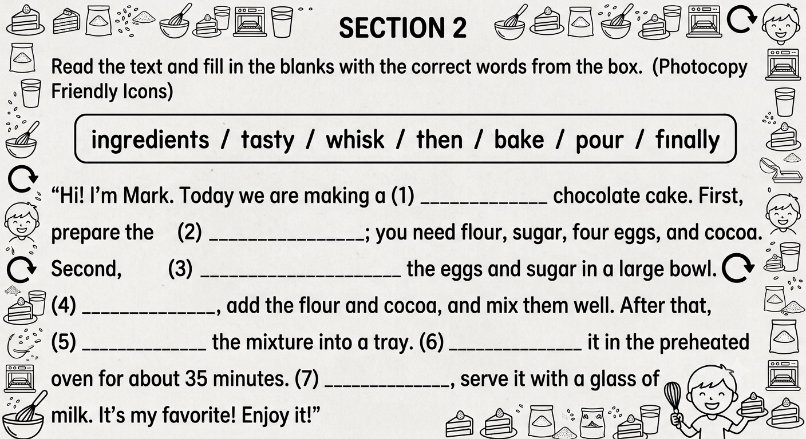

SECTION 3: CONTEXTUAL MULTIPLE-CHOICE QUESTIONS – LGS 2025- 2026 STYLE
- In an English test, the students should put the words into two groups. Here is the table of groups:

Group 1: Cooking Methods | Group 2: Kitchen Tools
• Grill | • Bowl
• Fry | • Boil
• Fork | • Pan

According to the information above, there is a mistake! Which two words should change places to be in the CORRECT groups?
A) Grill – Pan B) Fry – Bowl C) Grill – Boil D) Fork – Boil

- (LGS 2026 Style - Dialogue Completion)

Sam: What are the ingredients of a vegetable soup?
Mert: First, you need some onions, potatoes, and carrots.
Sam: ____________________?
Mert: You should use a large pot and a wooden spoon.

Which of the following completes the dialogue above?
A) How often do you cook it
B) What should I use to cook it
C) Do you prefer spicy or salty soup
D) How much salt do I need

3. (Contextual Vocabulary)
Mary: I love making apple pie. I usually (1) __________ the apples first. Then, I (2) __________ them with sugar. Finally, I (3) __________ it in the oven.

Which of the following completes the text in the CORRECT order?
A) peel / mix / bake
B) boil / pour / fry
C) chop / slice / grill
D) whisk / mash / steam
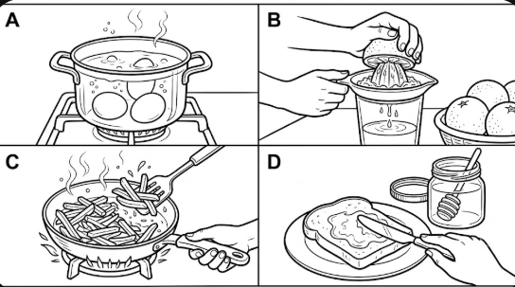
- (LGS 2026 Style - Visual Analysis)

Tommy is in the kitchen to prepare breakfast. First, he boiled some eggs. Second, he peeled and sliced some cucumbers. Then, he squeezed fresh orange juice. Finally, he spread some honey on the bread.
According to the text, which of the following shows a step that Tommy DID NOT do?

- (Preference & Reason)

Sarah: Do you prefer cooking pizza or pasta?
Jack: I’d rather cook pasta because it is __________ than pizza. I can prepare it in just ten minutes.

Which of the following completes the dialogue above?
A) easier
B) more difficult
C) more expensive
D) unhealthier

- (LGS 2026 Style - Content Analysis)

Aslı : "I love the strawberry and hazelnut in this cookie, but I didn’t like the honey taste in it. Next time, you should add some sugar, too."

According to the comment, which ingredient is NOT in the cookie right now?
A) Strawberry
B) Honey
C) Hazelnut
D) Sugar

- (Graph Analysis - LGS Style)

A researcher asked 100 teenagers about their favorite cooking methods. Here are the results:

Cooking Method | Percentage (%)
Grilling | 45%
Frying | 30%
Boiling | 15%
Steaming | 10%

According to the results, which of the following is CORRECT?
A) Most teenagers prefer healthy methods like steaming.
B) Nearly half of the teens prefer grilling their food.
C) Frying is more popular among teens than grilling.
D) Teens find boiling their food unbearable.

- (Identifying Opinions)

Ece: The pasta is very tasty and easy to eat.
Zeynep: I think the soup is too salty. I can't stand it.
Kaan: The grilled chicken is impressive and healthy.

Who says something NEGATIVE about the food?
A) Ece B) Zeynep C) Kaan D) None of them

- (Inquiry/Clarification)

Emma: To make pancakes, first whisk the eggs and milk.
Tom: ____________________?
Emma: I mean, you should mix them very quickly in a bowl.

Which of the following completes the dialogue above?

A) Do you prefer pancakes or omelettes
B) What do you mean by that
C) Is it a healthy breakfast
D) What are the ingredients

- (LGS 2026 Style - Table Analysis)

Four teenagers are talking about their cooking preferences:

Name | Favorite Meal | Cooking Method | Key Ingredients
Amy | Pizza | Bake | Flour, Tomato, Cheese
Tom | Omelette | Fry | Eggs, Milk, Salt

According to the information, which of the following is CORRECT?

A) Amy needs a pan to cook her favorite food.
B) Tom uses eggs and milk to make his meal.
C) Amy doesn’t need an oven.
D) Tom doesn't like adding any salt to his omelette.

SECTION 4: WORD HUNT

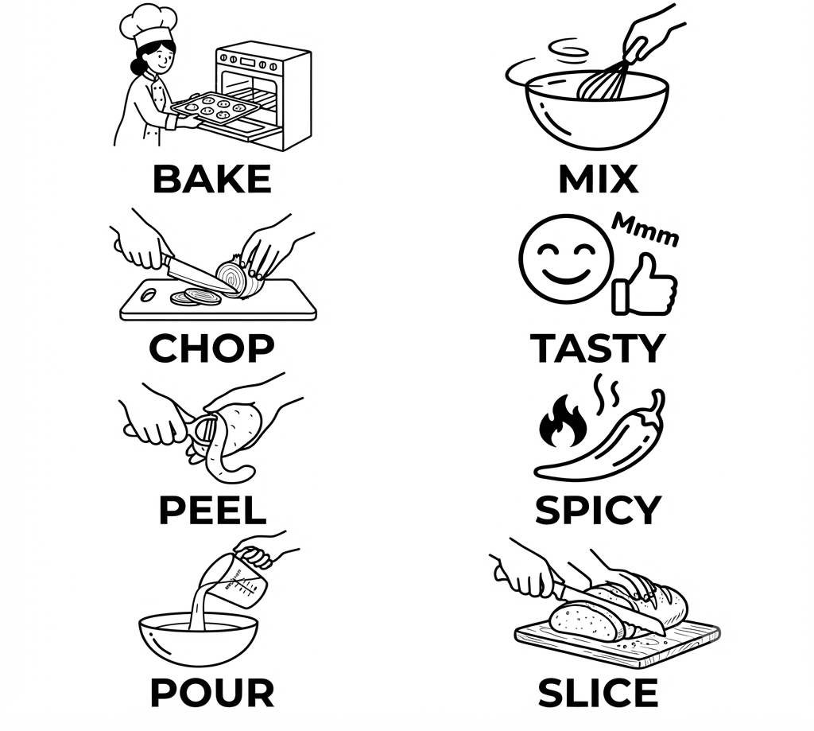

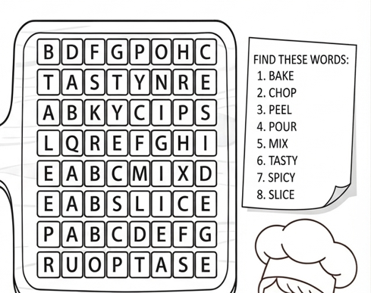

SECTION 5: COMMUNICATIVE TASK-BASED SPEAKING & WRITING
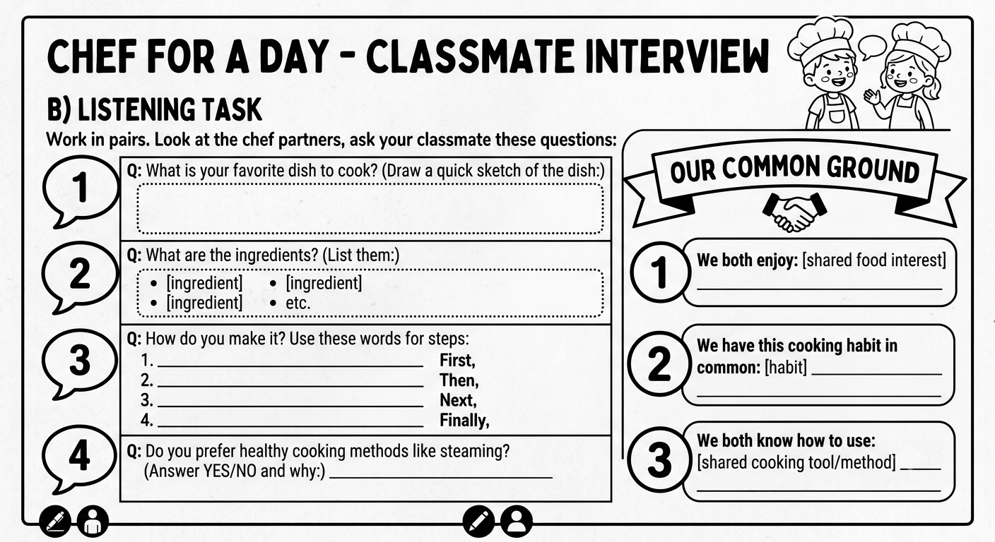

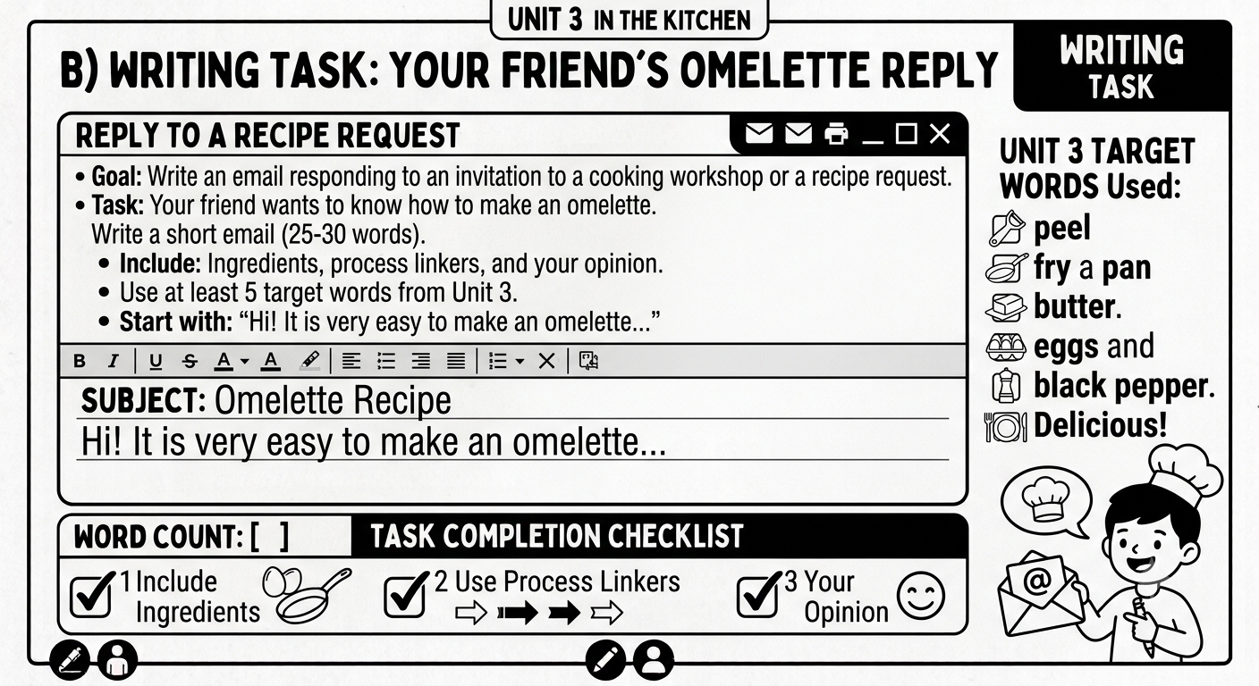

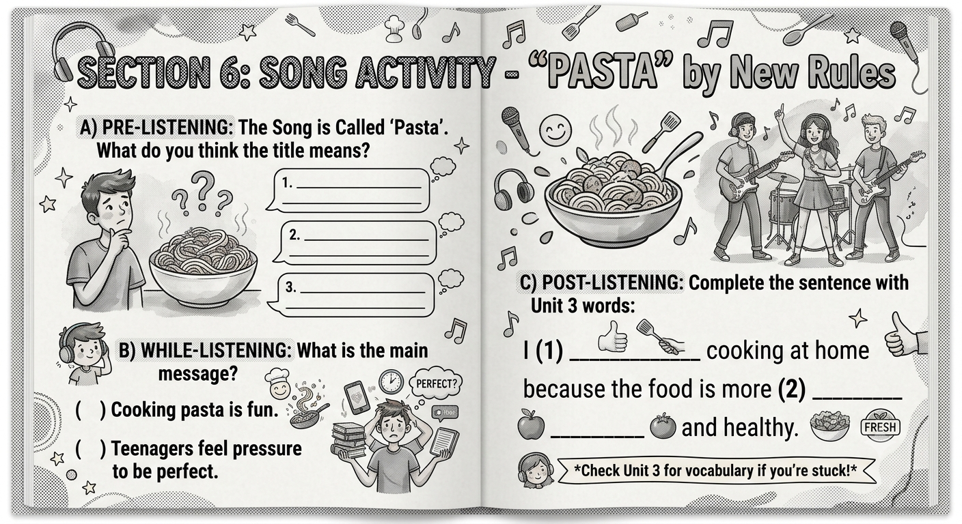
*The Song Pasta by New Rules – please listen to the official song

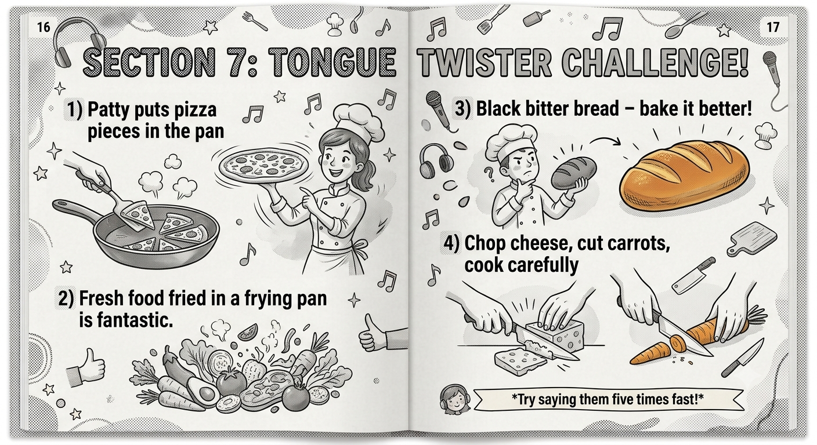

TEACHER'S ANSWER KEY & PEDAGOGICAL GUIDE
Worksheet Title: DYK WORKSHEET by BİLGE.SİMURG / UNIT 3 - IN THE KITCHEN
Level: Pre-Intermediate (A2)
Target Language: Kitchen Vocabulary, Cooking Methods, Process Descriptions, Preferences, and Inquiry/Clarification Structures

INTRODUCTION FOR THE TEACHER
This comprehensive answer key is designed to support you in delivering an effective and engaging lesson based on the "In the Kitchen" worksheet. Each section includes:
- Correct Answers with clear explanations
- Pedagogical Notes on how to present activities
- Common Student Errors with suggestions for correction
- Concept Checking Questions (CCQs) to ensure student understanding
The worksheet integrates vocabulary acquisition, contextual grammar practice, reading comprehension, visual analysis, and communicative tasks—all centered around the theme of cooking and kitchen activities. This approach aligns with communicative language teaching principles, ensuring students not only learn the language but also use it meaningfully.

SECTION 1: VOCABULARY & STRUCTURES
A. Vocabulary Table
Teacher's Notes:
- Objective: To introduce and consolidate key kitchen-related vocabulary.
- Method: Present the words in context first (using the sample dialogues), then use this table for reference and consolidation.
- Strategy: Have students create their own example sentences using the words after the table is completed.
Answer Key:
Word | Turkish Meaning | Synonym/Antonym | Example Sentence
Bake | Fırında pişirmek | Syn: Roast | I bake cookies for my buddies every Sunday.
Chop | Doğramak | Syn: Cut into pieces | First, chop the onions into small pieces.
Ingredients | Malzemeler | Syn: Materials | What are the ingredients for the pasta?
Peel | Soymak | Ant: Cover | Peel the potatoes before you boil them.
Pour | Dökmek | Syn: Tip, empty | Pour the mixture into the hot pan.
Salty | Tuzlu | Ant: Sweet / Sugar | This soup is too salty; I need some water.
Spicy | Baharatlı / Acılı | Syn: Hot, peppery | I love spicy food like Adana Kebab.
Tasty | Lezzetli | Syn: Delicious, Yummy | This apple pie is very tasty, thank you!
Whisk | Çırpmak | Syn: Mix quickly | Whisk the eggs and sugar in a bowl.
Healthy | Sağlıklı | Ant: Unhealthy / Greasy | Steaming vegetables is a healthy method.
Pedagogical Tips:
- Pronunciation: Pay attention to:
  - "Ingredients" /ɪnˈɡriːdiənts/ – the stress is on the second syllable.
  - "Whisk" /wɪsk/ – the 'h' is silent; students may mispronounce it as "wishk".
  - "Salty" /ˈsɔːlti/ – the 'l' is pronounced, unlike in "walk" or "talk."

- Concept Checking Questions (CCQs):
  - For "Bake": "Do you use an oven or a pan?" (Oven). "Is it a dry or wet method?" (Dry).
  - For "Chop": "Do you cut it into big pieces or small pieces?" (Small pieces).
  - For "Salty": "Does it have a lot of salt or sugar?" (Salt).
  - For "Peel": "Do you remove the skin or the seeds?" (Skin).
- Common Errors:
  - Students may confuse "bake" and "roast." Explain that both use an oven, but "roast" is typically used for meat, while "bake" is for bread, cakes, and pastries.
  - Students may use "spicy" to mean "hot" but confuse it with "sour" or "salty." Use taste tests (imaginary or real) to differentiate.

B. Useful Structures from Unit 3
Teacher's Notes:
- Objective: To help students identify and understand functional language used in recipes and kitchen conversations.
- Method: Have students read the sample dialogues first. Then, ask them to find and underline the target structures.
Answer Key (Underlined in the provided dialogues):
Dialogue 1: Preparing Pizza in the Kitchen
- Describing a Process:
  - "First, we make the dough. Second, we roll it out. Then, we spread the tomato sauce over it. After that, we add the ingredients like cheese, olives, and peppers. Finally, we bake it in the oven for twenty minutes."
- Expressing Preferences:
  - "Actually, I prefer cooking pizza to pasta."
  - "I'd rather bake than fry our dinner anyway."
- Asking for Details:
  - "What should I use to cook soup as a starter, though?"
  - "And how much sugar do I need for the sauce?"
- Inquiry/Clarification:
  - "What do you mean by that?"
  - "Oh, wait. Can you repeat that? I didn't hear you."
Dialogue 2: Making Fresh Lemonade
- Describing a Process:
  - "First, we squeeze the lemons. Second, we pour the lemon juice into a big jar. Then, we add water and sugar. After that, we mix it well. Finally, we put some fresh mint leaves and ice cubes."
- Expressing Preferences:
  - "I prefer drinking lemonade to cola."
  - "Actually, I prefer making homemade lemonade to buying it."
- Asking for Details:
  - "What should I use to cook soup for dinner later, by the way?"
  - "Back to the lemonade, how much sugar do I need for this jar?"
- Inquiry/Clarification:
  - "What do you mean by that? Is it too much?"
  - "Oh, sorry. Can you repeat that? I didn't listen to you."
Pedagogical Tips:
- Process Language: Use a visual timeline on the board (First → Second → Then → After that → Finally) to help students visualize the order.
- Preference Structures: Contrast "I prefer X to Y" (more formal) with "I'd rather X than Y" (more colloquial). Model both with examples: "I prefer tea to coffee" vs. "I'd rather have tea than coffee."
- Inquiry Language: Drill these phrases with varying intonation to show politeness and confusion. Role-play situations where students ask for clarification (e.g., when they don't understand a recipe step).

SECTION 2: CONTEXTUAL GAP FILLING
Teacher's Notes:
- Objective: To practice using vocabulary in a meaningful context (a recipe).
- Method: Students should read the entire text first for gist, then fill in the blanks.
- Strategy: Encourage students to use the pictures on the worksheet and the vocabulary list as clues.
Answer Key:
Blank | Word from Box | Explanation
1 | ingredients | The text begins by listing what is needed for the recipe. "Ingredients" is the most logical choice.
2 | pour | This follows "Then" in the process description. You pour the mixture into a bowl.
3 | whisk | This is an action you do with eggs or liquids. "Whisk" fits perfectly with "eggs and milk."
4 | then | This is part of the sequence words. It connects "whisk" to the next step.
5 | bake | The final step involves using an oven, so "bake" is correct.
6 | finally | This is the last sequence word, marking the final step.
Completed Text (Reconstructed):
Title: How to Make [Recipe Name]
First, gather all the (1) ingredients for the recipe. You need flour, eggs, milk, sugar, and some butter. Second, (2) pour the flour and sugar into a large mixing bowl. Then, crack the eggs and (3) whisk them together with the milk. (4) Then, add the melted butter to the bowl and mix everything well. (5) Bake the mixture in the oven for 25 minutes at 180°C. (6) Finally, let it cool before serving.
Pedagogical Tips:
- Contextual Clues: Teach students to look for surrounding words to help them guess the missing word. For example, if the blank is before "them together with the milk," the action must be a mixing verb ("whisk").
- Sequence Words: Use a gesture or visual cue (raising fingers to count steps) to reinforce "First, Second, Then, Finally."
- Common Errors:
  - Students may confuse "pour" and "whisk." Clarify: "Pour" is for liquids (moving them), while "whisk" is for mixing quickly (using a tool).
  - Students may use "after that" instead of "then." Both are acceptable, but consistency with the word box is required.

SECTION 3: CONTEXTUAL MULTIPLE-CHOICE QUESTIONS (LGS 2025-2026 STYLE)

Question 1
Answer: D) Fork -- Boil
Explanation:
- Group 1 (Cooking Methods): Should contain actions or techniques (e.g., Grill, Fry, Boil).
- Group 2 (Kitchen Tools): Should contain physical objects used in cooking (e.g., Bowl, Pan, Fork).
- Currently, "Boil" is incorrectly placed in Group 2 (it's a method), and "Fork" is incorrectly placed in Group 1 (it's a tool). Therefore, they should change places.
Teacher's Notes:
- Objective: To categorize vocabulary items (methods vs. tools).
- Common Error: Students may think "Fry" is a tool if they associate it with a "frying pan." Clarify: "Fry" is the action; "frying pan" is the tool.
- CCQ: "Can you use a fork to boil?" (No). "Can you use a pan to fry?" (Yes, but the method is "frying," not the pan).

Question 2
Answer: B) What should I use to cook it
Explanation:
- The dialogue asks for ingredients first, then tools. Mert's response mentions "a large pot and a wooden spoon," which are tools/equipment.
- Sam's question must, therefore, be about what to use (tools) to cook the soup.
Teacher's Notes:
- Objective: To practice functional language for asking about kitchen equipment.
- Common Error: Students might choose A (How often do you cook it) because they see "you" and "cook." Remind them that the answer is about tools, not frequency.
- Strategy: Have students underline the keywords in Mert's response ("large pot," "wooden spoon") and match them to the question type.

Question 3
Answer: A) peel / mix / bake
Explanation:
- The recipe for apple pie involves:
  - peel the apples (remove the skin).
  - mix them with sugar (combine ingredients).
  - bake it in the oven (final step).
- The other options do not make sense for making apple pie (you don't "boil" an apple pie or "grill" it).
Teacher's Notes:
- Objective: To sequence recipe steps correctly based on logical order.
- Common Error: Students might choose "chop" instead of "peel." Clarify the difference: "Peel" removes the skin; "chop" cuts into pieces. Both are possible, but the most logical first step is peeling.
- Visual Support: Use the image on the worksheet (if visible) to show a person peeling an apple. Ask: "What is the person doing first?"

Question 4
Answer: (Based on the visual analysis—see teacher's note below)
Teacher's Notes:
- Objective: To match textual information with visual representations.
- Method: Students read the text describing Tommy's breakfast preparation and compare it to the images provided.
- Strategy: Have students create a checklist from the text:
  - Boiled eggs
  - Peeled and sliced cucumbers
  - Squeezed orange juice
  - Spread honey on bread
Then, they look at the images (A, B, C, D) and identify the one that shows a step Tommy DID NOT do. For example:
- If one image shows "Tommy is frying eggs," that would be the correct answer because the text says he boiled eggs.
Common Error: Students may confuse "boiled eggs" with "fried eggs." Use CCQs: "Did Tommy boil the eggs or fry them?" (Boil them). "Which picture shows boiled eggs?" (A picture of eggs in a pot of water).

Question 5
Answer: A) easier
Explanation:
- Jack says he prefers pasta because "I can prepare it in just ten minutes." This indicates that pasta is faster and therefore easier to prepare than pizza.
Teacher's Notes:
- Objective: To understand preferences and reasons.
- Common Error: Students may choose "more difficult" because they misunderstand "just ten minutes." Clarify: "If something takes ten minutes, is it easy or difficult?" (Easy).
- CCQ: "Is ten minutes a long time or a short time?" (Short). "So, is cooking pasta easy or difficult?" (Easy).

Question 6
Answer: D) Sugar
Explanation:
- Chef Bilge says: "I love the strawberry and hazelnut in this cake, but the honey is a bit too much. Next time, you should add some sugar, too."
- This means:
  - Strawberry is in the cake.
  - Hazelnut is in the cake.
  - Honey is in the cake (but too much).
  - Sugar is NOT in the cake (it should be added next time).
Teacher's Notes:
- Objective: To distinguish between what is present and what is recommended.
- Common Error: Students may think "honey is not in the cake" because the chef says "it's too much." Clarify: "If something is 'too much,' is it there or not?" (It is there).
- Strategy: Use a simple table on the board with two columns: "In the cake now" and "Add next time." Have students place ingredients in the correct column.

Question 7
Answer: B) Nearly half of the teens prefer grilling their food.
Explanation:
- The graph shows: Grilling: 45%, Frying: 30%, Boiling: 15%, Steaming: 10%.
- 45% is nearly half (50%). Therefore, "Nearly half of the teens prefer grilling their food" is correct.
- A is incorrect because steaming (a healthy method) is only 10%.
- C is incorrect because grilling (45%) is more popular than frying (30%).
- D is incorrect because the graph does not show attitudes (unbearable), only preferences.
Teacher's Notes:
- Objective: To interpret simple graphical data and draw conclusions.
- Common Error: Students may misread percentages or confuse "nearly half" with "exactly half." Clarify: "What is half of 100?" (50). "Is 45 nearly 50?" (Yes).
- Strategy: Teach comparative language: "more popular than," "less popular than," "as popular as."

Question 8
Answer: B) Zeynep
Explanation:
- Ece: "The pasta is very tasty and easy to eat." (Positive)
- Zeynep: "I think the soup is too salty. I can't stand it." (Negative)
- Kaan: "The grilled chicken is impressive and healthy." (Positive)
Teacher's Notes:
- Objective: To identify opinion (positive/negative) based on keywords.
- Common Error: Students may think "too salty" is neutral. Clarify: "'Too salty' means it has more salt than you want. Is that good or bad?" (Bad).
- CCQ: "Can Zeynep eat the soup?" (She can't stand it, so no). "So, is her opinion positive or negative?" (Negative).

Question 9
Answer: B) What do you mean by that
Explanation:
- Emma gives a step ("whisk the eggs and milk"). Tom asks for clarification.
- Emma responds with "I mean, you should mix them very quickly in a bowl." This matches the clarification structure "What do you mean by that?"
- The other options are unrelated to clarification.
Teacher's Notes:
- Objective: To practice inquiry/clarification language.
- Common Error: Students might choose A (Do you prefer pancakes or omelettes) because it's a question. Clarify: "Is Tom asking about a choice or about the meaning?" (About the meaning).
- Strategy: Role-play this dialogue with exaggerated confusion to make the function clear.

Question 10
Answer: B) Tom uses eggs and milk to make his meal.
Explanation:
- For Tom: Favorite Meal = Omelette, Key Ingredients = Eggs, Milk, Salt.
- Therefore, "Tom uses eggs and milk to make his meal" is correct.
- A is incorrect because Amy's food (Pizza) requires baking (oven, not a pan).
- C is incorrect because Amy does need an oven (to bake pizza).
- D is incorrect because the table shows Tom does like adding salt to his omelette.
Teacher's Notes:
- Objective: To extract specific information from a table.
- Common Error: Students may misread "Tom" as "Amy." Emphasize reading the names carefully.
- Strategy: Model how to scan the table for specific information (e.g., "Look for Tom. What does he use?").

SECTION 4: WORD HUNT
Teacher's Guide:
- Objective: To reinforce spelling and word recognition in a fun, engaging way.
- Method: This is a great activity for fast finishers or as a warmer.
Instructions for the Teacher:
- Preparation: Before the lesson, it is helpful to give students the list of words they need to find. This provides a clear goal.
- Activity: Students search for the words in the grid. The words can be horizontal, vertical, or diagonal, and they can be forwards or backwards.
- Differentiation: For lower-level students, you can allow them to work in pairs. For higher-level students, you can make it a competition to see who finishes first.
- Follow-up: After the hunt, have students write a sentence using 3-4 of the words they found. This moves the activity from simple recognition to productive use.

SECTION 5: COMMUNICATIVE TASK-BASED SPEAKING & WRITING
Teacher's Notes:
- Objective: To promote productive language use (speaking and writing) through engaging, real-world tasks.
- Method: These tasks should be done in pairs or small groups to maximize communication.
- Strategy: Before beginning, model the task for students. Use a "think-pair-share" approach: students think individually, discuss with a partner, then share with the class.

Task 1: Describing a Picture (Visual Analysis)
Teacher's Notes:
- Objective: To practice using present continuous and vocabulary for describing kitchen scenes.
- Method: Show the visual (image 7, 8, or 9) and ask students to describe what is happening.
Model Answer (for a kitchen scene):
"In the picture, I can see a family in the kitchen. A woman is baking a cake in the oven. A man is chopping vegetables on the cutting board. A child is pouring milk into a glass. There are some ingredients on the table, like flour and sugar. The kitchen is clean and bright. I think they are preparing a meal together."
Teacher's Guide:
- Scaffolding: Provide sentence starters for weaker students:
  - "In the picture, I can see..."
  - "There is/are..."
  - "He/She is + verb-ing..."
  - "I think they are..."
- Peer Correction: After students describe the picture, have a partner give feedback.
- Extension: Ask students to predict what will happen next (e.g., "After chopping the vegetables, he will add them to the pan.").

Task 2: Writing a Recipe (Process Description)
Teacher's Notes:
- Objective: To practice using sequence words (First, Second, Then, After that, Finally) and imperative forms to write a clear recipe.
- Method: Students can use the pictures as a guide for steps.
Model Answer (for a simple recipe like "Making an Omelette"):
How to Make a Perfect Omelette
Ingredients:
- 3 eggs
- A pinch of salt
- A splash of milk
- Butter or oil
- Some cheese (optional)
Instructions:
- First, crack the eggs into a bowl and add the salt and milk.
- Second, whisk the eggs with a fork until they are well mixed.
- Then, heat a pan over medium heat and add a little butter or oil.
- After that, pour the egg mixture into the pan and let it cook for 2-3 minutes.
- Finally, sprinkle some cheese on top, fold the omelette in half, and serve it hot.
Teacher's Guide:
- Modeling: Write a recipe together as a class before students write their own.
- Language Focus: Remind students to use the imperative form (e.g., "Crack," "Whisk," "Heat," "Pour," "Let").
- Peer Review: Have students swap their recipes and check if the instructions are clear and logical.
- Extension: Students can present their recipes to the class or create a "class cookbook."

Task 3: Listening to "Pasta" by New Rules
Teacher's Notes:
- Objective: To practice listening for specific vocabulary and overall meaning in a song.
- Method: Play the song "Pasta" by New Rules. Before listening, have students predict what the song might be about (food, love, etc.).
Suggested Listening Questions:
- What food is mentioned in the song? (Pasta)
- Is the song happy or sad? (This depends on the song; guide students to listen for tone.)
- Write down any kitchen-related words you hear.
- What do you think the song is about? (It may be a metaphor for love/relationships.)
Teacher's Guide:
- Pre-Listening: Activate schemata by asking: "What do you know about pasta? Do you like it? How do you make it?"
- While-Listening: Play the song once for gist. Play a second time with a focus on specific words.
- Post-Listening: Have a class discussion. Ask: "Why do you think the writer chose 'pasta' as a title?" "Is the song literal or metaphorical?"
- Copyright Note: Since you have not provided the full lyrics, ensure you comply with copyright laws when using the song in class. Only play the audio and avoid distributing printed lyrics unless you have permission.

FINAL TEACHER'S CHECKLIST
Section | Activity Type | Skill Focus | Completed?
1 | Vocabulary Table | Vocabulary
1 | Sample Dialogues | Reading / Functional Language
2 | Gap Filling | Reading / Vocabulary in Context
3 | Multiple Choice (LGS Style) | Reading / Visual Analysis
4 | Word Hunt | Vocabulary / Spelling
5 | Picture Description | Speaking / Present Continuous
5 | Writing a Recipe | Writing / Process Language
5 | Listening to Song | Listening / Gist

ADDITIONAL PEDAGOGICAL TIPS FOR THE TEACHER – maarif corner
Differentiation Strategies
For Lower-Level Students:

- Pre-teach key vocabulary using visuals and realia (e.g., bring a whisk, a peeler, or a bowl to class).
- Reduce the number of words in the word hunt.
- Provide sentence starters and gap-fill templates for the writing task.
- Use pair work with stronger students to support weaker ones.

For Higher-Level Students:

- Encourage students to use more complex vocabulary (e.g., "simmer," "sauté," "drizzle," "sprinkle").
- Challenge them to write a recipe with 8-10 steps.
- Ask them to create a dialogue between a chef and a customer, incorporating the unit's structures.
- Encourage them to research a traditional dish from their culture and present it to the class.

Assessment Opportunities

- Formative: Observe students during pair work and group discussions. Use a checklist to note their use of target vocabulary and structures.
- Summative: Use the multiple-choice questions (Section 3) as a quiz. Collect and grade the written recipes.
- Self-Assessment: Have students complete a self-evaluation form at the end of the lesson (e.g., "I can name 5 kitchen tools in English," "I can describe a recipe using sequence words").

Extension Activities

- Cooking Demonstration: Have students bring a simple dish (or a video of themselves cooking) to class and describe the process in English.
- Cross-Curricular: Connect to science by discussing the chemical changes that occur during cooking (e.g., boiling, baking).
- Cultural Comparison: Have students research and present a dish from another country, using English to describe its ingredients and preparation.
- Digital Literacy: Encourage students to find an English recipe online and follow it at home, documenting the process with photos.

TELİF HAKKI, KULLANIM İZNİ, YAPAY ZEKÂ BEYANI VE SORUMLULUK REDDİ
DYK WORKSHEET BY BİLGE SİMURG /Unit 3 adlı bu çalışma kağıdı, Büşra ABBASOĞLU (Bilge Simurg Eğitim Sayfası) tarafından eğitim-öğretim amacıyla hazırlanmıştır. Materyalin özgün metinleri, etkinlik kurgusu, soru yapıları, pedagojik düzeni ve nihai editöryal çalışması eser sahibine aittir ve 5846 sayılı Fikir ve Sanat Eserleri Kanunu kapsamında korunan kısımlar için ilgili yasal hükümler uygulanır.
Bu materyalin hazırlanmasında üretken yapay zekâ araçlarından içerik geliştirme, görsel oluşturma ve tasarım desteği alınmıştır. Ancak tüm içerikler eser sahibi tarafından incelenmiş, doğrulanmış, düzenlenmiş ve eğitim programına uygun hâle getirilmiştir.
Bu çalışma kağıdı öğretmenler ve öğrenciler tarafından eğitim ve bireysel öğrenme amacıyla kullanılabilir. Ticari amaçla çoğaltılması, satılması, izinsiz yeniden yayımlanması, dijital ortamlarda kaynak gösterilmeksizin paylaşılması veya değiştirilerek eser sahibinin izni olmadan yeniden dağıtılması yasaktır.
Bu materyalde yer alan eser, sanatçı, marka veya şarkı adları yalnızca eğitim ve referans amacıyla kullanılmıştır. Şarkı sözlerinin tamamı paylaşılmamış olup ilgili eserlerin telif hakları hak sahiplerine aittir. Kullanılan yapay zekâ görselleri eğitim amaçlı illüstrasyon niteliğindedir; gerçek kişi, kurum veya olayları temsil etme amacı taşımaz.
Bu çalışma kağıdı özenle hazırlanmış olmakla birlikte, olası hata veya güncellik farklılıklarından dolayı kullanıcıların gerekli akademik ve mesleki değerlendirmeyi yapmaları önerilir.
© 2026 B. ABBASOĞLU – Bilge Simurg Eğitim Sayfası. Tüm hakları saklıdır.

