TEACHER LESSON PLAN
Lesson Title: Our Flag: The Turkish Flag – Reading & Speaking
Level: A1–A2
Duration: 40 minutes
Skill Focus: Reading, Speaking, Cultural Awareness
Theme: Our Flag / National Values (MEB First Lesson Theme)

1. Learning Objectives
By the end of the lesson, students will be able to:
- understand a short dialogue about the Turkish flag in a school context
- identify why the Turkish flag is displayed in many places
- answer simple comprehension questions
- speak briefly about national symbols and respect

2. Target Vocabulary
- flag
- nation
- unity
- freedom
- respect
- symbol
- country
- everywhere

3. Materials
- Student worksheet
- Board/smartboard
- Turkish flag visuals (optional)

4. Lesson Procedure (40 Minutes)
A. Warm-up / Lead-in /Brainstorming (5 minutes)
- The TURKISH FLAG on the board
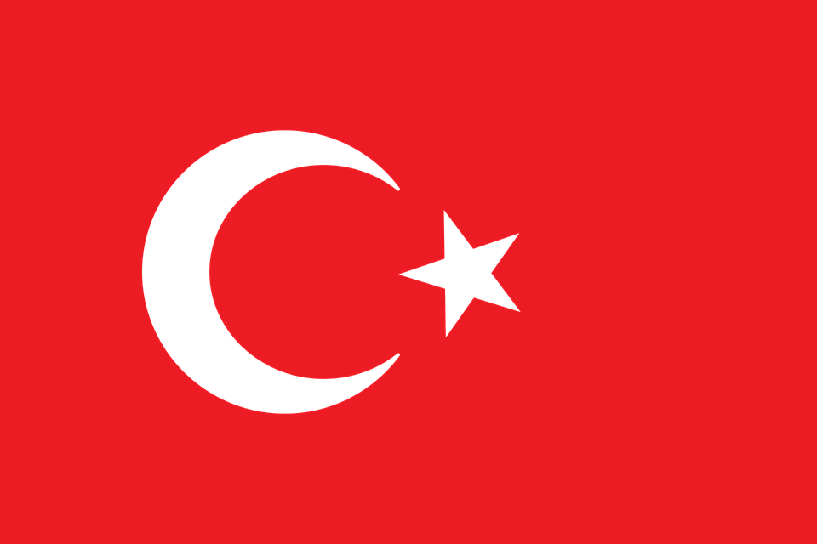
- Ask students to say words they associate with it.
- Accept single words or short phrases.
- Write key vocabulary on the board.

B. Pre-Reading (5 minutes)
- Introduce target vocabulary using visuals or gestures.
- Focus on meaning, not grammar.
- Drill pronunciation chorally.

C. While-Reading – First Reading (5 minutes)
- Ask a general question:
Where are Ali and Anna?
- Students read the dialogue silently and find the answer

D. While-Reading – Second Reading (5 minutes)
- Teacher reads aloud with natural intonation.
- Students follow.
- Pair reading: one student is Ali, one is Anna.

E. Post-Reading – Comprehension (7 minutes)
- Students answer short-answer questions individually.
- Check answers orally.
- Encourage simple complete sentences.

F. Speaking – Role Play (8 minutes)
- Students work in pairs.
- Student A: Turkish student
- Student B: International student
- Focus questions:
  - Why is the flag everywhere?
  - How do people show respect?
- Teacher monitors and supports.

G. Closure – Writing & Values (5 minutes)
- Students write one sentence about respecting the Turkish flag.
- Volunteers read aloud.
- Reinforce respect, unity, and national values.

5. Homework / Cultural Extension
- Read the anecdote about Atatürk and respect for flags.
- Be ready to answer next lesson:
Why is respect for the flag important in Turkish culture?

6. Assessment
- Observation of participation
- Accuracy of short answers
- Speaking effort during role play

Reading & Speaking Worksheet – Turkish Flag (A1–A2)
Name: _____________ Date: _____________

PRE-READING – BRAINSTORM
TURKISH FLAG
👉 What words come to your mind?
Words:

READING – DIALOGUE
Read the Dialogue and find the answer:
- Where are Ali and Anna?
………………………………………………………..

Ali: Hello! Welcome to our school.
Anna: Thank you. I’m happy to be here. I’m an international student.
Ali: Nice to meet you, Anna. Come on, let me show you around our school.
Anna: Thank you! I can see the Turkish flag everywhere. It looks very beautiful.
Ali: Yes, we display it in many places.
Anna: That’s nice, but why is it everywhere?
Ali: Because it represents our nation, unity, freedom, and history.
Anna: I see. Why do people respect it so much?
Ali: Because it is a symbol of our country and our identity. It reminds us of our ancestors and independence.
Anna: Is there anything special people do for the flag?
Ali: Yes. We never let it fall on the ground or get damaged. We always show respect.
Anna: I understand now. Flags are very important.

AFTER READING – SHORT ANSWER
Answer shortly.
- Who is the international student?
...............................................
- What does the Turkish flag represent?
...............................................
- Why don’t people put the flag on the ground?
...............................................
POST-READING – ROLE PLAY
Work in pairs.
Student A: As Ali
Student B: As Anna

CLOSING – WRITING
Write ONE sentence.
Use 3 new words you learned today.
👉 Why should we respect the Turkish flag?
...............................................

FURTHER READING – HOMEWORK
Atatürk and Respect for Flags
After the liberation of İzmir, a foreign flag was placed on the ground for Atatürk to step on. He refused and said that a flag is the symbol of a nation’s independence and must always be respected. He ordered the flag to be lifted from the ground.
Be ready to answer next lesson:
👉 Why is respect for the flag important in Turkish culture?

