
DYK WORKSHEET by BİLGE SİMURG / UNIT 2 -TEEN LIFE
SECTION 1: VOCABULARY & STRUCTURES
Word | Turkish Meaning | Synonym / Antonym* | Example Sentence
Casual | Günlük, rahat (giyim) | Ant: Formal | I prefer casual clothes on weekends.
Fashionable | Modaya uygun | Syn: Trendy | My sister is very fashionable.
Fond of | Düşkün, meraklı | Syn: Keen on, Interested in | I am fond of listening to music.
Impressive | Etkileyici | Syn: Terrific / Awesome | Your presentation was very impressive.
Keen on | Meraklı, düşkün | Syn: Fond of, Interested in,crazy about | Arda is keen on camping.
Prefer | Tercih etmek | Syn: Would rather | I prefer pop music to rock.
Ridiculous | Gülünç, saçma | Syn: Absurd | It is ridiculous to wear a coat in summer.
Serious | Ciddi | Ant: Funny | My teacher is serious but kind.
Snob | Kendini beğenmiş | Syn: Self-centered | She never talks to us. She is a snob.
Teenager | Ergen, genç | Syn: Teen | Most teenagers use social media.
Terrific | Harika | Syn: Awesome, Great | The concert was terrific!
Trendy | Modaya uygun | Syn: Fashionable | She always wears trendy clothes.
Unbearable | Katlanılmaz | Sim : Can't stand | Arabesque rap is unbearable to me.

*Ant : zıt ;syn : eş anlam; sim : benzer
Useful Structures from Unit 2:
- I prefer... to...
- I think... is... (expressing opinion)
- To be honest, ...
- I can't stand...
- I am fond of / keen on + V-ing
- I love / like / enjoy / hate / dislike + V-ing
- I find... (adjective)
Find and underline these structures in the text on the next page!

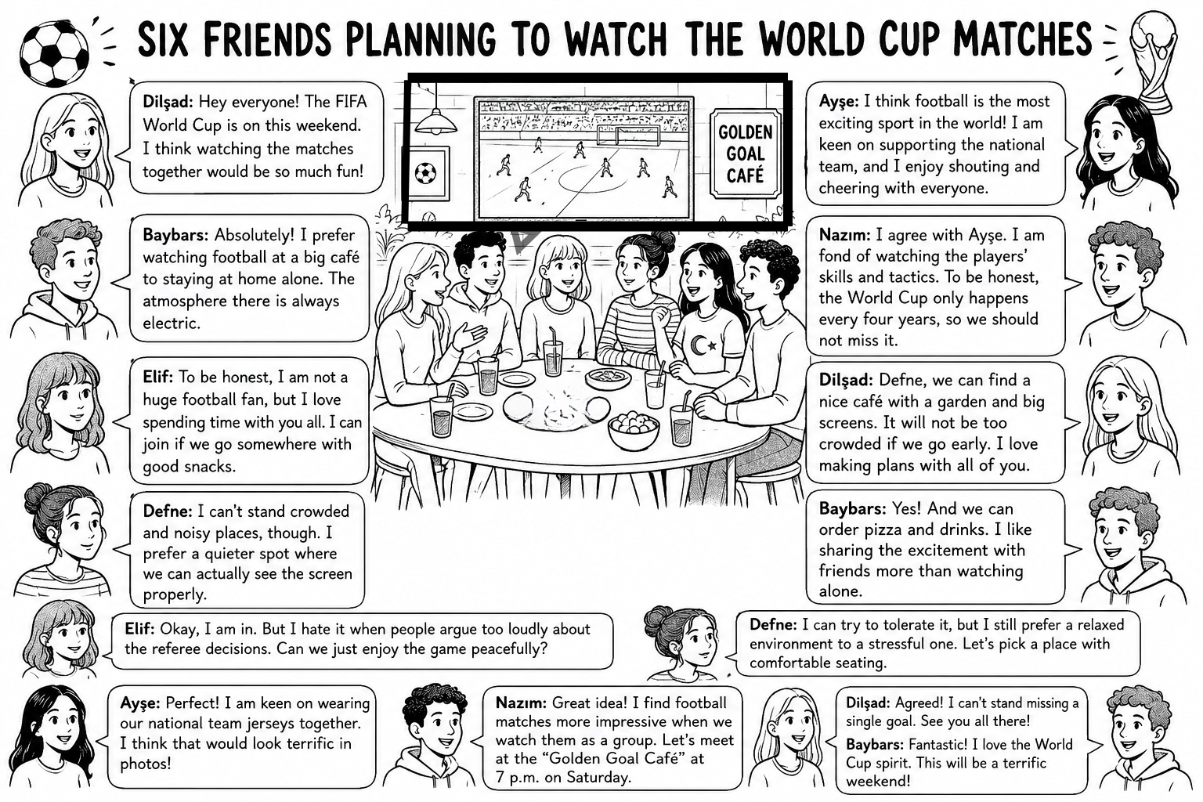

SECTION 2: CONTEXTUAL GAP FILLING

Read the text and fill in the blanks with the correct words from the box.
unbearable / trendy / terrific / keen on / prefer / snob / casual

Hi! I'm Molly. I'm a typical teenager, and I love spending time with my friends. I am (1) __________ playing volleyball and I practice every day after school. When it comes to music, I (2) __________ listening to pop because I think it is (3) __________. However, my best friend Zeynep thinks pop is (4) __________ and she only listens to classical music. She only wears (5) __________ clothes and she never talks to my other friends. I think she acts like a (6) __________ sometimes. I prefer (7) __________ style because it is more comfortable.

SECTION 3: CONTEXTUAL MULTIPLE-CHOICE QUESTIONS (LGS STYLE)
Choose the best option to complete the dialogue or answer the question.
- Sam: What do you think about heavy metal music?
Mert: __________, I find it unbearable. I can't stand it. I prefer slow songs.
A) To be honest
B) I hope so
C) That's a great idea
D) I'm fond of it
- Elly: What kind of clothes do you like?
Zeynep: I like __________ clothes because they are comfortable. I don't like formal wear.
A) trendy
B) casual
C) impressive
D) ridiculous
- Selin: She always follows the latest fashion, and she wears modern styles.
Mert: So, she is __________.
A) serious
B) unbearable
C) trendy
D) ridiculous
- Read the comments about Deniz:
  - Ece: He has amazing hobbies like caving and scuba diving.
  - Zeynep: His taste in music is terrible. He only listens to unbearable songs.
  - Kaan: He is serious about his studies, and he never jokes.
Who says something NEGATIVE about Deniz's interests?
A) Ece
B) Zeynep
C) Kaan
D) None
- Mert invites Burak to a jazz concert. Burak accepts the invitation.
Which of the following can be Burak's answer?
A) No, thanks. I'm full.
B) I'd love to come. I am keen on jazz music.
C) To be honest, I find jazz unbearable.
D) That sounds ridiculous!

- TABLE ANALYSIS: Teenagers' Music Preferences
Name | Music Preference | Opinion
Marry | Pop | Terrific
Burak | Rock | Unbearable
Deniz | Classical | Impressive
Zack | Pop | Trendy
According to the table, who has a POSITIVE opinion about their preferred music?
A) Marry and Deniz
B) Burak and Zack
C) Mary and Burak
D) Deniz and Zack
Activity | Percentage
Listening to Music | 55%
Doing Sports | 25%
Doing Homework | 15%
Other | 5%
- GRAPH ANALYSIS: Favorite Free Time Activities Among Teenagers

According to the survey results, teenagers __________.
A) find doing sports unbearable
B) prefer listening to music to other activities
C) are more keen on homework than music
D) think sports are ridiculous
- Josef : How often do you go to the theatre?
David: __________. I can watch a play about once a year
A) Always
B) Usually
C) Rarely
D) Often
- Which of the following is most likely to be "RIDICULOUS" for a teenager?
A) A terrific concert
B) A trendy outfit
C) An impressive book
D) An unbearable and bad song
- Katy: Why do you like hanging out with Tom?
Micheal: Because we have many things in common. We both __________ nature and outdoor sports.
A) prefer to
B) are keen on
C) can't stand
D) find ridiculous

SECTION 4 :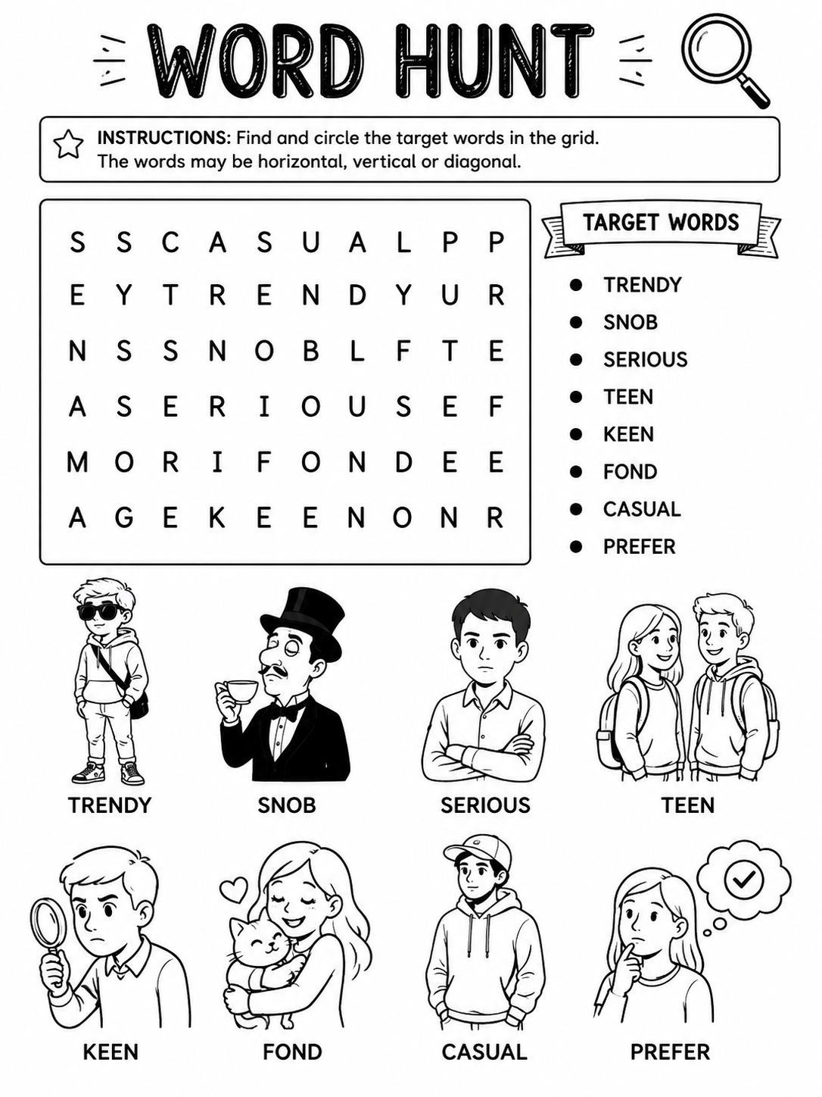
SECTION 5: COMMUNICATIVE TASK-BASED SPEAKING & WRITING
A) SPEAKING TASK – "FIND YOUR COMMON GROUND"
Goal: Interview your classmates to discover shared interests and report back to the class.
Task:
- Work in pairs. Ask your classmate these questions:
  - What kind of music do you prefer? Why?
  - How often do you listen to music or do sports?
  - Are you keen on outdoor activities?
  - What outdoor activities do you find unbearable?
- Take notes of your classmate's answers.
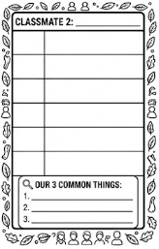
1
- Then find another classmate and repeat. Try to find at least 3 things you have in common with each classmate.
- Give a short presentation to the class like this:
“My classmate and I both prefer pop music. We are keen on camping. We find heavy metal unbearable.”
Assessment: Use at least 5 target vocabulary words from Unit 2 in your presentation.

B) WRITING TASK – "REPLY TO AN INVITATION"
Goal: Write an email responding to an invitation using the target vocabulary and structures from Unit 2.
Task:
- You have an invitation to a rock concert.
- Write a short email (25–30 words) in which you:
  - Accept or refuse the invitation.
  - If you refuse, give a school excuse (e.g., exam, project, course).
  - State your opinion about rock music (use words like prefer, fond of, unbearable, ridiculous, terrific, impressive, serious).
- Use at least 5 target words from Unit 2 vocabulary list.
- Start your email with: “Thanks for the invitation to the rock concert. ...”
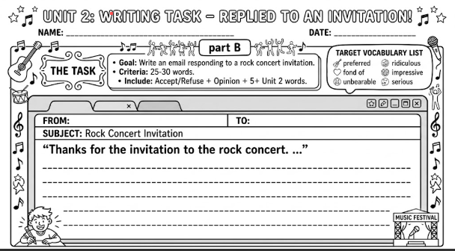
Dear ………………………,
SECTION 6:
SONG ACTIVITY  "UNWRITTEN" THEME by Natasha Bedingfield**
**We do not provide the lyrics due to copyright, but we will work on the theme and meaning of the song.

- PRE-LISTENING

- Title Prediction: The song is called "Unwritten". What do you think this title means? What in your life is "unwritten"? Write down two ideas.
…………………………………………………………………………….
- Vocabulary Prediction: Which of these words do you think you will hear in the song? Tick (✓) and explain why.
  - beginning
  - future
  - choices
  - mistakes
  - dreams
- Unit 2 Connection: How does the idea of "unwritten" relate to being a teenager? Write one sentence using a Unit 2 word.
…………………………………………………………………………..

B) WHILE-LISTENING
Listening 1 (General understanding): What is message of the song? Choose one and write why.
- Teenagers should have fun with friends.
- We can shape our own lives, and nothing is fixed.
- Music is an important part of life.
- Her English notebook is unwritten.
Listening 2 (Key ideas): Complete these sentences based on what you understand from the song (not the exact lyrics).
- The singer describes life as a __________.
- She says we can write our own story with our own __________.
- She says nobody else can __________ for you.

C) POST-LISTENING
- Discussion :
  - Which message in the song inspires you the most? Why?
- Vocabulary Use: Complete these sentences with target words from Unit 2.

  - I am __________ exploring new hobbies and discovering myself.
  - To be __________, I think being a teenager is the best time of life.
SECTION 7:

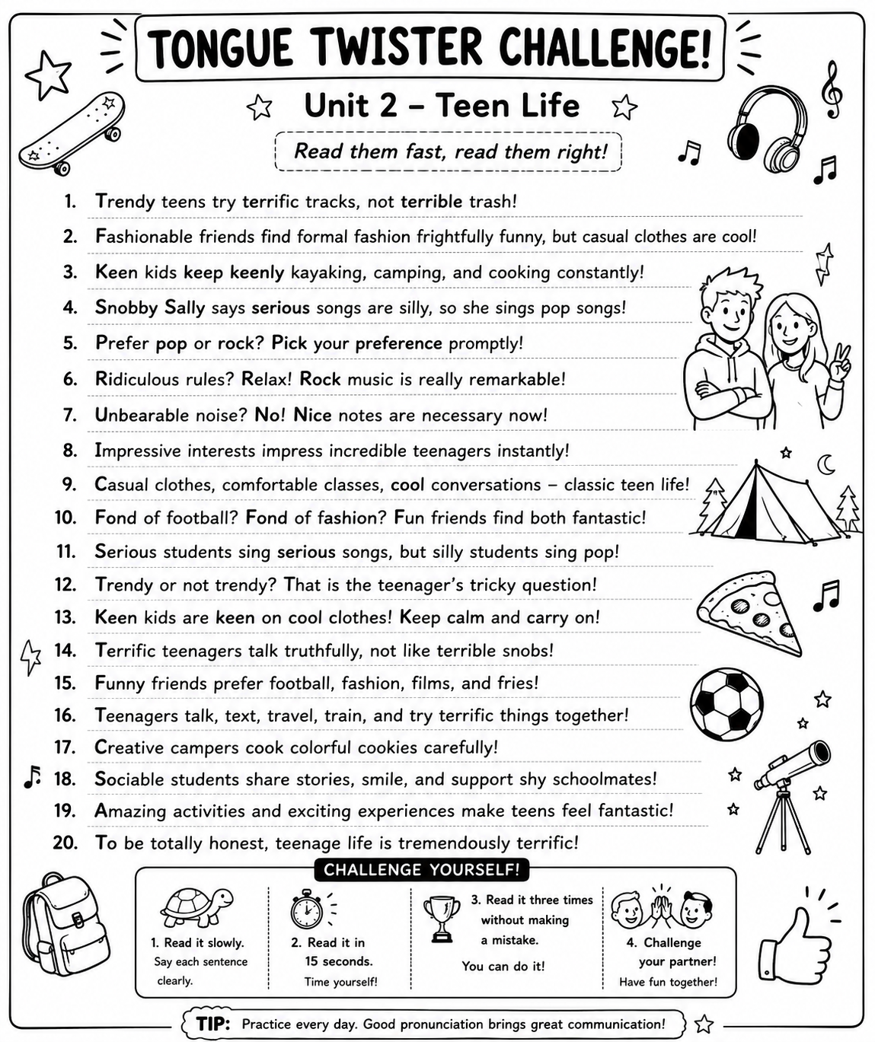

Detailed Answer Key for Teachers – Unit 2 Teen Life
SECTION 2: CONTEXTUAL GAP FILLING – Answer Key
1. keen on Explanation: "am keen on" is followed by a gerund (-ing form) and expresses strong interest.
2. prefer Explanation: "prefer" expresses a choice between two or more options.
3. terrific Explanation: Ece expresses a positive opinion about pop music using "terrific" (wonderful/great).
4. unbearable Explanation: This expresses a strong negative opinion – something that cannot be tolerated.
5. trendy Explanation: Describes Zeynep's fashion as fashionable/modern.
6. snob Explanation: Someone who thinks they are superior and often rejects social contact.
7. casual Explanation: Ece prefers comfortable, informal clothing.
SECTION 3: CONTEXTUAL MULTIPLE-CHOICE QUESTIONS – Answer Key with Explanations
QUESTION 1 Correct Answer: A) To be honest
Explanation:
In this dialogue, Sam asks Mert for his opinion about heavy metal music. Mert responds by saying he finds it unbearable and can't stand it. The phrase "To be honest" is the most appropriate choice because it is commonly used to introduce a personal opinion, especially when expressing a negative or strong feeling. The other options do not fit the context: "I hope so" is used to express a wish about future events, "That's a great idea" is used to agree with a suggestion, and "I'm fond of it" expresses a positive feeling, which contradicts Mert's negative opinion about heavy metal.

QUESTION 2
Correct Answer: B) casual
Explanation:
Zeynep explains that she likes a certain type of clothing because it is comfortable, and she explicitly states that she does not like formal wear. "Casual" refers to informal, comfortable clothing that is not formal or dressy. This directly matches her description. The other options are incorrect: "trendy" refers to fashionable clothing that follows the latest styles, which can sometimes be uncomfortable; "impressive" describes something that causes admiration; and "ridiculous" describes something absurd or silly, neither of which relates to the comfort aspect mentioned.

QUESTION 3
Correct Answer: C) trendy
Explanation:
Selin describes a person who "always follows the latest fashion" and "wears modern styles." The word "trendy" means being in fashion or following the latest styles, which perfectly describes this person. Mert correctly concludes that this person is "trendy." The other options do not match: "serious" refers to being solemn or not joking; "unbearable" means intolerable or impossible to stand; and "ridiculous" means absurd or foolish.

QUESTION 4
Correct Answer: B) Zeynep
Explanation:
The question asks who says something NEGATIVE about Deniz's interests. We need to analyze each person's comment:
- Ece says Deniz has "amazing hobbies like caving and scuba diving." This is clearly a positive comment.
- Zeynep says his taste in music is "terrible" and he only listens to "unbearable songs." This is negative because she uses words that express strong dislike and criticism. Therefore, Zeynep's comment is the negative one.
- Kaan says Deniz is serious about his studies and never jokes. While this might not be positive, it is a neutral observation about his personality, not a negative statement about his interests.

QUESTION 5
Correct Answer: B) I'd love to come. I am keen on jazz music.
Explanation:
The question states that Mert invites Burak to a jazz concert, and Burak accepts the invitation. Option B is the only answer that shows acceptance: "I'd love to come" expresses willingness to accept the invitation, and "I am keen on jazz music" provides a logical reason (he likes jazz, so he wants to attend). The other options show refusal or negative opinions: "No, thanks. I'm full" is an inappropriate response to an invitation; "To be honest, I find jazz unbearable" expresses a negative opinion and implies refusal; "That sounds ridiculous!" is a negative reaction that shows disapproval.

QUESTION 6
Correct Answer: A) Marry and Deniz
Explanation:
We need to identify who has a POSITIVE opinion about their preferred music. Analyzing the table:
- Marry prefers Pop and describes it as "Terrific" (meaning wonderful/great - POSITIVE)
- Burak prefers Rock and describes it as "Unbearable" (NEGATIVE)
- Deniz prefers Classical and describes it as "Impressive" (POSITIVE)
- Zack prefers Pop and describes it as "Trendy" (neutral/positive - trendy means fashionable, but it's more of a description than an opinion about the music itself)
The question asks for those with a POSITIVE opinion about their preferred music. Both Marry and Deniz express clear positive opinions with "terrific" and "impressive." Zack's "trendy" is less clearly a positive opinion and more a description of the music's popularity. Therefore, the correct answer is Marry and Deniz.

QUESTION 7
Correct Answer: B) prefer listening to music to other activities
Explanation:
Analyzing the graph data:
- Listening to Music: 55%
- Doing Sports: 25%
- Doing Homework: 15%
- Other: 5%
The data clearly shows that "Listening to Music" has the highest percentage (55%), meaning teenagers prefer this activity over all others listed. Option B correctly states that "teenagers prefer listening to music to other activities." The other options are incorrect: A) "find doing sports unbearable" - the 25% is not a negative percentage and doesn't indicate they find it unbearable; C) "are more keen on homework than music" - the data shows homework has only 15% compared to music's 55%, which is the opposite; D) "think sports are ridiculous" - there is no evidence for this claim in the data.

QUESTION 8
Correct Answer: C) Rarely
Explanation:
The context is David responding to Josef's question about how often he goes to the theatre. David says, "I can watch a play about once a year." Going to the theatre once a year means he does not go very often. "Rarely" means not occurring very often; it describes something that happens infrequently. The other options are incorrect: "Always" means every time or all the time (opposite of once a year); "Usually" means most of the time (also too frequent); "Often" means frequently (contradicts once a year).

QUESTION 9
Correct Answer: D) An unbearable and bad song
Explanation:
The question asks which of the following is most likely to be considered "RIDICULOUS" for a teenager. We need to understand the meaning of "ridiculous" (absurd, silly, laughable). Among the options:
- A) A terrific concert - "terrific" means great, so this is positive and not ridiculous
- B) A trendy outfit - "trendy" means fashionable, which is generally desirable
- C) An impressive book - "impressive" means admirable, a positive thing
- D) An unbearable and bad song - this describes something that is both unpleasant and of poor quality. A teenager might find a terrible song laughable or absurd, especially if it's considered popular but is actually bad quality. This is the most likely scenario to be described as "ridiculous."

QUESTION 10
Correct Answer: B) are keen on
Explanation:
Katy asks Micheal why he likes hanging out with Tom. Micheal responds that they have many things in common and mentions a shared interest. The sentence "We both ______ nature and outdoor sports" requires a phrase that expresses a positive interest or liking. "Are keen on" is the correct phrase because it means "are interested in" or "like very much" and is followed by a noun/gerund. The other options: "prefer to" is incomplete (needs another element for comparison or a verb); "can't stand" means strongly dislike (contradicts the positive context); "find ridiculous" means think is silly (negative, not appropriate here).

SUMMARY TABLE
Question | Correct Answer | Key Vocabulary Focus
1 | A) To be honest | Expressing opinions
2 | B) casual | Types of clothing/style
3 | C) trendy | Fashion vocabulary
4 | B) Zeynep | Identifying positive/negative opinions
5 | B) I'd love to come... | Accepting invitations / expressing preferences
6 | A) Marry and Deniz | Interpreting opinions from a table
7 | B) prefer listening to music... | Interpreting graph data
8 | C) Rarely | Frequency adverbs
9 | D) An unbearable and bad song | Understanding "ridiculous"
10 | B) are keen on | Expressing likes/preferences

COMMON STUDENT ERRORS TO WATCH FOR
- Question 1: Students might confuse "To be honest" with other opinion expressions. Remind them it's used to introduce personal, often strong opinions.
- Question 3: Students may confuse "trendy" with "casual." Emphasize that "trendy" relates to following fashion, while "casual" relates to being comfortable/informal.
- Question 4: Students need to carefully distinguish between comments about hobbies/interests versus comments about personality.
- Question 7: Students sometimes misread graph percentages. Teach them to always check the highest percentage for preferences.
- Question 10: Students often confuse "prefer to" (which needs a verb or comparison) with "prefer" (simple form). Practice the structure: "prefer + noun/gerund to + noun/gerund."
SECTION 4 :Answer Key
Word | Direction | Starting Position (Row, Column)
CASUAL | Horizontal | Row 1, Column 3
TRENDY | Horizontal | Row 2, Column 3
SNOB | Horizontal | Row 3, Column 1
SERIOUS | Horizontal | Row 4, Column 2
FOND | Horizontal | Row 5, Column 6
KEEN | Horizontal | Row 6, Column 4
TEEN | Vertical | Row 1, Column 9
PREFER | Vertical | Row 1, Column 8
Location Details
- CASUAL: Found horizontally in the first row.
- TRENDY: Found horizontally in the second row.
- SNOB: Found horizontally in the third row, starting from the first column.
- SERIOUS: Found horizontally in the fourth row, starting from the second column.
- FOND: Found horizontally in the fifth row, starting from the sixth column.
- KEEN: Found horizontally in the sixth row, starting from the fourth column.
- TEEN: Found vertically in the ninth column, starting from the first row.
- PREFER: Found vertically in the eighth column, starting from the first row.
SECTION 5: COMMUNICATIVE TASK-BASED SPEAKING & WRITING
A) SPEAKING TASK – "FIND YOUR COMMON GROUND"
Sample Interview Dialogue (for teacher reference):
Student A: What kind of music do you prefer? Why?
Student B: I prefer pop music because I find it terrific. What about you?
Student A: I'm also keen on pop music. I find it impressive.
Student B: How often do you listen to music?
Student A: I listen to music every day. Are you keen on outdoor activities?
Student B: Yes, I am very keen on camping and hiking.
Student A: What do you find unbearable?
Student B: I find heavy metal music unbearable. Do you think you are a fashionable person?
Student A: I think I'm quite trendy. I like following fashion.
Sample Presentation:
"My classmate and I both prefer pop music. We are keen on camping and outdoor activities. We find heavy metal music unbearable. We also think casual style is more comfortable than formal wear. To be honest, we enjoy spending time together because we have many interests in common."
Assessment Guide for Speaking Task (use symbols):

★ (Star) – Excellent
- Uses 5 or more target vocabulary words correctly.
- Uses several target structures naturally.
- Speaks fluently with very few hesitations.
- Finds 3 or more common interests with the classmate.
- Understands all questions without needing help.

+ (Plus) – Good / Satisfactory
- Uses 3–4 target vocabulary words correctly.
- Uses some target structures, with minor errors.
- Speaks with some pauses but meaning is clear.
- Finds 1–2 common interests.
- Understands most questions, may need occasional help.

! (Exclamation) – Needs Improvement / More Practice
- Uses fewer than 3 target vocabulary words.
- Rarely uses target structures.
- Frequent hesitations that make communication difficult.
- Finds no common interests.
- Struggles to understand questions even with help.
----------------------------------------------------------------

B) WRITING TASK – "REPLY TO AN INVITATION"
Sample Acceptance Answer:
"Thanks for the invitation to the rock concert. I'd love to come! To be honest, I am fond of rock music and find it terrific. I really enjoy listening to it. See you there!"
(27 words – uses: fond of, terrific, to be honest, enjoy, love)
Sample Refusal Answer:
"Thanks for the invitation to the rock concert. Unfortunately, I can't come because I have a serious exam. I find rock unbearable. I prefer pop music. Sorry!"
(26 words – uses: serious, unbearable, prefer, can't come, sorry)
Alternative Refusal Answer:
"Thanks for the invitation to the rock concert. I'm afraid I can't join you. I have to study for a project. To be honest, rock is unbearable to me. I prefer classical music."
(27 words – uses: unbearable, prefer, to be honest, can't join, afraid)
Assessment Guide for Writing Task (use symbols):

★ (Star) – Excellent
- All parts of the task are clearly addressed (accept/refuse, excuse, opinion).
- Uses 5 or more target vocabulary words correctly.
- No significant grammar or spelling errors.
- Proper email format with greeting and closing.
- Length is around 25–35 words.

+ (Plus) – Good / Satisfactory
- Most parts of the task are addressed.
- Uses 3–4 target vocabulary words correctly.
- A few minor grammar or spelling errors, but meaning is clear.
- Email format is mostly correct.
- Length is around 20–24 words.

! (Exclamation) – Needs Improvement / More Practice
- Key parts of the task are missing.
- Uses fewer than 3 target vocabulary words.
- Many grammar or spelling errors that affect understanding.
- No proper email format.
- Length is under 15 words or far over the limit.

SECTION 6: SONG ACTIVITY – "UNWRITTEN" THEME

A) PRE-LISTENING – Model Answers
1. Title Prediction (accept any reasonable predictions):
- "Unwritten" suggests something that hasn't been decided or recorded yet.
- Our lives are like blank pages that we fill with our own choices and experiences.
- My future plans are "unwritten" because I haven't decided what career I want yet.
- The story of my teenage years is still being written.
2. Vocabulary Prediction (students should explain their choices logically):
- beginning – The song likely talks about starting something new.
- future – "Unwritten" relates to what will happen later.
- choices – We write our own story through our decisions.
- mistakes – Part of "writing" our life includes learning from mistakes.
- dreams – The song might inspire us to follow our dreams.
3. Unit 2 Connection – Sample sentences:
- "Being a teenager is a time when our identity is still unwritten, and I think that's a terrific opportunity to discover ourselves."
- "I am keen on exploring new things because my future is unwritten."
- "To be honest, it's impressive to think that our lives are unwritten."
B) WHILE-LISTENING – Answer Key
Listening 1 (General understanding) – Correct answer:
We shape our own lives, and nothing is fixed.
Explanation: The song's central message is about empowerment, self-determination, and the idea that life is a blank page we can fill ourselves.
Listening 2 (Key ideas) – Suggested completions (based on theme):
- The singer describes life as a blank page / open book / unwritten story.
- She says we can write our own story with our own choices / words / dreams.
- She says nobody else can write / decide / live for you.
----------------------------------------------------------------
C) POST-LISTENING – Discussion & Vocabulary
Discussion questions – Model answers:
- Which message inspires you most?
"The message that inspires me most is that I control my own future. As a teenager, I sometimes feel pressured by expectations, but this song reminds me I can make my own choices."
Vocabulary Use – Suggested completions (accept any logical answer):
- - I am keen on/fond of exploring new hobbies and discovering myself.
ADDITIONAL TEACHER NOTES – Common Errors & Differentiation
Common Student Errors to Watch For:
1. "Keen on" vs. "Prefer"
- Wrong: I keen on music.
- Correct: I am keen on music. / I am keen on listening to music.
- Wrong: I prefer listen to pop.
- Correct: I prefer listening to pop. / I prefer pop to rock.
2. Word Form Confusion
- Wrong: I am impress of the concert.
- Correct: I find the concert impressive.
3. Using "prefer" with "than"
- Wrong: I prefer pop than rock.
- Correct: I prefer pop to rock.
4. Casual vs. Trendy
- Casual = comfortable/informal
- Trendy = fashionable/modern
- Students sometimes confuse these as synonyms.
----------------------------------------------------------------
Extension Activities for Advanced Students (optional):
1. Vocabulary Journal: Have students find 5 more words related to music, fashion, or hobbies and create their own vocabulary entries.
2. Debate Topic: "Teenagers should plan their future carefully" vs. "Teenagers should let their future be unwritten."
3. Writing Extension: Write a paragraph describing your ideal weekend, using at least 8 target vocabulary words.
4. Role-Play: Create a dialogue between two teenagers who have opposite opinions about something (music, fashion, activities).
----------------------------------------------------------------
Differentiation Suggestions:
For Lower-Level Students:
- Provide sentence starters for the speaking task.
- Reduce vocabulary requirement to 3 words for writing task.
- Allow Turkish-English dictionary use.
- Pair with stronger students.

For Higher-Level Students:
- Require 8+ vocabulary words in tasks.
- Ask for more complex sentence structures.
- Encourage original vocabulary beyond the list.
- Add a creative writing component.
Bence en doğrusu, her çalışma kağıdında 2-3 sayfalık hukuki metin yerine tek sayfalık, okunabilir ve hukuken temkinli bir bildirim kullanmak. Aşağıdaki metin; 5846 sayılı FSEK ile uyumlu, gereğinden fazla iddiada bulunmayan ve eğitim materyalleri için profesyonel bir dildir.

TELİF HAKKI, KULLANIM İZNİ, YAPAY ZEKÂ BEYANI VE SORUMLULUK REDDİ
DYK WORKSHEET BY BİLGE SİMURG – Unit 2 adlı bu çalışma kağıdı, Büşra ABBASOĞLU (Bilge Simurg Eğitim Sayfası) tarafından eğitim-öğretim amacıyla hazırlanmıştır. Materyalin özgün metinleri, etkinlik kurgusu, soru yapıları, pedagojik düzeni ve nihai editöryal çalışması eser sahibine aittir ve 5846 sayılı Fikir ve Sanat Eserleri Kanunu kapsamında korunan kısımlar için ilgili yasal hükümler uygulanır.
Bu materyalin hazırlanmasında üretken yapay zekâ araçlarından içerik geliştirme, görsel oluşturma ve tasarım desteği alınmıştır. Ancak tüm içerikler eser sahibi tarafından incelenmiş, doğrulanmış, düzenlenmiş ve eğitim programına uygun hâle getirilmiştir. Nihai içerik ve editöryal sorumluluk eser sahibine aittir.
Bu çalışma kağıdı öğretmenler ve öğrenciler tarafından eğitim ve bireysel öğrenme amacıyla kullanılabilir. Ticari amaçla çoğaltılması, satılması, izinsiz yeniden yayımlanması, dijital ortamlarda kaynak gösterilmeksizin paylaşılması veya değiştirilerek eser sahibinin izni olmadan yeniden dağıtılması uygun değildir.
Bu materyalde yer alan eser, sanatçı, marka veya şarkı adları yalnızca eğitim ve referans amacıyla kullanılmıştır. Şarkı sözlerinin tamamı paylaşılmamış olup ilgili eserlerin telif hakları hak sahiplerine aittir. Kullanılan yapay zekâ görselleri eğitim amaçlı illüstrasyon niteliğindedir; gerçek kişi, kurum veya olayları temsil etme amacı taşımaz.
Bu çalışma kağıdı özenle hazırlanmış olmakla birlikte, olası hata veya güncellik farklılıklarından dolayı kullanıcıların gerekli akademik ve mesleki değerlendirmeyi yapmaları önerilir.
© 2026 B. ABBASOĞLU – Bilge Simurg Eğitim Sayfası. Tüm hakları saklıdır.
Bu metni istersen daha kurumsal, daha resmî veya çalışma kağıdının alt kısmına sığacak şekilde 100–120 kelimelik "mini telif bildirimi" formatında da hazırlayabilirim. Bu kısa sürüm, özellikle PDF çalışma kağıtlarında çok şık duruyor.

