Overview of Activities

1hr 20 mins minutes total

Lesson Plan

Panau Latrine Program Introduction

1. Introduction
2. Data Collection
3. PESTLE Analysis
4. Review

Learning Outcomes

At the end of this session, the participants will be able to:

1. Describe the weather patterns, health of the population, latrine behaviours and political environment in Panau.
2. Identify the overall goal for the Panau latrine program.

Materials and Preparation

* 1 flip chart paper and some markers per group
* Prepare: Copies of the 8 ‘resident cards’ (printed to put onto wall)
* Prepare: Tape ‘resident cards’ around the room
* Handout: Copies of the PESTLE Analysis handout (1 per group)

Recommended Reading

* Review the 8 ‘resident cards’ (rice farmer, settlement chief, health care worker, mother, father, newspaper, shop owner, pit emptier)
* PESTLE Analysis handout

**10 minutes**

**Introduction**

1. Ask participants to divide into 5 small groups of 5-6 people. Participants will be working in these groups often throughout this workshop. Alternatively, you can predetermine the groups prior to this session and move people into their groups as needed based on experience, leadership skills, and needs.

**Trainer Tip**

Moving forward all lesson plans will refer to these groups as ‘Panau Groups’

1. Once in their small groups inform the teams that they will have 2 minutes to decide on a group name. This name will be used for the remainder of the workshop.
2. Once the two minutes are completed, ask the groups to share their names. Record the names so that you can refer to them during the workshop.
3. Explain that for this workshop CAWST has created a fictional story about a city called Latrina and a squatter settlement called Panau, located on the outskirts of the city. Explain that during the workshop, in their Panau groups, they will be asked to make decisions for a latrine program that they are designing and developing as if they were going to implement and monitor it.
4. Explain that they work for an NGO call “Do No Harm” (DNH) and that they have been tasked with designing a latrine program for the Panau settlement. They have one year to design, develop, implement and monitor their program, with the possibility to extend. DNH has received some funding for the program, which is enough to start, but they know it will not fund the whole program.
5. Present the learning outcomes or an overview of the lesson.

**30 minutes**

**Data Collection**

1. Tell participants that they are going to participate in a scenario.
2. Explain the scenario as follows: “Today you and your latrine program design team have travelled to Panau from Latrina. Most of you have never visited a squatter settlement and aren’t sure what to expect. You have a couple hours this morning to walk around and explore the community before you meet with the Panau chief. On your team walk, it is decided that you will each meet with a local resident of Panau to gather information that will inform the program design. You and your team will need to consider external factors and their potential impact in terms of starting a latrine program in Panau. Your team will want to consider political, economical, sociological, technological, legal and environmental factors.”
3. Explain that in this activity residents will be represented by cards that tell their stories.
4. Explain the two important rules:
   * Participants can send 1 group member to each resident’s card to get clues
   * Each group member can only interact with 1 Panau resident card at a time
   * If there are more ‘resident cards’ than group members, instruct groups to assign a second ‘resident card’ to group members so that all ‘resident cards’ are read.
5. Explain that they will be given a maximum of 10 minutes to gather information.

*Trainer Tip: Encourage group members to take notes, they could also take a picture of the resident card with their phone. You could show the group the PESTLE Analysis first so they know what kind of information they are trying to collect.*

**Trainer Tip**

The overarching goal for Panau’s latrine program is for households and communities to install and use latrines correctly, consistently, and continually.

1. Give the groups a list of the available ‘resident cards’ to interact with and allow them 5 minutes to develop a strategy of how they will collect information before they start.
2. Invite group members to go and collect information.
3. After the allotted time, ask the group members to return to their Panau groups.

**30 minutes**

**PESTLE Analysis**

1. Handout a copy of the PESTLE Analysis handout and a piece of flip chart paper to each group.
2. Instruct groups to create a large version of the PESTLE Analysis table on their flip chart.
3. Explain that group members now have 10 minutes to share the information they collected with their group members. Explain that group members should write factors they identified under the appropriate element.
4. Inform groups that they now have another 10 minutes to discuss and document the possible impacts these factors might have on their latrine program in Panau.
5. Once the allotted time has been completed, ask the larger group “What further questions do you have?” “What other information do you feel you are lacking or do you want to know more about?” Record these questions or thoughts on a flip chart paper.
6. Inform the group that some of these questions will be answered as we progress through the workshop. Take the time to recognize and value how they are feeling right now, wanting to know more and wanting to better understand the who, what, why, when, where and how is essential and productive for a latrine program.

**10 minutes**

**Review**

1. Have all groups place their PESTLE Analysis flip charts on the wall around the room, invite participants to move around the room looking at the other groups’ flip charts, give the group 5 minutes.
2. Explain that as they move from paper to paper they should be thinking about possible feedback they might give to other groups or identify something new that their group didn’t discuss.
3. At the end of 5 minutes, invite participants to share one new idea or piece of feedback about the PESTLE Analyses that they reviewed.

|  |  |
| --- | --- |
| This resource is open content and licensed under a [Creative Commons Attribution-ShareAlike 4.0 International License](https://creativecommons.org/licenses/by-sa/4.0/). Refer to CAWST’s guidelines for distributing, translating, adapting, or referencing CAWST resources ([resources.cawst.org/cc](https://resources.cawst.org/cc)). |  |

Rice Farmer

|  |  |
| --- | --- |
| person wearing brown straw hat while planting rice selective focus photography  <https://unsplash.com/photos/3u51-uLQICc> | * I have been a rice farmer on these lands for many years. * Farm life is controlled by the weather and the timing of the rice harvest. It’s hard work, but it provides food and income for my family and some of the people in Panau. * My family used to own much of this land until the government started declaring it as property of Latrina. When the first group of indigenous people started moving into the city, my father allowed them to set up camp here because many of them were also rice farmers and he needed the help. * Since then Panau hasn’t stopped growing. Many people have lost their fields or have been forced out of their homes due to logging and clearing of the rain forests. They move towards the city and hope for a better life. * The deforestation has caused many issues like landslides, soil erosion, flooding, and fewer crops. * Cultivating rice is the most available route to financial stability in Panau. It’s tough work, but it means that usually poorer members of the community who have no land can still generate an income and we can save the stalks to feed our cows. * Space is limited in Panau for fields, so many of the community still have to find work in the city, if they are lucky. * Clean water means healthy rice, I feel frustrated when I see people defecating in my rice fields. It is stinky and it pollutes my fields. * Me and my workers always walk to the latrines to defecate, but it takes a lot of time and when people are sick with diarrhea they don’t always get there fast enough. It would be nice to have a latrine close by. |

Settlement Chief

|  |  |
| --- | --- |
| women's white and purple striped headscarf  <https://unsplash.com/photos/WPD5yORDwdg> | * As the settlement chief my people trust me and look to me to keep us safe and to do what is best for our people. * Many of the people living in Panau are from poor rural areas, they tried to move to the city, but couldn’t afford to buy or rent a property there. * They hope that by moving closer they would find work, safety, better education and health, but the distance, high cost, and poor roads make travel to the city difficult and time consuming. * Squatter settlements are residential areas that have developed without a legal claim to the land or without permission from the local authorities. So, the Ministry of Urban Development usually ignores us or removes us from the land. They won’t provide any funding for improvements or service delivery. * In 2003 when Helping Hands of Dignity (HHD) first came to Panau they came to me for permission to work in our settlement. They talked about improving our health which would lead to a better economy and development, but nothing changed. * I have noticed that my people have been getting sicker with each rainy season, more flooding, water contamination, and infections. It seems to get worse as more people arrive. * This puts us in a difficult situation because I know we have to do something to improve the health of my people but I am struggling to trust the new NGO. HHD built latrines that were weak, and filled quickly with no services to help. * I am not sure more latrines will solve the problems we are having anyways, since many of my community choose open defecation or to dismantle the latrine materials for fire wood, storage, or to build what they really need. * I like to have a clean latrine for when visitors come, so I lock the one close to me and tell everyone they can’t use it. I’ve been told it is important to use a latrine, but I don’t always remember and sometimes it isn’t convenient, so I defecate in the open |

Community Healthy Worker

|  |  |
| --- | --- |
| four women standing near white-and-blue sack outdoor  <https://unsplash.com/photos/AyflGfRL9OA> | * Hello my name is Mary and I am a community health worker in Panau. * My role is to interact with the community and to help patients and families understand their health. * I have been told that I am a “critical link” between the community and the health care system, but I often don’t feel very important, useful or effective. * I have been noticing that during the summer monsoon season diseases like cholera, dengue, typhoid, malaria, and eye infections have been increasing. My colleagues believe that open defecation is causing surface water to be polluted. * I advise everyone that they should be boiling their water before they drink it and washing their hands frequently, but not everyone listens. * I tell everyone that diarrhea is very dangerous because if people don’t get rehydrated quickly they can die of dehydration. * I use a latrine always even if they are dirty because I want to show my community that they are better for our health. * The medicine and rehydration salts that they need to buy are expensive for them. Some people buy medicine and have no money left for anything else. * With more and more people moving into Panau we need better sanitation or water treatment options because our living situation isn’t going to change any time soon. |

Father

|  |  |
| --- | --- |
| white and red concrete building  <https://unsplash.com/photos/juET0JFrLGw> | * My name is Bertrum, I live in this home I made with my father out of scavenged wood and corrugated sheet metal. * I live here with my wife, two children, and my elderly parents. * We have a latrine nearby our home, but it was poorly constructed. They should have used better quality materials, like tin roofs and doors. These latrines are not built to last. The pit is filling up and the smell is very strong. * My wife tries to clean the latrine, but it requires that she carry water from the community borehole. It takes time away from her work at home. So we decided it is not worth the trouble and mostly continue to defecate in the open. * Last year our son got very sick with diarrhea and we started to wonder if using the latrine would help us protect him. * My parents struggle with their weak legs and painful hips to squat and stand when defecating. My wife tries to help my mother to use a latrine, but there isn’t enough space so they have to use the outdoors. * In the rainy season, I worry about my parents slipping in the mud, and my wife says the flooding makes everything dirtier, so a latrine might be better if it was close by. * I work as a mason building homes for people in Latrina. * It isn’t easy to travel back and forth between Panau and Latrina. The roads are broken and flood during the rainy season. * In the rainy season the winds are very strong. They often blow parts of our home away and we have to find other ways to stay dry and protected. When this happens, it scares my children and I wish I could be a better provider for them. |

Shop Owner

|  |  |
| --- | --- |
| woman standing in store | * My wife and I own a little shop in Panau. It isn’t easy to sell many things because people don’t have a lot of money. * We try to sell a little bit of everything so that people will come to us when they do have money to buy things. * Usually people are willing to spend more money after the harvest because they are excited to show what they have earned. * One idea we had recently was to carry more construction supplies and hygiene products like soap. * It is hard for the builders in our community to afford tools and other equipment to build latrines. There is no subsidy for this type of investment and it can cost up to $45 USD when they are first getting started. * I have even heard of some builders and masons borrowing or renting each other’s tools in a spirit of mutual cooperation. * We heard that a new NGO might be in Panau and will be building more latrines. This could be good for us if they would buy products from us, but could also be good in the long-term if we carry products and supplies people will need to take care of the new latrines. * We don’t use a latrine because my parents and neighbors always say latrines are dirty, and pollute our environment. We also don’t have enough money to build a latrine. |

Mother

|  |  |
| --- | --- |
| Image result for mother in asia slums  <https://gfamedia.org/u/circadian_photograph/gospel-for-asia-TD10-07790.jpg> | * My name is Francis and I am a mother of four children. * My son who is 12 is different from the other kids because one of his legs doesn’t work well. This makes it harder for him to walk and squat especially in the rainy season. * The latrines near our family home have no doors and are very hard for some people to use, especially when you are menstruating and need to care for yourself. It is embarrassing to care for yourself in the open, so travel with my neighbor to the latrines and we hold up a cloth in the doorway to get some privacy and safety. * But I have heard that some women, the elderly or disabled persons, try to eat less so that they won’t need to defecate. * When the latrines were first built we were so excited because they were free, but no one told us we would have to clean them or what to do when they got full. So, we don’t do anything, that is the government’s responsibility. * My mother in-law used to complain that having a latrine near our house was inviting the bad spirits and it would pollute the water. I don’t know if this is true, but it might explain why my husband and son died. * My husband would only use the latrine for defecation. He said it was freedom to urinate in nature. He died from diarrhea and we couldn’t afford any medications. |

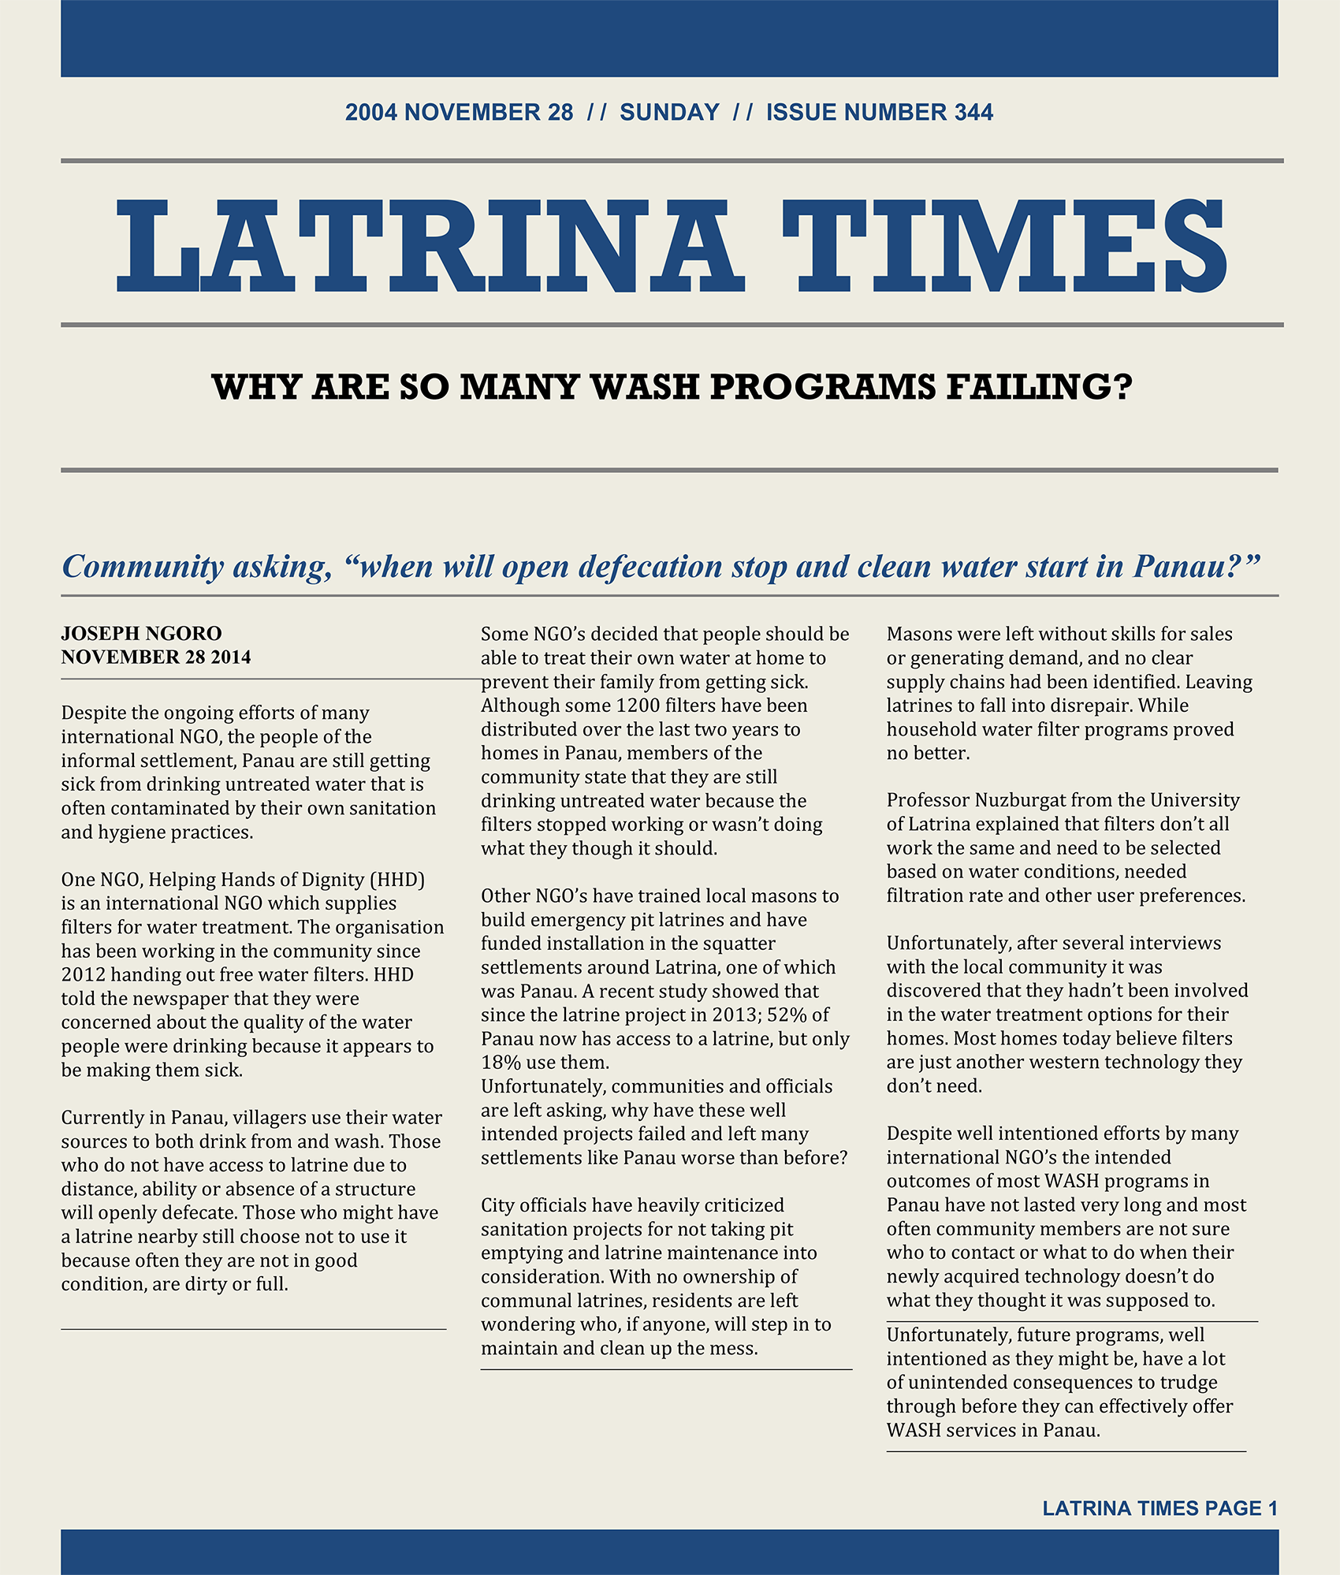

Pit Emptier

|  |  |
| --- | --- |
| Image result for Pit latrine manual emptiers | * I am one of very few emptiers in Panau. Because of the stigma, most people won’t pay us, so many of us try to find work in Latrina or we are forced to work at night. * Without steady pay most of us can’t afford basic protective gear such as gloves and boots, which means we are exposed to infections, diseases, and other dangerous waste like broken glass and garbage, especially when working directly in the pit. * Because of the dishonour and shame of our work we are often left out or shunned. Our families are rejected and ignored. What we do is important and not even the ministry, government, or public authorities recognize our efforts to keep our settlement clean and healthy. * We perform a vital role in latrine maintenance, as sludge emptying is a key activity and pits need to be emptied about every 10 months. * In squatter settlements like Panau I believe they don’t have services and infrastructures like water access, drainage, electricity, safe roads, or sanitation programs. I hear that most of the pits in Panau are currently unusable because they are full. * My friends tell me that most people in Panau practice open defecation. If they use a latrine it is shared and most people don’t care what condition the shared latrine is left in. The latrines are not connected to any sewer system which means someone has to empty them. * There are not many of us emptiers as it is a challenging job. It is difficult to access the latrines in such tight living spaces. |

|  |  |  |
| --- | --- | --- |
| **PESTLE Analysis** | | |
| **Elements** | **Factors** (data that you identified) | **Program Impact** (what is the potential impact of this factor on the program?) |
| **Political** (Government, policies, political change) |  |  |
| **Economical** (employment, taxes, financial situations, trends, industries) |  |  |
| **Sociological** (Demographics, population trends, health, education levels, relevant customs or traditions, history, current knowledge, attitudes) |  |  |
| **Technological** (access to technology, replacement options, changes) |  |  |
| **Elements** | **Factors** (data that you identified) | **Program Impact** (what is the potential impact of this factor on the program?) |
| **Legal** (human rights, legislation, ethical concerns) |  |  |
| **Environmental** (contextually relevant issues, regulations, seasonality, geographic location, weather impacts) |  |  |

Training and Consultancy. (2020). PESTLE Analysis Template. Retrieved from: <https://www.tcc-net.com/resources/templates/pestle-analysis>

|  |  |
| --- | --- |
| This resource is open content and licensed under a [Creative Commons Attribution-ShareAlike 4.0 International License](https://creativecommons.org/licenses/by-sa/4.0/). Refer to CAWST’s guidelines for distributing, translating, adapting, or referencing CAWST resources ([resources.cawst.org/cc](https://resources.cawst.org/cc)). |  |