Lesson Plan 13: Sustainable Total Sanitation **50 minutesLesson Description**



This lesson focuses on the sustainability of total sanitation after attaining it in the community and understanding the need of sustainable total sanitation. Also, the lesson plan focuses on the interventions to be considered to sustain total sanitation.

**Learning Outcomes**



By the end of this session, participants will be able to:

1. Define sustainable total sanitation
2. Understand need of sustainable total sanitation
3. Explain different things to consider to sustain total sanitation interventions

**Materials**



* Brown sheet paper
* Permanent markers
* Meta cards
* Masking tape
* Computer
* Projector

**Preparation**



* Write the session Learning Expectations on flipchart paper
* Write organogram of WASH Committee.
* Write roles and responsibilities of community to sustain TS in news print paper or prepare Power Points presentation on necessity of sustainable total sanitation and tips for it.

**Introduction 5 minutes**

1. Ask participants to write down the single habit you have changed in last year?
2. Ask two participants what habit they have changed? And what motivated them to change their habit and do it regularly?
3. Present learning outcomes of sessions.

Description: C:\Users\user\Desktop\Capture4.PNG**Sustainable Total Sanitation 5 minutes**

1. Ask participants what is sustainable total sanitation and give them 2 minutes to brain storm
2. Ask few participants to share their views.

**Understand need of sustainable total sanitation 10 minutes**

1. Description: C:\Users\user\Desktop\Capture4.PNGProvide Meta card to each participants and tell them to write why we need sustainable sanitation.
2. Description: C:\Users\user\Desktop\Capture4.PNGCollect those Meta card and put it on board. **How to sustain total sanitation 25 minutes**
3. Brain storm of participants ask them how to sustain total sanitation.
4. Note answers from participants on a flip chart paper.
5. Present the few points as tips to sustain total sanitation by trainer

**Trainer note**

1. **Use of local resources**

Use of local resources might be helpful to sustain total sanitation rather than choosing for the resources that one has to rely from distant. Ex. Use of rock and stone or wood to build infrastructure for latrine rather than relying for bricks

1. **Feeling of ownership**
2. **Coordination for Sustainable Total Sanitation**

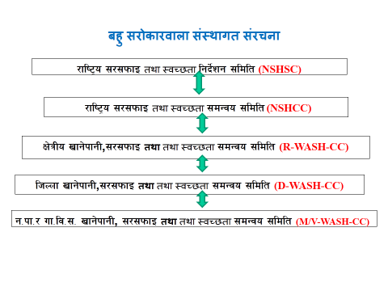Present organogram

1. **Fund Generation: Develop Sanitation fund**

We can generate community/ ward/ VDC/ Municipality/ District level WASH fund by utilizing local resources, cultural program at local festival/ Deausi vailo/ Promoting Home stay etc.

1. **Gender participation in WASH**

Make active and inclusive participation of all (Women, old aged, children, youth, and differently able peoples) in WASH from beginning of project cycle (Planning, Implementing, and Monitoring). Ensure minimum 33% women participation in every WASH committee and project team with key position. Ensure CGDE while constructing WASH hardware activities.

1. **Strength capacity of WASH committee**

* Strengthen the capacity of WASH as per need (TSC, BCC, Social Mobilization Leadership and Communication training etc)
* Regular meeting and discussion on WASH agenda and play role to bridge District and community.
* Advocacy for need base WASH issues

1. Divide roles and responsibilities to work along with making people aware

Make local people aware on total sanitation and the importance of sustaining it along with dividing the roles and responsibilities to work.

**Review 5 minutes**

* + - 1. Ask participants to make a nearby partner and ask them to share key points to sustain TS and ask to some participant about the necessity of sustaining Total Sanitation.

**Reflections on Lesson**