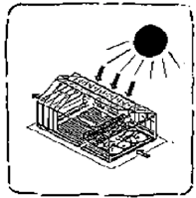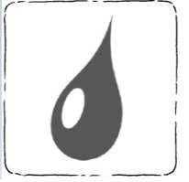

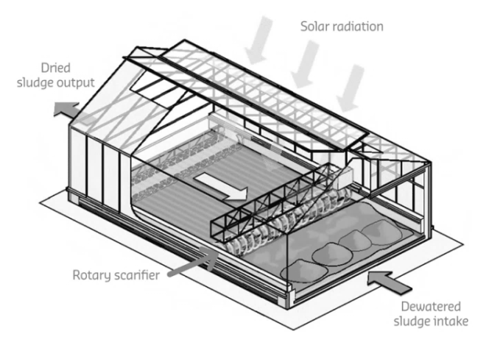

solar radiation

dewatered sludge intake

rotary scarifier

dried sludge output

*Diagram of a solar drying technology (Adapted: Suez Environment)*

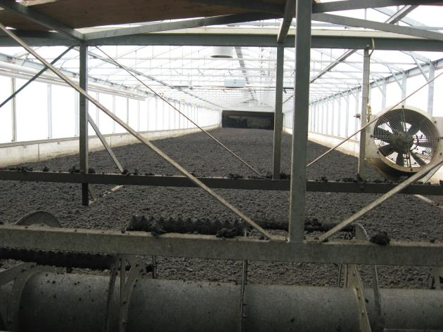

A thermal dryer used for drying wastewater sludge before combustion in Switzerland (Credit: Eawag-Sandec)

* **Design:** Thermal drying technologies remove more moisture from dewatered faecal sludge.
* **Operation:** Thermal drying technologies operate in batches, continuously or (semi-)continuously. Energy for drying can be solar or through other forms of energy, for example waste heat from industries.

Solar drying usually takes place in a greenhouse with transparent covers. Sludge is spread on the floor in shallow basins. The temperature in the greenhouse increases with sunlight and the water in the sludge evaporates. The greenhouse needs to have good ventilation to remove the moist air.

* **Time and energy required:** Thermal drying takes hours to weeks. They require a lot of energy, which can be provided through solar and waste heat.

|  |  |  |
| --- | --- | --- |
| Treatment Technology Description | | |
| **Thermal drying** | | |
| Treatment Objectives | Pathogens | **Medium** |
| Dewatering | **Medium** |
| Stabilization/Nutrient Management | **No** |
| Pathogen Inactivation |  | * Some pathogens are inactivated through drying and storage, depending on the retention time. * Some pathogens at the surface of the sludge layer are inactivated by sunlight. |
| Level of Development | \\172.16.2.22\Shared\Education Program Development\8 Workshops in Progress\Fecal Sludge Management\Illustrations\Icons\Level of development\Transferred.jpg | * Thermal drying technologies are being transferred from wastewater treatment. * There is limited experience in design, operation, and maintenance specifically for faecal sludge treatment. |

**References**

Strande, L., Ronteltap, M. & Brdjanovic, D. (2014). *Faecal sludge management: Systems approach for implementation and operation*. London, UK: IWA Publishing. Retrieved from: www.sandec.ch/fsm_book