August 2015 Trainer Manual

# Introduction to Environmental Sanitation

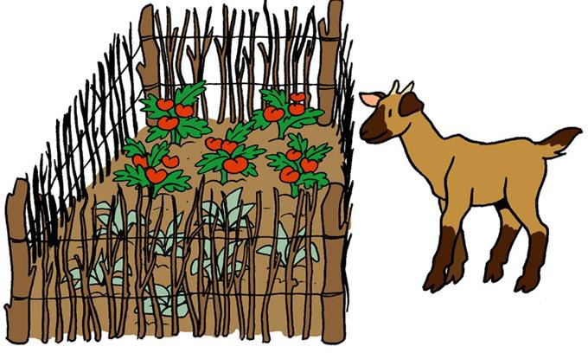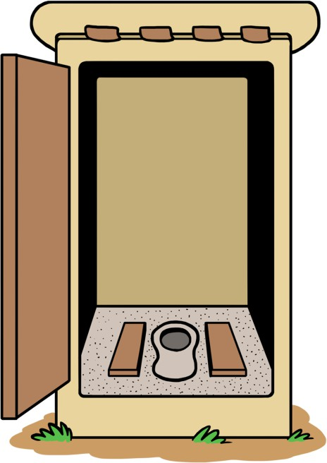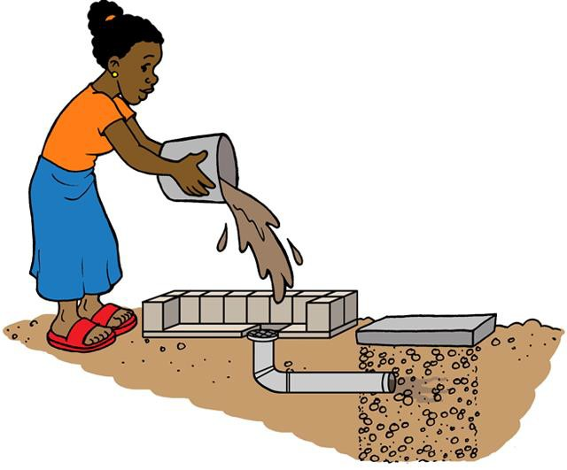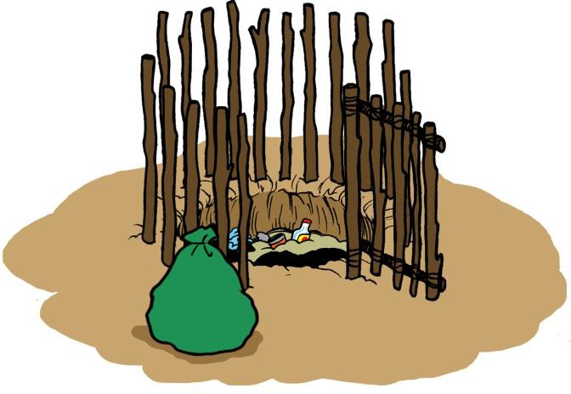



424 Aviation Road NE Calgary, Alberta, T2E 8H6, Canada

Phone: + 1 (403) 243-3285, Fax: + 1 (403) 243-6199

E-mail: resources@cawst.org, Website: www.cawst.org

CAWST, the Centre for Affordable Water and Sanitation Technology, is a nonprofit organization that provides training and consulting to organizations working directly with populations in developing countries who lack access to clean water and basic sanitation.

One of CAWST’s core strategies is to make knowledge about water common knowledge. This is achieved, in part, by developing and freely distributing education materials with the intent of increasing the availability of information to those who need it most.

This document is open content and licensed under the Creative Commons Attribution 4.0 International License. To view a copy of this license, visit: <http://creativecommons.org/licenses/by/4.0/>.

You are free to:

* Share – Copy and redistribute the material in any medium or format
* Remix – Remix, transform, and build upon the material for any purpose, even commercially

Under the following terms:

* Attribution – You must give appropriate credit to CAWST, provide a link to the license, and indicate if changes were made. You may do so in any reasonable manner, but not in any way that suggests that CAWST endorses you or your use. Please include our website: [www.cawst.org](http://www.cawst.org/)

CAWST will produce updated versions of this document periodically. For this reason, we do not recommend hosting this document to download from your website.

###### Stay up-to-date and get support:

* + Latest updates to this document
  + Other workshop and training related resources
  + Support on using this document in your work

*CAWST provides mentoring and coaching on the use of its education and training resources.*

[*www.cawst.org/resources*](http://www.cawst.org/resources)



CAWST and its directors, employees, contractors and volunteers do not assume any responsibility for, and make no warranty with respect to, the results that may be obtained from the use of the information provided.

**Table of Contents**

Acronyms iii

1. Introduction 1
2. Workshop Overview 1
   1. Participatory Learning 1
3. Workshop Planning 2
   1. Identify the Planning Team 2
   2. Fit Training into a Broader Plan 2
   3. Select Trainers 2
   4. Select Participants 3
   5. Identify the Workshop Host 5
   6. Logistics Management 5
   7. Addressing Barriers to Participation 6
4. Workshop Preparations 7
   1. Trainer Roles and Responsibilities 7
   2. Field Trip Logistics 7
   3. Translations and Interpreters 8
   4. Workshop Space 8
   5. Equipment and Materials 9
   6. Participant Materials 9
   7. PowerPoint Presentations 9
   8. Videos 10
5. How to Use This Manual 12
   1. Learning Outcomes 12
   2. Workshop Agendas 15
   3. Lesson Plans 21

Lesson Plan 1: Workshop Opening 22

Lesson Plan 2: Talking About Sanitation 28

Lesson Plan 3: Introduction to Environmental Sanitation 30

Lesson Plan 4: Local and Global Sanitation Issues 38

Lesson Plan 5: Disease Transmission 43

Lesson Plan 6: Human Excreta Management 50

Lesson Plan 7: Sanitation Ladder 55

Lesson Plan 8: Latrine Technologies 58

Lesson Plan 9: Project Framework 64

Lesson Plan 10: Handwashing 71

Lesson Plan 11: Behaviour Change 76

Lesson Plan 12: Menstrual Hygiene Management 80

Lesson Plan 13: Animal Excreta Management 86

Lesson Plan 14: Solid Waste Management 95

Lesson Plan 15: Domestic Wastewater Management 103

Lesson Plan 16: Vector Control 108

Lesson Plan 17: Environmental Sanitation Inspections 110

Lesson Plan 18: Environmental Sanitation Walk 116

Lesson Plan 20: Sanitary Inspections 124

Appendix 1: Workshop Materials Appendix 2: Tools

Appendix 3: Latrine Posters

Appendix 4: Environmental Sanitation Inspection Forms Appendix 5: Sanitary Inspection Forms

|  |  |
| --- | --- |
| **Acronyms** |  |
| CAWST | Centre for Affordable Water and Sanitation Technology |
| CD | compact disc |
| LP | lesson plan |
| MDGs | Millennium Development Goals |
| UNICEF | United Nations Children’s Fund |
| USB | universal serial bus |
| VIP | ventilated improved pit |
| WASH | water, sanitation and hygiene |
| WHO | World Health Organization |

## Introduction

This Trainer Manual is to support people who facilitate the Introduction to Environmental Sanitation workshop. It is based on the practical experience of the CAWST, the Centre for Affordable Water and Sanitation Technology.

This introduction provides background on how and why the workshop was developed, tips that help you plan for a successful workshop, and several tools to help deliver your training, such as checklists, lesson plans and PowerPoint presentations. It is recommended that you adapt the tools to suit your style and the needs of your audience.

## Workshop Overview

Environmental sanitation aims to protect and promote human health and well-being by providing a clean environment and breaking the cycle of disease. Environmental sanitation is more than just building latrines. It takes a broader look at the community and addresses different, but interconnected, aspects, including human and animal excreta management, solid waste management, vector control, domestic wastewater management and stormwater drainage.

In this introductory level workshop, participants will gain an overall understanding of the issues and best practices for on-site environmental sanitation in low-income, non-networked communities.

The workshop explores the relationship between environmental sanitation, disease transmission and health. It addresses technical topics such as human excreta management including different latrine designs; animal excreta management; solid waste management; vector control for mosquitos and rodents; and domestic wastewater management. Aspects of hygiene, such as handwashing and menstrual hygiene, are also discussed as they relate to sanitation. The workshop also introduces a framework for implementing a sustainable and successful project, and the theory of behaviour change and sanitation promotion to create demand for environmental sanitation.

#### Participatory Learning

Participatory approaches are widely used to engage and actively involve everyone in the workshop. Effective learning often comes from shared experiences and participants learning from each other. Much of the course content is delivered through interactive presentations, demonstrations, group discussions and case studies.

## Workshop Planning

The following activities should be undertaken to get started with workshop planning and arranging logistics.

#### Identify the Planning Team

Many decisions must be made and work done leading up to the workshop, and you will find it helpful to have a team to handle many of the details. The workshop planning team should include people who are:

* + - Familiar with the workshop material
    - Familiar with the participants that will be attending
    - Knowledgeable about the training site

#### Fit Training into a Broader Plan

Training is just one element of a successful project. This workshop makes the most sense when it is part of an individual’s or organization’s plan to support environmental sanitation. There must be follow-up and ongoing support to the project implementers to help them successfully implement the knowledge they gain during this workshop.

#### Select Trainers

To be an effective trainer for this workshop, you should possess the following knowledge, skills and attitudes.

Knowledge. This manual is designed for trainers who have expertise in the subject matter and knowledge regarding the background of the participants, including:

* + - Global environmental sanitation issues
    - Pathogens disease transmission
    - Human excreta management, including latrine design and construction
    - Animal excreta management
    - Solid waste management
    - Domestic wastewater management
    - Vector control
    - Handwashing
    - Menstrual hygiene management
    - Project planning
    - Project implementation

Skills. This manual assumes that you have experience in planning and organizing workshops and are comfortable with group facilitation. An effective trainer uses various facilitation skills to:

* + - Help people feel comfortable with a participatory approach to learning
    - Encourage people to share information, ideas, concerns and knowledge
    - Communicate clearly
    - Manage group dynamics and resolve conflicts
    - Keep the training practical and relevant

Attitude. You should aim to create a positive learning environment for all participants. This is achieved in part by your approach and manner, such as being:

* + - Friendly, open and approachable
    - Objective
    - Respectful
    - Aware of cultural differences
    - Gender sensitive

Any multiday workshop is a big responsibility. You may want to have several co-trainers to share the work, especially if you have a large number of participants. It is recommended to have two trainers for every 20 participants. All trainers should be comfortable with the subject matter and have good facilitation skills.

It can also be helpful to have guest speakers or local experts on a topic to participate in the training. If the guest speakers have a strong technical background or experience, the more likely they can help deal with practical issues and provide clear responses to questions. Always talk to your guest speakers beforehand about your expectations and be sure that they understand their role and time commitment.

#### Select Participants

For the most effective workshop, it is important to take care in inviting participants by considering:

* + - Number of participants. It is important to choose the correct number of people. You may want to have a small group to provide intensive training and support, or a larger group to have a wider range of participation. A common reason for training sessions to fail is that too many participants attend. A maximum of 20 participants is recommended so that everyone has the chance to fully participate in the training.
    - Participants from diverse backgrounds and levels of experience add to the discussions that evolve through the workshop. If there is a group that is going to be working on the same project, it is advantageous to have the project manager and relevant staff involved so they all understand the whole process involved and are better able to coordinate using the same concepts and methods. The reason for training is to enable the participants to put their knowledge into practice. This is most likely to happen when a critical mass of a project’s staff is familiar with environmental sanitation.

The ideal participants are those who are:

* + - Working in water, sanitation and hygiene (WASH), community development or health projects seeking solutions for environmental sanitation
    - Program organizers or project managers with the responsibility for organizing projects and making decisions
    - Motivated to start or strengthen projects for improving environmental sanitation It is an advantage if participants have the following:
    - Source of funding in place to begin implementation (as this will allow for immediate application of the knowledge and skills gained in the workshop)
    - Support of their organization which recognizes that environmental sanitation may be beneficial for the communities where they work

You should be clear about who you will be training before the workshop begins. Understanding your audience is an essential first step to facilitating a successful workshop. The following questions will help you conduct a needs assessment of your participants. The information will help you adapt the content of the workshop if necessary and select relevant learning aids:

* + - Why are the participants attending? Is it their own choice or has a superior instructed them to be present?
    - What prior knowledge might they have about environmental sanitation?
    - What are their learning expectations?
    - What range of experience is likely to be represented?
    - Do they have any biases against you or your organization?

A pre-workshop questionnaire can be used to help you better understand the background of your participants and their expectations. Participants often do not complete the questionnaire in advance. The planning team may need to follow up with participants to encourage them to submit their responses. For participants with lower levels of reading and writing skills, a pre- workshop questionnaire may not be appropriate. See the CAWST Workshop Materials for an example pre-workshop questionnaire.

If you do not use a pre-workshop questionnaire or do not get all of the responses back, the workshop opening session includes time for you to help determine the participant’s prior knowledge, experience and learning expectations. You may need to be flexible in adapting the workshop agenda to meet their needs based on what you learn in this session.

Keep in mind that in any workshop there may be participants who have different levels of ability in reading and writing. There may be participants who do not understand the language of instruction well, even if they said they do. You will need to modify the way you normally train to accommodate their learning needs. Use short sentences, pictures and illustrations, gestures, demonstrations, small group discussions and hands-on practice. These methods will help all participants understand and remember the information better, but are especially important for participants with lower reading, writing or language skills.

#### Identify the Workshop Host

The organization that hosts the workshop has a number of responsibilities, from helping to select the venue and organizing registration to planning events outside of the workshop hours (if applicable).

Finding the perfect host for your workshop is not always easy. An ideal workshop host will:

* + - Ask you to organize a training
    - Communicate with you in a timely and honest way
    - Have the authority to make decisions regarding the workshop (i.e., no need for approval at a higher level)
    - Be motivated to start a WASH project after the training or use the training to increase its staff’s knowledge and skills
    - Be in charge of inviting and registering the participants
    - Invite people from organizations that are motivated to use what they will be learning during the training
    - Have a good reputation and is well-known in the country/town
    - Have access to grassroots organizations
    - Be well located (i.e., accessible to lots of other organizations)
    - Find a good venue for the training
    - Translate materials (if needed)
    - Print the training materials
    - Provide an interpreter (if needed)
    - Provide accommodation and local transport for trainers
    - Be available and willing to help you with logistics during the workshop
    - Be someone you can trust

#### Logistics Management

The workshop planning team (the trainers and the host) will need to determine the workshop logistics such as:

Pre-workshop

* + - What is the workshop budget?
    - Who will invite the participants and communicate with them?
    - Who will organize and coordinate food and accommodation?
    - Who will manage participant travel?
    - Who will organize the training site and set up?
    - Who will purchase and organize the training equipment and materials?
    - Who is responsible for pre-workshop registration?
    - Who is responsible for onsite registration?
    - Who is responsible for organizing construction materials?
    - Who is responsible for printing the participant materials?
    - Who is responsible for training what session in the agenda?

During the workshop

* + - Who will check that snacks and food are ready at the appropriate times?
    - Who will prepare the room in the morning and reorganize in the evening?
    - Who will prepare the flipcharts for the day?
    - Who is in charge of checking participant list details?
    - Who is in charge of preparing evaluations, certificates and CDs?

Post-workshop

* + - Who will type up the workshop evaluations?
    - Who will clean up the workshop materials and space?
    - Who is responsible for replacing materials if needed?
    - Who is responsible for the reporting?
    - Who is responsible to maintain communication with the participants?

#### Addressing Barriers to Participation

When setting up a workshop, it is important to consider barriers that may limit certain participants from attending. What can you do to make it easier for them to attend? Factors that you may want to consider are:

* + - Time of the workshop: Is the workshop being held at a time of day and week that all people can attend? Is there a time that will interfere less with domestic responsibilities or other work obligations? Is it being held at a time of year when harvest obligations, national holidays, celebrations or political events may prevent people from attending? Do organizations or staff have major project deadlines at that time?
    - Length: Will participants need to be away from home to attend the workshop? If so, is the length of the workshop reasonable? Could it be divided into shorter sessions and delivered over a longer period of time to encourage more participation?
    - Location: Is the location easy and convenient for participants to access? Can people with disabilities access the space? Is the location safe for both men and women to access independently at any time of day? If people need to stay over, are there affordable accommodations and places to eat nearby?
    - Child Care: Are children welcome at your workshop? If not, are you providing child care options to encourage caregivers to attend?
    - Language: Will interpretation and/or translated documents be available for participants who are not fluent in the language in which the workshop will be delivered? Does everyone invited know that interpretation will be available, and into which languages? People often overestimate their language skills, and may feel embarrassment about their language level. Even if they do not understand during the workshop, they may not request interpretation.
    - Finances: If you are charging a participant registration fee, can everyone afford the fee? Is it possible to offer scholarships or opportunities for reduced fees? Can those who cannot afford the fee arrange to volunteer or contribute in-kind instead of paying a fee?

When planning the workshops, anticipate the barriers that may prevent your target audience from attending. Reduce these challenges as much as possible when organizing the logistics.

## Workshop Preparations

There are several things that you will need to do to get ready for the workshop.

#### Trainer Roles and Responsibilities

It is essential that the facilitation team work well together. You should meet with the other trainers before the workshop to discuss the workshop agenda and then assign the roles and responsibilities. It is also useful to clarify the role of the other trainers when they are not actually conducting a workshop session – should they be assisting in the group work, be available to answer questions, or be setting up for the next session? Where possible, ensure that all the trainers can be present for the entire workshop.

#### Field Trip Logistics

An environmental sanitation walk is scheduled for the second day of the workshop (see Lesson Plan 17: Environmental Sanitation Walk). This lesson gives participants an opportunity to consolidate and apply their new knowledge about environmental sanitation in a realistic setting.

The following are things that you should do in advance of the workshop to prepare the logistics for the field trip:

* + - Ask the host organization to select an appropriate site for the environmental sanitation walk that is close to the workshop location. If possible, try to find a location that highlights both good and bad practices for various aspects of environmental sanitation including excreta management, solid waste management domestic wastewater management and vector control. For simplicity, the walk can be done around the premises of the workshop location.
    - If required, ensure permission is granted and set up transport and logistics with the host
    - If possible, visit the site ahead of time and identify different environmental sanitation practices

At the end of the first day of the workshop, you should explain the field trip to the participants to give them time to prepare, including the following information:

* + - Where you will be going, and what you will do there
    - The objective of the environmental sanitation walk, and what you want the participants to learn from the activity
    - Any ground rules for the environmental sanitation walk (e.g., respectful behaviour when visiting people’s homes, what to do in an emergency, where to find the first aid kit, if needed)
    - How long it will take, when you will be back, what the participants should bring, and any other logistical arrangements

#### Translations and Interpreters

The materials may need to be translated and an interpreter may be required if the participants do not speak the language of instruction (e.g., English, French, Spanish) as their first language. It is common for participants to overstate their language comprehension. This is often out of embarrassment and not wanting to look bad in front of their colleagues. If there is any doubt, you should translate the training materials and use an interpreter for the workshop to make sure that all participants have equal opportunity to fully understand the content.

Using an interpreter takes more time than if you are delivering the workshop in one language. You will likely have to adjust the workshop agenda to account for the extra time required.

Some tips for working with an interpreter include:

* + - Try to find an experienced interpreter who is known and trusted by the organizer
    - Give them a copy of the training materials to review in advance of the workshop, including the participant materials, trainer manual and PowerPoint presentations
    - Meet at least one day before the workshop to discuss their role, review the agenda and learning activities, and ensure that they understand the content and key vocabulary
    - Practice using microphones and headsets if simultaneous interpretation is going to be used
    - Ask them to write out the flipchart headings in the local language in advance
    - Include them in the end of day debrief meetings and ask for their feedback

#### Workshop Space

If possible, visit the training site before the participants are due to arrive, and set up your electrical equipment and materials. Try to identify potential sources of distraction in the room, both to yourself and participants, and make changes to mitigate them.

Seating arrangements have a big influence on the training. It is recommended to arrange the tables and chairs so that participants can make eye contact with one another and can break into small groups easily. Participants will also need to be able to view the speakers, the PowerPoint slides, and flipchart posters.

#### Equipment and Materials

You will need to gather and bring the following materials and equipment to the workshop.

Equipment: Materials:

* + - Computer
    - Speakers
    - Projector
    - Extension cord(s)
    - Camera
    - Name tags
    - Markers
    - Pens or pencils
    - Paper
    - Flipchart or large pieces of paper
    - Tape

For all other materials required for individual sessions refer to the Lesson Plans and Appendix 1: Workshop Materials.

#### Participant Materials

You will need to decide where and when the participant materials will be printed; and who will manage the printing.

Appendix 1: Workshop Materials contains a list of the participant materials that need to be printed and compiled into one document (e.g., bound together, folder).

There may be other resources that participants will need during the workshop that are included with the corresponding lesson plans. All of the PowerPoint presentations that you plan on using can be printed as handouts and included in the participant materials.

It is recommended to provide each participant with an electronic version of all the materials on a CD or USB flash drive, to take with them.

You will also need to determine if any adjustments to language, concepts or materials are required based on the participants’ needs assessment.

#### PowerPoint Presentations

This workshop includes PowerPoint presentations that can be used as a learning aid. For optimal learning, PowerPoint presentations should only be used as a supplemental tool to discussions and learning activities, and not be the only way to transfer information to the participants. The lesson plans have been organized so that PowerPoint presentations are an optional tool. If PowerPoint presentations are not used, alternate visual aids should be used while speaking to enhance learning. It has been shown that it is easiest to understand and remember information when learners see text with simple pictures. This is especially true for learners with lower reading and writing skills.

For optimal learning, PowerPoint presentations should only be used as a supplemental tool to discussions and learning activities, and not be the only way to transfer information to the participants.

If you decide to use the PowerPoint presentations, much of the content of the workshop is described in detail in the speaker notes within the file. To use them fully, you should print and study the speaker notes pages along with the lesson plans to help prepare in advance. The notes provide more background and detail that you need to understand the content and the order for the presentation. The notes should *not* be read aloud during the presentation. Rather, you will want to become familiar with the material, prepare your own brief notes and practice speaking with the slides.

Several of the presentations include slides for introducing or explaining the participatory activities. The speaker notes explain when to display these so that participants can refer to them during their individual or small group work.

There are also optional PowerPoint slides that are country specific. You will need to select the appropriate slides depending on the audience.

You may want to alter or reorganize some of the slides. This is best done prior to printing the handouts for the participant binders. Keep in mind that if you add or delete slides, the slide numbers will change, shifting the content in the lesson plans. If changing the slide format or design, please take care to retain the embedded logos that indicate the workshop authors.

#### Videos

Videos are used as optional learning aids in some lessons. Use the following criteria to decide whether or not to show a video in the workshop:

* + - The content of the video (is it relevant to the workshop?)
    - The experience of the participants (do they need to learn this?)
    - Whether a similar video has already been shown, or the material has already been covered in the workshop (is it repetitive?)
    - The language spoken and how fast people talk in the video (will participants be able to understand the speakers?)
    - The language of the subtitles (if any), and the participants’ reading ability (will participants be able to understand the text?)
    - The cultural relevance and context (is it appropriate?)

Note that while many videos can be useful teaching tools, the information presented in a video may not be correct or may not be exactly what you want to teach the participants. Watch every video you plan to show in the workshop before the workshop, so that you understand exactly what it teaches. Make a list of points in the video that you will discuss with participants after watching the video. The list of discussion points may include things that were done well in the video, things that you recommend doing differently, or things that are done differently in your local area.

It is helpful when using videos as teaching tools to provide participants with a short list of questions to consider while watching the video. You can write the questions on the flipchart, or hand out printed questions to each participant. The questions should focus on what you want the participants to learn from the video, and what you want them to think about. Discuss participants’ answers to the questions after watching the video.

In each lesson plan, the internet link to each video is given in the materials section. Because the internet may not be available during the workshop, or the connection may not be strong, it is a good idea to download the videos to your computer before the workshop. You may be able to get a copy of some downloaded videos from CAWST. Alternatively, the following website is an example of one way you can download videos that are publicly available online.

Application: aTube Catcher Instructions:

* Download and install aTube Catcher (freeware application to save videos) from <http://atube-catcher.dsnetwb.com/video/index.html>
* Go to the website of the video you want to download, such as YouTube.
* Copy the web address of the video you want to download.
* Open aTube Catcher on your computer.
* Paste the web address into aTube Catcher where indicated.
* Select the format you want to save the video in. The mp4 version is recommended – it has high quality with a reasonable file size. Save the video to your computer or an external/USB flash drive.

Appendix 1: Workshop Materials contains a list of the videos that need to be downloaded for the workshop.

## How to Use This Manual

This section explains the workshop agenda and individual sessions that have been developed to meet the participant learning expectations.

#### Learning Outcomes

The following learning outcomes describe what the participants will be able to do by the end of the workshop to demonstrate increased knowledge, improved skills, or changes in attitude.

Each lesson plan refers to the specific learning outcomes covered in that lesson.

**Participant Learning Outcomes**

|  |  |  |
| --- | --- | --- |
| **Lesson Plan #** | **Lesson Plan** | **Learning Outcomes** |
| 1 | Workshop Opening | 1. Meet the trainer, host organization and workshop participants. 2. Determine participants’ existing level of knowledge and skills on workshop topics. 3. Establish how the group is expected to work together during the workshop. 4. Describe CAWST’s and/or the host organization’s role. |
| 2 | Talking about Sanitation | 1. Discuss the personal and sensitive nature of sanitation, particularly defecation practices and the implications for sanitation projects. |
| 3 | Introduction to Environmental Sanitation | 1. Identify the different aspects of sanitation. 2. Explain the difference between sanitation and environmental sanitation. |
| 4 | Local and Global Issues | 1. Discuss the local and global issues involved with access to basic sanitation. 2. Discuss how poor sanitation is connected to and causes the cycle of poverty to continue. |
| 5 | Disease Transmission | 1. Identify the four types of pathogens. 2. Identify diseases related to environmental sanitation. 3. Identify different transmission routes of diseases.\ 4. Explain how environmental sanitation can prevent the transmission of diseases. |
| 6 | Human Excreta Management | 1. Discuss the five components of a sanitation system to properly manage human excreta. 2. Explain why the entire sanitation system must be addressed to ensure safe and sustainable sanitation. |
| 7 | Sanitation Ladder | 1. Explain the sanitation ladder. 2. Discuss why being higher up on the sanitation ladder is important. 3. Discuss the advantages and challenges of moving up the sanitation ladder. 4. Discuss where on the sanitation ladder is best for new latrine users to start. 5. Discuss incremental improvements that can be made within a sanitation system. |
| 8 | Latrine Technologies | 1. Identify different latrine pit, tank and chamber technologies. 2. Explain the basic operation of each excreta storage technology. |

|  |  |  |
| --- | --- | --- |
| **Lesson Plan #** | **Lesson Plan** | **Learning Outcomes** |
| 9 | Project Framework | 1. Discuss the purpose of the project framework. 2. Describe the five components of the project framework. |
| 10 | Handwashing | 1. Discuss the importance of handwashing to prevent disease transmission. 2. Demonstrate proper handwashing technique. 3. List the critical times for handwashing. 4. Discuss the need for both handwashing hardware and software. |
| 11 | Behaviour Change | 1. Discuss what if feels like and what is needed to change behaviour. 2. Discuss how understanding behaviour change will shape their approach to implementing an environmental sanitation project. 3. Explain why sanitation promotion is important for changing behaviour and creating demand. |
| 12 | Menstrual Hygiene Management | 1. Discuss the challenges of menstrual hygiene management for women and girls. 2. Discuss the impact of poor menstrual hygiene on health and education. 3. Identify solutions to ensure menstrual hygiene-friendly homes, schools and work places. |
| 13 | Animal Excreta Management | 1. Identify some diseases that are related to animal excreta. 2. Discuss the importance of animal excreta management. 3. Discuss some good animal excreta management practices to prevent disease transmission. |
| 14 | Solid Waste Management | 1. Discuss ways to recycle solid waste. 2. Discuss ways to collect and transport solid waste. 3. Describe composting and its benefits. 4. Discuss the hazards and safety precautions of burning and burying solid waste. |
| 15 | Domestic Wastewater Management | 1. List the three components of domestic wastewater: blackwater, greywater and overflow water. 2. Discuss the importance of properly managing greywater and overflow water. 3. Identify management options for greywater. 4. Identify management options for overflow water. |
| 16 | Vector Control | 1. Identify different types of vectors. 2. Explain why vectors should be controlled. 3. Describe the difference between passive and active vector control. |
| 17 | Environmental Sanitation Inspections | 1. Describe the benefits and purpose of an environmental sanitation inspection. 2. Select which data gathering methods are appropriate (observation or interview). 3. Use environmental sanitation inspection forms to gather information. 4. Give examples of how culture, time, gender, safety and security may influence data gathering exercises. |
| 18 | Environmental Sanitation Walk | 1. Identify different environmental sanitation practices in a realistic setting. 2. Apply environmental sanitation awareness within a field setting 3. Practice methods of observation and data gathering. 4. Recommend improvements to poor environmental sanitation practices. |

|  |  |  |
| --- | --- | --- |
| **Lesson Plan #** | **Lesson Plan** | **Learning Outcomes** |
| 19 | Workshop Closing | 1. End of workshop self-assessment and reflection. 2. Review learning outcomes to see if they were met. 3. Complete a final evaluation of the workshop. 4. Distribute certificates and make closing remarks. |
| 20  (Optional) | Sanitary Inspections | 1. Analyze sources of contamination of drinking water sources. 2. Evaluate risks of contamination of drinking water sources. |

#### Workshop Agendas

The general outline of the workshop is as follows:

* + - Workshop opening. To welcome people and allow participants and trainers to get to know one another.
    - Individual sessions. To focus on a selected topic. Each individual session includes an introduction, a main lesson, and a closing activity to review the content.
    - Breaks and lunch. To keep people working and feeling positive, breaks are needed. Plan for a mid-morning and mid-afternoon break that allows people to use the washroom, take a drink or eat a snack. While planning your workshop it is also important to clarify with participants in advance as to whether or not food and snacks will be provided.
    - Review of previous day. Start the day with a review of the material learned during the previous day. This also helps focus the participants and trainers’ brains on the workshop. See the list of review tools in the Trainer Manual Appendix 2 for activities you can use.
    - End of day review. To gain feedback from the participants and to clarify any areas of uncertainty. Example review activities are provided in the Trainer Manual Appendix 2.
    - End of day evaluation. To gain feedback from the participants and to clarify any areas of uncertainty. See the list of evaluation tools in the Trainer Manual Appendix 2 for activities you can use.
    - End of workshop closing. The end of the workshops can be official or unofficial depending on what is appropriate. Certificates are typically handed out.
    - End of workshop evaluation. To allow participants to assess the strengths and weaknesses of the workshop for further improvement. See the list in the Workshop Closing lesson plan for alternative formats for the end of workshop evaluation.
    - Organizer and trainers’ debrief. A daily exercise to discuss what went well, what areas of the day can be improved and what needs to be done for the next day and in the future. Debriefs are held at the end of the workshop.

Two sample agendas are provided:

**2-Day workshop:** This workshop is targeted to an audience with strong skills in the language of instruction, including speaking, reading and writing. This group requires an overview of all aspects of environmental sanitation. This agenda is suitable for audiences who do not have access to a field location for an environmental sanitation walk. There is a lot of information to cover in two days, so this workshop moves quite quickly to cover all the topics.

**2.5-Day workshop:** The agenda is targeted to an audience with basic skills in the language of instruction, including speaking, reading and writing. This group requires an overview of all aspects of environmental sanitation and wants practical experience with environmental sanitation inspections.This agenda is suitable for audiences that have access to a field location for an environmental sanitation walk. There is a lot of information to cover in 2.5 days, so this workshop moves quite quickly to cover all the topics.

The agendas include some optional sessions, allowing the trainer to customize the workshop to the participants’ needs, and allowing participants to go in depth with certain topics. The trainers should customize the agenda for each workshop, based on the audience. Look at the following sample agenda to see options for how sessions may be arranged, added or removed.

###### Example 2-Day Introduction to Environmental Sanitation Workshop Agenda

*Audience: Suitable for an audience with strong skills in the language of instruction and who require an overview of all aspects of environmental sanitation*

|  |  |  |  |  |
| --- | --- | --- | --- | --- |
| **Time** | **DAY 1** | **LP** | **DAY 2** | **LP** |
| 2 hours | **Workshop Opening** (60 min)   * Introductions * Agenda * Housekeeping * Creating the learning environment * Workshop format and learning strategies   **Talking About Sanitation** (15 min)   * Local words for feces, urine, defecation   **What is Environmental Sanitation?**  (15 min)   * Aspects of environmental sanitation * Difference between sanitation and environmental sanitation definitions | 1  2  3 | **Opening Activity** (15 min)   * Day 1 review activity * Discussion and fill in gaps   **Handwashing** (45 min)   * Importance of handwashing * Proper technique * Critical times * Hardware and software needed   **Solid Waste Management** (60 min)   * Recycling, composting, burning, burying * Hazardous waste management | 10  14 |
|  | **Local and Global Sanitation Issues** (30 min)   * Access to sanitation and poverty cycle | 4 |  |  |
| **15 min** | **BREAK** |  | **BREAK** |  |
| 1 hour  45 min | **Disease Transmission** (60 min)   * Pathogens and diseases related to environmental sanitation   **Project Framework** (45 min)   * Purpose * Five components of the framework | 5  9 | **Animal Excreta Management** (45 min)   * Diseases related to animal excreta * Importance of animal excreta management * Good management practices   **Domestic Wastewater Management**  (30 min)   * Greywater and overflow water * Treatment, use and disposal | 13  15 |
|  |  |  | **Vector Control** (30 min)   * Passive and active control measures for mosquitos and rodents | 16 |
| **1 hour** | **LUNCH** |  | **LUNCH** |  |
| 1 hour  45 min | **Behaviour Change** (50 min)   * What it feels like and what is needed * External and internal factors * Sanitation promotion | 11 | **Environmental Sanitation Inspections** (1 hour 45 min)   * Benefits and purpose of environmental sanitation inspections * Use environmental sanitation inspection forms | 17 |
|  | **Human Excreta Management** (55 min)   * Five components of a sanitation system | 6 |  |
| **15 min** | **BREAK** |  | **BREAK** |  |
|  | **Sanitation Ladder** (30 min)   * Order options for improving sanitation | 7 | **Environmental Sanitation Inspections**  continued (20 min) |  |
| 1 hour  30 min | **Latrine Technologies** (50 min)   * Basic design of latrines focusing on excreta storage   **End of Day Review** (10 min)   * Review Day 1 activities * Closing and evaluation activity | 8 | **Workshop Closing** (60 min)   * Participant self-assessment * Review learning outcomes * Final evaluation * Certificate presentations | 19 |

LP – Lesson Plan in Trainer Manual for Introduction to Environmental Sanitation

###### Suggested Daily Opening and Closing Activities:

|  |  |  |
| --- | --- | --- |
| **Workshop Day** | **Opening Activity** | **Closing and Evaluation Activity** |
| Day 1 | Lesson Plan 1: Workshop Opening | Appendix 2: Tools   * Alligator Arms * Plus/Change * Scales |
| Day 2 | Appendix 2: Tools   * Charades * What Am I? | Appendix 2: Tools   * Final Workshop Evaluation |

**Optional Lesson Plans:**

* + - Lesson Plan 12: Menstrual Hygiene Management (can be used with Lesson Plan 17: Environmental Sanitation Walk instead of Lesson Plan 16: Environmental Sanitation Inspections)
    - Lesson Plan 20: Sanitary Inspections (can be combined with Lesson Plan 17: Environmental Sanitation Walk)
    - Behaviour Change Lesson Plans from Community Health Promotion Trainer Manual

###### Example 2.5 Day Introduction to Environmental Sanitation Workshop Agenda

*Audience: Suitable for an audience with strong skills in the language of instruction. This group requires an overview of all aspects of environmental sanitation and wants practical experience with environmental sanitation inspections.*

|  |  |  |  |  |  |  |
| --- | --- | --- | --- | --- | --- | --- |
| **Time** | **DAY 1** | **LP** | **DAY 2** | **LP** | **DAY 3** | **LP** |
| 2 hours | **Workshop Opening** (60 min)   * Introductions * Agenda * Housekeeping * Creating the learning environment * Workshop format and learning strategies   **Talking About Sanitation** (15 min)   * Local words for feces, urine, defecation   **What is Environmental Sanitation?** (15 min)   * Aspects of environmental sanitation * Difference between sanitation and environmental sanitation definitions   **Local and Global Sanitation Issues** (30 min)   * Access to sanitation and poverty cycle | 1  2  3  4 | **Opening Activity** (15 min)   * Day 1 review activity * Discussion and fill in gaps   **Handwashing** (45 min)   * Importance of handwashing * Proper technique * Critical times * Hardware and software needed   **Solid Waste Management** (60 min)   * Recycling, composting, burning, burying * Hazardous waste management | 10  14 | **Opening Activity** (15 min)   * Day 2 review activity * Discussion and fill in gaps   **Environmental Sanitation Walk** (1hr 30 min – 2 hours)   * Field trip to identify local practices | 18 |
| **15 min** | **BREAK** |  | **BREAK** |  | **BREAK** |  |
| 1 hour  45 min | **Disease Transmission** (60 min)   * Pathogens and diseases related to environmental sanitation   **Project Framework** (45 min)   * Purpose * Five components of the framework | 5  9 | **Animal Excreta Management** (45 min)   * Diseases related to animal excreta * Importance of animal excreta management * Good management practices   **Domestic Wastewater Management** (30 min)   * Greywater and overflow water * Treatment, use and disposal   **Vector Control** (30 min)   * Passive and active control measures for mosquitos and rodents | 13  15  16 | **Environmental Sanitation Walk**  continued  **Workshop Closing** (60 min)   * Participant self-assessment * Review learning outcomes * Final evaluation * Certificate presentations | 19 |
| **1 hour** | **LUNCH** |  | **LUNCH** |  |  | |

|  |  |  |  |  |
| --- | --- | --- | --- | --- |
| **Time** | **DAY 1** | **LP** | **DAY 2** | **LP** |
| 1 hour  45 min | **Behaviour Change** (50 min)   * What it feels like and what is needed * External and internal factors * Sanitation promotion | 11 | **Environmental Sanitation Inspections** (1 hour 20 min)   * Benefits and purpose of environmental sanitation inspections * Select appropriate data gathering methods * Prepare for environmental sanitation walk on Day 3 | 17 |
|  | **Human Excreta Management** (55 min)   * Five components of a sanitation system | 6 |  |
| **15 min** | **BREAK** |  | **BREAK** |  |
| 1 hour  30 min | **Sanitation Ladder** (30 min)   * Order options for improving sanitation   **Latrine Technologies** (50 min)   * Basic design of latrines focusing on excreta storage | 7  8 | **Menstrual Hygiene Management** (60 min)   * Challenges for women and girls * Impact of poor menstrual hygiene on health and education * Solutions for menstrual hygiene-friendly homes, schools and work places | 12 |
|  | **End of Day Review** (10 min)   * Review Day 1 activities * Closing and evaluation activity |  | **End of Day Review** (10 min)   * Review Day 2 activities * Closing and evaluation activity |  |

LP – Lesson Plan in Trainer Manual for Introduction to Environmental Sanitation

###### Suggested Daily Opening and Closing Activities:

|  |  |  |
| --- | --- | --- |
| **Workshop**  **Day** | **Opening Activity** | **Closing and Evaluation Activity** |
| Day 1 | Lesson Plan 1: Workshop Opening | Appendix 2: Tools   * Plus/Change |
| Day 2 | Appendix 2: Tools   * Charades | Appendix 2: Tools   * Scales |
| Day 3 | Appendix 2: Tools   * What Am I? | Appendix 2: Tools   * Final Workshop Evaluation |

**Optional Lesson Plans:**

* Lesson Plan 20: Sanitary Inspections (can be combined with Lesson Plan 17: Environmental Sanitation Walk)

#### Lesson Plans

Here is a list of the icons used in this Trainer Manual and their explanations.

|  |  |
| --- | --- |
|  | Learning Outcomes. Describes what the participants will be able to do by the end of the session to demonstrate increased knowledge, improved skills or changes in attitude. Each lesson plan should reference the overall learning outcomes listed in the participant competencies. |
|  | Time. The clock symbol appears next to the amount of time the session may take. This is an estimate and the session may be longer or shorter depending on how you facilitate it. |
|  | Materials. Lists all the materials that will be required for the session. |
|  | Preparation. The clipboard appears when there is preparation that needs to be done prior to the session including materials needed and things to prepare in advance. |
|  | Introduction. This hook appears where there is an introduction to a topic. This will help participants connect personal experience to the knowledge they are about to learn. |
|  | Key Points. The key appears where there are important points and topics to discuss. These are reminders of what key points the participants should understand by the end of the session. |
|  | Main Activity. The puzzle appears at the beginning of a main learning activity. |
|  | Trainer Notes. The exclamation point appears to remind you of things to do or consider while facilitating the session. |
|  | Review. The question mark appears when you are reviewing a topic or checking for learning. What have participants learned? Can they recall the information? |
|  | Handouts. This appears when there are handouts for the participants. |



**Lesson Plan 1: Workshop Opening**

**60 minutes total**

###### Lesson Description

This lesson opens the workshop and sets the tone for the training and learning environment by using a variety of participatory activities. Participants have an opportunity to meet the trainer, host organization and other participants, as well as create their ground rules for how they are expected to work together during the workshop. The trainer has the opportunity to better understand the participant’s background, assess their knowledge and skills, and determine their learning expectations.

###### Learning Outcomes

1. Meet the trainer, host organization and workshop participants.
2. Determine participants’ existing level of knowledge and skills on workshop topics.
3. Establish how the group is expected to work together during the workshop.
4. Describe CAWST’s and/or the host organization’s role.

###### Materials

* + Flipchart paper
  + Markers
  + Tape
  + Sticker dots (2 different colours)
  + Name tags
  + Printed package of Introduction to Environmental Sanitation materials (1 per participant)
  + Pens or pencils (1 per participant)
  + Notebooks (1 per participant)

###### Optional:

* + 3 balls or stuffed animals for Option E Icebreaker: Ball Toss Name Game
  + Pre-workshop questionnaire (1 per participant)
  + Computer, projector and speakers
  + Video: CAWST Animation (Think Fast) (length 02:34) Available online at: www.youtube.com/watch?v=9fiWixoGNJo

###### Preparation

* + Write the agenda for the day on flipchart paper
  + Prepare the self-assessment flipchart (See Self-Assessment section of Lesson Plan)
  + Write the heading “*Group Learning Expectations”* on flipchart paper
  + Write the heading “*Group Agreement”* on flipchart paper
  + Print Introduction to Environmental Sanitation materials and organize them into one package for each participant (See list in Appendix 1)
  + Organize the participant materials, name tag, notebook and pen at each seat (1 per participant)
  + Prepare the materials needed for the Icebreaker Activity
  + If your organization uses a participant liability waiver, print one for each participant
  + If you will be asking participants to fill in a pre-workshop questionnaire, print one questionnaire for each participant
  + If you are planning to use video:
    - Cue the video on your computer
    - Check that the projector and speakers are working
  + Optional: Write the session Learning Outcomes on flipchart paper

###### Introduction 15 minutes

1. Introduce trainers, workshop hosts and other guests as appropriate.

In some countries, a formal welcoming ceremony will start the workshop. Consult with your host beforehand to determine the protocol and the amount of time required. You may need to adjust your agenda accordingly.

1. Workshop logistics - ask host if there is anything that needs to be communicated.
2. Explain the building/workshop layout, bathroom location, emergency exits, first aid, and daily schedule.
3. Review overall agenda for the workshop (i.e. 4 or 5 days with time spent in theoretical and practical sessions).
4. Lead an icebreaker activity to help participants meet each other and introduce themselves to the group. See options below for suggested icebreakers.

###### Option A Icebreaker: Name Game

1. Have everyone stand up where they are. Ask the whole group to concentrate on everyone’s name as they are being said.
2. Pick someone to start the game and ask them to say their name.
3. Person 2 sitting beside them must repeat the first person’s name, and then say their own name.
4. Person 3 will say the first person’s name, the second person’s name, and then their own name.
5. Continue around the group until everyone has said their own name, and then end with your turn. You may then see if Person 1 and Person 2 can repeat everyone’s names since they were the first to go.

###### Option B Icebreaker: Names and Adjectives

1. Have all participants think of an adjective that describes them at the moment or in general. The adjective must start with the same letter as their first name. For example: I’m Harry and I’m Happy.
2. Go around the circle and have everyone introduce themselves using their name and adjective. They may also silently role play the adjective as they introduce themselves.

**Option C Icebreaker: Two Truths and One Untruth** (This is a good activity for groups that already know each other)

1. Have participants stand or sit in a circle. Explain that whoever has the ball must say two things that are true and one thing that is untrue about themselves. Then the other participants in the circle will guess which statement is false.
2. You may want to start yourself as an example: hold the ball, say two true and one untrue thing about yourself. Ask the participants to guess which statement is untrue. Then throw the ball to a participant.
3. Repeat until everyone has held the ball.

###### Option D Icebreaker: Guess Whose Story

1. Use tent card or paper, ask the participants to write down an interesting fact or brief story about themselves but not to put their names on the cards.
2. Collect and redistribute the cards. Ask the participants to stand up, mingle and find out which person their card belongs to.
3. When they are ready, ask the participants to introduce the person they found. Give each participant a chance to expand and to explain why they have come to the workshop.

###### Option E Icebreaker: Ball Toss Name Game

1. Have all participants and yourself stand in a circle. Go around the circle once and have everyone say their name. Start with a ball or stuffed animal in your hands and call someone’s name who is across the circle from you and throw the object to them. They will then say someone else’s name and throw to them. Keep the game going until each participant has been thrown to only once and the object is back in your hands where it started. Then explain that you are going to do the same thing but speed it up.
2. Once you feel that they have good speed and confidence with one object then you can add to the challenge by starting the same process with a second object in the circle still throwing to the same person. Wait until the previous object has gone to the third or fourth person, then start the second object. Add a third and fourth object if they are up to it.

###### Group Agreement – Making Ground Rules 5-10 minutes

1. Explain that ground rules are agreements created by the group that will allow everyone to learn together.
2. Ask the participants to reflect on their past training or learning experiences. What made those experiences so positive? Negative?
3. Ask the participants to suggest ways to create a positive learning environment for everyone. Write the expectations on the *“Group* Agreement” flipchart paper.
   * *Respect, ask questions, silence cell phones, punctuality, no side talk*
4. Determine daily timetable including start and end times and breaks (length and time).
5. If not already suggested, ask for a timekeeper.
6. Ask if there will be consequences for breaking group agreements and have the group suggest humourous consequences (e.g., lead the group in song or dance when late).
7. Explain that any other ground rules can be added through the workshop.
8. Place the flipchart in a prominent place to be seen throughout the workshop.

###### Self-Assessment 10 minutes

1. Write on a piece of flipchart paper 3-6 key topics of the workshop that you plan to cover with a scale written beside each topic. For example:

Human Excreta Management Latrine Design and Construction Solid Waste Management

None A Little A Lot

None A Little A Lot

None A Little A Lot

1. Explain this is a tool to assess what knowledge and skills participants have before starting the workshop. Discuss how it is OK for people to have little or no knowledge of a topic at the start of the workshop. Explain that we will do this exercise again at the end of the workshop to see how much we have learned. The goal of the workshop is to help each person move up on the scale.
2. Ask the participants to place a sticker dot along the line based on where they think they are at the moment. Use one color dot for the beginning of the workshop and a different color dot at the end of the workshop. If you do not have coloured sticker dots use marker pens.
3. **OPTIONAL**: If you are using a pre-workshop questionnaire, hand them out now. Ask participants to complete as much as they can, to give you more information for planning and adjusting the workshop for the group.

###### Group Learning Expectations 10 minutes

1. Discuss how there is a range of understanding among the participants and the importance of a common base of knowledge. Some of the material that will be presented may be new for some and repetition for others. It is helpful for participants who have more knowledge or experience to share with the group.
2. Ask the participants to list what they hope to learn or expect during the training. Record participants’ expectations on the “*Group Learning Expectations”* flipchart paper.
3. Review the list and identify the expectations that you will be covering during the workshop.
4. If there are things that are outside the scope of the workshop, explain that they will not be discussed. Offer any alternatives for discussing those topics if they are relevant, such as websites, research papers, other workshops, consulting visits and names of other organizations.

###### Workshop Format and Agenda 10 minutes

1. Discuss the CAWST philosophy for training and learning:
   * *Experiential, hands-on and learn by doing*
   * *Individual and group activities*
   * *Case studies and learning from others’ experience*
   * *Open discussion, questions and answers*
   * *Develop a sense of community and network within group*
2. Review the daily agenda.
3. Explain the participant materials (e.g., Technical Briefs, Fact Sheets).
4. If your organization has a liability waiver form for participants to sign, pass them out and ask them to read and sign the waivers.

###### Introduction to CAWST / Host Organization 5 minutes

1. Explain the role of CAWST and/or the host organization.
   * *CAWST is a nonprofit organization based in Canada. We provide* [*training and*](http://www.cawst.org/en/what-we-do)[*consulting*](http://www.cawst.org/en/what-we-do) *to organizations that work directly with populations in developing countries who lack access to clean water and basic sanitation.*
   * *CAWST "walks beside" over 500 organizations — government agencies, community groups, and local and international NGOs of all sizes — in* [*63*](http://www.cawst.org/en/where-we-work)[*countries*](http://www.cawst.org/en/where-we-work)*. We work with them as they develop their capacities to deliver water and sanitation programs locally.*
   * *CAWST provides training in developing countries for organizations and agencies who implement water and sanitation projects. We may also do consulting visits to projects to assist with troubleshooting, problem solving, improve monitoring or do on-site training with local staff.*
   * *CAWST WET Centres (Water Expertise and Training Centres) are partner organizations in developing countries that work closely with CAWST. The goal of the WET Centre program is to build organizations that can provide leadership, training, consulting and technical resources in water, sanitation and hygiene locally.*
2. Optional: Play Video: CAWST Animation (Think Fast).

###### Review 2 minutes

1. Ask if there are any thoughts or questions about the workshop?

###### Reflections on Lesson



**Lesson Plan 2: Talking About Sanitation**

**15 minutes total**

**Lesson Description**

This lesson is extremely important to get the participants to easily talk about feces, urine and defecation for the rest of the workshop. People are often uncomfortable saying words related to feces or defecation. In some cultures, women and men may not feel comfortable talking about this topic together. One of the best ways to create an atmosphere of comfort is to make people laugh. Make jokes with the words, laugh and talk about the subject with confidence.



###### Learning Outcomes

At the end of this session participants will be able to:

1. Discuss the personal and sensitive nature of sanitation, particularly defecation practices and the implications for sanitation projects.

###### Materials

* + Flipchart paper
  + Tape
  + Markers

###### Preparation

* + Write the heading “*Feces”* on flipchart paper
  + Write the heading “*Urine*” on flipchart paper
  + Write the heading “*Defecation”* on flipchart paper
  + Ask your host for common words in the local language that are used to describe feces, urine and defecation
  + Optional: Write the Learning Outcomes on flipchart paper

###### Introduction 3 minutes

1. Ask the participants to list words that people use to explain when something is great.
   * *Wonderful, excellent, awesome, good…*
2. **LINK:** Ask the participants to turn to the person next to them and say how great this workshop is using one of the words.
3. Present the lesson description or learning outcomes.

###### Local Vocabulary 10 minutes

1. Discuss why sanitation is a personal and sensitive topic for most people.
2. Ask the participants what words they know to describe feces, urine or the act of defecation. Record answers accordingly on the flipchart papers *Feces*, *Urine* or *Defecation*. There should be a fairly long list. If no one is forthcoming, then use a local word that you have learned from the host in advance to start the list.
   * *Shit, crap, poo, poop, pee, caca, diarrhea, taking a dump, going to the toilet…*
3. Ask the participants if there are any words or phrases for feces, urine or defecation that people find extremely uncomfortable. Cross these words off the lists.
4. Tell the participants that it is time to get them laughing. Explain that we are going to say or sing all the words for feces, urine and defecation together so nobody has to say them alone. Ask the participants to chant or sing the list of words with you. You may have to say a few on your own to try and get participants started.
5. If there are very few words you can get the participants to copy the tone or pitch of voice that you use. Or pretend to be a famous politician and say to each other
   * *‘I enjoy a good shit every day’*
6. Ask the participants to identify some of the implications to projects if people are not comfortable discussing sanitation and their personal practices.
   * *Difficult to access and observe people’s homes, harder to understand current*

*practices and baseline conditions (e.g., people won’t tell the truth or not speak in interviews or surveys), difficult to identify needs and motivators for behaviour change*

1. Discuss the importance of finding out what words are used locally and being sensitive and confident to help people feel more comfortable to talk about sanitation.

###### Review 2 minutes

1. In pairs, ask the participants to pretend they are very serious professors and say to each other the phrase “*Today we are going to talk about* ” and fill in the end with a

word or phrase from one of the lists.

###### Reflections on Lesson



**Lesson Plan 3: Introduction to Environmental Sanitation**

**15 minutes total**

**Lesson Description**

This lesson explains the difference between the definitions of sanitation and environmental sanitation.



###### Learning Outcomes

At the end of this session participants will be able to:

1. Identify the different aspects of sanitation.
2. Explain the difference between sanitation and environmental sanitation.

###### Materials

* + Flipchart paper
  + Tape
  + Markers

###### Optional:

* + Computer and projector
  + Contamination posters
  + PowerPoint: Introduction to Environmental Sanitation

###### Preparation

* + Review topic in the Technical Brief: Introduction to Sanitation and Technical Brief: Introduction to Environmental Sanitation
  + Write the heading “*What is Environmental Sanitation?”* on flipchart paper
  + Optional: Write the session Learning Outcomes on flipchart paper
  + Optional: Print Contamination posters (1 for every 2 participants) if not using PowerPoint. Use only the poster that best represents the region that you are working in (e.g., Asia, Africa, Latin America, Caribbean).
  + If using PowerPoint: Introduction to Environmental Sanitation
    - Review the PowerPoint presentation
    - Check that the projector is working
    - Cue the PowerPoint on the computer

###### Introduction 3 minutes

1. With a partner, ask the participants to discuss what they think sanitation is.
2. **LINK:** Share some responses with the large group.
3. Present the lesson description or learning outcomes.

###### Introduction to Environmental Sanitation 10 minutes

1. Divide participants into pairs and hand out a Contamination Poster to each pair. Optional: Use PowerPoint: Introduction Environmental Sanitation to show the Contamination Poster instead of handing out hard copies.
2. Ask the participants to look at the Contamination Poster and discuss the issues they see with sanitation, as well as any issues that are not illustrated in the poster.
3. After 1-2 minutes, share responses as a large group. Write the responses on the flipchart titled “*What is Environmental Sanitation?”* Note that household wastewater management and stormwater drainage are not shown in the posters, so you may have to identify these as other aspects of environmental sanitation.
   1. *Human and animal excreta (feces and urine) management*
   2. *Domestic wastewater management*
   3. *Solid waste management*
   4. *Vector control*
   5. *Stormwater drainage*
4. Explain that drinking water is sometimes included in the definition, as sustainable environmental sanitation cannot be planned and implemented in isolation from water supply.
5. Explain that we will be discussing the first four topics during the workshop. Stormwater drainage will not be discussed in detail.
6. Ask participants what is the difference between sanitation and environmental sanitation?

* *Sanitation is specifically the management of human excreta.*
* *Environmental sanitation is a broader definition of sanitation and tries to include all aspects which may affect human health and well-being.*

###### Review 2 minutes

1. In pairs, ask the participants to discuss whether or not they agree with the definitions of sanitation and environmental sanitation. Ask them to explain why or why not.

###### Reflections on Lesson

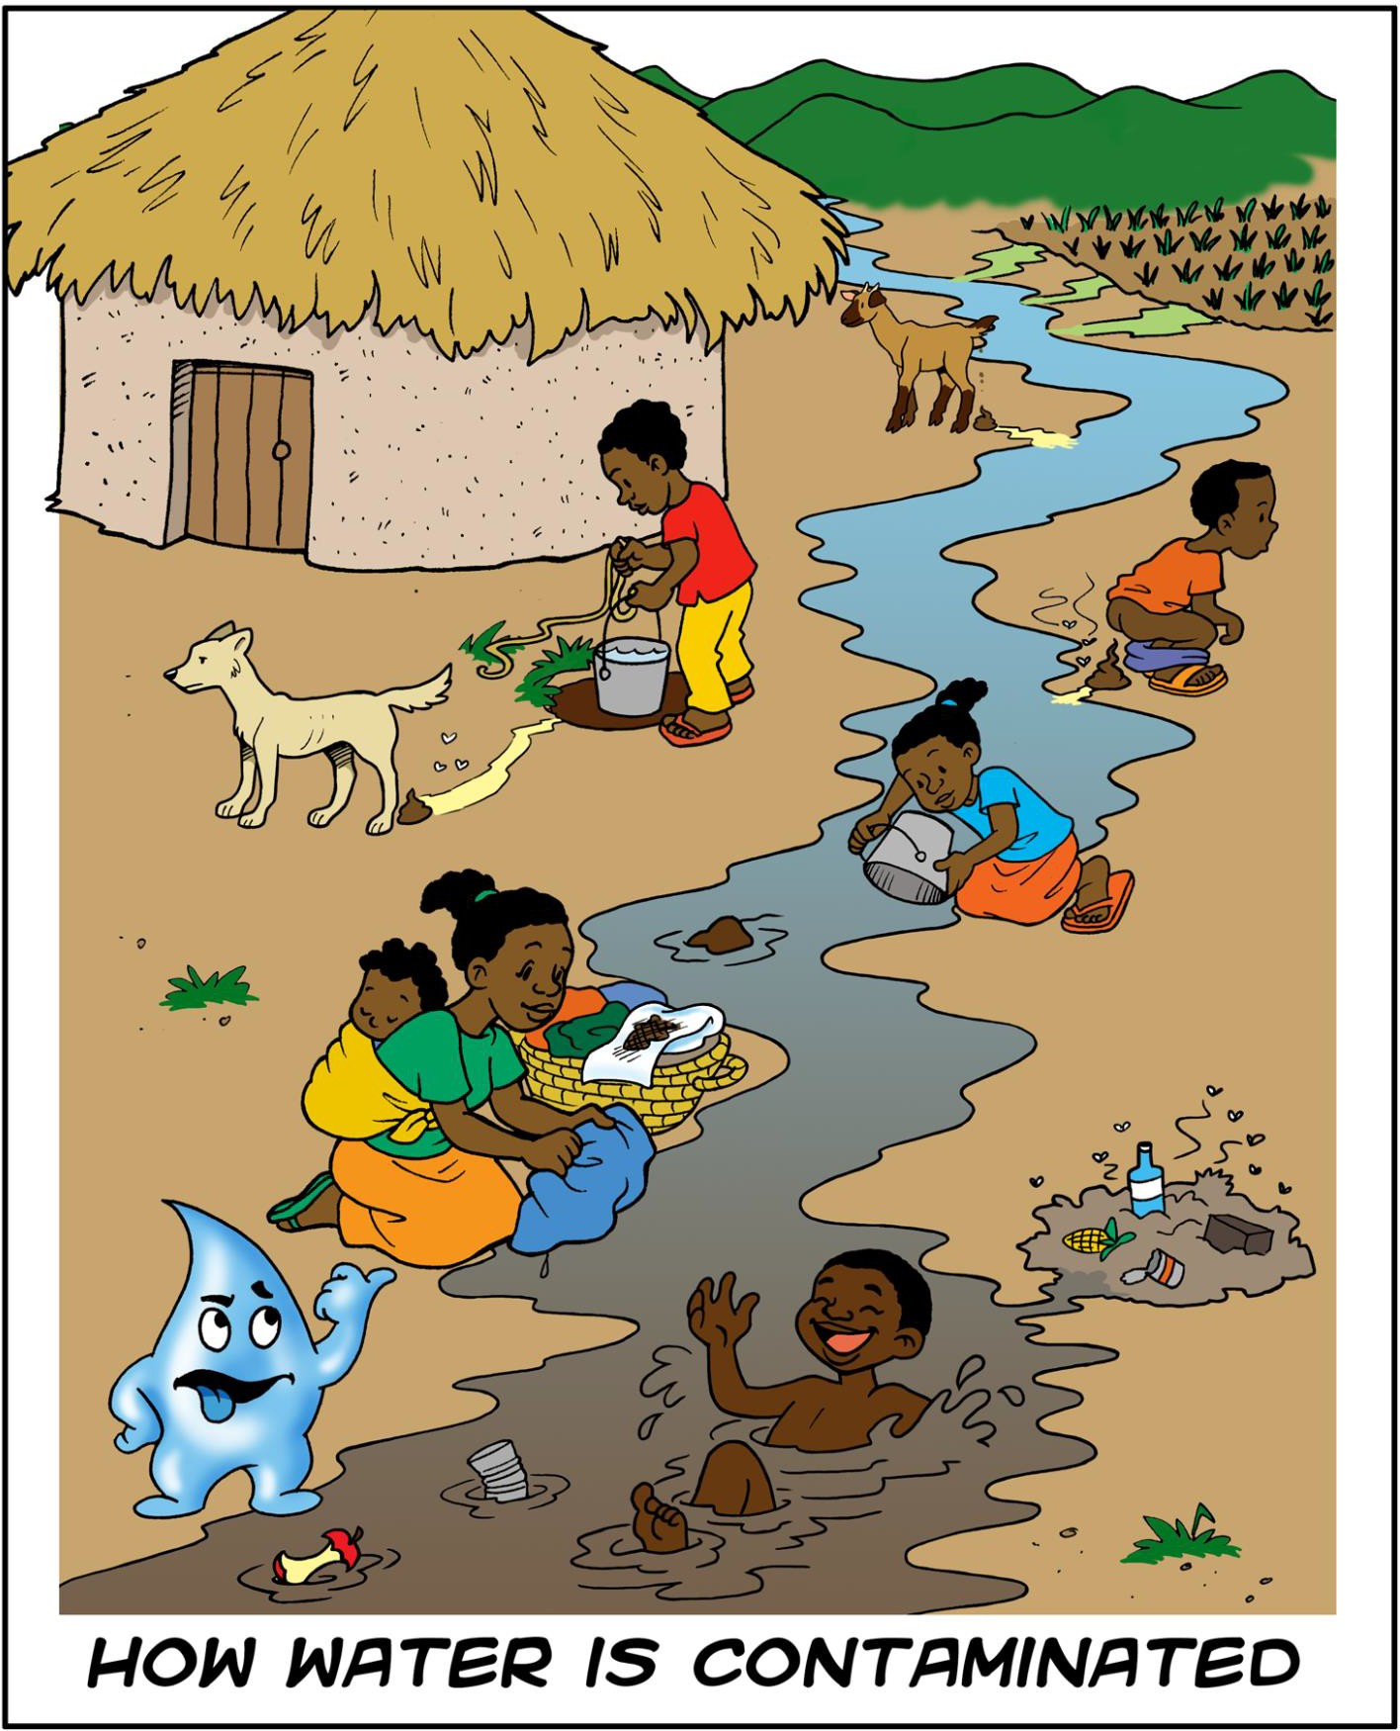

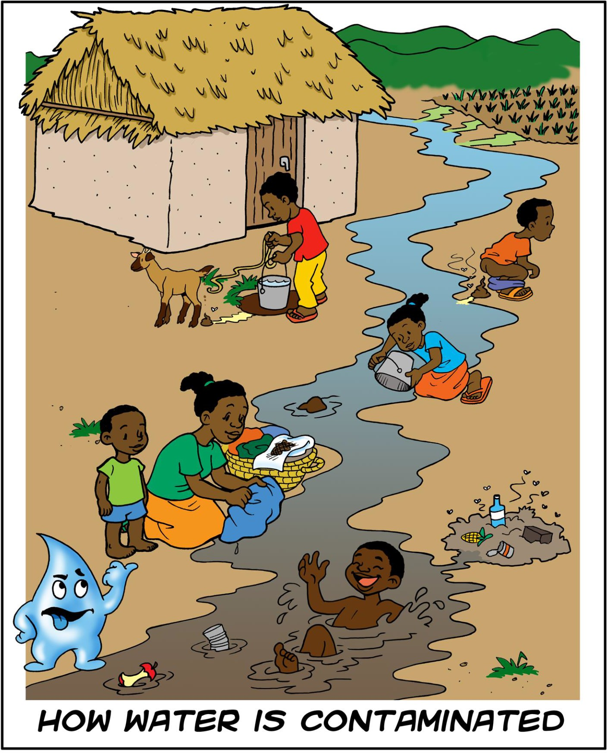

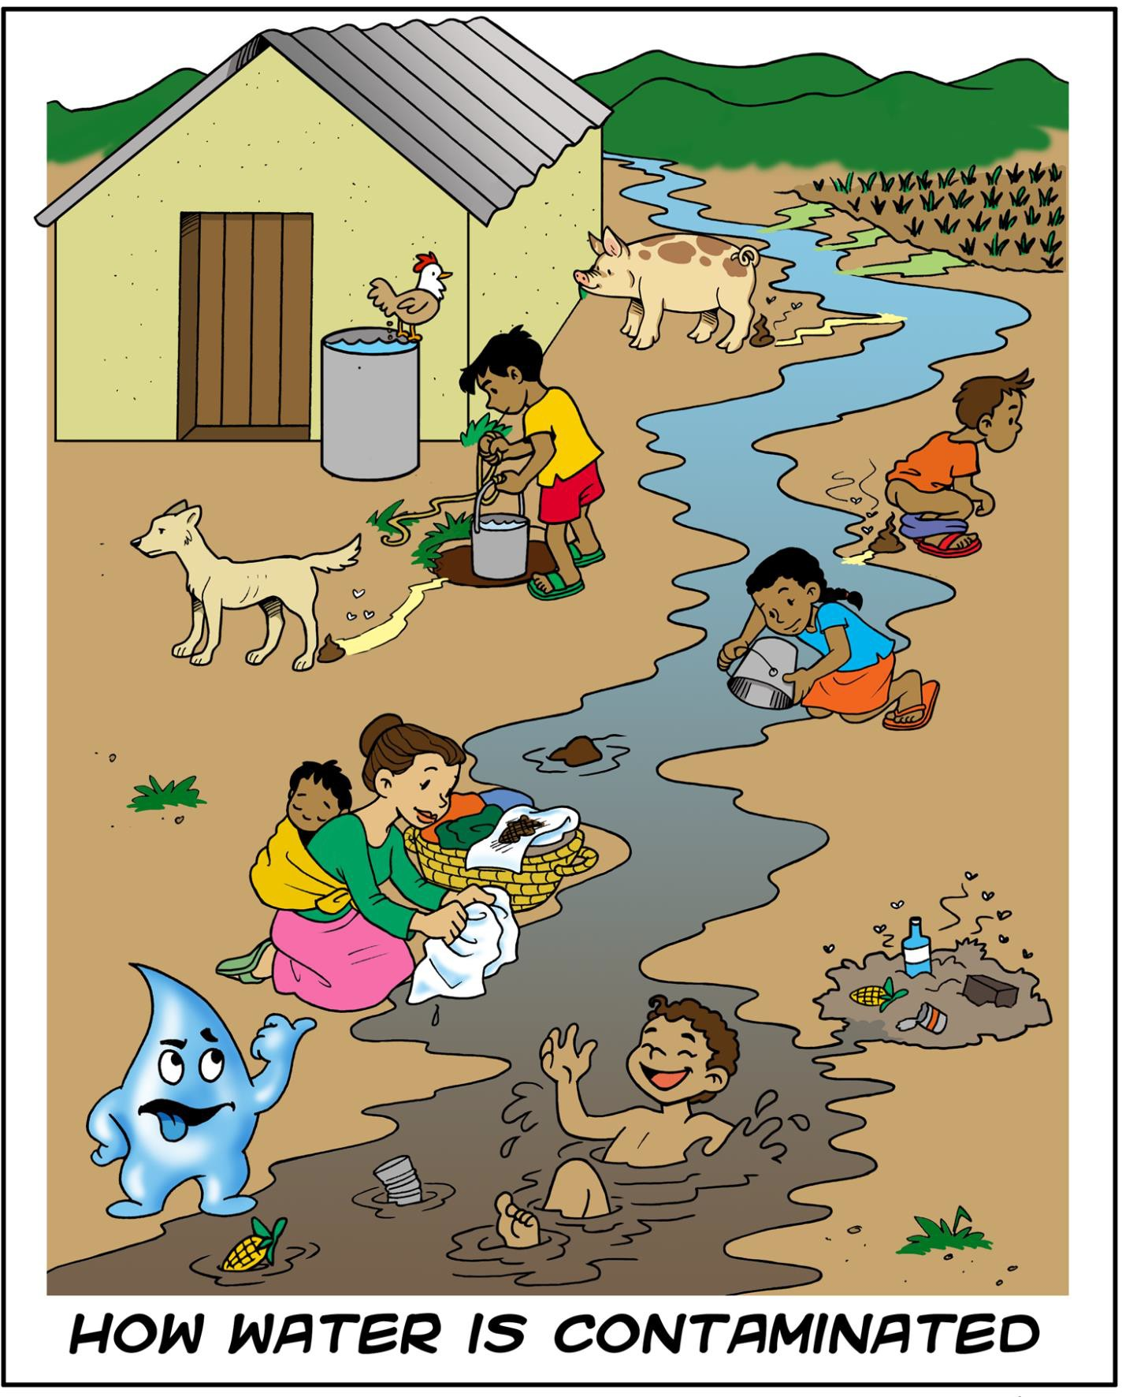

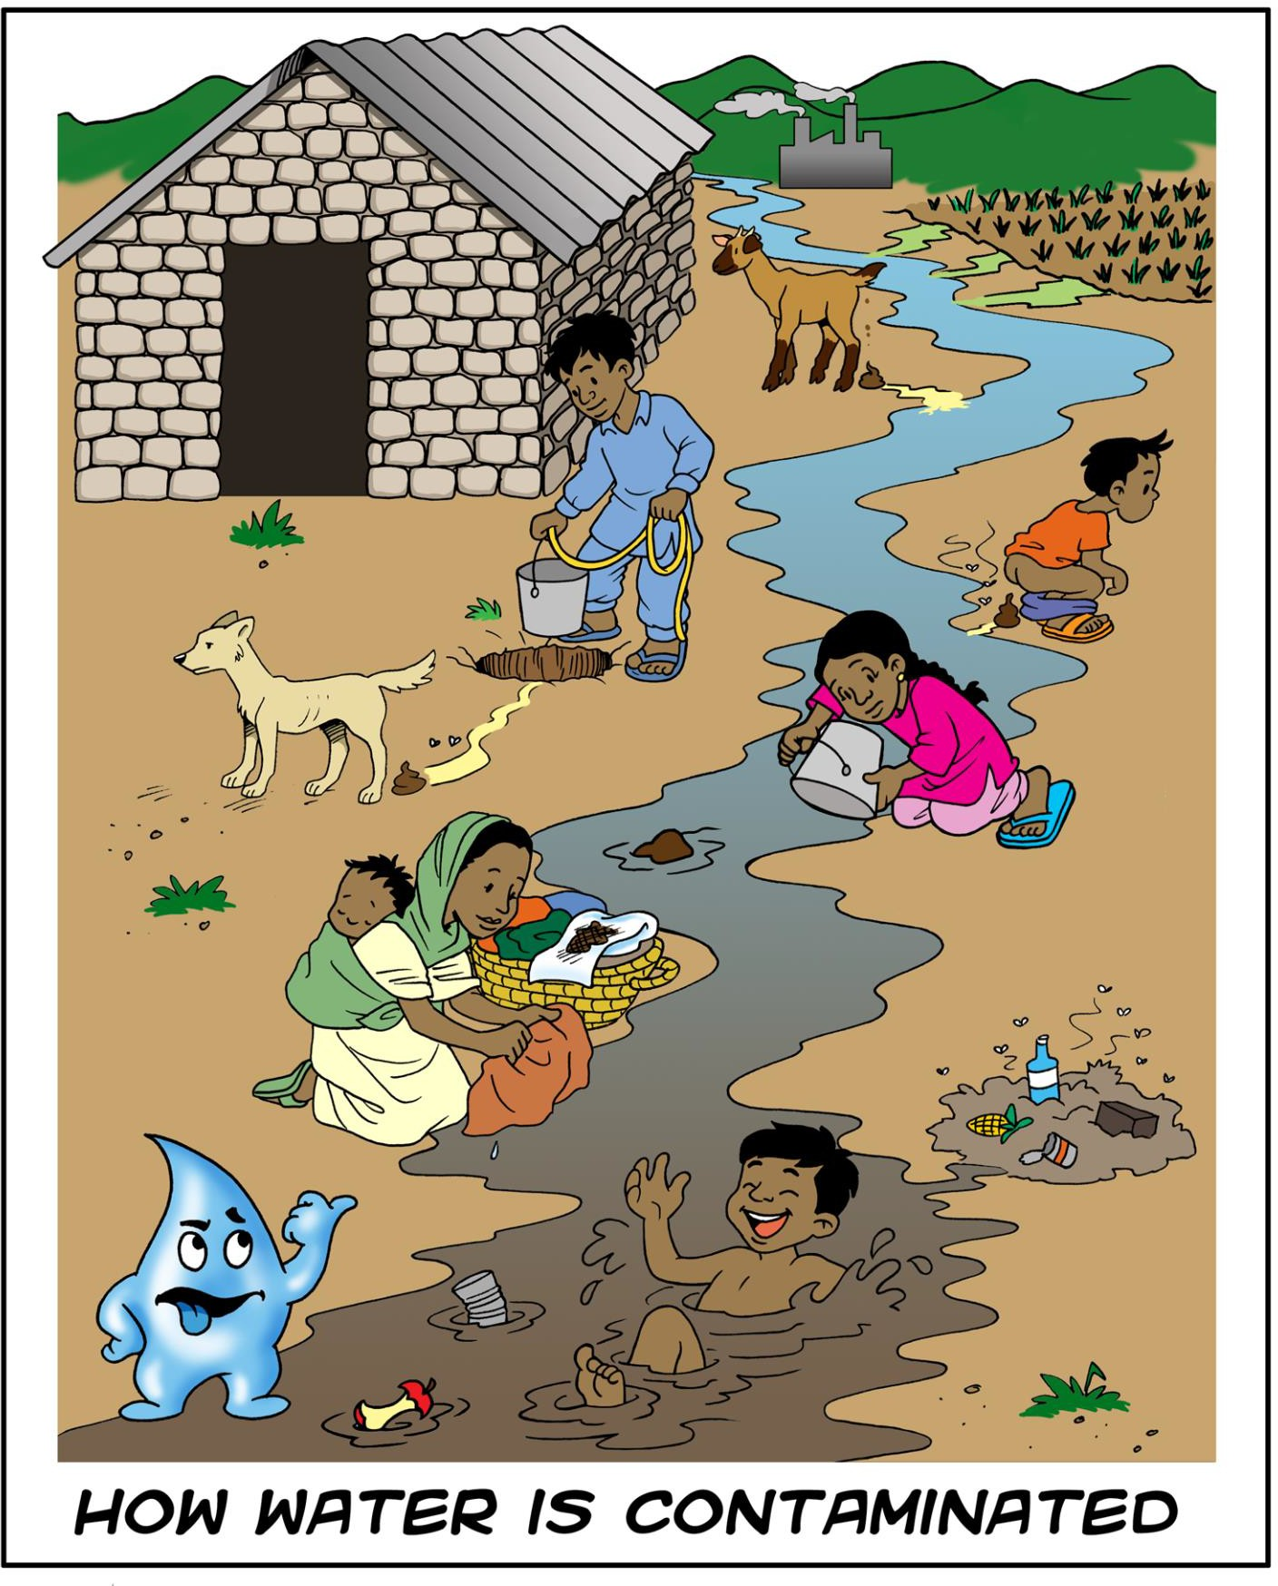

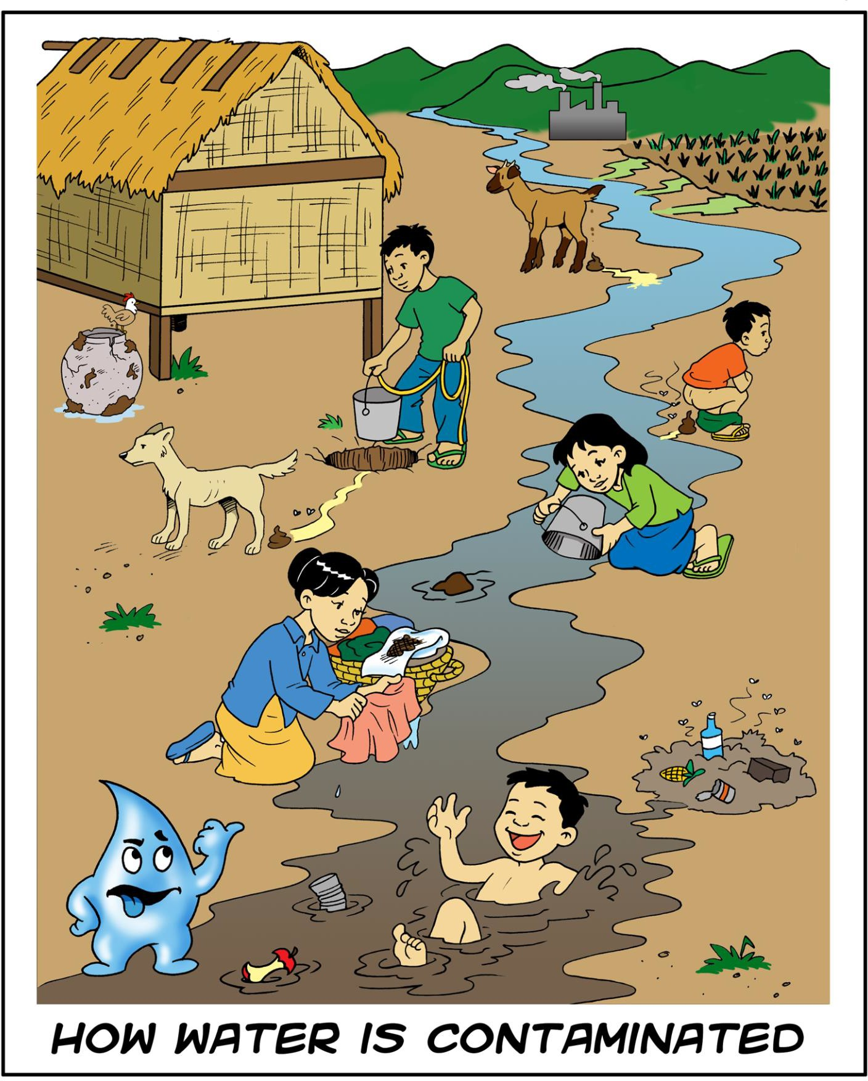

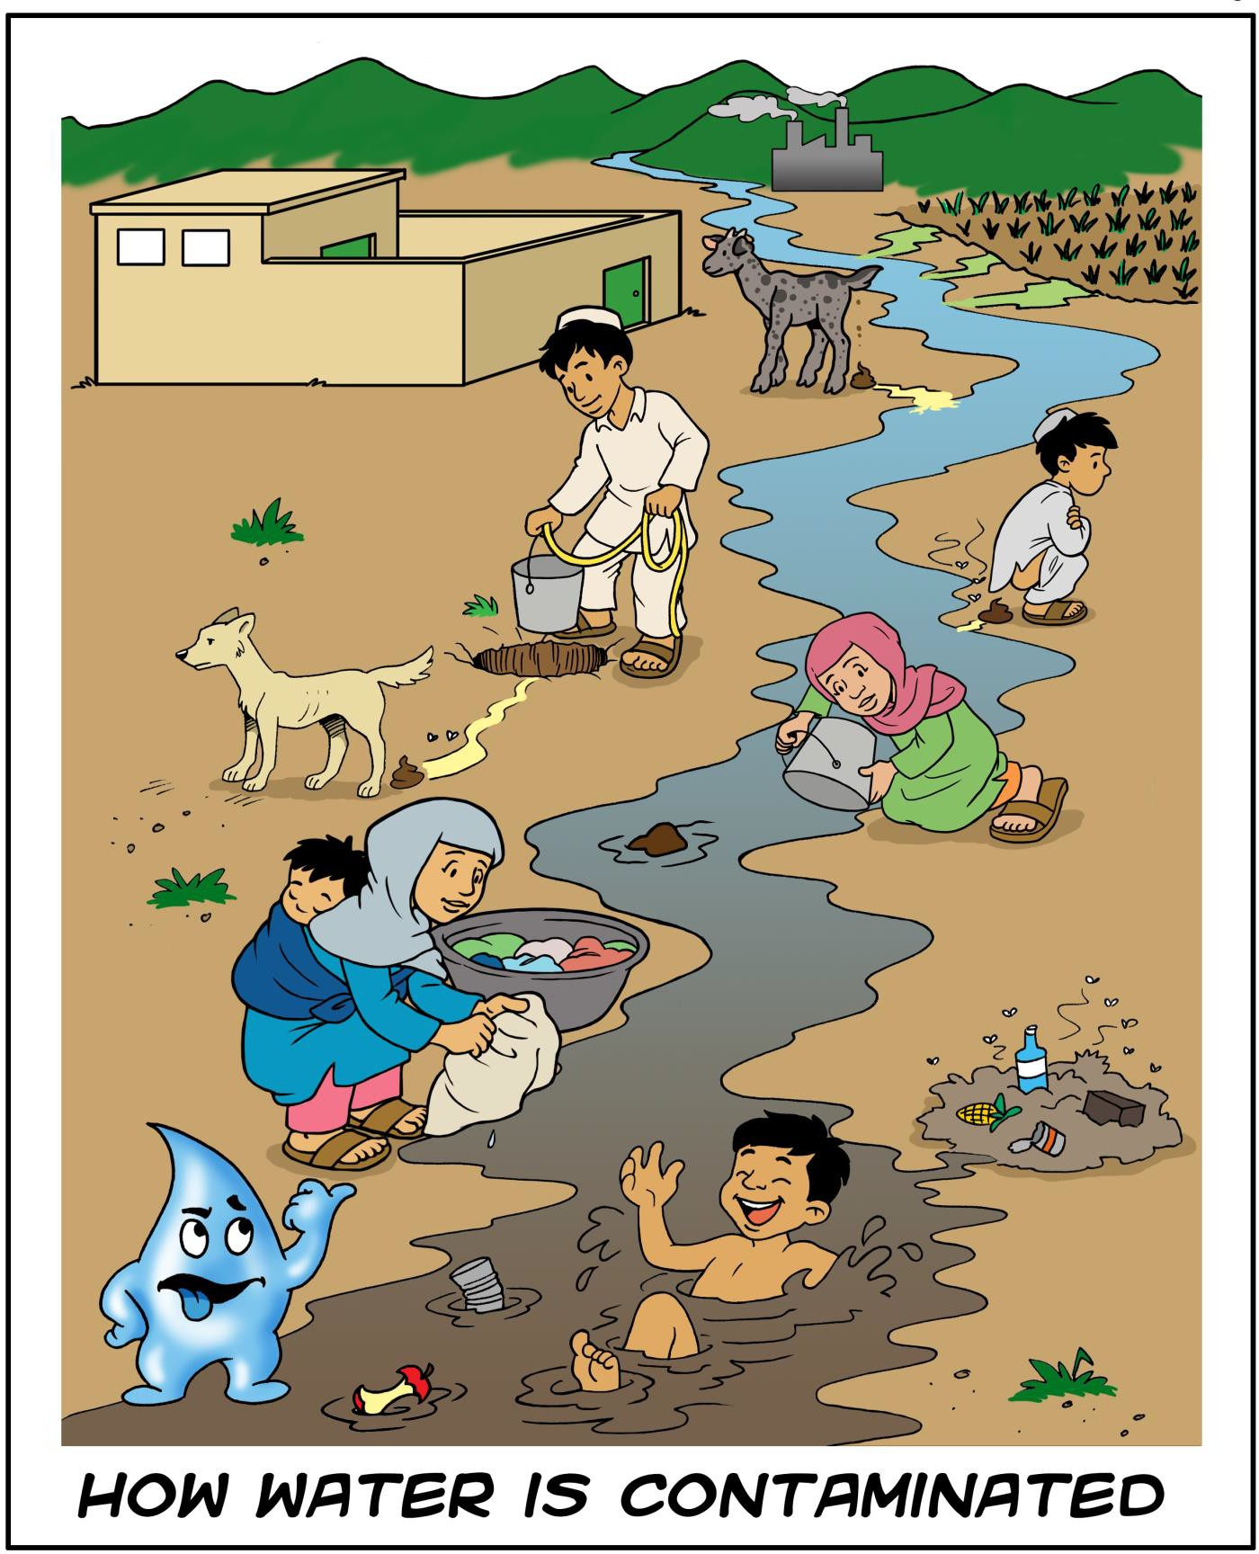



**Lesson Plan 4: Local and Global Sanitation Issues**

**30 minutes total**

**Lesson Description**

This lesson discusses the local and global issues involved with access to basic sanitation and its connection to the poverty cycle. Different options are given to facilitate the lesson depending on the participants’ background and time.



###### Learning Outcomes

At the end of this session participants will be able to:

1. Discuss the local and global issues involved with access to basic sanitation.
2. Discuss how poor sanitation is connected to and causes the cycle of poverty to continue.

###### Materials

* + Flipchart paper
  + Tape
  + Markers
  + Scissors

###### Optional:

* + Vocabulary list
  + Scissors
  + Tool: Problem Tree
  + Computer and projector
  + PowerPoint: Local and Global Sanitation Issues

###### Preparation

* + Review topic in the Technical Brief: Introduction to Sanitation and Technical Brief: Introduction to Environmental Sanitation
  + Optional: Print and cut out the vocabulary list at the end of this lesson plan
  + Optional: Review Tool: Problem Tree (See Appendix 2)
  + Optional: Write the session Learning Outcomes on flipchart paper
  + If using PowerPoint: Local and Global Sanitation Issues
    - Review the PowerPoint presentation
    - Add country specific latrine photos and data to local issues slide (available from the WHO/UNICEF Joint Monitoring Programme for Water Supply and Sanitation at: www.wssinfo.org)
    - Check that the projector is working
    - Cue the PowerPoint on the computer

###### Introduction 5 minutes

1. Divide participants into small groups of three or four people. Ask the groups to discuss any issues they have seen or heard with respect to sanitation. Share as a large group.
   1. *Water contamination, no latrines at home, work or school, lack of availability or access to sanitation, health issues*
2. Present the lesson description or learning outcomes.

###### Local and Global Sanitation Issues 20 minutes Option A: Cycle of Poverty Activity

1. Divide participants into small groups of three or four people. Hand out one piece of letter sized paper and one flipchart paper to each group.
2. Ask the groups to divide their letter sized paper into three sections: Child, Adult, Community.
3. Ask the groups to discuss how sanitation affects children, adults and the community from a social and economical perspective. Ask the groups to record their thoughts on the letter sized paper.
4. Ask the groups to write Sanitation Issues in the middle of their flipchart paper.
5. Ask the groups to discuss and draw how sanitation issues are connected with the cycle of poverty.
   * *If children are sick, they can’t go to school, they can’t get an education, then they can’t get a job. If adults are sick, they can’t work, they can’t earn money. If a school doesn’t have a latrine, adolescent girls don’t want to go to school, they can’t get an education, then they can’t get a job...*
6. After 5 minutes, ask the groups to post their flipchart paper around the room. Ask the groups to do a Gallery Walk (i.e, walk around the room to look at the ideas on the flipcharts of other groups).
7. Discuss with the large group the connection between sanitation and the cycle of poverty.

###### Option B: Group Discussion

1. Hand out one vocabulary term to each participant.
2. Ask participants share their vocabulary term one at a time and discuss in one minute what they know or think about the topic. If a participant does not know what their term means, ask someone else to discuss the topic. After a participant has finished, ask the others if they would like to add anything or have any questions.
3. Summarize the discussion and clarify the following:
   * *As of 2012, around 2.5 billion people lack access to adequate sanitation (UNICEF and WHO, 2014)*
     + *784 million people use public or shared sanitation facilities*
     + *732 million use unimproved sanitation facilities that do not hygienically separate human excreta from human contact*
     + *1 billion (14% of the world population) defecate in the open*
     + *The majority (70%) of those without sanitation live in rural areas, where 90% of all open defecation takes place*
   * *Millennium Development Goals (MDGs) are a United Nations led initiative to promote development through reduction of poverty, achievement of universal primary education, increasing access to water and sanitation, etc. There are eight goals to be achieved by 2015. They will be replaced by the Sustainable Development Goals in 2016.*
   * *MDG definition of improved sanitation*
     + *Connection to public pipe sewer system or septic tank, pit latrine with slab, ventilated improved pit (VIP) latrine, composting latrine, pour flush latrine*
   * *Since 1990, almost 2 billion people have gained access to an improved sanitation facility, and open defecation declined from 24% to 14% of the world population. The world, however, remains off track to meet the MDG target of providing basic sanitation to 75% of the world’s population by 2015, and will miss the target by more than half a billion people. Sanitation coverage in 2012 was 64% of the world’s population (UNICEF and WHO, 2014).*
   * *Sanitation System – the safe management of human excreta to prevent harmful contact with humans or the enviornment*
   * *Sustainable Services - sanitation systems and support should function sustainbly beyond the term of the project*
   * *Sanitation Access- is the avilability of sanitation systems at household level, in schools, hospitals and public spaces*
   * *Sanitation Use – people are choosing to use sanitation systems over open defecation*

###### Option C: PowerPoint

1. Use PowerPoint: Local and Global Sanitation Issues.
2. Review the global information as well as the local statistics.

###### Option D: Problem Tree

1. Use Tool: Problem Tree to analyze the causes and consequences of poor environmental sanitation. (See Appendix 2)

###### Review 5 minutes

1. Ask the participants to stand in two lines facing each other in pairs. Name one line A and the other B.
2. Ask line A to briefly discuss some of the local and global sanitation issues. After 1 minute, ask line A to move one person to the right. Line B will then discuss the same topic with a new partner for 1 minute.
3. Ask line A to briefly discuss poor sanitation is connected to and causes the cycle of poverty to continue. After 1 minute, ask line A to move one person to the right. Line B will then discuss the same topic with a new partner for 1 minute.

**Reflections on Lesson**

**Group Discussion Vocabulary**

|  |  |
| --- | --- |
| **Open Defecation** | **Latrine** |
| **Sanitation & Gender** | **Handwashing** |
| **Water Contamination** | **Behaviour Change** |
| **Millennium Development Goals** | **Sanitation Access** |
| **Improved Sanitation** | **Challenges at School** |
| **2.5 Billion People** | **Sanitation Use** |
| **Most Vulnerable** | **Rural** |
| **Cycle of Poverty** | **Urban** |



**Lesson Plan 5: Disease Transmission 60 minutes total**

**Lesson Description**

This lesson provides several options to introduce pathogens and diseases related to environmental sanitation, depending on the background of the participants and the time available. Participants will play the Transmission Routes activity or a modified version of the Three Pile Sorting activity to identify different transmission routes and how environmental sanitation can prevent the transmission of diseases.



###### Learning Outcomes

At the end of this session participants will be able to:

1. Identify the four types of pathogens.
2. Identify diseases related to environmental sanitation.
3. Identify different transmission routes of diseases.
4. Explain how environmental sanitation can prevent the transmission of diseases.

###### Materials

* + Flipchart paper
  + Markers
  + Tape

###### Optional:

* + Tool: Transmission Routes (See Appendix 2, available at: www.cawst.org/resources)
  + Tool: Three Pile Sorting (See Appendix 2, available at: www.cawst.org/resources)
  + Extra paper
  + Computer, projector and speakers
  + PowerPoint: Disease Transmission
  + Video: Prescription for Health (length 23:32)
    - Available at: <http://idl-bnc.idrc.ca/dspace/handle/10625/10770?mode=full>
  + Video: The Story of Cholera (length 04:29) Note: This video is also available on YouTube in other languages including Spanish, Haitian Creole, Krio and Andeyo
    - Available at: [www.globalhealthmedia.org/story-of-cholera/videos/](http://www.globalhealthmedia.org/story-of-cholera/videos/)

###### Preparation

□ Review topic in Technical Brief: Introduction to Sanitation, Technical Brief: Handwashing, Technical Brief: Solid Waste Management, Technical Brief: Domestic Wastewater Management, Technical Brief: Vector Control, Technical Brief: Animal Excreta Management

* + Write the heading *Pathogens* on flipchart paper
  + Write the heading *Diseases Related to Environmental Sanitation* on flipchart paper
  + Optional: Write the heading *Disease Transmission* on flipchart paper
  + Optional: Write the session Learning Outcomes on flipchart paper
  + Disease Transmission Option A: Review Tool in Appendix 2. Print and cut out the activity cards. Have one set prepared for each group.
  + Disease Transmission Option B: Review Tool in Appendix 2.Choose the cards from the Three Pile Sorting activity that you want to use. Print and cut out two different cards per group.
  + If you are planning to use a video or PowerPoint: Disease Transmission
    - Check that the projector and speakers are working
    - Cue the Video: Prescription for Health or Video: The Story of Cholera on the computer
    - Prepare flipchart paper with the video questions or print a question sheet for each participant

###### Introduction 5 minutes

1. Optional: Enter the room pretending to be sick and complaining of diarrhea, cramps and nausea.
2. Ask the participants if they have had diarrhea before or do they know anyone else who has been sick with diarrhea?
3. **LINK:** Ask the participants what could have caused the diarrhea?
4. Present the lesson description or the learning outcomes.

###### Pathogens 15 minutes

1. Give the definition of a pathogen. Ask the participants to list as many examples of pathogens they can think of. Write the four pathogens on the *Pathogens* flipchart.
   * *Pathogen – Any living organism that causes disease*
   * *Helminths (worms), protozoa, bacteria, virus*
2. Demonstrate the size difference of the pathogens.

**Option A:** Draw a picture on a flipchart. Start with a helminth being as big as the flipchart page. Draw a protozoa the size of your little finger. A bacteria will be the size of the end of a pencil. A virus will be the smallest dot you can make with a pen.

**Option B:** Show the PowerPoint: Disease Transmission.

1. Briefly discuss the details of each type of pathogen.

**Option A:** Using the flipchart that compares the sizes of the pathogens, describe and write the key features of each pathogen.

**Option B:** Show the PowerPoint: Disease Transmission.

1. Ask the participants which types of pathogens can be found in feces?
   * *All of them*
2. Optional depending on time: Divide participants into groups of three to four people. Ask the groups to create a physical action to represent all four types of pathogens. Ask the participants to demonstrate the action of the pathogens in order from biggest to smallest. Then again from smallest to biggest.

###### Diseases Related to Environmental Sanitation 15 minutes Option A: Group Discussion

1. Ask the participants to identify what diseases are related to environmental sanitation, including excreta management, wastewater management, solid waste management and vector control. Record responses on flipchart *Diseases Related to Environmental Sanitation*.
   * *Drinking water contaminated with fecal pathogens (water-borne) – diarrhea (bacteria), cholera (bacteria), typhoid (bacteria), shigellosis (bacteria), hepatitis A and E (virus), amoebic dysentery (protozoa), cryptosporidiosis (protozoa), giardiasis (protozoa), guinea worm (helminth)*
   * *Washing in water contaminated with fecal pathogens (water-based) – schistosomiasis (helminth), Fasciola (liver flukes)*
   * *Contact with fecal pathogens in soil – Roundworm (helminth), hookworm (helminth)*
   * *Lack of water for basic hygiene (water-washed) – trachoma (bacteria), scabies (mites)*
   * *Insects that breed or live in standing water (water insect vectors) – malaria (protozoa transmitted by mosquitos), dengue fever (virus transmitted by mosquitos), yellow fever (virus transmitted by mosquitos), filariasis (helminth transmitted by black flies and mosquitos), river blindness (helminth/bacteria transmitted by black flies), sleeping sickness (protozoa transmitted by tsetse fly)*
   * *Insects that breed or live in animal feces (feces insect vectors) – leishmaniasis (protozoa transmitted by sand flies)*
   * *Rats, mice and other rodents that breed or live in unsanitary conditions – hantavirus (virus, transmitted by contact with rodent excreta), typhus (bacteria, transmitted by fleas or lice on rodents), leptospirosis (bacteria, transmitted by water, soil or food contaminated with infected urine), bubonic plague (bacteria, transmitted by fleas on rodents)*
2. Ask the participants what can be done to prevent these diseases.
   * *Drinking safe water, using latrines to safely dispose excreta, disposing wastewater to remove standing water, cleaning out drainage channels, treating and disposing solid waste, managing animal excreta, using insecticides, using bed nets, rodent control*

###### Option B: PowerPoint

1. Show the PowerPoint: Disease Transmission.

**Disease Transmission 20 minutes**

**Option A: Transmission Routes Activity**

**This activity is appropriate for participants who are not familiar with disease transmission. Note that this activity only addresses disease transmision related to excreta management and is not inclusive of all elements of environmental sanitation (i.e., domestic wastewater management, solid waste management, vector control).**

1. Divide participants into groups of three or four people.
2. Hand out the white cards and arrows to each group. Explain that they should use the white cards and arrows to create as many transmission routes as they can.
3. Optional depending on time: When the groups have made their diagrams, ask one group to share with another group. Let them respond to questions raised by the other group.
4. Hand out the yellow cards to each group. Explain that they should use the yellow cards to block the transmission of disease. It is useful to have blank paper and pens so that the group can create its own blocks if the pre-cut cards do not cover all situations.
5. Optional depending on time: When the groups have made their diagrams, ask one group to share with another group. Let them respond to questions raised by the other group.
6. Discuss with the large group the different ways to block transmission of pathogens. Ask if the groups identified any new ways that were not included in the yellow cards.
   * *Treat your water to make it safe to drink*
   * *Wash your hands*
   * *Prepare food well (e.g., washing vegetables with safe water)*
   * *Cover food and water to prevent contact from animals and flies*
   * *Use latrines and keep them clean*
7. Encourage discussion to find out why participants placed the pictures in the particular order and ensure everyone understands the meaning of “transmission route”.
8. Summarize by explaining that if we can prevent feces from getting into the environment in the first place, then we do not have to worry so much about treating water, storing food correctly or keeping away flies. That is why our first priorities should be safe excreta disposal and hand washing with soap.

###### Option B: Disease Transmission using Three Pile Sorting Cards 20 minutes

**This activity is appropriate for participants who are familiar with disease transmission. It addresses most of the elements of environmental sanitation.**

1. Divide participants into groups of two to four people. Give each group two cards from the Three Pile Sorting activity. Make sure that you use a variety of environmental sanitation situations (e.g., excreta management, domestic wastewater management, solid waste management, vector control).
2. Ask the groups to discuss how diseases are transmitted in each situation.
3. Discuss with the large group and record or draw the disease transmission routes on the *Disease Transmission* flipchart.
4. Ask the groups to discuss how the transmission could be prevented in each situation.
5. Discuss with the large group and record the prevention methods on the same flipchart.
6. Summarize by explaining that if we can prevent feces from getting into the environment in the first place, then we do not have to worry so much about treating water, storing food correctly or keeping away flies. That is why our first priorities should be safe excreta disposal and handwashing with soap.

###### Optional: Video 25 minutes

1. Tell participants they are going to watch a video, either Prescription for Health or The Story of Cholera.
2. Hand out the video questions (or write them up on a flipchart and provide them with paper to write their responses, or read the questions out for an audience with lower reading skills). Ask the participants to keep the questions in mind as they watch the video.
3. If you are showing The Story of Cholera, explain that this video talks specifically about cholera, but the information is the same for most water-related diarrheal diseases.
4. After the video discuss the questions with the large group.

###### Review 5 minutes

1. In pairs, explain that person A will first say a disease transmission route and person B has to say the prevention strategy. Then switch roles.

**Reflections on Lesson**

#### Prescription for Health Video

1. How can drinking water become contaminated?
2. How can you protect yourself from getting sick from water-related diseases?
3. Who is responsible for keeping families safe from water-related diseases?
4. How can environmental sanitation help prevent the transmission of disease?

#### The Story of Cholera Video

1. How can drinking water become contaminated?
2. How can you protect yourself from getting sick from water-related diseases like cholera?
3. Who is responsible for keeping families safe from water-related diseases?
4. How can environmental sanitation help to prevent the transmission of disease?



**Lesson Plan 6: Human Excreta Management**

**55 minutes total**

###### Lesson Description

This lesson introduces the five components of a sanitation system to properly manage human excreta. Participants learn about sanitation systems and discuss why the entire system must be addressed to ensure safe and sustainable sanitation.



###### Learning Outcomes

At the end of this session participants will be able to:

* 1. Identify the five components of a sanitation system to properly manage human excreta.
  2. Discuss why sanitation should be considered as a system to ensure safe and sustainable sanitation.

###### Materials

* + - Flipchart paper
    - Markers
    - Tape

Optional:

* + - Computer and projector
    - PowerPoint: Human Excreta Management

###### Preparation

* + - Review topic in Technical Brief: Introduction to Sanitation
    - Optional: Write out each component of the sanitation system and its description on separate pieces of flipchart paper. See activity below for the descriptions. Cover the descriptions and reveal them as you do the activity.
    - Introduction Option A: Print and cut out the functions and arrows of the sanitation system (1 set per group). Draw the sanitation system on flipchart paper.
    - Optional: Write the learning outcomes on flipchart paper
    - If using PowerPoint: Human Excreta Management
      * Review the PowerPoint presentation
      * Check that the projector is working
      * Cue the PowerPoint on the computer

###### Introduction 10 minutes

**Option A:**

1. Divide participants into small groups.
2. Hand out the functions and arrows of the sanitation system to each group.
3. Ask the groups to place the components in a sequential order.
4. After 3 minutes, show the framework diagram on the flipchart. Ask the groups to discuss and compare their diagrams with yours.
5. **LINK:** Ask the participants what have they created with their diagram?
   * *A system for managing human excreta*
6. Present the lesson description or learning outcomes.

###### Option B:

1. Ask the participants “What is needed to make a phone call to someone? What does that entire system look like?”
   * *The caller and receiver both need to purchase phones*
   * *The caller needs to have credit or an agreement to pay the bill for the phone call*
   * *The caller needs to know how to use the phone to dial the number*
   * *The cell phone towers need to connect the calls*
   * *The receiver needs to pick up the phone*
2. Ask the participants “What would happen if one part of this system didn’t work?”
   * *You still might have the phone and be able to use it to play games or music.*
   * *You could get the call display and know that the person called them.*
   * *In most of the cases the call would not be made and message would not be communicated.*
3. Ask participants to now think of household sanitation as a system. Ask “Where could a sanitation system fail and what would be the consequences?” Share some answers as a large group.
   * *Contaminated environment*
   * *Contaminated drinking water*
   * *Sick people*
4. Present the lesson description or learning outcomes.

###### Sanitation Systems 35 minutes

1. Explain that sanitation (or managing human excreta) is much more than building latrines and stopping people from open defecation. Sanitation is a system, rather than a single technology or a latrine.
2. Explain to participants that you are going to lead them through a story. Tell the participants to imagine that they live in a peri-urban area and have decided to build a latrine for their family. Optional: Use either flipcharts or PowerPoint as a visual aid throughout the next steps.
3. In pairs, ask the participants to discuss “What features do you want in your latrine?” Share some answers as a large group.
4. Explain that people usually first think about how it will look, type of toilet and how they will cleanse themselves. Tell participants that the term we will use to encompass all of those aspects is ‘user interface’.
5. Show participants the “*User Interface*” flipchart and read the description.
   * *The things a person encounters when they use and maintain the latrine.*
6. Ask the participants “What parts of latrine are considered the user interface?” Record the following 5 components on the *“User Interface*” flipchart.
   * *Toilet*
   * *Slab*
   * *Superstructure*
   * *Latrine accessories (e.g., anal cleansing materials, a place to wash or dispose of menstrual hygiene products)*
   * *Handwashing station*
7. Tell participants that they have now built a very sturdy and private superstructure, with a toilet on a smooth concrete slab, a handwashing station, and an area for women to wash their menstrual hygiene products. Ask the participants “Where does the excreta go?” Share some answers as a large group.
8. Show participants the “*Excreta Storage”* flipchart and read the description.
   * *A latrine needs some type of pit, tank or chamber to safely collect and store excreta until it is emptied, removed or covered.*
9. Tell participants to go back to their imaginary latrine. Explain that they have been using it for a few years now and when they look down the hole they can see that the excreta is close to the top of the slab. They want to keep using it for years to come. Ask the participants “What do you do now?” Share some answers as a large group.
10. Show participants the “*Emptying and Transport”* flipchart and read the description.
    * *Full latrines must be either emptied or moved to a new location. Latrines should be emptied in a safe and hygienic manner by well-equipped and protected workers who transport the sludge to a treatment, use or disposal site.*
11. Tell participants that the pit is now emptied and the excreta is ready for transport. Ask the participants “What do you need to figure out next?” Share some answers as a large group.
12. Explain that most people think of disposal first. It’s important to think about disposal and ensure that the excreta is put somewhere where it will not come in contact with people or contaminate the environment. However, there are also options to first treat the excreta to ensure its safety, like composting for instance.
13. Show participants the “*Treatment”* flipchart and read the description.
    * *It is important to treat excreta before use and sometimes disposal. Treatment helps to protect the environment and public health from fecal pathogens and other contaminants.*
14. Explain to participants that after treating the excreta you can either dispose of it safely or you have the option to use it. The practice of using excreta in agriculture has been used for centuries. Excreta is nutrient rich and can add a lot value to crops and soil. If it is going to be used for this purpose, it must be treated properly to ensure safety. This is known as ecological sanitation.
15. Show participants the “*Use or Disposal”* flipchart and read the description.
    * *Using or disposing treated excreta in ways that are the least harmful to people and the environment.*
16. In pairs, ask the participants to discuss “Why is it important to consider all of the components of a sanitation system when you build a latrine?” Share some responses as a large group.
    * *Each component should be taken into account to ensure that the technology choices will support the ultimate goal of keeping excreta out of contact with people and the environment.*
    * *Often sanitation projects only consider the user interface and excreta storage. There are no clear plans of what should be done when the latrine is full. By not thinking through the entire system you cannot have a sustainable project or long-term sanitation use.*
    * *Many of the technology and user decisions made for each component will affect the other components and technologies. You need to make sure that all the technologies work together in order to create a functioning sanitation system.*

###### Review 10 minutes

1. Explain that participants will work in groups to create actions to help remember the 5 components of a sanitation system. They will come up with one action for each component. After 2 minutes, they will share their actions with the large group.
2. Divide the participants into 3 groups. Give them 2 minutes to come up with their actions.
3. Ask each group to share their actions.
4. Optional depending on time: Call out each component and get the whole group to do their action. Do this more than once and when participants are comfortable, you can start calling them out of order.

**Reflections on Lesson**

**Introduction Activity: The Sanitation System**

|  |  |
| --- | --- |
| **User Interface** |  |
| **Excreta Storage** |  |
| **Latrine Emptying and Sludge Transport** |  |
| **Sludge Treatment** |  |
| **Sludge Use or Disposal** |  |



**Lesson Plan 7: Sanitation Ladder**

**30 minutes total**

**Lesson Description**

Participants will use the Sanitation Ladder activity to discover how some sanitation practices and latrines are better than others. They will discuss the advantages and challenges of building a latrine higher up on the ladder, and where is best for new latrine users to start on the ladder. As well, participants will discuss incremental improvements that can be made within an entire sanitation system.



###### Learning Outcomes

At the end of this session participants will be able to:

1. Explain the sanitation ladder.
2. Discuss why being higher up on the sanitation ladder is important.
3. Discuss the advantages and challenges of moving up the sanitation ladder.
4. Discuss where on the sanitation ladder is best for new latrine users to start.
5. Discuss incremental improvements that can be made within a sanitation system.

###### Materials

□ Tool: Sanitation Ladder (See Appendix 2: Tools, available at: [www.cawst.org/resources](http://www.cawst.org/resources))

###### Preparation

□ Review topic in Technical Brief: Introduction to Sanitation

□ Review Tool: Sanitation Ladder in Appendix 2. Print and cut out the activity cards (1 set per group). Use only the cards that best represents the region that you are working in (e.g., Asia, Africa, Latin America)

* Optional: Write the learning outcomes on flipchart paper

###### Introduction 5 minutes

1. Ask participants to close their eyes and picture different types of latrines that they have used.
2. Ask them to identify which latrine was the best and which one was the worst.
3. In pairs, ask participants to describe each latrine and explain why it was best or worst.
4. Present the lesson description or learning outcomes.

###### Sanitation Ladder 20 minutes

1. Divide the participants into groups of 4 or 5 people.
2. Give each group a set of sanitation ladder activity cards. Ask each group to order the cards from the worst sanitation option to the best. Tell them they will have up to 10 minutes.

If there disagreement about how to order the cards, explain that the cards can be placed as equal and that they should go back to them again later. Ask participants to explain why they think one card is a better option.

Note: There are several ways to order the cards. There is no right answer for this activity. The value of this activity is what participants learn while discussing the cards with each other. Try to encourage discussion.

1. Give a signal to the participants when time is almost up.
2. Optional depending on time: Ask the participants to walk around and look at the other groups’ sanitation ladders and see if they are the same as their own.
3. Ask the participants “Why it is better to be higher up on the sanitation ladder?”
   * *Stops human, animal and insect contact with the feces and reduces disease transmission*. *Remind participants about the Transmission Routes activity that they completed earlier in the day (see Lesson Plan: Disease Transmission). Remind them that if we can prevent feces from getting into the environment in the first place, then we do not have to worry so much about treating water, storing food correctly or keeping away flies. That is why our first priorities should be safe excreta disposal and handwashing with soap.*
   * *Sludge is safer to empty*
   * *People will like it more, aspirational*
   * *Increased privacy, safety and weather protection*
4. Ask the participants “What challenges are there for people to move up the sanitation ladder?
   * *Current defecation practices*
   * *Current sanitation system*
   * *Knowledge about sanitation systems*
   * *Skills to build and maintain a latrine or other components of a sanitation system*
   * *Building materials available*
   * *Funds available*
   * *Social and cultural habits and beliefs*
   * *Environmental conditions*
5. Ask the participants “Should new latrine users should start near the bottom of the ladder or go right to the top of the ladder?”
   * *It depends on users. It may be difficult for them to make a lot of changes at once and change their behavior, or hard to afford a latrine at the top of the ladder.*
   * *Large steps can be taken to climb the sanitation ladder at once. For instance, some people may be able to go directly from open defecation to a latrine that meets all their needs and preferences, if they are motivated and have the resources (such as technical information, construction skills, building materials and funds). Having a desirable and high-quality latrine may make it more likely that people will continue to use it on a long-term basis.*
   * *People can also upgrade to a better sanitation option as they get the resources. This may mean changing the entire latrine (for example, changing from a pit latrine to a twin pit VIP latrine) or making it better quality or more luxurious (for example, build a better superstructure, put on a better roof, or tile in inside with ceramic tiles).*
   * *Knowing whether people can make big steps up the sanitation ladder means knowing your users.*
6. Explain that this activity only shows ways that latrines can be improved. Ask the participants “What are other ways that sanitation in the community can be improved?”
   * *Ensuring the rest of the sanitation system (beyond the latrine) is in place is another incremental improvement that can be made. The latrine is usually the first component of a sanitation system that is built. The rest of the system may not be implemented for some time after the latrine is built.*
   * *Start a latrine emptying service*
   * *Teach people how to treat or safely dispose of their pit contents*
   * *Set up a sludge treatment facility*
   * *Use treated sludge as a resource, for example as a fertilizer in agriculture*

###### Review 5 minutes

1. In pairs, ask participants to decide who will be a pit latrine owner and who will be a salesperson. Tell the salesperson that they have 1 minute to convince the pit latrine owner that they should improve their latrine.
2. After 1 minute, discuss as a large group what arguments were used to convince latrine owners to improve their sanitation situation? What kind of improvements were discussed? Were the latrine owners convinced?

###### Reflections on Lesson



**Lesson Plan 8: Latrine Technologies**

**50 minutes total**

**Lesson Description**

This lesson introduces different latrine technologies that are commonly used in developing countries for excreta storage, including latrine pits, tanks and chambers. Participants learn about the basic design and operation of each technology.



###### Learning Outcomes

At the end of this session participants will be able to:

1. Identify different latrine pit, tank and chamber technologies.
2. Explain the basic operation of each excreta storage technology.

###### Materials

* + Flipchart paper
  + Tape
  + Markers
  + Scissors
  + Piece of cotton cloth
  + Glass of water
  + Bucket
  + Excreta Storage Table
  + Latrine Fact Sheets (see [www.cawst.org/resources](http://www.cawst.org/resources)) or Latrine Posters (see Appendix 3: Latrine Posters)
  + Cards for Activity: What Latrine Am I?

###### Preparation

* + Review topic in Technical Brief: Sanitation System – Excreta Storage and the Latrine Fact Sheets
  + Optional: Write the learning outcomes on flipchart paper
  + Print Excreta Storage Table (1 for each participant) Optional: Print out the solutions table for the participants.
  + Print and cut out the cards from the Review Activity: What Latrine Am I? (1 card per participant)
  + Option A: Print the Latrine Posters. Set up 4 stations around the room with the following titles and the corresponding posters:
    1. Pits: Pit latrine, VIP latrine, Arborloo latrine
    2. Chambers: Composting latrine, Dehydrating latrine
    3. Tanks: Septic tank, Aqua privy, Biogas reactor
    4. Other: Removable container, Holding tank

###### Introduction 5 minutes

1. Ask two volunteers to hold the corners of the cloth tight and make it flat in the air. Ask another volunteer to pour water over the cloth. Watch the water pass through the cloth and drip underneath. Place a bucket below to catch the water dripping from the cloth.
2. Tell the participants to imagine that the cloth is a wall of a latrine pit. Ask them “What does the water represent?”
   * *The water represents the liquid that passes out of the pit into the surrounding soil.*
3. Ask the participants “What does infiltration mean?” Share some responses as a large group.
   * *To pass into or through something. Infiltration is the process by which liquid from a latrine enters the surrounding soil.*
4. Explain that understanding infiltration is important for understanding how some latrine technologies work.
5. Present the lesson description or learning outcomes.

###### Excreta Storage Technologies 40 minutes

1. Explain to participants that we will be looking at different excreta storage technologies. These technologies fall under 4 categories: pit, chamber, tank and other.
2. Hand out one Excreta Storage Table to each participant and review the headings. Explain that for each technology participants will have to fill out the answers in the table. They can place a checkmark in each box that applies, or write “yes” or “no”. Let them know they will have 20 minutes to complete the activity.
3. Option A: Appropriate for participants who need longer time to read through information. In pairs, participants move through 4 stations set up around the room. They can learn about each technology by reading the Latrine Posters and discussing with their partner. They will fill out the Excreta Storage Table. Ensure that some participants start at each station.

Option B: Appropriate for participants who have high literacy and can quickly read through information. Do not set up stations around the room. Pairs work together in one spot. They review the Latrine Fact Sheets from their package of participant materials and discuss with their partner. They will fill out the Excreta Storage Table.

1. After 20 minutes, ask the participants to return to the large group. Ask if there are any questions about how the technologies work.
2. As a large group, review the answers on the Excreta Storage Table. Briefly explain the basic operation of each excreta storage technology. Optional: Hand out a copy of the solutions table to the participants.
3. Optional: Explain how some latrines can also be built as twin (or double) pits. When the first pit fills up, it is closed and the second pit is used. When the second pit is full, the first pit is emptied. Ask the participants “What are the reasons for having a twin pit design?”
   * *Because the sludge has sat in the pit for some time (2 years or more), it has reduced pathogen levels and is safer to handle.*
4. Optional: Ask the participants “Which excreta storage options would do not use a twin design?”
   * *Arborloo, septic tank, aqua privy, biogas reactor, holding tank, removable containers*
5. Optional: Ask the participants “Which excreta storage technologies can use a urine diversion toilet?”
   * *Urine diversion can be used with any of the technologies. Composting toilets may work better with urine in them (i.e., kill more pathogens and produce better fertilizer).*
   * *The only technology that MUST use a urine diversion toilet is the dehydrating latrine.*
6. Optional: Ask the participants “What is the benefit of using a urine diversion toilet?”
   * *Reduces the amount of liquid in the pit/tank/chamber. This may mean less infiltration (good if soil or groundwater contamination is a concern).*
   * *It also reduces the volume in the storage pit/tank/chamber (i.e., it doesn’t fill up as fast).*
   * *Less liquid also reduces the weight of removable containers.*
   * *Reduces the smell in the latrine – excreta smells most when urine and feces are mixed.*

###### Review 5 minutes

1. Tape one “What Latrine Am I?” card to the back of every participant.
2. Explain that the objective is to figure out what latrine they have on their back by asking others only yes/no questions. Provide an example of a yes/no question. Explain that participants can only ask one question to each person.
3. When the participants have guessed their latrine, take the card off of their back and give them another card. Continue the activity for 5 minutes.

###### Reflections on Lesson

**Activity: Excreta Storage Table.** Fill in the table by reading the Latrine Fact Sheets or Posters.

|  |  |  |  |  |  |  |  |  |  |  |
| --- | --- | --- | --- | --- | --- | --- | --- | --- | --- | --- |
| Excreta Storage Technology | What can it be connected  to? | | What can go in? | | | | | | | Does liquid infiltrate  into soil? |
| Wet toilet | Dry toilet | Urine | Feces | Anal cleansing water | Soft anal  cleansing materials | Hard anal  cleansing materials | Flush water | Cover material | (yes / no) |
| Pit Latrine |  |  |  |  |  |  |  |  |  |  |
| VIP Latrine |  |  |  |  |  |  |  |  |  |  |
| Arborloo |  |  |  |  |  |  |  |  |  |  |
| Septic Tank |  |  |  |  |  |  |  |  |  |  |
| Aqua Privy |  |  |  |  |  |  |  |  |  |  |
| Biogas Reactor |  |  |  |  |  |  |  |  |  |  |
| Composting Latrine |  |  |  |  |  |  |  |  |  |  |
| Dehydrating Latrine |  |  |  |  |  |  |  |  |  |  |
| Holding Tank |  |  |  |  |  |  |  |  |  |  |
| Removable Containers |  |  |  |  |  |  |  |  |  |  |

###### SOLUTIONS

|  |  |  |  |  |  |  |  |  |  |  |
| --- | --- | --- | --- | --- | --- | --- | --- | --- | --- | --- |
| Excreta Storage Technology | What can it be connected  to? | | What can go in? | | | | | | | Does liquid infiltrate  into soil? |
| Wet toilet | Dry toilet | Urine | Feces | Anal cleansing water | Soft anal  cleansing materials | Hard anal  cleansing materials | Flush water | Cover material | (yes / no) |
| Pit Latrine |  |  |  |  |  |  |  |  |  | YES |
| VIP Latrine |  |  |  |  |  |  |  |  |  | YES |
| Arborloo |  |  |  |  |  |  |  |  |  | YES |
| Septic Tank |  |  |  |  |  |  |  |  |  | YES |
| Aqua Privy |  |  |  |  |  |  |  |  |  | YES |
| Biogas Reactor |  |  |  |  |  |  |  |  |  | NO |
| Composting Latrine |  |  |  |  |  |  | ? |  |  | NO |
| Dehydrating Latrine |  |  | separate |  |  |  | ? |  |  | NO |
| Holding Tank |  |  |  |  |  |  | ? |  | ? | NO |
| Removable Containers |  |  |  |  |  |  | ? |  |  | NO |

? = Depends on the emptying method and end use of the sludge

###### Review Activity: What Latrine Am I?

|  |  |
| --- | --- |
| **Aqua Privy** | **Septic Tank** |
| **Pit Latrine** | **Biogas Reactor** |
| **Removable Containers** | **Arborloo** |
| **Ventilated Improved Pit Latrine** | **Composting Latrine** |
| **Holding Tank** | **Dehydrating Latrine** |



**Lesson Plan 9: Project Framework**

**45-65 minutes total**

**Lesson Description**

This lesson introduces a framework to implement a sustainable and successful environmental sanitation project. A familiar product, like a mobile phone, is used to illustrate how the components of the project framework can be applied. Example sanitation case studies from different regions are also provided to illustrate the project framework. There is also an optional activity to discuss how gender fits into the different components of implementing a project.



###### Learning Outcomes

At the end of this session participants will be able to:

1. Discuss the purpose of the project framework.
2. Describe the five components of the project framework.

###### Materials

* + Flipchart paper
  + Tape
  + Markers
  + Scissors
  + Pieces of paper (5 per group) or framework components printed and cut out from end of Lesson Plan (1 set per group)
  + Computer and projector
  + PowerPoint: Project Framework

###### Preparation

* + Review topic in the Technical Brief: Introduction to Sanitation
  + Write the heading “*Creating Demand*” on flipchart paper
  + Write the heading “*Supplying Products and Services*” on flipchart paper
  + Write the heading “*Monitoring and Improvement*” on flipchart paper
  + Write the heading “*Building Human Capacity*” on flipchart paper
  + Write the heading “*Program Financing*” on flipchart paper
  + Print a blank project framework diagram or draw the diagram on flipchart paper (1 per group). Depending on the level of the participants, you can put numbers in the blank diagram to make it easier for them to match the components.



* + Print and cut out or write the following 5 components on separate pieces of paper (1 set per group)
    - *Creating demand*
    - *Supplying products and services*
    - *Monitoring for improvement*
    - *Building human capacity*
    - *Program financing*
  + To use PowerPoint: Project Framework
    - Cue the presentation on your computer so it is ready to go
    - Check that the projector is working
  + Optional: Identify local examples that can be used to illustrate the five components of the project framework.
  + Optional: Write the Learning Outcomes on flipchart paper

###### Introduction 10 minutes

1. Divide participants into groups of 3 or 4 people.



1. Hand out the blank framework diagram and give each group the 5 components printed on pieces of paper
2. Ask the groups to place the components into the framework and discuss why they placed them in those places.
3. After 5 minutes, show the framework diagram on the PowerPoint: Project Framework. Ask the groups to discuss and compare their diagrams with the one on the PowerPoint.
4. Present the lesson description or learning outcomes.

###### Purpose of the Framework 5 minutes

1. Explain the purpose and how the framework can be used.
   * *A guide to help understand the key components that enable successful project implementation (i.e., correct and sustained use of latrines or other environmental sanitation practices by the end user)*
   * *Helps to think through and focus on all the aspects of successful implementation in a structured manner.*

###### Project Framework 25 minutes

1. Explain that the participants are going to sell a new mobile phone in a community (other options could be bananas, bicycles, etc.). Ask the small groups to discuss how they would create demand for the mobile phone.
2. Discuss with the large group and record responses on the “*Creating Demand*” flipchart paper.



1. Use the PowerPoint presentation to explain what creating demand means in the context of environmental sanitation. Optional: Discuss a local implementation example.
   * *Various environmental sanitation projects have failed because they were supply driven. For example, people will only use latrines that they really want themselves (demand driven). Demand for sustainable systems is only created when people have the motivation, opportunity and ability to invest in environmental sanitation which suits their needs and aspirations.*
2. Ask the groups to discuss what products and services are necessary for the mobile phone and how would they supply them?
3. Discuss with the large group and record responses on the “*Supplying Products and Services*” flipchart paper.
4. Use the PowerPoint presentation to explain what supply of products and services means in the context of environmental sanitation. Optional: Discuss a local implementation example.
   * *Households need both the sanitation “hardware”, as well as support services to ensure its proper and consistent use over the long-term. Latrines are not a passive resource; they require ongoing management and maintenance by users.*
5. Ask the groups to discuss what will need to be monitored to maintain quality control, sustained use of the mobile phone, and improve processes along the way.
6. Discuss with the large group and record responses on the “*Monitoring for Improvement*” flipchart paper.
7. Use the PowerPoint presentation to explain what monitoring for improvement means in the context of environmental sanitation. Optional: Discuss a local implementation example.
   * *Monitoring helps to create a feedback loop for making ongoing improvements within a project. It is particularly important for measuring a project’s impact and success, especially if an organization wants to scale up. Monitoring should ensure that at project closure all desired project outcomes have been achieved and can be sustained indefinitely.*
8. Ask the groups to discuss why capacity building is a thread for the three components. Discuss with the large group and record responses on the “*Building Human Capacity*” flipchart paper.
9. Use the PowerPoint presentation to explain what building human capacity means in the context of environmental sanitation. Optional: Discuss a local implementation example.
   * *Developing people’s knowledge and skills is part of building the capacity required for implementation. The ultimate objective of sanitation projects should be to build the capacity of local populations to meet their own needs.*
10. Ask the groups to discuss why program financing is a thread for the three components.
11. Discuss with the large group and record responses on the “*Program Financing*” flipchart paper.
12. Use the PowerPoint presentation to explain what program financing means in the context of environmental sanitation. Optional: Discuss a local implementation example.
    * *Implementers need adequate, consistent and long-term funding to ensure that all of their project activities are executed without disruption.*
13. Summarize the discussion by emphasizing that all five components of the framework must be addressed for a project to be successful and sustainable.

###### Optional: Gender in the Project Framework 20 minutes

1. Explain to participants that they are going to look at how gender fits into the different components of implementing an environmental sanitation project. Provide an example to illustrate how gender could be incorporated into each component. For example:
   * *Creating demand: addressing mothers’ needs and desires when promoting a product (e.g., latrine design for safe and private menstrual hygiene management)*
   * *Providing products and services: make sure products are accessible and affordable for female-headed households*
   * *Monitoring for improvement: ensure women’s, men’s, boys’ and girls’ opinions, knowledge and skills are recorded*
   * *Building human capacity: ensure men know how to use the technology, in addition to women*
   * *Program financing: providing women with access to micro-credit to purchase products*
2. Divide participants into 5 groups and send each group to a piece of flipchart paper with one of the components of the project framework.
3. Explain that each group will have two minutes to brainstorm what their component of the framework has to do with gender and to write down their ideas.
4. Rotate groups every two minutes until each group has contributed ideas about the different parts of the framework.
5. Ask the original group at each flipchart to report back to the large group about what is written on their piece of paper.
6. Add any ideas or information not included by the group.

###### Review 5 minutes

1. Ask partners to discuss one aspect of the project framework that was new or most interesting to them and why.
2. Share a few responses with the large group.

**Reflections on Lesson**

**Project Framework Diagram**

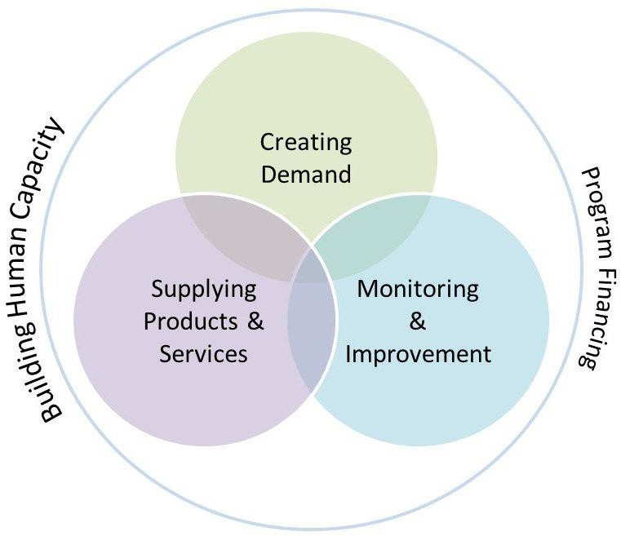

**Project Framework Blank Diagram**



**Project Framework Components**

|  |
| --- |
| **Creating Demand** |
| **Supplying Products and Services** |
| **Monitoring for Improvement** |
| **Building Human Capacity** |
| **Program Financing** |



**Lesson Plan 10: Handwashing**

**45 minutes total**

**Lesson Description**

This lesson introduces the importance of handwashing to prevent disease transmission. Participants learn the critical times and proper technique to wash their hands. The need for both hardware and software to promote handwashing is also discussed by using case studies



###### Learning Outcomes

At the end of this session participants will be able to:

1. Discuss the importance of handwashing to prevent disease transmission.
2. Demonstrate proper handwashing technique.
3. List the critical times for handwashing.
4. Discuss the need for both handwashing hardware and software.

###### Materials

* + Flipchart paper
  + Markers
  + Tape
  + Two handwashing case studies
  + Locally available soap and handwashing hardware (e.g., tippy tap) for demonstration

###### Optional:

* + Glitter for introduction activity (1 package)
  + Computer, projector and speakers
  + Video: Handwashing Dance (length 4:48). Available at: www.youtube.com/watch?v=HTackKuNxjA

###### Preparation

* + Review topic in Technical Brief: Handwashing
  + Write the heading *“Times for Handwashing”* on flipchart paper
  + Find local materials that are used for handwashing (e.g., soap, tippy taps)
  + Print and cut out the two handwashing case studies (1 case study per participant)
  + Optional: Write the session Learning Outcomes on flipchart paper
  + To use the Video: Handwashing Dance
    - Check that the projector and speakers are working
    - Cue the video on the computer

###### Introduction 5 minutes

**Option A: Glitter Hand Shake**

1. Put a small amount of loose glitter on your hands without the participants knowing.
2. Shake hands with everyone and ask them to shake hands with each other as if they are meeting in the street or at a community gathering.
   * *Ask the participants to look at their hands and clothes and see how the glitter has been transferred*
3. **LINK:** Ask the participants to discuss what diseases can be passed between people when they shake hands.
4. Present the lesson description or learning outcomes.

###### Option B: No Glitter Hand Shake

1. Ask the participants to shake hands with everyone as if they are meeting them in the street or at a community gathering.
2. **LINK:** Ask the participants to discuss what diseases can be passed between people when they shake hands.
3. Present the lesson description or the learning outcomes.

###### Method for Proper Handwashing 10 minutes

1. Ask the participants to put their hands out in front of them. Explain that a tap has just been turned on and they need to wash their hands. Ask the participants to mime washing their hands for 20 seconds.
2. Use local materials (e.g., soap, container) to explain and demonstrate the steps for proper handwashing. Ask participants to mime the steps at the same time.
   1. *Wet hands with clean, running water (warm or cold) and apply soap.*
   2. *Rub hands together to make a lather and scrub them well; be sure to scrub the back of hands, between fingers, and under fingernails.*
   3. *Continue rubbing hands for at least 20 seconds.*
   4. *Rinse hands well under running water.*
   5. *Dry hands using a clean cloth or air dry them.*
3. Ask the participants for suggestions on what can be used if soap is not available.

* *Soil, mud, ash, other materials where friction can help to remove dirt and pathogens (e.g., hand sanitizers)*
* *Handwashing with water is good; handwashing with mud, soil or ash is better; and handwashing with soap is the best*

1. Explain that it can be difficult for people to remember the steps for handwashing. Ask the participants to share fun ways to help people practice and remember these steps.

* *For example, sing a song that is approximately 20 seconds long, such as singing happy birthday twice.*

1. Optional: Show the Video: Handwashing Dance as an example of how students of Iligan Medical Center College in the Philippines made handwashing steps easier to remember and practice. The video is 4:48 minutes long, but you only need to show the first 3 minutes.

###### Critical Times for Handwashing 10 minutes

1. Ask the participants to identify the key times when handwashing should be done. Record responses on the “*Times for Handwashing*” flipchart. Normally there are several times identified and the list can become quite long.
   * *After defecation*
   * *After handling child feces or cleaning a child’s anus*
   * *Before preparing food*
   * *Before feeding a child*
   * *Before eating*
2. Ask the participants to vote on the two most critical times for handwashing found by researchers in Bangladesh. Participants can vote in secret by holding up a finger in front of their chest.
   * *After defecation*
   * *Before preparing food*
3. Discuss how promoting fewer critical times may be more effective and have greater impact.
   * *Handwashing at one critical time would be a huge improvement in many situations*
   * *Few programs have been successful in promoting five times for handwashing*
   * *Each critical time is so different*
   * *Messaging can get confusing when promoting multiple critical times, need to keep the message simple and make it easy for people to remember*

###### Promoting Handwashing: Software and Hardware 20 minutes

1. Ask the participants if handwashing is so important, then why isn’t everyone doing it?
   * *Handwashing is about behaviour; changing handwashing practices means changing behaviour.*
2. Ask the group to recall the behaviour change lesson from the previous day and refer to the “*What Do You Need?*” flipchart. Briefly review the personal (internal) and outside (external) things people need to change their behaviour.
   * *Personal (Internal): Motivation, courage, confidence, self-esteem, determination*
   * *Outside (External): Encouragement, support, knowledge, skills, rewards/incentives, consequences, environment, social influences*
3. Divide participants into small groups of 3 or 4 people. Hand out one case study to each group. Ask the groups to read their case study and discuss the questions for 10 minutes.

Questions:

1. What are the handwashing needs?
2. What are possible motivations for people to wash their hands?
3. What personal (internal) and outside (external) things do people need to change their handwashing behaviour?
4. Discuss the two case studies with the large group. Summarize the following points for handwashing to become a long-term and sustainable solution.
   * *Find ways to make new handwashing practices convenient and easy to do*
   * *Make sure that people are experiencing and recognizing the benefits of the new practices*
   * *Make sure that people have the hardware they need to wash their hands*
   * *Eliminate any barriers that might prevent people from practicing handwashing*

###### Review 1 minute

1. Ask the participants to mime the steps for proper handwashing and demonstrate any of the fun techniques they learned for remembering the steps.

**Reflections on Lesson**

**Activity: Handwashing Case Studies**



**Handwashing Case Study #1**

Households in a rural community fetch their water from the river, which is a 10 minute walk away. The homes are relatively poor and most families live on subsistence farming. It is not a common practice for people to wash their hands and they often have diarrhea, especially young children. Soap is sometimes used, but only to wash clothes. Most homes have a simple pit latrine.

###### Questions for Discussion:

1. What are the handwashing needs?
2. What are possible motivations for people to wash their hands?
3. What personal (internal) and outside (external) things do people need to change their handwashing behaviour?

###### Handwashing Case Study #2

The local elementary school has 500 students between the ages of six and twelve. Many children often miss school because they have diarrhea. The school has recently built new pit latrines for the students, but there are no facilities for handwashing. The school’s water supply comes from a hand pump that is located on the property. The school has a small budget to provide water, sanitation and hygiene (WASH) facilities for the students, but most of it was spent to build the latrines. WASH is currently not taught as part of the curriculum.

###### Questions for Discussion:

1. What are the handwashing needs?
2. What are possible motivations for children to wash their hands?
3. What personal (internal) and outside (external) things do children need to change their handwashing behaviour?



**Lesson Plan 11: Behaviour Change**

**50 minutes total**

###### Lesson Description

This lesson introduces the theory of behaviour change and sanitation promotion, and how they relate to creating demand as part of the framework for implementing an environmental sanitation project. Based on their personal experience, participants identify internal and external factors needed to change behaviour. Note that this is only an introductory lesson plan. Additional behaviour change theory and lesson plans can be found in CAWST’s Community Health Promotion Manual and Trainer Manual.



###### Learning Outcomes

At the end of this session participants will be able to:

* 1. Discuss what if feels like and what is needed to change behaviour.
  2. Discuss how understanding behaviour change will shape their approach to implementing an environmental sanitation project.
  3. Explain why sanitation promotion is important for changing behaviour and creating demand.

###### Materials

* + - Flipchart paper
    - Tape
    - Markers
    - Paper (1 sheet per participant)
    - Pens or pencils (1 per participant)

###### Optional:

* + - Computer and projector
    - PowerPoint: Sanitation Promotion

###### Preparation

* + - Review topic in CAWST’s Community Health Promotion Manual
    - Write the heading “*What Does it Feel Like?*” on a flipchart paper
    - Write the heading “*What Do You Need?*” on a flipchart paper. Underneath the main heading, write the subheadings “*Personal (Internal)”* and “*Outside (External)”* in two columns.
    - Optional: Write the Learning Outcomes on flipchart paper
    - If using PowerPoint: Sanitation Promotion
      * Review the PowerPoint presentation
      * Check that the projector is working
      * Cue the PowerPoint on the computer

###### Introduction 5 minutes

1. Divide participants into groups of three or four people.
2. Hand out a piece of paper and a pencil or pen to each participant.
3. Ask the participants to each write down three things that make them really good at what they do (e.g., whether in their job, as a parent, as an athlete).
   * *For example, drink coffee in the morning, dress nicely, make a checklist*
4. Ask the participants to share their lists with their groups.
5. **LINK:** Tell the participants that they have to choose one thing they are no longer allowed to do. Ask the participants to discuss what they selected with their group.
6. For this lesson, DO NOT present the lesson description or learning expectations yet.

###### What is Needed to Change Behaviour? 20 minutes

1. Ask the participants to imagine going about their day without doing one thing that makes them good at what they do. Ask the groups to discuss how they feel.
2. Discuss with the large group and record the answers on the “*What Does it Feel Like?”* flipchart.
   * *Difficult, scared, sad, incapable, stressed, hopeless, frustrated…*
3. Ask the groups to discuss what they would need from themselves and from others to manage this change.
4. Discuss with the large group and record the answers in the appropriate column on the “*What Do You Need?”* flipchart.
   * *Personal (Internal): Motivation, courage, confidence, self-esteem, determination*
   * *Outside (External): Encouragement, support, knowledge, skills, rewards/incentives (e.g., certificate, personal recognition from an official), consequences (e.g., fines), environment (e.g., putting reminders on the door), social influences (e.g., peer pressure)*
5. Ask the participants to consider what are they asking people to do with their daily habits when they are implementing an environmental sanitation project, such as trying to get people to stop open defecation or stop throwing their garbage on the ground?
   * *To change them*
   * *Environmental sanitation is about behaviour; changing practices means changing behaviour.*
6. Ask the participants how do think the community or household members will feel about this?
   * *Same answers as they felt*
   * *Change can be difficult for many people. We all have routines and habits that we feel comfortable with and enjoy. It is hard for people – especially adults – to change a behaviour that we have been doing for most of our lives. Habitual behaviours are often learned at an early age. The longer someone has been practicing a behaviour, the harder it will be for them to change.*
7. Ask the participants what will people need in order to change?
   * *Same things they needed*
8. Present the learning expectations.
9. Discuss how this understanding will affect the participant’s work in implementing an environmental sanitation project.
   * *Be more sensitive to people’s needs when asked to change, try to address the different internal and external factors that influence behaviour, understand that behaviour change can be a challenging and long process, be patient, have more realistic expectations*

###### Sanitation Promotion to Change Behaviour and Create Demand 20 minutes

1. Ask the participants to each write a list of what motivates them to want a latrine in their own home.
   * *Better health, dignity, prestige…*
2. Ask the participants to rank their list according to the strongest motivating factors.
3. Ask some people to share their top three motivating factors with the large group.
4. Tell participants the top motivating factors from a study of households in rural Benin. If using PowerPoint: Sanitation Promotion, then show slide #3.

**Benefits of latrine to 320 households in rural Benin (Average importance rating, scale 1-4)**

* Avoid discomforts of the bush 3.98
* Gain prestige from visitors 3.96
* Avoid dangers at night 3.86
* Avoid snakes 3.85
* Reduce flies in compound 3.81
* Avoid risk of smelling/seeing faeces in bush 3.78
* Protect my faeces from enemies 3.71
* Have more privacy to defecate 3.67
* Keep my house/property clean 3.59
* Feel safer 3.56
* Save time 3.53
* Make my house more comfortable 3.50
* Reduce my household’s health care expenses 3.32
* Leave a legacy for my children 3.16
* Have more privacy for household affairs 3.00
* Make my life more modern 2.97
* Feel royal 2.75
* Make it easier to defecate due to age/sickness 2.62
* For health (spontaneous mention) 1.27
* Be able to increase my tenants’ rent 1.17

(Jenkins, 1999)

1. Ask the participants if they are surprised by these answers. Ask the participants how this may influence their project?
   * *While good health may seem like an obvious benefit, it may not be as strong a motivating factor as other potential benefits.*
   * *People don’t always have the same reasons for wanting to change behaviours or for buying products. You must first figure out what their beliefs, desires and motivators are, and what will convince them to change!*
   * *Promote products in a way that people understand, and appeals to their needs, wants and values*
2. Discuss sanitation promotion to change behaviour and create demand.
   * *Knowing is not enough. Knowing why and how about environmental sanitation is no guarantee that people will actually do it. It is now understood that ‘educating’ people to practice good sanitation because it has health benefits will usually not result in long-term behaviour charge.*
   * *Sanitation promotion builds upon what people know, do and want. It focuses on identifying motivations for behaviour change based on existing practices and beliefs. By identifying motivators of change and finding ways to trigger them, effective sanitation promotion reduces the risky behaviours and practices among key target groups.*
   * *You must understand what motivates people in a community*
   * *You must understand the demand in a community before implementing a project*
3. Ask the participants to identify and discuss what kinds of sanitation promotion approaches they have seen before, and how these approaches support behaviour change in the community by targeting internal and external factors.
   * *SARAR (Self-esteem, Associative strength, Resourcefulness, Action planning, Responsibility)*
   * *Participatory hygiene and sanitation transformation (PHAST)*
   * *Participatory rural appraisal (PRA)*
   * *Community health clubs*
   * *Child to child (CtC)*
   * *Social marketing (uses commercial marketing principles to achieve social benefits, such as changes in attitudes and behaviours)*

###### Review 5 minutes

1. In pairs, ask participants to discuss what they can do to help people change their behaviour.
2. In pairs, ask participants to discuss how this session has changed how they think about behaviour change and environmental sanitation.

###### Reflections on Lesson



**Lesson Plan 12: Menstrual Hygiene Management**

**60 minutes total**

**Lesson Description**

This lesson uses a role play activity to introduce the challenges that many women and girls have in managing their menstrual hygiene, and the impacts on their health and education. Participants will identify solutions to meet the menstrual hygiene needs of women and girls at home and in school.

This can be a sensitive topic to address, especially for traditional cultures or religions where menstruation is a taboo topic and with a mixed group of male and female participants. The trainer needs to be professional and confident when discussing menstrual hygiene management to help make the environment comfortable and respectful for men and women.



###### Learning Outcomes

At the end of this session participants will be able to:

1. Discuss the challenges of menstrual hygiene management for women and girls.
2. Discuss the impact of poor menstrual hygiene on health and education.
3. Identify solutions to ensure menstrual hygiene-friendly homes, schools and work places.

###### Materials

* + Flipchart paper
  + Markers
  + Tape
  + Small post-it notes or stickers
  + Role play cards

###### Optional:

* + Tool: Placemat Activity
  + Local products used for menstruation (e.g., sanitary pads, cloths)
  + Local education materials used to teach boys and girls about puberty and menstruation

###### Preparation

* + Review topic in Technical Brief: Menstrual Hygiene Management and Lesson Plan 7: Behaviour Change
  + Put the “*What Do You Need?”* flipchart from the previous day in a visible location
  + Print and cut out the role play cards for the introduction activity (1 card per participant). Depending on the size of the group, 1 or 2 people can play the role of the student with the object stuck to them, 1 or 2 people can play the bully role, 1 or 2 people can play the supportive friend role, and the remaining participants can be general students in the classroom.
  + Identify participants who would be comfortable actively participating in the role play as the student with the object stuck to them, bully and supportive friend. If possible, have at least one man play the role of the student with the object and a woman to play the bully. Speak with these participants individually about their roles the day before or in the morning before the workshop begins so that they are prepared, but do not tell them that this activity is about menstrual hygiene management. Give the object to stick to the participant’s clothes in advance so that the others are unaware of what is happening.
  + Ask the host about local words or phrases used to describe menstruation, practices used for menstrual hygiene, and social and cultural attitudes.
  + Optional: Find examples of local products that girls and women use for menstruation (e.g., sanitary pads, cloths).
  + Optional: Find examples of local education materials that are used to teach boys and girls about puberty and menstruation. Books used in schools in Tanzania, Ghana, Ethiopia and Cambodia can be downloaded for free from: www.growandknow.org/books.html
  + Optional: Review Tool: Placemat Activity (See Appendix 2)
  + Optional: Write the session Learning Outcomes on flipchart paper

###### Introduction 15 minutes

1. Ask the participants to imagine that they are back in their school days and hand out a role play card to each participant. Ask them to quietly read their role and not discuss it with anyone else. Ask the participants to leave the training room and enter after 1 minute. They are to act out their different roles when they come back into the room.



1. While students are outside of the room rearrange the chairs into rows, similar to a traditional classroom.
2. You will be the teacher in the role play. Before students reenter the room, change something about your appearance to represent the change in your role, for example put on a tie or a suit jacket, pull back your hair, put glasses on, etc.
3. Stand at the front of the room and teach a simple lesson to the students that is appropriate based on the participant’s knowledge base. Be authoritarian, for example make students raise their hands and then stand up when they have a question.
4. After a few minutes, ask the student(s) with the object on their clothes to come to the front of the classroom and do something in front of the other students, for example write something on the board or flipchart, recite some text.
5. When the student(s) ask for permission to leave the classroom, make them stand up and explain why they need to leave. Make them feel uncomfortable and embarrassed.
6. Do not reprimand or punish the bully when they identify the object on the student’s clothes. You can also tease the student about the object. If the bully is not able to identify the student after a few minutes, then you can identify the student and tease them about the object.
7. After the role play is finished, do not present the lesson description or the learning outcomes.
8. When the role play is over ask participants to leave the room. Rearrange the chairs into a circle, return to your original appearance, and then invite the participants to reenter the room.

###### Role Play Debrief 15 minutes

1. Ask the group to sit in a circle to make the debrief activity more intimate.
2. Ask the participants playing the role of general students to describe what they observed.
3. Ask the participants playing the general students to describe what they felt.
4. Ask the participant with the object to describe how it felt to hide their object from others and then be teased about it.
   * *Stressful, difficult, couldn’t concentrate on teacher and lesson, wanted to leave to make it easier to hide the object*
5. Ask the bully to describe how it felt to tease the other student.
6. Ask the friend to describe how it felt to support the other student when they were being teased by the teacher and bully.
7. Ask the group to discuss what impact this could have on a student’s attendance at school and their education.
   * *Stay home, avoid school, easier to hide object from others, poor education decreases chances for job opportunities and perpetuates the poverty cycle (discussed in first day of the workshop)*
8. Ask the group to recall the behaviour change lesson from the previous day and refer to the “*What Do You Need?*” flipchart. Discuss what personal (internal) and outside (external) things the student needed to be more equipped to cope with the situation.
   * *Personal (Internal): Motivation, courage, confidence, self-esteem, determination*
   * *Outside (External): Encouragement, support, knowledge, skills, rewards/incentives, consequences, environment, social influences*
9. Ask the group to identify what this role play activity is similar to in real life?
   * *Menstrual hygiene for women and girls*
10. Present the lesson description or learning outcomes.

###### Menstruation Facts 5 minutes

1. Present the facts about menstruation to ensure that all participants have a common base of knowledge. This information may be review for participants or new information depending on their background and culture. Try to use local words and expressions if you know them.
   * *Menstruation, commonly called a period, is the natural process of shedding the lining of a woman or adolescent girl’s uterus. During menstruation, blood flows from the uterus and passes out of the body through the vagina. This process happens for 2–7 days every month as part of a normal menstrual cycle.*
   * *Girls begin to menstruate usually between the ages of 9 and 14. Menstruation usually stops when a women is in her late 40s or early 50s, which is called menopause. A woman will menstruate for approximately 3,000 days during her lifetime.*
   * *Having regular menstrual cycles is a sign that important parts of the female body are working normally. The menstrual cycle provides important body chemicals, called hormones, to keep women and girls healthy. It also prepares the body for pregnancy each month.*
2. Discuss that menstruation is a natural process; however, if not properly managed it can result in health problems. Optional: Hold up a rag, cloth or other local sanitary product. Ask participants to imagine not being able to properly clean it with soap and water, hanging it in a dark place, and then putting it against your skin for a whole day. Ask the participants to imagine how that would feel.
   * *Reports have identified links between poor menstrual hygiene practices and the following health impacts in women and girls: rashes and irritations; urinary, vaginal and perineal infections; complications with reproduction and pregnancy, complications associated with female genital mutilation or cutting.*

###### Challenges and Solutions 20 minutes

**Optional:** The Tool: Placemat Activity can be used instead to ensure that everyone has an equal opportunity to share in the discussion, especially if there are shy or dominant participants in the group. The placemat activity can take more time and is appropriate for a more advanced audience.

1. Divide participants into groups of 3 or 4 people. Depending on the participants and the group dynamics, you can create mixed groups or gender specific groups. Grouping men and women separately may help to ensure that both male and female perspectives are openly discussed and shared.
2. Hand out flipchart paper and markers to each group. Ask the groups to divide their flipchart paper into two columns.
3. Ask the groups to brainstorm some of the challenges and barriers to good menstrual hygiene management in the communities that they live or work in. They should consider at home, school and work places. Ask them to record their ideas in the left column on the flipchart.
4. After 5 minutes, discuss the challenges and barriers with the large group.
   * *Lack of sanitary products*
   * *Lack of water and soap for cleaning*
   * *Lack of access to appropriate sanitation facilities*
   * *Cultural and religious restrictions*
   * *Shame and embarrassment*
   * *Lack of information and awareness*
5. Ask the groups to brainstorm some solutions to the barriers and challenges. Ask them to record their ideas in the right column of the flipchart.
6. After 5 minutes, discuss the solutions with the large group. Emphasize that both the hardware (e.g., WASH facilities) and software (e.g., information and education) are needed to encourage good menstrual hygiene at home, school and work.
   * *Ensure sanitary products and underwear are available, affordable, and easy to access.*
   * *Provide access to water, sanitation and hygiene at home and in public places, like schools and work. Women and girls need somewhere safe and private to change their sanitary products; clean water and soap for washing their hands, bodies, and reusable cloths; and facilities for safely disposing of used sanitary products or a clean and well lit place to dry them if reusable.*
   * *Provide factual information to girls and boys, men and women to counter negative customs and give positive support to women and girls. Schools provide an opportunity to reach a large number of girls (and boys) with information on menstrual hygiene.*
   * *Offer education programs for teachers and school authorities, as well as sensitization for parents and wider communities.*
7. Ask the participants to share any specific examples that they have seen or used in their work to support menstrual hygiene management. Optional: Show examples of local education materials that are used to teach boys and girls about puberty and menstruation.

###### Review 5 minutes

1. In pairs, ask participants to discuss how they might use this information on either a personal level or in their project work.

**Reflections on Lesson**

**Introduction Activity: Role Play Cards**

|  |
| --- |
| **You are a 14 year old student in a classroom with other boys and girls. You have an object stuck to your clothes which is very embarrassing and shameful in your culture. You need to try to hide the object from your classmates and teacher and not discuss it with anyone else.**  **After a few minutes in the role play, raise your hand to ask the teacher if you can leave the classroom for a personal reason. You secretly want to remove the object from your clothes, but do not say why you need to leave the class.** |
| **You are a 14 year old student in a classroom with other boys and girls. One of your classmates has an object stuck to their clothes which is very embarrassing and shameful in your culture. They are trying to hide the object from everyone. Try to identity this student and tease them in front of the class when you notice the object.** |
| **You are a 14 year old student in a classroom with other boys and girls. One of your friends has an object stuck to their clothes which is very embarrassing and shameful in your culture. They are trying to hide the object from everyone. Provide support to your friend if they are bullied by others and try to make them feel more comfortable.** |
| **You are a 14 year old student in a classroom with other boys and girls. Participate in the lesson and follow the teacher’s instructions.** |



**Lesson Plan 13: Animal Excreta Management**

**45 minutes total**

**Lesson Description**

This lesson introduces zoonotic diseases related to animal excreta and the importance of animal excreta management. Three different participatory activities are given as options for participants to learn about different diseases, their transmission routes and prevention methods.



###### Learning Outcomes

At the end of this session participants will be able to:

1. Identify some diseases that are related to animal excreta.
2. Discuss the importance of animal excreta management.
3. Discuss some good animal excreta management practices to prevent disease transmission.

###### Materials

* + Flipchart paper
  + Markers
  + Tape

###### Optional:

* + Glitter or turmeric
  + Tool: Animal Excreta Transmission Routes
  + Role play activity

###### Preparation

* + Review topic in Technical Brief: Animal Excreta Management
  + Ask host about local diseases that are related to animal excreta
  + Introduction Option B: Write the heading “*Zoonoses*” on flipchart paper and the following definitions underneath:
    - *Animals that have very large noses, like an elephant*
    - *Diseases that are transmitted from animals to people*
    - *Animals that have escaped from the zoo*
    - *Diseases that are transmitted from people to animals*
  + Disease Transmission Option A: Review Tool (See Appendix 2). Print and cut out the Animal Excreta Transmission Routes activity cards appropriate for the region, available at: www.cawst.org/resources. Have one set prepared for each group. You can interchange animals from different regions (e.g., pig, cow, goat) to match your local context.
  + Disease Transmission Option B or C: Select the animal excreta disease cards that best represent local diseases. Print and cut out the cards at the end of the Lesson Plan. Have one card prepared for each group.

###### Introduction 5 minutes

**Option A:**

1. Put glitter or turmeric on the floor, people walk around, look at their feet and see what’s on the bottom.
2. **LINK:** Ask people what the glitter/turmeric on the bottom of their shoes represents.
3. Explain that the glitter represents soil contaminated by animal feces.

Ask the participants to discuss what diseases can be passed between soil and people.

1. Present the lesson description or learning outcomes.

###### Option B:

1. Show the definitions of the word “zoonoses” on the flipchart paper or read the definitions aloud.
2. Ask the participants to guess which the correct definition is. They can vote in secret by showing their fingers in front of their chest. For example, 1 finger means definition one, 2 fingers means definition two, 3 fingers means definition three, 4 fingers means definition four.
3. **LINK:** Zoonoses are diseases and infections that are naturally transmitted between animals and people.
4. Present the lesson description or learning outcomes.

###### Disease Transmission 35 minutes

1. Explain that just as human excreta presents health hazards, so does animal excreta. Many zoonotic diseases are transmitted by pathogens found in animal excreta. Not only can animal excreta transmit pathogens directly, it can also provide a breeding site for other disease vectors, like flies.

###### Option A: Animal Excreta Transmission Routes Activity (Appropriate for an audience with low literacy level. This activity is also easier after having completed the regular Transmission Routes Activity for Human Excreta in Lesson Plan 5.)

1. Divide participants into groups of three or four people. Tell the participants that we are going to do the transmission routes activity again (if already done in Lesson Plan 5: Disease Transmission), but this time considering animal feces instead of human feces.
2. Introduce the topic and start with the pictures of the animal feces and the child. Explain that there are many ways in which pathogens can be “transmitted” from the feces to the child. The transmission does not necessarily have to be to the child’s mouth, it can also affect other parts of the body, like the foot in the case of soil- transmitted helminths.
3. Hand out the white cards and arrows to each group. Explain that they should use the white cards and arrows to create as many transmission routes as they can to show how pathogens can find their way from the animal feces to the child.
4. Optional depending on time: When the groups have made their diagrams, ask one group to share with another group. Let them respond to questions raised by the other groups.
5. Hand out the orange cards to each group. Explain that they should use the orange cards to block the transmission of disease. It is useful to have blank paper and pens so that the group can create its own blocks if the pre-cut cards do not cover all situations.
6. Optional depending on time: When the groups have made their diagrams, ask one group to share with another group. Let them respond to questions raised by the other group.
7. Discuss with the large group the different ways to block transmission of pathogens from animal excreta, and what is similar and different with preventing diseases from human feces. Ask if the groups identified any new ways that were not included in the orange cards.
   * *Treat your water to make it safe to drink*
   * *Wash your hands*
   * *Prepare food well (e.g., washing vegetables with safe water)*
   * *Cover food and water to prevent contact from animals and flies*
   * *Fence or tether animals*
   * *Fence gardens to prevent animals from accessing them*
   * *Wear protective footwear to prevent soil-transmitted helminth infections*
   * *Remove excreta from the living environment and treat/dispose in a safe location*
8. Encourage discussion to find out why participants placed the pictures in the particular order and ensure everyone understands the meaning of “transmission route”.
9. Summarize by explaining that if we can prevent animal feces from getting into the environment in the first place, then we do not have to worry so much about treating water, storing food correctly or keeping away flies. That is why our first priorities should be safe animal excreta management and handwashing with soap.
10. Ask the participants to identify any local diseases that are related to animal excreta and good management practices to prevent their transmission.

###### Option B: Role Play (Appropriate for an audience with a high literacy level and understanding of some basic medical terminology, like disease symptoms.)

1. Divide participants into groups of three or four people. Hand out a different role play card to each group.
2. Ask each group to create a short role play (3 minutes maximum) using the information on their card, including the disease description, its symptoms, the transmission routes, and how to prevent transmission of the disease.
3. Ask each small group to present their role play to the large group. After each role play, ask the large group to identify the disease and add other possible prevention ideas. Summarize the disease and its transmission with the large group. Optional: Draw or write the transmission routes on flipchart paper.
4. Ask the participants to identify any other local diseases that are related to animal excreta and good management practices to prevent their transmission.
5. Discuss with the large group the different ways to block transmission of pathogens from animal excreta, and what is similar and different with preventing diseases from human feces. Ask if the groups identified any new ways that were not discussed.
   * *Treat your water to make it safe to drink*
   * *Wash your hands*
   * *Prepare food well (e.g., washing vegetables with safe water)*
   * *Cover food and water to prevent contact from animals and flies*
   * *Fence animals*
   * *Fence gardens to prevent animals from accessing them*
   * *Wear protective footwear to prevent soil-transmitted helminth infections*
   * *Remove excreta from the living environment and treat/dispose in a safe location*

###### Option C: Drawing Transmission Routes (Appropriate for an advanced audience with a high literacy level who are able to analyze and organize information.)

1. Divide participants into groups of three or four people. Hand out a different transmission route card, flipchart paper and markers to each group.
2. Ask each group to draw a diagram of the transmission routes of the disease using the information on their card.
3. Optional depending on time: When the groups have made their diagrams, ask one group to share with another group. Let them respond to questions raised by the other group.
4. Ask each group to draw on their diagram how to prevent the transmission of the disease.
5. Optional depending on time: When the groups have made their diagrams, ask one group to share with another group. Let them respond to questions raised by the other group.
6. Ask each group to post their diagrams on the wall. Discuss with the large group the different ways to block transmission of pathogens from animal excreta, and what is similar and different with preventing diseases from human feces. Ask if the groups identified any new ways that were not included.
   * *Treat your water to make it safe to drink*
   * *Wash your hands*
   * *Prepare food well (e.g., washing vegetables with safe water)*
   * *Cover food and water to prevent contact from animals and flies*
   * *Fence animals*
   * *Fence gardens to prevent animals from accessing them*
   * *Wear protective footwear to prevent soil-transmitted helminth infections*
   * *Remove excreta from the living environment and treat/dispose in a safe location*
7. Ask the participants to identify any other local diseases that are related to animal excreta and good management practices to prevent their transmission.

###### Review 5 minutes

1. In pairs, ask the participants to discuss something new or interesting that they learned about animal excreta management.

**Reflections on Lesson**

**Option B and C: Animal Excreta Disease Cards**



**Disease: Cystic echinococcosis**

**Pathogen: *Echinococcus granulosus* tapeworm**

**Description: Cysts, often in the stomach, grow slowly over time and can become very large. The cure is usually surgery.**

**Symptoms: Because the cysts grow slowly, people may not have symptoms for many years. Pain or discomfort in the chest, nausea, vomiting, or coughing may occur. The cysts can rupture and cause allergic reactions or even death.**

**Transmission: The tapeworm’s natural life cycle is as a cyst in sheep and as a tapeworm in dogs. Dogs feed on infected sheep meat and in turn shed eggs in their feces, which are ingested by sheep. People become infected by ingesting food or water contaminated with animal feces containing tapeworm eggs, or when they have direct contact with infected dogs.**

**Prevention:**

* **Using sanitation to prevent sheep and dog feces from contaminating food and water**
* **Deworming dogs and preventing dogs from eating undercooked sheep meat**
* **Controlling stray dogs**
* **Using proper hygiene when slaughtering sheep**
* **Washing hands after contact with dogs and sheep**
* **Treating water to make it safe to drink**
* **Washing food with safe water before eating**

**Disease: Cysticercosis**

**Pathogen: *Taenia solium* tapeworm**

**Description: Tapeworm cysts infect the brain, muscle, or other tissue. They are a major cause of adult seizures in most low-income countries.**

**Symptoms: Cysts in the brain may cause seizures and/or headaches. Other less common symptoms include confusion, difficulty with balance, and can result in death. Cysts in the muscles generally do not cause symptoms. They may cause lumps under the skin.**

**Transmission: People become infected when eating raw or undercooked pork meat contaminated with tapeworm larvae. The larvae develop in the intestine of humans where they become adult tapeworms, which can grow to more than three metres long. These adult worms shed eggs in human feces. These can infect other people as well as pigs by direct contact or by ingesting contaminated water or food.**

**Prevention:**

* **Using sanitation to prevent human and pig feces from contaminating food and water**
* **Cooking pork meat thoroughly to kill larvae**
* **Treating water to make it safe to drink**
* **Washing food with safe water before eating**

**Disease: Leishmaniasis Pathogen: *Leishmania* protozoa**

**Symptoms: Visceral leishmaniasis (also known as kala-azar) is the most serious form of the disease and fatal if left untreated. It affects several organs, usually the spleen, liver and bone marrow.**

**Symptoms: Some people do not have any symptoms. People who develop symptoms usually have fever, weight loss, enlargement (swelling) of the spleen and liver, and abnormal blood tests.**

**Transmission: People can become infected with leishmaniasis if bitten by female *phlebotomine* sandflies carrying the *leishmania* protozoa. The sandflies can breed or live in animal feces, dung and mud-plastered houses, rodent nests, garbage and bushes.**

**Poverty increases the risk for leishmaniasis. Poor and crowded housing and a lack of environmental sanitation (e.g., lack of waste management, open sewerage) can increase sandfly breeding and resting sites, as well as their access to people.**

**Prevention:**

* **Reducing sandfly breeding and resting sites through sanitation to properly manage animal excreta, and solid waste management to remove garbage**
* **Controlling sandflies by using insecticide spray, insecticide–treated bed nets and personal protection**

**Disease: Roundworm Infection Pathogen: *Ascaris lumbricoides* worm**

**Description: The roundworm reproduces inside the intestine. The worm goes through several stages:**

1. **Swallowed eggs first hatch in the intestine.**
2. **The larvae then move through the bloodstream to the lungs.**
3. **After maturing, the roundworms leave the lungs and return to the stomach and small intestine. There they lay eggs.**
4. **The cycle continues. Some eggs are excreted through the feces. Other eggs hatch and return to the lungs.**

**Children have the highest risk of infection and it impairs their physical, nutritional and cognitive development.**

**Symptoms: People infected with roundworms often show no symptoms. The symptoms depends on where roundworms are found in the body. Symptoms of roundworms in the lungs include coughing or gagging, vomiting roundworms, and wheezing or shortness of breath. Symptoms of roundworms in the intestines include nausea, vomiting, irregular stools, stomach pain and weight loss.**

**Transmission: Roundworm infections are transmitted by eggs present in human and animal feces, which in turn contaminate soil in areas where sanitation is poor. This can happen in several ways:**

* + **Eggs attached to vegetables are ingested when the vegetables are not carefully cooked, washed or peeled**
  + **Eggs are ingested from contaminated water**
  + **Eggs are ingested by children who play in soil and then put their hands in their mouths without washing them**

**Prevention:**

* + **Using sanitation to prevent human and animal feces from contaminating soil**
  + **Treating water to make it safe to drink**
  + **Washing food with safe water before eating**
  + **Washing hands after contact with contaminated soil (especially for children playing outside)**



**Lesson Plan 14: Solid Waste Management**

**60 minutes total**

###### Lesson Description

This lesson introduces integrated solid waste management and the different stages where intervention activities can be effective, including collection, recycling, composting, burning and final disposal.



###### Learning Outcomes

At the end of this session participants will be able to:

1. Discuss ways to recycle solid waste.
2. Discuss ways to collect and transport solid waste.
3. Describe composting and its benefits.
4. Discuss the hazards and safety precautions of burning and burying solid waste.

###### Materials

* + Flipchart paper
  + Tape
  + Markers
  + Scissors
  + Bag of garbage (e.g., bottles, cans, paper, plastic, food waste)
  + Gloves
  + Bag of Garbage activity cards

###### Preparation

* + Review topic in Technical Brief: Solid Waste Management
  + Print and cut out the cards from Activity: Bag of Garbage
    - 1 copy with enough cards for each participant
    - 3 copies for review activity
  + Write the heading “*Collection*” on flipchart paper
  + Write the heading “*Recycling*” on flipchart paper
  + Write the heading “*Composting*” on flipchart paper
  + Write the heading “*Burning*” on flipchart paper
  + Write the heading “*Burying*” on flipchart paper
  + Optional: Write the Learning Outcomes on flipchart paper

###### Introduction 5 minutes

1. Wearing a pair of gloves, go through a bag of garbage in an exaggerated way looking for something. Toss the items all over the floor.
2. Respond to the participants’ reaction accordingly, eventually asking what’s wrong with what you are doing?
3. **LINK:** Ask the participants why throwing garbage all over the place is not a good practice?
4. Present the lesson description or learning outcomes.

###### Solid Waste Management 50 minutes

1. Give each participant a card from the bag of garbage activity. Explain that for the rest of the lesson they will be the item on the card that they hold. Tell participants that all together, the items create an imaginary bag of garbage that belongs to you. They are going to go through the process of waste management.



1. Tell participants that the bag of garbage is so heavy and big that you cannot move it. Ask the participants what should you do? Record answers on flipchart paper.
   * *Reduce, reuse, recycle, compost, burn, bury*
2. Ask the participants what is recycling and its benefits? Record answers on the “*Recycling*” flipchart.
   * *Recycling is taking a product, breaking it down from its current form and making something new from the same material*
   * *Recycling companies often pay for materials, income can be generated*
   * *Good for the environment, uses less raw materials*
3. Ask the participants what items can be recycled in their country? Record answers on “*Recycling*” flipchart.
   * *Paper, metal, plastic, glass*
4. Draw an imaginary line on the floor. Tell the participants if their card item can be recycled, then they should move to the left side of the line. The rest of the participants move to the right side. Tell participants that we have taken those items out of our garbage bag to be recycled.
5. Ask the participants what is composting? Record answers on “*Composting*” flipchart.
   * *A natural process that breaks down organic material (material that once came from a living thing) to create a valuable soil amendment*
6. Ask the participants what items can be composted? Record answers on “*Composting*” flipchart.
   * *Fruit, vegetables, paper, husks, grass, leaves*
7. Remind participants of the line on the floor. Ask those with compostable items to move to the left side and join the recyclables if their item is compostable.
8. Discuss the benefits of composting. Record main points on “*Composting*” flipchart.
   * *In developing countries, up to 85% of the waste stream is organic material that can be composted*
   * *Reduces the amount of waste to be collected and transported*
   * *Creates valuable resource for agriculture, including a home garden*
   * *Soil holds water better*
   * *Enhances effectiveness of fertilizer*
   * *Can be done at home*
   * *Costs very little to get started and nothing to operate*
9. Tell the participants that you can now lift the bag. But you want it to be taken away because you don’t want to see garbage scattered across your yard or community. Ask the participants how can you get your bag of garbage taken away? Discuss the following points and record them on the “*Collection*” flipchart.
   * *Formal collection services – Mostly serve planned urban and wealthy areas. Big trucks often can’t fit into unplanned areas because roads are too narrow, too steep or poor quality.*
   * *Take waste to a centralized point where waste services will pick it up.*
   * *Pay someone with smaller vehicles to pick it up – Tricycle carts, hand carts, semi-motorized carts.*
10. Tell participants that you checked your imaginary area and there are absolutely no collection services near you. Not even a centralized pick-up site. Ask the participants what can you do to make the garbage disappear?
    * *Burn it, bury it*
11. Ask the participants what are the dangers of burning waste at home? Record responses on the “*Burning*” flipchart.
    * *Fire spreading*
    * *Chemicals released into the air – plastics are especially dangerous. Wood, paper and some construction debris less dangerous. Chemicals cause serious air pollution and are related to illnesses such as cancer.*
    * *Smoke from burning is hazardous to human health, especially lungs. Also bothers eyes, nose, and throat.*
12. Ask those with cards left in the garbage bag to line up from least hazardous at the front, to most hazardous at the back. Once lined up, ask the participants to say their item aloud.
13. Ask the participants if there was no other option but to burn the materials, how can that be done safely? Record main points on “*Burning*” flipchart.
    * *Burn waste as far away as possible from people and items that can catch fire, such as your house*
    * *Burn it in a pit or a barrel to prevent fire spreading*
    * *Bury ashes in a pit or landfill; they may have dangerous substances in them*
14. Tell participants that you have lots of property and you want to bury the waste because you don’t want to burn it due to the health effects. Explain what happens when garbage is buried.
    * *Leachate, a liquid that is formed as materials break down, is formed and can contaminate groundwater*
    * *Greenhouse gases (e.g., methane) are released however, taking out the organics and composting them reduces the amount of gases produced*
    * *Methane gas can also migrate and is explosive*
15. Knowing the concerns, ask the participants to discuss what they would recommend for locating and maintaining a pit. Record responses on the “*Burying*” flipchart.
    * *Locate the site at least 500 metres away and downhill from drinking water sources.*
    * *Ensure that there is at least 2 metres between the bottom of the disposal pit and the highest annual groundwater level. The more distance between the bottom of the pit and the groundwater, the lower the risk of contamination.*
    * *Do not dispose waste in an area susceptible to flooding.*
    * *Locate the site in clay-like soil if possible. The smaller the soil grain size, the lower the risk of soil and groundwater contamination. Do not dispose waste in sandy areas.*
    * *Cover waste with 0.1 metres of soil or ash regularly (e.g., daily or weekly) to reduce smells and pests, and prevent waste from blowing away.*
    * *Construct a fence to keep animals and children out of the disposal site.*
16. Once full, backfill the pit with at least 0.5 meters of soil cover. Discuss any hazardous waste materials that are left over (e.g., batteries, used syringe) and options for their disposal.
    * *Do not reuse containers that held hazardous material.*
    * *Do not burn hazardous waste.*
    * *Do not dispose hazardous waste in latrines, drainage channels, water sources or on the ground.*
    * *Use less hazardous materials as substitutes*
    * *Separate hazardous waste from general household waste*
    * *Use better storage before and during collection of hazardous waste*
    * *Dispose hazardous waste in a separate landfill site from general household waste*
    * *Take medical waste to a local health care facility for disposal, if available*
17. In pairs, ask the participants to discuss what they have learned and what methods they might use to promote better solid waste management in communities. Share some responses with the large group.

###### Review 5 minutes

1. Divide participants into three groups. Hand out one set of the Bag of Garbage activity cards to each group.
2. Explain that the participants will take turns to run across the room to place one card in the correct waste management pile (e.g., recycle, compost, burn, bury, hazardous waste). The participant must return to their group before the next person can do the same. The first group to sort all their cards wins.

**Reflections on Lesson**

**Activity: Bag of Garbage**

|  |  |
| --- | --- |
|  |  |
|  |  |
|  |  |

|  |  |
| --- | --- |
|  |  |
|  |  |
|  |  |

|  |  |
| --- | --- |
|  |  |
|  |  |
|  |  |



**Lesson Plan 15: Domestic Wastewater Management**

**30 minutes total**

**Lesson Description**

This lesson explains the differences between blackwater, greywater and overflow water. It focuses on the proper management of greywater and overflow water to protect public health and the environment. A demonstration is used to visually show what greywater looks like and how it is separated using a grease trap.

For blackwater management, see Lesson Plan: Human Excreta Management.



###### Learning Outcomes

At the end of this session participants will be able to:

1. List the three components of domestic wastewater: blackwater, greywater and overflow water.
2. Discuss the importance of properly managing greywater and overflow water.
3. Identify management options for greywater.
4. Identify management options for overflow water.

###### Materials

* + Flipchart paper
  + Tape
  + Markers

Optional:

* + Computer and projector
  + PowerPoint: Domestic Wastewater
  + Greywater demonstration materials:
    - Clear container (like a 1 litre plastic water bottle)
    - Water
    - Liquid dish soap
    - Cooking oil
    - Food scraps

###### Preparation

□ Review topic in Technical Brief: Domestic Wastewater Management

□ Write the heading “*Water Used in the Home*” on flipchart paper

□ Write the heading “*Domestic Wastewater*” on flipchart paper. Underneath write the definitions of blackwater, greywater and overflow water.

* + Write the heading “*Greywater Management*” on flipchart paper with the following bullets underneath:
    - *Source control*
    - *Treat*
    - *Reuse in agriculture*
    - *Reuse as toilet flush water*
    - *Dispose into the ground*
    - *Discharge into surface water*
  + Write the heading “*Overflow Water Management*” on flipchart with the following bullets underneath:
    - *Reuse in agriculture*
    - *Dispose into the ground*
    - *Discharge into surface water*
  + Optional: Write the learning outcomes on flipchart paper
  + Optional: Practice doing the greywater demonstration to make sure that it works
  + If using PowerPoint: Domestic Wastewater
    - Review the PowerPoint presentation
    - Print the speaker’s notes
    - Check that the projector is working
    - Cue the PowerPoint on the computer

###### Introduction 5 minutes

1. Ask the participants to list all the different types of water that is used in the home. Record the responses on the “*Water Used in the Home*” flipchart.
2. Select a type of water from the list. Ask the participants to use alligator arms to indicate how contaminated that type of water type is. If they think the water is very contaminated, then participants open their arms very wide. If they think the water is not contaminated and safe, then participants keep their arms closed. Participants open their arms a little bit if they think the water is somewhat contaminated. Repeat for all water types.
3. Explain that all wastewater generated in the home is called domestic wastewater. Present the lesson description or learning outcomes.

###### Domestic Wastewater 5 minutes

1. Ask the participants to define blackwater. Share some responses and then show the definition on the “*Domestic Wastewater*” flipchart.
   * *Human excreta mixed with toilet flushing water and materials used for anal cleansing, such as toilet paper.*
   * *Highest levels of pathogens from the feces.*
2. Ask the participants to define greywater. Share some responses and then show the definition on the “*Domestic Wastewater*” flipchart. Discuss the characteristics of greywater.
   * *All other types of wastewater from domestic activities (e.g., laundry, dish washing, bathing, cleaning).*
   * *Usually has low levels of pathogens, especially compared to blackwater. Any pathogens are usually from cross-contamination with excreta. Fecal pathogens can end up in greywater through handwashing after defecation, washing children after defection, and washing children’s diapers.*
   * *Greywater may also have other contaminants like oil, grease, soap, detergent or other household chemicals.*
   * *The amount of greywater produced depends on how much water a person uses in a day. A household with no water shortages and a piped supply typically produces about 90–120 litres/person/day. But this can be much less, especially in water scarce areas where people must fetch their water and use only 20–30 litres/person/day.*
3. Ask the participants to define overflow water. Share some responses and then show the definition on the “*Domestic Wastewater*” flipchart.
   * *Wastewater that has spilled from wells or water points.*
   * *Should have very low levels of pathogens. However, overflow water can quickly become contaminated with pathogens from human and animal feces when it is not well managed and causes standing water.*
4. Explain that domestic wastewater includes blackwater, greywater and overflow water. This lesson is going to focus on the management of greywater and overflow water. Blackwater is discussed as part of the sanitation system to manage human excreta.

###### Greywater Management 10 minutes

1. Ask the participants to identify ways that greywater is currently managed in their communities.
2. Ask the participants to discuss the public health and environmental impacts when greywater is poorly managed.
   * *In urban and peri-urban areas of low and middle-income countries, greywater is most often discharged untreated into drains or sewers (provided they exist). This water then flows into surface water body, like a lake, river or ocean. This can lead to oxygen depletion, increased turbidity, and microbiological and chemical contamination of surface water.*
   * *In areas with no drainage or sewer system, a common practice is to simply dump the greywater onto the ground or street outside the home. This can lead to stagnant and smelly water that also provides a good breeding site for mosquitos. It also negatively impacts the local living conditions.*
   * *Another practice is to dispose greywater in pit latrines. Sometimes the size of the latrine is designed to hold greywater. But usually this is not the case since most households just build their latrine big enough to collect excreta. Adding greywater can cause the pits to fill up faster than planned, which increases the frequency and cost to empty them. As well, putting untreated greywater into pit latrines causes them to smell and attracts flies and other insects.*
3. Show the “*Greywater Management*” flipchart. Discuss the options for treating, reusing and disposing greywater in ways that are the least harmful to people and the environment:
   * *Source control to reduce the amount of greywater contamination in the first place*
   * *Treat greywater by using primary (e.g. grease trap, septic tank) and/or secondary treatment technologies*
   * *Reuse greywater to irrigate household gardens and agricultural crops*
   * *Reuse greywater as toilet flush water*
   * *Dispose of greywater into the ground using a soak pit or infiltration trench*
   * *Discharge greywater into a surface water body (e.g., pond, stream, river, lake)*
4. Emphasize the using a grease trap and soak pit are the simplest and cheapest ways for households to manage their greywater.
5. Optional: Grease trap demonstration. Explain that greywater flows into the trap where oils, fats and soap scum float to the surface and gravity settles heavier suspended solids to the bottom. Relatively clean water then flows out of the grease trap. It is important to install a grease trap before infiltrating greywater into the ground, reusing it in agriculture, or discharging it to surface water.

Explain that we are going to watch what happens in a grease trap. Ask for a volunteer to help with the separation demonstration. Ask the volunteer, with input from the rest of the participants, to create greywater by putting dish soap, oil and food bits into a clear container filled with water. Place the greywater somewhere the participants can view it throughout the lesson.

Later in the workshop, ask the participants to look back at the greywater that was created in the demonstration. Discuss their observations. The water, oil and food bits should have separated into different layers.

1. Optional: Use PowerPoint: Domestic Wastewater to show different greywater management options.

###### Overflow Water Management 5 minutes

1. Ask the participants to identify ways that overflow water is currently managed in their communities.
2. Ask the participants to discuss the public health and environmental impacts when overflow water is poorly managed.
   * *Should be channeled away so that it does not cause standing water.*
   * *Overflow water that does not drain away from water points could backflow into the water source and possibly contaminate the drinking water.*
   * *Or the overflow water can cause the soil to erode away and damage the water point structure.*
3. Show the “*Overflow Management*” flipchart. Discuss the options for reusing and disposing overflow water in ways that are the least harmful to people and the environment:
   * *Used as irrigation water for agriculture*
   * *Infiltrated into the ground using soak pits and infiltration trenches*
   * *Released directly to surface waters (e.g., lakes, rivers or ponds)*
   * *Overflow water does not normally require treatment before it can be used, infiltrated or disposed.*
4. Optional: Use PowerPoint: Domestic Wastewater to show different overflow management options.

###### Review 5 minutes

1. Use Tool: A Tell B.
2. A tell B: What is blackwater and where does it come from?
3. B tell A: What is greywater and where does it come from?
4. A tell B: What is overflow water and where does it come from?
5. A tell B: What are options to manage greywater?
6. B tell A: What are options to manage overflow water?

###### Reflections on Lesson



**Lesson Plan 16: Vector Control**

**30 minutes total**

**Lesson Description**

This lesson introduces common disease vectors related to environmental sanitation. The focus is placed on mosquito and rodent control.



###### Learning Outcomes

At the end of this session participants will be able to:

1. Identify different types of vectors.
2. Explain why vectors should be controlled.
3. Describe the difference between passive and active vector control.

###### Materials

* + Flipchart paper
  + Tape
  + Markers
  + Blank paper (1 piece per participant)
  + Locally available vector control technologies
  + Computer and projector
  + PowerPoint: Vector Control

###### Preparation

* + Write the heading “*Vectors*” on flipchart paper
  + Optional: Write the Learning Outcomes on flipchart paper
  + Gather locally available vector control technologies (e.g., mosquito coils, insect spray, bed nets, rodent traps)
  + To use PowerPoint: Vector Control
    - Review the PowerPoint presentation
    - Check that the projector is working
    - Cue the PowerPoint on the computer

###### Introduction 5 minutes

1. In pairs, ask the participants to define a vector. Share responses with the large group.
   * *A living thing that transmits a pathogen*
2. In pairs, ask the participants to guess which transmission route in the F-diagram is considered a vector (this should be review from Lesson Plan 5: Disease Transmission). Share responses with the large group.
   * *Flies*
3. In pairs, ask the participants to discuss what other living things are vectors. Share responses with the large group.
   * *Rodents, cockroaches, mosquitoes, fleas, sandflies, ticks*
4. **LINK:** Ask the participants why is it important to control vectors?
   * *They spread disease, are dirty, spread garbage*
5. Present the lesson description or learning outcomes.

###### Vector Control 20 minutes

1. Use the PowerPoint: Vector Control to lead the discussion.
2. Before each new vector, ask the participants what they have done or seen to control that vector?
   * *Emphasize that much of vector control is a last resort – you often only have vectors if the environmental sanitation is poor!*
3. Demonstrate various active and passive vector control technologies that are locally available (e.g., mosquito coils, insect spray, bed nets, rodent traps). Pass them around so that participants have a chance to handle the different technologies.
4. Ask participants for their observations and feedback on the availability, cost and effectiveness of the different technologies.

###### Review 5 minutes

1. Hand out a piece of blank paper to each participant. Ask them to draw the vectors that were discussed.



1. In pairs, ask the participants to share their drawings and discuss one way to control each vector drawn.
2. In pairs, ask the participants to discuss the difference between passive and active controls.

###### Reflections on Lesson



**Lesson Plan 17: Environmental Sanitation Inspections**

**1 hour 45 min total**

**Lesson Description**

This lesson introduces environmental sanitation inspections. Participants practice using environmental sanitation inspection forms and discuss the ethical concerns related to doing an environmental sanitation inspection.



###### Learning Outcomes

At the end of this session participants will be able to:

1. Describe the benefits and purpose of an environmental sanitation inspection.
2. Select which data gathering methods are appropriate (observation or interview).
3. Use environmental sanitation inspection forms to gather information.
4. Give examples of how culture, time, gender, safety and security may influence data gathering exercises.

###### Materials

* + Flipchart paper
  + Markers
  + Tape
  + 10-15 small objects (e.g., pen, notebook, candy)
  + Cloth to cover objects (e.g., towel, tablecloth, shawl, scarf)
  + Environmental Sanitation Inspection Form: Animal Excreta Management (1 per participant) in Appendix 4
  + Environmental Sanitation Inspection Form: Hygiene Practices (1 per participant) in Appendix 4
  + A large version of Environmental Sanitation Inspection Form: Animal Excreta Management

###### Preparation

* + Write the following headings on separate pieces of flipchart paper: Gender, Culture, Safety and Time
  + Organize 10-15 small objects and cover for the Introduction activity
  + Print Animal Excreta Environmental Sanitation Inspection Form (1 per participant)
  + Print Environmental Sanitation Inspection Form: Animal Excreta Management (1 per participant)
  + Optional: Write session Learning Outcomes on flipchart paper
  + Copy the Environmental Sanitation Inspection Form: Animal Excreta Management to a piece of flipchart paper so it can be seen clearly by participants at the back of the room.

###### Introduction 5 minutes

1. Place 10-15 small objects on the floor or a table top and cover them with a cloth.
2. Tell participants they will have 10 seconds to observe the objects and see how many they can remember.
3. Uncover the objects for 10 seconds then replace the cover.
4. Ask participants to record what they saw in their notebooks after the objects are covered up.
5. See who remembered the most items and if people observed the same things.
   * *Rarely will two people see the exact same things in a given situation. That is why witness reports can be so different and sometimes unreliable.*
6. Ask the participants how is this activity similar to an environmental sanitation inspection. **LINK**: Environmental sanitation inspections require good observation skills. It’s important to practice these skills to collect accurate information.
7. Present the lesson description or learning outcomes.

###### Introduction to Environmental Sanitation Inspections 20 minutes

1. In partners, ask participants to discuss what they know about Environmental Sanitation Inspections. If they are very unfamiliar with the topic ask them to think about what it might mean based on the name.
2. Share ideas as a large group:
   * *Related to good health and hygiene and protection from dirt, infection or disease*
   * *Human and animal excreta (feces and urine) management*
   * *Household wastewater management*
   * *Solid waste management*
   * *Vector control*
   * *Domestic wastewater management*
   * *May also include water collection treatment and storage practices*
3. Share the official definition of environmental sanitation inspections:

###### An environmental sanitation inspection is an on-site inspection of environmental sanitation practices and technologies, to identify potential sources and transmission of WASH-related diseases.

1. Ask the participants the purpose of environmental sanitation inspections. Record responses on flipchart paper.
   * *Provide a simple and fast means of assessing and identifying hazards associated with unsanitary practices*
   * *Observation and inspection of community and household practices*
   * *Identify potential and actual risks*
   * *Useful in assessing small community upgrading options*
   * *Identify WASH practices: excreta management, hygiene, domestic wastewater management, animal excreta management, vector control and solid waste management*
   * *Identify potential sources of microbiological (fecal) contamination*

###### Environmental Inspection Forms 20 minutes

1. Hand out the *Hygiene Practices and Animal Excreta Management Environmental Sanitation Inspection Forms* to each participant. Explain that these are 2 examples of the environmental sanitation inspection forms. There are also forms on the following topics:
   * Domestic Wastewater
   * Excreta Management
   * Public Facilities
   * Solid Waste
   * Vector Control
2. Give the participants time to read through the forms. If there are low-literacy participants, partner them with a person with strong reading skills.
3. Describe the *Environmental Sanitation Inspection Forms*.
   * *Standardized environmental sanitation inspection forms are used to ensure consistent assessments*
   * *Inspectors use appropriate forms for the situation being assessed.*
   * *Questions on the form are in a simple ‘yes’ or ‘no’ format to reduce subjectivity*
   * *‘Yes’ answers indicate poor practices*
   * *At the end of the form you total the number of ‘yes’ responses to calculate the level of risk*
   * *Encourage people to adapt the forms for the local context. Remove questions that are not appropriate and add questions that are appropriate.*
4. Optional: With participants who are not comfortable using forms, verbally share the following scenario for animal excreta management, and ask them to mark their form. Walk participants through how to fill out the form using the large version of the Animal Excreta Management Form prepared on the flip chart.

*You visit a community to inspect their animal excreta management. You discover cows, pigs and goats wondering freely on the streets, and chickens inside people’s homes. People have fenced off their gardens to stop livestock from eating the produce, but you discover many cows at the water source. When you*

*ask people what they do with the animal excreta, they explain that they make patties for fuel and always wash their hands after doing so.*

###### Collecting Information 10 minutes

1. Ask the participants how they would gather information on whether or not a person washes their hands after defecating. Record the responses on a flipchart.
   * *Look for soap by the latrine,*
   * *Look for water point by the latrine*
   * *Observe users leaving a latrine*
   * *Ask the users when they wash their hands*
   * *Ask the users how many times they wash their hands a day*
   * *Ask the users or other members of the family if they wash their hands*
2. Explain:
   * *Different questions may require different forms of observation.*
   * ***Observation can be used*** *for observing the presence or absence of things and their condition. It may also indicate some behavioral practices. For example, you can directly observe solid waste in drainage ditches, or the lack of a latrine facility, or animal excreta management practices.*
   * ***Interview*** *may be necessary to collect information about practices and behaviours as they are hard to observe directly. For example, defecation practices, hygiene practices, and the presence or absence of vectors.*
3. Check to ensure that participants understand the difference between observation and interview. Review the list developed at the beginning of the activity of ways to check whether a person is washing their hands. Ask participants to raise 1 finger if the method involves observation and 2 fingers if it requires interview.
4. Ask participants who they should talk to when conducting interviews in the community.
   * *For example, men, women, youth, elders, and community leaders*
5. Explain that it is important when conducting interviews to include different groups to ensure representation of multiple perspectives. Consider interviewing people of different genders, religions, tribal groups, incomes, and labor groups.

###### Practice using the Environmental Sanitation Inspection Forms (Optional) 45 minutes

**This practice is to be used for participants without field trip access. Participants with field access should skip the practice and move to ‘Ethical Concerns Related to Environmental Sanitation Inspections’. This lesson is used with Lesson Plan 18: Environmental Sanitation Walk.**

1. Tell participants that they are going to use their observation and interview skills to fill out an environmental sanitation inspection form.
2. Explain that participants will be divided into 2 groups. Each group will be working with the *Animal Excreta Management Environmental Sanitation Inspection Form*. Group 1 will be responsible for creating a village that illustrates some of the problems on the inspection form. Group 2 will be responsible for conducting the inspection to find the problems.
3. Divide participants into 2 groups.
4. Tell Group 1 to:
   * *Decide which of the problems on the inspection form that their village will have and the extent of the problems (i.e., will it be widespread or with just one family?)*
   * *Decide what problems they can illustrate through objects and how they will do this*
   * *Decide what roles they will play in the community, and what information they will provide when they are interviewed*
5. Tell Group 2 to:
   * *Decide what information on the forms can be found through observation and what information they will need to gather using interviews*
   * *Discuss who will be responsible for what during the inspection*
6. When the groups are ready ask Group 1 to begin the scenario and Group 2 to conduct the inspection. Provide them with about 10 minutes to do this.
7. In the large group, ask Group 2 to share their results by filling out the large version of the *Animal Excreta Management Form* on the flip chart at the front of the room.
8. Ask Group 1 to discuss the accuracy of Group 2’s assessment.
9. Ask the group to consider:
   * What information was best collected by interview? By observation?
   * What are some of the concerns and limitations of the form?
   * How would you change the form for your context?
10. If time permits, ask Group 1 and Group 2 to switch roles, so that Group 2 creates the scenario and Group 1 conducts the interviews using the *Hygiene Practices Environmental Sanitation Inspection Form*.

###### Ethical Concerns Related to Environmental Sanitation Inspections 20 minutes

1. Place the sheets of flipchart paper with the headings *Gender, Culture, Safety* and *Time* in different places around the room. Divide the participants into four groups and assign each group to one of the flipcharts.
2. In their groups, ask participants to discuss what they will need to consider regarding the topic on their flipchart when conducting an environmental sanitation inspection. Ask each group to record their considerations on the flipchart.
3. Give each group approximately 3 minutes at each flipchart and then ask them to rotate to the next flipchart. Continue this process until each group has commented on each of the topics:
   * Gender concerns –
     + *Are respondents comfortable with the gender of the interviewer?*
     + *Do different genders have different practices and experiences?*
   * Cultural concerns
     + *Is it culturally acceptable to talk about this matter?*
     + *Are there particular religious beliefs or practices that will inform the communities and affect their response?*
   * Safety and security
     + *Are we putting the respondent at risk of harm (physical or otherwise) as a result of the interview and observations?*
     + *Are we putting the inquirer at risk of harm (physical or otherwise) as a result of the interview and observations?*
   * Time
     + *Will responses in the community vary through the seasons?*
     + *Will responses in the community vary during the day as different labor groups have different schedules?*
4. As a large group, review the flipcharts and highlight key points.

###### Review 5 minutes

1. Ask the participants to line up in 2 rows facing each other.
2. Explain that you will ask a question that everyone must respond to at the same time. The participants must talk continuously without pausing. People should compete with the person in front of them to see who can talk the longest. As soon as one of the participants takes a pause they must stop talking and see how long their partner can continue. Questions:
   * Why do we use environmental sanitation inspection forms?
   * What data gathering methods could you use to learn about excreta management practices in a community?
   * Give examples of how culture, time, gender, safety and security may influence data gathering exercises.

###### Reflections on Lesson



**Lesson Plan 18: Environmental Sanitation Walk**

**75 minutes total**

**Lesson Description**

This lesson gives participants an opportunity to consolidate and apply their new knowledge about environmental sanitation in a realistic setting. Participants observe and identify different environmental sanitation practices (including excreta management, solid waste management, domestic wastewater management and vector control), and discuss recommendations for improvement where appropriate.



###### Learning Outcomes

At the end of this session participants will be able to:

1. Identify different environmental sanitation practices in a realistic setting.
2. Apply environmental sanitation awareness within a field setting.
3. Practice methods of observation and data gathering.
4. Recommend improvements to poor environmental sanitation practices.

###### Materials

* + Flipchart paper
  + Markers
  + Tape
  + Environmental Sanitation Inspection Forms (1 set of forms per participant) in Appendix 4

###### Optional:

* + Camera

###### Preparation

* + Ask the host organization to select an appropriate site for the environmental sanitation walk that is close to the workshop location. If possible, try to find a location that highlights both good and bad practices for various aspects of environmental sanitation including excreta management, solid waste management domestic wastewater management and vector control. For simplicity, the walk can be done around the premises of the workshop location.
  + Be clear with the host community that this is a training exercise for NGO’s and will result in any material benefits to the community.
  + If required, ensure permission is granted and set up transport and logistics with the host.
  + If possible, visit the site ahead of time and identify different environmental sanitation practices
  + If possible prearrange some community members to be available to interview
  + Print the Environmental Sanitation Inspection Forms (1 set per participant)
  + Optional: write the Learning Outcomes on flipchart paper

###### Introduction 5 minutes

1. Give the participants this introduction well before going on the environmental sanitation walk – even the night before – to give them time to prepare. Give them a print out of the handout.
2. Explain to the participants where you will be going, and what you will do there.
3. Explain they will be working in groups and we will be comparing findings
4. Explain the objective of the environmental sanitation walk, and what you want the participants to learn from the activity.
5. Explain any ground rules for the environmental sanitation walk (e.g., respectful behaviour when visiting people’s homes, what to do in an emergency, where to find the first aid kit, if needed).
6. Explain how long it will take, when you will be back, what the participants should bring, and any other logistical arrangements.
7. Remind participants to bring their notepads and pens to take notes, invite participants to use cameras or cameras on their phones to document their observations.
8. Present the lesson description or learning outcomes.

###### Environmental Sanitation Walk 60 minutes or longer

1. Divide the participants into two groups. If there are enough people ask the participants to work with a partner within their group to discuss and record their observations.
2. Share the responsibilities for filling out the form so that each group will report back on all sections.
3. Before leaving on the environmental sanitation walk or before conducting any activities upon arrival, review the relevant aspects that you want participants to observe and identify: excreta management, solid waste management, domestic wastewater management and vector control.
4. As you walk around, ask the participants to identify different environmental sanitation practices (both good and bad situations), and discuss any recommendations for improvement.
5. Optional: Take photos during the field trip if appropriate. Capture photos of “good” situations (e.g., well maintained latrines, absence of garbage or vectors), and “learning opportunities” (e.g., observations of poor environmental sanitation practices like poorly maintained latrines, standing water that can be a breeding ground for mosquitos, garbage that can attract flies and rodents). Share the photos with participants after the environmental sanitation walk. For example, you could include the best photos on the participant CDs, or show them as a review tool on the projector screen when you get back to the classroom.
6. Record key learning points as they are discovered during the field trip. You can use these to help with the review.
7. Going through the form section by section ask each group to report on what they found and discuss the similarities and differences.

###### Review 10 minutes

1. Debrief with the large group at the end of the environmental sanitation walk. Conduct the review during the walk in a quiet location, in the vehicle on the way back, or when you return to the classroom.
2. Ask the participants what they learned during the environmental sanitation walk. Highlight any “learning opportunities” and recommendations for improvement.
3. Ask the participants if they have any questions about what they learned or saw during the walk.

###### Reflections on Lesson

**Lesson Plan 19: Workshop Closing ** **60 minutes total Lesson Description**

This lesson closes the workshop by having participants reflect on their learning, conduct a self-assessment, review the learning outcomes, and complete a final evaluation. The workshop certificates are distributed to the participants and closing remarks are made.

###### Learning Outcomes

1. End of workshop self-assessment and reflection.
2. Review learning outcomes to see if they were met.
3. Complete a final evaluation of the workshop.
4. Distribute certificates and make closing remarks.

###### Materials

* + Flipchart self-assessment from Day 1
  + Flipchart Group Learning Expectations from Day 1
  + Stickers for self-assessment
  + Markers
  + Tape
  + Certificates (template available from CAWST in workshop training materials)
  + Final evaluations (template available from CAWST in workshop training materials)
  + Participant CDs with workshop materials
  + Camera

###### Optional:

* + Tool: Word in a Hat
  + Hat or other container (for Word in a Hat Review)
  + Scissors
  + Paper
  + Ball of string

###### Preparation

* + Prepare stickers for Self-Assessment activity
  + Print certificates and sign them if necessary. Double check the names and make sure each participant is accounted for.
  + Print final evaluations (See Appendix 2, 1 per participant)
  + Burn the participant CDs (1 per participant)
  + Optional: Review Tool: Word in a Hat (See Appendix 2). Write important words or terms on pieces of paper for Word in a Hat review or use sample words at the end of this Lesson Plan
  + Optional: Write the session Learning Outcomes on flipchart paper

###### Introduction 15 minutes

 **Option A: Word in a Hat Review**

1. Play Word in a Hat to review important lessons learned during the workshop.
2. Write words or terms related to the workshop on pieces of paper or use the list at the end of this Lesson Plan. Place the papers in a hat (or other container). Pass the hat around the circle. Each participant pulls a piece of paper out of the hat and has to explain what the word means, or tell the group what they have learned about it.
3. Present the lesson description or learning outcomes.

###### Option B: What’s Next?

1. Ask participants to silently reflect for a few minutes on what they will do with the information they have learned in the workshop.
2. Ask each person to share with the group what they will do next as an action step towards using their new knowledge.
3. Present the lesson description or learning outcomes.

###### Self-Assessment 10 minutes

1. Ask the participants to place stickers on the self-assessment chart from the beginning of the workshop again.
2. Discuss the results with the entire group. Ask participants if they think the workshop was a success or not.

###### Group Learning Expectations 5 minutes

1. Review the Group Learning Expectations from the first day and see if all of them were addressed. If not, quickly cover the answers, give options for participants to find the information they were looking for, or identify next steps for follow-up.

###### Optional Depending on Time: Participant Appreciation 15 minutes

This is a chance to express appreciation to the participants, and for them to express positive feedback to each other.

1. Make your final comments on the workshop and the participants.
2. Explain that each participant will complete a workshop evaluation, so they will have a chance to express their opinions about the workshop at that time, in confidence.
3. Allow time here for participants to make any final comments to each other or about the workshop in general. You can let whoever wishes to speak address the group, or use one of the options below.

###### Option A: Writing on Backs

Tape a piece of paper on each participant’s back. Each participant then writes on every other person’s back something they like, admire or appreciate about that person. When they have all finished, participants can take their papers home with them as a reminder.

Note: This option should not be used with cultures where touch between opposite gendered individuals is considered inappropriate.

###### Option B: Networking Game

Ask the participants to form a circle. Randomly pass a ball of string from one person to another to form a web while stating how they can share information or work together in the future.

###### Option C: How Do You Feel?

Ask each person to say what they feel at the end of the workshop:

“I feel because .” OR “My favorite part was .”

###### Final Evaluations 10 minutes

1. Hand out final evaluations and ask everyone to complete one.
2. Optional depending on time: The evaluations can be completed during lunch or after the workshop is finished. Make sure to collect the evaluations before the participants leave the workshop!

###### Group Photo 10 minutes

1. Arrange to have somebody take a group photo with the Trainers and all of the participants.
2. Arrange to have the photo taken the day before, if you wish to include the photo on the participant CD.

###### Certificates 10 minutes

**Option A**

Hand out the certificates randomly. Ask each participant to present the certificate they were given to the person whose name is on the certificate. When they hand the person the certificate, have them say something positive about the person, such as something they appreciated about or learned from that person during the workshop.

###### Option B

Randomly hand out the certificates face down to each participant. Ask the participants to check in secrecy whose certificate they have been given. Ask each participant to say something positive about the person whose name appears on the certificate (without saying the name of that person). Have the group guess who that person might be. Have the person give the recipient their certificate.

###### Option C

You hand out the certificates to each recipient. This may be more appropriate in certain countries and allows an opportunity for individual photos.

**Reflections on Lesson and Workshop Overall**

**Review Tool: Word in a Hat**

|  |  |
| --- | --- |
| **Excreta management** | **Latrines** |
| **Solid waste management** | **Animal excreta management** |
| **Wastewater management** | **Menstrual hygiene** |
| **Vector control** | **Behaviour change** |
| **Handwashing** | **Importance of sanitation** |
| **Global need for sanitation** | **Local need for sanitation** |
| **Sanitation system** | **Environmental sanitation** |
| **Improved sanitation** | **Ecological sanitation** |



**Lesson Plan 20: Sanitary Inspections**

**40-140 minutes total**

**Lesson Description**

This lesson introduces sanitary inspections to identify actual and potential sources of contamination around a drinking water source. It gives participants the options of developing their own Sanitary Inspection Forms and practicing how to conduct a sanitary inspection in a realistic setting.



###### Learning Outcomes

At the end of this session participants will be able to:

1. Analyze sources of contamination of drinking water sources.
2. Evaluate risks of contamination of drinking water sources.

###### Materials

* + Flipchart paper
  + Markers
  + Tape
  + 10-15 small objects (e.g., pen, notebook, candy)
  + Cloth to cover objects (e.g., towel, tablecloth, shawl, scarf)
  + Tool: Big Mouth Review
  + Example Sanitary Inspection Form (1 per participant) (See Appendix 5)

###### Optional:

* + Option A: Sanitary Inspection Forms
  + Option B: Pens, clipboard, Sanitary Inspection Forms (see Lesson Plan 18: Environmental Sanitation Walk)

###### Preparation

* + Review topic in the Introduction to Drinking Water Quality Testing Manual
  + Review Tool: Big Mouth (See Appendix 2)
  + Write the heading “*Advantages and Limitations”* on flipchart paper
  + Optional: Write session Learning Outcomes on flipchart paper
  + Organize 10-15 small objects and cover for the Introduction activity
  + Print an example Sanitary Inspection Form (1 per participant)
  + Option A: Print Sanitary Inspection Forms at the end of this Lesson Plan (4 copies for each group)
    - Borehole with Hand Pump (3 pages)
    - Open Dug Well (3 pages)
    - Protected Spring (3 pages)
    - Rainwater Harvesting Tank (3 pages)
  + Option B: Organize a field visit to perform a sanitary inspection. Can be combined with Lesson Plan 18: Environmental Sanitation Walk.
    - Have the host organization select an appropriate site for a sanitary inspection visit (e.g., water supply, sanitation or household water treatment project site)
    - Ensure permission is granted and set up transport and logistics with the host
    - If possible, visit the site ahead of time and choose appropriate inspection points
    - Print appropriate Sanitary Inspection Forms (1 per participant)

###### Introduction 5 minutes

1. Place 10-15 small objects on the floor or a table top and cover them with a cloth.
2. Tell participants they will have 10 seconds to observe the objects and see how many they can remember.
3. Uncover the objects for 10 seconds then replace the cover.
4. Ask participants to record what they saw in their notebooks after the objects are covered up.
5. See who remembered the most items and if people observed the same things.
   * *Rarely will two people see the exact same things in a given situation. That is why witness reports can be so different and sometimes unreliable.*
6. Present the lesson description or learning outcomes.

###### Introduction to Sanitary Inspections 30 minutes

1. Ask the participants to define sanitary.
   * *Related to good health, or protection from dirt, infection or disease*
2. Ask the participants to define inspection.
   * *The act of looking at something closely in order to learn more about it, to find problems*
3. Ask the participants to share with a partner what they think a sanitary inspection is.
4. Share the definition of sanitary inspections as a large group.

###### A sanitary inspection is an on-site inspection of a water supply to identify actual and potential sources of contamination.

1. Ask the participants what is the role of observation in doing a sanitary inspection.
   * *Sanitary inspections are done through observation and inspection of a water supply from source to consumer.*
   * *People doing the inspections may focus on different parts of a water supply system that includes all steps from source to point of use.*
   * *By using standardized sanitary inspections forms, inspectors can ensure that all key parts of an inspection point are consistently covered.*
2. Ask the participants what is the purpose of sanitary inspections. Record responses on flipchart paper.
   * *Provide a simple and fast means of assessing and identifying hazards associated with waters supply and treatment systems.*
   * *A water supply and treatment system includes all steps of water delivery from source to point of use by the consumer.*
   * *Observation and inspection of a water supply from source to consumer.*
   * *Identifies potential and actual risks to drinking water quality.*
   * *Potential risks may cause contamination (e.g., cracked spring box lid).*
   * *Actual risks will cause contamination (e.g., latrine uphill and within 10 metres of a well).*
   * *Useful in assessing small community managed drinking water supplies (e.g., boreholes, dug wells, protected springs, simple piped water systems).*
   * *Usually focuses on sources of microbiological (fecal) contamination.*
   * *Concerned with the physical structure of the supply, its operation and external environmental factors.*
   * *Should be done for all new sources of water (e.g., boreholes, dug wells, protected springs), before they are used then on a regular basis (see Introduction to Drinking Water Testing Manual for suggested minimum frequency of annual sanitary inspections).*
   * *Training community members to do sanitary inspections on their own water supplies can allow them to occur more frequently.*
   * *Important to train community members on how to take appropriate corrective actions for risks that they identify.*
3. Explain the purpose of a visual inspection.
   * *Visual inspection is similar to sanitary inspection, but is less structured.*
   * *Visual inspection involves observing how water is stored, handled and used within individual homes, so that unhygienic practices can be identified.*
   * *It provides qualitative data that are collected by observation, and then reported in spoken or written form.*
4. Describe procedure for doing sanitary inspections.
   * *Developed by the World Health Organization (WHO) as part of water safety plans (WSP).*
   * *WSP assess and manage risks to all steps in a water supply from catchment to consumer.*
   * *Standardized sanitary inspection forms are used to ensure consistent assessments.*
   * *WHO forms have 10 questions and include a risk of contamination scale to calculate a risk score (from low to very high).*
   * *Not all forms include a risk scale.*
   * *Inspectors use appropriate forms for the situation being assessed (e.g., water storage containers, rainwater harvesting tank, spring box, open well).*
   * *Questions on the form are in a simple ‘yes’ or ‘no’ format to reduce subjectivity.*
   * *‘Yes’ answers indicate contamination risk, the wording is sometimes awkward.*
   * *Forms are prepared and adapted for specific water sources and situations or for local conditions and language.*
   * *Pictorial forms can be used for inspectors with low literacy levels.*
5. Hand out an example Sanitary Inspection Form to each participant.
6. Ask the participants to identify advantages and limitations of sanitary inspections. Record responses on flipchart paper.

Advantages:

* + *Inexpensive, requires no equipment or highly skilled staff.*
  + *Can reveal conditions or practices that may cause short or long term contamination.*
  + *Identifies microbiological and physical contamination risks.*

Limitations:

* + *May not reveal all sources of contaminations (e.g., groundwater contamination).*
  + *Does not provide confirmation of contamination.*
  + *Does not usually identify chemical contamination risks.*
  + *Training is needed to ensure consistent observations between inspectors.*

###### Optional: Developing Sanitary Inspection Forms 15 minutes

1. Divide participants into small groups of 3 or 4 people.
2. Ask the groups to develop a set of 5 questions appropriate for a sanitary inspection with ‘yes’ or ‘no’ answers. Questions should be structured so that a ‘yes’ answer indicates a contamination risk. For example, is the tap situated outside the house (e.g., in the yard)?
3. Give each group a scenario. The groups will use the scenarios to develop appropriate sanitary inspection questions:
   * *Household storage container*
   * *Household water treatment (e.g., BSF)*
   * *Dug well with hand pump*
   * *Borehole with hand pump*
   * *Rainwater harvesting tank*
4. After 5-10 minutes, ask the small groups to present and discuss their inspection questions with the whole group.
5. Ask the whole group to give feedback considering the following:
   * *Are the questions appropriate (relevant) for a sanitary inspection?*
   * *Are the questions structured such that a ‘yes’ answer indicates potential contamination?*

###### Optional: Sanitary Inspection Practice

 **Option A: Classroom Exercise (30 minutes)**

1. Divide participants into 4 groups.
2. Hand out the Sanitary Inspection Form with explanatory notes and illustrations to each group. Give each group a different scenario. Ask the groups to assess the scenarios.
   * *Protected Spring*
   * *Open Dug Well with Hand Pump*
   * *Borehole with Hand Pump*
   * *Rainwater Harvesting Tank*
3. After 10 minutes, debrief and discuss the findings as a large group.
   * *Risk scale is at the bottom of the Sanitary Inspection Forms*
   * *Have groups calculate the Risk Score for their illustration and provide recommendations.*

###### Option B: Combine with Lesson Plan 18: Environmental Sanitation Walk (60 minutes)

1. Organize a field site to perform a sanitary inspection.
2. Choose inspection points and give participants the appropriate Sanitary Inspection Forms:
   * Household piped water
   * Household storage container
   * Hand dug well
   * Hand dug well with hand pump
   * Borehole with hand pump
   * Borehole with mechanized pump
   * Rainwater harvesting tank
   * Protected spring
3. Have participants conduct sanitary inspections with supervision and interactive discussion. Recommend having 1 trainer with each group.
4. After each inspection, debrief with the entire group.
   * *What were their observations?*
   * *What risks were identified?*
   * *Were there any difficulties in assessing the risks?*
   * *What is the calculated risk score?*
   * *What are the recommendations?*
5. Provide constructive feedback to help participants improve their observational skills in the next inspection.

###### Review 5 minutes

1. Use Tool: Big Mouth Review.
2. Ask the participants to line up in 2 rows facing each other.
3. Explain that you will ask a question and every person must begin to talk at once answering the question. The participants must talk continuously without pausing - trying to talk the longest. As soon as one of the participants takes a pause they must stop talking and see how long their partner can continue for.
4. Ask: “If you are doing a sanitary inspection on a hand pump what things will you look for?” (or another water supply as appropriate)
5. Optional: Shift participants so they have a new partner and ask the question: “If you are doing a sanitary inspection on a protected spring what things will you look for?” (or another water supply as appropriate)

###### Reflections on Lesson

August 2014 Trainer Manual

# Introduction to Environmental Sanitation

#### Appendix 1: Workshop Materials





424 Aviation Road NE Calgary, Alberta, T2E 8H6, Canada

Phone: + 1 (403) 243-3285, Fax: + 1 (403) 243-6199

E-mail: resources@cawst.org, Website: www.cawst.org

CAWST, the Centre for Affordable Water and Sanitation Technology, is a nonprofit organization that provides training and consulting to organizations working directly with populations in developing countries who lack access to clean water and basic sanitation.

One of CAWST’s core strategies is to make knowledge about water common knowledge. This is achieved, in part, by developing and freely distributing education materials with the intent of increasing the availability of information to those who need it most.

This document is open content and licensed under the Creative Commons Attribution Works 3.0 Unported License. To view a copy of this license, visit <http://creativecommons.org/licenses/by/3.0> or send a letter to Creative Commons, 171 Second Street, Suite 300, San Francisco, California 94105, USA.

You are free to:

* Share – to copy, distribute and transmit this document
* Remix – to adapt this document

Under the following conditions:

* Attribution. You must give credit to CAWST as the original source of the document. Please include our website: [www.cawst.org](http://www.cawst.org/)

CAWST will produce updated versions of this document periodically. For this reason, we do not recommend hosting this document to download from your website.

*CAWST provides mentorship and coaching on the use of its education and training resources.*

###### Stay up-to-date and get support:

* Latest updates to this document



* Other workshop & training related resources
* Support on using this document in your work

[*www.cawst.org/resources*](http://www.cawst.org/resources)

CAWST and its directors, employees, contractors and volunteers do not assume any responsibility for and make no warranty with respect to the results that may be obtained from the use of the information provided.



## Table of Contents

* 1. General Equipment and Materials Checklist 1
  2. Pre-Workshop Equipment and Materials Checklist 2
  3. Optional Equipment and Materials Checklist 3
  4. Printed Materials Checklist 4
  5. Videos Checklist 7





#### General Equipment and Materials Checklist

General equipment and materials are needed daily for workshop delivery.

|  |  |  |  |
| --- | --- | --- | --- |
| **Equipment / Material** | **Quantity** | **Lesson Plan #** |  |
| Computer or laptop | 1 | All |  |
| LCD projector | 1 | All |  |
| External computer speakers | 1 | All |  |
| Extension cord(s) | 1 | All |  |
| Camera | 1 | All |  |
| Markers | 1 box | All |  |
| Printer paper | 1 pack | All |  |
| Flipchart paper  (or large pieces of paper) | 1-2 pads | All |  |
| Tape | 1 roll | All |  |
| Scissors | 1 | Several |  |
| Extra paper | 1 pack | Several |  |
| Name tags | 1 per participant | 1 |  |
| Pens or pencils | 1 per participant | 1 |  |
| Notebooks | 1 per participant | 1 |  |
| Sticker dots | 1 package, 2 different colours | 1 |  |
| Certificate paper | 1 per participant | 19 |  |
| CD with workshop materials | 1 per participant | 19 |  |

#### Pre-Workshop Equipment and Materials Checklist

Some equipment and materials required for this workshop must be found locally in advance.

|  |  |  |  |
| --- | --- | --- | --- |
| **Equipment / Material** | **Quantity** | **Lesson Plan #** |  |
| Local soap for handwashing demonstration | 1 | 10 |  |
| Local hardware (e.g., tippy tap) for handwashing  demonstration | 1 | 10 |  |
| Post-it notes or stickers | 3 packages | 12 |  |
| Bag of garbage (e.g., bottles, cans, paper, plastic, food  waste) | As needed | 14 |  |
| Gloves | 1 pair | 14 |  |
| Greywater demonstration materials: clear container, water, liquid dish soap,  cooking oil, food scraps | As needed | 15 |  |
| Local vector control technologies | As available | 16 |  |
| Small objects (e.g., pen, notebook, candy) | 15 | 17 |  |
| Cloth to cover objects (e.g., towel, tablecloth, shawl, scarf) | 1 | 17 |  |

#### Optional Equipment and Materials Checklist

Some equipment and materials are optional depending on how the trainer uses the Lesson Plans. Check the lesson plans and determine which of the following materials you will need.

|  |  |  |  |
| --- | --- | --- | --- |
| **Equipment / Material** | **Quantity** | **Lesson Plan #** |  |
| Balls or stuffed animals | 3 | 1 |  |
| Glitter or turmeric | 1 package | 10 |  |
| Local products used for menstruation (e.g., sanitary  pads, cloths) | As available | 12 |  |
| Local education materials used  to teach boys and girls about puberty and menstruation | As available | 12 |  |
| Hat or other container | 1 | 19 |  |
| Ball of string | 1 | 19 |  |
| Small objects (e.g., pen, notebook, candy) | 15 | 20 |  |
| Cloth to cover objects (e.g., cloth, towel, scarf) | 1 | 20 |  |
| Clipboard | 1 | 20 |  |

#### Printed Materials Checklist

Print the following materials in advance of the workshop, depending on the Lesson Plans and optional activities you use (e.g., PowerPoint presentations). The Technical Briefs and Fact Sheets should be compiled into one document for the participants (e.g. bound together, use a folder) and given to the participants at the beginning of the workshop.

|  |  |  |  |
| --- | --- | --- | --- |
| **Equipment / Material** | **Quantity** | **Lesson Plan #** |  |
| Technical Brief: Introduction to Environmental Sanitation | 1 per participant | 1, 3 |  |
| Technical Brief: Introduction to Sanitation | 1 per participant | 3 – 7, 8 |  |
| Technical Brief: Handwashing | 1 per participant | 5, 10 |  |
| Technical Brief: Menstrual Hygiene Management | 1 per participant | 12 |  |
| Technical Brief: Animal Excreta Management | 1 per participant | 5, 13 |  |
| Technical Brief: Solid Waste Management | 1 per participant | 5, 14 |  |
| Technical Brief: Domestic Wastewater Management | 1 per participant | 5, 15 |  |
| Technical Brief: Vector Control | 1 per participant | 5, 16 |  |
| PowerPoint: Project Framework | 1 per participant | 9 |  |
| PowerPoint: Vector Control | 1 per participant | 16 |  |
| Vocabulary List | 1 | 4 |  |
| Sanitation Chain activity cards | 5 sets | 6 |  |
| Sanitation Ladder activity cards | 1 card per participant or 1 set per group | 7 |  |
| Latrine Fact Sheets | 1 set per participant | 8 |  |
| Latrine Posters | 1 set | 8 |  |
| What Latrine Am I? activity cards | 1 per participant | 8 |  |
| Handwashing case studies | 1 case study per participant | 10 |  |
| Menstrual hygiene management role play cards | 1 card per participant | 12 |  |
| Bag of Garbage activity cards | * 1 card per participant * 3 sets for review | 14 |  |
| Environmental Sanitation Inspection Form: Hygiene  Practices | 1 per participant | 17 |  |

|  |  |  |  |
| --- | --- | --- | --- |
| **Equipment / Material** | **Quantity** | **Lesson Plan #** |  |
| Environmental Sanitation Inspection Form: Animal Excreta  Management | 1 per participant | 17 |  |
| Environmental Sanitation Inspection Forms (7 forms) | 1 set per participant | 18 |  |
| End of day evaluations | 1 per participant | See agenda |  |
| Workshop final evaluations | 1 per participant | 19 |  |
| Certificates | 1 per participant | 19 |  |
| Optional: Pre-workshop questionnaire | 1 per participant | 1 |  |
| Optional: Contamination Posters | 1 for every 2 participants | 3 |  |
| Optional: Transmission Routes activity cards | 1 set per group | 5 |  |
| Optional: Three Pile Sorting activity cards | 2 cards per group | 5 |  |
| Optional: Prescription for Health video questions | 1 per participant | 5 |  |
| Optional: The Story of Cholera video questions | 1 per participant | 5 |  |
| Optional: Project Framework blank diagram | 1 per group | 9 |  |
| Optional: Project Framework components | 1 per group | 9 |  |
| Optional: Animal Excreta  Transmission Routes activity cards | 1 set per group | 13 |  |
| Optional: Animal Excreta disease cards | 1 set per group | 13 |  |
| Optional: Technical Brief: Composting Domestic Waste | 1 per participant | 14 |  |
| Optional: Domestic Wastewater puzzle pieces | 1 set for every 2 participants | 15 |  |
| Optional: Technical Brief: Soak Pit and Infiltration Trench Design | 1 per participant | 15 |  |
| Optional: Sanitary Inspection Forms | * 1 per participant * 4 copies for each group for optional activity | 20 |  |
| Optional PowerPoint: Introduction to Environmental Sanitation | 1 per participant | 3 |  |
| Optional PowerPoint: Local and Global Sanitation Issues | 1 per participant | 4 |  |
| Optional PowerPoint: Disease Transmission | 1 per participant | 5 |  |

|  |  |  |  |
| --- | --- | --- | --- |
| **Equipment / Material** | **Quantity** | **Lesson Plan #** |  |
| Optional PowerPoint: Human Excreta Management | 1 per participant | 6 |  |
| Optional PowerPoint: Latrine Technologies | 1 per participant | 8 |  |
| Optional PowerPoint: Sanitation Promotion | 1 per participant | 11 |  |
| Optional PowerPoint: Domestic Wastewater | 1 per participant | 15 |  |

#### Videos Checklist

Videos are used as optional learning aids in some lessons. Because the internet may not be available during the workshop, or the connection may not be strong, it is a good idea to download the videos to your computer before the workshop. You may be able to get a copy of some downloaded videos from CAWST.

|  |  |  |  |
| --- | --- | --- | --- |
| **Video or Audio** | **Link**  Available online at: | **Lesson Plan #** |  |
| Optional: CAWST  Animation (Think Fast) | [www.youtube.com/watch?v=9fiWixoGNJo](http://www.youtube.com/watch?v=9fiWixoGNJo) | 1 |  |
| Optional: Prescription for  Health | [http://idl-](http://idl-bnc.idrc.ca/dspace/handle/10625/10770?mode%2Bfull) [bnc.idrc.ca/dspace/handle/10625/10770?mode+full](http://idl-bnc.idrc.ca/dspace/handle/10625/10770?mode%2Bfull) | 5 |  |
| Optional: The Story of Cholera | [www.globalhealthmedia.org/story-of-](http://www.globalhealthmedia.org/story-of-cholera/videos) [cholera/videos](http://www.globalhealthmedia.org/story-of-cholera/videos) | 5 |  |
| Optional: Handwashing  Dance | [www.youtube.com/watch?v=HTackKuNxjA](http://www.youtube.com/watch?v=HTackKuNxjA) | 10 |  |

December 2013 Trainer Manual

# Introduction to Environmental Sanitation

#### Appendix 2: Tools





424 Aviation Road NE Calgary, Alberta, T2E 8H6, Canada

Phone: + 1 (403) 243-3285, Fax: + 1 (403) 243-6199

E-mail: resources@cawst.org, Website: www.cawst.org

CAWST, the Centre for Affordable Water and Sanitation Technology, is a nonprofit organization that provides training and consulting to organizations working directly with populations in developing countries who lack access to clean water and basic sanitation.

One of CAWST’s core strategies is to make knowledge about water common knowledge. This is achieved, in part, by developing and freely distributing education materials with the intent of increasing the availability of information to those who need it most.

This document is open content and licensed under the Creative Commons Attribution Works 3.0 Unported License. To view a copy of this license, visit <http://creativecommons.org/licenses/by/3.0> or send a letter to Creative Commons, 171 Second Street, Suite 300, San Francisco, California 94105, USA.

You are free to:

* Share – to copy, distribute and transmit this document
* Remix – to adapt this document

Under the following conditions:

* Attribution. You must give credit to CAWST as the original source of the document. Please include our website: [www.cawst.org](http://www.cawst.org/)

CAWST will produce updated versions of this document periodically. For this reason, we do not recommend hosting this document to download from your website.

###### Stay up-to-date and get support:



* + Latest updates to this document
  + Other workshop & training related resources
  + Support on using this document in your work

*CAWST provides mentorship and coaching on the use of its education and training resources.*

[*www.cawst.org/resources*](http://www.cawst.org/resources)

CAWST and its directors, employees, contractors and volunteers do not assume any responsibility for and make no warranty with respect to the results that may be obtained from the use of the information provided.

## Table of Contents

* 1. Tool: A Tell B 1
  2. Tool: Think Pair Share 2
  3. Tool: Placemat 3
  4. Tool: Problem Tree 4
  5. Tool: Three Pile Sorting 5
  6. Tool: Transmission Routes 7
  7. Tool: Animal Excreta Transmission Routes 9
  8. Tool: Sanitation Ladder 11
  9. Review Activities 13

A Tell B 13

Big Mouth 13

Charades 13

Finger Review 13

Flashcards 14

Graffiti Review 14

Learning Ball Game 14

Mime (Silent Role Play) 14

Paper Airplane Quiz Game 14

Paper Cabbage 15

Quiz Game 15

Think Pair Share 15

What Am I? 15

Word in a Hat 16

* 1. End of Day Evaluation Tools 17

Alligator Arms 17

Apples and Onions 17

Plus/Change 17

Scales 17

* 1. Written Evaluations 19

End of Day Evaluation 1 21

End of Day Evaluation 2 23

Workshop Final Evaluation 25



#### Tool: A Tell B

###### What is it?

Using this tool promotes participants to individually have a chance to speak to a partner while the partner listens. Then the partner has a chance to do the same.

###### Why use it?

This tool encourages participants to think about a question or issue and then share their understanding through voicing their thought and discussing with a partner. The discussion also brings up their level of confidence in their own thoughts and might enhance their willingness to share with a larger group.

###### How to use it

1. Choose a teachable moment during the class or at the end of a learning session where the process of reflection and shared discussion would bring deeper understanding and insert a brief A tell B, B tell A (or simply A tell B) activity into the lesson.
2. Prepare a topic, question or prompt for a planned A Tell B activity. Have a clear objective for what you are trying to illicit from the participants in order to move the comments and discussion in that direction.
3. Ask participants to decide who in their partnership is A and who is B.
4. Then ask A to tell B or B to tell A the answer to a question or their thought to a topic.
5. Then switch randomly so that each partner has a chance to participate as the speaker.
6. Call upon some pairs to share their learning and ideas with the whole class OR get the participants to swap partners and exchange their ideas again to extend the activity.

###### Trainer notes

1. Use A Tell B in all subject areas for almost any topic. For example, to discuss ethical topics, review previously learned material, clarify understanding of new learning, solving problems, and exchanging ideas.
2. Use it at any point during a lesson, for very brief intervals or in a longer time frame.
3. Increase the amount of time devoted to A Tell B depending on the complexity of the reading or question being considered. This strategy can be used for relatively simple questions and for ones that require more sophisticated thinking skills, such as hypothesizing or evaluating.
4. Take the time the first time around to ensure that all participants understand the stages of the process and what is expected of them.
5. Review the skills that participants need to participate effectively in A Tell B, such as good listening, turn-taking, respectful consideration of different points of view, asking for clarification and rephrasing ideas.
6. After participants share in pairs, consider sharing as a whole group or switching partners and continuing the exchange of ideas.

#### Tool: Think Pair Share

###### What is it?

Using this tool promotes participants to individually consider an issue or problem and then discuss their ideas with a partner.

###### Why use it?

This tool encourages participants to think about a question, issue or reading and the refine their understanding through discussion with a partner. The discussion also brings up their level of confidence in their own thoughts and might enhance their willingness to share.

###### How to use it

1. Choose a teachable moment during the class or at the end of a learning session where the process of reflection and shared discussion would bring deeper understanding and insert a brief Think Pair Share activity into the lesson.
2. Prepare a topic, question or prompt for a planned activity. Have a clear objective for what you are trying to illicit from the participants in order to move the comments and discussion in that direction.
3. Ask participants to spend several minutes thinking about and possibly writing down their ideas if time. Set clear expectations regarding the focus of thinking and sharing to be done.
4. Ask participants to turn the person beside them to share and clarify their ideas and understanding.
5. Call upon some pairs to share their learning and ideas with the whole class OR get the participants to swap partners and exchange their ideas again to extend the activity.

###### Trainer notes

* + Use Think Pair Share in all subject areas for almost any topic. For example: to discuss ethical topics, review previously learned material, clarify understanding of new learning, solving problems, exchanging ideas.
  + Use it at any point during a lesson, for very brief intervals or in a longer time frame.
  + Increase the amount of time devoted to Think Pair Share, depending on the complexity of the reading or question being considered. This strategy can be used for relatively simple questions and for ones that require more sophisticated thinking skills, such as hypothesizing or evaluating.
  + Take the time the first time around to ensure that all participants understand the stages of the process and what is expected of them.
  + Review the skills that participants need to participate effectively in Think Pair Share, such as good listening, turn-taking, respectful consideration of different points of view, asking for clarification and rephrasing ideas.
  + After participants share in pairs, consider sharing as a whole group or switching partners and continuing the exchange of ideas.



#### Tool: Placemat

###### What is it?

This tool is a great way to individually brainstorm, share ideas, and then come to a consensus.

###### Why use it?

This tool encourages participants to write their own ideas down, to take turns sharing and listening to others ideas, then finally to take the key ideas from each person and write them in the middle.

###### How to use it

1. Distribute flipchart paper to small groups of 3 to 5 participants. Ask the group to draw a medium sized circle in the middle of the page. Then draw lines from the circle making a section for each person to write in.
2. Given a topic, ask each participant to individually write whatever comes to mind in their space.
3. After 3-5 minutes, ask the small groups to do a “round robin” of sharing. This is where each person offers one idea at a time going in a circle so that each participant has the opportunity to contribute something.
4. After all the ideas are shared, ask the groups to identify the main points that the group agrees on and one person writes these in the middle circle.
5. In order to share as a whole group there are a couple of options:
   * Have each group present their main ideas
   * Have everyone stand up and walk around to look at the other groups ideas
   * Do a round robin sharing as a whole so that every group gets to contribute

###### Trainer notes

* Depending on the topic more time may be needed for each part. Just watch for how much is being written, or how much discussion is going on. Watch the time though so that it doesn’t eat up the whole session.
* Give notice of time. If there is only 2 minutes left, let them know. Then 1 minute notice. This will hopefully allow them time to finish what they were writing or saying.

(Adapted from Think Literacy, 2003)

#### Tool: Problem Tree

###### What is it?

This tool involves participants using a drawing of the trunk, roots and branches of a tree to identify a problem relating to water, sanitation and hygiene (WASH) and the causes and effects of the problem.

###### Why use it?

Using the problem tree helps to:

* + - Provide a visual and non-threatening way to look closely at problems
    - Identify the main causes and effects of the problem
    - Identify the issues that lie behind the main causes and effects
    - Begin to identify what can be done to address the causes and reduce the effects

###### How to use it

1. Explain the purpose of the tool and ask participants to identify a problem related to WASH. For example, a lot of diarrhea in the local community.
2. Make a large drawing of the trunk of a tree and draw or write the problem on the trunk.
3. Encourage the participants to identify all the main causes of the problem. Draw these along large roots of the tree, indicating that they are ‘root’ problems.
4. Select one of the main causes. Ask, ‘Why do you think this happens?’ This question will help participants identify the secondary causes. Draw or write the secondary causes as small roots coming off the larger root of the tree.
5. Repeat the process for each of the main causes.
6. Encourage the participants to identify the main effects of the problem. Ask them to write each effect as large branches of the tree.
7. Select one of the main effects. Ask the participants, ‘Why do you think this happens?’ to encourage them to identify the secondary effects. Ask them to write the secondary effects as small branches coming off the larger branch of the tree.
8. Repeat the process for the other main effects.
9. When completed, discuss what the problem tree shows. For example, how do the causes and effects relate to each other? What are the root causes of the problem?
10. Summarize the discussion.

###### Trainer notes

* + This tool can be used with the Tool: Solution Tree to identify the solutions to the root causes of the problem.

Adapted from International HIV/AIDS Alliance. (2006). Tools Together Now! 100 Participatory Tools to Mobilize Communities for HIV/AIDS. Available at: [www.aidsalliance.org/publicationsdetails.aspx?id=229](http://www.aidsalliance.org/publicationsdetails.aspx?id=229)

#### Tool: Three Pile Sorting

###### What is it?

This activity allows participants to exchange information and discuss common water, sanitation and hygiene (WASH) practices according to their good and bad impacts on health. The aim is not to test people’s knowledge or to correct personal habits, but rather to provide a starting point for a discussion of local hygiene and sanitation beliefs and practices.

###### Why use it?

This tool can be used to:

* + - Assess people’s understanding of water, hygiene and sanitation practices and the impact on health
    - Provide a way to explore issues about water, hygiene and sanitation
    - Start discussions about local beliefs and practices

###### How to use it

1. Print and cut out the cards before starting. Activity cards are available at: [http://resources.cawst.org](http://resources.cawst.org/). If you intend to use this as a teaching activity with one group then one set of cards is suitable. If you intend to complete this using several groups at the same time, then print out as many versions as you need so that each group has a complete set of cards.
2. Give out the sets of three pile sorting drawings, and three heading cards – one with the word “good”, another with the word “bad” and third with the word “in-between”. Symbols to represent these qualities are also printed on each card (i.e., smile, frown, no expression.)
3. Ask the participants to sort the pictures into three piles.
   * Good – those which they think show activities that are good for health.
   * Bad – those which they think show activities that are bad for health.
   * In-between – those which they think show activities that are neither good nor bad for health or which they are unsure about.
4. After 20-30 minutes ask the participants to explain their selections and why they made these choices. Let the group answer any questions that the other participants raise.
5. Facilitate a discussion on the way the participants have sorted the drawings. This discussion will provide a chance for participants to share what they know with the rest of the group. Clarify any misconceptions about disease transmission routes, and encourage the group to think carefully about the choices moving cards from one pile to another if necessary. The group may realize there are knowledge gaps and look for ways to fill these.
6. Ask the group to consider and discuss the common behaviours in its own community. Ask the group to consider whether these behaviours are similar to any of the good and bad practices it has identified.
7. At this stage or at a later session the group may start to discuss ways of eliminating the bad practices it has identified in its community. Encourage this discussion and have the group keep a record of suggestions made.

###### Alternative method

* + If two or more sets of three pile card sorting drawings are available and the group of participants is quite large, the group can be split into two or more subgroups. Each subgroup then carries out the exercise, and the trainer encourages a debate between groups on why they made the choices they did.

###### Trainer notes

* + It is good to include some drawings which can be interpreted in a number of different ways. This helps to make the activity more challenging and stimulates discussion.
  + Don’t prompt or direct the choices of the group by giving information. If people ask you specific questions, redirect the questions back to the group for a response. If the group is unable to interpret any one drawing, suggest that it is set aside.
  + If the group wants to know how many people practice good and bad behaviours, the “Pocket Chart” tool can be used to help find this information.

Adapted from Wood S, Sawyer R, Simpson-Hebert M. (1998) PHAST Step-by-step Guide: A Participatory Approach for the Control of Diarrhoeal Disease. WHO, Geneva, Switzerland.

Available at: [www.who.int/water_sanitation_health/hygiene/envsan/phastep/en/index.html](http://www.who.int/water_sanitation_health/hygiene/envsan/phastep/en/index.html)

#### Tool: Transmission Routes

###### What is it?

This tool educates people about fecal-oral transmission routes using the F-Diagram and how controls can be used to block the disease transmission routes. The name “F-Diagram” only works in English and stands for feces, food, flies, fields, fingers, fluids and face. Call this game Transmission Routes or something similar in another language.

###### Why use it?

This tool can help participants discover and analyze how diarrheal disease can be spread through the environment.

###### How to use it

1. Print and cut out the cards before starting. Activity cards for different regions are available at: [http://resources.cawst.org](http://resources.cawst.org/)
2. Introduce the topic and start with the pictures of feces and the child’s face. Explain that there are many ways in which pathogens can be “transmitted” from the feces to the mouth.
3. Divide participants into groups of 3-5 people. Hand out the white cards and arrows to each group. Explain that they should use the white cards and arrows to create as many transmission routes as they can to show how pathogens can find their way from the feces to the child.
4. When the groups have made their diagrams, ask each group to show and explain its diagram to the other groups. Let them respond to questions raised by the other groups.
5. Discuss the similarities and differences between the various diagrams. Encourage discussion to find out why participants placed the pictures in the particular order and ensure everyone understands what a “transmission route” is.
6. Facilitate a discussion to help the group use this new knowledge to examine its own situation. Discuss and identify:
   * The transmission routes in the community
   * The problem areas and behaviours that are putting people at risk of infection.
7. Then ask each group to identify practices that can break the transmission routes; the transmission barriers. Hand out the yellow cards to each group. Explain that they should use the yellow cards to block the transmission of disease. It is useful to have blank paper and pens so that the group can create its own blocks if the pre-cut cards do not cover all situations.
8. When the groups have made their diagrams, ask each group to show and explain its diagram to the other groups. Let them respond to questions raised by the other groups.
9. Discuss the similarities and differences between the various diagrams. Encourage discussion to find out why participants placed the barrier cards where they did and ensure everyone understands how that barrier works.
10. Encourage discussion to find out why participants placed the pictures in the particular order and ensure everyone understands the meaning of “transmission route”.

###### Trainer notes

* + The F-Diagram only works in English so it should be called Transmission Routes or a similar name in other languages.
  + Some participants may at first be shocked at the content of this activity. There may be some disbelief that feces can be transmitted to the mouth. The best way to deal with this situation is to get the group working together as quickly as possible. Those participants who are more receptive than others will help the disbelievers to become more involved.
  + Do not be concerned if the groups do not identify all the fecal-oral routes. It is enough if they have identified some of the routes.
  + Do not prompt or direct the groups when they are trying to create their diagrams.
  + If the whole group does not manage to clearly identify the transmission routes, then try to find out why. It may be useful to hold a group discussion to evaluate the activity, which then can be tried a second time.
  + Put the diagrams on the wall so it is easy for everyone to see and refer to later on.
  + This activity has been adapted to investigate diseases transmitted through animal excreta. The Animal Excreta Transmission Routes activity is available at: [http://resources.cawst.org](http://resources.cawst.org/)

Adapted from Wood S, Sawyer R, Simpson-Hebert M. (1998) PHAST Step-by-step Guide: A Participatory Approach for the Control of Diarrhoeal Disease. WHO, Geneva, Switzerland.

Available at: [www.who.int/water_sanitation_health/hygiene/envsan/phastep/en/index.html](http://www.who.int/water_sanitation_health/hygiene/envsan/phastep/en/index.html)

#### Tool: Animal Excreta Transmission Routes

###### What is it?

This tool is an adaptation of the Transmission Routes activity and introduces diseases that can be transmitted by animal excreta and the importance of animal excreta management. It educates people about different disease transmission routes and how controls can be used to block the transmission routes.

###### Why use it?

This tool helps participants to discover and analyze how diseases related to animal excreta can be spread through the environment.

###### How to use it

1. Print and cut out the cards before starting. Activity cards for different regions are available at: [http://resources.cawst.org](http://resources.cawst.org/). You can interchange animals from different regions (e.g., pig, cow, goat) to match your local context.
2. Introduce the topic and start with the pictures of the animal feces and the child. Explain that there are many ways in which pathogens can be “transmitted” from the feces to the child. The transmission route does not necessarily have to be to the child’s mouth, it can also affect other parts of the body, like the foot in the case of soil-transmitted helminths.
3. Divide participants into groups of 3-5 people. Hand out the white cards and arrows to each group. Explain that they should use the white cards and arrows to create as many transmission routes as they can to show how pathogens can find their way from the animal feces to the child.
4. When the groups have made their diagrams, ask each group to show and explain its diagram to the other groups. Let them respond to questions raised by the other groups.
5. Discuss the similarities and differences between the various diagrams. Encourage discussion to find out why participants placed the pictures in the particular order and ensure everyone understands what a “transmission route” is.
6. Facilitate a discussion to help the group use this new knowledge to examine its own situation. Discuss and identify:
   * The transmission routes in the community
   * The problem areas and behaviours that are putting people at risk of infection.
7. Then ask each group to identify practices that can break the transmission routes; the transmission barriers. Hand out the orange cards to each group. Explain that they should use the orange cards to block the transmission of disease. It is useful to have blank paper and pens so that the group can create its own blocks if the pre-cut cards do not cover all situations.
8. When the groups have made their diagrams, ask each group to show and explain its diagram to the other groups. Let them respond to questions raised by the other groups.
9. Discuss the different ways to block transmission of pathogens from animal excreta, and what is similar and different with preventing diseases from human feces. Ask if the groups identified any new ways that were not included in the orange cards.
   * *Treat your water to make it safe to drink*
   * *Wash your hands*
   * *Prepare food well (e.g., washing vegetables with safe water)*
   * *Cover food and water to prevent contact from animals and flies*
   * *Fence or tether animals*
   * *Fence gardens to prevent animals from accessing them*
   * *Wear protective footwear to prevent soil transmitted helminth infections*
   * *Remove excreta from the living environment and treat/dispose in a safe location*
10. Summarize by explaining that if we can prevent animal feces from getting into the environment in the first place, then we do not have to worry so much about treating water, storing food correctly or keeping away flies. That is why our first priorities should be safe animal excreta management and handwashing with soap.
11. Ask the participants to identify any local diseases that are related to animal excreta and good management practices to prevent their transmission.

###### Trainer notes

* + Some participants may be surprised at the content of this activity. There may be some disbelief that animal feces can transmit diseases. The best way to deal with this situation is to get the group working together as quickly as possible. Those participants who are more receptive than others will help the disbelievers to become more involved.
  + Do not be concerned if the groups do not identify all of the transmission routes. It is enough if they have identified some of the routes.
  + Do not prompt or direct the groups when they are trying to create their diagrams.
  + If the whole group does not manage to clearly identify the transmission routes, then try to find out why. It may be useful to hold a group discussion to evaluate the activity, which then can be tried a second time.
  + Put the diagrams on the wall so it is easy for everyone to see and refer to later on.
  + Refer to CAWST’s Technical Brief: Animal Excreta Management for more information on specific diseases and transmission routes.

Adapted from Wood S, Sawyer R, Simpson-Hebert M. (1998) PHAST Step-by-step Guide: A Participatory Approach for the Control of Diarrhoeal Disease. Geneva, World Health Organization. [www.who.int/water_sanitation_health/hygiene/envsan/phastep/en/index.html](http://www.who.int/water_sanitation_health/hygiene/envsan/phastep/en/index.html)

#### Tool: Sanitation Ladder

###### What is it?

The sanitation ladder helps people to identify options for improving sanitation in their community and realize that this can be a gradual process.

###### Why use it?

This activity helps participants to:

* + - Describe the community’s sanitation situation
    - Identify options for improving sanitation
    - Discover that improvements can be made step-by-step

###### How to use it

1. Print and cut out the cards before starting. Activity cards are available at: [http://resources.cawst.org](http://resources.cawst.org/)
2. Give the participants the pictures depicting the various methods of excreta disposal. It may be useful to have some paper and pen so that participants can draw other methods which are not included in the set of drawings.
3. Ask the participants to sort the pictures into steps according to improvements in sanitation practices. Participants can take 15-20 minutes for this work.
4. When the groups have completed this task, ask the group to explain its sanitation ladder to the other participants.
5. After the presentations, encourage a group discussion covering:
   * The similarities and differences in the way the options have been arranged as steps.
   * The options that have been identified as best for the community
   * The advantages of each option
   * The difficulties or obstacles that would make moving up the ladder difficult
   * How these decisions were reached
6. Explain to the group that the next activity will help it to develop a plan to get from where it is now to the situation it would like to have in the future.

###### Alternative methods

* + If the size of your group is almost the same as the number of illustrations you have (about 16) give one illustration to each participant. Have the participants arrange themselves in a line, in order from worst sanitation practice to best. Starting from the worst end of the line, ask each participant to explain to the group why their illustration is a better practice than the previous illustration. The group and trainer can discuss whether they agree with the order.
  + This activity can also be used to deal with other questions and other problems. For instance the sanitation ladder can be adapted to make a water ladder. The activity would be conducted in the same way, but using drawings showing different water options for improving quality, quantity and access to water supply. The options shown would need to range from most simple to the more complex. Drawings of unsafe or unprotected water

sources and collection would have to be included since some communities would be starting from this step.

###### Trainer notes

* + Before you begin this activity it would be helpful to have information on:
    - The design principles of different sanitation options
    - The effectiveness of different options
    - The use and maintenance of each option
    - The cost of different options
    - The durability and sustainability of each option
  + The sanitation ladder shows that improvements can be made step by step. The idea that a community can progress up the ladder at different rates can be very appealing to groups. They realize that changes can be made over time, at a pace that is appropriate and manageable to them. When groups discover this, it can inspire them to become more involved.
  + Some options are equally good. Two options can be placed side by side so the ladder has “branches”. The idea of progression and choosing for the future is more important than the shape of the ladder.

Adapted from Wood S, Sawyer R, Simpson-Hebert M. (1998) PHAST Step-by-step Guide: A Participatory Approach for the Control of Diarrhoeal Disease. WHO, Geneva, Switzerland.

Available at: [www.who.int/water_sanitation_health/hygiene/envsan/phastep/en/index.html](http://www.who.int/water_sanitation_health/hygiene/envsan/phastep/en/index.html)

#### Review Activities

You can use these activities to review material at the end of a session or the end of a day. You could also use these tools first thing in the morning as a fun way to review the previous days’ material and get everybody’s brains functioning and focused for the day.

Keep in mind the literacy level of the group as you choose activities. Not all of these activities may be appropriate for groups with low literacy levels. However, you can change most activities to suit your group. For example, use pictures instead of written words; ask participants to discuss with others or draw instead of writing.

##### A Tell B

At any time during the workshop think of a relevant question for reviewing topics previously discussed. Tell participants to turn to their neighbour and decide on who will be A and who will be B. Get A to answer the question to B, and then get B to answer the question to A. This gives each person a chance to speak to a partner while their partner listens. You can extend this activity by calling upon some pairs to share their learning and ideas with the whole class OR get the participants to swap partners and exchange their ideas again to extend the activity.

##### Big Mouth

Get the group to break off into pairs. Ask a question about one of the topics recently covered in the workshop. Every person begins to talk at once answering the question. The participants must talk continuously without pausing - trying to talk the longest. As soon as one of the participants takes a pause they must stop talking and see how long their partner can continue for.

##### Charades

On a small piece of paper write out the words or phrases that have to do with workshop topics. Make sure the terms have already been covered in the course. Ask a participant to come up and randomly choose one without looking, and then act out their phrase without talking or writing. The other participants guess out loud what the person is acting. Whoever guesses correctly is the next person to act out a word. Make sure that each participant has a turn to act.

##### Finger Review

Come up with a few true or false review questions. Pose each question to the group asking them to answer by raising their fingers in front of their chest. Raise one finger for true and all five for false. This allows all participants to answer the questions and allows you to easily and quickly assess how well the participants understand the material. This activity allows participants to keep their answers confidential.

##### Flashcards

Create a set of flashcards that list a topic on one card with the corresponding characteristics of that topic written on another card. Give each participant one card and have them find the person holding the corresponding card.

##### Graffiti Review

Write different review topics on separate pieces of flipchart paper. For example:

* Local and Global Issues
* Disease Transmission
* Sanitation Chain
* Latrine Technologies

Tape the pages on the walls around the room where they can be written on. Divide the participants into groups of 2 or 3 and start each group at a different topic. Give them about one minute per topic to write as much as they can think about and then tell them to move onto the next one. They should read what is there and only write new things down. As the pages fill up you may have to give them more time at each sheet. Once participants return to the sheet they started at, get them to walk around the room and read the sheets to see what they forgot, remembered or are surprised about.

##### Learning Ball Game

Have the group standing in a circle. Ask a participant to throw a ball to another participant. That person must say something new that they learned that day.

##### Mime (Silent Role Play)

After a practical session (or possibly classroom information) ask participants to turn to a partner and silently explain the concept or the steps of the session using actions.

##### Paper Airplane Quiz Game

Write a series of questions related to the workshop content that has already been covered. Divide the participants into small groups. Give each group a piece of paper, and ask them to make a paper airplane. Arrange a hoop or finish line out of wire, tape, rope or two chairs.

Explain that when you ask a question, the first group to throw their airplane through the hoop (or over the finish line / between the chairs) gets to answer the question. If they answer incorrectly, the other groups may discuss and come to consensus on an answer. Keeping points for correct answers is optional.

##### Paper Cabbage

Prepare review questions and put each question on its own piece of paper. Take the first question and crunch it into a ball, take the next one and wrap it around the first one. Continue wrapping the ball of paper until all the questions are part of the ball. Get all the participants to stand in a circle. Start music, or clap your hands if there is no music available. The participants pass the cabbage around the circle, or throw it to each other. Periodically stop the music or clapping. When the sound stops the person who is holding the cabbage opens the outside paper and answers the question that is written on it. The game continues until all the layers have been unwrapped.

##### Quiz Game

Write a series of questions related to the workshop content that has already been covered. Divide the participants into two groups. Each group sends one person up to the front to answer a question. First person to hit the ‘buzzer’ (the buzzer can just be a sticky note, or an object they can grab) gets to answer the question. If they answer incorrectly, the entire other team gets to discuss and come to consensus on an answer. If the other team answers incorrectly, the first person gets to consult his/her entire team to try again. Each team sends up a different person for the second question, and so on.

Alternatively, ask the entire team a question and allow them to consult and answer within a specified time limit (say 30 seconds). If they answer incorrectly, the other team gets to try to answer. Points can be assigned for each correct answer.

##### Think Pair Share

At any time during the workshop come up with a relevant question for reviewing topics previously discussed. Tell participants to think about the answer on their own for half a minute to two minutes depending on the complexity of the question. Tell them they are welcome to write down some of their thoughts. Once enough time has lapsed, ask them to turn to a partner and share their answers. This encourages participants to discuss their thoughts and gain confidence in their knowledge. This also allows quieter participants to speak up and share. To extend this activity call upon some pairs to share their learning and ideas with the whole class OR get the participants to swap partners and exchange their ideas again to extend the activity.

##### What Am I?

Pick a topic from the workshop. On pieces of paper, write down examples from that topic or print pictures. Stick one word or picture to each participant’s back, so that they cannot see it. Then ask participants to walk around the room, asking each other questions to try to figure out what is on their back. The questions they ask can only be answered by “yes” or “no”. The game continues until everyone has figured out what they are.

##### Word in a Hat

Write words related to the workshop on pieces of paper (one word per paper). Place the words in a hat (or other container). Pass the hat around the circle. Each participant pulls a piece of paper out of the hat and has to explain what the word means, or tell the group what they have learned about it.

#### End of Day Evaluation Tools

##### Alligator Arms

Ask participants to stand with their arms sticking out in front of them, palms touching like an alligator’s mouth. One topic at a time, ask participants how valuable each topic covered in the workshop that day was. Arms wide apart (one arm up and one arm down) means it was very valuable, arms closed together in front means it wasn’t at all valuable, plus anywhere in between.

Similarly, a scale can be used by sitting, standing, and standing with arms raised in the air.

##### Apples and Onions

If possible purchase an apple and an onion. Explain that the apple represents something positive about the day; it could be something new they learned or something they enjoyed. The onion represents something they wish to change about the day: it could be something they found confusing or difficult to do, or it could be something they want to change or learn more about. Sitting in the circle, give a participant an apple and an onion and have them say something about the day for each.

The apple and onion is than passed along the circle until everyone has had a chance to express themselves

##### Plus/Change

Ask each participant to say one positive (plus) thing about the day, and one thing they would change. This can also be done on paper – give each participant a small piece of paper; on one side they write something positive, on the other side something that could be changed in future.

##### Scales

Write the numbers 1, 5, 10 on a piece of paper and post them along the wall as a continuum. Inform the participants that a 1 is low, a 5 is medium, and a 10 is high. Ask questions about the sessions that were conducted such as:

* How valuable did you find the disease transmission lesson?
* How useful was the latrine technology activity?
* Did you enjoy the menstrual hygiene role play?

After each question have participants stand along the scale to indicate how they felt about each topic.

#### Written Evaluations

Written evaluations can be used at the end of the day, or as a formal evaluation at the end of the workshop. The following are examples of evaluations that can be used at the end of each day or mid-week.

##### End of Day Evaluation 1

Name (optional):

Tell us about today…

1. The most important or useful things that I learned today are:
2. A question that I have from today is:
3. The part of the day that I liked best was:
4. The part of today that I liked the least or didn’t find useful was:

##### End of Day Evaluation 2

Name (optional):

Think about the workshop so far. Finish the following sentences: Something I am really excited to have learned is…

I feel…

I was surprised…

I was wondering…

I realized…

I appreciated…

I felt challenged…

I am clearer about…

Tomorrow I would like…

Any additional comments are welcome here:

##### Workshop Final Evaluation

1. **Did the workshop meet your expectations?** *(Please check the appropriate box.)*

Completely [ ] Partially [ ] Not at all [ ]

*Please explain – why or why not?*

1. **What do you think about the length of the workshop? Consider the limits on your time and the topics discussed.** *(Please check the appropriate box.)*

Too Long [ ] Just Right [ ] Too Short [ ]

*Please explain:*

1. **How relevant was the workshop to your organization or project’s needs?** *(Please check the appropriate box.)*

Very Relevant [ ] Somewhat Relevant [ ] Not Relevant [ ]

*Please explain:*

1. **Rate the time balance for the following activities.** *(Please check only one box for each item listed below.)*

**Far Too Much Too**

**Much**

**Just Right**

**Too Shor**

**Far Too Short**

|  |  |  |  |  |  |  |  |  |  |  |
| --- | --- | --- | --- | --- | --- | --- | --- | --- | --- | --- |
| Presentations | [ | ] | [ | ] | [ | ] | [ | ] | [ | ] |
| Large Group Discussions | [ | ] | [ | ] | [ | ] | [ | ] | [ | ] |
| Small Group Discussions | [ | ] | [ | ] | [ | ] | [ | ] | [ | ] |
| Participatory Activities | [ | ] | [ | ] | [ | ] | [ | ] | [ | ] |
| Field Trip | [ | ] | [ | ] | [ | ] | [ | ] | [ | ] |
| Breaks / Lunch | [ | ] | [ | ] | [ | ] | [ | ] | [ | ] |

1. **Which part of the workshop was the most useful? Please explain.**
2. **Which part of the workshop was the least useful? How would you improve this part? Please explain.**
3. **How would you rate the following?** *(Please check only one box for each item listed below.)*

**Poor Fair Good Very Good Excellent**

|  |  |  |  |  |  |  |  |  |  |  |
| --- | --- | --- | --- | --- | --- | --- | --- | --- | --- | --- |
| Presentations | [ | ] | [ | ] | [ | ] | [ | ] | [ | ] |
| Participatory Activities | [ | ] | [ | ] | [ | ] | [ | ] | [ | ] |
| Participant Materials | [ | ] | [ | ] | [ | ] | [ | ] | [ | ] |
| Course Content | [ | ] | [ | ] | [ | ] | [ | ] | [ | ] |
| Trainers | [ | ] | [ | ] | [ | ] | [ | ] | [ | ] |
| Facilities | [ | ] | [ | ] | [ | ] | [ | ] | [ | ] |

1. **Would you like more information about any other topics? Would you like to participate in another workshop about any other topics? Please explain.**
2. **Do you have other comments about the workshop, CAWST or other issues? Please explain.**
3. **Are you a woman or man?**

 Woman  Man

Name (Optional): Organization (Optional):

August 2015 Trainer Manual

# Introduction to Environmental Sanitation

#### Appendix 3: Latrine Posters





424 Aviation Road NE Calgary, Alberta, T2E 8H6, Canada

Phone: + 1 (403) 243-3285, Fax: + 1 (403) 243-6199

E-mail: resources@cawst.org, Website: www.cawst.org

CAWST, the Centre for Affordable Water and Sanitation Technology, is a nonprofit organization that provides training and consulting to organizations working directly with populations in developing countries who lack access to clean water and basic sanitation.

One of CAWST’s core strategies is to make knowledge about water common knowledge. This is achieved, in part, by developing and freely distributing education materials with the intent of increasing the availability of information to those who need it most.

This document is open content and licensed under the Creative Commons Attribution 4.0 International License. To view a copy of this license, visit: <http://creativecommons.org/licenses/by/4.0/>.

You are free to:

* Share – Copy and redistribute the material in any medium or format
* Remix – Remix, transform, and build upon the material for any purpose, even commercially

Under the following terms:

* Attribution – You must give appropriate credit to CAWST, provide a link to the license, and indicate if changes were made. You may do so in any reasonable manner, but not in any way that suggests that CAWST endorses you or your use. Please include our website: [www.cawst.org](http://www.cawst.org/)

CAWST will produce updated versions of this document periodically. For this reason, we do not recommend hosting this document to download from your website.

###### Stay up-to-date and get support:



* + Latest updates to this document
  + Other workshop and training related resources
  + Support on using this document in your work

*CAWST provides mentoring and coaching on the use of its education and training resources.*

[*www.cawst.org/resources*](http://www.cawst.org/resources)

CAWST and its directors, employees, contractors and volunteers do not assume any responsibility for, and make no warranty with respect to, the results that may be obtained from the use of the information provided.

### Pit Latrine

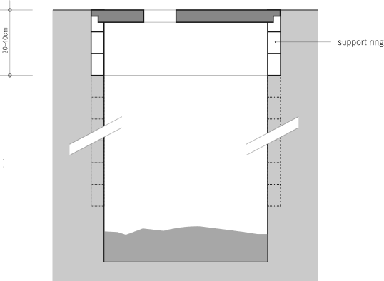

footing (ring beam)

(Credit: Tilley et al., 2014)

###### Description

A rectangular or circular pit dug into the ground and covered with a slab. One of the most common and low cost latrine options.

* Slab sits on a footing (ring beam or partial pit lining)
* Pit may be fully lined if the soil is loose, or if the pit will be emptied when it gets full
* Can be used with a dry toilet or a water-flushed toilet
* Can be used by wipers and washers
* Liquids will infiltrate into the surrounding soil
* Sludge will build up in the pit – it must eventually be emptied, or covered and a new pit dug
* Pit depth depends on the groundwater conditions, number or users, and how often the pit should be emptied
* Building two pits (twin pits) will make the sludge safer to handle when the pit must be emptied. One pit is used until full, then it is covered and the other pit is used. When the second pit is full, it is covered, and the first pit emptied and re-used.
* Connecting the pit to a water-flushed toilet using pipes allows the latrine superstructure to be built near the home while the pit is further away
* Flies and smells can be controlled by using a drop hole lid, a water seal, or by adding some organic cover material (such as sawdust, soil, ash, or leaves) after every defecation

### Ventilated Improved Pit (VIP) Latrine

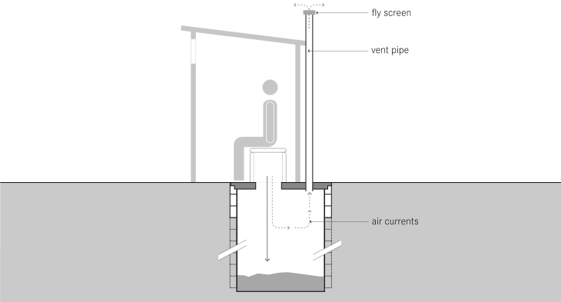

fly screen

vent pipe

air flow

(Credit: Tilley et al., 2014)

###### Description

Modification of the pit latrine with the additions of a vent pipe, open drop hole (do not use a lid!) and a vent or gap above the door. The design is intended to reduce smells and flies in the latrine.

* Slab sits on a footing (ring beam or partial pit lining)
* Pit may be fully lined if the soil is loose, or if the pit will be emptied when it gets full
* Should be used with a dry toilet, toilet must not have a water seal
* Can be used by wipers and washers
* Liquids will infiltrate into the surrounding soil
* Sludge will build up in the pit – it must eventually be emptied, or covered and a new pit dug
* Pit depth depends on the groundwater conditions, number or users, and how often the pit should be emptied
* Building two pits (twin pits) will make the sludge safer to handle when the pit must be emptied. One pit is used until full, then it is covered and the other pit is used. When the second pit is full, it is covered, and the first pit emptied and re-used.
* Flies are controlled through the latrine design and by keeping the inside of the latrine dark. Any flies in the pit are attracted to the light at the top of the vent pipe, where they are trapped by a screen.
* Smells are controlled through the latrine design, which promotes air flow through the structure. You can increase the air flow by painting the vent pipe black so that it heats up in the sun, and facing the latrine door into the wind.

### Arborloo Latrine

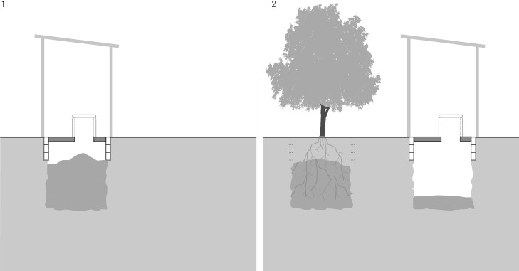

(Credit: Tilley et al., 2014)

###### Description

Modification of the pit latrine. Uses a shallow pit. When full, the pit is covered with soil and a tree planted in it. A new pit is dug, and the superstructure, toilet and slab are moved to the new pit.

* Slab and superstructure must be portable so they can be moved to a new pit
* Slab sits on a footing (ring beam or partial pit lining)
* Should be used with a dry toilet
* Can be used by wipers and washers
* Liquids will infiltrate into the surrounding soil
* Pits are generally 1 to 1.5 metres deep
* Flies and smells can be controlled by using a drop hole lid, or by adding some organic cover material (such as sawdust, soil, ash, or leaves) after every defecation

### Septic Tank

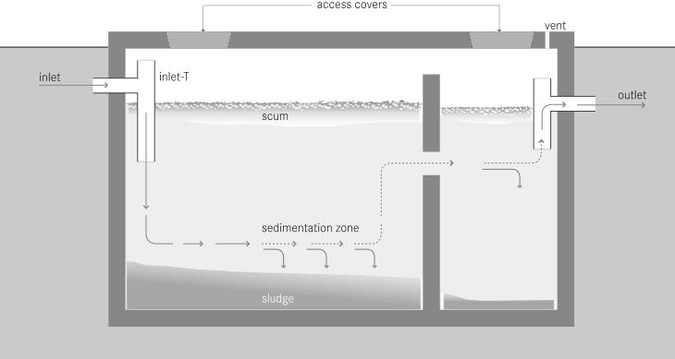

access covers

inlet

inlet-T

outlet

scum

sedimentation zone

sludge

(Credit: Tilley et al., 2014)

###### Description

A two or three compartment tank built belowground. Excreta and flush water enter through the inlet pipe. In the tank, they are partially treated before being infiltrated into the soil or discharged to a sewer system. Sludge settles to the bottom, and has to be emptied periodically. Any water- flushed toilet can be connected to a septic tank.

* Must be used with a water-flushed toilet
* Can be used by wipers (soft degradable wiping materials) and washers
* Liquids from the outlet pipe should go into a soak pit or infiltration trench. The liquid will infiltrate from the soak pit or infiltration trench into the surrounding soil.
* Sludge must be emptied periodically, usually by vacuum truck
* The latrine superstructure may be built near the home while the septic tank and soak pit or infiltration trench are further away
* Flies and smells can be controlled by using a water seal in the toilet

### Aqua Privy

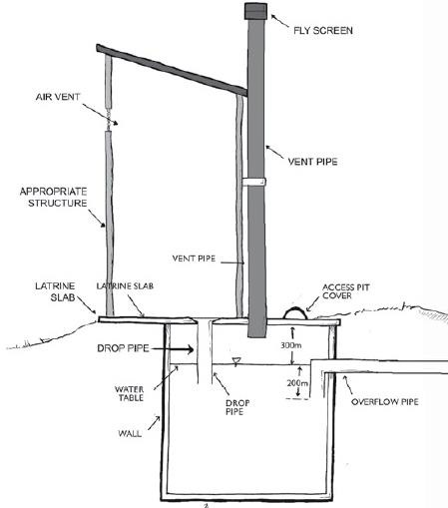

wall

overflow pipe

drop pipe

water table

drop pipe

latrine slab

latrine slab

access cover

vent pipe

appropriate structure

vent pipe

air vent

fly screen

(Credit: Lifewater, 2010)

###### Description

The toilet is built directly above an impermeable tank filled with water. Excreta drops or is flushed down into the tank through a pipe. The end of the pipe is below water – this creates a water seal that controls smells and flies. In the tank, sludge settles to the bottom. The liquid drains out through the outlet pipe (placed at the level of the water seal in the tank). The effluent is infiltrated into the soil or discharged to a sewer system.

* Can be used with a dry toilet or a water-flushed toilet
* Can be used by wipers and washers
* Water may need to be added to maintain the water level at the level of the outlet pipe, especially if there is leakage through the pit walls
* Liquids from the outlet pipe should go into a soak pit or infiltration trench. The liquid will infiltrate from the soak pit or infiltration trench into the surrounding soil.
* Sludge must be emptied periodically, usually by vacuum truck or motorized pump
* Flies and smells are controlled by using a water seal in the toilet

### Biogas Reactor

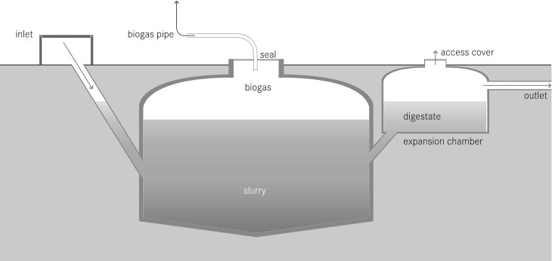

inlet

biogas pipe

seal

access cover

biogas

outlet

slurry

slurry chamber

sludge

(Credit: Tilley et al., 2014)

###### Description

A tank built above or belowground to decompose excreta. The reactor produces biogas, which can be used in the home for cooking, lighting or heat. Connection to a latrine is not sufficient to produce biogas – the addition of animal manure, kitchen/garden waste or excreta from many latrines is required.

* Must be used with a water-flushed toilet
* Can be used by wipers (soft degradable wiping materials) and washers
* Animal manure and kitchen or garden waste is added through a second inlet
* Produces slurry, which can be treated and used as a soil conditioner
* Sludge must be emptied periodically, usually by vacuum truck
* The latrine superstructure may be built near the home while the tank is further away
* Flies and smells can be controlled by using a water seal in the toilet

### Composting Latrine

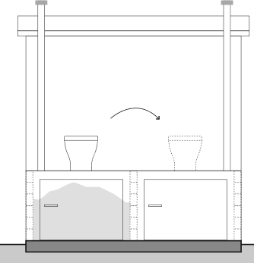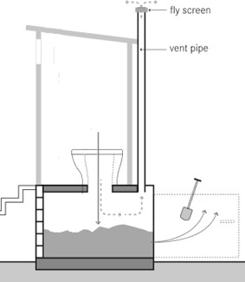

fly screen

vent pipe

(Credit: Adapted from Tilley et al., 2014)

###### Description

Uses two watertight chambers to store excreta. An organic cover material (e.g., sawdust, soil, ash, leaves) is added to the chamber after defecation to help degrade the excreta, reduce smells and control flies. One chamber is used for up to two years and then covered and left while the other chamber is used. During this time, microbes decompose the excreta, reduce the pathogens, and create compost – a soft, dark, earthy material.

* Must be used with a dry toilet
* Can be used by wipers (soft degradable wiping materials) and washers
* Compost must be emptied every 1 to 2 years
* The compost usually requires secondary treatment before it is safe to use (because optimal composting conditions are difficult to achieve in latrine chambers)
* The final compost product can be used in gardens or fields to improve soil structure and provide nutrients for plant growth
* Liquid leachate from the bottom of the chamber should be infiltrated or treated
* Can also be built as two shallow pits instead of chambers. Shallow pits will infiltrate a small amount of liquid into the surrounding soil.
* Flies and smells can be controlled by adding an organic cover material after every defecation

### Dehydrating Latrine

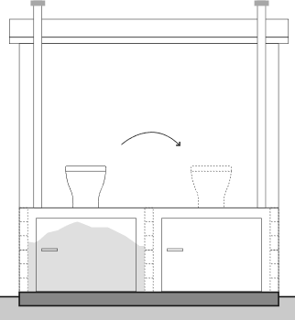

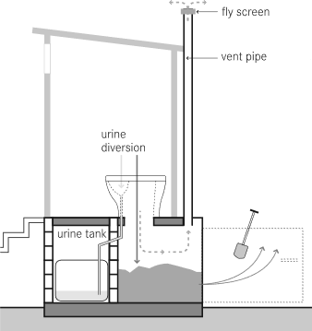

fly screen

vent pipe

urine tank

urine diversion

(Credit: Tilley et al., 2014)

###### Description

Uses two watertight chambers where the urine and feces are collected and stored separately. A special urine diverting toilet is required. A cover material (e.g., sawdust, ash) is added to the chamber after defecation to help dry the excreta, reduce smells and control flies. One chamber is used for up to two years and then covered and left while the other chamber is used.

Pathogens are reduced through dehydration.

* Must be used with a dry, urine diverting toilet
* Can be used by wipers (soft degradable wiping materials)
* Urine can be infiltrated or stored for up to 6 months and used in agriculture
* Dried feces must be emptied every 6 months to 2 years
* The dried feces usually require secondary treatment before it is safe to use (because pathogens are not usually completely removed in latrine chambers)
* The final product can be used in gardens or fields to improve soil structure and provide nutrients for plant growth
* Flies and smells can be controlled by adding cover material after every defecation

### Holding Tank

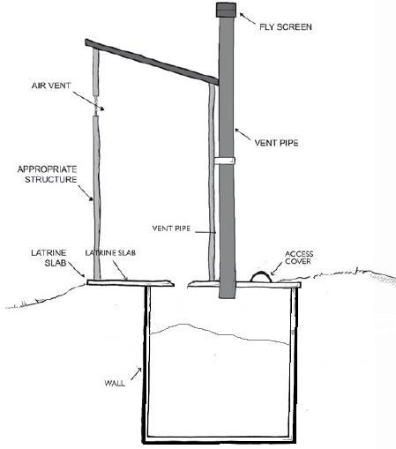

air vent

vent pipe

latrine slab

wall

latrine slab

access cover

appropriate structure

vent pipe

fly screen

(Credit: Adapted from Lifewater, 2010)

###### Description

Holding tanks are sometimes called cesspits. They are sealed pits, tanks or chambers that store excreta. They are watertight tanks, usually built belowground. Because there is no infiltration of liquid into the soil, a holding tank must be emptied more frequently than a septic tank or pit. Due to the cost of frequent emptying, holding tanks may not be suitable for family or communal latrines. Note that a pit that is fully lined with an impermeable lining is a holding tank.

* Usually used with a water-flushed toilet.
* Can be used by wipers (soft degradable wiping materials) and washers
* Sludge must be emptied frequently, usually by vacuum truck
* The latrine superstructure may be built near the home while the holding tank is further away
* Flies and smells can be controlled by using a water seal in the toilet

### Removable Containers

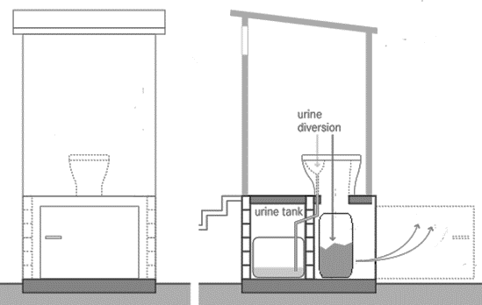

urine tank

urine diversion

(Credit: Adapted from Tilley et al., 2014)

###### Description

In some situations, it may be appropriate to store excreta in portable containers. The removable containers must be hygienically collected, emptied and cleaned frequently – ideally by a trained service team.

* Must be used with a dry toilet
* Can be used by wipers
* If urine diversion is used, the urine can be infiltrated, collected and removed by a trained service team, or collected and used by the family in agriculture
* Feces containers should have a maximum volume of 50 litres so they can be moved
* Feces container must be hygienically sealed, removed, and replaced with a clean container frequently
* Full containers must be safely transported, emptied and cleaned
* Sludge must be treated at a semi-centralized location before it is used or disposed of
* Flies and smells can be controlled by adding cover material after every defecation

August 2015 Trainer Manual

# Introduction to Environmental Sanitation

#### Appendix 4: Environmental Sanitation Inspection Forms

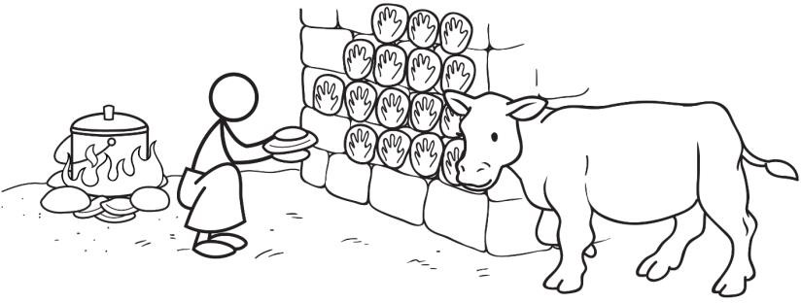

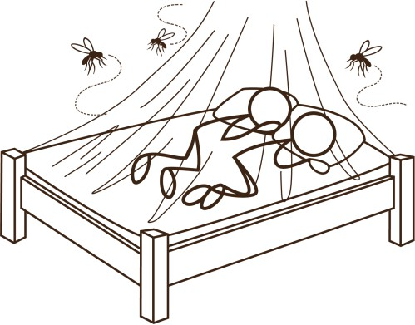



424 Aviation Road NE Calgary, Alberta, T2E 8H6, Canada

Phone: + 1 (403) 243-3285, Fax: + 1 (403) 243-6199

E-mail: resources@cawst.org, Website: www.cawst.org

CAWST, the Centre for Affordable Water and Sanitation Technology, is a nonprofit organization that provides training and consulting to organizations working directly with populations in developing countries who lack access to clean water and basic sanitation.

One of CAWST’s core strategies is to make knowledge about water common knowledge. This is achieved, in part, by developing and freely distributing education materials with the intent of increasing the availability of information to those who need it most.

This document is open content and licensed under the Creative Commons Attribution 4.0 International License. To view a copy of this license, visit: <http://creativecommons.org/licenses/by/4.0/>.

You are free to:

* + Share – Copy and redistribute the material in any medium or format
  + Remix – Remix, transform, and build upon the material for any purpose, even commercially

Under the following terms:

* + Attribution – You must give appropriate credit to CAWST, provide a link to the license, and indicate if changes were made. You may do so in any reasonable manner, but not in any way that suggests that CAWST endorses you or your use. Please include our website: www.cawst.org

CAWST will produce updated versions of this document periodically. For this reason, we do not recommend hosting this document to download from your website.

###### Stay up-to-date and get support:



* + - Latest updates to this document
    - Other workshop and training related resources
    - Support on using this document in your work

*CAWST provides mentoring and coaching on the use of its education and training resources.*

*www.cawst.org/resources*

CAWST and its directors, employees, contractors and volunteers do not assume any responsibility for, and make no warranty with respect to, the results that may be obtained from the use of the information provided.

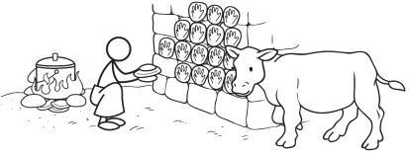**Environmental Sanitation Inspection Form: Animal Excreta Management**

###### Part 1. General information:

1. Location: .............................................................................................................
2. Village/Town: ......................................................................................................
3. People served: ....................................................................................................
4. Date of visit: ........................................................................................................

**Part 2. Risk assessment:** Please adapt this form for the local context. Remove questions that are not appropriate and add questions that are appropriate.

Walk through the community to observe practices and ask community members questions. Be respectful of the community and local traditions. When necessary, seek permission from community leaders to do the inspection.

Circle ‘Yes’ if there is a potential risk and ‘No’ if there is no or very low risk. Add notes to the results and comments section on the next page. See explanation on the next page for details about each question.

|  |  |  |  |
| --- | --- | --- | --- |
|  | **Question** | **Observation** | |
| 1 | Are animals walking through the community freely? | Yes | No |
| 2 | Do livestock live in the household with family members? | Yes | No |
| 3 | Do cats live in the household with pregnant women? | Yes | No |
| 4 | Is animal excreta poorly managed around the households (e.g., animal feces are not collected or properly disposed)? | Yes | No |
| 5 | Do people use untreated animal excreta on crops or gardens as fertilizer? | Yes | No |
| 6 | Do animals have access to crops or gardens in the community? | Yes | No |
| 7 | Do animals have access within 10 m of water sources in the community? | Yes | No |
| 8 | Is animal excreta poorly handled when used as fuel or within the home (e.g., no handwashing with soap after making or burning dung cakes/pats)? | Yes | No |
| 9 | Is animal excreta compost poorly managed (e.g., people or animals can easily contact the excreta while being composted)? | Yes | No |
| 10 | Do people practice poor personal hygiene after handling livestock and animal excreta? | Yes | No |
| **Risk of contamination** (add the number of ‘Yes’ answers) | |  | |

###### Part 3. Results and comments:

1. Risk of contamination (check the appropriate box):

|  |  |  |  |
| --- | --- | --- | --- |
| 9-10 = Very high | 6-8 = High | 3-5 = Medium | 0-2 = Low |
|  |  |  |  |

1. The following risks were observed:

###### Part 4. Name and signature of inspectors:

**Explanatory Notes: Animal Excreta Management**

1. *Are animals walking through the community freely?* Animals that freely roam the community can contaminate water sources, food, people and other animals. Observe whether livestock animals (e.g., cattle, goats) or stray animals (e.g., cats, dogs) are freely roaming the community around homes and gardens. Fences (to keep the animals in or out) are a good way to reduce the risk of contamination.
2. *Do livestock live in the household with family members?* Livestock may live in the household with family members, including goats and sheep. There is a high risk of contamination when livestock sleep and live within the household. If this is not practiced, then circle ‘No’.
3. *Do cats live in the household with pregnant women?* Cat feces can transmit a disease called toxoplasmosis. A pregnant women infected with toxoplasmosis can pass the parasite on to their unborn child. The disease has health impacts on the child, such as vision loss, mental disability and seizures. Women who are or may become pregnant should avoid coming into contact with cat feces, wash hands with soap after contacting soil or clean food from a garden.
4. *Is animal excreta poorly managed around the households (e.g., animal excreta is not collected)?* Animal excreta around households should be collected on a daily basis and moved to a location that is away from water, food and people, especially children. Observe whether livestock animals (e.g., cattle, goats) are kept away from home gardens by using fences or tethers.
5. *Do people use untreated animal excreta on crops or gardens as fertilizer?* Observe or ask if animal excreta is applied to agricultural crops or gardens as a fertilizer. There is a high risk of contamination if the community uses animal excreta directly on crops or gardens. Depending on the type and extent of treatment, if treatment is used at all, pathogens may still be a risk to both human and animal health.
6. *Do animals have access to crops or gardens in the community?* If there is no fence (or the fence is damaged) then animals can access the crops or gardens and may pollute the area with excreta. You will need to check the protection of the site as well as check whether animals are routinely in the area of crops or gardens.
7. *Do animals have access within 10 m of water sources in the community?* If there is no fence (or the fence is damaged) then animals can access the water source and may damage the structure as well as pollute the area with excreta. You will need to check the protection of the site as well as check whether animals are routinely in the area (sometimes animals are kept in the fenced area for security purposes) (WHO, 2012).
8. *Is animal excreta poorly handled when used as fuel or within the home?* There is a high risk of contamination if people are not practicing good hygiene when handling animal excreta. It is very important that people wash their hands with soap and water after making animal dung cakes or pats and before touching food (e.g., preparing food, eating). People can also reduce transmission of pathogens by wearing protective clothing, such as gloves, when handling animal dung in the home. If this is not practiced, then circle ‘No’.
9. *Is animal excreta compost poorly managed (e.g., humans or animals can easily contact animal feces)?* Composting is a traditional practice in many rural communities. The risk of contamination from the compost pile is high if the compost is easy to access by household members and animals. If this is not practiced, then circle ‘No’.
10. *Do people practice poor personal hygiene after handling livestock and animal excreta?* It is very important that people wash their hands with soap and water after handling livestock and animal excreta. People can also reduce transmission of pathogens by wearing protective clothing, such as gloves, when handling livestock and animal excreta.

###### Additional Resources

CAWST (2014). Environmental Sanitation Inspection Forms. CAWST, Calgary, Canada. Available at: [www.cawst.org/resources](http://www.cawst.org/resources).

* + Use this form with the other Environmental Sanitation Inspection Forms, in particular the Vector Control Form.

CAWST (2013). Technical Brief: Animal Excreta Management. CAWST, Calgary, Canada. Available at: [www.cawst.org/resources](http://www.cawst.org/resources).

* + This Technical Brief discusses diseases related to animal excreta and how to properly treat, use and dispose of animal excreta.

###### References

Stockholm Environment Institute (1998). Proxy Indicators for Rapid Assessment of Environmental Health Status of Residential Areas: The Case of the Greater Accra Metropolitan Area (GAMA), Ghana. Available at: [http://www.ircwash.org/sites/default/files/Songsore-1998-](http://www.ircwash.org/sites/default/files/Songsore-1998-Proxy.pdf) [Proxy.pdf](http://www.ircwash.org/sites/default/files/Songsore-1998-Proxy.pdf)

World Health Organization (2012). Rapid Assessment of Drinking-Water Quality: A Handbook for Implementation. WHO, Geneva, Switzerland. Available at: [www.who.int/water_sanitation_health/publications/2012/rapid_assessment/en/index.html](http://www.who.int/water_sanitation_health/publications/2012/rapid_assessment/en/index.html)

CAWST (Centre for Affordable Water and Sanitation Technology) Calgary, Alberta, Canada

Website: [www.cawst.org](http://www.cawst.org/) Email: [resources@cawst.org](mailto:resources@cawst.org)

*Wellness through Water. Empowering People Globally*

Last Update: August 2015

This document is open content. You are free to:

* Share – to copy, distribute and transmit this document
* Remix – to adapt this document

Under the following conditions:

* Attribution. You must give credit to CAWST as the original source of the document. Please include our website: [www.cawst.org](http://www.cawst.org/)

CAWST and its directors, employees, contractors and volunteers do not assume any responsibility for, and make no warranty with respect to, the results that may be obtained from the use of the information provided.

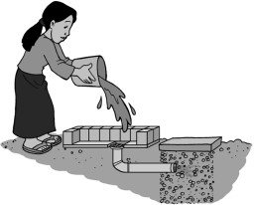**Environmental Sanitation Inspection Form: Domestic Wastewater Management**

###### Part 1. General information:

1. Location: .............................................................................................................
2. Village/Town: ......................................................................................................
3. People served: ....................................................................................................
4. Date of visit: ........................................................................................................

**Part 2. Risk assessment:** Please adapt this form for the local context. Remove questions that are not appropriate and add questions that are appropriate.

Walk through the community to observe practices and ask community members questions. Be respectful of the community and local traditions. When necessary, seek permission from community leaders to do the inspection.

Circle ‘Yes’ if there is a potential risk and ‘No’ if there is no or very low risk. Add notes to the results and comments section on the next page. See explanation on the next page for details about each question.

|  |  |  |  |
| --- | --- | --- | --- |
|  | **Question** | **Observation** | |
| 1 | Is untreated blackwater disposed in areas where it can contact people or animals? | Yes | No |
| 2 | Is untreated blackwater used to irrigate crops? | Yes | No |
| 3 | Is there a lack of drainage channels in the community for rainwater? | Yes | No |
| 4 | Are drainage channels blocked by solid waste, vegetation or silt? | Yes | No |
| 5 | Are there wells or boreholes where the drainage is absent or faulty allowing water to pool within 2 m of the drinking water source? | Yes | No |
| 6 | Are there drainage channels that are absent, cracked, broken or in need of cleaning? | Yes | No |
| 7 | Is there standing water in other locations in the community? | Yes | No |
| **Risk of contamination** (add the number of ‘Yes’ answers) | |  | |

###### Part 3. Results and comments:

1. Risk of contamination (check the appropriate box):

|  |  |  |  |
| --- | --- | --- | --- |
| 7 = Very high | 5-6 = High | 3-4 = Medium | 0-2 = Low |
|  |  |  |  |

1. The following risks were observed:

###### Part 4. Name and signature of inspectors:

**Explanatory Notes: Domestic Wastewater Management**

1. *Is untreated blackwater disposed in areas where it can contact people or animals?* Blackwater is wastewater that has been used to flush a toilet or latrine and contains excreta (e.g., sewage). Blackwater should be disposed in areas where it will not contact people or animals. This water has many pathogens in it, and is a high risk of contamination if disposed of close to humans or animals.
2. *Is untreated blackwater used to irrigate crops?* Blackwater is wastewater that has been used to flush a toilet or latrine and contains excreta (e.g., sewage). This water has many pathogens in it, and is a high risk of contamination if used to irrigate crops for people or animals to eat. It is recommended that blackwater only be used to irrigate crops that will not be eaten raw (WHO, 2006).
3. *Is there a lack of drainage channels in the community for rainwater?* Drainage channels carry rainwater away from households, to prevent standing water. Drainage channels can be used to carry wastewater to be treated, infiltrated into the ground or to irrigate crops. Observe if the community has enough drainage channels to prevent standing water.
4. *Are drainage channels blocked by solid waste, vegetation or silt?* Drainage channels need to be clear of solid waste, vegetation, and silt to work well. Observe whether the drainage channels are unblocked and clear of debris.
5. *Are there wells or boreholes where the drainage is absent or faulty allowing water to pool within 2 m of the drinking water source?* If pools of water collect around the well or borehole they may provide a way for contaminants to enter the source (WHO, 2012).
6. *Are there drainage channels that are absent, cracked, broken or in need of cleaning?* Poor construction or maintenance of the drainage channel, leading to cracks or breaks, is a high

risk to water quality, especially when combined with water spillage and poor sanitary conditions (WHO, 2012).

1. *Is there standing water in other locations in the community?* Standing water can spread pathogens and breed vectors. Poor drainage and drainage management can cause more frequent and severe flooding, spreading contamination. There is a high risk of spreading pathogens and disease.

###### Additional Resources

CAWST (2014). Environmental Sanitation Inspection Forms. CAWST, Calgary, Canada. Available at: [www.cawst.org/resources](http://www.cawst.org/resources).

* + Use this form with the other Environmental Sanitation Inspection forms.

CAWST (2013). Technical Brief: Domestic Wastewater Treatment, Use and Disposal. CAWST, Calgary, Canada. Available at: [www.cawst.org/resources](http://www.cawst.org/resources).

* + This technical brief discusses how to safely and properly compost organic waste in developing countries.

###### References

Stockholm Environment Institute (1998). Proxy Indicators for Rapid Assessment of Environmental Health Status of Residential Areas: The Case of the Greater Accra Metropolitan Area (GAMA), Ghana. Available at: [http://www.ircwash.org/sites/default/files/Songsore-1998-](http://www.ircwash.org/sites/default/files/Songsore-1998-Proxy.pdf) [Proxy.pdf](http://www.ircwash.org/sites/default/files/Songsore-1998-Proxy.pdf)

World Health Organization (2006). Guidelines for the Safe Use of Wastewater, Excreta and Greywater. WHO, Geneva, Switzerland. Available at: [www.who.int/water_sanitation_health/wastewater/en/](http://www.who.int/water_sanitation_health/wastewater/en/)

World Health Organization (2012). Rapid Assessment of Drinking-Water Quality: A Handbook for Implementation. WHO, Geneva, Switzerland. Available at: [www.who.int/water_sanitation_health/publications/2012/rapid_assessment/en/index.html](http://www.who.int/water_sanitation_health/publications/2012/rapid_assessment/en/index.html)

CAWST (Centre for Affordable Water and Sanitation Technology) Calgary, Alberta, Canada

Website: [www.cawst.org](http://www.cawst.org/) Email: [resources@cawst.org](mailto:resources@cawst.org)

*Wellness through Water. Empowering People Globally*

Last Update: August 2014

This document is open content. You are free to:

* Share – to copy, distribute and transmit this document
* Remix – to adapt this document

Under the following conditions:

* Attribution. You must give credit to CAWST as the original source of the document. Please include our website: [www.cawst.org](http://www.cawst.org/)

CAWST and its directors, employees, contractors and volunteers do not assume any responsibility for, and make no warranty with respect to, the results that may be obtained from the use of the information provided.

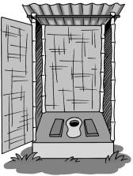**Environmental Sanitation Inspection Form: Excreta Management**

###### Part 1. General information:

1. Location: .............................................................................................................
2. Village/Town: ......................................................................................................
3. People served: ....................................................................................................
4. Date of visit: ........................................................................................................

**Part 2. Risk assessment:** Please adapt this form for the local context. Remove questions that are not appropriate and add questions that are appropriate.

Walk through the community to observe practices and ask community members questions. Be respectful of the community and local traditions. When necessary, seek permission from community leaders to do the inspection.

Circle ‘Yes’ if there is a potential risk and ‘No’ if there is no or very low risk. Add notes to the results and comments section on the next page. See explanation on the next page for details about each question.

|  |  |  |  |
| --- | --- | --- | --- |
|  | **Question** | **Observation** | |
| 1 | Do people practice open defecation (e.g., adults or children)? | Yes | No |
| 2 | Do people with access to a latrine practice open defecation? | Yes | No |
| 3 | Are there households that use unimproved latrines (e.g., pit latrine without a slab, open pit, hanging latrines, or bucket latrine)? | Yes | No |
| 4 | Are there latrines that overflow with excreta? | Yes | No |
| 5 | Are latrines poorly maintained or dirty? | Yes | No |
| 6 | Is there a latrine located less than 30 metres from a drinking water source? | Yes | No |
| 7 | Is there a latrine or other source of fecal contamination uphill of a drinking water source? | Yes | No |
| 8 | Do latrines sometimes fill with water during the year (e.g., during the rainy season)? | Yes | No |
| 9 | Are latrines contaminating other water sources (e.g., rivers, lakes)? | Yes | No |
| **Risk of contamination** (add the number of ‘Yes’ answers) | |  | |

###### Part 3. Results and comments:

1. Risk of contamination (check the appropriate box):

|  |  |  |  |
| --- | --- | --- | --- |
| 9 = Very high | 6-8 = High | 3-5 = Medium | 0-2 = Low |
|  |  |  |  |

1. The following risks were observed:

###### Part 4. Name and signature of inspectors:

**Explanatory Notes: Excreta Management**

1. *Do people practice open defecation (e.g., adults or children)?* Open defecation scatters human excreta in and near to the living environment where children, adults, animals, rodents and insects may come in contact with it. The risk of contamination and disease transmission is very high, especially in crowded living conditions. The risk is lower in a hot and dry climate or in a region where population density is very low.
2. *Do people with access to a latrine practice open defecation?* Open defecation scatters human excreta in and near to the living environment where children, adults, animals, rodents and insects may come in contact with it. The risk of contamination and disease transmission is very high, especially in crowded living conditions. The risk is lower in a hot and dry climate or in a region where population density is very low.
3. *Are there households that use unimproved latrines (e.g., pit latrine without a slab, open pit, hanging latrines, or bucket latrine)?* Unimproved latrines do not prevent contact between excreta, people and/or the environment. Therefore, they do not protect human and environmental health. These latrines present a high risk of contamination.
4. *Are there latrines that overflow with excreta?* Latrines that overflow with excreta do not prevent contact between excreta, people and/or the environment. Therefore, they do not protect human and environmental health. These latrines present a high risk of contamination.
5. *Are latrines poorly maintained or dirty?* Dirty latrines may have excreta on the slab or seat, garbage disposed of in the latrine, or have a hole cover that is dirty. Poorly maintained latrines may lack of a superstructure, superstructure is in poor condition, slab is in poor condition, or lack a hole cover. These latrines may not prevent contact between excreta, people and/or the environment. Therefore, they may not protect human and environmental health.
6. *Is there a latrine located less than 30 metres from a water source?* Latrines located less than 30 metres from a drinking water source may contaminate the source. There is a risk of contamination, depending on the soil and groundwater conditions (WHO, 2012).
7. *Is there a latrine or other source of fecal contamination uphill of a drinking water source?* Contamination on higher ground poses a risk, especially in the wet season, as excreta (and other contaminants) may flow into the water source. The risk is increased if no surface water diversion is present (WHO, 2012).
8. *Do latrines sometimes fill with water during the year (e.g., during the rainy season)?* Contamination of the groundwater occurs when latrines fill with water at any time of the year. There is a risk of contaminating drinking water sources such as wells, boreholes, or springs that are located near the latrine.
9. *Are latrines contaminating other water sources (e.g., rivers, lakes)?* People, animals and other communities may use other water sources such as rivers, lakes, lagoons, and streams. Contaminating any water source presents a risk of contamination and disease for people and animals.

###### Additional Resources

CAWST (2014). Environmental Sanitation Inspection Forms. CAWST, Calgary, Canada. Available at: [www.cawst.org/resources](http://www.cawst.org/resources).

* + Use this form with the other Environmental Sanitation Inspection forms.

CAWST (2013). Technical Brief: Introduction to Sanitation. CAWST, Calgary, Canada. Available at: [www.cawst.org/resources](http://www.cawst.org/resources).

* + This technical brief discusses the need for sanitation and its importance, explains the sanitation chain and gives a project framework for project implementers.

###### References

Stockholm Environment Institute (1998). Proxy Indicators for Rapid Assessment of Environmental Health Status of Residential Areas: The Case of the Greater Accra Metropolitan Area (GAMA), Ghana. Available at: [http://www.ircwash.org/sites/default/files/Songsore-1998-](http://www.ircwash.org/sites/default/files/Songsore-1998-Proxy.pdf) [Proxy.pdf](http://www.ircwash.org/sites/default/files/Songsore-1998-Proxy.pdf)

World Health Organization (2012). Rapid Assessment of Drinking-Water Quality: A Handbook for Implementation. WHO, Geneva, Switzerland. Available at: [www.who.int/water_sanitation_health/publications/2012/rapid_assessment/en/index.html](http://www.who.int/water_sanitation_health/publications/2012/rapid_assessment/en/index.html)

World Health Organization (2005). Water Safety Plans: Managing Drinking-Water Quality from Catchment to Consumer. WHO, Geneva Switzerland. Available at: www.who.int/water_sanitation_health/dwq/wsp0506/en/index.html

CAWST (Centre for Affordable Water and Sanitation Technology) Calgary, Alberta, Canada

Website: [www.cawst.org](http://www.cawst.org/) Email: [resources@cawst.org](mailto:resources@cawst.org)

*Wellness through Water. Empowering People Globally*

Last Update: August 2014

This document is open content. You are free to:

* Share – to copy, distribute and transmit this document
* Remix – to adapt this document

Under the following conditions:

* Attribution. You must give credit to CAWST as the original source of the document. Please include our website: [www.cawst.org](http://www.cawst.org/)

CAWST and its directors, employees, contractors and volunteers do not assume any responsibility for, and make no warranty with respect to, the results that may be obtained from the use of the information provided.

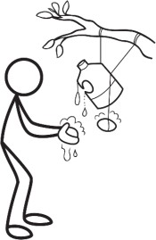**Environmental Sanitation Inspection Form: Hygiene Practices**

###### Part 1. General information:

1. Location: .............................................................................................................
2. Village/Town: ......................................................................................................
3. People served: ....................................................................................................
4. Date of visit: ........................................................................................................

**Part 2. Risk assessment:** Please adapt this form for the local context. Remove questions that are not appropriate and add questions that are appropriate.

Walk through the community to observe practices and ask community members questions. Be respectful of the community and local traditions. When necessary, seek permission from community leaders to do the inspection.

Circle ‘Yes’ if there is a potential risk and ‘No’ if there is no or very low risk. Add notes to the results and comments section on the next page. See explanation on the next page for details about each question.

|  |  |  |  |
| --- | --- | --- | --- |
|  | **Question** | **Observation** | |
| 1 | Are there latrines in the community without a handwashing facility? | Yes | No |
| 2 | Are there public eating facilities without handwashing facilities? | Yes | No |
| 3 | Are there people who do not wash their hands after using the latrine? | Yes | No |
| 4 | Are there people who do not wash their hands before preparing food? | Yes | No |
| 5 | Are there people who do not wash their hands before eating? | Yes | No |
| 6 | Are there caregivers who do not wash their hands after cleaning a child who has defecated? | Yes | No |
| 7 | Are there unwashed dishes and cooking utensils in the households? | Yes | No |
| 8 | Are there households that are poorly maintained and dirty? | Yes | No |
| 9 | Are there people walking in the community without shoes? | Yes | No |
| 10 | Are there poorly maintained bathing facilities in the households? | Yes | No |
| **Risk of contamination** (add the number of ‘Yes’ answers) | |  | |

###### Part 3. Results and comments:

1. Risk of contamination (check the appropriate box):

|  |  |  |  |
| --- | --- | --- | --- |
| 9-10 = Very high | 6-8 = High | 3-5 = Medium | 0-2 = Low |
|  |  |  |  |

1. The following risks were observed:

###### Part 4. Name and signature of inspectors:

**Explanatory Notes: Hygiene Practices**

1. *Are there latrines in the community without a handwashing facility?* A handwashing facility has water and soap or ash in one place for proper handwashing. Different types of handwashing hardware include: a sink with piped water, tippy taps, buckets with taps, and a pitcher and a basin.
2. *Are there public eating facilities without handwashing facilities?* A handwashing station has water and soap or ash in one place for proper handwashing. Different types of handwashing hardware include: a sink with piped water, tippy taps, buckets with taps, and a pitcher and a basin.
3. *Are there people who do not wash their hands after using the latrine?* Handwashing after defecating is one of the critical times for handwashing. There is a risk of contamination if hands are not washed after using the latrine. The majority of people should be practicing this habit.
4. *Are there people who do not wash their hands before preparing food?* Handwashing before preparing food is one of the critical times for handwashing. There is a risk of contamination if hands are not washed before preparing food. The majority of people should be practicing this habit.
5. *Are there people who do not wash their hands before eating?* Handwashing before eating is one of the critical times for handwashing. There is a risk of contamination if hands are not washed before eating. Caregivers should also wash their hands before feeding a child. The majority of people should be practicing this habit.
6. *Are there caregivers who do not wash their hands after cleaning a child who has defecated?* Handwashing after handling a child’s feces or cleaning a child’s anus is one of the critical times for handwashing. There is a risk of contamination if hands are not washed after

cleaning a child that defecated. The majority of caregivers should be practicing this habit.

1. *Are there unwashed dishes and cooking utensils in the households?* Unwashed dishes and cooking utensils can attract vectors such as flies and rats into the home. Vectors transmit disease in a number of ways, such as direct contamination through dirt, urine, and feces or fleas carried on their bodies.
2. *Are there households that are poorly maintained and dirty?* A poorly maintained household is at risk of contamination from the environment entering the household. Dirty households have visible dirt contaminating the home, which may include animal or human excreta. This is a subjective question. It’s important that the surveyor knows the community customs and norms. Discuss this point with the surveyors before doing the risk assessment to ensure consistency.
3. *Are there people walking in the community without shoes?* Some pathogens are transmitted through the soil, such as worms. People who walk without shoes risk the transmission of a disease through contact with the soil.
4. *Are there poorly maintained bathing facilities in the households?* A bathing facility is any space in the household designed for washing the body with soap and water. A poorly maintained bathing facility may leave standing water and greywater in or near the household. Standing water provides breeding sites for mosquitos.

###### Additional Resources

CAWST (2014). Environmental Sanitation Inspection Forms. CAWST, Calgary, Canada. Available at: [www.cawst.org/resources](http://www.cawst.org/resources).

* + Use this form with the other Environmental Sanitation Inspection forms.

CAWST (2013). Technical Brief: Handwashing. CAWST, Calgary, Canada. Available at: [www.cawst.org/resources](http://www.cawst.org/resources).

* + This technical brief discusses describes the critical times for handwashing, the proper method for handwashing and its importance, and how to promote handwashing and handwashing hardware.

###### References

Stockholm Environment Institute (1998). Proxy Indicators for Rapid Assessment of Environmental Health Status of Residential Areas: The Case of the Greater Accra Metropolitan Area (GAMA), Ghana. Available at: [http://www.ircwash.org/sites/default/files/Songsore-1998-](http://www.ircwash.org/sites/default/files/Songsore-1998-Proxy.pdf) [Proxy.pdf](http://www.ircwash.org/sites/default/files/Songsore-1998-Proxy.pdf)

CAWST (Centre for Affordable Water and Sanitation Technology) Calgary, Alberta, Canada

Website: [www.cawst.org](http://www.cawst.org/) Email: [resources@cawst.org](mailto:resources@cawst.org)

*Wellness through Water. Empowering People Globally*

Last Update: August 2014

This document is open content. You are free to:

* Share – to copy, distribute and transmit this document
* Remix – to adapt this document

Under the following conditions:

* Attribution. You must give credit to CAWST as the original source of the document. Please include our website: [www.cawst.org](http://www.cawst.org/)

CAWST and its directors, employees, contractors and volunteers do not assume any responsibility for, and make no warranty with respect to, the results that may be obtained from the use of the information provided.

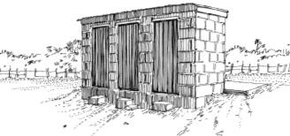**Environmental Sanitation Inspection Form: Public Facilities**

###### Part 1. General information:

1. Location: .............................................................................................................
2. Village/Town: ......................................................................................................
3. People served: ....................................................................................................
4. Date of visit: ........................................................................................................

Credit: Shaw

**Part 2. Risk assessment:** Please adapt this form for the local context. Remove questions that are not appropriate and add questions that are appropriate. Walk through the community to observe practices and ask community members questions. Be respectful of the community and local traditions. When necessary, seek permission from community leaders to do the inspection.

Circle ‘Yes’ if there is a potential risk and ‘No’ if there is no or very low risk. Add notes to the results and comments section on the next page. See explanation on the next page for details about each question.

|  |  |  |  |
| --- | --- | --- | --- |
|  | **Question** | **Observation** | |
| 1 | Do schools have enough latrines for every student (1 latrine for every 25 girls and female staff and 1 latrine for every 50 boys and male staff)? | Yes | No |
| 2 | Is there enough water (minimum of 5 litres per person per day) for hygiene at schools (e.g., handwashing, anal cleansing)? | Yes | No |
| 3 | Is there a lack of menstruation management options in schools with girls aged 11 or older? | Yes | No |
| 4 | Do public or community latrines close for a period of time each year? | Yes | No |
| 5 | Is there a lack of menstruation management options at public or community latrines? | Yes | No |
| 6 | Are public or community latrines poorly maintained or dirty? | Yes | No |
| 7 | Are there public or community latrines without handwashing facilities? | Yes | No |
| 8 | Are handwashing facilities at public or community latrines poorly maintained or dirty? | Yes | No |
| 9 | Are public or community latrines inaccessible to people with disabilities or other physical limitations (e.g., children, elderly, pregnant women)? | Yes | No |
| 10 | Are public or community latrines inaccessible to other vulnerable groups (e.g., stigmatized people)? | Yes | No |
| 11 | Do people need to wait more than 10 minutes to use a public latrine facility? | Yes | No |
| 12 | Are there poorly maintained community bathing facilities? | Yes | No |
| **Risk of contamination** (add the number of ‘Yes’ answers) | |  | |

###### Part 3. Results and comments:

1. Risk of contamination (check the appropriate box):

|  |  |  |  |
| --- | --- | --- | --- |
| 10-12 = Very high | 7-9 = High | 4-6 = Medium | 0-3 = Low |
|  |  |  |  |

1. The following risks were observed:

###### Part 4. Name and signature of inspectors:

**Explanatory Notes: Public Facilities**

1. *Do schools have enough latrines for every student (1 latrine for every 25 girls and 1 latrine for every 50 boys)?* If schools do not have enough latrines, then students may practice open defecation, which is a health risk. Schools may have both latrines and urinals for students. This depends on the local context and number of students (WHO, 2009).
2. *Is there enough water for hygiene at schools (e.g., handwashing, anal cleansing)?* The WHO recommends 5 litres per person per day for all school children and staff. This is for drinking and handwashing. Latrines require: 10-20 litres per person per day for conventional flushing toilets, 1.5-3.0 litres per person per day for pour-flush toilets, and 1-2 litres per person per day for anal washing (WHO, 2009). Contamination spreads quickly without enough water for hygiene.
3. *Is there a lack of menstruation management options in schools with girls aged 11 or older?* Girls in schools need somewhere safe and private to change their sanitary products; clean water and soap for washing their hands, bodies, and reusable cloths; and facilities for safely disposing of used sanitary products or a clean place to dry them if reusable. School latrines should meet these criteria.
4. *Do public or community latrines close for a period of time each year?* Public or community latrines may close during the year because of management issues or because they are broken and unusable. If public or community latrines are not reliable places for defecation, people may practice open defecation.
5. *Is there a lack of menstruation management options at public or community latrines?* Women and girls need somewhere safe and private to change their sanitary products; clean water and soap for washing their hands, bodies, and reusable cloths; and facilities for safely disposing of used sanitary products. Public or community latrines should meet these criteria.
6. *Are public or community latrines poorly maintained or dirty?* Dirty latrines may have excreta on the slab or seat, garbage disposed of in the latrine, or have a hole cover that is dirty. Poorly maintained latrines may lack of a superstructure, superstructure is in poor condition, slab is in poor condition, or lack a hole cover. These latrines may not prevent contact between excreta, people and/or the environment. Therefore, they may not protect human and environmental health.
7. *Are there public or community latrines without handwashing facilities?* A handwashing facility has water and soap or ash in one place for proper handwashing. Different types of handwashing hardware include: a sink with piped water, tippy taps, buckets with taps, and a pitcher and a basin.
8. *Are handwashing facilities at public or community latrines poorly maintained or dirty?* A public handwashing facility may spread contamination, if it’s poorly maintained or dirty. Poorly maintained facilities may not have enough water or lack soap or ash. Dirty handwashing facilities have visible dirt or excreta contaminating the facility.
9. *Are public or community latrines inaccessible to people with disabilities or other physical limitations (e.g., children, elderly, pregnant women)?* Consider how level and firm the path is to the latrine, whether there are steps, how level the latrine slab is, and the general accessibility by all people (WEDC, 2013.) If public or community latrines are not accessible places for all people, then people may practice open defecation.
10. *Are public or community latrines inaccessible to other vulnerable groups (e.g., stigmatized people)?* Vulnerable and stigmatized groups may include people suffering from a particular disease (e.g., people living with HIV/AIDS) or a lower caste. If public or community latrines are not accessible places for all people, then people may practice open defecation.
11. *Do people need to wait more than 10 minutes to use a public latrine facility?* Public facilities with long lines discourage people from using the latrine. Some people may practice open defecation instead of waiting to use a public latrine facility.
12. *Are there poorly maintained bathing facilities in the households?* A bathing facility is any space designed for washing the body with soap and water. A poorly maintained bathing facility may leave standing water and greywater in the community. Standing water provides breeding sites for mosquitos.

###### Additional Resources

CAWST (2014). Environmental Sanitation Inspection Forms. CAWST, Calgary, Canada. Available at: [www.cawst.org/resources](http://www.cawst.org/resources).

* + Use this form with the other Environmental Sanitation Inspection forms.

CAWST (2013). Technical Brief: Menstrual Hygiene Management. CAWST, Calgary, Canada. Available at: [www.cawst.org/resources](http://www.cawst.org/resources).

* + This technical brief discusses the variety of sanitary products available, WASH as it relates to menstrual hygiene, cultural and religious restrictions related to menstrual hygiene and the impact it has on health and education.

CAWST (2013). Technical Brief: Handwashing. CAWST, Calgary, Canada. Available at: [www.cawst.org/resources](http://www.cawst.org/resources).

* + This technical brief discusses the critical times for handwashing, the proper method for handwashing and its importance as well as discussing how to promote handwashing and handwashing hardware.

UNICEF (2011). WASH in Schools Monitoring Package. UNICEF, New York, USA. Available at: <http://www.unicef.org/wash/files/WASH_in_Schools_Monitoring_Package_English.pdf>

* + This package was designed for WASH and Education professionals to monitor the progress of WASH in schools at a national level. This includes basic monitoring questions and a survey module that can be used to evaluate WASH in schools.

WEDC (2013). Equity and Inclusion in Water, Sanitation and Hygiene. WEDC, Loughborough University, UK. Available at: [https://wedc-knowledge.lboro.ac.uk/collections/equity-](https://wedc-knowledge.lboro.ac.uk/collections/equity-inclusion/general.html) [inclusion/general.html](https://wedc-knowledge.lboro.ac.uk/collections/equity-inclusion/general.html)

* + This package of materials includes tools to evaluate the accessibility and safety of WASH facilities. There are accessibility audits for latrines, school latrines, and water points.

###### References

Stockholm Environment Institute (1998). Proxy Indicators for Rapid Assessment of Environmental Health Status of Residential Areas: The Case of the Greater Accra Metropolitan Area (GAMA), Ghana. Available at: [http://www.ircwash.org/sites/default/files/Songsore-1998-](http://www.ircwash.org/sites/default/files/Songsore-1998-Proxy.pdf) [Proxy.pdf](http://www.ircwash.org/sites/default/files/Songsore-1998-Proxy.pdf)

UNICEF (2009). Child Friendly Schools Manual. UNICEF, New York, USA. Available at: <http://www.unicef.org/publications/files/Child_Friendly_Schools_Manual_EN_040809.pdf>

WEDC (2013). Equity and Inclusion in Water, Sanitation and Hygiene. WEDC, Loughborough University, UK. Available at: [https://wedc-knowledge.lboro.ac.uk/collections/equity-](https://wedc-knowledge.lboro.ac.uk/collections/equity-inclusion/general.html) [inclusion/general.html](https://wedc-knowledge.lboro.ac.uk/collections/equity-inclusion/general.html)

WHO (2009). Water, sanitation and hygiene standards for schools in low-cost settings. WHO Press, Geneva, Switzerland. Available at: <http://www.who.int/water_sanitation_health/publications/wash_standards_school.pdf>

CAWST (Centre for Affordable Water and Sanitation Technology) Calgary, Alberta, Canada

Website: [www.cawst.org](http://www.cawst.org/) Email: [resources@cawst.org](mailto:resources@cawst.org)

*Wellness through Water. Empowering People Globally*

Last Update: August 2014

This document is open content. You are free to:

* Share – to copy, distribute and transmit this document
* Remix – to adapt this document

Under the following conditions:

* Attribution. You must give credit to CAWST as the original source of the document. Please include our website: [www.cawst.org](http://www.cawst.org/)

CAWST and its directors, employees, contractors and volunteers do not assume any responsibility for, and make no warranty with respect to, the results that may be obtained from the use of the information provided.

**Environmental Sanitation Inspection Form: Solid Waste Management**

###### Part 1. General information:

1. Location: .............................................................................................................
2. Village/Town: ......................................................................................................
3. People served: ....................................................................................................
4. Date of visit: ........................................................................................................

**Part 2. Risk assessment:** Please adapt this form for the local context. Remove questions that are not appropriate and add questions that are appropriate.

Walk through the community to observe practices and ask community members questions. Be respectful of the community and local traditions. When necessary, seek permission from community leaders to do the inspection.

Circle ‘Yes’ if there is a potential risk and ‘No’ if there is no or very low risk. Add notes to the results and comments section on the next page. See explanation on the next page for details about each question.

|  |  |  |  |
| --- | --- | --- | --- |
|  | **Question** | **Observation** | |
| 1 | Are there uncollected piles of solid waste in the community? | Yes | No |
| 2 | Are waste disposal sites located within 500 metres from drinking water sources? | Yes | No |
| 3 | Are waste disposal sites located in an area with a high water table and/or susceptible to flooding? | Yes | No |
| 4 | Are waste disposal sites covered regularly (e.g., daily or weekly) with soil or ash? | Yes | No |
| 5 | Is there a fence around waste disposal sites? | Yes | No |
| 6 | Do people unsafely scavenge for waste materials? | Yes | No |
| 7 | Do animals roam in waste disposal sites? | Yes | No |
| 8 | Is there uncontrolled burning of solid waste? | Yes | No |
| 9 | Does solid waste block drainage channels? | Yes | No |
| 10 | Is solid waste disposed in other water sources (e.g., lagoons, rivers)? | Yes | No |
| 11 | Is hazardous waste (e.g., medical waste, chemicals, batteries) collected and disposed separately from household waste? | Yes | No |
| **Risk of contamination** (add the number of ‘Yes’ answers) | |  | |

###### Part 3. Results and comments:

1. Risk of contamination (check the appropriate box):

|  |  |  |  |
| --- | --- | --- | --- |
| 9-11 = Very high | 6-8 = High | 3-5 = Medium | 0-2 = Low |
|  |  |  |  |

1. The following risks were observed:

###### Part 4. Name and signature of inspectors:

**Explanatory Notes: Solid Waste Management**

1. *Are there uncollected piles of solid waste in the community?* Irregular or no formal waste collection services exposes people to waste and increases the risk of disease transmission. Uncollected solid waste can be a breeding site for disease vectors, including flies, mosquitos and rodents.
2. *Are waste disposal sites located within 500 metres from drinking water sources?* This distance can help to protect ground and surface water from becoming contaminated.
3. *Are waste disposal sites located in an area with a high water table and/or susceptible to flooding?* Disposal sites should be located in areas with a lower water table and that are not susceptible to flooding. This can help to protect soil, groundwater and surface water from becoming contaminated.
4. *Are waste disposal sites covered regularly (e.g., daily or weekly) with soil or ash?* Waste disposal sites should be covered with 0.1 metres of soil or ash regularly (e.g., daily or weekly) to reduce odours and disease vectors, as well as prevent waste from blowing away.
5. *Is there a fence around waste disposal sites?* Waste disposal sites should have a fence to keep animals and children out of the area. As well, fences can prevent lighter materials (e.g., plastic bags) from blowing away. Children are especially vulnerable to risks from solid waste. They often play outside and might pick up waste materials that adults know to avoid.
6. *Do people unsafely scavenge for waste materials?* Waste picking without the use of personal safety equipment (such as gloves, masks and shoes) increases people’s risk of diarrhea, infections and respiratory illnesses. Punctures caused by pieces of glass or needles are very common and can lead to infections, tetanus, hepatitis or HIV.
7. *Do animals roam in waste disposal sites?* Animals often look for food among waste disposal sites. They can become vectors of different diseases and increase the spread of waste in the environment.
8. *Is there uncontrolled burning of solid waste?* Uncontrolled burning can result in large fires at disposal sites. As well, the smoke contributes to air pollution and can cause respiratory problems. It may be necessary to burn household waste if landfill space is very limited. In this case, it is best to burn the waste as far as possible from people, keep it contained in a pit or barrel to prevent the fire from uncontrolled spreading, and burn it as hot as possible. The ashes may be contaminated and should be disposed of in a pit or landfill.
9. *Does solid waste block drainage channels?* Blocked drains can cause increased flooding, especially in high-density urban areas. Blocked drains can create standing water, which is an ideal breeding site for mosquitos.
10. *Is solid waste disposed in other water sources (e.g., lagoons, rivers)?* Waste can block water sources and cause increased flooding. Liquid produced from waste can contaminate the water source.
11. *Is hazardous waste (e.g., medical waste, chemicals, batteries) collected and disposed separately from household waste?* Hazardous waste includes toxic waste, medical waste, pharmaceuticals, chemicals, and batteries. Do not dispose hazardous waste in latrines, drainage channels, water sources or on the ground. Hazardous waste that is disposed with household waste is dangerous, especially for waste pickers.

###### Additional Resources

CAWST (2014). Environmental Sanitation Inspection Forms. CAWST, Calgary, Canada. Available at: [www.cawst.org/resources](http://www.cawst.org/resources).

* + Use this form with the other Environmental Sanitation Inspection forms.

CAWST (2013). Technical Brief: Solid Waste Management. CAWST, Calgary, Canada. Available at: [www.cawst.org/resources](http://www.cawst.org/resources).

* + This technical brief discusses how to treat waste through recycling, composting and incineration. It discusses hazardous waste, menstrual hygiene waste as well as solid waste attitudes.

###### References

Stockholm Environment Institute (1998). Proxy Indicators for Rapid Assessment of Environmental Health Status of Residential Areas: The Case of the Greater Accra Metropolitan Area (GAMA), Ghana. Available at: [http://www.ircwash.org/sites/default/files/Songsore-1998-](http://www.ircwash.org/sites/default/files/Songsore-1998-Proxy.pdf) [Proxy.pdf](http://www.ircwash.org/sites/default/files/Songsore-1998-Proxy.pdf)

CAWST (Centre for Affordable Water and Sanitation Technology) Calgary, Alberta, Canada

Website: [www.cawst.org](http://www.cawst.org/) Email: [resources@cawst.org](mailto:resources@cawst.org)

*Wellness through Water. Empowering People Globally*

Last Update: August 2014

This document is open content. You are free to:

* Share – to copy, distribute and transmit this document
* Remix – to adapt this document

Under the following conditions:

* Attribution. You must give credit to CAWST as the original source of the document. Please include our website: [www.cawst.org](http://www.cawst.org/)

CAWST and its directors, employees, contractors and volunteers do not assume any responsibility for, and make no warranty with respect to, the results that may be obtained from the use of the information provided.

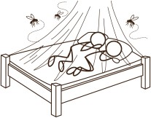**Environmental Sanitation Inspection Form: Vector Control**

###### Part 1. General information:

1. Location: .............................................................................................................
2. Village/Town: ......................................................................................................
3. People served: ....................................................................................................
4. Date of visit: ........................................................................................................

**Part 2. Risk assessment:** Please adapt this form for the local context. Remove questions that are not appropriate and add questions that are appropriate.

Walk through the community to observe practices and ask community members questions. Be respectful of the community and local traditions. When necessary, seek permission from community leaders to do the inspection.

Circle ‘Yes’ if there is a potential risk and ‘No’ if there is no or very low risk. Add notes to the results and comments section on the next page. See explanation on the next page for details about each question.

|  |  |  |  |
| --- | --- | --- | --- |
|  | **Question** | **Observation** | |
| 1 | Are there flies where people prepare food? | Yes | No |
| 2 | Are there rats or other rodents in the households? | Yes | No |
| 3 | Are water storage containers or tanks uncovered? | Yes | No |
| 4 | Is there standing water in the community (e.g., flower and plant pots, blocked gutters and drains, open latrines and septic tanks)? | Yes | No |
| 5 | Are there mosquito larvae in water storage containers or standing water? | Yes | No |
| 6 | Are there other places for flies to breed in the community (e.g., garbage dumps, open latrines)? | Yes | No |
| 7 | Are there many people in the community with mosquito-related diseases (e.g., malaria, dengue fever, Japanese Encephalitis)? | Yes | No |
| 8 | Are there many people in the community with rodent-related diseases (e.g., leptospirosis, typhus, hantavirus)? | Yes | No |
| 9 | Are there many people in the community with fly-related diseases (e.g., trachoma)? | Yes | No |
| **Risk of contamination** (add the number of ‘Yes’ answers) | |  | |

###### Part 3. Results and comments:

1. Risk of contamination (check the appropriate box):

|  |  |  |  |
| --- | --- | --- | --- |
| 8-9 = Very high | 6-7 = High | 3-5 = Medium | 0-2 = Low |
|  |  |  |  |

1. The following risks were observed:

###### Part 4. Name and signature of inspectors:

**Explanatory Notes: Vector Control**

1. *Are there flies where people prepare food?* Flies pick up pathogens on their bodies when laying their eggs or feeding and then transport pathogens to people’s food, tableware and faces. Flies have a high risk of transmitting pathogens from the environment to people when they are in areas where people prepare food.
2. *Are there rats or other rodents in the households?* Rats and other rodents can find their way into homes, as well as food and grain storage areas. They transmit disease in a number of ways, such as direct contamination through dirt, urine, and feces or fleas carried on their bodies. Controlling them reduces the risk of disease transmission and can also decrease food loss and spoiling.
3. *Are water storage containers or tanks uncovered?* Water storage containers and tanks include rainwater harvesting tanks, buckets, or other containers. Uncovered water storage containers and tanks are ideal breeding sites for mosquitos.
4. *Is there standing water in the community (e.g., flower and plant pots, blocked gutters and drains, open latrines and septic tanks)?* Standing water is water that has pooled or accumulated in an area. Standing water occurs in flower or plant pots, blocked gutters and drains, open latrines and septic tanks. Standing water provides breeding sites for mosquitos.
5. *Are there mosquito larvae in water storage containers or standing water?* Standing water is water that has pooled or accumulated in an area. Standing water provides breeding sites for mosquitos. Mosquito larvae are visible in standing water that is not turbid.
6. *Are there other places for flies to breed in the community (e.g., garbage dumps, open latrines)?* Flies lay their eggs in organic material that provide food for emerging maggots.

Excreta found in unsanitary latrines is ideal for this, as is domestic food waste that is not properly disposed of. Garbage dumps, waste disposal sites, and open latrines are ideal places for flies to breed.

1. *Are there many people in the community with mosquito-related diseases (e.g., malaria, dengue fever, Japanese Encephalitis)?* Mosquito-related diseases include malaria, dengue fever, Japanese Encephalitis, West Nile fever, yellow fever, and chikungunya. If there are many people with these diseases, then there is a high risk of transmission in the community.
2. *Are there many people in the community with rodent-related diseases (e.g., leptospirosis, hantavirus)?* Rodent-related diseases include leptospirosis, typhus, hantavirus, and the plague. If there are many people with these diseases, then there is a high risk of transmission in the community.
3. *Are there many people in the community with fly-related diseases (e.g., trachoma)?* Fly- related diseases include trachoma. Flies also play a role in transmitting many diarrheal diseases. If there are many people with these diseases, then there is a high risk of transmission in the community.

###### Additional Resources

CAWST (2014). Environmental Sanitation Inspection Forms. CAWST, Calgary, Canada. Available at: [www.cawst.org/resources](http://www.cawst.org/resources).

* + Use this form with the other Environmental Sanitation Inspection forms.

CAWST (2013). Technical Brief: Vector Control. CAWST, Calgary, Canada. Available at: [www.cawst.org/resources](http://www.cawst.org/resources).

* + This technical brief discusses what vectors are, the diseases that they spread and how to control vectors, specifically mosquitos, flies and rodents.

###### References

Stockholm Environment Institute (1998). Proxy Indicators for Rapid Assessment of

Environmental Health Status of Residential Areas: The Case of the Greater Accra Metropolitan Area (GAMA), Ghana. Available at: <http://www.ircwash.org/sites/default/files/Songsore-1998-Proxy.pdf>

CAWST (Centre for Affordable Water and Sanitation Technology) Calgary, Alberta, Canada

Website: [www.cawst.org](http://www.cawst.org/) Email: [resources@cawst.org](mailto:resources@cawst.org)

*Wellness through Water. Empowering People Globally*

Last Update: August 2014

This document is open content. You are free to:

* Share – to copy, distribute and transmit this document
* Remix – to adapt this document

Under the following conditions:

* Attribution. You must give credit to CAWST as the original source of the document. Please include our website: [www.cawst.org](http://www.cawst.org/)

CAWST and its directors, employees, contractors and volunteers do not assume any responsibility for, and make no warranty with respect to, the results that may be obtained from the use of the information provided.

August 2014 Trainer Manual

# Introduction to Environmental Sanitation

#### Appendix 5: Sanitary Inspection Forms

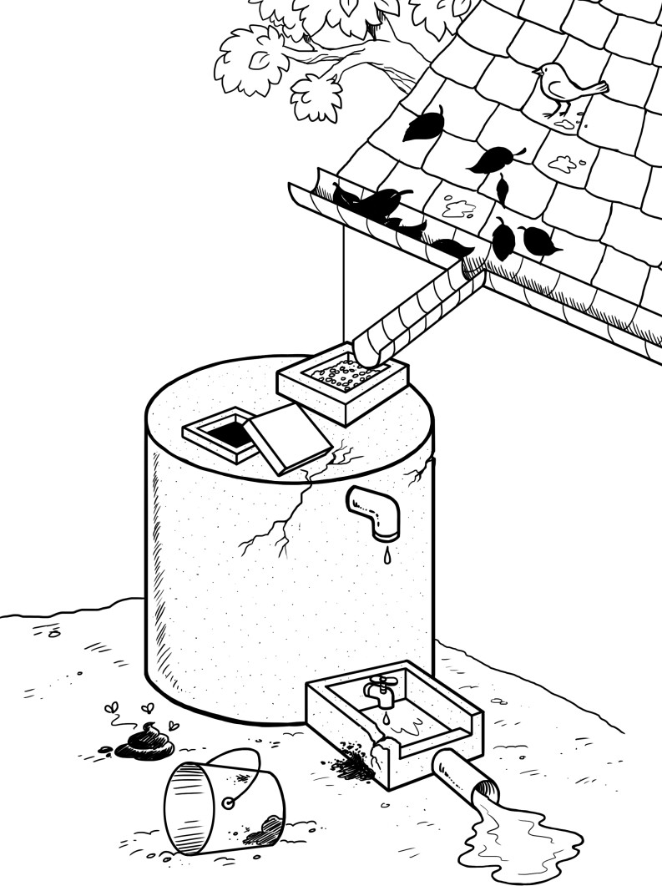



424 Aviation Road NE Calgary, Alberta, T2E 8H6, Canada

Phone: + 1 (403) 243-3285, Fax: + 1 (403) 243-6199

E-mail: resources@cawst.org, Website: www.cawst.org

CAWST, the Centre for Affordable Water and Sanitation Technology, is a nonprofit organization that provides training and consulting to organizations working directly with populations in developing countries who lack access to clean water and basic sanitation.

One of CAWST’s core strategies is to make knowledge about water common knowledge. This is achieved, in part, by developing and freely distributing education materials with the intent of increasing the availability of information to those who need it most.

This document is open content and licensed under the Creative Commons Attribution Works 4.0 International License. To view a copy of this license, visit <http://creativecommons.org/licenses/by/4.0> or send a letter to Creative Commons, 171 Second Street, Suite 300, San Francisco, California 94105, USA.

You are free to:

* Share – to copy, distribute and transmit this document
* **Remix** – to adapt this document

Under the following conditions:

* Attribution. You must give credit to CAWST as the original source of the document. Please include our website: [www.cawst.org](http://www.cawst.org/)

CAWST will produce updated versions of this document periodically. For this reason, we do not recommend hosting this document to download from your website.

###### Stay up-to-date and get support:



* + Latest updates to this document
  + Other workshop & training related resources
  + Support on using this document in your work

*CAWST provides mentorship and coaching on the use of its education and training resources.*

[*www.cawst.org/resources*](http://www.cawst.org/resources)

CAWST and its directors, employees, contractors and volunteers do not assume any responsibility for and make no warranty with respect to the results that may be obtained from the use of the information provided.

**Sanitary Inspection Form: Borehole with Hand Pump**

###### Part 1. General information:

1. Location: .............................................................................................................
2. Village/Town: ......................................................................................................
3. People served: ....................................................................................................
4. Water sample taken? ……………………. Sample ID …………………………….
5. Date of visit: ........................................................................................................

**Part 2. Risk assessment:** Circle the most appropriate answer. A ‘Yes’ answer means that there is a potential risk and a ‘No’ answer that there is no or very low risk. See explanation on reverse.

###### Observation

|  |  |
| --- | --- |
| 1. Is there a latrine within 10 m of the borehole? | Y/N |
| 2. Is there a latrine or other source of fecal contamination uphill of the borehole? | Y/N |
| 3. Is there any source of other contamination within 10 m of the borehole (e.g., animals, agriculture, roads, industry, etc.)? | Y/N |
| 4. Is the drainage absent or faulty allowing water to pool within 2 m of the borehole? | Y/N |
| 5. Is the drainage channel absent, cracked, broken or in need of cleaning? | Y/N |
| 6. Is the wall or fence around the pump inadequate? | Y/N |
| 7. Is the well apron less than 2 m in diameter? | Y/N |
| 8. Does spilt water collect in the apron area? | Y/N |
| 9. Is the well apron or pump cover cracked or damaged? | Y/N |
| 10. Is the hand pump loose at the point of attachment? For rope-washer pumps, is the pump cover missing? | Y/N |
| Risk of contamination (add the number of 'Yes' answers): | ……/10 |

**Part 3. Results and comments:**

1. Risk of contamination (check the appropriate box):

|  |  |  |  |
| --- | --- | --- | --- |
| 9-10 = Very high | 6-8 = High | 3-5 = Medium | 0-2 = Low |
|  |  |  |  |

1. The following risks were observed:

**Part 4. Name and signature of inspectors:**

**Explanatory Notes: Borehole with Hand Pump**

1. *Is there a latrine within 10 m of the borehole?* Latrines close to groundwater supplies may affect water quality (e.g., by infiltration). You may need to visually check structures to see if they are latrines in addition to asking household members.
2. *Is there a latrine or other source of fecal contamination uphill of the borehole?* Contamination on higher ground poses a risk, especially in the wet season, as feces (and other contaminants) may flow into the water source. The risk is increased if no surface water diversion is present. Groundwater may also flow towards the borehole from the direction of the latrine.
3. *Is there any source of other contamination within 10 m of the borehole (e.g., animals, agriculture, roads, industry, etc.)?* Animal or human feces close to the borehole are a serious risk to water quality, especially when water diversion ditches are not present. Open disposal of other waste (e.g., household, agricultural) is also a risk to water quality.
4. *Is the drainage absent or faulty allowing water to pool within 2 m of the borehole?* If pools of water collect around the borehole they may provide a way for contaminants to enter the source.
5. *Is the drainage channel absent, cracked, broken or in need of cleaning?* Poor construction or maintenance of the drainage channel, leading to cracks or breaks, is a high risk to water quality, especially when combined with water spillage and poor sanitary conditions.
6. *Is the wall or fence around the pump inadequate?* If there is no fence or the fence is damaged, then animals can access the borehole and may damage the structure as well as contaminate the area with feces. You will need to check the fencing at the site as well as check whether animals are routinely in the area (sometimes animals are kept in the fenced area for security).
7. *Is the well apron less than 2 m in diameter?* The apron (also known as the platform or slab) is built to prevent backflow of water into the borehole. To do this adequately the apron needs to be at least 2 m in diameter.
8. *Does spilt water collect in the apron area?* If water does not drain away from the apron area, then water (possibly contaminated) could backflow into the water source.
9. *Is the well apron or pump cover cracked or damaged?* Cracks, especially deep ones, in the apron or pump cover may allow backflow into the water source.
10. *Is the hand pump loose at the point of attachment? For rope-washer pumps, is the pump cover missing?* A loose hand pump or missing pump cover may allow backflow of contaminated water into the water source.

Sanitary Inspection Form adapted from:

World Health Organization (2012). Rapid Assessment of Drinking-Water Quality: A Handbook for Implementation. WHO, Geneva, Switzerland. Available at: [www.who.int/water_sanitation_health/publications/2012/rapid_assessment/en/index.html](http://www.who.int/water_sanitation_health/publications/2012/rapid_assessment/en/index.html)

World Health Organization (2005). Water Safety Plans: Managing Drinking-Water Quality from Catchment to Consumer. WHO, Geneva Switzerland. Available at: [www.who.int/water_sanitation_health/dwq/wsp0506/en/index.html](http://www.who.int/water_sanitation_health/dwq/wsp0506/en/index.html)

World Health Organization (1997). Guidelines for Drinking Water Quality, Second Edition, Volume 3, Surveillance and Control of Community Supplies. WHO, Geneva, Switzerland. Available at: www.who.int/water_sanitation_health/dwq/gdwq2v1/en/index2.html

**Illustration of Borehole with Hand Pump**

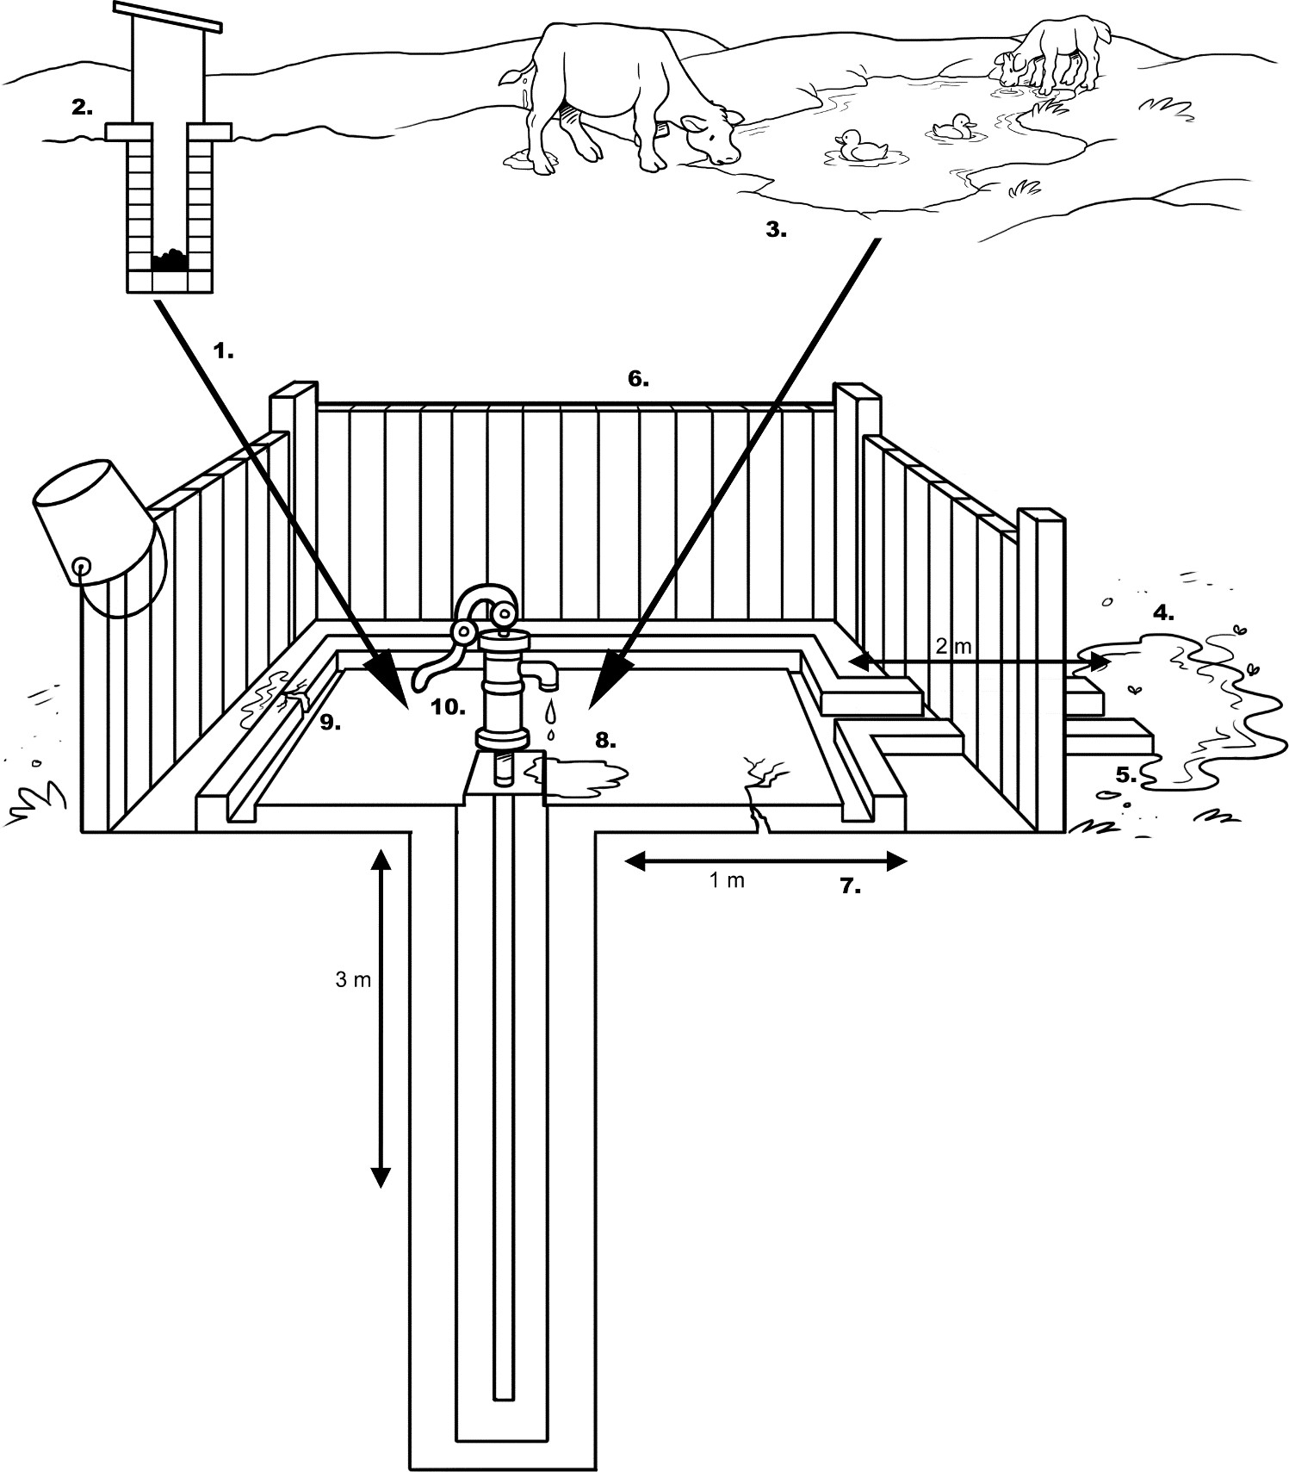

**Sanitary Inspection Form: Borehole with Mechanized Pump**

###### Part 1. General information:

1. Location: .............................................................................................................
2. Village/Town: ......................................................................................................
3. People served: ....................................................................................................
4. Water sample taken? ……………………. Sample ID …………………………….
5. Date of visit: ........................................................................................................

**Part 2. Risk assessment:** Circle the most appropriate answer. A ‘Yes’ answer means that there is a potential risk and a ‘No’ answer that there is no or very low risk. See explanation on reverse.

###### Observation

|  |  |
| --- | --- |
| 1. Is there a latrine or sewer within 100 m of the pump? | Y/N |
| 2. Is there a latrine within 10 m of the borehole? | Y/N |
| 3. Is there any source of other contamination within 50 m of the borehole (e.g., animals, agriculture, roads, industry)? | Y/N |
| 4. Is there an uncapped well within 100 m? | Y/N |
| 5. Is the drainage channel absent, cracked, broken or in need of cleaning? | Y/N |
| 6. Can animals come within 50 m of the borehole? | Y/N |
| 7. Is the base of the pumping mechanism permeable to water? | Y/N |
| 8. Is there stagnant water within 2 m of the pump? | Y/N |
| 9. Is the well seal dirty? | Y/N |
| 10. Is the borehole cap cracked? | Y/N |
| Risk of contamination (add the number of 'Yes' answers): | ……/10 |

**Part 3. Results and comments:**

1. Risk of contamination (check the appropriate box):

|  |  |  |  |
| --- | --- | --- | --- |
| 9-10 = Very high | 6-8 = High | 3-5 = Medium | 0-2 = Low |
|  |  |  |  |

1. The following risks were observed:

**Part 4. Name and signature of inspectors:**

**Explanatory Notes: Borehole with Mechanized Pump**

1. *Is there a latrine or sewer within 100 m of the pump?* Any leaks from the sewer or latrine could contaminate the borehole water by draw down caused by pumping. You can observe latrines and check with household members, but you may need to ask relevant professionals about the location of sewers.
2. *Is there a latrine within 10 m of the borehole?* Latrines close to groundwater supplies may contaminate the water quality (e.g., by infiltration). You may need to visually check structures to see if they are latrines in addition to asking household members.
3. *Is there any source of other contamination within 50 m of the borehole (e.g., animals, agriculture, roads, industry)?* Animal or human feces close to the borehole are a serious risk to water quality, especially when there are no water diversion ditches. Open disposal of other waste (e.g., household, agricultural etc.) is also a risk to water quality.
4. *Is there an uncapped well within 100 m?* Uncapped wells can be easily contaminated and the pollution can spread through the groundwater. You can check visually for such wells and also ask household members.
5. *Is the drainage channel absent, cracked, broken or in need of cleaning?* Poor construction or maintenance of the drainage channel (leading to cracks or breaks) is a high risk to water quality, especially when combined with water spillage and poor sanitary conditions.
6. *Can animals come within 50 m of the borehole?* If there is no fence or the fence is damaged, then animals can access the borehole and may damage the structure as well as pollute the area with feces. You will need to check the fencing at the site as well as check whether animals are routinely in the area (sometimes animals are kept in the fenced area for security).
7. *Is the base of the pumping mechanism permeable to water?* If the base is permeable (e.g., there is no cover or the cover has deep cracks), then surface water run-off could provide a way for contamination to enter the ground water.
8. *Is there stagnant water within 2 m of the pump?* Pools of water that collect around the pump may provide a way for contaminants to enter the water source.
9. *Is the well seal dirty?* Feces, garbage and other waste around the well seal are a risk to the water quality.
10. *Is the borehole cap cracked?* Cracks allow contaminants to enter the borehole and are a risk to water quality.

Sanitary Inspection Form adapted from:

World Health Organization (2012). Rapid Assessment of Drinking-Water Quality: A Handbook for Implementation. WHO, Geneva, Switzerland. Available at: [www.who.int/water_sanitation_health/publications/2012/rapid_assessment/en/index.html](http://www.who.int/water_sanitation_health/publications/2012/rapid_assessment/en/index.html)

World Health Organization (2005). Water Safety Plans: Managing Drinking-Water Quality from Catchment to Consumer. WHO, Geneva Switzerland. Available at: [www.who.int/water_sanitation_health/dwq/wsp0506/en/index.html](http://www.who.int/water_sanitation_health/dwq/wsp0506/en/index.html)

World Health Organization (1997). Guidelines for Drinking Water Quality, Second Edition, Volume 3, Surveillance and Control of Community Supplies. WHO, Geneva, Switzerland. Available at: www.who.int/water_sanitation_health/dwq/gdwq2v1/en/index2.html

**Sanitary Inspection Form: Dug Well with Hand Pump**

###### Part 1. General information:

1. Location: .............................................................................................................
2. Village/Town: ......................................................................................................
3. People served: ....................................................................................................
4. Water sample taken? ……………………. Sample ID …………………………….
5. Date of visit: ........................................................................................................

**Part 2. Risk assessment:** Circle the most appropriate answer. A ‘Yes’ answer means that there is a potential risk and a ‘No’ answer that there is no or very low risk. See explanation on reverse.

###### Observation

1. Is there a latrine within 10 m of the well? Y/N
2. Is there a latrine or other source of fecal contamination uphill of the well? Y/N
3. Is there any source of other contamination within 10 m of the well

(e.g., animals, agriculture, cultivation, roads, industry)? Y/N

1. Is the drainage absent or faulty allowing water to pool within 3 m of the well? Y/N
2. Is the drainage channel absent or cracked, broken or in need of cleaning? Y/N
3. Is the apron less than 2 m in diameter around the top of the well? Y/N
4. Does spilt water collect in the apron area? Y/N
5. Is the well apron cracked or damaged? Y/N
6. Is the hand pump loose at the point of attachment? For rope-washer pumps,

is the pump cover missing? Y/N

1. Is the well cover absent or dirty? Y/N

Risk of contamination (add the number of 'Yes' answers): ……/10

###### Part 3. Results and comments:

* 1. Risk of contamination (check the appropriate box):

|  |  |  |  |
| --- | --- | --- | --- |
| 9-10 = Very high | 6-8 = High | 3-5 = Medium | 0-2 = Low |
|  |  |  |  |

* 1. The following risks were observed:

**Part 4. Name and signature of inspectors:**

**Explanatory Notes: Dug Well with Hand Pump**

1. *Is there a latrine within 10 m of the well?* Latrines close to groundwater supplies may affect water quality (e.g. by infiltration). You may need to visually check structures to see if they are latrines in addition to asking residents.
2. *Is there a latrine or other source of fecal contamination uphill of the well?* Contamination on higher ground poses a risk, especially in the wet season, as feces (and other contaminants) may flow into the water source. The risk is increased if no surface water diversion is present. Groundwater may also flow towards the borehole from the direction of the latrine.
3. *Is there any source of other contamination within 10 m of the well (e.g. animals, agriculture, roads, industry)?* Animal or human feces close to the borehole are a serious risk to water quality, especially when water diversion ditches are not present. Open disposal of other waste (e.g., household, agricultural) is also a risk to water quality.
4. *Is the drainage absent or faulty allowing water to pool within 3 m of the well?* If pools of water collect around the borehole, then they may provide a route for contaminants to enter the water source.
5. *Is the drainage channel absent or cracked, broken or in need of cleaning?* Poor construction of maintenance of the drainage channel, leading to cracks and breaks, especially when combined with spillage of water and poor sanitary conditions, poses a high risk to water quality.
6. *Is the apron less than 2 m in diameter around the top of the well?* The apron (also known as the platform or slab) is built to prevent backflow of water into the borehole. To do this adequately the apron needs to be at least 2 m in diameter.
7. *Does spilt water collect in the apron area?* If water does not drain away from the apron area, then water (possibly contaminated) could backflow into the water source.
8. *Is the well apron cracked or damaged?* Cracks, especially deep ones, in the concrete may allow backflow into the water source.
9. *Is the hand pump loose at the point of attachment? For rope-washer pumps, is the pump cover missing?* A loose hand pump or missing pump cover may allow backflow of contaminated water into the water source.
10. *Is the well cover absent or dirty?* Absence of a cover or a dirty cover increases the chances of contamination entering the well.

Sanitary Inspection Form adapted from:

World Health Organization (2012). Rapid Assessment of Drinking-Water Quality: A Handbook for Implementation. WHO, Geneva, Switzerland. Available at: [www.who.int/water_sanitation_health/publications/2012/rapid_assessment/en/index.html](http://www.who.int/water_sanitation_health/publications/2012/rapid_assessment/en/index.html)

World Health Organization (2005). Water Safety Plans: Managing Drinking-Water Quality from Catchment to Consumer. WHO, Geneva Switzerland. Available at: [www.who.int/water_sanitation_health/dwq/wsp0506/en/index.html](http://www.who.int/water_sanitation_health/dwq/wsp0506/en/index.html)

World Health Organization (1997). Guidelines for Drinking Water Quality, Second Edition, Volume 3, Surveillance and Control of Community Supplies. WHO, Geneva, Switzerland. Available at: www.who.int/water_sanitation_health/dwq/gdwq2v1/en/index2.html

**Sanitary Inspection Form: Household Piped Water**

###### Part 1. General information:

1. Household:............................................................................................................
2. Source of water: ...................................................................................................
3. Village/Town: .........................................................................................................
4. Water sample taken? ……………………. Sample ID …………………………….
5. Date of visit: ........................................................................................................

**Part 2. Risk assessment:** Circle the most appropriate answer. A ‘Yes’ answer means that there is a potential risk and a ‘No’ answer that there is no or very low risk. See explanation on reverse.

###### Observation

|  |  |
| --- | --- |
| 1. Is the tap outside the house (e.g. in the yard)? | Y/N |
| 2. Is the water stored in a container inside the house? | Y/N |
| 3. Is the storage tank or any of the taps leaking or damaged? | Y/N |
| 4. Are any taps shared with other households? | Y/N |
| 5. Is the area around the tank or tap dirty? | Y/N |
| 6. Are there any leaks in the household pipes? | Y/N |
| 7. Do animals have access to the area around the pipe? | Y/N |
| 8. Have users reported pipe breaks in the last week? | Y/N |
| 9. Has there been a disruption in the water supply in the last 10 days? | Y/N |
| 10. Does the household water come from more than one source? | Y/N |
| Risk of contamination (add the number of 'Yes' answers): | ……/10 |

**Part 3. Results and comments:**

1. Risk of contamination (check the appropriate box):

|  |  |  |  |
| --- | --- | --- | --- |
| 9-10 = Very high | 6-8 = High | 3-5 = Medium | 0-2 = Low |
|  |  |  |  |

1. Does the distribution system deliver water directly to a storage tank (usually on the roof)?
2. The following risks were observed:

**Part 4. Name and signature of inspectors:**

**Explanatory Notes: Household Piped Water**

1. *Is the tap outside the house (e.g., in the yard)?* Taps in yards may be more prone to damage, especially if animals have access to the yard (see question 7). The cleanliness of the yard could also be a risk to water quality (see question 5).
2. *Is the water stored in a container inside the house?* There is the risk of contamination during and after collection from the tap, for example, from dirty hands or from using a dirty container (see Sanitary Inspection Form for Household Containers).
3. *Is the storage tank or any of the taps leaking or damaged?* If the storage tank or taps are leaking or damaged, then cracks may be a route for contaminants to enter the pipes. You will need to see if water is leaking from the taps or if it is only spilt water. If water from the distribution system goes directly to a storage tank (usually located on the roof), then record this in Part 3 of the form.
4. *Are any taps shared with other households?* Shared taps may not be well maintained since no one has independent ownership and, therefore, responsibility.
5. *Is the area around the tank or tap dirty?* Feces, garbage and other waste are a risk to water quality.
6. *Are there any leaks in the household pipes?* You will need to observe visible pipes and check with household members about other possible leaks.
7. *Do animals have access to the area around the pipes or taps?* If animals can access the pipes or taps, then they may cause damage to the structures as well as contaminate the area with feces. You will need to check whether animals are routinely in the area by asking household members and by visually checking for signs of animals and feces.
8. *Have users reported pipe breaks in the last week?* Pipe breaks (or major leaks) are a risk to water quality as contaminants can enter the system through the break. You will need to ask household members about any pipe breaks. You could also check whether the system was disinfected after the last break was fixed.
9. *Has there been a disruption in water supply in the last 10 days?* During disruptions the distribution pipes become empty and pressure differences may lead to water (and silt) from the soil entering the pipes. The soil may be contaminated and is a risk to water quality. You will need to ask household members about disruptions (record the frequency and duration if this is possible).
10. *Does the household water come from more than one source?* Different water sources may have different qualities and may not all be “improved” or “safe”. This may be a seasonal occurrence, affected by factors such as availability of sources or the length of queues at water points. You will need to ask household members about their use of single or different sources of water (in different seasons or during disruptions).

Sanitary Inspection Form adapted from:

World Health Organization (2012). Rapid Assessment of Drinking-Water Quality: A Handbook for Implementation. WHO, Geneva, Switzerland. Available at: [www.who.int/water_sanitation_health/publications/2012/rapid_assessment/en/index.html](http://www.who.int/water_sanitation_health/publications/2012/rapid_assessment/en/index.html)

World Health Organization (2005). Water Safety Plans: Managing Drinking-Water Quality from Catchment to Consumer. WHO, Geneva Switzerland. Available at: [www.who.int/water_sanitation_health/dwq/wsp0506/en/index.html](http://www.who.int/water_sanitation_health/dwq/wsp0506/en/index.html)

World Health Organization (1997). Guidelines for Drinking Water Quality, Second Edition, Volume 3, Surveillance and Control of Community Supplies. WHO, Geneva, Switzerland. Available at: www.who.int/water_sanitation_health/dwq/gdwq2v1/en/index2.html

**Sanitary Inspection Form: Household Water Storage Container**

###### Part 1. General information:

1. Household:.............................................................................................................
2. Source of water: ....................................................................................................
3. Village/Town: .........................................................................................................
4. Water sample taken? ……………………. Sample ID …………………………….
5. Date of visit: ........................................................................................................

**Part 2. Risk assessment:** Circle the most appropriate answer. A ‘Yes’ answer means that there is a potential risk and a ‘No’ answer that there is no or very low risk. See explanation on reverse.

###### Observation

|  |  |
| --- | --- |
| 1. Is the container used for storing any other liquid or material? | Y/N |
| 2. Is the container kept at ground level? | Y/N |
| 3. Is the container lid or cover missing or not in place? | Y/N |
| 4. Is the container cracked, leaking, or dirty? | Y/N |
| 5. Is the area around the container dirty? | Y/N |
| 6. Do animals have access to the area around the container? | Y/N |
| 7. Is the tap or utensil (e.g., cup, ladle) used to draw water from the container dirty? | Y/N |
| 8. Is the water from the container also used for washing or bathing? | Y/N |
| 9. Has there been a disruption in the water supply in the last 10 days? | Y/N |
| 10. Does the stored water come from more than one source? | Y/N |
| Risk of contamination (add the number of 'Yes' answer0s): | ……/10 |

**Part 3. Results and comments:**

1. Risk of contamination (check the appropriate box):

|  |  |  |  |
| --- | --- | --- | --- |
| 9-10 = Very high | 6-8 = High | 3-5 = Medium | 0-2 = Low |
|  |  |  |  |

1. The following risks were observed:

**Part 4. Name and signature of inspectors:**

**Explanatory Notes: Household Water Storage Container**

1. *Is the container used for storing any other liquid or material?* Other liquids or materials in contact with the container may be contaminated and be a risk to water quality. You will need to visually check the container for evidence of storing other liquids or materials, and also ask household members.
2. *Is the container kept at ground level?* Keeping the container on the ground is a risk to water quality, especially when sanitation and hygiene practices are poor in the home. You can visually check the location of the container.
3. *Is the container lid or cover missing or not in place?* Water stored in uncovered containers can be easily contaminated. You can visually check for the lid or cover, and also ask household members.
4. *Is the container cracked, leaking or dirty?* A damaged container may be a route for contaminants to get into the water. You will need to see if water is from leaking from the container or if it is only spilt water. A dirty container is also a risk to water quality.
5. *Is the area around the container dirty?* Feces, garbage, and other waste are a risk to the water quality.
6. *Do animals have access to the area around the container?* Animals can contaminate the area or the container with feces. You will need to check whether animals are routinely in the area by asking household members and by visually checking for signs of animals and feces.
7. *Is the tap or utensil (e.g., cup, ladle) used to draw water from the container dirty?* If the tap is dirty or, if there is no tap, then the utensil used to collect water may be dirty and contamination can be introduced to the container this way.
8. *Is the water from the container also used for washing or bathing?* Water may be contaminated (e.g., by dirty hands) during collection for washing or bathing.
9. *Has there been a disruption in the water supply in the last 10 days?* During disruptions the distribution pipes become empty and pressure differences may lead to water (and silt) from the soil entering the pipes. The soil may be contaminated and is a risk to water quality. In addition, stored water may be collected from other sources, which may be “unimproved”. You will need to ask household members about disruptions (record the frequency and duration if this is possible).
10. *Does the stored water come from more than one source?* Different water sources may have different qualities and may not all be “improved” or “safe”. This may be a seasonal occurrence, affected by factors such as availability of sources or the length of queues at water points. You will need to ask household members about their use of single or different sources of water (in different seasons or during disruptions).

Sanitary Inspection Form adapted from:

World Health Organization (2012). Rapid Assessment of Drinking-Water Quality: A Handbook for Implementation. WHO, Geneva, Switzerland. Available at: [www.who.int/water_sanitation_health/publications/2012/rapid_assessment/en/index.html](http://www.who.int/water_sanitation_health/publications/2012/rapid_assessment/en/index.html)

World Health Organization (2005). Water Safety Plans: Managing Drinking-Water Quality from Catchment to Consumer. WHO, Geneva Switzerland. Available at: [www.who.int/water_sanitation_health/dwq/wsp0506/en/index.html](http://www.who.int/water_sanitation_health/dwq/wsp0506/en/index.html)

World Health Organization (1997). Guidelines for Drinking Water Quality, Second Edition, Volume 3, Surveillance and Control of Community Supplies. WHO, Geneva, Switzerland. Available at: www.who.int/water_sanitation_health/dwq/gdwq2v1/en/index2.html

**Sanitary Inspection Form: Open Dug Well**

###### Part 1. General information:

1. Location: .............................................................................................................
2. Village/Town: ......................................................................................................
3. People served: ....................................................................................................
4. Water sample taken? ……………………. Sample ID …………………………….
5. Date of visit: ........................................................................................................

**Part 2. Risk assessment:** Circle the most appropriate answer. A ‘Yes’ answer means that there is a potential risk and a ‘No’ answer that there is no or very low risk. See explanation on reverse.

###### Observation

1. Is there a latrine within 10 m of the well? Y/N
2. Is there a latrine or other source of fecal contamination uphill of the well? Y/N
3. Is there any source of other contamination within 10 m of the well

(e.g., animals, agriculture, roads, industry, etc.)? Y/N

1. Is the drainage absent or faulty allowing water to pool within 2 m of the well? Y/N
2. Is the drainage channel absent or cracked, broken or in need of cleaning? Y/N
3. Is the wall (parapet) around the top of the well inadequate, allowing surface

water to enter the well? Y/N

1. Is the well apron less than 2 m in diameter? Y/N
2. Are the walls of the well inadequately sealed at any point for 3 m below ground? Y/N
3. Is the well apron cracked or damaged? Y/N
4. Are the rope and bucket left in such a position that they may become contaminated? Y/N
5. Is the fence around the well inadequate? Y/N Risk of contamination (add the number of 'Yes' answers): ……/11

###### Part 3. Results and comments:

* 1. Risk of contamination (check the appropriate box):

|  |  |  |  |
| --- | --- | --- | --- |
| 9-11 = Very high | 6-8 = High | 3-5 = Medium | 0-2 = Low |
|  |  |  |  |

* 1. The following risks were observed:

###### Part 4. Name and signature of inspectors:

1. *Is there a latrine within 10 m of the well?* Latrines close to groundwater supplies may affect water quality (e.g., by infiltration). You may need to visually check structures to see if they are latrines in addition to asking household members.
2. *Is there a latrine or other source of fecal contamination uphill of the well?* Contamination on higher ground poses a risk, especially in the wet season, as feces (and other contaminants) may flow into the water source. The risk is increased if no surface water diversion is present. Groundwater may also flow towards the well from the direction of the latrine.
3. *Is there any source of other contamination within 10 m of the well (e.g., animals, agriculture, roads, industry, etc.)?* Animal or human feces close to the borehole are a serious risk to water quality, especially when water diversion ditches are not present. Open disposal of other waste (e.g., household, agricultural) is also a risk to water quality.
4. *Is the drainage absent or faulty allowing water to pool within 2 m of the well?* If pools of water collect around the well they may provide a way for contaminants to enter the source.
5. *Is the drainage channel absent or cracked, broken or in need of cleaning?* Poor construction or maintenance of the drainage channel, leading to cracks or breaks, is a high risk to water quality, especially when combined with water spillage and poor sanitary conditions.
6. *Is the wall (parapet) around the top of the well inadequate, allowing surface water to enter the well? Surface water entering the well is usually contaminated and a high risk to water quality.*
7. *Is the well apron less than 2 m in diameter?* The apron (also known as the platform or slab) is built to prevent backflow of water into the well. To do this adequately the apron needs to be at least 2 m in diameter.
8. *Are the walls of the well inadequately sealed at any point for 3 m below ground?* Poorly constructed walls can allow contamination to infiltrate into the well water.
9. *Is the well apron cracked or damaged?* Cracks, especially deep ones, in the apron may allow backflow into the water source.
10. *Are the rope and bucket left in such a position that they may become contaminated?* A dirty rope and bucket can easily contaminate the well water.
11. *Is the fence around the well inadequate?* If there is no fence or the fence is damaged, then animals can access the well and may damage the structure as well as contaminate the area with feces. You will need to check the fencing at the site as well as check whether animals are routinely in the area (sometimes animals are kept in the fenced area for security).

Sanitary Inspection Form adapted from:

World Health Organization (2012). Rapid Assessment of Drinking-Water Quality: A Handbook for Implementation. WHO, Geneva, Switzerland. Available at: [www.who.int/water_sanitation_health/publications/2012/rapid_assessment/en/index.html](http://www.who.int/water_sanitation_health/publications/2012/rapid_assessment/en/index.html)

World Health Organization (2005). Water Safety Plans: Managing Drinking-Water Quality from Catchment to Consumer. WHO, Geneva Switzerland. Available at: [www.who.int/water_sanitation_health/dwq/wsp0506/en/index.html](http://www.who.int/water_sanitation_health/dwq/wsp0506/en/index.html)

World Health Organization (1997). Guidelines for Drinking Water Quality, Second Edition, Volume 3, Surveillance and Control of Community Supplies. WHO, Geneva, Switzerland. Available at: www.who.int/water_sanitation_health/dwq/gdwq2v1/en/index2.html

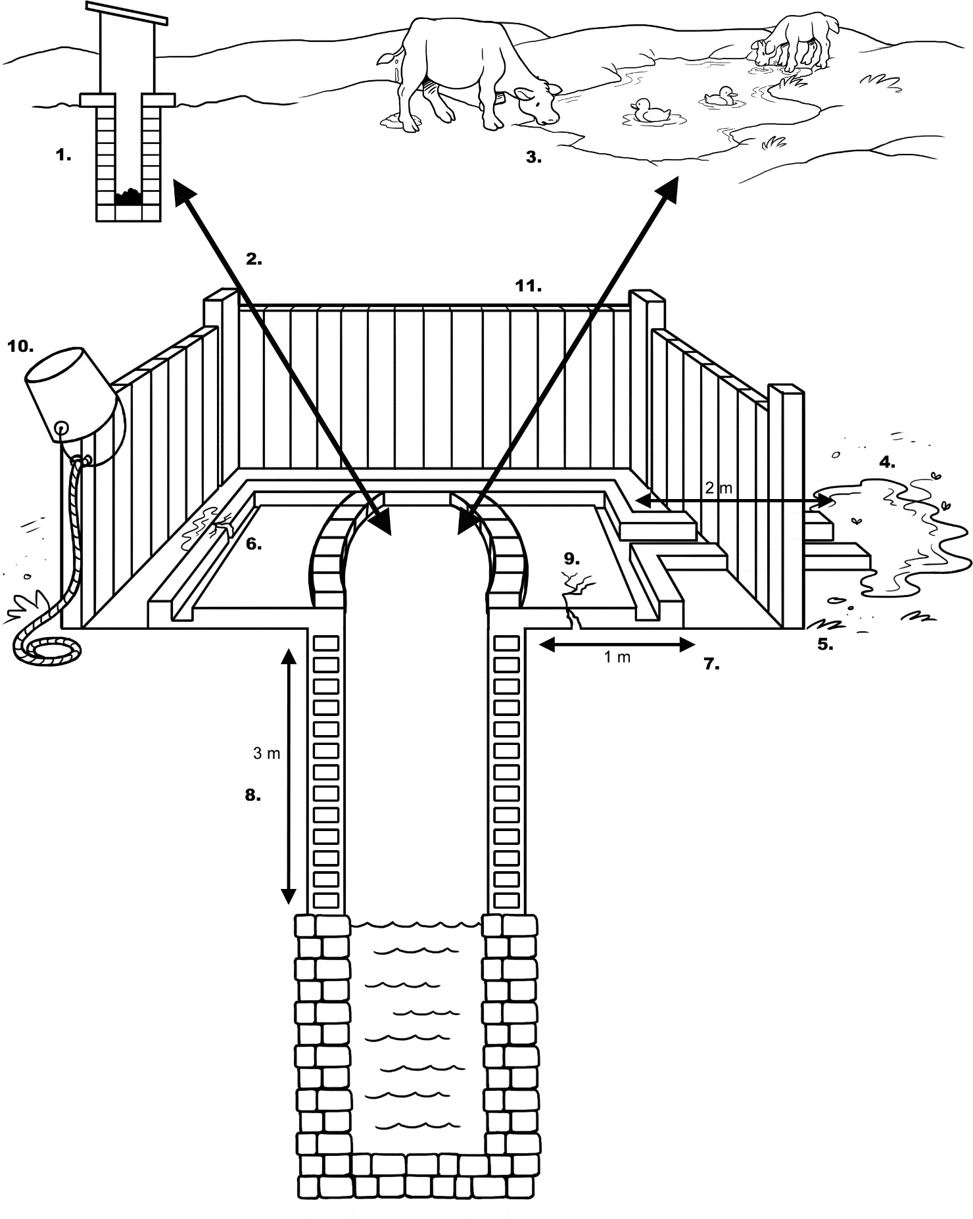

###### Part 1. General information:

* 1. Spring location: .....................................................................................................
  2. Village/Town: .........................................................................................................
  3. People served: ......................................................................................................
  4. Water sample taken? ……………………. Sample ID …………………………….
  5. Date of visit: ........................................................................................................

**Part 2. Risk assessment:** Circle the most appropriate answer. A ‘Yes’ answer means that there is a potential risk and a ‘No’ answer that there is no or very low risk. See explanation on reverse.

###### Observation

|  |  |
| --- | --- |
| 1. Is the collection or spring box absent or faulty? | Y/N |
| 2. Is the masonry or backfill area protecting the spring faulty or eroded? | Y/N |
| 3. If there is a spring box, is there an unsanitary inspection cover? | Y/N |
| 4. Does the spring box contain contaminating silt or animals? | Y/N |
| 5. Is there an air vent in the masonry and is it unsanitary? | Y/N |
| 6. Is there an overflow pipe, is it unsanitary? | Y/N |
| 7. Is the fence around the spring inadequate? | Y/N |
| 8. Can animals have access to within 10 m of the spring? | Y/N |
| 9. Is the diversion ditch above the spring absent or not working properly? | Y/N |
| 10. Are there any other sources of contamination uphill of the spring (e.g., latrines, waste)? | Y/N |
| Risk of contamination (add the number of 'Yes' answers): | ……/10 |

**Part 3. Results and comments:**

1. Risk of contamination (check appropriate box):

|  |  |  |  |
| --- | --- | --- | --- |
| 9-10 = Very high | 6-8 = High | 3-5 = Medium | 0-2 = Low |
|  |  |  |  |

1. The following risks were observed:

###### Part 4. Name and signature of inspectors:

1. *Is the collection or spring box absent or faulty?* The box helps to protect the water from contamination by surface water run-off. There is a risk to water quality if the box is absent or faulty.
2. *Is the masonry or backfill area protecting the spring faulty or eroded?* The masonry diverts surface water run off away from the spring box, protecting the water source from contamination. The backfill area protects the masonry, as well as helping to divert run off.
3. *If there is a spring box, is there an unsanitary inspection cover?* If the inspection cover (if present) is dirty, then the water source can become contaminated.
4. *Does the spring box contain contaminating silt or animals?* Silt accumulation or animals that have access to the spring box can be a source of water contamination.
5. *Is there an air vent in the masonry and is it unsanitary?* A dirty air vent can be another source of water contamination.
6. *Is there an overflow pipe, is it unsanitary*? If water does not drain away from the area, then water (possibly contaminated) could backflow into the water source or the soil can erode away and cause damage to the spring box.
7. *Is the fence around the spring inadequate?* If there is no fence or the fence is damaged, then animals can access the spring and may damage the structure as well as contaminate the area with feces. You will need to check the fencing at the site as well as check whether animals are routinely in the area (sometimes animals are kept in the fenced area for security).
8. *Can animals have access within 10 m of the spring?* Animals may damage the spring box as well as contaminate the area with feces. You will need to check the protection of the site and whether animals are routinely in the area.
9. *Is the diversion ditch above the spring absent or not working properly?* The diversion ditch protects the water source from possibly contaminated surface water run-off by directing it away from and downhill of the box. If the ditch is filled with waste or is poorly contoured, then run-off could collect and enter the source posing a risk to water quality.
10. *Are there any other sources of contamination uphill of the spring (e.g., latrines, waste)?* Contamination on higher ground poses a risk, especially in the wet season, as feces (and other contaminants) may flow into the water source. The risk is increased if no surface water diversion is present. Groundwater may also flow towards the spring box from the direction of a latrine.

Sanitary Inspection Form adapted from:

World Health Organization (2012). Rapid Assessment of Drinking-Water Quality: A Handbook for Implementation. WHO, Geneva, Switzerland. Available at: [www.who.int/water_sanitation_health/publications/2012/rapid_assessment/en/index.html](http://www.who.int/water_sanitation_health/publications/2012/rapid_assessment/en/index.html)

World Health Organization (2005). Water Safety Plans: Managing Drinking-Water Quality from Catchment to Consumer. WHO, Geneva Switzerland. Available at: [www.who.int/water_sanitation_health/dwq/wsp0506/en/index.html](http://www.who.int/water_sanitation_health/dwq/wsp0506/en/index.html)

World Health Organization (1997). Guidelines for Drinking Water Quality, Second Edition, Volume 3, Surveillance and Control of Community Supplies. WHO, Geneva, Switzerland. Available at: www.who.int/water_sanitation_health/dwq/gdwq2v1/en/index2.html

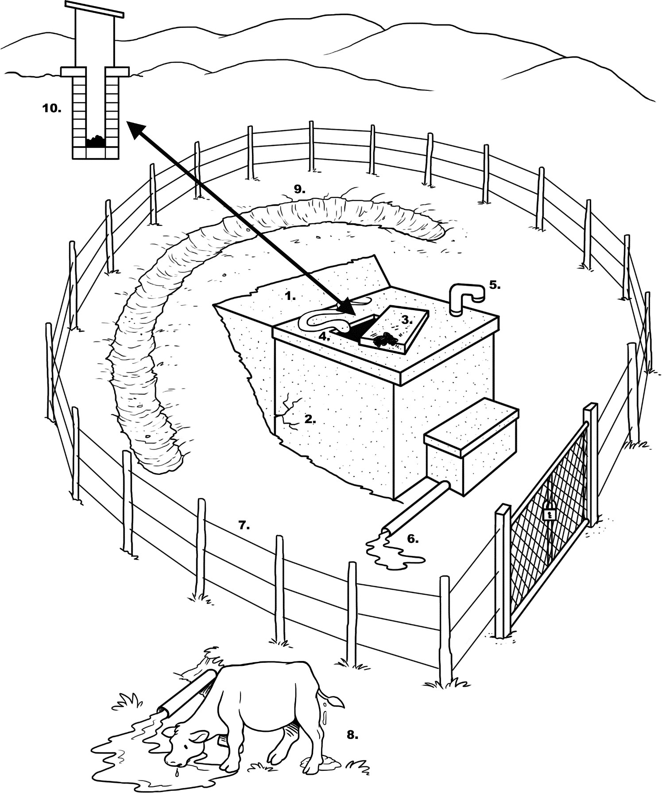

###### Part 1. General information:

* 1. Tank location: .....................................................................................................
  2. Village/Town: .........................................................................................................
  3. People served: ......................................................................................................
  4. Water sample taken? ……………………. Sample ID …………………………….
  5. Date of visit: ........................................................................................................

**Part 2. Risk assessment:** Circle the most appropriate answer. A ‘Yes’ answer means that there is a potential risk and a ‘No’ answer that there is no or very low risk. See explanation on reverse.

###### Observation

|  |  |
| --- | --- |
| 1. Are there visible signs of contamination on the roof (e.g., feces, dirt, leaves)? | Y/N |
| 2. Is the gutter system that collects rainwater dirty or blocked? | Y/N |
| 3. Are there any problems with the filter box or first flush system at the tank inlet? | Y/N |
| 4. Is there any other point of entry to the tank that is not properly covered? | Y/N |
| 5. Is the top or wall of the tank cracked or damaged? | Y/N |
| 6. Is the tap leaking or broken? | Y/N |
| 7. Is the concrete floor under the tap missing, broken or dirty? | Y/N |
| 8. Is the water collection area inadequately drained? | Y/N |
| 9. Is there any source of contamination around the tank or water collection area? | Y/N |
| 10. Is a bucket in use and left in a place where it may become contaminated? | Y/N |
| Risk of contamination (add the number of 'Yes' answers: | ……/10 |

**Part 3. Results and comments:**

1. Risk of contamination (check appropriate box):

|  |  |  |  |
| --- | --- | --- | --- |
| 9-10 = Very high | 6-8 = High | 3-5 = Medium | 0-2 = Low |
|  |  |  |  |

1. The following risks were observed:

###### Part 4. Name and signature of inspectors:

1. *Are there visible signs of contamination on the roof (e.g. feces, dirt, leaves)?* Water quality is at risk if the roof is dirty or contaminated.
2. *Is the gutter system that collects rainwater dirty or blocked?* Dirty gutters can contaminate the rainwater or introduce dirt into the tank in the same way the roof can.
3. *Are there any problems with the filter box or first flush system at the tank inlet?* Rainwater harvesting tanks should have a way to divert the first water collected during a rainstorm.

The first flow (especially at the end of the dry season) may contain vegetation, dirt, and animal feces washed from the roof, which are a risk to water quality.

1. *Is there any other point of entry to the tank that is not properly covered?* Open rainwater collection tanks collect dust and dirt from the air, which is a possible risk to water quality. They can also be mosquito breeding sites, and the mosquitoes may spread dengue fever and malaria, which is a health risk (though not a water quality risk).
2. *Is the top or wall of the tank cracked or damaged?* Deep cracks can allow contaminants to reach the rainwater stored in the tank.
3. *Is the tap leaking or broken?* A broken tap can become a pathway for contaminants. You will need to check that any water around the tap is from a leak rather than from being spilled.
4. *Is the concrete floor under the tap missing, broken or dirty?* Missing or broken drainage under the tap can lead to pools of water collecting which pose a risk.
5. *Is the water collection area inadequately drained?* If water does not drain away from the collection area, then water (possibly contaminated) could backflow into the water source or the soil can erode away and cause damage to the tank.
6. *Is there any source of contamination around the tank or water collection area?* Feces, garbage and other waste are a risk to the water quality.
7. *Is a bucket in use and left in a place where it may become contaminated?* Buckets, cups or other devices used to collect water need to be properly stored and kept clean so that safe drinking water does become contaminated.

Sanitary Inspection Form adapted from:

World Health Organization (2012). Rapid Assessment of Drinking-Water Quality: A Handbook for Implementation. WHO, Geneva, Switzerland. Available at: [www.who.int/water_sanitation_health/publications/2012/rapid_assessment/en/index.html](http://www.who.int/water_sanitation_health/publications/2012/rapid_assessment/en/index.html)

World Health Organization (2005). Water Safety Plans: Managing Drinking-Water Quality from Catchment to Consumer. WHO, Geneva Switzerland. Available at: [www.who.int/water_sanitation_health/dwq/wsp0506/en/index.html](http://www.who.int/water_sanitation_health/dwq/wsp0506/en/index.html)

World Health Organization (1997). Guidelines for Drinking Water Quality, Second Edition, Volume 3, Surveillance and Control of Community Supplies. WHO, Geneva, Switzerland. Available at: www.who.int/water_sanitation_health/dwq/gdwq2v1/en/index2.html

