Solvatten
Source Protection | Safe Transportation | Sedimentation | Filtration | Disinfection | Safe Storage

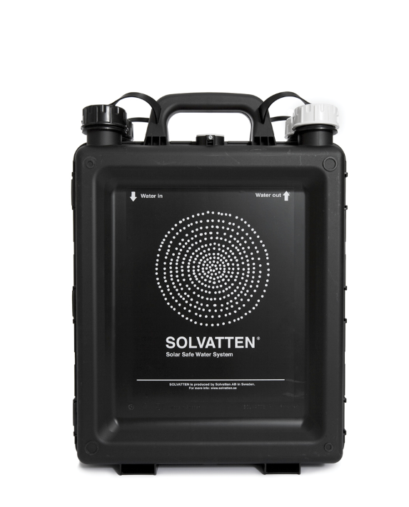
What is it?
Solvatten is a portable water treatment device that doubles as a solar water heater. Users open Solvatten like a book, pour water into the inner containers, and expose it to sunlight. Fabric filters (35 micron pore size) in the container openings remove larger particles. Heat and ultraviolet radiation from the sun inactivate and kill pathogens.

Performance

Microbiological Effectiveness:
Parameter | Effectiveness
Bacteria | Very Effective (>99%)
Viruses | Very Effective (>99%)
Protozoa | Very Effective (>99%)
Helminths | Very Effective*
*Assumption based on pathogen size

Other Parameters
Not effective for turbidity, chemicals, or colour.

Source Water Requirements
Turbid water should be filtered or settled before using Solvatten.

Capacity
Treats 10 L at a time. Treatment takes two to six hours, depending on weather conditions.

Lifespan
According to the manufacturer, Solvatten lasts 7 years on average. Actual lifespan will vary depending on use, care, and source water quality.

Ease of Use & Acceptability

Operation & Maintenance
The user opens Solvatten like a book and fills both containers with water. They push the “sun” button to reset the indicator, then place Solvatten in direct sunlight until the face on the indicator turns from red/sad to green/happy. Typically treatment takes two to six hours. The inside of Solvatten should be cleaned occasionally by adding a handful of dry beans, rice, or woolen balls to the unit along with water, then shaking and rinsing.

Repair & Replacement
Made of durable plastic, Solvatten does not require batteries, chemicals, or other consumables. The fabric prefilters can be replaced with locally-sourced cloth if needed. The whole unit must be replaced if it breaks.

User Considerations & Preferences
Solvatten works best in areas where there is lots of sunshine. It can be used for short-term storage of treated water. Solvatten doubles as a solar water heater, warming water to up to 75°C. It does not reduce turbidity.

Feasibility

Availability
Must be purchased from Solvatten AB; can be purchased online.

Cost
US$46–93, depending on unit type and size.

Size & Weight
The 10 L unit is 36 x 47 x 13 cm and weighs approximately 2.7 kg (empty).

More Information
Details and references: www.hwts.info/products-technologies/6201ce2b/solvatten

