Lesson Plan 3: Safe Water and PoU options **90 minutes Lesson Description**



The focus of this lesson is to differentiate between clean water and safe water. Also, this lesson focuses on the point of use that is effective at school level including the demonstration of use of chlorine.

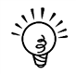**Learning outcomes**



At the end of the session, participants will be able to:

1. Differentiate between clean water and safe water.
2. Identify different types of water treatment option at school level.
3. Demonstrate the use of chlorine.

**Materials**



* Newsprint paper
* Marker
* Masking tape
* 3 glasses
* Water
* PoU flex

**Preparation**



* Write the learning outcomes on flip chart paper
* Prepare safe, filthy(hand washed) and tap water
* Prepare the hand out of NDWQS guidelines

**Introduction 10 minutes**



1. Present two statements written on brown sheet paper to the participants.
   1. All clean water is safe water
   2. All safe water is clean water
2. Now, ask participants if there is any difference between these two lines.
3. Collect answers from the participants and if there is any contrasting answer from participants ask for the reason behind contrasting answer.
4. If all participants have same idea, inform them that two statements are completely different and only one of them is true, that is, ‘All safe water is clean water’
5. Inform participants that they will be exploring more on the idea in the session and present the learning outcome of the session.

**OR,**

1. Present three glass of water in front of participants.
   1. Glass A: Safe water to drink
   2. Glass B: Filthy water- hand washed water (*Dhamilo pani- haat dhoyeko pani)*
   3. Glass C: Plain tap water
2. Ask participants which glass of water might be safe to drink.
3. Collect the vote of participants for each glass. *Possible answer: glass A and C, as the water is clean.*
4. Inform participants that if the facilitator is made to drink water from those, one will drink from glass A and not from other glass and also drink a sip from glass A. Ask participants what might be the reason for drinking water from glass A only and not from other glasses?
5. Further clear to the participants that glass A water is disinfected and is safe water while glass C is a plain tap water and is not disinfected and it might contain a spoon of filthy water in the glass. Demonstrate the activity while explaining by adding a spoonful of water from glass B to glass C and mixing it, making it unsafe to drink yet it is clean while observing it.
6. Explain further, this might be the similar case in their drinking water; it might be contaminated in the source of water, or in transmission line or in their own household.
7. Present the learning outcome of the session.

**Safe water 15 minutes**



1. 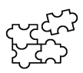Ask participants if clean water is safe water? *Possible answer: No*
2. Ask participants what is safe water. Give a minute to think and ask few participants to volunteer their view.
3. Inform participants that clean water means the water is physically clean, but it might not be same with chemical and microbiological contaminants.
4. Explain further, safe water means the water is physically, chemically and microbiologically safe to use (or no physical, chemical and microbiological contamination).
5. Also inform that Government of Nepal has a guideline for the drinking water, NDWQS with 6-physical parameters, 19- chemical parameters and 2 microbial parameters.
6. Explain further with few common examples of each parameter.
   1. Physical parameter: turbidity, color, taste and odor, total dissolved solids
   2. Chemical parameters: Iron, Manganese, Chloride, Arsenic, Ammonia, Nitrate
   3. Biological parameters: Total coliform or presence of any bacterial contamination
7. For the sole purpose of keeping water clean, people should be aware from protecting water source to minimize the contamination in water. To this, water should be disinfected before drinking and it should be stored safely for further use.

**Water Treatment Options at school level 50 minutes**



1. Tell the participants that the ultimate safeguard to make water safe for consumption is the use of treatment methods at the point of use, that is, just before drinking.
2. Ask the participants what ways they know of, to make drinking water safe. Make a list of their responses. Add to their responses if they miss a method. The list should include:
   * Boiling
   * Chlorination
   * Solar disinfection (SODIS)
   * Filtration
3. Ask in a large group “What treatment method seems most appropriate for schools? Give a minute to think and again ask participants “why” they think it is appropriate method to treat water.
4. Inform participants that while discussing about ‘Point of Use’ in schools, boiling and SODIS might not be appropriate or feasible as in the school, huge amount of water should be treated and the options are feasible for small amount of water only.
5. Ask to participants if they know of any schools currently treating their water? What has their experience been?
6. Relating to the experience shared by the participants, introduce the appropriate methods of water disinfection for school starting from filtration method.
7. Description: C:\Users\user\Desktop\Capture5.PNGIn the filtration method, explain the working mechanism of filter that is the core part of filter is filter media with very small pores which bar the movement of pathogens while only water can pass through the small pores.
8. Further, explain that there are various types of filter available in the market. Ex. simple candle filter, Colloidal Silver filter (CS filter), Bio sand filter and other types of modern types of filters.
9. Present the picture of candle filter (from the flex of PoU options) and ask participants if they have seen it or used it. If participants say yes, ask the participant to volunteer his/her idea on the filter (whatever they know).
10. Add or correct information if needed. Else, summarize the information on the type of filter and move to next type of filter- CS filter.
11. Repeat the process of presenting the pictures of other types of filter, ask if participants know it, sharing information from the participants and add on information or summarize it.

**Or,**

* Divide participants into 3 groups and ask each group to discuss on a type of filter; Candle filter, CS filter and Bio-sand filter.
* Provide 2 to 3 minutes time for the discussion and ask a volunteer from each group to share their discussion and summarize and add information as a group present their thoughts and continue same process for each group.

1. After description of filters, other method to disinfect huge amount of water is ‘chlorination’. Further explain that chlorination is the process of disinfecting water with the use of chemical ‘chlorine’. However, while using chlorine to disinfect water, one should be aware of the proper dosing of chlorine.
2. Description: C:\Users\user\Desktop\Capture5.PNGExample of chlorine that are easily available in the market are Piyush and Piyush Plus with 0.5% and 0.7% chlorine respectively. Further, explain the dozing of common chlorine available in the market.
3. Explain that Chlorination is a good process for schools having lager number of student because school having maximum students requires large volume of water.
4. Demonstrate the process of chlorination / Piyush by taking a liter of clean water in a bottle. Add 3 drops of Piyush (0.5% chlorine) to the water and mix it. Leave the bottle for 30 minutes and after the time, water is disinfected and can be consumed.

**Safe Storage of Water 10 minutes**



1. Ask the participants: “After using PoU options, in which things they should focus on to keep it safe?”
2. Ask voluntarily with 1-2 participants for their suggestions.

Reponses may include: Store it safely to avoid re-contamination as most of the treated water is re-contaminated during the storage of treated water.

1. Ask participants: “What are the features of good and bad storage containers in school?” Responses should include:

Good: Tightly fitting lid or cover, Tap or narrow opening to prevent contamination or avoid dipping hand into the water, out of reach of children to play, easy to clean, etc.

Bad: No lid or cover, wide opening that is easy to contaminate, easy to climb and play by students, not easily accessible to kids to mess around, etc.



**Review 5 minutes**

1. Ask participants to think about the suitable option of PoU in context of their school.
2. Ask a participant to volunteer his/ her thought.
3. Ask other one or two volunteer to add on the thought and/ or discuss on the point.



**Reflection on Lesson**

**Trainer Reference: Safe water and PoU options**

**Filtration:** Various types of filter are available in market, filters only physical particulates and few pathogens while some are effective for microorganisms also, easy to handle, easily accessible in market



1. **Candle filter:** Easy to use, easily accessible in market, filter candle should be cleaned in certain time interval, candle should be cleaned with soft brush and soap should not be used while cleaning and candle should not be boiled, effective for physical and few microorganisms.
2. 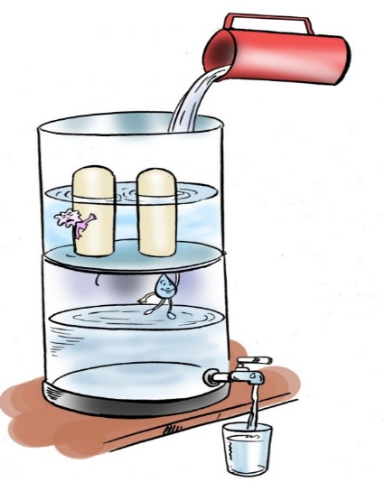**Colloidal silver (CS) filter:** effective method to treat water (effective for physical and microbial contamination), main component of the filter is the silver coating/ powder used while making candle or plate which kills pathogens present in water, without any chemical process water is disinfected, filter candle/ plate should be cleaned in certain time interval, candle/ plate should be cleaned with soft brush and soap should not be used while cleaning and candle/ plate should not be boiled.

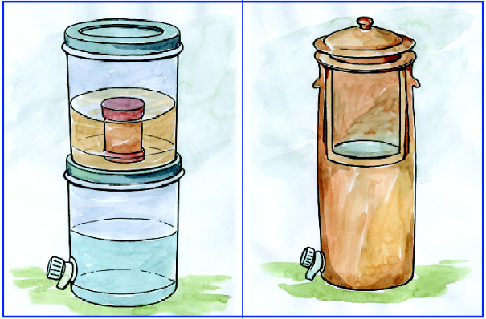

**Colloidal Silver Filter**

1. 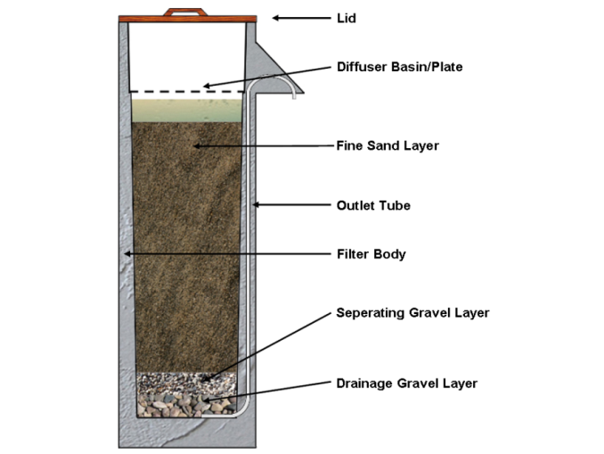**Biosand filter:** A **biosand filter** (BSF) is a point-of-use water treatment system adapted from traditional [slow sand filters](https://en.wikipedia.org/wiki/Slow_sand_filter). Biosand filters remove pathogens and suspended solids from water using biological and physical processes that take place in a sand column covered with a [biofilm](https://en.wikipedia.org/wiki/Biofilm). BSFs have been shown to remove heavy metals, turbidity, bacteria, viruses and protozoa. BSFs also reduce discoloration, odor and unpleasant taste. Bio sand filter is effective for physical, microbial and some chemical components can be made locally by a trained person, sufficient amount of water is filtered.

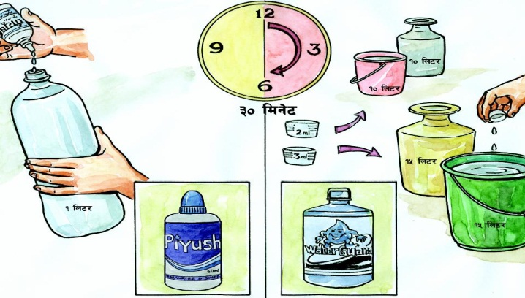**Chlorination:** Treat water with chlorine, kills pathogen and somehow treats chemical compounds like iron, manganese, hydrogen sulfide, ex. Piyush and Piyush plus manufactured by ENPHO, chlorine dosing should not be used in guess- if chlorine dose is not enough does not treat water effectively, if chlorine dose is high- might have negative effect in health, should wait 30 minutes after dosing chlorine, chlorine should be stored in out of reach of children and should not be stored in direct sunlight.

**Mass chlorination (1% chlorine solution)**: Measure 40gm (approx.. 5 tea spoon) of bleaching powder on few ml of water on mug, take water from 1litre of water. Stir the solution to make the paste, add remaining water on that mug. Stir properly and leave the solution to settle down (time varies). Pour the clear solution in colorful jerry can that is not transparent. Label the jerry can properly. Amount to be used: 100 ml of 1% chlorine solution can treat 1000 litre of water. Points to be noted: close the cap properly, place at cool, dry and dark place, far from reach of children, contact time of this 1% solution is also 30 minutes.

|  |  |  |
| --- | --- | --- |
| Concentration of Chlorine | Amount of Chlorine | Amount of water treated |
| 0.7% of chlorine solution (Piyush plus) | 1 ml | 5 liters |
| 1% of chlorine solution | 1 ml | 10 liters |
| 5% of chlorine solution | 40 ml | 1000 liters |
| 0.5% of chlorine (Piyush) | 3 drops | 1 liter |
| Aquatabs (20 mg available chlorine) | 1 tablet | 4/5 liters |

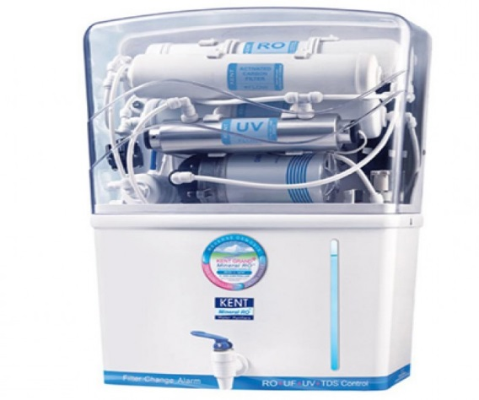**Modern technology:** Some modern types of filters are available in market with UV rays and reverse osmosis (RO) processes which are effective to kill pathogens and also treat physical and chemical contamination. Example of filters available in market- Euro guard, Aqua guard, Sawyer, Straw filter, Sky juice

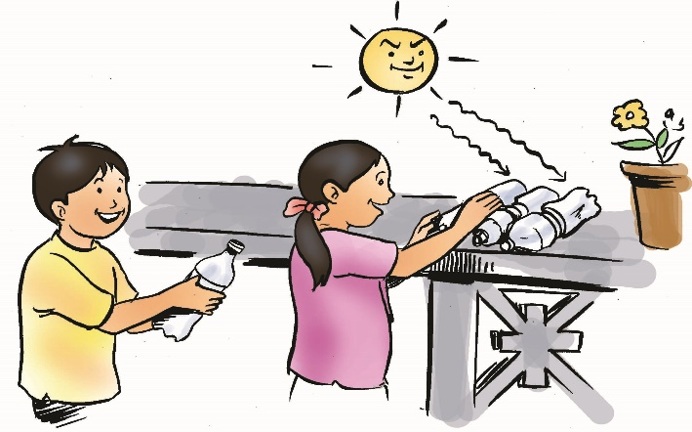**SODIS (solar disinfection):** SODIS is a simple, cost effective method to treat water against microbial contamination through the UV rays and heat of the sunlight. SODIS is ideal to disinfect small quantities of water of low turbidity. Contaminated water is filled into transparent plastic bottles and exposed to full sunlight for six to eight hours. During the exposure to the sun, pathogens are destroyed. In case of cloudiness plastic bottles with water need to be exposed for 2 consecutive days in order to produce water safe for consumption.