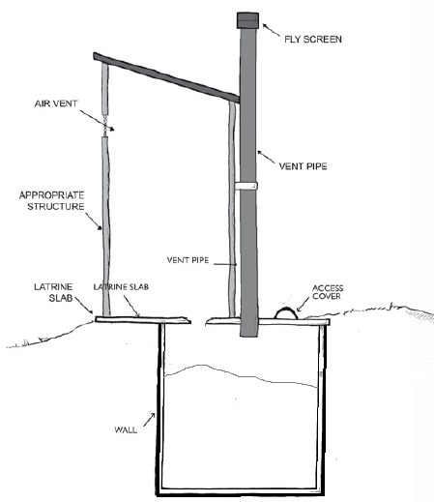

(Credit: Adapted from Lifewater, 2010)

**Sanitation System**

User Interface

**Excreta**

**Storage**

Emptying and Transport

Treatment

Use or Disposal

**General Information**

A permanent holding tank (also called cesspit, sealed pit, tank or chamber) can be used to store excreta. It is a watertight tank that is usually built belowground. Because there is no infiltration of liquid into the soil, a holding tank must be emptied more frequently than a septic tank or pit. It should be emptied by a trained service team. There must be safe treatment, use or disposal so that sludge is not dumped unsafely in the environment. Due to the cost of frequent emptying, holding tanks may not be suitable for family or communal latrines. They are only appropriate when there are no other feasible sanitation options, such as in certain challenging environments.

**User Interface**

* Usually connected to a water-flushed toilet
* Can be used by washers and wipers for anal cleansing, wipers should use degradable wiping materials
* A water seal controls smells and flies

**Operation & Maintenance**

* Empty as required (sometimes as often as weekly), usually by vacuum truck; frequency depends on size and number of users
* Check tank regularly to make sure it is working correctly and watertight

**Design Components**

* Watertight (also called impermeable) tank with inlet pipe and access cover, there is no outlet pipe, may have vent pipe

**Design Options**

* Numerous tank designs, depends on what is locally available
* Can buy prefabricated tanks or build a tank using local materials (such as concrete, cement blocks, bricks, concrete rings)
* Can design in a variety of shapes and sizes
* Urine may be collected separately if a urine diversion toilet or urinal is used

**Siting**

* Can be built aboveground or belowground
* Vacuum truck or emptying service must be able to access the tank
* May be suited for areas with high groundwater, with frequent flooding, where it is difficult to dig, or environmentally sensitive

**Implementation**

* Need frequent, affordable, reliable emptying service
* A safe sanitation system including sludge treatment and safe use or disposal is essential if this option is to have minimal negative impacts on public health and the environment
* Holding tanks are sometimes confused with septic tanks, education is needed so that users understand the difference between the technologies

**References**

Harvey, P. (2007). Excreta Disposal in Emergencies: A Field Manual. Water, Engineering and Development Centre, Loughborough University, UK. Retrieved from: <http://wedc.ac.uk/publications/>

**Additional Resources**

CAWST offers free and open content education and training resources on sanitation systems, latrine technologies, latrine construction and siting, and latrine project implementation. Available at: www.cawst.org/resources