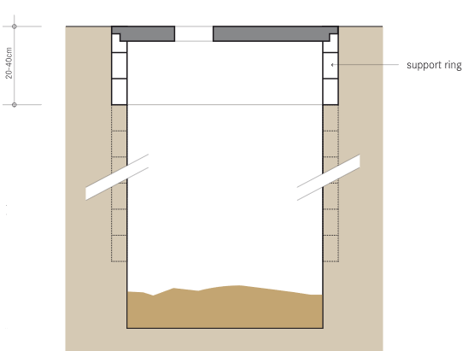

(Credit: Tilley et al., 2014)

**Sanitation System**

User Interface

**Excreta**

**Storage**

Emptying and Transport

Treatment

Use or Disposal

**General Information**

The pit latrine is one of the most common, low cost sanitation options and used widely around the world. It is a pit dug into the ground, covered with a slab, and usually has some sort of structure (also called a superstructure) around it for privacy and weather protection. Fully or partially lining the pit prevents it from collapsing and provides support for the slab and superstructure. As the pit fills with excreta, liquid infiltrates through the pit wall into the surrounding soil. Microbes help to degrade and reduce the amount of excreta. However, sludge does build up over time and the pit must be periodically emptied or relocated.

**User Interface**

* Can be used with various types of toilets (including dry, pour flush and urine diverting)
* Can be used by washers and wipers for anal cleansing
* Using a lid or water seal can help control smells and flies

**Operation & Maintenance**

* No daily maintenance needed other than keeping the latrine clean
* A full pit can be a) emptied and reused or b) filled and covered, and the slab and superstructure moved to a new pit

**Design Components**

* Pit that is partially or fully lined (but still permeable)
* Slab
* Superstructure

**Design Options**

* Can dig a square, rectangular or circular pit
* If the pit is to be emptied, then it should be fully lined to ensure its stability and safety
* Can build two shallower pits (also called twin or double pits) and alternate their use – the excreta in the full pit degrades over time, making manual emptying easier and safer
* Twin pits connected to a pour flush toilet can also be dug at a distance away from the superstructure (called offset pits)
* Can build a raised pit in areas with high groundwater or frequent flooding

**Siting**

* Need permeable soil and enough space to infiltrate the liquid from the pit
* Not suited for soils that are difficult to dig
* Not suited for areas with high groundwater or frequent flooding

**Implementation**

* If the pit is to be reused, then sludge emptying, treatment, use and/or disposal services are needed

**References**

Tilley, E., Ulrich, L., Lüthi, C., Reymond, P. and C. Zurbrügg (2014). Compendium of Sanitation Systems and Technologies, 2nd Revised Edition. Swiss Federal Institute of Aquatic Science and Technology (Eawag), Duebendorf, Switzerland. Retrieved from: www.sandec.ch/compendium

Reed, B. (2014). Simple Pit Latrines. WEDC, Loughborough University, UK. Retrieved from: <https://wedc-knowledge.lboro.ac.uk/details.html?id=21751>

**Additional Resources**

CAWST offers free and open content education and training resources on sanitation systems, latrine technologies, latrine construction and siting, and latrine project implementation. Available at: www.cawst.org/resources