Overview of Activities

65–75 minutes total

Lesson Plan

Global Agenda for Safe Drinking Water

1. **Scenario:** Introduction
2. **Small Group Discussion**: MDGs, SDGs, Human Right to Water
3. **Mapping Activity**: HWTS and the SDGs
4. **Presentation**: Local Standards and Regulations (Optional)
5. **Role-Play**: Review

Learning Outcomes

At the end of this session, the participants will be able to:

1. Explain how safe drinking water is defined and measured under the MDGs and SDGs
2. Describe how HWTS contributes to the SDGs
3. Describe local government standards or regulations relevant to HWTS (Optional)

Recommended Reading

Technical Brief: Safe Drinking Water and the Global Development Agenda

Technical Brief: Introduction to Household Water Treatment and Safe Storage (HWTS)

Materials

PowerPoint: Global Agenda for Safe Drinking Water (optional; edit the section on local policies and standards in advance)

Handout: Global Agenda for Safe Drinking Water (2 pages; 1 copy per participant)

Handout: Sustainable Development Goals (1 page; 2 copies per group)

Flip chart paper

Markers

15 minutes

Introduction: Scenario

Optional: Use “PowerPoint: Global Agenda for Safe Drinking Water” for this introduction.

1. Explain: “Now that we’ve discussed why safe drinking water is so important, this next session will explore how the world is doing at addressing this need.”

Trainer Tip

Give examples or ask probing questions to help participants think of targets and indicators. For example:

* Would you identify the types of water sources people are using?
* Would you test the quality of water in people’s homes?
* Would you check how close people are to a safe water source?
* What is most important and why?

1. Divide the participants into groups of 3–4 people. Give each group a large piece of paper.
2. Ask the participants to imagine that they have huge global influence and they are responsible for setting goals and targets for safe drinking water. Ask them to discuss in their groups what targets and indicators they would use to track progress
3. Give the groups about 5 minutes to discuss and record their ideas.
4. Ask some groups to share their ideas with the large group. Summarize common themes.
5. Present the “Learning Outcomes” slide or provide an overview of the lesson.

25 minutes

Small Group Discussion: MDGs, SDGs, Human Right to Water

Optional: Use “PowerPoint: Global Agenda for Safe Drinking Water” for this activity.

1. Explain: “As we just realized in our scenario, ensuring safe drinking water for everyone is a complex problem. We will now discuss how the global community has approached this problem.”
2. Ask the participants to stay in their small groups. Give each participant a copy of “**Handout: Global Agenda for Safe Drinking Water**.”
3. Give each group a piece of flipchart paper and a set of markers.
4. Explain that the handout is divided into 3 sections (MDGs, Human Right to Water, SDGs). After introducing a section of the handout, ask for a participant from the large group to explain what that topic means. Share a few key facts about each topic.
5. Ask the participants to review the handout in their groups and discuss the following question: “How have language, targets, and indicators for safe drinking water changed over time?” Have the groups record their ideas on flip chart paper, along with any questions or points of confusion.
6. Ask each group to share some of its reflections with the full group. Answer any questions and summarize key points.
7. Ask participants to list 1 or 2 key points in their **workbooks** under “Global Agenda for Safe Drinking Water” for each topic: MDGs, Human Right to Water, and SDGs.

Key Points

* The MDGs measured access to improved water sources. People assumed that improved water sources were safe, but this was not always true. The goal of “halving the gap” led to a focus on those easiest to reach (not always the most vulnerable).
* Recognition of the human right to water changed how safe drinking water was viewed. Global responsibility has increased for making water accessible to all.
* The SDGs include both water quality and water availability. As well, the language of “equitable” and “universal” means the global community must focus on the most vulnerable and difficult to reach.

20 minutes

Mapping Activity: HWTS and the SDGs

Optional: Use “PowerPoint: Global Agenda for Safe Drinking Water” for this activity.

1. Explain: “Now we understand the SDG target and indictors for safe drinking water, let’s talk about how the SDGs relate to HWTS.”
2. Ask: “Does HWTS contribute to reaching the SDG target for safe drinking water?” Ask for several participants to share what they think. Use the PowerPoint slide of the SDG ladder to show how HWTS can improve water at the different steps. *Trainer Tip: See the Key Points below.*
3. Explain: “The SDGs cover much more than safe drinking water. These goals relate to many different aspects of development.” Give examples.

Trainer Tip

Depending on the group, participants might want to put “safe drinking water” in the centre of their maps instead of “HWTS.”

For the diagram, you may need to show an example: HWTS -> less illness -> more time to work -> no poverty (SDG 1).

1. Give each group flip chart paper, markers, and 2 copies of “**Handout: Sustainable Development Goals**.”
2. Ask each group to draw a circle in the middle of its flip chart paper and label the circle “HWTS”. Ask them to draw a mind map showing how HWTS could contribute to other SDGs.
3. Ask the groups to hang their maps on the wall and then walk around the room to look at the other groups’ maps.
4. Ask the participants to share their reflections or comments about how HWTS contributes to SDGs.
5. Summarize key points.

Key Points

* HWTS can improve water quality issues at every step of the service ladder except for the “safely managed” level (see PowerPoint slide).
* Contamination between source and home is a major concern. HWTS can help with incremental improvements to water quality (but current monitoring of SDG progress does not always account for improvements made by HWTS).
* HWTS can address water quality issues and help reach vulnerable populations. It does not solve issues related to reliability and access.
* HWTS (and safe drinking water) contributes to multiple development goals.

10 minutes

Presentation: Local Standards and Regulations (Optional)

Optional: Use “PowerPoint: Global Agenda for Safe Drinking Water” for this activity. *Trainer Note:* *You must edit the PowerPoint in advance to show local standards and regulations.*

1. Explain: “In addition to global goals and declarations, many countries have local goals, regulations, and standards that apply to water quality.”
2. Ask: “What standards, policies, and regulations are you aware of in this [country/community/province] that relate to drinking water quality?”
3. Use the PowerPoint slides to briefly explain any relevant local policies, regulations, or strategies related to safe drinking water or HWTS.
4. Ask participants to write 1 or 2 key points in their **workbooks** under the topic “My Country’s Policies and Regulations.”

5 minutes

Role-Play: Review

Optional: Use “PowerPoint: Global Agenda for Safe Drinking Water” for this activity.

1. Ask the participants to form pairs to pretend they are an HWTS implementer who must describe their HWTS project to a UN or government official. Ask them to practice explaining how HWTS contributes to the SDGs and to local goals and policies.
2. Summarize and clarify key points as needed.

|  |  |
| --- | --- |
| This resource is open content and licensed under a [Creative Commons Attribution-ShareAlike 4.0 International License](https://creativecommons.org/licenses/by-sa/4.0/). Refer to CAWST’s guidelines for distributing, translating, adapting, or referencing CAWST resources ([resources.cawst.org/cc](https://resources.cawst.org/cc)). |  |

Global Agenda for Safe Drinking Water Handout

# Millennium Development Goals (MDGs) (2000 – 2015)

Target for drinking water: “To halve, by 2015, the proportion of people without sustainable access to safe drinking water and basic sanitation” (compared to 1990 baseline).

Table 1: Service levels for household access to drinking water under the MDGs

|  |  |
| --- | --- |
| Service Level  (highest to lowest) | Definition |
| Improved: Piped on Premises | Drinking water from a piped household water connection located inside the user’s dwelling, plot, or yard. |
| Improved: Other Improved Sources | Drinking water from an improved source (piped water, borehole or tubewell, protected dug well, protected spring or rainwater). |
| Unimproved | Drinking water from an unprotected well or unprotected spring, surface water, or bottled water. |

(World Health Organization & UNICEF, n.d.)

# Sustainable Development Goals (SDGs) (2015+)

Target 6.1: By 2030, achieve universal and equitable access to safe and affordable drinking water for all.

Table 2: Service levels for household access to drinking water under the SDGs

|  |  |
| --- | --- |
| Service Level  (highest to lowest) | Definition (households) |
| Safely Managed | Drinking water from an improved (basic) drinking water source that is:   * located on premises, * available when needed, and * free of fecal and priority chemical contamination. |
| Basic | Drinking water from an improved source (piped water, borehole or tubewell, protected dug well, protected spring, or rainwater). Collection time must be no more than 30 minutes for a round trip, including time spent waiting in line. |
| Limited | Drinking water from an improved source with a total collection time of more than 30 minutes for a roundtrip including time spent waiting in line. |
| Unimproved | Drinking water from an unprotected well or unprotected spring. |
| Surface Water | Drinking water collected directly from rivers, dams, lakes, ponds, streams, canals or irrigation channels. |

(World Health Organization, 2017)

Table 3: Service levels for school and health centre access to drinking water under the SDGs

|  |  |  |
| --- | --- | --- |
| Service Level  (highest to lowest) | Definition (Schools) | Definition (Health Centres) |
| Advanced | To be defined at national level | To be defined at national level |
| Basic | Drinking water from an improved source is available at the school. | Water from an improved source is available on premises. |
| Limited | There is an improved source at the school, but water is not available at time of survey. | Water from an improved source is available off premises, or there is an improved source on site but no water available. |
| No Service | No water source or an unimproved water source at the school. | No water source or an unimproved water source. |

(World Health Organization, 2017)

# Human Right to Water (2010)

“The United Nations General Assembly explicitly recognized the human right to water and sanitation and acknowledged that clean drinking water and sanitation are essential to the realisation of all human rights. The Resolution calls upon States and international organisations to provide financial resources, help capacity-building and technology transfer to help countries, in particular developing countries, to provide **safe, clean, accessible and affordable drinking water and sanitation for all.**” (United Nations Office of the High Commissioner for Human Rights, UN Habitat, & World Health Organization, 2010).

# References

United Nations Office of the High Commissioner for Human Rights, UN Habitat, & World Health Organization. (2010). *The Human Right to Water* (Fact Sheet No. No. 35). Geneva, Switzerland. Retrieved from http://eldis.org/vfile/upload/1/document/1112/righttowaterindicators.pdf

World Health Organization. (2017). *Safely managed drinking water - thematic report on drinking water 2017*. Geneva, Switzerland: World Health Organization. Retrieved from http://apps.who.int/iris/handle/10665/177752

World Health Organization, & UNICEF. (n.d.). The Drinking Water Ladder. Retrieved from http://www.who.int/water_sanitation_health/monitoring/water.pdf

|  |  |
| --- | --- |
| This resource is open content and licensed under a [Creative Commons Attribution-ShareAlike 4.0 International License](https://creativecommons.org/licenses/by-sa/4.0/). Refer to CAWST’s guidelines for distributing, translating, adapting, or referencing CAWST resources ([resources.cawst.org/cc](https://resources.cawst.org/cc)). |  |

Sustainable Development Goals Handout

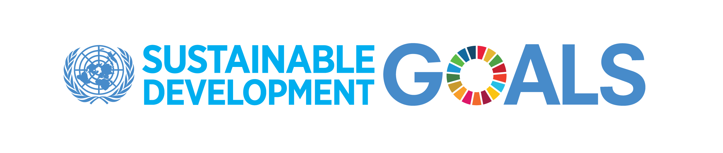

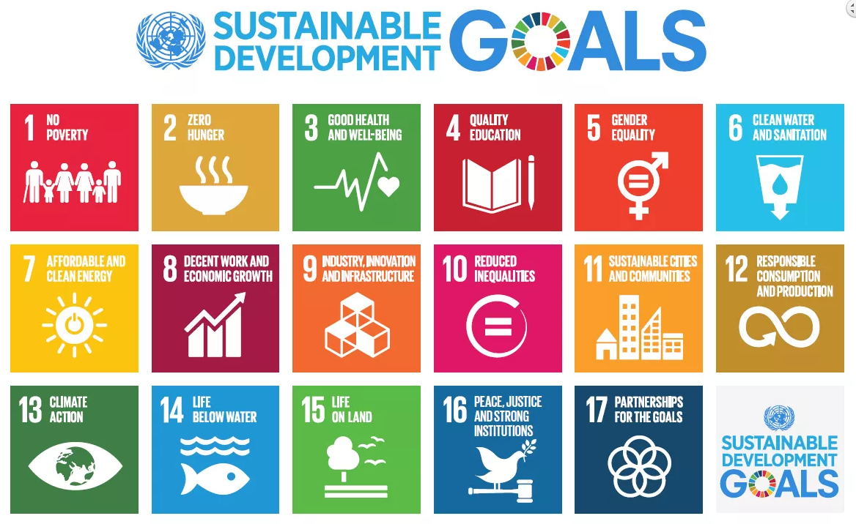

Refer to: <http://www.undp.org/content/undp/en/home/sustainable-development-goals.html>