Lesson Plan: Action Planning
30 minutes total

Lesson Description
In this lesson, participants will create individual action plans. Action plans help participants set goals to become better Community WASH Promoters and constantly improve their effectiveness to create a bigger impact.
Learning Outcomes
At the end of this session participants will be able to:
- Set goals to improve their effectiveness as Community WASH Promoters
Materials
- Flip chart paper
- Markers
- Tape
- Option 1: Action Plan Template
- Option 2: Action Plan Tree trunk and leaves (3 per participant)

Preparation
- Write Action Plan Example Goal (see end of lesson) on flip chart paper
- Option 1: Print Action Plan Template (1 for every participant)
- Option 2: Cut out a tree trunk with branches and stick it on the wall. (see Action Plan Tree at end of lesson plan for reference)
- Option 2: Cut out 3 tree leaves per participant (see end of lesson plan for template)
- Optional: Write the learning outcomes on the flip chart

Introduction 5 minutes
- As a large group, ask participants to imagine they are just finishing working with a household. Ask them: "Why would you want a household to have an action plan?" The purpose of the household visit is to give people new knowledge and skills to use in their lives. By creating an action plan and commitment, households will have a clear idea of how to put their new learning into practice.
- Explain to participants that they will be creating an action plan for themselves on what they would like to improve as Community WASH Promoters.
- Explain to participants that when we talk about behaviour change, we are not only talking about household members, we are also talking about ourselves.
- Present the learning outcomes or lesson description.

Action Planning 20 minutes
- In pairs, ask the participants to discuss: "Why is it important to continue to learn and improve?" Continuous learning is important to ensure that our skills are up to date and that we are passing on accurate information to households. The more we learn and practice the better we become as Community WASH Promoters and the more effective we are at changing people’s behaviours to adopt WASH practices and improve people’s lives.
- In pairs, ask participants to discuss: "What skills would you like to develop to become a better Community WASH Promoter?"
- Explain to participants that they will set 3 goals to work toward the skills they have identified.
- Ask the participants: "Why is 3 a good number of goals?" 3 is a manageable number; more than 3 may overwhelm someone. It is easier to see results when we focus on a limited number of goals.
Option 1: Action Plan Forms
- Explain that goals are broken into 3 parts
    - What you will do
    - Why it is important
    - How you are going to do it

- Post the Action Plan Example Goal on the flip chart.
- Hand out a copy of the Action Plan Template to each participant and ask them to fill it in. Remind participants to be specific about their goals.
- Ask the participants: "How will you use this action plan?" Review it before working with community members and remind yourself of the things you would like to focus on to improve.
- Tell participants when they have accomplished a goal they can create a new one.
Option 2: Action Plan Tree
- Explain to participants that you will be giving them 3 pieces of paper in the shape of a leaf. They will need to write what they plan to do after this workshop with their new knowledge and skills. They will need to write 1 goal on each leaf. Once they have finished, they will stick their leaves on the Action Plan Tree.
- Hand out 3 leaves to each participants and ask them to fill them out.
- Ask a few participants to share their action plan leaves.

Review 2 minutes
- Option 1: Divide the participants into groups of 3 and ask them to share their action plans with each other
- Option 2: Ask all the participants to bring their action plan leaves and stick them on the Action Plan Tree. Ask them to read of the other action plan leaves that have been stuck to the wall.

Reflections on Lesson

I will… practice asking effective questions to household members to better understand why they are not consistently using their filters.

Because… it is important for me to know why so that I can provide the proper recommendation and advice.

My strategy to implement this action is… to practice with other Community WASH Promoters and households, observe how other Community WASH Promoters ask questions, and practice asking effective questions with a colleague.

Action Plan Tree Example:

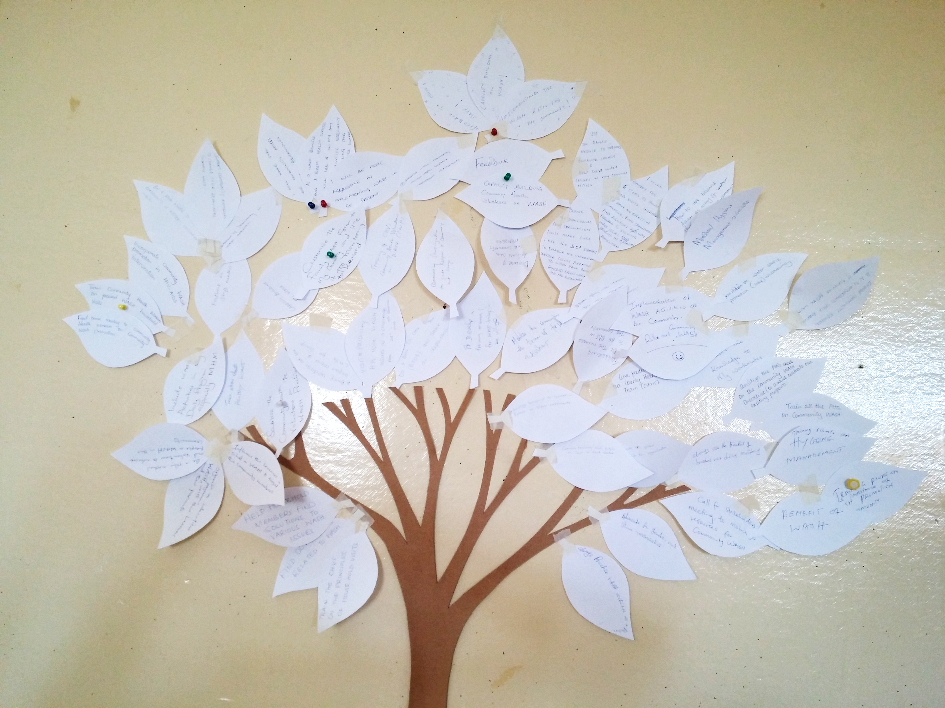


Action Plan Tree Leaves

Name: _____________________________ Date: ______________

To improve my effectiveness as a Community WASH Promoter:

- I will…

because…

My strategy to implement this action is…

- I will…

because…

My strategy to implement this action is…

- I will…

because…

My strategy to implement this action is…

Signature: _________________________

