# The Impact of Literacy and Essential Skills

Have you ever had difficulty filling out a form? Do you have a hard time with numbers and math? Did you know that these skills are related to literacy?

Literacy has traditionally meant the ability to read and write (Merriam-Webster, 2015). However, over time, this standard definition has been expanded. According to UNESCO (2004), literacy now includes gaining the skills necessary to be effective and productive within society. Many of these skills are called essential or life skills. They typically include reading, writing, using numbers (also called numeracy), using documents, communicating orally, working with others, learning continuously, using technology and critical thinking (Government of Canada , 2014).

While some countries place more importance on certain skills above others, all of the essential skills are applicable across the world. Gaps in literacy and essential skills have been linked globally to poor life outcomes (Cree , Kay, & Steward, 2012). In a worldwide study of 24 countries, the Organization for Economic Cooperation and Development (2013) identified proficiency in essential skills as being directly correlated to a person’s health, employment outcomes, wages and wider community involvement.

# Literacy and Essential Skills in Training

When we deliver training our audience will contain people from different backgrounds and levels of education. Some participants may struggle with traditional literacy skills such as reading and writing. Others may be strong with these skills, but experience difficulty in other areas.

Many water, sanitation and hygiene (WASH) activities involve skills such as reading, writing, speaking, and using numbers. In some training activities there may be required calculations, charts, tables or graphs. If a participant struggles with these skills, they may avoid participating in or completing activities. As trainers, we must take into account potential low literacy or skills gaps among the communities we work with. We can use strategies to ensure participants do not experience significant barriers as a result of these challenges.

When preparing for a workshop, reflect on your content and your audience:



* What types of activities are you asking participants to do?
* What are the skills required to be successful in these activities?
* Have you provided support for participants experiencing challenges with any of these skills?

# What You Can Do as a Trainer

Part of being an effective trainer is remembering that everyone has particular strengths and weaknesses. We need to provide support for our participants whenever possible to create an inclusive learning environment.

## Recognize the Skills Required

The first step is to recognize the essentials skills required for common tasks. For instance, filling out a registration form requires the ability to read, write and use forms. Small group work requires oral skills and the ability to work with others.

As trainers, we operate at certain levels of understanding and ability. We may not recognize the basic skills required to perform seemingly simple tasks. It is important to deconstruct our own competencies, analyze our training activities, and determine the range of skills required for participants to complete the tasks. Once you have done this analysis you may discover that you need to create better support for participants by changing activities or teaching the required basic skills.

For additional information on recognizing and deconstructing our own competencies, refer to *Trainer Essentials: Stages of Learning.*

## Communicate Clearly

Ensure that your communication is as clear as possible. If you have difficulty communicating a message, then the participants likely had difficulty understanding it. Depending on the audience and topic, adjust the way you speak and the words you use so that your key messages are understood by everyone. This is particularly important when using slang, jargon, new vocabulary or idioms. Take the time to ensure participants understand before moving on to a new topic.

For more information on communicating clearly, refer to *Trainer Essentials: Giving Clear Instructions.*

## Model Skills & Competencies

Another important strategy is to model the types of skills and competencies you are asking of your participants. For example, if you ask participants to fill in a form, show them an example of a form that has already been filled in. You could also display a sample form and fill it in as a large group. Filling in forms is a different skill than reading. Being able to read does not necessarily mean a person can easily complete other related activities.

If working with numbers, you may need to demonstrate how to complete calculations while explaining the process verbally.

You can also provide opportunities for participants to practice and work together. This will help them to become more comfortable with whatever task you are asking them to complete.

# Recognizing and Accommodating for Literacy and Essential Skills

Take a look at the training activity described below. Identify what essential skills are required to complete it and what you can do to support participants missing some of these skills.

**Training Activity:**

*You are working with a group of Community WASH Promoters. You need to teach them how to use a form that they will fill out during household visits. The form has a number of tables and is entirely text based. In one section of the form, the Community WASH promoters are asked to record the flowrate of the biosand filter in the household.*

**Essential Skills:**

To complete this activity Community WASH Promoters will require the following skills:

* Reading: To read the text-based form
* Writing: To fill out the form
* Document use: To understand how the form works and how to use the tables within it
* Numeracy: To calculate the flow rate of the biosand filter

**Supporting the Community WASH Promoters:**

The first step that you can do is simplify the form. This can be done by adding pictures to go with the words, or substituting the words entirely. Areas of the form requiring a written response can be replaced with check boxes. Tables within the form can also be minimized or taken out entirely.

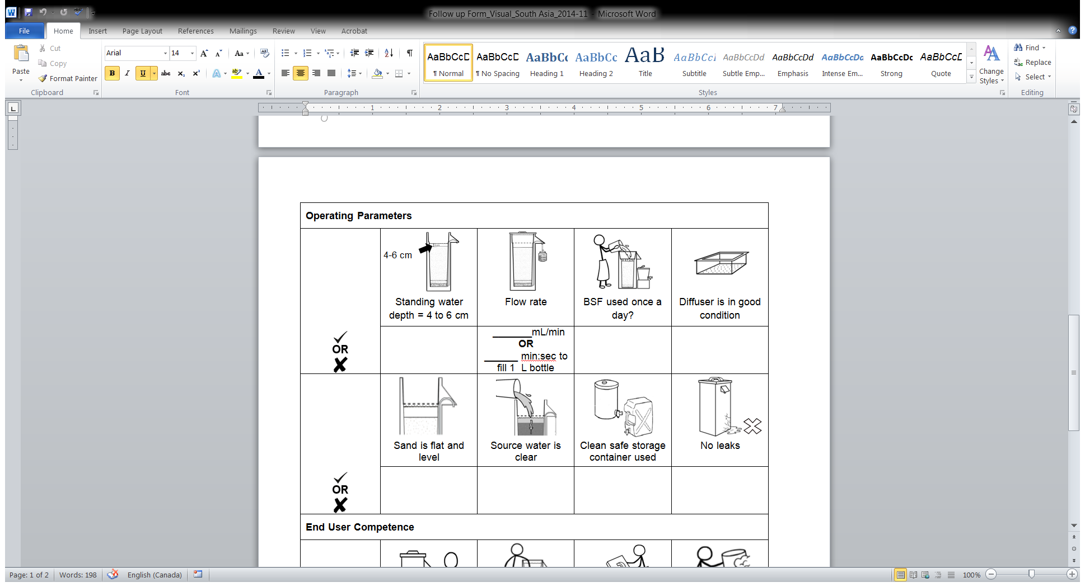

For calculating the biosand filter flow rate, provide the WASH Promoters with a measuring cup and a stopwatch. This will help them to easily collect, measure and then record the volume of water. Get the WASH Promoters to practice taking the flow rate with a partner that is comfortable with this skill.

When introducing the form ask the WASH Promoters to look through it with a partner and tell you how they would fill it out. This explanation will help you understand any difficulties they may have with the form. Create a large replica of the form on flipchart paper and demonstrate how to fill it in. Provide different household scenarios to get the promoters to practice using the form. Check-in with people individually to clarify any questions that they aren’t comfortable discussing with the full group.

This example illustrates the broad range of considerations and actions that we can take to support participants with skill gaps. Addressing literacy and essential skills is necessary to ensure the people we work with are able to benefit fully from training we provide. While we may not be able to accommodate every need, our aim should be to make our training as inclusive and accessible as possible. This will help to ensure that participants do not experience barriers due to gaps in literacy or essential skill.

# References

Cree , A., Kay, A., & Steward, J. (2012). *The Economic and Social Cost of Illiteracy: A Snapshot of Illiteracy in a Global Context.* World Literacy Foundation. Retrieved from http://www.worldliteracyfoundation.org/The_Economic_&_Social_Cost_of_Illiteracy.pdf

Government of Canada . (2014, 07 17). *Skills Definitions and Levels of Complexity*. Retrieved from Employment and Social Development Canada: http://www.esdc.gc.ca/eng/jobs/les/definitions/index.shtml

Merriam-Webster. (2015). *Literacy*. Retrieved from Merriam-Webster: http://www.merriam-webster.com/dictionary/literacy

OECD. (2013). *OECD Skills Outlook 2013: First Results from the Survey of Adult Skills.* OECD Publishing. Retrieved from http://dx.doi.org/10.1787/9789264204256-en

UNESCO. (2004). *The Plurality of Literacy and its Implications for Policies and Programmes.* France: UNESCO. Retrieved from UNESCO: http://unesdoc.unesco.org/images/0013/001362/136246e.pdf

CAWST (Centre for Affordable Water and Sanitation Technology)

Calgary, Alberta, Canada

Website: www.cawst.org Email: resources@cawst.org

*Wellness through Water.... Empowering People Globally*

Last Update: March 2015

This document is open content. You are free to:

* **Share** – to copy, distribute and transmit this document
* **Remix** – to adapt this document

Under the following conditions:

* Attribution. You must give credit to CAWST as the original source of the document. Please include our website: www.cawst.org

CAWST and its directors, employees, contractors, and volunteers do not assume any responsibility for, and make no warranty with respect to, the results that may be obtained from the use of the information provided.