## Lesson Plan: Safe Water Storage and Handling

**45 minutes total**

Lesson Description



This lesson focuses on keeping water safe from recontamination. It covers safe storage, as well as safe handling of clean water.



Learning Outcomes



At the end of this session participants will be able to:

1. Identify different ways water can get re-contaminated in a household
2. Discuss how to avoid recontamination of safe water
3. Explain the importance of safe water handling
4. Identify characteristics of a good safe storage container



Materials



* Flip chart
* Markers
* Sticky-notes
* 20 L ideal water safe storage container with tap, lid, and handle
* Optional: Image of safe storage container (end of lesson plan)
* Large Transparent jug of water (can use one of containers above if needed)
* Water
* Cup with a handle
* Juice powder, food colouring, turmeric, or any powder that will make clear water turn colourful.

Preparation



* Read and prepare lesson plan
* Find different water storage containers (including 1 ideal safe storage container)
* Optional: Print image of safe storage container (end of lesson plan)
* Write learning outcomes or lesson description on the flip chart
* Fill large transparent jug with water
* Place cup with handle next to transparent jug on the table.

Introduction 5 minutes



1. Place filled jug of water in front of participants for all to see.
2. Explain to participants that the jug contains clean water that has just been treated. You can see that the water is clear.
3. Explain to participants that the cup is clean.
4. Ask a participant to come to front and confirm that the water and the cup is clean.
5. Without the participants seeing, rub juice powder on your hands.
6. Grab the cup in your soiled hand to raise it from the table, making sure that the juice powder gets on the outside of the cup.
7. Explain to participants that most people don’t want to dip their fingers in the water when they collect it for drinking as their fingers may be dirty.
8. Grab the cup by the handle and proceed to collect water from the jug. At this point, the water should start to turn a certain colour.

**Trainer Note:** You are attempting to colour the water without actually touching it with your hands. The key message is to show that although your hands are not directly touching the water, a dirty cup touching the water may be enough to contaminate it.

1. Ask participants: “Would you drink from the water in the container? Is the water now safe to drink?” *No, it is now contaminated.*
2. Explain to participants that bacteria reproduce themselves and multiply very quickly. It only takes a very small amount of pathogens to contaminate a large amount of water.
3. Present the lesson description or learning outcomes.

Re-contamination of Safe Water 5 minutes



1. Ask the participants: “How can clean water get contaminated in a household?” *Some answers include:* 
   * *Using the same container for collection and storage,*
   * *Dipping a dirty cup or hand into the water,*
   * *Drinking directly from container,*
   * *Children, animals, or insects accessing the container,*
   * *Poor cleaning and hygiene practices.*
2. Write down their answers on flipchart paper.

Avoiding Re-contamination (Safe Water Handling) 15 minutes



1. Explain to participants that they will now try to identify ways to prevent water from being re-contaminated in the household.
2. Divide the participants into groups of 4-5 people.
3. Give each group a pile of sticky-notes.
4. Ask participants to write ideas on individual sticky-notes of what household members can do to avoid recontamination of safe water. *Some answers include:* 
   * *use chlorine to store safe water,*
   * *use a lid,*
   * *use a container with a tap instead of scooping from it,*
   * *container that is easy to clean,*
   * *use a different container to store water than to collect it,*
   * *clean container frequently,*
   * *use the treated water quickly after it has been treated,*
5. Once they have written down 1 idea per sticky-note, ask a member of each group to come to the front and stick the sticky-note on the board. As participants stick the ideas on the board, try grouping together the ideas into 2 general themes: ‘characteristics of a safe storage container’, and ‘safe handling practices’.
6. Explain to participants that you have grouped the ideas into 2 categories: safe storage container, and safe handling practices.
7. Review the answers you have grouped under ‘safe handling practices’ and add any other ideas that participants may have.

Safe Storage Container 15 minutes



1. Explain to participants that the second group of ideas describes how to store water so that it does not get re-contaminated.
2. Show an ideal safe storage container (or a picture of an ideal safe storage container from the end of this lesson plan)
3. Ask the participants: “Why is this container an ideal safe storage container?” and “What does it have that makes it an ideal storage container?”
4. As the participants give answers, refer back to the answers they provided on sticky notes. If they are some missing, add some to the list.
   1. *Tightly-sealing lid,*
   2. *Narrow opening for filling,*
   3. *Has a tap,*
   4. *Has a stable base so it does not tip over,*
   5. *It is durable and strong,*
   6. *It is not-transparent or see-through,*
   7. *It is easy to clean,*
   8. *It is easy to carry.*

Review 5 minutes



1. Ask participants to reflect and write down what they believe are the three most important things that a household member can do to keep their water safe from re-contamination.

Reflections on Lesson

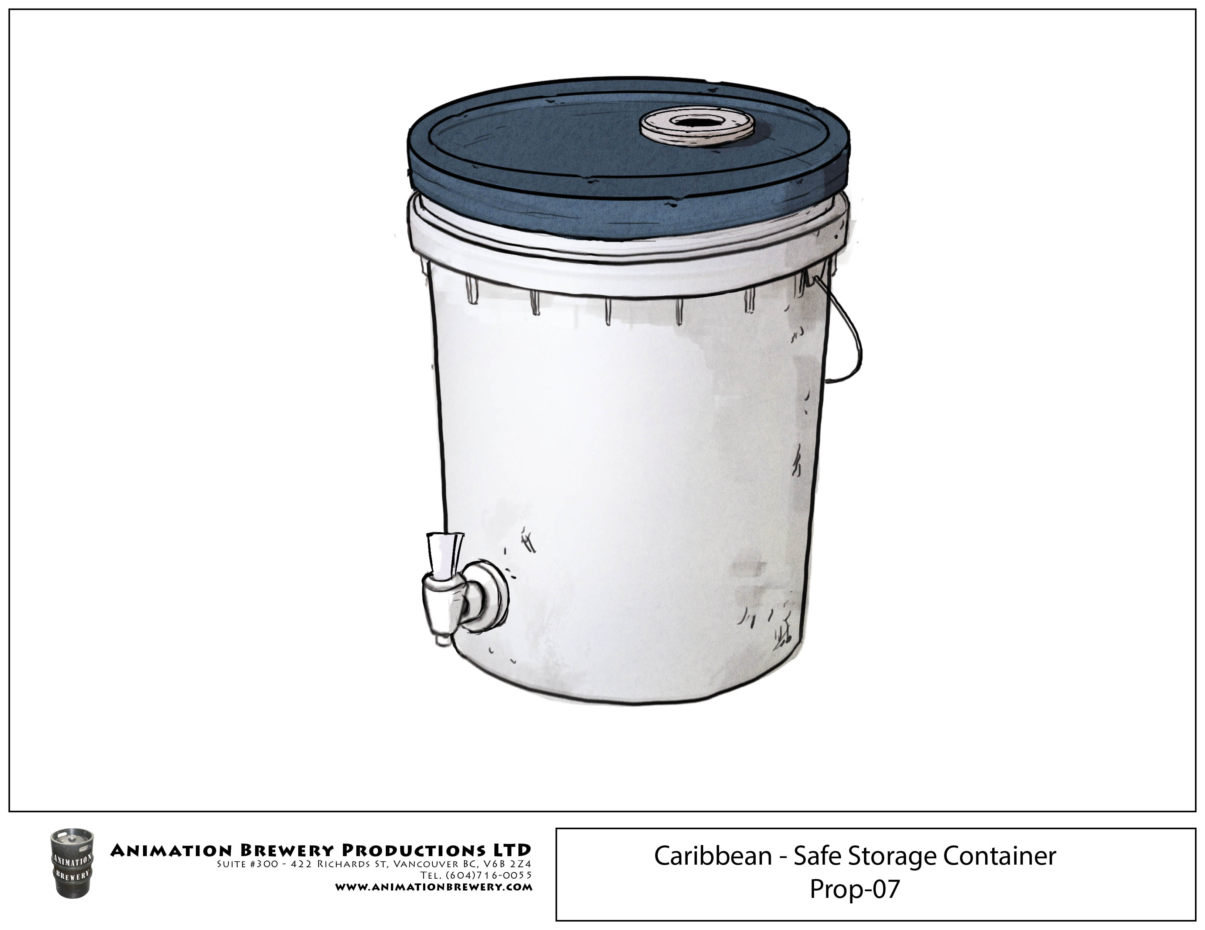

C:\Users\vmasterson\AppData\Local\Microsoft\Windows\INetCache\Content.Word\SafeStorage_Container_2016-05.tif