**Table of Contents**

1. **Introduction to Environmental Sanitation 3**
2. **Introduction to Sanitation 10**
3. **Solid Waste Management 26**
4. **Animal Excreta Management 38**
5. **Greywater Management 52**
6. **Overflow Water Management 65**
7. **Soak Pit and Infiltration Trench Design 72**
8. **Vector Control 101**
9. **Handwashing 116**
10. **Menstrual Hygiene Management 132**
11. **Composting Domestic Waste 143**



**Contents**

1. Introduction 3
2. What is Environmental Sanitation? 3
3. The Importance of Environmental Sanitation 4
4. Project Framework 6
5. Additional Resources 7
6. References 7

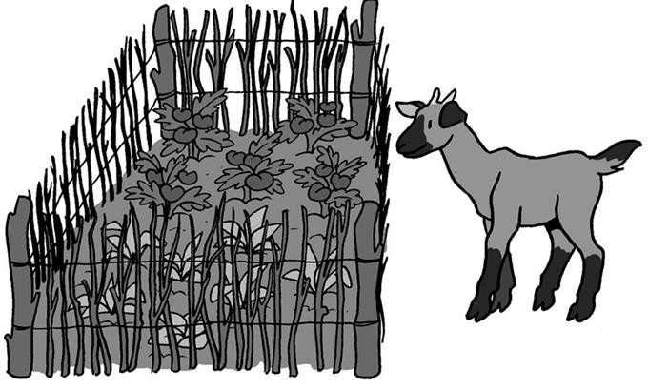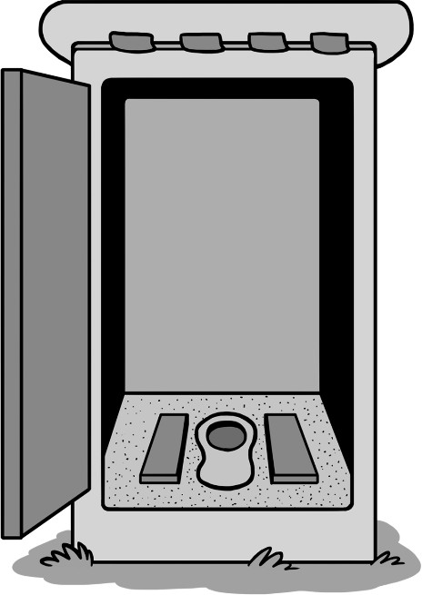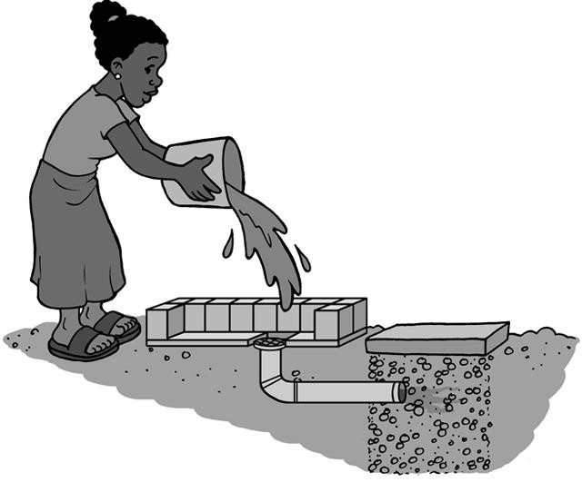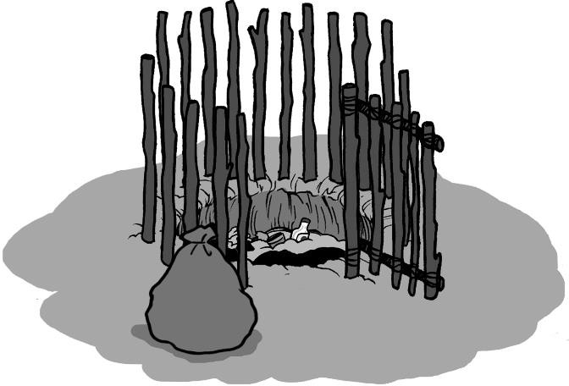

1. **Introduction**

CAWST focuses on the planning, designing and implementing on-site environmental sanitation projects for low-income, non-networked communities. For such communities, household or decentralized sanitation offers a hygienic and affordable solution.

The target audience for CAWST’s environmental sanitation education resources and training workshops are individuals and organizations who are:

* + Working in water, sanitation and hygiene (WASH), community development or health projects seeking solutions for environmental sanitation
  + Project leaders or engineers with the responsibility for organizing projects and making decisions
  + Community health promoters or labourers who may be involved in some aspects of environmental sanitation implementation, and who may educate and/or conduct follow up visits with users

CAWST’s open content education resources and schedule of international training workshops can be found at: [www.cawst.org](http://www.cawst.org/)

This Technical Brief defines the different aspects of environmental sanitation and introduces the importance for environmental sanitation to realize public health, environmental, social and economic benefits. As well, it discusses how to implement low cost environmental sanitation projects in developing countries by using a project framework to ensure that your project is successful and sustainable.

1. **What is Environmental Sanitation?**

There is no universally agreed definition of sanitation and environmental sanitation. Many different terms and definitions are used depending on the culture, location, organization, and type of work. The following definitions are commonly used in the international development and the water, sanitation, and hygiene (WASH) sectors.

Sanitation can be defined as the “conditions that lead to good human health”, but it also means more specifically the management of human excreta (feces and urine). The main objective of excreta management is to protect and promote human health by providing a clean environment and breaking the cycle of disease (SuSanA, no date).

Environmental sanitation is a broader definition of sanitation and tries to include all aspects which may affect human health and well-being. It typically includes the following aspects:

* + Human and animal excreta management
  + Domestic wastewater management
  + Stormwater drainage
  + Solid waste management
  + Vector control

As well, drinking water is sometimes included in the definition, as sustainable environmental sanitation cannot be planned and implemented in isolation from water supply (Schertenleib *et al*., 2005).

The different aspects of environmental sanitation are interconnected and require a broader look at the entire community. Planning and actions to improve environmental sanitation should be considered in a holistic manner so that improvements in one aspect are not undermined by neglecting another, and to prevent the problem from being transported elsewhere (e.g., collecting solid waste from one community, but then dumping it in stormwater drainage channels which can lead to flooding).

**2 The Importance of Environmental Sanitation**

Health can be compromised when pathogens – microorganisms that cause disease such as bacteria, viruses, protozoa and helminths – are transmitted due to poor environmental sanitation practices. As shown in the following table, there are numerous diseases related to poor environmental sanitation.

**Some Diseases Associated with Poor Environmental Sanitation**

|  |  |  |
| --- | --- | --- |
| **Possible Diseases** | **How We Get Sick** | **How to Stop Getting Sick** |
| Diarrhea, cholera, typhoid, shigellosis, hepatitis A and E, amoebic dysentery, cryptosporidiosis, giardiasis, guinea worm | Fecal pathogens in water and food are ingested or passed through person-to- person contact | * Use sanitation to prevent feces from contaminating water and food sources * Treat water to make it safe to drink * Wash hands after defecation and before touching food |
| Schistosomiasis, fasciola | Fecal pathogens in water enter through the skin | * Use sanitation to prevent feces from contaminating water sources * Do not bath or swim in water that is known to be contaminated |
| Ascariasis, hookworm infection | Fecal pathogens in soil are ingested or enter through the skin | * Use sanitation to prevent feces from contaminating soil * Wash food with safe water before eating * Wash hands after contact with soil (especially for children playing outside) * Wear protective footwear |
| Trachoma, scabies | Pathogens touch the skin or eye | * Provide enough water for basic hygiene * Improve hygiene practices |
| Malaria, dengue fever, yellow fever, filariasis, river blindness, sleeping sickness | Pathogens are passed on by insects, such as mosquitos, that breed or live in water | * Manage domestic wastewater and stormwater to prevent insects from breeding in standing water * Use pesticides to control insect populations * Prevent insects from biting by using bed nets and wearing long clothes |

|  |  |  |
| --- | --- | --- |
| **Possible Diseases** | **How We Get Sick** | **How to Stop Getting Sick** |
| Leishmaniasis | Pathogens are passed on by insects that breed or live in animal feces, rodent nests, garbage, mud-plastered houses and bushes | * Reduce insect breeding and resting sites through rodent control, animal excreta management, solid waste management, domestic wastewater management and stormwater management * Use pesticides to control insect populations * Prevent insects from biting by using bed nets and wearing long clothes |
| Typhus, bubonic plague, hantavirus, leptospirosis | Pathogens are passed on by rodents through:   * Direct contamination from dirt and feces carried on their bodies * Bites or scratches * Fleas carried on their bodies * Urine and feces | * Manage solid waste to reduce food supplies that attract rodents * Use rodent-proof food storage containers * Design rodent-proof buildings * Deter rodents with cats and dogs * Use rodenticides and traps to reduce rodent populations |

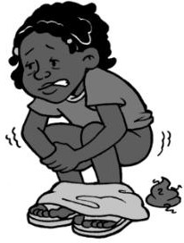Out of all the diseases related to environmental sanitation, diarrhea is the leading disease that causes death and illness, especially for children. Globally, an estimated 2,000 children under the age of five die every day from diarrheal diseases, and of these deaths 1,800 are linked to sanitation, water and hygiene (UNICEF Canada, 2013). For every child that dies from diarrhea, countless others suffer from poor health and lost educational opportunities leading to poverty in adulthood.

Consequently the WASH sector’s primary focus is on reducing the incidence of diarrheal disease. Establishing the relative impact (and thus relative importance) of different environmental sanitation interventions is difficult. But it is generally accepted that to reduce the risks of diarrheal disease, priority should be given to the following three interventions which break the transmission of pathogens from feces (Peal *et al*., 2010).

* + Using sanitation to prevent feces from contaminating water and food sources
  + Treating water to make it safe to drink
  + 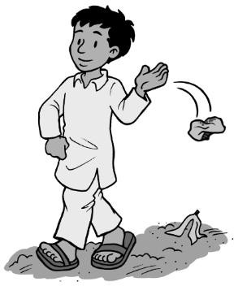Washing hands after defecation and before touching food

However, other environmental sanitation practices (such as properly disposing garbage, preventing mosquito bites and reducing rodent populations) are important as well. The “ranking” of risks may vary from one community to another. For example, the risks due to poor insect control may be greater in some communities than those risks associated with poor household water quality (Peal *et al*., 2010).

There is very little research on the ranking of different environmental sanitation risks, especially since it is specific to the local circumstances. Possible sources of information on local diseases can be found at health clinics and by speaking to community members. There may be many different local names for different diseases so it is also important to find out what they are called in your community.

**3 Project Framework**

There are many approaches or ways you can implement an environmental sanitation project. How do you choose? What will ensure your project is successful and sustainable? Regardless of the approach that you choose, the following five project framework components must be addressed:

1. **Creating Demand** – Various projects have failed because they were supply driven. For example, people will only use latrines that they really want to use (demand driven). Demand for sustainable systems is only created when people have the motivation, opportunity and ability to invest in environmental sanitation which suits their needs and aspirations.
2. **Supplying Products and Services** – Households need both the sanitation “hardware”, as well as support services, to ensure proper and consistent use over the long-term. For example, latrines are not a passive resource; they require ongoing management and maintenance by users. Therefore, like mobile phones, after-sales support is essential for sustainable use of latrines.
3. **Monitoring for Improvement** – Monitoring helps to create a feedback loop for making ongoing improvements within a project. It is particularly important for measuring a project’s impact and success, especially if an organization wants to scale up.
4. **Building Human Capacity** – Developing people’s knowledge and skills is part of building the capacity required for implementation. The ultimate objective of environmental sanitation projects should be to build the local capacity to meet the needs of local populations.
5. **Program Financing** – Implementers need adequate, consistent and long-term funding to ensure that all of their project activities are executed without disruption. It is essential to determine the capital and ongoing costs for environmental sanitation, and who is going to pay for them.

These five project framework components can be addressed using different approaches that fit the local context and achieve the specific aims of the project. A few examples of popular approaches include Community-Led Urban Environmental Sanitation (CLUES), Community-Led Total Sanitation (CLTS), School-Led Total Sanitation (SLTS), behaviour change communication (BCC), sanitation marketing and Water and Sanitation Users Groups.

Different approaches can be combined to make sure all five project framework components are addressed. For example, CLTS may be used to ignite a community and create demand for latrines. But using CLTS alone will not support the community in accessing sanitation products and services (such as latrine emptying). To address this component, you may choose to also

use an approach that supports small-scale sanitation businesses (such as masons and latrine emptiers).

CAWST’s materials about implementation approaches can help you understand many of the common methods used in environmental sanitation projects. They will help you to determine which approaches to use in your project, which project framework component(s) each approach addresses and how different approaches can work together.

**4 Additional Resources**

CAWST resources on low cost sanitation. Available at: [www.cawst.org/resources](http://www.cawst.org/resources)

* CAWST offers free and open content education and training resources on a variety of sanitation topics including environmental sanitation, domestic wastewater management, solid waste management, menstrual hygiene management, animal excreta management, vector control, the sanitation chain, latrine technologies, latrine construction and latrine project implementation.

Eawag: Swiss Federal Institute of Aquatic Science and Technology. Strategic Environmental Sanitation Planning. Available at: [www.eawag.ch/forschung/sandec/publikationen/sesp/index_EN#Bellagio](http://www.eawag.ch/forschung/sandec/publikationen/sesp/index_EN#Bellagio)

* This website provides a variety of resources on environmental sanitation guidelines and planning.

**5 References**

Peal, A., Evans, B. and C. van der Voorden (2010). Hygiene and Sanitation Software: An Overview of Approaches. Water Supply & Sanitation Collaborative Council, Geneva, Switzerland. Available at: [www.wsscc.org/node/745](http://www.wsscc.org/node/745)

Prüss-Üstün, A., Bos, R., Gore, F. and J. Bartram (2008). Safer Water, Better Health: Costs, Benefits and Sustainability of Interventions to Protect and Promote Health. World Health Organization, Geneva, Switzerland. Available at: <http://whqlibdoc.who.int/publications/2008/9789241596435_eng.pdf>

Schertenleib, R., Morel, A., Kalbermatten, J. and D. Saywell (2005). Guidelines for the Implementation of the Bellagio Principles and the Household-Centred Environmental Sanitation Approach. Eawag: Swiss Federal Institute of Aquatic Science and Technology, Dübendorf, Switzerland. Available at: [www.eawag.ch/forschung/sandec/publikationen/sesp/index_EN#Bellagio](http://www.eawag.ch/forschung/sandec/publikationen/sesp/index_EN#Bellagio)

Sustainable Sanitation Alliance (no date). What is Sustainable Sanitation? Deutsche Gesellschaft für Internationale Zusammenarbeit (GIZ) GmbH, Eschborn, Germany. Available at: [www.susana.org/lang-en/sustainable-sanitation/156-introduction-of-sustainable-sanitation/53-](http://www.susana.org/lang-en/sustainable-sanitation/156-introduction-of-sustainable-sanitation/53-comment-definir-lassainissement-durable-) [comment-definir-lassainissement-durable-](http://www.susana.org/lang-en/sustainable-sanitation/156-introduction-of-sustainable-sanitation/53-comment-definir-lassainissement-durable-)

UNICEF Canada (2013). Children dying daily because of unsafe water supplies and poor sanitation and hygiene, UNICEF says. Available at: www.unicef.ca/en/press-release/children- dying-daily-because-of-unsafe-water-supplies-and-poor-sanitation-and-hygiene-

UNICEF and WHO (2008). Progress on Drinking Water and Sanitation: Special Focus on Sanitation. WHO/UNICEF Joint Monitoring Programme for Water Supply and Sanitation. UNICEF, New York, USA and WHO, Geneva, Switzerland. Available at: [www.wssinfo.org/fileadmin/user_upload/resources/1251794333-JMP_08_en.pdf](http://www.wssinfo.org/fileadmin/user_upload/resources/1251794333-JMP_08_en.pdf)

UNICEF and World Health Organization (2013). Progress Report on Drinking Water and Sanitation: 2013 Update. WHO/UNICEF Joint Monitoring Programme for Water Supply and Sanitation. UNICEF, New York, USA and WHO, Geneva, Switzerland. Available at: [www.wssinfo.org/fileadmin/user_upload/resources/JMPreport2013.pdf](http://www.wssinfo.org/fileadmin/user_upload/resources/JMPreport2013.pdf)

UN-Water (2008). Fact Sheet 2: Sanitation Generates Economic Benefits. WHO, Geneva, Switzerland. Available at: <http://esa.un.org/iys/docs/2%20fact-sheet_economic%20benefits.pdf>

CAWST (Centre for Affordable Water and Sanitation Technology) Calgary, Alberta, Canada

Website: [www.cawst.org](http://www.cawst.org/) Email: [resources@cawst.org](mailto:resources@cawst.org)

*Wellness through Water. Empowering People Globally*

Last Update: December 2013

This document is open content. You are free to:

* Share – to copy, distribute and transmit this document
* Remix – to adapt this document

Under the following conditions:

* Attribution. You must give credit to CAWST as the original source of the document. Please include our website: [www.cawst.org](http://www.cawst.org/)

CAWST and its directors, employees, contractors and volunteers do not assume any responsibility for, and make no warranty with respect to, the results that may be obtained from the use of the information provided.

**Contents**

1. Introduction 10
2. What is Sanitation? 10
3. The Importance of Sanitation 12
4. The Global Need for Sanitation 13
5. Targets for Sustainable Sanitation Services 14
6. Scale of Sanitation Systems 15
7. Sanitation Systems 16
8. Incremental Improvements to Sanitation 19
9. Selecting Sanitation Technologies 20
10. Project Implementation 21
11. Additional Resources 22
12. References 23

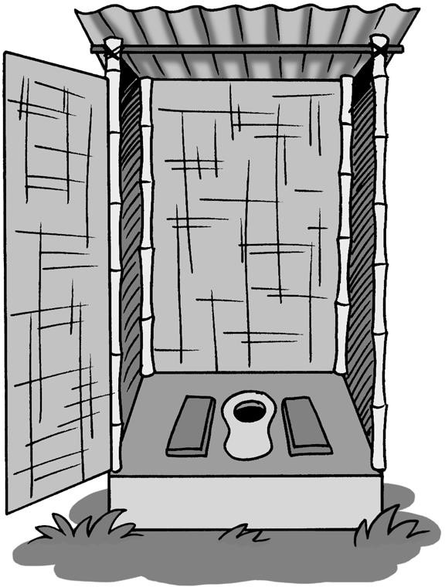



1. **Introduction**

This Technical Brief introduces the importance and global need for basic sanitation to realize public health, environmental, social and economic benefits. As well, it discusses how to implement low cost sanitation projects by creating a sanitation system and using a project framework to ensure that your project is successful and sustainable.

For more information on latrine projects, CAWST’s Technical Briefs and Fact Sheets provide details on:

* How to select, site and construct latrines
* Latrine emptying
* Sludge treatment, use and disposal
* Approaches for sustainable latrine project implementation

The target audience for CAWST’s sanitation education resources and training workshops are individuals and organizations who are:

* Working in water, sanitation and hygiene (WASH), community development or health projects seeking solutions for sanitation
* Program organizers or project managers with the responsibility for organizing projects and making decisions
* Motivated to start or strengthen projects for improving sanitation

Please see the Guide to CAWST Sanitation Resources for a complete glossary, list of abbreviations, unit conversions, and an overview of resources available.

CAWST focuses on the planning, design and implementation of on-site sanitation projects for low-income communities not connected to a sewer. For such communities, household or decentralized sanitation offers a hygienic and affordable solution.

CAWST’s free, open content resources can be found at: [www.cawst.org/resources](http://www.cawst.org/resources), and schedule of international training workshops at [www.cawst.org/training](http://www.cawst.org/training).

1. **What is Sanitation?**

There is no universally agreed upon definition of sanitation. Many different terms and definitions are used to describe sanitation depending on the culture, location, organization and type of work. The following explains some of the most common terms used in the international development and WASH sectors.

Sanitation can be defined as the “conditions that lead to good human health”, but it also means more specifically the management of human excreta (feces and urine). The main objective of excreta management is to protect and promote human health by providing a clean environment and breaking the cycle of disease (SuSanA, no date).

Sustainable sanitation describes a sanitation system that is economically viable, socially acceptable, and technically and institutionally appropriate. Sustainable sanitation should also protect the environment and the natural resources (SuSanA, no date).

Environmental sanitation is a broader definition of sanitation and tries to include all aspects which may affect human health and well-being. It typically includes excreta management, domestic wastewater management, stormwater drainage, solid waste management and vector control. As well, drinking water is sometimes included in the definition, as sustainable environmental sanitation cannot be planned and implemented in isolation from water supply (Schertenleib et al., 2005).

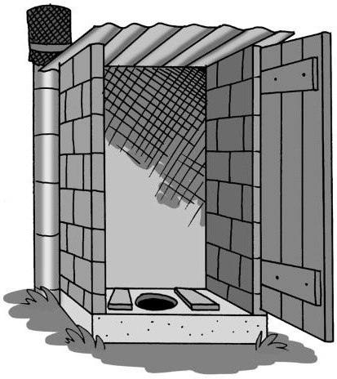Ecological sanitation (also known as ecosanitation, ecosan or productive sanitation) is an approach that aims to safely recycle nutrients, water and/or energy from excreta and wastewater, This should be done in a way that minimizes the use of non-renewable resources (SSWM, nd).

Improved sanitation hygienically separates human excreta from human contact. This term was developed by the UNICEF and World Health Organization (WHO) Joint Monitoring Programme (JMP) for Water Supply and Sanitation. It is used to measure progress towards achieving the Millennium Development Goal (MDG) target of cutting in half the proportion of people without sustainable access to basic sanitation by 2015 (UNICEF and WHO, 2014b). The definition of improved sanitation is under review and may change in the new sanitation targets set for post-2015 under the Sustainable Development Goals.

**What Are Improved Sanitation Facilities?**

|  |  |
| --- | --- |
| **Improved Sanitation Facilities** | **Unimproved Sanitation Facilities** |
| * Pit latrine with slab * Ventilated improved pit (VIP) latrine * Composting latrine * Flush or pour flush latrine discharging to:   + pit latrine   + septic tank   + piped sewer system | * Pit latrine without slab, or open pit * Bucket latrine * Hanging latrine * Flush or pour flush latrine discharging to elsewhere * Shared latrine facilities of any type * No facilities; bush or field |

(UNICEF and WHO, 2014b)

1. **The Importance of Sanitation**

Health can be compromised when pathogens – microorganisms such as bacteria, viruses, protozoa and helminths that cause disease – contaminate drinking water. Most of the pathogens that contaminate drinking water come from human feces.

**One Gram of Feces = Millions of Pathogens**

1 million bacteria



10 million viruses

100 helminth eggs

1,000 protozoa cysts

(UNICEF, 1999)

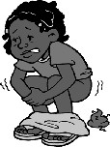Diarrhea is one of the leading diseases that cause death and illness. Globally, an estimated 2,000 children under the age of five die every day from diarrheal diseases, and of these deaths 1,800 are linked to water, sanitation and hygiene (UNICEF Canada, 2013). For every child that dies from diarrhea, countless others suffer from poor health and lost educational opportunities leading to poverty in adulthood. The reduction in diarrhea by meeting the sanitation MDG target would add almost 200 million days of school attendance per year (UN- Water, 2008).

Providing basic sanitation to the 2.5 billion people who currently lack access (UNICEF and WHO, 2014a), is an essential long-term goal that will yield great health and economic benefits. The WHO estimates that 88% of diarrheal cases are preventable through modifications to the environment, including increasing the availability of safe water and improving sanitation and hygiene (Prüss-Üstün et al., 2008).

The economic benefits of sanitation are persuasive. Improved sanitation in developing countries typically yields about US$9 worth of benefits for every dollar spent (UN-Water, 2008). As well, improved sanitation saves time. People without toilets at home spend a great deal of time each day lining up for public toilets or seeking secluded spots to defecate. Improved sanitation would give every household (of six people) an additional 1,000 hours a year to work, study, care for children, and rest. This time has an estimated annual economic value of well over US$100 billion each year (UN-Water, 2008).

The benefits of improved sanitation extend beyond better health and economics. No one wants to live, work or go to school in dirty, smelly, unsanitary conditions. Improved sanitation also contributes to the general well-being of a population. It provides convenience, safety, privacy and dignity; especially for women and children. There is also a connection between improved sanitation and increased school attendance. Girls are reluctant to attend schools if there are no safe, private toilets for them to use. This is particularly true for adolescent girls once menstruation has begun.

And finally, sanitation is a basic human right. In 2010, the United National General Assembly declared safe drinking water and sanitation as a human right essential for the full enjoyment of life and all other human rights.

1. **The Global Need for Sanitation**

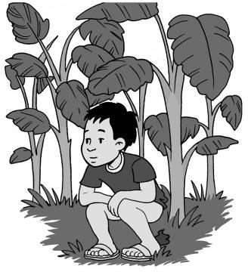By the end of 2012, there were around 2.5 billion people who still did not use improved sanitation facilities. By far the greatest numbers are in Southern Asia, but there are also large numbers in Eastern Asia and Sub-Saharan Africa. Of these, 784 million people use public or shared sanitation facilities, and another 732 million use unimproved facilities that do not hygienically separate human excreta from human contact. The remaining 1 billion (14% of the world population) still defecate in the open, that is in fields, forests, bushes, water bodies or other open spaces. The majority (70%) of those without sanitation live in rural areas, where 90% of all open defecation takes place (UNICEF and WHO, 2014a).

Since 1990, almost 2 billion people have gained access to an improved sanitation facility, and open defecation declined from 24% to 14% of the world population. The world, however, remains off track to meet the MDG target of providing basic sanitation to 75% of the world’s population by 2015, and will miss the target by more than half a billion people. Sanitation coverage in 2012 was 64% of the world’s population. The rural poor are most in need of improved sanitation and otherwise excluded and marginalized groups (UNICEF and WHO, 2014a).



“Open defecation is the last recourse for those without any form of sanitation – those at the bottom of the sanitation ladder who must endure the daily indignity of defecating in open, often publicly accessible, spaces. Open defecation is of fundamental importance to development because of the public health hazard it poses to anyone living nearby. If some members of a community continue to defecate in the open, then the whole community is at greater risk of diarrheal diseases, worm infestations and hepatitis than people living in communities where open defecation is not practiced.”

(UNICEF and WHO, 2008)

1. **Targets for Sustainable Sanitation Services**

In 2012, UNICEF and WHO Joint Monitoring Programme organized a working group to define a new vision and targets for global sanitation. These are called the Sustainable Development Goals and will set targets for 2015–2030. Currently improved sanitation is defined as people with access to an improved latrine. However, access to an improved latrine does not mean that people are using the latrine, maintaining the latrine, or practicing good hygiene behaviours.

Therefore, access to improved sanitation may not result in health and economic benefits. If people are not using the latrines then the community may continue to be at risk of sanitation- related diseases.

Since the 1990’s many latrine projects have failed to achieve sustained use of latrines in target communities despite access to a latrine. As a result, many projects today place a higher emphasis on creating demand and behaviour change (RICE, 2014).

The proposed vision and targets for the Sustainable Development Goals focus on sustainable sanitation services. Access to a latrine is no longer the only goal. The goal is for individuals and communities to use latrines, maintain latrines, and practice good hygiene behaviours. The ultimate goal is to protect people and the environment from contamination and illness.



***Vision:*** *Safe and sustainable sanitation used by all.*

By 2030:

* Eliminate open defecation
* Achieve universal access to sanitation and hygiene for households, schools and health facilities
* Halve the proportion of the population without access at home to safely managed drinking water and sanitation services
* Progressively eliminate inequalities in access

(UNICEF and WHO, 2014b)

1. **Scale of Sanitation Systems**

Sanitation systems can be implemented on different scales, ranging from conventional sewerage systems to on-site sanitation, depending on the local context and population needs.

In a conventional sewerage system, excreta and water from toilets, as well as other wastewater from sinks and showers, is transported from the home by a direct connection to a system of pipes (sewers) buried deep underground. Ideally the sewage is sent to a treatment facility before disposal; however, in many developing countries, it is often directly discharged into a surface water body. The investment for construction, operation and maintenance costs of sewer systems are very high, so local government must be in a position to take on the responsibility for the infrastructure. Conventional sewerage is best suited for high population densities, and is common in large cities and industrialized countries.

Small-piped sewerage systems, also known as small-bore, simplified or low-cost sewerage systems, use smaller diameter pipes which are buried shallower than a conventional system to collect excreta and wastewater produced at a community level. The sewage can either be treated within the community or transported to a treatment plant. It is often suitable to use small-piped sewerage systems in areas where the population density is too high for on-site sanitation (e.g., lack of space for latrine pits or tanks near every home, saturation of the surrounding soil from the infiltration of latrine waste), or in situations where the local population and public authorities don’t have the means to invest in the construction, operation and maintenance of a conventional sewerage system (Monvois et al., 2010).

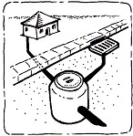

Conventional sewerage system (Credit: AKVO, n.d.)

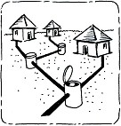

Simplified sewerage system (Credit: AKVO, n.d.)

For many low-income communities, particularly in developing countries, installing a conventional or small-piped sewerage system is not a feasible option due to the high cost and need for a piped water supply. For such communities, on-site sanitation – dealing with excreta where it is deposited – offers a hygienic and affordable solution (Franceys et al., 1992). On-site sanitation is particularly suited to rural or peri-urban communities with lower population densities. Examples of on-site sanitation systems include pit latrines and septic tanks.



CAWST’s education and training materials focus on the planning, design and implementation of on-site sanitation projects for low-income communities not connected to a sewer. Many of the principles also apply to conventional and small-piped sewerage systems.

1. **Sanitation Systems**

Sanitation is much more than building latrines and stopping people from open defecation. Sanitation is a system or a collection of technologies that deals with human excreta from the time it is captured in a latrine until it is used or disposed of safely. Sanitation systems are built for people, are managed by people, and affect people’s daily lives. The entire system must be addressed to ensure sustainable and safe sanitation. For example, what happens after the latrine is built? How is it cleaned? Who maintains and repairs damaged latrines? What happens when the latrine fills up? Where does the sludge from the latrine go?

Designing a sanitation system begins with an appropriate latrine. The latrine is made up of the:

* “Front-end” or the user interface: the parts that every user interacts with, including the toilet (seat or pan), slab and superstructure
* “Back-end” or excreta storage: the pit, tank or chamber used to store excreta

The latrine is the part of a sanitation system that people interact with the most, and if people do not like or want the latrine, then they will not use it. User-focused design is one approach for designing a latrine that people like and want to use. It means always keeping the users in mind. The more closely a latrine matches people’s needs and preferences, the less support they will need to change their behaviour, and the more likely it is that they will use the latrine over the long-term.

A sanitation system also includes emptying the latrine, and the safe treatment, use or disposal of sludge. The components within the sanitation system may be named differently depending on the local context or organization. Regardless of what they are called, each component must be addressed in a sustainable sanitation project. The five components of a sanitation system are illustrated in the following diagram:

**Sanitation System**



Use or Disposal

Treatment

Emptying and Transport

Excreta Storage

User Interface

A brief description of each sanitation system component is given below. For more information, see CAWST’s resources on Latrine Design and Construction, and Sludge Treatment, Use and Disposal.

**Notes on Sanitation Systems**



* All five components of a sanitation system must be addressed.
* Different technologies can be combined to address each component of the sanitation system. For example, there are a variety of toilet types, superstructure materials (e.g., wood, concrete, sheet metal) and slab designs (e.g., concrete reinforced slab, dome slab, wood slab) that can be used for the “front-end” of a latrine (the user interface). As well, there are different ways that the excreta from a pit latrine can be emptied (e.g., mechanical or manual) and then treated, used and disposed of.
* Some technologies cannot be combined. For example, excreta from a pour flush latrine cannot be directly composted because it is too wet. A dry toilet (one that does not flush with water) cannot be used with a septic tank or biogas reactor, since the excreta must be flushed through the pipes into the tank.
* Some technologies address multiple components in a sanitation system. For example, an arborloo latrine does not require sludge emptying, transport or treatment.
* Some latrines treat excreta to some degree, such as composting latrines, but do not usually make it pathogen-free. Further treatment is required to make the excreta safe for use in agriculture.
* CAWST does not use the term “ecosanitation” to refer to a specific latrine technology, such as a urine diversion toilet or composting latrine. Instead, ecosanitation is considered a system which, at some point, treated excreta is used as a nutrient resource. In this sense, ecosanitation can take many forms and combine many types of technologies to create a sustainable sanitation system.
  1. 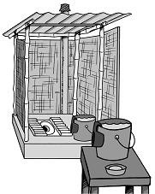**User Interface**

The user interface includes all the things that people see or touch when using the latrine. This includes the:

* + - Toilet
    - Slab
    - Superstructure
    - Latrine accessories (e.g., anal cleansing materials; a place to wash or dispose of menstrual hygiene products; support handrails for people who need help squatting)
    - Handwashing station

The parts selected for the user interface will largely determine whether people are satisfied with their latrine. People will only like and use a latrine if it is desirable, safe, socially and culturally acceptable, comfortable to use, easy to clean and maintain, and adequate for their needs. The latrine should:

* + - Be accessible for everyone needing to use it (including children, elderly, sick and people with disabilities)
    - Meet girls’ and women’s needs for menstrual hygiene management
    - Be safe, convenient and comfortable
    - Provide privacy
    - Be culturally appropriate and meet the needs and preferences of the users
  1. 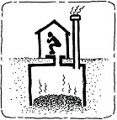**Excreta Storage**

A latrine needs some type of pit, tank or chamber to store excreta until it is emptied or the latrine moved. This may be a simple pit, ventilated improved pit (VIP), arborloo, composting chamber, dehydration chamber, biogas reactor, septic tank, or aqua privy. The design and selection of the storage component

usually depends on the soil type and depth to the groundwater table.

* 1. **Emptying Latrines and Transporting Sludge**

Latrine pits, tanks and chambers will sooner or later fill up. Full latrines must be either emptied or moved to a new location. There are two types of latrine emptying: manual emptying (using a bucket or hand pump) and motorized pit emptying (using a motorized pump or vacuum truck). Once emptied, the sludge must be safely transported to a treatment or disposal location.

(Credit: AKVO, n.d.)

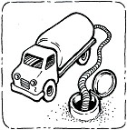

(Credit: AKVO, n.d.)

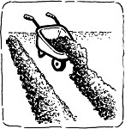Emptying and transporting sludge is an essential service that is often neglected in latrine design. Ideally, latrines should be emptied in a safe and hygienic manner by well-equipped and protected workers who transport the sludge to a treatment, use or disposal site. However in reality, many latrines are emptied using unsafe and unhygienic methods and the sludge is simply dumped onto the plot, in the street or in nearby water sources.

* 1. **Sludge Treatment**

Sludge can be treated to reduce the risk of disease transmission from fecal pathogens and protect the environment from contamination. It is critically important to treat excreta before it is used in agriculture so that pathogens do not contaminate crops that people eat.

(Credit: AKVO, n.d.)

Technologies available for treating excreta include storage, composting, drying, and anaerobic digestion (e.g., biogas reactors). Excreta can be treated at the household, or community levels if there is land available, someone has the skills, and it can be done hygienically without risk of people coming into contact with untreated excreta. It may also be treated together with household food and garden waste and animal excreta from the community (for example, co- composting).

* 1. **Use and Disposal**

The following are some options for using or disposing of urine and feces in ways that are the least harmful to people and the environment:

* + - 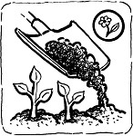Use urine as a fertilizer
    - Use treated feces or mixed excreta (urine and feces) as a soil amendment in home gardens and agriculture to provide nutrients for plant growth and improve the physical qualities of soil
    - Use treated excreta as a soil amendment in forestry, sod and turf growing, flower growing, landscaping, parks, golf courses, mine reclamation, landfill

cover, or erosion control

(Credit: AKVO, n.d.)

* + - Use excreta as a source of nutrients and water for growing aquatic plants and animals (also known as aquaculture)
    - Dispose of urine into the ground using a soak pit or infiltration trench
    - Dispose of excreta by burying in a pit or monofill (landfills only meant for excreta)
    - Dispose of excreta by placing into permanent piles (also called surface disposal)

1. **Incremental Improvements to Sanitation**

Improvements in sanitation can be made in small steps. Latrines can be improved over time to be more hygienic, more environmentally sustainable, or more “luxurious” for the users. The changes that people are able and willing to make to improve their sanitation situation depends on their:

* + - Current defecation practices
    - Current sanitation system
    - Knowledge about sanitation systems
    - Skills to build and maintain a latrine or other components of a sanitation system
    - Building materials available
    - Funds available
    - 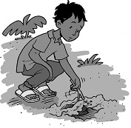Social and cultural habits and beliefs
    - Environmental conditions

The least desirable form of sanitation, from a public health standpoint, is open defecation. A slightly better solution is improved open defecation, where feces are buried and covered. This is considered an improvement because it stops human, animal and insect contact with the feces, reducing disease transmission. If people practice open defecation and are not willing or able to build and use latrines, encouraging improved open defecation would be an improvement.

Covering excreta is an improvement

Similarly, if a family is using a simple pit with no slab as a latrine, helping them build a slab would be an improvement. A family that has a solidly built pour flush latrine may want to upgrade their latrine when they can afford it by finishing the inside with ceramic tiles and changing the cement pan to a white ceramic pan.

Large steps can also be taken to climb the sanitation ladder at once. For instance, some people may be able to go directly from open defecation to a latrine that meets all their needs and preferences, if they are motivated and have the resources (such as technical information, construction skills, building materials and funds). Having a desirable and high-quality latrine may make it more likely that people will continue to use it on a long-term basis.

Ensuring the rest of the sanitation system (beyond the latrine) is in place is another incremental improvement that can be made. The latrine is usually the first component of a sanitation system that is built. The rest of the system may not be implemented for some time after the latrine is built. For example, it may take several years for a household’s latrine pit to fill up. By this time, there should be options in place for pit emptying services or relocating the latrine. Similarly, the treatment, use or disposal options required for the sludge should be ready by the time the latrine needs to be emptied. In the case of some latrines, such as composting or dehydrating latrines, this could be as early as one or two years after the latrines are built.

1. **Selecting Sanitation Technologies**

There are many technology options to select from when designing a sanitation system. Each sanitation system design has its own characteristics, advantages and limitations. Many people simply want to select one technology that will be the “best” for a community. Because there are so many factors influencing what the “best” sanitation system is for a situation, each household should be presented with appropriate options and select solutions that fit their own needs, preferences and budget.

While community outsiders should not prescribe models of sanitation systems, we do believe that the community should have someone to advise them on technical aspects. That person would help people choose appropriate technologies for them based on key criteria such as user needs and preferences, technical and environmental factors, affordability (initial and ongoing costs), and excreta handling requirements. We believe that this advice will:

* + - Enable the community to choose the most appropriate technologies for them (including those they may not have been aware of)
    - Result in a higher quality of sanitation service which is more likely to be acceptable and therefore sustained
    - Ensure that people understand the implications of their choice and are prepared for the ongoing maintenance or cost requirements
    - Result in the use of sanitation technologies that are technically sound and truly reduce the risk of disease

CAWST’s experience with household water treatment and safe storage (HWTS) implementation has made us confident that implementers can provide this type of technical advice while still leaving control in the hands of the users, where it belongs.

For more information, see CAWST’s Technical Brief: Designing and Selecting Latrines.

1. **Project Implementation**

There are many approaches or ways you can implement a sanitation project. How do you choose? What will ensure your project is successful and sustainable? Regardless of the approach that you choose, the following five project framework components must be addressed:

1. **Creating Demand:** Various sanitation projects have failed because they were supply driven. People will only use latrines that they really want to use (demand driven). Demand for sustainable systems is created when people have the motivation, opportunity and ability to invest in sanitation which suits their needs and aspirations.
2. **Supplying Products and Services:** Households need both the sanitation “hardware”, as well as support services, to ensure its proper and consistent use over the long-term. Latrines require ongoing management and maintenance by users. Therefore, providing support to users after building a latrine is essential, to encourage sustainable use.
3. **Monitoring for Improvement:** Monitoring helps to create a feedback loop for making ongoing improvements within a project. It is particularly important for measuring a project’s impact and success, especially if an organization wants to scale up.
4. **Building Human Capacity:** Developing people’s knowledge and skills is part of building the capacity required for implementation. The ultimate objective of sanitation projects should be to build the local capacity to meet the needs of local populations.
5. **Program Financing:** Implementers need adequate, consistent and long-term funding to ensure that all of their project activities are implemented without disruption and to completion. Households and communities must be able to pay the ongoing costs of managing and maintaining sanitation hardware.

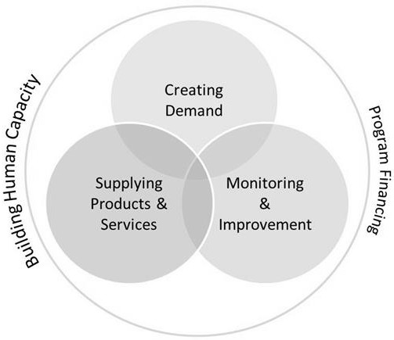

Project framework components

These five project framework components can be addressed using different implementation approaches. Specific approaches should be selected that fit the local context and achieve the specific aims of the project. A few examples of popular approaches include Community-Led Total Sanitation (CLTS), Community-Led Urban Environmental Sanitation (CLUES), School-Led Total Sanitation (SLTS), behaviour change communication (BCC), sanitation marketing, Community Sanitation Clubs or Health Clubs, and Water and Sanitation Users Groups.

Different implementation approaches can be combined to make sure all five project framework components are addressed. For example, CLTS may be used to ignite a community and create demand for latrines. But using CLTS alone will not support the community to access sanitation products (like latrine parts) or services (such as pit emptying). To address this component, you may choose to also use an approach that supports establishing small-scale sanitation businesses (for example, masons to build latrine slabs and services to empty latrine pits).

It is also critical that the implementation approaches address the entire sanitation system. For instance, a project should not only provide support for building latrines. It should also find solutions for cleaning and maintaining latrines; emptying and transporting the latrine sludge; and treating, using or disposing of the excreta in a safe way.

CAWST’s resources on Latrine Project Implementation can help you understand many of the common methods used in projects. They will help you to determine which approaches to use in your project, which project framework components each approach addresses, and how different approaches can work together.

1. **Additional Resources**

**CAWST Sanitation Resources.** Available at: [www.cawst.org/resources](http://www.cawst.org/resources)

* CAWST’s education and training resources are available on a variety of sanitation topics including latrine design, siting and construction; latrine parts and technologies; latrine emptying and transporting sludge; sludge treatment, use and disposal; and latrine project implementation.

**Compendium of Sanitation Systems and Technologies.** Tilley, E., Ulrich, L., Lüthi, C., Reymond, P. and Zurbrügg, C. (2014). 2nd Revised Edition. Eawag: Swiss Federal Institute of Aquatic Science and Technology, Dübendorf, Switzerland. Available at: [www.eawag.ch/forschung/sandec/publikationen/compendium_e](http://www.eawag.ch/forschung/sandec/publikationen/compendium_e/index_EN)

* The Compendium presents the concept of sanitation systems together with detailed information about sanitation technologies for each component of sanitation systems. The document targets engineers, planners and other professionals who are familiar with sanitation technologies and processes. However, it is also a useful document for non- experts to learn about the main advantages and limitations of different technologies and the appropriateness of different systems.
* The e-Compendium, is an online, interactive version of the Compendium, complete with a tool for combining technologies into a complete sanitation system. Available at: [http://ecompendium.sswm.info](http://ecompendium.sswm.info/)

**Sustainable Sanitation Alliance (SuSanA).** Available at: [www.susana.org](http://www.susana.org/)

* SuSanA is an open international network of members who share a common vision on sustainable sanitation. SuSanA works as a coordination platform, working platform, sounding board, contributor to the policy dialogue on sustainable sanitation, and as a catalyst. The SuSanA website provides extensive resources including publications, case studies, photos and videos and a discussion forum targeted at practitioners, educators and researchers.

**Sustainable Sanitation and Water Management (SSWM) Toolbox.** Conradin, K., Kropac, M., Spuhler, D. (Eds.) (2010). Seecon international gmbh, Basel, Switzerland. Available at: [www.sswm.info](http://www.sswm.info/)

* The SSWM Toolbox is an open source and comprehensive collection of tools and approaches on water management and sustainable sanitation. It was designed with nongovernmental organizations (NGOs) and community-based organizations (CBOs) as target groups. As well, the SSWM Toolbox can be a knowledge base for enterprises, engineers and planners.

1. **References**

Franceys, R., Pickford, J. and R. Reed (1992). A Guide to the Development of On-site Sanitation. World Health Organization, Geneva, Switzerland. Retrieved from: <http://whqlibdoc.who.int/publications/1992/9241544430_eng.pdf>

Monvois, J., Gabert, J., Frenoux, C. and M. Guillame (2010). Concerted Municipal Strategies Methodological Guide No.4, How to Select Appropriate Technical Solutions for Sanitation.

Municipal Development Partnership (MDP) and Programme Solidarité Eau (pS-Eau). Retrieved from: [www.pseau.org/fr/recherche-developpement/production/smc/six-methodological-guides](http://www.pseau.org/fr/recherche-developpement/production/smc/six-methodological-guides)

Prüss-Üstün, A., Bos, R., Gore, F. and J. Bartram (2008). Safer Water, Better Health: Costs, Benefits and Sustainability of Interventions to Protect and Promote Health. World Health Organization, Geneva, Switzerland. Retrieved from: <http://whqlibdoc.who.int/publications/2008/9789241596435_eng.pdf>

Research Institute for Compassionate Economics (RICE), Sanitation quality use access & trends (SQUAT), SQUAT policy brief (2014), Retrieved from: [http://squatreport.in/wp-](http://squatreport.in/wp-content/uploads/2014/07/SQUAT-policy-brief.pdf) [content/uploads/2014/07/SQUAT-policy-brief.pdf](http://squatreport.in/wp-content/uploads/2014/07/SQUAT-policy-brief.pdf)

Schertenleib, R., Morel, A., Kalbermatten, J. and D. Saywell (2005). Guidelines for the Implementation of the Bellagio Principles and the Household-Centred Environmental Sanitation Approach. Eawag: Swiss Federal Institute of Aquatic Science and Technology, Dübendorf, Switzerland. Retrieved from: [www.eawag.ch/forschung/sandec/publikationen/sesp/index_EN#Bellagio](http://www.eawag.ch/forschung/sandec/publikationen/sesp/index_EN#Bellagio)

SuSanA (Sustainable Sanitation Alliance) (no date). “Sustainable Sanitation – the Definition”. Retrieved from: [www.susana.org/en/about/sustainable-sanitation](http://www.susana.org/en/about/sustainable-sanitation)

UNICEF (1999). A Manual on Hygiene Promotion, Water, Environment and Sanitation Technical Guidelines Series No. 6. Programme Division Water, Environment and Sanitation, UNICEF, New York, USA. Retrieved from: [www.unicef.org/wash/files/hman.pdf](http://www.unicef.org/wash/files/hman.pdf)

UNICEF Canada (2013). Children dying daily because of unsafe water supplies and poor sanitation and hygiene, UNICEF says. Retrieved from: www.unicef.ca/en/press- release/children-dying-daily-because-of-unsafe-water-supplies-and-poor-sanitation-and- hygiene-

UNICEF and WHO (2008). Progress on Drinking Water and Sanitation: Special Focus on Sanitation. WHO/UNICEF Joint Monitoring Programme for Water Supply and Sanitation. UNICEF, New York, USA and WHO, Geneva, Switzerland. Retrieved from: [www.wssinfo.org/fileadmin/user_upload/resources/1251794333-JMP_08_en.pdf](http://www.wssinfo.org/fileadmin/user_upload/resources/1251794333-JMP_08_en.pdf)

UNICEF AND WHO (2014a). Progress on Drinking Water and Sanitation – 2014 Update. WHO/UNICEF Joint Monitoring Programme for Water Supply and Sanitation. UNICEF, New York, USA and WHO, Geneva, Switzerland. Retrieved from: [www.wssinfo.org/documents/](http://www.wssinfo.org/documents/)

UNICEF and WHO (2014b). WASH POST-2015: Proposed Targets and Indicators for Drinking-water, Sanitation and Hygiene. WHO/UNICEF Joint Monitoring Programme for Water Supply and Sanitation. UNICEF, New York, USA and WHO, Geneva, Switzerland. Retrieved from: [www.wssinfo.org/fileadmin/user_upload/resources/post-2015-WASH-targets-factsheet-](http://www.wssinfo.org/fileadmin/user_upload/resources/post-2015-WASH-targets-factsheet-) 12pp.pdf

UN-Water (2008). Fact Sheet 2: Sanitation Generates Economic Benefits. WHO, Geneva, Switzerland. Retrieved from: [http://esa.un.org/iys/docs/2%20fact-](http://esa.un.org/iys/docs/2%20fact-sheet_economic%20benefits.pdf) [sheet_economic%20benefits.pdf](http://esa.un.org/iys/docs/2%20fact-sheet_economic%20benefits.pdf)

CAWST (Centre for Affordable Water and Sanitation Technology) Calgary, Alberta, Canada

Website: [www.cawst.org](http://www.cawst.org/) Email: [resources@cawst.org](mailto:resources@cawst.org)

*Wellness through Water. Empowering People Globally*

Last Update: December 2014

This document is open content. You are free to:

* Share – to copy, distribute and transmit this document
* Remix – to adapt this document

Under the following conditions:

* Attribution. You must give credit to CAWST as the original source of the document. Please include our website: [www.cawst.org](http://www.cawst.org/)

CAWST and its directors, employees, contractors and volunteers do not assume any responsibility for, and make no warranty with respect to, the results that may be obtained from the use of the information provided.

**Contents**

1. Introduction 26
2. Waste Generation and Collection 27
3. Waste Treatment 28
   1. Recycling 28
   2. Composting 29
   3. Incineration 30
4. Disposal 30
5. Hazardous Waste 32
6. Menstrual Hygiene Waste 33
7. Solid Waste Attitudes 34
8. Additional Resources 35
9. References 35

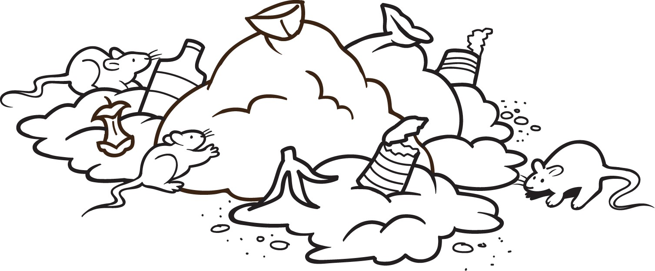

1. **Introduction**

The term “waste” has a different meaning for different people. In general, one can say that waste is a product or material that is ‘unwanted’ and does not have value anymore for the person who throws it away. But ‘unwanted’ is subjective and the waste could have value for another person in a different circumstance, or even in a different culture (WASTE, 2001). Waste is often called other names like rubbish, trash, refuse or garbage. Human and animal excreta are not considered to be solid waste and are managed differently as discussed in the CAWST’s Technical Briefs on Introduction to Sanitation and Animal Excreta Management.

Integrated waste management is a process with different stages where intervention activities can be effective. Generally, the earlier a waste management activity is practiced in the process, the better. This is also commonly known as the waste management hierarchy.

**Waste Management Stages and Activities**

**Generation and Collection**

* Prevent or minimize waste generation
* Reduce toxicity of waste that is generated
* Small scale collection to transfer points
* Safe handling and collection of hazardous waste

**Treatment**

* Reuse materials in their current form
* Recycle waste into new products
* Compost organic waste
* Incinerate waste and possibly recover energy

**Disposal**

* Safe disposal of solid waste, generally in sanitary landfills
* Safe disposal of hazardous waste

Solid waste is uncontrolled in many parts of the world. A typical solid waste management system in a developing country has a variety of problems, including:

* Low collection coverage
* Irregular collection services
* Open dumping
* Uncontrolled burning
* Air and water pollution
* Breeding of disease vectors
* Unsafe handling through informal waste management activities (e.g., waste picking)



**Risks Associated with Poor Waste Management**

* Breeding sites for disease vectors, including flies, mosquitos and rodents
* Air, water and general pollution resulting in respiratory problems, poor water quality, and decline in living conditions
* Fires in uncontrolled dump sites
* Unsafe human contact with hazardous waste
* Blocked drains causing increased flooding, especially in high density urban areas



1. **Waste Generation and Collection**

The poor in developing countries produce significantly less waste (about 0.4 to 0.9 kg per person per day) than people living in industrialized countries (between 1.1 and 5.07 kg per person per day). The poor living in rural communities also tend to produce less waste than those living in urban areas since they have less income and less access to consumer products. However, urbanization and rising incomes will eventually lead to people using more resources and therefore generating more waste (Hoornweg and Thomas, 1999).

Waste composition—or what waste is made of— is also influenced by external factors such as geographical location, the population’s standard of living, energy source and weather.

Generally, the waste produced by low and middle income countries contains a high percentage of organic material, ranging from 40 to 85% of the total. As populations become wealthier and more urbanized, their waste composition changes to have a higher percentage of consumer packaging materials such as paper, plastic, glass, and metal (Hoornweg and Thomas, 1999).

Minimizing the amount of waste a community generates reduces the need for collection and the cost for collection services. Collection can account for almost 50% of the total annual cost of urban solid waste management (Tchobanoglous *et al*., 1993).

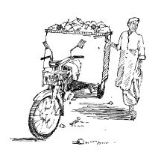Most urban centres have some kind of waste collection and disposal service. These services often only cover the wealthier sections of the city. Peri-urban and unplanned, informal housing areas may have no or limited service, and in these settings waste is usually collected from centralized points located at the perimeter of the area. In such cases, large scale methods of transport (e.g., trucks, compactors) won't usually work because of the width, slope, congestion, and surface of the roads. A possible solution in densely populated communities is to use hand carts, semi-motorized carts, front-loaded tricycles, or carts pulled by animals to transport waste to a transfer point.

1. **Waste Treatment**

Solid waste treatment includes the following activities:

Motorcycle and solid waste cart (Credit: Shaw)

* Reuse materials in their current form (e.g., wearing clothes passed on from a neighbour)
* Recycle waste into new products (e.g., aluminium from cans is melted down and made into new cans)
* Compost organic waste and create a soil amendment
* Incinerate waste and possibly recover energy
  1. **Recycling**

Separating and recycling paper, metal, plastic, and glass is already a common practice in developing countries since it is a way for many people to informally earn a living. Materials that have high market prices are often recycled, and include paper, glass, and metal.

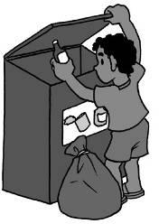In developing countries, recycling is usually part of the informal sector (i.e., individuals or working teams who are not usually incorporated or registered as a business; do not keep formal accounting books; and do not usually pay license fees or taxes). Often it is waste pickers who sort out recyclable materials from mixed waste at gutters, street bins and piles, markets, transfer points, collection trucks, and dumps (legal and illegal). They generally sell the recyclables to a middleman who in turn sells it to a company that will use or export the material. Without the activities of the informal sector, much more waste would end up in dumps or the environment.

Informal sector activities are seldom recognized, supported or promoted by the local authorities. Waste picking is one of the highest risk jobs in urban areas, especially for children. Waste pickers live and work in very poor conditions (often at the dump site), and are subject to social stigma and frequent harassment.

* 1. **Composting**

Composting is a natural process that decomposes organic material (i.e., material that once came from a living thing) into a valuable soil amendment that can be used for agriculture. Composting is especially appropriate in many developing countries and has the following benefits:

* + - Diverts waste from collection, transportation and disposal, especially since as much as 85% of the waste stream in low- and middle- income countries can be composted
    - Improves the quality of recyclable materials since they are not contaminated with organic material
    - Reduces landfill leachate and methane gas (a greenhouse gas that is 21 times more powerful than carbon dioxide)
    - Enhances the effectiveness of fertilizers in agriculture
    - Can be implemented at different levels, from households to large-scale centralized facilities
    - Can be started with very little capital and operating costs
    - Accommodates seasonal waste fluctuations, such as leaves and crop residue after harvest

(Adapted from Hoornweg et al., 1999)

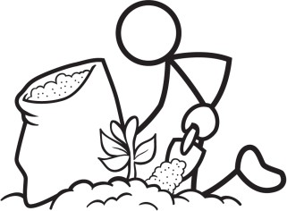Composting is a traditional practice that is already used in many rural communities to manage household and agricultural waste, but can also be done in peri-urban and urban areas. Household composting can be a simple way to manage kitchen and garden waste. It’s most appropriate for homes that have enough space in their yard for the compost piles, and where they can use the final compost product in their own gardens.

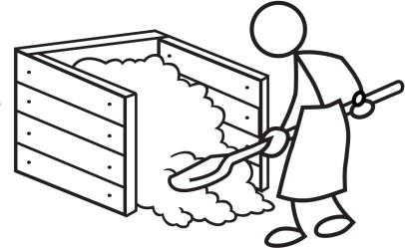Composting can take anywhere from two months in hot and humid countries with well-tended compost piles to a few years in colder countries with untended compost piles. The process needs water, oxygen, and organic materials such as household food waste and agricultural waste (e.g. husks, leaves).

There are many different composting designs and options. Composting units can be made out of locally available materials such as wood, bamboo, clay bricks, and wire mesh. The design and operation of the composters should not attract rodents, insects, or other scavenging animals. Keeping meat, fish, bones, dairy, cooked and fatty food out of the composter is the best way to keep pests away from the unit.

Vermicomposting may also work in developing countries, especially for households in urban centers with little land space. This process uses the natural digestion of redworms and earthworms to break down organic material. From the moment it hatches, a worm can consume daily its body weight in organic matter such as vegetables, fruit, leaves, grass, meat, fish, sludge, cardboard, and paper. The worms can be housed in any ventilated container with a lid that has drainage holes or a layer of gravel in the bottom to let liquid created in the process to drain.

Further details about composting are provided in CAWST’s Technical Brief: Composting.

* 1. **Incineration**

Incineration burns waste at extremely high temperatures in a controlled environment and turns it into ash, gas, and heat. It is usually done to reduce the amount of waste to be disposed, and in some cases, the heat generated by incineration can be also used to generate electric power.

Incineration is also a popular option for treating some hazardous waste, like medical waste produced by clinics and hospitals.

Incineration is commonly used to treat waste in industrialized countries where there is little space for landfill disposal, especially in Europe and Japan. Modern, large-scale incineration facilities use advanced technology and are designed by engineers to protect people and the environment from odours, dust, and air pollution.

Large-scale incineration facilities are not as common in developing countries due to the high cost and complexity of the technology. Simple burning of waste is more commonly practiced in developing countries to reduce the volume of waste to be disposed. However, burning is not the best option for waste treatment since it releases harmful chemicals into the air. It creates thick smoke that contains carbon monoxide, nitrogen oxide, and soot; all of which are hazardous to human health and air quality. In particular, burning plastic like polyvinyl chloride (PVC) is very harmful since it produces chemicals that can cause cancer. There are some materials (such as wood, paper, and construction debris) that are less harmful when burned and are commonly used as fuel for cooking and heating.

It may be necessary to burn household waste if landfill space is very limited. In this case, it is best to burn the waste as far away as possible from people, keep it contained in a pit or barrel to prevent the fire from uncontrolled spreading, and burn it as hot as possible. The ashes may be contaminated and should be disposed of in a pit or landfill.

1. **Disposal**

All communities will produce some waste even with the best minimization and treatment practices. The most common way to deal with this waste is to bury it. In industrialized countries, waste is disposed in sanitary landfills which are engineered to meet environmental regulations. A sanitary landfill is designed to protect soil, ground and surface water; reduce odours and pests; capture leachate; and reduce harmful gas emissions. Sanitary landfills can be found in large cities in some developing countries. However, open dumping is more common due to a lack of the resources needed to properly construct and operate a sanitary landfill.

In small rural communities that produce relatively small quantities of waste, households can manage their waste disposal on-site. In larger rural communities, waste disposal may be best managed as a community service, with one or several conveniently located, large waste disposal sites shared by everyone. In this case, individuals can either transport their own waste to the site or organize a collection service similar to those found in urban areas.

The following are best practices for locating and maintaining a small-scale waste disposal site:

* 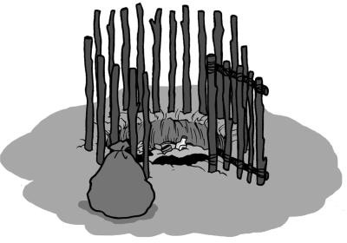Locate the site at least 500 metres away and downhill from drinking water sources.
* Ensure that there is at least 2 metres between the bottom of the disposal pit and the highest annual groundwater level. The more distance between the bottom of the pit and the groundwater, the lower the risk of contamination.
* Do not dispose waste in an area susceptible to flooding.
* Locate the site in clay-like soil if possible. The smaller the soil grain size, the lower the risk of soil and groundwater contamination. Do not dispose waste in sandy areas.
* Cover waste with 0.1 metres of soil or ash regularly (e.g., daily or weekly) to reduce smells and pests, and prevent waste from blowing away.
* Construct a fence to keep animals and children out of the disposal site.
* Once full, backfill the pit with at least 0.5 meters of soil cover.

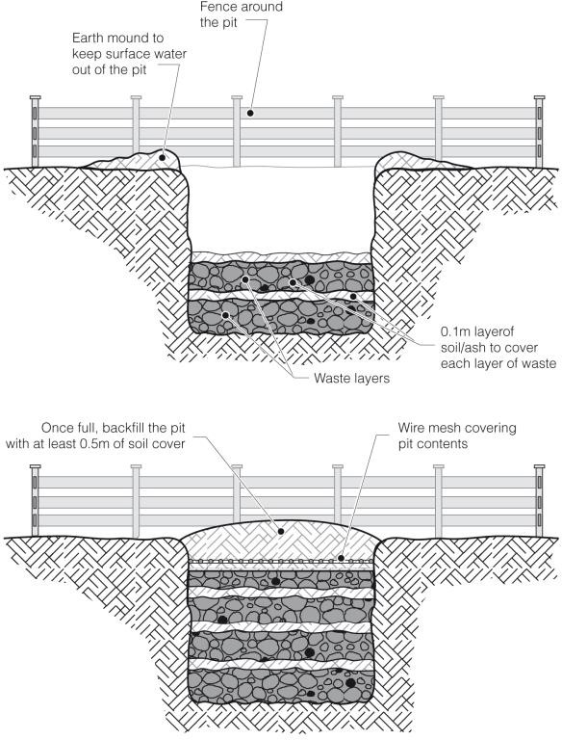

Design of a solid waste disposal pit (Credit: Chatterton, WEDC)

1. **Hazardous Waste**

Proper collection, treatment and disposal of hazardous waste is a large problem in developing countries. Hazardous waste includes:

* Toxic waste
* Medical waste
* Pharmaceuticals
* Chemicals
* Batteries

This waste needs specialized collection and treatment beyond just putting it in a landfill. However, much of the risk from hazardous waste occurs in the stages before disposal. For example, needles from syringes that are not separated from the regular waste can pose a large health threat to waste collectors and waste pickers.

In many cases, the technology needed to treat and dispose of hazardous waste is not affordable or feasible (i.e., incinerators). However, there are actions that can be taken to minimize exposure to hazardous waste such as:

* Use less hazardous materials as substitutes
* Separate hazardous waste from general household waste
* Use better storage before and during collection of hazardous waste
* Dispose hazardous waste in a separate landfill site from general household waste
* Take medical waste to a local health care facility for disposal, if available



**Hazardous Waste Management**

* **Do not reuse** containers that held hazardous material.
* **Do not burn** hazardous waste.
* **Do not dispose** hazardous waste in latrines, drainage channels, water sources or on the ground.

1. **Menstrual Hygiene Waste**

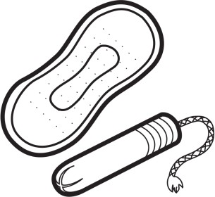Women and girls need to use clean material to absorb or collect their menstrual blood. Sanitary pads or tampons are most commonly used and these are normally changed around four times a day during menstruation. Some sanitary pads are meant for single use and are disposed afterwards, while others can be washed and reused. It is estimated that most women will use between 7,000 to 10,000 sanitary pads or tampons in their life. On average, a woman throws away 125 to 150 kg of sanitary pads, tampons and applicators in her lifetime (House et al., 2012).

To manage menstruation hygienically and with dignity, it is essential that women and girls have a way to safely dispose used sanitary products at home, in schools and in public places. Waste management facilities needed for menstrual hygiene include the following:

* A discrete, washable container with a lid in which sanitary products can be temporarily stored
* Collection, transfer and emptying of the containers
* Treatment and final disposal of sanitary products through incineration, burying or other method

Each stage of menstrual waste management must be discrete and not cause embarrassment to women and girls by taking the following into consideration:

* The collection point should offer privacy
* Final disposal should not be near to male latrines or involve walking past groups of men or boys
* In schools, students may be embarrassed to see their female teachers disposing of their sanitary products, so separate disposal facilities or times for students and teachers may be necessary

The waste chain should also be hygienic and not cause risks to those responsible for operating it. Methods sometimes used for the treatment and final disposal of sanitary products include:

* Incineration
* Composting of biodegradable products
* Disposal into a latrine
* Disposal into a small-scale pit
* Disposal into a regular waste management collection and disposal system

When there is no convenient method for disposing sanitary products, women and girls often throw them into latrines. Potential problems with this disposal method can be:

* The sanitary products can easily block pour flush latrines
* Pit latrines can fill up more quickly
* Non-biodegradable sanitary products can pose a challenge for the degradation process in composting latrines
* It can also cause problems with pumps and vacuum trucks when emptying pit latrines

(House et al., 2012) Further details are provided in CAWST’s Technical Brief: Menstrual Hygiene Management.

1. **Solid Waste Attitudes**

Waste management is often a very low priority for people, even though it is an obvious and very visible issue in many rural, peri-urban and urban communities. Generally, individuals and communities prioritize safe drinking water projects above sanitation, and especially above solid waste management.

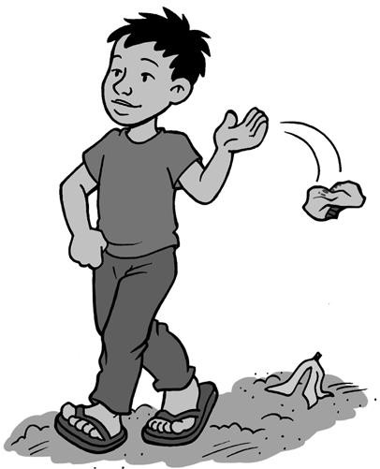Other attitudes that may have to be overcome are stigmas that are attached to the handling of waste. Some cultures may not find it acceptable to handle waste or find it inconvenient to separate waste. They may also look poorly upon those whose job it is to collect or transport the waste, in particular waste pickers who are not officially recognized.

It may be difficult to change people’s attitudes and behaviours. Behaviour change is necessary to get people to spend the effort, time and money needed to separate waste (into recyclables, compostable material and general waste) and to treat and dispose of it properly. Community desire and awareness coupled with culturally sensitive and appropriate solutions are necessary for a successful solid waste project.

1. **Additional Resources**

CAWST (2013). Technical Brief: Composting. CAWST, Calgary, Canada. Available at: [www.cawst.org/resources](http://www.cawst.org/resources).

* This technical brief discusses how to safely and properly compost organic waste in developing countries.

CAWST (2013). Technical Brief: Menstrual Hygiene Management. CAWST, Calgary, Canada. Available at: [www.cawst.org/resources](http://www.cawst.org/resources).

* This technical brief discusses the challenges of menstrual hygiene management, including a lack of access to appropriate sanitation facilities, for women and girls in developing countries.

UN-HABITAT (2010). Solid Waste in the World’s Cities. London, UK. Available at: <http://www.waste.nl/sites/waste.nl/files/product/files/swm_in_world_cities_2010.pdf>

* The goal of this book is to enable decision-makers to develop and implement solutions to meet solid waste needs in cities around the world.

House, S., Mahon, T. and S. Cavill (2012). Menstrual Hygiene Matters: A Resource for Improving Menstrual Hygiene Around the World. WaterAid, London, UK. Available at: www.wateraid.org/what-we-do/our-approach/research-and-publications/view- publication?id=02309d73-8e41-4d04-b2ef-6641f6616a4f&sc_lang=en

* This resource includes a range of technical options for waste collection containers and incinerators to handle menstrual hygiene waste.

1. **References**

Chatterton, K. (nd). Soak Pit Design, WEDC Image Library. Water, Engineering and Development Centre, Loughborough University, UK. Available at: <http://wedc.lboro.ac.uk/>

Hoornweg, D. and L. Thomas (1999). What a Waste: Solid Waste Management in Asia. The World Bank, Washington, DC, USA. Available at: [www.worldbank.org/urban/solid_wm/erm/CWG%20folder/uwp1.pdf](http://www.worldbank.org/urban/solid_wm/erm/CWG%20folder/uwp1.pdf)

Hoornweg, D., Thomas, L. and L. Otten (1999) Composting and Its Applicability in Developing Countries. The World Bank, Washington, DC, USA. Available at: www.worldbank.org/urban/solid_wm/erm/CWG%20folder/uwp8.pdf

House, S., Mahon, T. and S. Cavill (2012). Menstrual Hygiene Matters: A Resource for Improving Menstrual Hygiene around the World. WaterAid, London, UK. Available at: www.wateraid.org/what-we-do/our-approach/research-and-publications/view- publication?id=02309d73-8e41-4d04-b2ef-6641f6616a4f&sc_lang=en

Shaw, R. (2005). Drawing Water: A Resource Book of Illustrations on Water and Sanitation in Low-Income Countries. WEDC, Loughborough University, UK. Available at: <http://wedc.lboro.ac.uk/dw/index.htm>

Tchobanoglous, G., Theisen, H. and S. Vigil (1993). Integrated Solid Waste Management: Engineering Principles and Management Issues. McGraw-Hill, New York, USA.

WASTE (2001). Integrated Sustainable Waste Management - The Concept. WASTE, Gouda, the Netherlands. Available at: [www.waste.nl/sites/waste.nl/files/product/files/tools_iswm_concept_eng1.pdf](http://www.waste.nl/sites/waste.nl/files/product/files/tools_iswm_concept_eng1.pdf)

CAWST (Centre for Affordable Water and Sanitation Technology) Calgary, Alberta, Canada

Website: [www.cawst.org](http://www.cawst.org/) Email: [resources@cawst.org](mailto:resources@cawst.org)

*Wellness through Water. Empowering People Globally*

Last Update: August 2015

This document is open content. You are free to:

* Share – to copy, distribute and transmit this document
* Remix – to adapt this document

Under the following conditions:

* Attribution. You must give credit to CAWST as the original source of the document. Please include our website: [www.cawst.org](http://www.cawst.org/)

CAWST and its directors, employees, contractors and volunteers do not assume any responsibility for, and make no warranty with respect to, the results that may be obtained from the use of the information provided.

**Contents**

1. Introduction 38
2. Diseases Related to Animal Excreta 38
   1. Diarrheal Disease 40
   2. Cystic echinococcosis 40
   3. Cysticercosis 41
   4. Leishmaniasis 41
   5. Leptospirosis 42
   6. Soil-Transmitted Helminth Infections 43
3. How Long Pathogens Survive and Remain Infectious 44
4. Treatment, Use and Disposal 45
   1. Preventing Contamination 46
   2. Composting 47
   3. Drying and Burning 47
5. Additional Resources 48
6. References 49

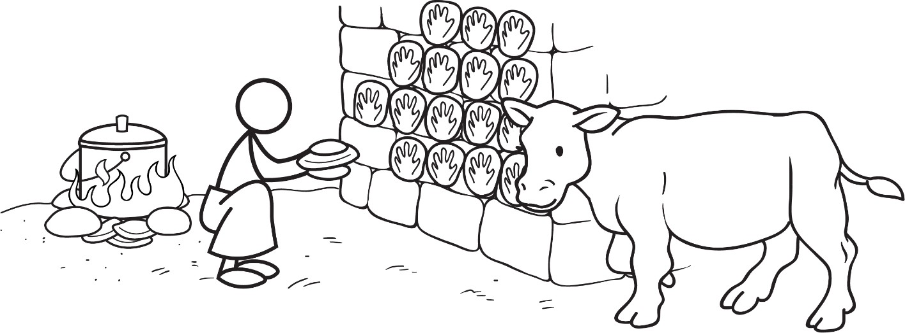

1. **Introduction**

Just as human excreta presents health hazards, so does animal excreta. There are many pathogens – microorganisms such as bacteria, viruses, protozoa and helminths that cause disease – that can be found in animal feces and urine. Zoonoses are diseases and infections that are naturally transmitted between animals and people (WHO, 2006a). Many zoonotic diseases are transmitted by pathogens found in animal excreta. Not only can animal excreta transmit pathogens directly, it can also provide a breeding site for other disease vectors, like sandflies.

Low income people are more at risk of contracting zoonoses. There is a strong association between poverty and living in close contact with animals. Zoonoses typically affect isolated rural communities who keep livestock and those living in urban slums. The number of poor livestock- keepers worldwide is estimated to be between 500 and 900 million (WHO, 2006a). For these people, livestock are an important part of their survival and can help to break the poverty cycle. Basic sanitation, proper hygiene and safe drinking water can also help break the cycle of poverty.

As well, in communities where people are suffering from zoonoses, the animals are sure to be affected as well. When an animal does fall ill, it is difficult for many livestock keepers to afford treatment or to have good access to veterinary services and healthcare information (WHO, 2006a).

Effectively managing animal excreta will help to prevent and control several zoonotic diseases, resulting in decreased disease burden, reduced poverty and increased food supply for large numbers of the rural poor worldwide (WHO, 2006a)

1. **Diseases Related to Animal Excreta**

Human health can be compromised when pathogens are transmitted due to poor animal excreta management. This is shown in the following table. Many animals infected with pathogens do not show symptoms of disease or illness, so you do not know that they are able to transmit pathogens to people.

The following diseases related to animal excreta are considered by the World Health Organization (2013a) to be neglected tropical diseases, and are discussed in more detail in the next sections. The term “neglected” highlights that these diseases affect mainly poor and marginalized populations in low-resource settings.

* Cystic echinococcosis
* Cysticercosis
* Leishmaniasis
* Soil-transmitted helminths infections

**Some Diseases Associated with Animal Excreta**

|  |  |  |  |
| --- | --- | --- | --- |
| **No.** | **Possible**  **Diseases** | **How We Get Sick** | **How to Stop Getting Sick** |
| 1 | Diarrhea, salmonellosis, giardiasis, cryptosporidiosis, toxoplasmosis | Fecal pathogens in water and food are ingested, or passed through direct contact with infected animal feces | * Use sanitation to prevent human and animal feces from contaminating water and food * Treat water to make it safe to drink * Wash hands after handling animal feces and before touching food |
| 2 | Ascariasis roundworm infection, hookworm infection | Helminths (fecal pathogens) in dried animal feces or contaminated soil are ingested (roundworm) or go through the skin (hookworm) | * Use sanitation to prevent human and animal feces from contaminating soil * Wash food with safe water before eating * Wash hands after contact with contaminated soil (especially for children playing outside) or dried animal feces (e.g., using dried dung for fuel) * Wear protective footwear |
| 3 | Cystic echinococcosis | *Echinococcus granulosus* tapeworm eggs (pathogen in human, sheep and dog feces) in water or food are ingested, or passed through direct contact with infected dogs | * Use sanitation to prevent human, sheep and dog feces from contaminating food and water * Deworm dogs and prevent dogs from eating undercooked sheep meat * Control stray dogs * Proper hygiene when slaughtering sheep * Wash hands after contact with infected dogs and sheep |
| 4 | Cysticercosis | *Taenia solium* tapeworm larvae (pathogen in human and pig feces) in water, food and raw or undercooked pork meat are ingested | * Use sanitation to prevent human and pig feces from contaminating food and water * Cook pork meat thoroughly to kill larvae * Treat water to make it safe to drink * Wash hands after contact with human or pig feces |
| 5 | Leishmaniasis | *Leishmania* protozoa are passed on by bites from *phlebotomine sandflies* that breed or live in animal feces, rodent nests, garbage, mud-plastered houses and bushes | * Reduce sandfly breeding and resting sites through rodent control, animal excreta management, solid waste management, domestic wastewater management, and stormwater management * Use pesticides to control sandfly populations * Prevent sandflies from biting by using bed nets and wearing long clothes |
| 6 | Leptospirosis, hantavirus | * Leptospirosis – Passed on by water, soil or food contaminated with infected rodent urine, or direct contact with infected rodent urine * Hantavirus – Passed on by contact with rodent excreta | * Manage solid waste to reduce food supplies that attract rodents * Use rodent-proof food storage containers * Design rodent-proof buildings * Deter rodents with cats and dogs * Use rodenticides and traps to reduce rodent populations * Do not work, bathe or swim in water that is known to be contaminated with animal urine |

* 1. 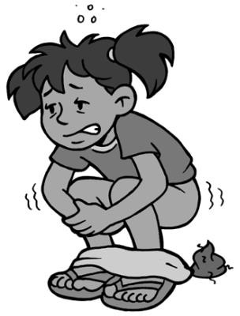**Diarrheal Disease**

Diarrhea is one of the leading causes of death and illness. Globally, an estimated 2,000 children under the age of five die every day from diarrheal diseases. Of these deaths 1,800 are linked to water, sanitation and hygiene (UNICEF Canada, 2013). For every child that dies from diarrhea, countless others suffer from poor health and lost educational opportunities leading to poverty in adulthood. The reduction in diarrhea by meeting the sanitation Millennium Development Goal (MDG) target would add almost 200 million days of school attendance per year (UN- Water, 2008).

Measures to prevent the transmission of diarrhea include the following:

* + - Using sanitation to prevent human and animal feces from contaminating food and water
    - Treating water to make it safe to drink
    - Washing hands after handling human and animal feces and before touching food
  1. **Cystic echinococcosis**

Cystic echinococcosis (also known as hydatid disease) is caused by the tapeworm *Echinococcus granulosus*. Its natural cycle is as a cyst in sheep and as a tapeworm in dogs. Dogs feed on infected sheep meat and in turn shed eggs in their feces which are ingested by sheep. People become infected by ingesting food or water contaminated with animal feces containing tapeworm eggs, or when they have direct contact with infected dogs. Cysts, often in the stomach, grow slowly over time and can become very large. The cure is usually surgery.

Cystic echinococcosis is found throughout the world in communities where sheep are raised together with dogs. It is highly prevalent in many developing countries, especially in poor communities. It causes serious human suffering and considerable losses in agricultural and human productivity.

Measures to prevent the transmission of cystic echinococcosis include the following:

* + - Using sanitation to prevent sheep and dog feces from contaminating food and water
    - Deworming dogs and preventing dogs from eating undercooked sheep meat
    - Controlling stray dogs
    - Using proper hygiene when slaughtering sheep
    - Washing hands after contact with infected dogs and sheep

(WHO, 2006a)

* 1. **Cysticercosis**

Cysticercosis is caused by the *Taenia solium* tapeworm and is emerging as a serious public health and agricultural problem in many poorer countries of Africa, Asia and Latin America. People become infected when eating raw or undercooked pork meat contaminated with cysticerci, the larval form of the tapeworm. The larvae develop in the intestine of humans where they become adult tapeworms which can grow to more than three metres long. These adult worms shed eggs in human feces. These can infect other people as well as pigs by direct contact or by ingesting contaminated water or food.

Ingested eggs result in larval worms that migrate to different parts of the human and pig body and form cysts (cysticercosis). Pigs can harbour thousands of these cysts, making the pork from these animals unsafe to eat. A principle site of migration in humans is the central nervous system. Human neurocysticercosis occurs when the cysts develop in the brain. It is considered to be the most common parasitic infection of the human nervous system and the most frequent preventable cause of epilepsy in the developing world. Cysticercosis affects about 50 million people worldwide and, in endemic areas, causes some 50,000 deaths.

Measures to prevent the transmission of cystic echinococcosis include the following:

* + - Using sanitation to prevent human and pig feces from contaminating food and water
    - Cooking pork meat thoroughly to kill larvae
    - Treating water to make it safe to drink

(WHO, 2006a)

* 1. **Leishmaniasis**

There are three main types of leishmaniasis:

* + - Visceral leishmaniasis (also known as kala-azar) is the most serious form of the disease and fatal if left untreated. It is characterized by irregular bouts of fever, weight loss, enlargement of the spleen and liver, and anaemia. It is highly endemic in the Indian subcontinent and in East Africa. An estimated 200,000 to 400,000 new cases occur worldwide each year. Over 90% of new cases occur in six countries: Bangladesh, Brazil, Ethiopia, India, South Sudan and Sudan.
    - Cutaneous leishmaniasis is the most common form of the disease and causes ulcers on exposed parts of the body, leaving life-long scars and serious disability. About one-third of cases occur in the Americas, the Mediterranean basin, the Middle East and Central Asia. An estimated 0.7 to 1.3 million new cases occur worldwide annually.
    - Mucocutaneous leishmaniasis leads to partial or total destruction of mucous membranes of the nose, mouth and throat. Most cases are reported in Bolivia, Brazil and Peru.

People can become infected with leishmaniasis if bitten by female *phlebotomine sandflies* carrying the *leishmania* protozoa. The sandflies can breed or live in animal feces, dung and mud-plastered houses, rodent nests, garbage and bushes.



Poverty increases the risk for leishmaniasis. Poor and crowded housing and a lack of environmental sanitation (e.g., lack of waste management, open sewerage) can increase sandfly breeding and resting sites, as well as their access to people.

Measures to prevent the transmission of leishmaniasis include the following:

* + - 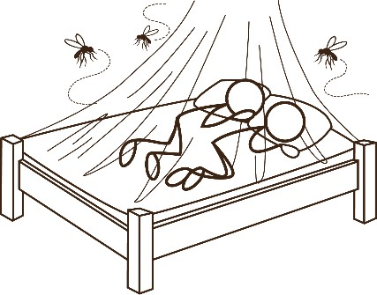Reducing sandfly breeding and resting sites through sanitation to properly manage animal excreta, and solid waste management to remove garbage
    - Controlling sandflies by using insecticide spray, insecticide– treated bed nets and personal protection (see CAWST’s Technical Brief: Vector Control)

(WHO, 2013b)

* 1. **Leptospirosis**

Leptospirosis (also known as Weil’s syndrome, canicola fever, canefield fever, nanukayami fever, seven-day fever) is a bacterial disease that is transmitted to people through contact with:

* + - Urine (or other body fluids, except saliva) from infected animals
    - Water, soil or food contaminated with the urine of infected animals

The bacteria can enter the body through skin or mucous membranes (eyes, nose, or mouth), especially if the skin is broken from a cut or scratch. Drinking contaminated water can also cause infection.

Rodents were the first recognized carriers of leptospirosis and are considered the primary source of infection to people. Cattle, buffalos, horses, sheep, goats, pigs and dogs are also considered common reservoirs of the bacteria that cause leptospirosis.

Leptospirosis occurs worldwide, but is most prevalent in tropical and subtropical regions. Outbreaks of leptospirosis have been reported following natural disasters, such as flooding. Some people have a high risk of exposure because of their occupation or the environment they live in. Occupations at risk include farmers, slaughterhouse workers, sewer maintenance workers and waste disposal facility workers. In some countries, most of the population is at risk as a result of high exposure to contaminated water in their daily activities; for example, working in rice paddies and sugarcane plantations. Although leptospirosis is often considered to be a rural disease, people living in cities may also be at risk from exposure to infected rats.

Measures to prevent transmission of leptospirosis include the following:

* + - Wearing protective clothing, especially for at risk occupations (e.g., boots, gloves, safety glasses, aprons, masks)
    - Covering broken skin with waterproof dressings
    - Preventing access to, or giving adequate warning about, bodies of water known or suspected to be contaminated (e.g., pools, ponds, rivers)
    - Avoiding bathing or swimming in potentially contaminated water
    - Washing or showering after exposure to urine splashes or contaminated soil or water
    - Washing and cleaning wounds after potential exposure to urine or contaminated soil or water
    - Avoiding or preventing urine splashes and aerosols, avoiding touching ill or dead animals or assisting animals in giving birth
    - Using hygienic measures during care or handling all animals
    - Where feasible, disinfecting contaminated areas (e.g., scrubbing floors in stables, butcheries, abattoirs)
    - Drinking safe water

(CDC, 2013 and WHO, 2012)

* 1. **Soil-Transmitted Helminth Infections**

The main helminth species that infect people are roundworms *(Ascaris lumbricoides*) and hookworms (*Necator americanus* and *Ancylostoma duodenale*). Helminth infections are transmitted by eggs present in human and animal feces, which in turn contaminate soil in areas where sanitation is poor. This can happen in several ways:

* + - Eggs attached to vegetables are ingested when the vegetables are not carefully cooked, washed or peeled
    - Eggs are ingested from contaminated water sources
    - Eggs are ingested by children who play in soil and then put their hands in their mouths without washing them

In addition, hookworm eggs hatch in the soil, releasing larvae that mature into a form that can actively penetrate the skin. People become infected with hookworm primarily by walking barefoot on the contaminated soil.

There is no infection from fresh feces, because eggs passed in feces need about three weeks to mature in the soil before they become infective. As well, roundworm eggs can remain viable for years, creating long-term contamination of soil wherever infected feces are allowed to disintegrate.

Soil-transmitted helminth infections are among the most common infections worldwide and affect the poorest communities. More than 1.5 billion people, or 24% of the world's population, have soil-transmitted helminth infections. Infections are widely distributed in tropical and subtropical areas, with the greatest numbers occurring in sub-Saharan Africa, the Americas, China and East Asia. Children have the highest risk of infection and it impairs their physical, nutritional and cognitive development.

Measures to prevent the transmission of helminths infections include the following:

* + - Using sanitation to prevent human and animal feces from contaminating soil
    - Washing food with safe water before eating
    - Washing hands after contact with contaminated soil (especially for children playing outside)
    - Wearing protective footwear

(WHO, 2013c)

1. **How Long Pathogens Survive and Remain Infectious**

Many people mistakenly believe that only fresh animal feces present a health risk. In fact, many pathogens found in animal feces can survive and be infectious for days, weeks or even years after an animal has defecated.

**How Long Pathogens Survive in the Environment**

|  |  |  |  |
| --- | --- | --- | --- |
| **Pathogen** | **Animal Feces** | **Soil** | **Water** |
| *Escherichia coli* O157 bacteria | 2 months-1 year | 2 days-10 months | 2 weeks-6 months |
| *Salmonella* bacteria | 3-5 weeks | 8 months | 6 months |
| *Cryptosporidium* protozoa | 2 months-1 year | 1 year | 1 month |
| *Giardia* protozoa | 1 week-1 year | 2 months | 3 months |
| *Ascaris lumbricoides* roundworm | Years | Years | Years |

(Adapted from Sobsey *et al*., 2006 and University of Wisconsin, no date)

Some pathogens, like bacteria and *giardia* protozoa, are immediately infectious after an animal has defecated, while other pathogens require some time before they are infectious to people. For example, *toxoplasma* oocysts in cat feces take one to five days after defecation to become infective to people and other animals. *Ascaris* roundworms eggs in animal feces do not begin to become infectious until the feces have aged for a week or longer (Beeler and May, 2011).

**Duration from Defecation to Infectivity of Common Pathogens in Animal Feces**

Immediate – Bacteria and *Giardia* cysts are infectious

24 hours – *Toxoplasma* oocysts start to become infectious

7 days – Roundworm eggs start to become infectious

**Aging Animal Feces**

(Credit: Beeler and May, 2011)

1. **Treatment, Use and Disposal**

Over time, the number of pathogens will naturally decrease in untreated excreta due to sunlight (UV radiation), drying, high temperatures and high or low pH. However, pathogen reduction may not be extensive and it depends on factors such as the type of pathogen, characteristics of the animal excreta and the environmental conditions. Compared to human excreta management, there is relatively little research on the effectiveness of different technologies to reduce pathogens and disease transmission from animal excreta (Sobsey *et al*., 2006).

The rate that pathogens are inactivated or removed from animal excreta can be improved through different treatment technologies, many of which also generate a beneficial product that can be used, including the following methods:

* + - Composting to produce a material that can be used to improve soil structure and provide nutrients for plant growth
    - Exposing feces to sunlight (UV radiation) and drying
    - Using lagoons or constructed wetlands
    - Using anaerobic digestion to produce methane gas as a fuel source (e.g., biogas digester)

Animal dung has other beneficial uses in some countries. For example in Sudan, cow dung is mixed with clay to make bricks and donkey dung is used as a protective coating for mud walls and roofs (Majzoub, 1999). It is also a common practice in many developing countries to make cakes or patties out of cow and buffalo dung, dry them in sunlight and then use them as a fuel source (e.g., cooking and heating by fire).

For final disposal, animal feces are often applied to agricultural crops as a fertilizer. Depending on the type and extent of treatment, if treatment is used at all, pathogens may still be present at concentrations of concern to both human and animal health (Sobsey *et al*., 2006).

As shown in the following illustration, there are many different routes that animal fecal pathogens can be transmitted from animal or human excreta to people, for example:

* + - Pathogens can be ingested directly from contaminated crop food
    - Pathogens can enter surface and ground water supplies that are used as drinking water sources
    - Flies can transfer pathogens to food
    - Farmers that handle animal excreta can transfer the pathogens directly from their unwashed hands to their mouths.
    - If human or animal excreta is not properly treated before being used as a fertilizer it will remain high in pathogens and be a potential contamination hazard.

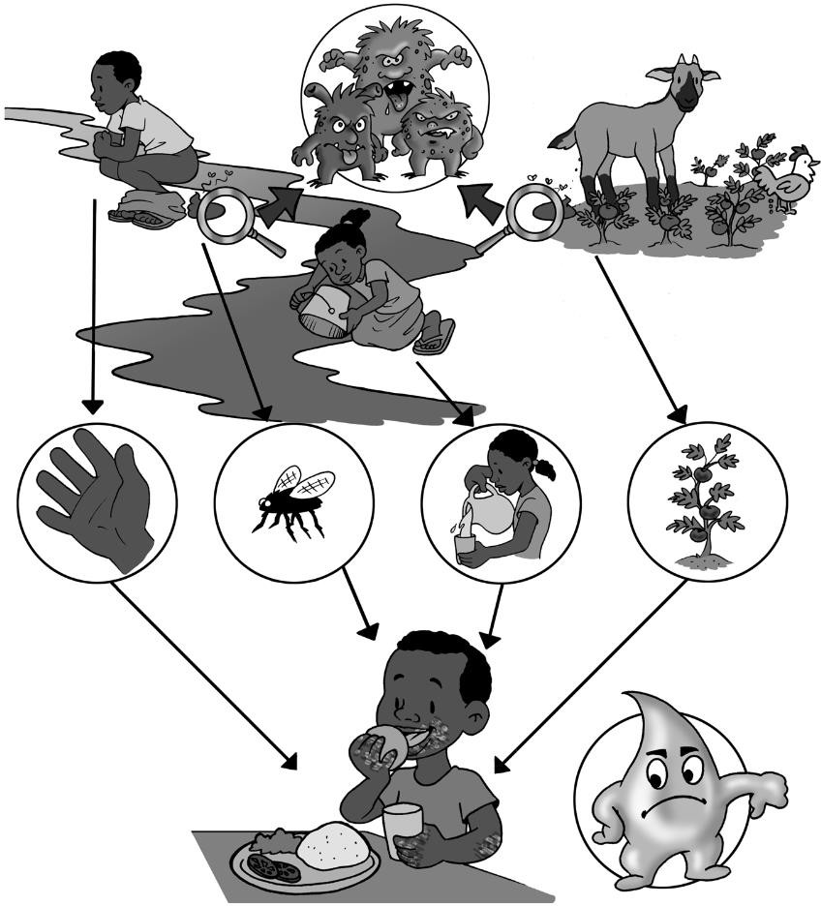

Transmission of pathogens from human and animal excreta to people

* 1. **Preventing Contamination**

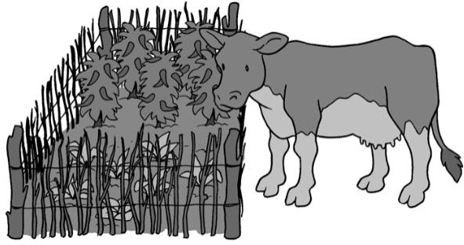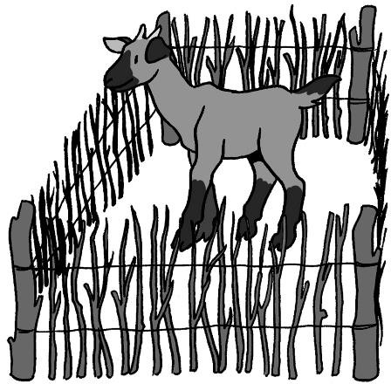As a minimum, animal excreta around households should be collected on a daily basis and moved to a location that is away from water, food and people, especially children. As well, livestock animals (e.g., cattle, goats) should be kept away from homes and gardens by using fences to keep the animals in or out.

Using fences to keep animal feces away from homes and gardens

* 1. 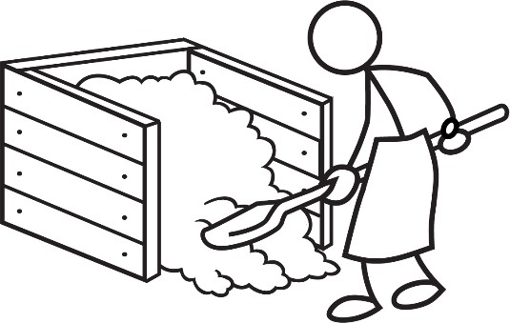**Composting**

Composting can be an effective method for reducing pathogen concentrations in animal excreta and is a traditional practice in many rural communities. This process accelerates the decomposition of excreta with the help of bacteria and other organisms (e.g., yeast, fungi, worms). The result is a compost material that can be used to improve soil structure and provide nutrients for plant growth.

Composting as a traditional waste management practice

There are three main techniques for composting animal excreta:

1. Pile – Excreta is mixed with a bulking agent (e.g., another organic material like leaves or wood chips) that encourages aeration. Air is blown into the mixture for approximately 21 days followed by a 30-day curing period.
2. Windrow – Excreta is mixed with a bulking agent and then piled into rows 1-2 metres high. The rows are turned every few days for 30-60 days.
3. In-vessel – Excreta is mixed in a composting vessel while air is forced through the materials.

It is important to optimize the composting conditions (e.g., air, water, heat) to ensure that pathogens are reduced and the final compost product is safe to use afterwards. The temperature of the composting process is critical since heat is needed to kill or inactivate the pathogens. In a static pile process, a temperature of 55°C or higher must be maintained for three days or longer to achieve effective pathogen reduction (Bitton, 1999 cited in Sobsey *et al*., 2006).

* 1. **Drying and Burning**

Drying animal feces and burning it as a fuel source is another widely practiced approach in many rural communities in developing countries. Cow and buffalo feces are shaped by hand into dung cakes or pats, placed in sunlight to dry out, and then burned as fuel for cooking, boiling water and heating.

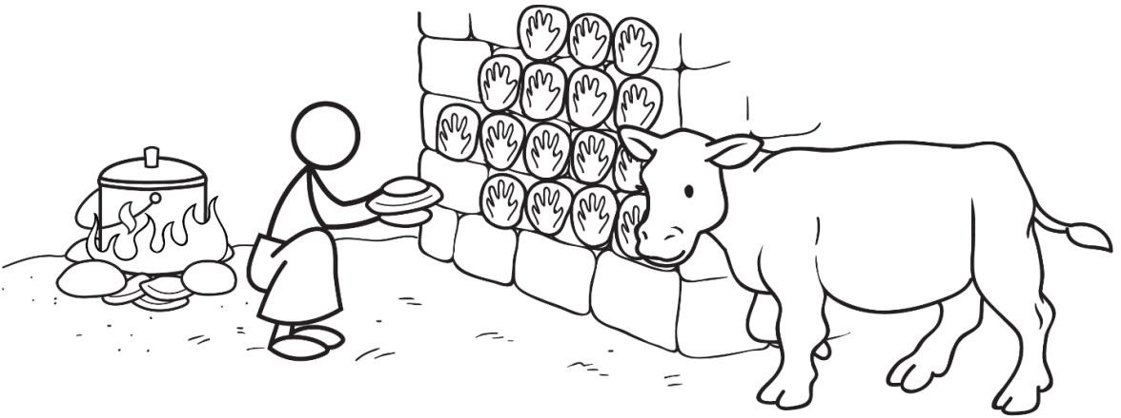

Using animal feces to make dung pats for fuel

Bacteria are highly susceptible to sunlight (i.e., UV light) and drying; however, viruses, protozoa and helminths are more resistant and can survive for weeks or months. Little is known about the extent to which pathogens are reduced because there have been few studies to document the effectiveness of UV light and drying (Sobsey *et al*., 2006). One study found the effect of sunlight and rainfall on animal dung pats to be complex. For the initial one to three weeks after defecation, sunlight actually helped bacteria to grow by warming the pats to optimum temperatures and creating a crust on the pat that retains water. After this time, sunlight then helped to reduce the number of bacteria through dehydration (Sinton *et al*., 2007).

While drying and burning animal dung may reduce the amount of waste that requires final disposal, it is also a serious public health problem. Pathogens from animal dung pats can be transmitted to people through different routes. The main route is directly from unwashed hands to mouths. It is very important that people wash their hands with soap and water after making animal dung pats and before touching food (e.g., preparing food, eating). Although it is rarely practiced, people can also reduce transmission of pathogens by wearing protective clothing, such as gloves, when handling animal dung.

Another potential transmission route is from insects that breed or live in the animal dung pats as they are drying. For example, *leishmania* protozoa are passed on by the bite from *phlebotomine* sandflies that breed or live in animal feces, dung and mud-plastered houses, rodent nests, garbage and bushes.

As well, the inefficient burning of animal dung in an open fire or traditional stove indoors creates hundreds of air pollutants - primarily carbon monoxide and small particles. The resulting indoor air pollution is responsible for more than 1.5 million deaths a year – mostly young children and their mothers. Millions more suffer every day with difficulty in breathing, stinging eyes and chronic respiratory disease (WHO, 2006b).

**7 Additional Resources**

CAWST (2013). Technical Brief: Composting. CAWST, Calgary, Canada. Available at: [www.cawst.org/resources](http://www.cawst.org/resources)

* + - This technical brief discusses how to safely and properly compost organic waste in developing countries.

CAWST (2013). Technical Brief: Handwashing. CAWST, Calgary, Canada. Available at: [www.cawst.org/resources](http://www.cawst.org/resources)

* + - This technical brief discusses when and how to properly wash hands with soap, as well as the hardware and software needed to change behaviour and promote handwashing.

CAWST (2013). Technical Brief: Vector Control. CAWST, Calgary, Canada. Available at: [www.cawst.org/resources](http://www.cawst.org/resources)

* + - This technical brief discusses passive and active methods to control mosquitos, flies and rodents.

Sobsey, M., Khatib, L., Hill, V., Alocilja, E. and S. Pillai (2006). Pathogens in Animal Wastes and the Impacts of Waste Management Practices on their Survival, Transport and Fate. Animal Agriculture and the Environment: National Centre for Manure and Animal Waste Management White Papers. St. Joseph, Michigan, USA. ASABE Pub No. 913C0306, pp. 609-666. Available at: <http://munster.tamu.edu/Web_page/Research/Ecoli/pathogens-animalagriculture.pdf>

* + - This report reviews the pathogens potentially present in farm animal excreta, and discusses the effectiveness of different treatment and management technologies.

**8 References**

Beeler, E. and M. May (2011). The Link Between Animal Feces and Zoonotic Disease. Rx for Prevention, LA County Department of Public Health, June-July 2011. Available at: <https://admin.publichealth.lacounty.gov/wwwfiles/ph/media/media/rxjunejuly11.pdf>

Centers for Disease Control and Prevention (2013). Leptospirosis. National Center for Emerging and Zoonotic Infectious Diseases, CDC, Atlanta, USA. Available at: [www.cdc.gov/leptospirosis/index.html](http://www.cdc.gov/leptospirosis/index.html)

Hoornweg, D., Thomas, L. and L. Otten (1999) Composting and Its Applicability in Developing Countries. The World Bank, Washington, DC, USA. Available at: [www.worldbank.org/urban/solid_wm/erm/CWG%20folder/uwp8.pdf](http://www.worldbank.org/urban/solid_wm/erm/CWG%20folder/uwp8.pdf)

Majzoub, M. (1999). Technical Brief: Utilization of Cow-Dung in Brickmaking. Practical Action, Warwickshire, UK. Available at: <http://practicalaction.org/utilization-of-cow-dung-in-brickmaking>

Rozendaal, J. (1997). Vector Control: Methods for Use by Individuals and Communities. WHO, Geneva, Switzerland. Available at: [www.who.int/water_sanitation_health/resources/vectorcontrol/en/](http://www.who.int/water_sanitation_health/resources/vectorcontrol/en/)

Sinton, L., Braithwaite, R., Hall, C. and M. Mackenzie (2007). Survival of Indicator and Pathogenic Bacteria in Bovine Feces on Pasture. Appl Environ Microbiol. 2007 December; 73(24): 7917–7925. Available at: [www.ncbi.nlm.nih.gov/pmc/articles/PMC2168137/](http://www.ncbi.nlm.nih.gov/pmc/articles/PMC2168137/)

Sobsey, M., Khatib, L., Hill, V., Alocilja, E. and S. Pillai (2006). Pathogens in Animal Wastes and the Impacts of Waste Management Practices on their Survival, Transport and Fate. Animal Agriculture and the Environment: National Centre for Manure and Animal Waste Management White Papers. St. Joseph, Michigan, USA. ASABE Pub No. 913C0306, pp. 609-666. Available at: <http://munster.tamu.edu/Web_page/Research/Ecoli/pathogens-animalagriculture.pdf>

UNICEF Canada (2013). Children dying daily because of unsafe water supplies and poor sanitation and hygiene, UNICEF says. Available at: [www.unicef.ca/en/press-release/children-](http://www.unicef.ca/en/press-release/children-dying-daily-because-of-unsafe-water-supplies-and-poor-sanitation-and-hygiene-) [dying-daily-because-of-unsafe-water-supplies-and-poor-sanitation-and-hygiene-](http://www.unicef.ca/en/press-release/children-dying-daily-because-of-unsafe-water-supplies-and-poor-sanitation-and-hygiene-)

UN-Water (2008). Fact Sheet 2: Sanitation Generates Economic Benefits. WHO, Geneva, Switzerland. Available at: <http://esa.un.org/iys/docs/2%20fact-sheet_economic%20benefits.pdf>

World Health Organization (2006a). The Control of Neglected Zoonotic Diseases: A Route to Poverty Alleviation. Report of a joint WHO/DFID-AHP Meeting, 20 and 21 September 2005. WHO, Geneva, Switzerland. Available at: [www.who.int/zoonoses/Report_Sept06.pdf](http://www.who.int/zoonoses/Report_Sept06.pdf)

World Health Organization (2006b). Fuel for Life: Household Energy and Health. WHO, Geneva, Switzerland. Available at: [www.who.int/indoorair/publications/fuelforlife.pdf](http://www.who.int/indoorair/publications/fuelforlife.pdf)

World Health Organization (2012). Leptospirosis Fact Sheet. WHO, Geneva, Switzerland. Available at: [www.wpro.who.int/mediacentre/factsheets/fs_13082012_leptospirosis/en/index.html](http://www.wpro.who.int/mediacentre/factsheets/fs_13082012_leptospirosis/en/index.html)

World Health Organization (2013a). Neglected Tropical Diseases. WHO, Geneva, Switzerland. Available at: [www.who.int/neglected_diseases/en/](http://www.who.int/neglected_diseases/en/)

World Health Organization (2013b). Leishmaniasis, Fact Sheet No. 375. WHO, Geneva, Switzerland. Available at: [www.who.int/mediacentre/factsheets/fs375/en/index.html](http://www.who.int/mediacentre/factsheets/fs375/en/index.html)

World Health Organization (2013c). Soil-Transmitted Helminth Infections, Fact Sheet No. 366. WHO, Geneva, Switzerland. Available at: [www.who.int/mediacentre/factsheets/fs366/en/index.html](http://www.who.int/mediacentre/factsheets/fs366/en/index.html)

CAWST (Centre for Affordable Water and Sanitation Technology) Calgary, Alberta, Canada

Website: [www.cawst.org](http://www.cawst.org/) Email: [resources@cawst.org](mailto:resources@cawst.org)

*Wellness through Water. Empowering People Globally*

Last Update: August 2014

This document is open content. You are free to:

* Share – to copy, distribute and transmit this document
* Remix – to adapt this document

Under the following conditions:

* Attribution. You must give credit to CAWST as the original source of the document. Please include our website: [www.cawst.org](http://www.cawst.org/)

CAWST and its directors, employees, contractors and volunteers do not assume any responsibility for, and make no warranty with respect to, the results that may be obtained from the use of the information provided.

**Contents**

1. **Introduction 52**
2. **Impact of Poor Greywater Management 53**
3. **Greywater Characteristics 54**
4. **Greywater Management Options 55**
   1. Source Control 55
   2. Treatment 55
      1. Primary Treatment 56
      2. Secondary Treatment 58
   3. Reuse 58
   4. Disposal 60
5. **Definitions 61**
6. **Additional Resources 62**
7. **References 63**

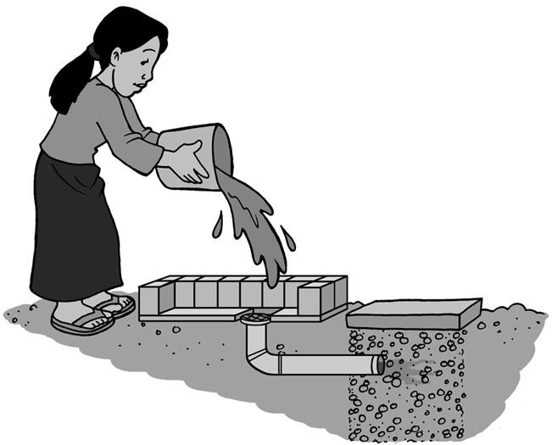



1. **Introduction**

Managing greywater from homes is an important part of environmental sanitation to protect public health and prevent environmental contamination. Greywater includes used water from domestic activities (for example, laundry, dish washing, bathing, cleaning).

This Technical Brief discusses greywater characteristics and simple, low cost options available to manage greywater. Using greywater in home gardens and agriculture is introduced as a way to improve crops and conserve fresh water supplies. As well, treatment, and disposal technologies are presented, like grease traps, soak pits, and infiltration trenches.

This document provides a technical overview and is not a design manual. An experienced professional should be consulted for the design of specific technologies.

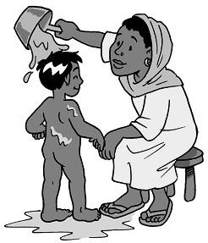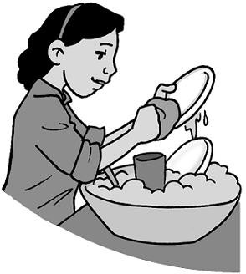

Greywater from bathing and washing dishes

CAWST focuses on the planning, design, and implementation of on-site sanitation projects for low-income communities not connected to a sewer. For such communities, household or decentralized sanitation offers a hygienic and affordable solution.

CAWST’s free, open content resources and schedule of international training workshops can be found at: [https://resources.cawst.org](https://resources.cawst.org/) and [www.cawst.org/training](http://www.cawst.org/training).

1. **Impact of Poor Greywater Management**

In urban and peri-urban areas of low- and middle-income countries, greywater is most often discharged untreated into drains or sewers (provided they exist). This water then flows into a surface water body, like a lake, river or ocean. This can lead to oxygen depletion, increased turbidity, and microbiological and chemical contamination of surface water (Morel and Diener, 2006).

In areas with no drains or sewers, a common practice is to simply dump the greywater onto the ground outside the home. This can lead to stagnant and smelly water that also provides a good breeding site for mosquitos. It also negatively impacts the local living conditions. Nobody likes living in an environment that looks and smells bad.

Another practice is to dispose of greywater in pit latrines. Sometimes the size of the latrine is designed to hold greywater. But usually this is not the case since most households just build their latrine big enough to collect excreta. Adding greywater can cause the pits to fill up faster than planned, increasing the frequency and cost to empty them. As well, putting untreated greywater into pit latrines causes them to smell and attracts flies and other insects.

Pathogens can spread quickly through the environment when greywater is poorly managed. For instance, standing water can:

* Spread pathogens that cause disease (like schistosomiasis)
* Breed disease vectors (like mosquitos that transmit dengue

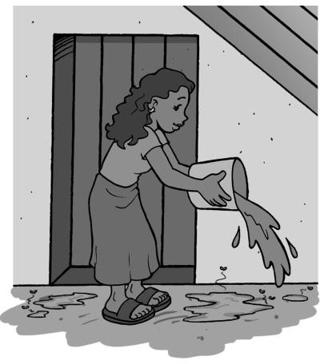

Dumping greywater outside of the home

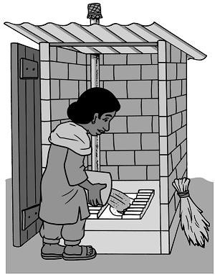

Disposing greywater into a pit latrine

fever, Japanese encephalitis, West Nile fever, Zika virus, and malaria)

* Enter a water point, like a well or tap stand, and contaminate the water source

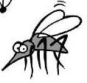

**What is the Connection to Malaria?**

Poor drainage of overflow water can cause standing water. Pools of stagnant water provide an ideal environment for mosquitos to breed, including those that transmit malaria.

In 2015, there were about 214 million malaria cases and an estimated 438,000 malaria deaths. People living in the poorest countries are the most vulnerable to malaria, especially in Africa. As well, children under five are particularly susceptible to malaria illness, infection, and death.

(World Health Organization, 2015)

1. **Greywater Characteristics**

Greywater comes from laundry, dish washing, bathing, and cleaning. It can add up to over 60% of all the domestic wastewater generated in the home. The amount of greywater produced depends on how much water a person uses in a day. A household with no water shortages and a piped supply typically produces about 90–120 litres per person daily. But this can be much less, especially in water scarce areas where people fetch their water and use only 20–30 litres per person daily (Ridderstolpe, 2004; WHO, 2006).

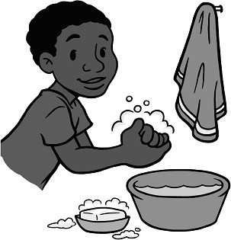The characteristics of greywater vary depending on the household activities. Greywater is influenced by culture, living standards, and the demographics of the family (Morel and Diener, 2006). For instance, a sick person will likely produce a different quality of greywater than a healthy person. The greywater from a sick person may contain more pathogens and body care products.

Greywater usually has low levels of pathogens, especially compared to blackwater. Any pathogens found in greywater are usually from cross- contamination with excreta (WHO, 2006). Fecal pathogens can end up in greywater through handwashing after defecation, washing children after defecation, and washing children’s diapers.

Greywater may also have other contaminants like oil, grease, soap, detergent or other household chemicals. There is little information about the specific characteristics of greywater in low- and middle-income countries. Most of the greywater research focuses on Europe and North America. The following table describes some of the typical characteristics of greywater.

**Table: Greywater Characteristics**

|  |  |
| --- | --- |
| **Source of Greywater** | **Characteristics** |
| Kitchen | * Contains solids (like pieces of food), high amounts of oil and grease, and dishwashing detergent * Occasionally contains drain cleaners and bleach * High in nutrients and suspended solids * Does not usually contain pathogens |
| Bathroom | * Considered the least contaminated source of greywater * Contains soaps, shampoos, toothpaste, other body care products, skin, hair, lint * May also contain pathogens from small amounts of urine and feces |
| Laundry | * Contains high concentrations of chemicals from soap (such as sodium, phosphorous, nitrogen) * May also contain bleach, solids, oils, paints, solvents, and nonbiodegradable fibres from clothing * May also contain pathogens if children’s diapers are washed |

(Adapted from Morel and Diener, 2006)

1. **Greywater Management Options**

The following are options to manage greywater in ways that are the least harmful to people and the environment:

* Source control to reduce the amount of greywater contamination in the first place
* Treat greywater by using primary and secondary treatment technologies
* Reuse greywater to irrigate household gardens and agricultural crops
* Reuse greywater as toilet flush water
* Infiltrate greywater into the ground using a soak pit or infiltration trench
* Discharge greywater into a surface water body (for example, pond, stream, river, lake) These management options are further discussed in the following sections.
  1. **Source Control**

Usually the best management option is to reduce the amount of greywater contamination in the first place. This can be done right in the home. The choice and amount of cleaning products directly impacts the level of greywater contamination. For instance, most hard soaps and common washing powders have sodium salts. When greywater is used for irrigation, these products cause higher salt levels which can harm plants and soils over time. In this case, sodium-based cleaning products should be replaced with potassium-based products, like liquid soaps. Potassium is a fertilizer and supports the growth of plants (Morel and Diener, 2006).

Household cleaning products and laundry soaps often contain chemicals, like bleach, softeners, and whitening products. These products should be avoided since they are harmful to the environment. But this is challenging to do, especially in low- and middle-income countries.

Product labelling is often incomplete and does not show if they are environmentally-friendly (Morel and Diener, 2006). As well, environmentally-friendly cleaning products are usually more expensive than standard products, and may not even be available in many communities.

The amount of solids (like pieces of food) in greywater can be simply reduced in the home. Screens or traps can be used in kitchen sinks, showers and pipes to catch large solids before they enter the greywater system (Morel and Diener, 2006).

* 1. **Treatment**

The choice of treatment option usually depends on the initial quality of the greywater and its final use or disposal. For instance, greywater for irrigation will likely need more treatment than greywater that is infiltrated into the ground. Even if greywater is not reused, treating it before discharge can help to reduce water and soil contamination.

There are three levels of greywater treatment: primary, secondary, and tertiary. Primary treatment is the first step in the process. It uses physical methods (like screening, sedimentation, flotation, and filtration) to remove the following from greywater:

* Coarse solids
* Suspended solids that can settle
* Oil, fat, and scum that can float
* Part of the organic material

Secondary treatment follows primary treatment. The objective is to further remove solids and biodegradable organic material, and reduce pathogen and nutrient levels. Secondary treatment technologies use engineered biological processes in addition to physical methods (like filtration) to treat the greywater. They are usually more complex to construct, operate, and maintain than primary treatment options. These technologies work best after primary treatment (like a grease trap or septic tank) to remove larger solids, oil, grease, and scum.

Tertiary treatment (also called post-treatment) follows secondary treatment. It uses advanced technologies to further remove pathogens, organic material, and nutrients (like phosphorous) from wastewater. Tertiary treatment is sometimes used in centralized wastewater treatment facilities. Tertiary treatment is not necessary or appropriate at the household level for treating greywater.

The level of treatment depends on the final use or disposal of greywater. In some cases, only primary treatment is needed (like disposing greywater into a soak pit). At other times, both primary and secondary treatment may be needed (for instance, reusing greywater for irrigation or discharging to surface water).

The following sections describe primary and secondary treatment technology options that can be used at a household or community level.

* + 1. ***Primary Treatment***

A grease trap can be used to remove coarse solids (like pieces of food), oil, fat, and scum from greywater. A grease trap acts like a small septic tank. Dirty water flows into the trap where oils, fats, and soap scum float to the surface and gravity settles heavier suspended solids to the bottom. Relatively clean water then flows out of the grease trap.

It is important to install a grease trap before infiltrating greywater into the ground, reusing it in agriculture, or discharging it. This lowers the risk of clogging the soak pit or infiltration trench and reduces the potential amount of contamination entering the environment.

Septic tanks are another way to treat greywater before disposal. They are the most common small-scale on-site treatment system worldwide (WHO, 2006). Septic tanks are usually designed to treat toilet flush water and excreta, and greywater can be added as well. Adding greywater can cause the tanks to fill up faster than planned, which increases the frequency and cost to empty them. It is also recommended to pass the greywater through a grease trap before it flows into the septic tank. The effluent from septic tanks still has high levels of pathogens (since the greywater is mixed with excreta). The effluent can be directly discharged to a soak pit or infiltration trench so that it can be infiltrated into the ground, or it can go through secondary treatment. Many countries have national standards for septic tank design and size.

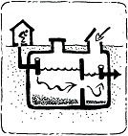

Septic tank (Credit: AKVO, n.d.)

For more information about septic tanks, see the following CAWST resources:

* + - * Fact Sheet: Septic Tanks
      * Technical Brief: Sanitation System – Excreta Storage
      * Technical Brief: Effluent Management
      * Technical Brief: Design Calculations for Soak Pits and Infiltration Trenches



**What About Other Primary Treatment Methods?**

It is not recommended to use sand or gravel filters as primary treatment for greywater. There are many examples of problems with sand or gravel filters. They are easily clogged and must be well-maintained. The filter material must be washed or replaced periodically. Washing the filter material is difficult, unpleasant, and most importantly, unhygienic. Replacing the filter material can become expensive over time. Sand or gravel filters should only be used as a secondary treatment step (Morel and Diener, 2006).

Pond systems are also not recommended for primary treatment of greywater at the household level. They have been used before, though mainly for large-scale applications (Morel and Diener, 2006). Pond systems can look unpleasant, smell bad, and are a perfect breeding place for mosquitos if they are not well-operated and maintained (Ridderstolpe, 2004 cited in Morel and Diener, 2006). The World Health Organization (WHO) Guidelines for treating greywater says that any pond system must be built in a way that it does not cause a different environmental problem, like creating a breeding site for mosquitos (WHO, 2006).

* + 1. ***Secondary Treatment***

The following table describes the most common secondary treatment technologies for greywater that can be used at a household or community level.

**Table: Greywater Secondary Treatment Technologies**

|  |  |  |
| --- | --- | --- |
| **Secondary**  **Treatment Technology** | **Description** | **Use** |
| Anaerobic Filter | One or more watertight tanks are filled with filter material, like gravel, crushed rocks or bricks. A biolayer forms around the filter material over time. As greywater flows through the filter, the filter traps solid particles and the biolayer degrades organic material. Anaerobic filters are not efficient at removing nutrients and pathogens. However, worm eggs may be removed depending on the filter material used (Tilley, Ulrich, Lüthi, Reymond & Zurbrügg, 2014). The filter works without oxygen, so harmful and bad smelling gases are produced which need to be managed and vented. | Have been widely used as secondary treatment in household greywater treatment systems. |
| Vertical Flow Filter | Also called percolation beds, infiltration beds, subsurface biofilters or intermittent sand filters. A vertical flow filter is a watertight tank filled with filter material, usually sand and gravel. A biolayer forms around the filter material over time. Greywater flows intermittently into the top of the tank, and filters through the sand and gravel. It is then collected in a drainage system at the bottom or infiltrated directly into the soil. The filter traps solid particles and the biolayer degrades organic material. The filter works with oxygen, so there are no bad smells. | Are frequently used as secondary treatment in household greywater treatment systems throughout the world. Have been shown to work even in cold climates. |
| Constructed Wetlands | Also called planted gravel filters. A constructed wetland aims to copy the naturally occurring processes in wetlands. They are constructed of a bed that is lined with impermeable material and filled with coarse sand and gravel. A soil layer is usually placed on top to grow plants. As effluent slowly flows through the wetland, solid particles are trapped and adsorped, and pathogens, organic material, and nutrients are degraded by complex biochemical processes. | Frequently used where greywater is to be reused in irrigation or where there are water quality requirements for disposing greywater into surface water bodies. Does not work as well in cold climates. |

* 1. **Reuse**

(WHO, 2006; Morel and Diener, 2006; Illustrations credit: AKVO, n.d.)

Reusing greywater for irrigating home gardens or agricultural land is common, especially in regions with water scarcity or high water prices, such as the Middle East, parts of Africa, and Latin America. In regions with plentiful water supplies, there is less importance placed on reusing greywater and it is simply disposed of (Morel and Diener, 2006).

Greywater can be beneficially used to irrigate a household garden or larger agricultural crops. This can help communities to grow more food while at the same time, conserve precious water. Using greywater in agriculture is also considered to be a low-cost treatment method. It relies on the soil to remove any pathogens and nutrients from the greywater. Overall, using greywater in agriculture instead of disposing of it directly into surface water can actually reduce the negative impacts on public health and the environment (WHO, 2006).



**Watch the Salt!**

Salinity of greywater is normally not a problem, but is can be an issue when greywater is used for irrigation. Salt can interfere with plant growth and have long-term impacts on the soil.

When using greywater for irrigation, liquid laundry soaps containing potassium are preferred, since hard soaps and washing powders often contain sodium (WHO, 2006).

There may be some health risks with using greywater in agriculture. Any risks are usually from greywater being cross-contaminated with excreta. The risks can be reduced by first treating the greywater and using a multi-barrier approach of health protection measures. The WHO Guidelines for greywater use in agriculture (2006) gives specific recommendations to minimize the health risks, as shown in the following table. These barriers focus on protecting the people handling the greywater (farmers), those eating the food or using the product (consumers), and the local community.

**Table: Barriers to Protect Health**

|  |  |  |
| --- | --- | --- |
| **Barriers to Protect Health** | | **Action** |
|  | Restrict crops | Only use greywater for crops that:   * Are not eaten (like cotton) * Are processed (like wheat) * Are cooked (like potatoes) * Do not directly touch the ground (like bananas) |
|  | Application techniques | Do not apply greywater directly on the plant. |
|  | Use protective equipment | Wear protective equipment, such as clothing, gloves, and shoes. |
|  | Waiting period | Wait one month after irrigating with greywater before harvesting crops. Pathogens continue to be inactivated once they are in the soil. Inactivation is much faster in hot and sunny climates than cold and rainy climates. |
|  | Prepare food properly | Wash fruits and vegetables with safe water before eating. Wash hands with soap before cleaning and preparing food. Cook all food thoroughly and do not eat raw food. |

|  |  |  |
| --- | --- | --- |
| **Barriers to Protect Health** | | **Action** |
|  | Wash hands | Wash hands with soap after handling greywater. |
|  | Train | Train farmers, families, and the community on proper greywater management and hygiene practices. |

Greywater can also be collected from laundry and showers to flush the toilet (WHO, 2006). This is a common practice in areas with interrupted water supplies. Modern buildings (mainly in industrialized countries) are using innovative designs to reuse greywater for toilet flushing.

* 1. **Disposal**

Discharging greywater into a surface water body (like a river, pond, lake or sea) is the most common method of disposal, especially in urban and peri-urban areas. Most countries do not have greywater-specific standards for discharge into surface water bodies (Morel and Diener, 2006). The WHO (2006) recommends that greywater is treated before discharge to protect public health and the environment.

There are other options to dispose of greywater at the household level that are simple, low cost, and effective. Infiltrating greywater into the ground using a soak pit or infiltration trench is a simple and suitable method (WHO, 2006).

A soak pit is a dug pit that allows used water to safely infiltrate into the ground. Soak pits must be lined or filled with rocks to prevent erosion and to prevent the walls from collapsing. The size of the soak pit is based on the amount of water entering the pit and whether the water is clean or dirty. Infiltration only happens through the side walls of the soak pit. Almost no infiltration occurs through the base of the pit because it quickly clogs with solids. It is important to design the size of the soak pit to handle peak flows of water, especially if the infiltration capacity of the surrounding soil is low.

The simplest and quickest way to build a soak pit is to dig a pit and fill it with rocks. However, the rocks reduce the volume of water that the pit can hold and finding enough rock may be difficult in some places. Lining the soak pit walls with bricks or blocks overcomes both of these issues, but it increases the construction time and difficulty.

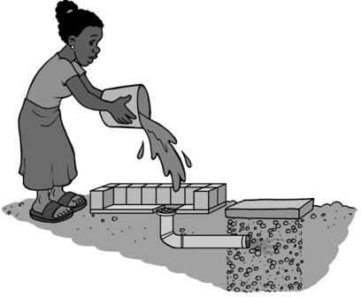

Disposing greywater into a soak pit

Trenches can be used in situations where a soak pit is unable to infiltrate the total amount of greywater water. This can be either because of low soil infiltration capacity, large amounts of water or a combination of the two. Infiltration trenches are long shallow pits. They require more planning, space, and materials than a soak pit, but create a much greater surface area for infiltration into the soil. Infiltration trenches are often used in conjunction with septic tanks.

There are no WHO Guidelines for treating greywater before it is disposed of using a soak pit or infiltration trench. However, a grease trap should be used to clean greywater before it is infiltrated into the ground. Suspended solids, grease, and scum in greywater will clog the soil and reduce the infiltration rate. Greywater must be free of these substances before infiltration.

The WHO (2006) recommends locating soak pits and infiltration trenches so that they do not contaminate groundwater. See CAWST’s Technical Brief: Siting Latrines for recommendations that can also be used to site soak pits and infiltration trenches.

For more information, see CAWST’s Technical Brief: Design Calculations for Soak Pits and Infiltration Trenches.

1. **Definitions**

**Disposal:** The return of waste to the environment, ideally in a way that is least harmful to public health and the environment.

**Domestic wastewater:** Also called used water. Includes three types of used water generated by households: (1) toilet flush water that contains excreta (also called blackwater), (2) water from household activities such as bathing, dishwashing, laundry, and cleaning (also called greywater), and (3) overflow water from water points. Wastewater can be managed on-site or off-site. Wastewater managed off-site is often called sewage.

**Environmental sanitation:** Interventions that reduce people’s exposure to disease by providing a clean environment in which to live, with measures to break the cycle of disease. It usually includes human and animal excreta management, wastewater management, stormwater drainage, solid waste management, vector control, and personal and domestic hygiene. As well, drinking water is sometimes included in the definition, as sustainable environmental sanitation cannot be planned and implemented in isolation from water supply.

**Excreta:** Urine and feces that are not mixed with any flush water.

**Greywater:** Used water from household activities, such as laundry, dishwashing, bathing, and cleaning. It does not include toilet flush water.

**Impermeable:** Also called watertight. Liquids cannot pass through.

**Infiltrate:** To pass into or through something. Infiltration is the process by which liquid enters the surrounding soil.

**Pathogen:** An organism that causes disease.

**Primary treatment:** The first stage in wastewater treatment to remove solids and organic material mostly through sedimentation or flotation.

**Secondary treatment:** Follows primary treatment to remove biodegradable organic material and suspended solids in wastewater. Nutrient removal and disinfection can be included in both the definitions of secondary and tertiary treatment, depending on the configuration.

**Suspended solids:** Small solid particles in water. Suspended solids will settle over time if left undisturbed.

**Tertiary treatment:** Also called post-treatment. Follows secondary treatment to further remove organic material, pathogens, and nutrients (in particular phosphorous) in wastewater. Nutrient removal and disinfection can be included in both the definitions of secondary and tertiary treatment, depending on the configuration.

**Vector:** A living thing that transmits a disease to a host. Vectors include mosquitos, flies, and rodents. For example, flies can carry and transmit pathogens from feces to humans.

**Virus:** A tiny organism that multiplies within cells of a living host and cause disease such as hepatitis and rotavirus.

**Wastewater:** Used water from any combination of domestic, industrial, commercial or agricultural activities, surface runoff (stormwater), and any sewer inflow (infiltration). Wastewater can be managed on-site or off-site. Wastewater managed off-site is often called sewage.

1. **Additional Resources**

**CAWST Sanitation Resources.** Available at: [http://resources.cawst.org](http://resources.cawst.org/)

* CAWST’s education and training resources are available on a variety of sanitation topics including environmental sanitation (including vector control); latrine design and construction; fecal sludge management; and sanitation implementation.

Morel, A. and S. Diener (2006). **Greywater Management in Low and Middle Income Countries: Review of Different Treatment Systems for Households or Neighbourhoods.** Swiss Federal Institute of Aquatic Science and Technology (EAWAG). Dübendorf, Switzerland. Available at: [www.eawag.ch/forschung/sandec/publikationen/ewm/dl/GW_management.pdf](http://www.eawag.ch/forschung/sandec/publikationen/ewm/dl/GW_management.pdf)

* Presents an overview of the issues related to greywater management, describes the characteristics of greywater, and provides a wide range of management options that are appropriate for on-site sanitation systems in developing countries.

World Health Organization (2006). **Guidelines for the Safe Use of Wastewater, Excreta and Greywater.** WHO, Geneva, Switzerland. Available at: [www.who.int/water_sanitation_health/wastewater/en/](http://www.who.int/water_sanitation_health/wastewater/en/)

* The purpose of the Guidelines are to maximize public health and the beneficial use of wastewater, excreta and greywater. Volume 2 focuses on the use of wastewater, excreta, and greywater in agriculture to manage the health risks and ensure that it is as safe as possible.

1. **References**

Morel, A. and S. Diener (2006). *Greywater management in low and middle income countries: Review of different treatment systems for households or neighbourhoods*. Dübendorf, Switzerland: Swiss Federal Institute of Aquatic Science and Technology (Eawag). Retrieved from [www.eawag.ch/forschung/sandec/publikationen/ewm/dl/GW_management.pdf](http://www.eawag.ch/forschung/sandec/publikationen/ewm/dl/GW_management.pdf)

Ridderstolpe, R. (2004). *Introduction to greywater management*. Stockholm, Sweden: Stockholm Environment Institute. Retrieved from [www.ecosanres.org](http://www.ecosanres.org/)

Tilley, E., Ulrich, L., Lüthi, C., Reymond, P. and C. Zurbrügg (2014). *Compendium of sanitation systems and technologies*, 2nd Revised Edition. Dübendorf, Switzerland: Swiss Federal Institute of Aquatic Science and Technology (Eawag). Retrieved from www.sandec.ch/compendium

World Health Organization (2006). *Guidelines for the safe use of wastewater, excreta and greywater*. Geneva, Switzerland: WHO. Retrieved from [www.who.int/water_sanitation_health/wastewater/en/](http://www.who.int/water_sanitation_health/wastewater/en/)

World Health Organization (2015). *Fact sheet: World malaria report 2015*. Geneva, Switzerland: WHO. Retrieved from [www.who.int/malaria/media/world-malaria-report-2015/en/](http://www.who.int/malaria/media/world-malaria-report-2015/en/)

CAWST (Centre for Affordable Water and Sanitation Technology) Calgary, Canada

Website: [www.cawst.org](http://www.cawst.org/) Email: [support@cawst.org](mailto:support@cawst.org)

*Wellness through Water. Empowering People Globally*

Last Update: July 2016

This document is open content. You are free to:

* Share – Copy and redistribute the material in any medium or format
* Adapt – Remix, transform, and build upon the material for any purpose, even commercially

Under the following terms:

* Attribution – You must give appropriate credit to CAWST, provide a link to the license, and indicate if changes were made. You may do so in any reasonable manner, but not in any way that suggests that CAWST endorses you or your use. Please include our website: www.cawst.org

CAWST and its directors, employees, contractors, and volunteers do not assume any responsibility for, and make no warranty with respect to, the results that may be obtained from the use of the information provided.

**Contents**

1. **Introduction 65**
2. **Impact of Poor Overflow Water Management 65**
3. **Overflow Water Management Options 66**
   1. Reuse in Agriculture 66
   2. Infiltrate into the Ground 67
   3. Discharge to Surface Water 68
4. **Definitions 69**
5. **Additional Resources 70**
6. **References 70**

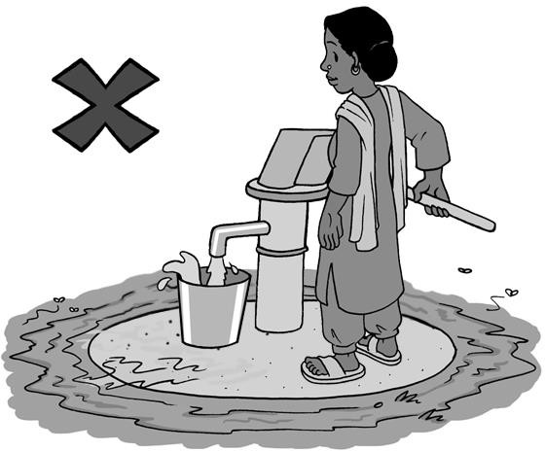



**Technical Brief: Overflow Water Management**

1. **Introduction**

Managing overflow water that has spilled from wells or water points is an important part of environmental sanitation to protect public health and prevent environmental contamination. Yet, overflow water has traditionally received little attention.

This Technical Brief focuses on simple and low cost options available to manage overflow water. Using overflow wastewater in home gardens and agriculture is introduced as a way to improve crops and conserve fresh water supplies. As well, specific disposal technologies are presented, like soak pits and infiltration trenches.

CAWST focuses on the planning, design, and implementation of on-site sanitation projects for low-income communities not connected to a sewer. For such communities, household or decentralized sanitation offers a hygienic and affordable solution.

CAWST’s free, open content resources and schedule of international training workshops can be found at: [https://resources.cawst.org](https://resources.cawst.org/) and [www.cawst.org/training](http://www.cawst.org/training).

1. **Impact of Poor Overflow Water Management**

Pathogens can spread quickly through the environment when overflow water is poorly managed. For instance, standing water can:

* Spread pathogens that cause disease (like schistosomiasis)
* Breed disease vectors (like mosquitos that transmit dengue fever, Japanese encephalitis, West Nile fever, and malaria)
* Backflow into the water point, like a well or tap stand, and contaminate the water source
* Become stagnant and cause bad smells that make the local environmental unpleasant for those living in the area
* Erode the soil away and damage the water point structure.

Poor drainage can also cause more frequent and severe flooding, spreading contamination. In some places, waterborne disease outbreaks can be reduced through better overflow water management.



**What is the Connection to Malaria?**

Poor drainage of overflow water can cause standing water. Pools of stagnant water provide an ideal environment for mosquitos to breed, including those that transmit malaria.

In 2015, there were about 214 million malaria cases and an estimated 438,000 malaria deaths. People living in the poorest countries are the most vulnerable to malaria, especially in Africa. As well, children under five are particularly susceptible to malaria illness, infection, and death.

(World Health Organization, 2015)

1. **Overflow Water Management Options**

Overflow water from a pump or tap stand should have very low levels of pathogens. It is a good quality water source that requires little or no treatment before it can be reused for various purposes or safely disposed. However, overflow water can quickly become contaminated with pathogens from human and animal excreta when it is not well managed.

Overflow water can be managed in the following ways:

* Used as irrigation water for agriculture
* Discharged directly to surface water (for example, lakes, rivers or ponds)
* Infiltrated into the ground using soak pits or infiltration trenches

Regardless of the management option used, all water points should have a concrete apron around them to direct the overflow water away and prevent standing water. As well, drainage channels can be built to carry overflow water away from the water point. Drainage channels can transport the overflow water to be the point where it is to be used, discharged, or infiltrated.

* 1. **Reuse in Agriculture**

There is growing recognition of the value of used water. In water scarce regions, people are looking to use overflow water as an alternative to help save fresh water sources. Overflow water can be reused for various purposes, such as irrigation for home gardens or agricultural crops.

Overflow water can be beneficially used to irrigate a household garden or larger agricultural crops. This can help communities to grow more food while at the same time conserve water. Using overflow water in agriculture is also considered to be a low-cost treatment method. It relies on the soil to remove any pathogens and nutrients from the water. Overall, using overflow water in agriculture instead of disposing of it directly into surface water may reduce the negative impacts on public health and the environment.

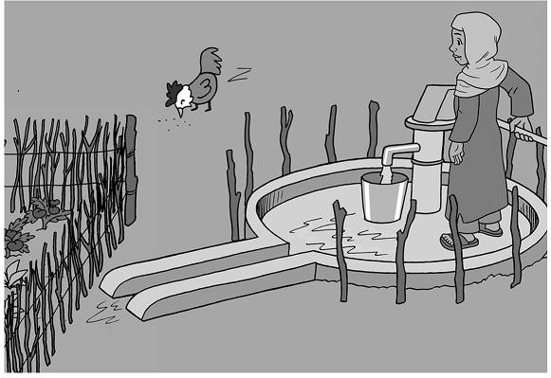

Hand pump with a concrete apron that directs the overflow water to a nearby garden

There may be some health risks of using overflow water in agriculture. Any risks are usually from overflow water being cross-contaminated with excreta. The risks can be reduced by using a multi-barrier approach of health protection measures. These barriers focus on protecting the people handling the overflow (like farmers), those eating the food or using the product (consumers), and the local community.

**Table: Barriers to Protect Health**

|  |  |  |
| --- | --- | --- |
| **Barriers to Protect Health** | | **Action** |
|  |  | Only use overflow water for crops that: |
| Crop restriction | * Are not eaten (like cotton) * Are processed (like wheat) * Are cooked (like potatoes) |
|  | * Do not directly touch the ground (like bananas) |
|  | Application techniques | Do not apply overflow water directly on the plant. |
|  | Use protective equipment | Wear protective equipment, such as clothing, gloves, and shoes. |
|  | Waiting period | Wait one month after irrigating with overflow water before harvesting crops. Pathogens continue to be inactivated once they are in the soil. Inactivation is much faster in hot and sunny climates than cold and rainy climates. |
|  | Prepare food properly | Wash fruits and vegetables with safe water before eating. Wash hands with soap before cleaning and preparing food. Cook all food thoroughly and do not eat raw food. |
|  | Wash hands | Wash hands with soap after handling overflow water. |
|  | Train | Train farmers, families, and the community on proper overflow water management and hygiene practices. |

* 1. **Infiltrate into the Ground**

Infiltrating overflow water into the ground using a soak pit is another simple and suitable option for households. A soak pit is a dug pit that allows used water to safely infiltrate into the ground.

Soak pits must be lined or filled with rocks to prevent erosion and to prevent the walls from collapsing. The size of the soak pit is based on the amount of water entering the pit and whether the water is clean or dirty. Infiltration only happens through the side walls of the soak pit. Almost no infiltration occurs through the base of the pit because it quickly clogs with solids. It is important to design the size of the soak pit to handle peak flows of water, especially if the infiltration capacity of the surrounding soil is low.

The simplest and quickest way to build a soak pit is to dig a pit and fill it with rocks. However, the rocks reduce the volume of water that the pit can hold and finding enough rock may be difficult in some places. Lining the soak pit walls with bricks or blocks overcomes both of these issues, but it increases the construction time and difficulty.

**Figure: Soak Pit Filled with Rocks**

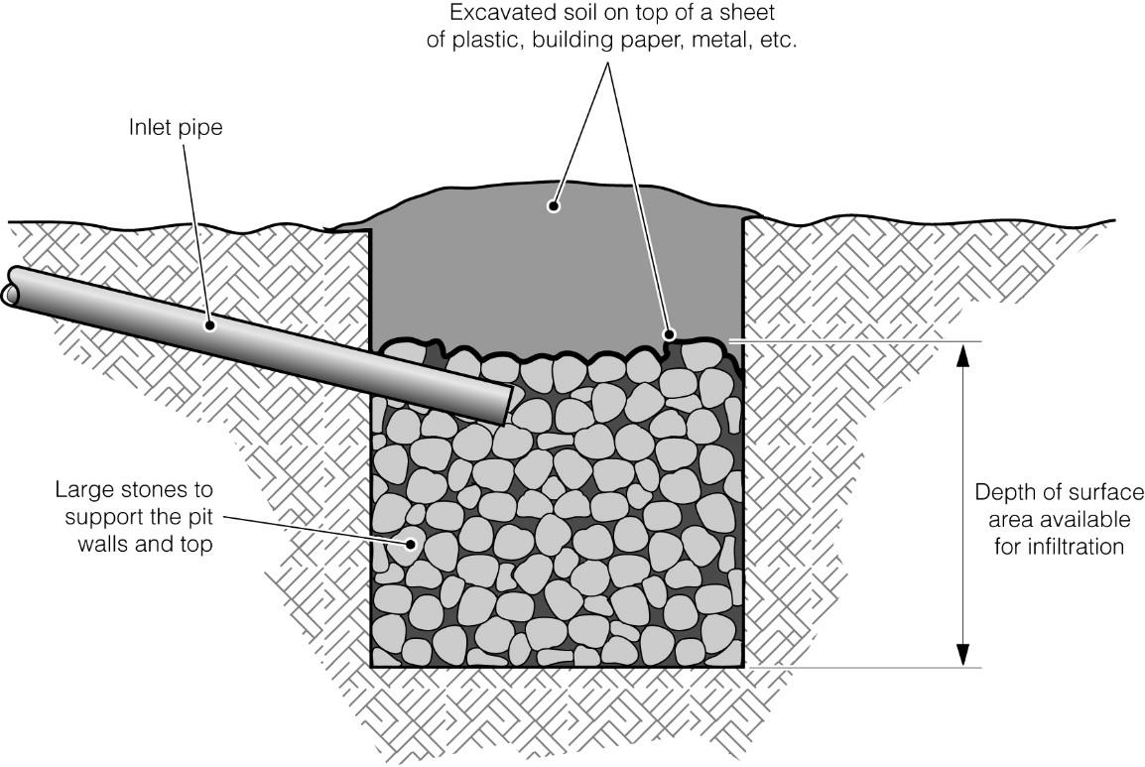

Excavated soil on top of a sheet of plastic, building paper, or metal

Inlet pipe

Large stones to support the pit walls and top

Depth of surface area available for infiltration

Soak pit filled with rocks and covered sheet and soil (Credit: Chatterton)

Trenches can be used in situations where a soak pit is unable to infiltrate the total amount of overflow water. This can be either because of low soil infiltration capacity, large amounts of water or a combination of the two. Infiltration trenches are long shallow pits. They require more planning, space, and materials than a soak pit, but create a much greater surface area for infiltration into the soil. Infiltration trenches are often used in conjunction with septic tanks.

More information about soak pit design can be found in CAWST’s Technical Brief: Design Calculations for Soak Pits and Infiltration Trenches.

* 1. **Discharge to Surface Water**

Discharging overflow water into a surface water body (like a river, pond, lake or sea) is the most common method of disposal, especially in urban and peri-urban areas. Most countries do not have specific standards for discharging overflow water.

The water point should be constructed with a concrete apron and drainage channels, which can be open or closed. The channels carry the overflow water away to where it is discharged. In many places, drainage channels become dumps for household waste. Channels must be kept clean of waste to prevent them from blocking water flow and causing additional flooding. See CAWST’s Technical Brief: Solid Waste Management for further information on how to properly dispose of solid waste.

1. **Definitions**

**Disposal:** The return of waste to the environment, ideally in a way that is least harmful to public health and the environment.

**Environmental sanitation:** Interventions that reduce people’s exposure to disease by providing a clean environment in which to live, with measures to break the cycle of disease. It usually includes human and animal excreta management, wastewater management, stormwater drainage, solid waste management, vector control, and personal and domestic hygiene. As well, drinking water is sometimes included in the definition, as sustainable environmental sanitation cannot be planned and implemented in isolation from water supply.

**Excreta:** Urine and feces that are not mixed with any flush water.

**Infiltrate:** To pass into or through something. Infiltration is the process by which liquid enters the surrounding soil.

**Overflow water:** Water that has spilled from wells or water points.

**Pathogen:** An organism that causes disease.

**Vector:** A living thing that transmits a disease to a host. Vectors include mosquitos, flies, and rodents. For example, flies can carry and transmit pathogens from feces to humans.

**Wastewater:** Used water from any combination of domestic, industrial, commercial or agricultural activities, surface runoff (stormwater), and any sewer inflow (infiltration). Wastewater can be managed on-site or off-site. Wastewater managed off-site is often called sewage.

1. **Additional Resources**

**CAWST Sanitation Resources.** Available at: [https://resources.cawst.org](https://resources.cawst.org/)

* CAWST’s education and training resources are available on a variety of sanitation topics including environmental sanitation (including vector control); latrine design and construction; fecal sludge management; and sanitation implementation.

1. **References**

Chatterton, K. (nd). *Soak pit.* WEDC Image Library. Loughborough, UK: WEDC. Retrieved from <http://wedc.lboro.ac.uk/knowledge/img-lib-lres.html?id=10-0>

World Health Organization (2015). *Fact sheet: World malaria report 2015*. Geneva, Switzerland: WHO. Retrieved from [www.who.int/malaria/media/world-malaria-report-2015/en/](http://www.who.int/malaria/media/world-malaria-report-2015/en/)

CAWST (Centre for Affordable Water and Sanitation Technology) Calgary, Canada

Website: [www.cawst.org](http://www.cawst.org/) Email: support@cawst.org

*Wellness through Water. Empowering People Globally*

Last Update: July 2016

This document is open content. You are free to:

* Share – Copy and redistribute the material in any medium or format
* Adapt – Remix, transform, and build upon the material for any purpose, even commercially

Under the following terms:

* Attribution – You must give appropriate credit to CAWST, provide a link to the license, and indicate if changes were made. You may do so in any reasonable manner, but not in any way that suggests that CAWST endorses you or your use. Please include our website: www.cawst.org

CAWST and its directors, employees, contractors, and volunteers do not assume any responsibility for, and make no warranty with respect to, the results that may be obtained from the use of the information provided.

**Contents**

1. Introduction 72
2. Design Basics 72
3. Calculations Using Design Tables 73
   1. Pit Shape 73
   2. Soil Type 74
   3. Design Tables 75
   4. Practice Questions 78
4. Calculations by Hand 79
   1. Calculating Infiltration Area for Pits and Trenches Based on Dimensions 79
      1. Rectangular Pit 79
      2. Circular Pit 83
   2. Calculating Infiltration Area Based on Usage 86
   3. Summary of Equations 89
   4. Example Questions 90
      1. Rectangular Soak Pit Calculation – Finding Depth 90
      2. Circular Soak Pit Calculation – Finding Depth 93
      3. Infiltration Trench – Finding Length 96
5. Additional Resources 99
6. References 99

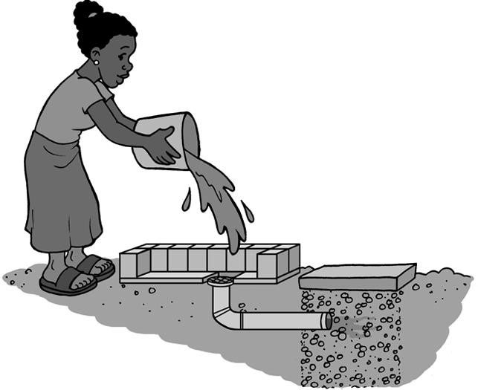

1. **Introduction**

This Technical Brief explains how to design soak pits and infiltration trenches used to manage domestic wastewater. A soak pit is a dug pit that allows wastewater to be safely infiltrated into the ground. Trenches can be used in situations where a soak pit is unable to infiltrate the total amount of wastewater. See CAWST’s Technical Brief: Domestic Wastewater Management for further information.

The following information is provided in this Technical Brief:

* Design tables for soak pits and infiltration trenches
* Practice questions using the design tables
* Explanations of the equations used for soak pit and infiltration trench calculations
* Step-by-step sample calculations with full solutions

1. **Design Basics**

There are five pieces of information that must be considered to design a soak pit or infiltration trench:

1. **Infiltration area (iA):** The surface area required to infiltrate the amount of wastewater entering the pit. **IMPORTANT**: This is the surface area of just the sides of the pit. This does not include the surface area of the bottom or top of the pit. This is because the bottom clogs quickly and does not infiltrate very much water.
2. **Pit dimensions:**
   * **Length (L)** and **width (W)** for a rectangular or square pit.
   * **Diameter (d)** (the distance from one side of the circle to the opposite through the middle) for a circular pit.
3. **Soil infiltration rate (iR):** The rate at which water moves from the pit into the soil. This depends on the characteristics of the soil.
4. **Wastewater loading (Q):** The amount of wastewater entering the pit throughout a day.
5. **Pit depth (D):** How deep the pit is.
6. **Calculations Using Design Tables**

This section provides tables that can be used to design a soak pit or infiltration trench. These tables do not cover all possible options. If none of the options are appropriate for your needs, then you will have to design your soak pit or infiltration trench by hand. Section 4 Calculations by Hand explains how to do this.

* 1. **Pit Shape**

You first need to decide whether you are constructing a soak pit or infiltration trench. If building a soak pit, you then need to choose the pit shape. Soak pits can be either rectangular or circular. Infiltration trenches are normally rectangular.

**Rectangular Pit**

**Diameter (d)**

Depth (D)

Depth (D)

Width (W)

Length (L)

**Circular Pit**

**Infiltration Trench**

Depth (D)

Length (L)

When choosing the shape, remember the following:

* Circular pits are less likely to collapse because the pressure from the surrounding soil is evenly spread.
* Rectangular pits tend to collapse more often because pressure is placed on the four walls. This leaves the corners to absorb the stress.

Pressure from surrounding ground

Pressure from surrounding ground

(Lifewater, 2009)

* 1. **Soil Type**

You must know the type of soil to make sure you get the right design. The following table shows the different types of soil and their physical descriptions.

**Types of Soil and their Physical Description**

|  |  |
| --- | --- |
| **Soil Type** | **Physical Description** |
| Gravel, coarse and medium sand | Moist soil will not stick together |
| Fine and loamy sand | Moist soil sticks together, but will not form a ball |
| Sandy loam and loam | Moist soil forms a ball, but still feels gritty when rubbed between the fingers |
| Loam, porous silt loam | Moist soil forms a ball which easily deforms and feels smooth between the fingers |
| Silty clay loam and clay loam | Moist soil forms a strong ball which smears when rubbed but does not go shiny |
| Clay* | Moist soil molds like plasticine and feels sticky when wet |

(Harvey *et al*., 2002)

* Clay is not suitable for soak pits or trenches since it is difficult for the water to infiltrate the soil.

* 1. **Design Tables**

This section provides tables that can be used to design a soak pit or infiltration trench. The tables can be used to design soak pits or infiltration trenches for inputs of 80, 120 and 160 litres of wastewater daily.

The tables were calculated assuming that the pit or trench will be lined and not filled with rocks. You may want to slightly increase the dimensions of your pit or trench if you will be filling it with rocks instead of lining it.



**Important Information for Soak Pit Tables**

The tables are calculated assuming a concrete slab will be placed as a cover. If your soak pit will be buried underground, you will need space for cover, drainage, and backfill. For buried pits, add at least 0.2 metres onto the value found in the table.

**Practical Considerations**

1. A pit deeper than 1.2 metres should be supported by lining or shoring (a temporary support structure) while digging. This will help to prevent it from collapsing on the person digging.
2. The bottom of the pit should be at least 2 metres above the highest annual groundwater level.
3. Infiltration trenches are long, narrow (about the width of a shovel), and shallow. They usually require more space and materials, but can infiltrate a larger amount of water than a soak pit.

**Soak Pit Design for 1 metre Diameter (Circular) or 1 x 1 metre Square (Rectangular)**

|  |  |  |  |  |  |  |
| --- | --- | --- | --- | --- | --- | --- |
| **Soil Type** | **Pit Depth (metres)** | | | | | |
| **80 litres Daily** | | **120 litres Daily** | | **160 litres Daily** | |
| Circle | Square | Circle | Square | Circle | Square |
| Gravel, coarse and medium sand | 0.5 | 0.4 | 0.8 | 0.6 | 1.0 | 0.8 |
| Fine and loamy sand | 0.8 | 0.6 | 1.2 | 0.9 | 1.5 | 1.2 |
| Sandy loam and loam | 1.1 | 0.8 | 1.6 | 1.3 | 2.1 | 1.7 |
| Loam, porous silt loam | 1.4 | 1.1 | 2.1 | 1.7 | 2.8 | 2.2 |
| Silty clay loam and clay loam | 3.2 | 2.5 | 4.8* | 3.8* | 6.4* | 5.0* |

**Soak Pit Design for 1.2 metre Diameter (Circular) or 1.2 x 1.2 metre Square (Rectangular)**

|  |  |  |  |  |  |  |
| --- | --- | --- | --- | --- | --- | --- |
| **Soil Type** | **Pit Depth (metres)** | | | | | |
| **80 litres Daily** | | **120 litres Daily** | | **160 litres Daily** | |
| Circle | Square | Circle | Square | Circle | Square |
| Gravel, coarse and medium sand | 0.4 | 0.3 | 0.6 | 0.5 | 0.8 | 0.7 |
| Fine and loamy sand | 0.6 | 0.5 | 1.0 | 0.8 | 1.3 | 1.0 |
| Sandy loam and loam | 0.9 | 0.7 | 1.3 | 1.0 | 1.8 | 1.4 |
| Loam, porous silt loam | 1.2 | 0.9 | 1.8 | 1.4 | 2.4 | 1.9 |
| Silty clay loam and clay loam | 2.7 | 2.1 | 4.0 | 3.1 | 5.3 | 4.2 |



**Important Information for Infiltration Trench Tables**

These tables were calculated for a 0.5 metre depth and a 1.0 metre depth. When you actually go to build the trench, dig at least 0.2 metres deeper so that there is space for soil cover. For example, if you want a trench depth of 0.5 metres, then you must dig 0.7 metres deep. For a 1.0 metre depth, you must dig 1.2 metres deep.

**Infiltration Trench Design for 0.5 metre Deep Trench (not including depth of cover)**

|  |  |  |  |
| --- | --- | --- | --- |
| **Soil Type** | **Trench Length (metres)** | | |
| **80 litres Daily** | **120 litres Daily** | **160 litres Daily** |
| Gravel, coarse and medium sand | 1.6 | 2.4 | 3.2 |
| Fine and loamy sand | 2.4 | 3.6 | 4.8 |
| Sandy loam and loam | 3.3 | 5.0 | 6.7 |
| Loam, porous silt loam | 4.4 | 6.7 | 8.9 |
| Silty clay loam and clay loam | 10.0 | 15.0 | 20.0 |

**Infiltration Trench Design for a 1.0 metre Deep Trench (not including depth of cover)**

|  |  |  |  |
| --- | --- | --- | --- |
| **Soil Type** | **Trench Length (metres)** | | |
| **80 litres Daily** | **120 litres Daily** | **160 litres Daily** |
| Gravel, coarse and medium sand | 0.8 | 1.2 | 1.6 |
| Fine and loamy sand | 1.2 | 1.8 | 2.4 |
| Sandy loam and loam | 1.7 | 2.5 | 3.3 |
| Loam, porous silt loam | 2.2 | 3.3 | 4.4 |
| Silty clay loam and clay loam | 5.0 | 7.5 | 10.0 |

* 1. **Practice Questions**

Use the design tables in Section 3.3 to answer the following questions. Solutions are found at the end of this section.

**Question 1**

* A family wants to build a rectangular soak pit
* They need to dispose of 80 litres of wastewater each day
* They want to make it 1 metre by 1 metre
* They are digging in sandy loam How deep should their pit be?

**Question 2**

* A family wants to build a circular soak pit
* They need to dispose of 120 litres of wastewater each day
* They want to make it with a 1.2 metre diameter
* They are digging in fine and loamy sand How deep should their pit be?

**Question 3**

* A family wants to build an infiltration trench.
* They need to dispose of 80 litres of wastewater each day
* The depth of the trench walls is 0.5 metres
* They are digging in sandy loam

How long should their trench be? How deep do they have to dig to account for 0.2 metres of cover?

**Answers to Practice Questions:**

1. Pit depth = 0.8 metres
2. Pit depth = 1.0 metres
3. Trench depth = 3.3 metres, Dig = 3.5 metres
4. **Calculations by Hand**

This section will explain the equations that are used to design soak pits and infiltration trenches. It will then lead you through sample and practice questions.

There are two ways to calculate the infiltration area: 1) using the dimensions of the pit or trench, or 2) based on how much wastewater will enter the pit or trench.

* 1. **Calculating Infiltration Area for Pits and Trenches Based on Dimensions**

We will start with the pit shapes and the equations that are needed to figure out infiltration area.

* + 1. **Rectangular Pit**

The infiltration area for a rectangular pit can be calculated from the three pit dimensions:

* + - * **Depth**
      * **Length**
      * **Width**

**Rectangular Soak Pit**

**Infiltration Trench**

Depth (D)

Depth (D)

Length (L)

Width (W)

Length (L)

A rectangular shape is made of three sets of rectangles that have different dimensions.

1. **Top and bottom** are the same
2. **Front and back** are the same
3. **Side and side** are the same

Width (W)

***Top and Bottom***

This is the shape that you see when you look at the pit from above.

The length and width of the pit are most likely determined by the size of slab you have or can build.

Length (L)

***Front and Back***

You create the depth as you dig your pit.

The *front and back* rectangle shares the length dimension of the *top and bottom* rectangle.

Depth (D)

The dimensions of this rectangle are length (L) and depth (D).

Length (L)

***Side and Side***

The *side and side* rectangle has the same depth (D) as the *front and back* rectangles.

Depth (D)

It also has the same width (W) as the *top and bottom*

rectangles.

Width (W)

***Infiltration Area***

**Area of Front and Back Rectangles**

*Area*  *Length*  *Depth A*  *L*  *D*

Depth (D)

* + - * + Length and depth are measured in metres (m)
        + Surface area is measured in square metres (m2)

Length (L)

**Area of Side and Side Rectangles**

*Area*  *Width*  *Depth A*  *W*  *D*

Depth (D)

The side and side rectangle has the same depth (D) as the front and back rectangles.

Width (W)



**Important Information**

In soak pit calculations, *infiltration area* refers to the total area of all the **sides** of the rectangle (this does not include the top and bottom because the bottom clogs so quickly).

In infiltration trench calculations, *infiltration area* refers to the total area of only the two long sides (it does not include the top and bottom because the bottom clogs quickly or the two ends (side and side) because that area is so small). In an infiltration trench the length will always be larger than the depth.

**Soak Pit Infiltration Area**

The infiltration area of the pit is the total area of the front, back, and two sides.

Infiltrati on area  Front area  Back area  Side area  Side area

*iA*  (*L*  *D*)  (*L*  *D*)  (*W*  *D*)  (*W*  *D*)

*iA*  2  (*L*  *D*)  2  (*L*  *D*)

*iA*  2  *D*  (*L*  *W* )

**Infiltration Trench Infiltration Area**

The infiltration area of the trench is the total area of the front and back.

Infiltration area  Front area  Back area

iA  (L  D)  (L  D)

iA  2  L  D

This equation can be rearranged to find length.

L 

iA

2  D



**Practical Considerations**

Usually, infiltration trenches are no deeper than about 1 metre. This is because it is easier to dig a long shallow trench rather than a deep trench. A soak pit may better meet your needs if you are going much deeper than 1 meter.

Infiltration trenches require a soil cover that is normally at least 0.2 metres. Remember to add this to your total depth after doing your calculations. This is how deep you will actually dig.

* + 1. **Circular Pit**

Infiltration area for a circular pit can be calculated from the two pit dimensions: **depth and diameter** (the distance across the circle through the middle)**.**

Diameter (d)

Depth (D)

**Circular Pit**



**Important Information**

In soak pit calculations, *infiltration area* refers to the total side area of a circular pit (this does not include the top and bottom). This is because the bottom will clog very quickly and not infiltrate much water.

A circular pit shape is called a cylinder. It is made up of two identical circles that are the top and the bottom, and a rectangle that wraps around them. If you were to unroll a cylinder and lay it flat on the ground it would look like this:

Depth (D)

Diameter (d)

Length (L)

The rectangular part of the unrolled cylinder is the sides of the pit. Therefore the area of this rectangle is the **infiltration area**.

Depth (D)

Infiltration Area  Length Depth

iA  L D

Length (L)

* Length and depth are measured in metres (m)
* Surface area is measured in square metres (m2)

When designing a circular pit we do not know the length of the rectangle. What we do know is that the length of the rectangle is equal to the distance around one of the circles, also known as circumference of a circle. We can figure out the circumference and therefore the length based on the diameter of the pit.

Length  Diameter  3.14 L  d 3.14

* + Diameter is measured in metres (m)

Diameter (d)

* + Length is measured in metres (m)
  + 3.14 is a rounded value for the ratio pi (π)

Therefore, the equation for the **infiltration area** of a circular pit is:

Infiltration Area  LengthDepth

iA  L D

iA  d 3.14 D

* 1. **Calculating Infiltration Area Based on Usage**

The following equation tells us how much infiltration area is needed based on how much water will be entering the pit.

Wastewater loading is how much water is entering the pit daily.

Infiltration area  Wastewater loading

Soil infiltration rate

* Soil infiltration rate is how fast the water entering the pit can move through the soil.
* This rate is based on the type of soil.

iA  Q

iR

The following table gives soil infiltration rates based on the type of soil where the pit will be dug.

**Typical Soil Infiltration Rates According to Soil Type**

|  |  |  |
| --- | --- | --- |
| **Soil Type** | **Physical Description** | **Infiltration Rate of Wastewater (L/m2/day)** |
| Gravel, coarse and medium sand | Moist soil will not stick together | 50 |
| Fine and loamy sand | Moist soil sticks together, but will not form a ball | 33 |
| Sandy loam and loam | Moist soil forms a ball, but still feels gritty when rubbed between the fingers | 24 |
| Loam, porous silt loam | Moist soil forms a ball which easily deforms and feels smooth between the fingers | 18 |
| Silty clay loam and clay loam | Moist soil forms a strong ball which smears when rubbed but does not go shiny | 8 |
| Clay* | Moist soil molds like plasticine and feels sticky when wet | Unsuitable for soak pits or infiltration trenches |

(Harvey *et al*., 2002)

An infiltration rate test can be done if you cannot determine the soil type and infiltration rate from the above table. This test measures how much water infiltrates into the ground in a specific period of time. For accurate results, the test should be done at the same depth as the base of the planned pit or trench.

**Method**

1. Force an open steel or plastic cylinder or tube (approximately 30 cm diameter) into the ground.
2. Insert a ruler or other measure marked in millimetres into the tube.
3. Fill the tube with clean water and measure the fall in water level over time. For example measurements can be taken at 5, 10, 20, 30 and 60 minutes.
4. Determine the infiltration rate for each time period in mm/day using the calculation below:

Infiltration rate(mm/day or L/m2/day)  Fall in water level (mm) 1440 (min/ day)

Time (min)

**NOTE:** mm/day and L/m2/day are the same unit, just expressed differently. Infiltration rate tables often use L/m2/day.

1. Calculate the average using the calculation below:

*Average Infiltration rate(mm/day)* 

*Sum of infiltration rates Number of infiltration rates*

1. Estimate the infiltration rate for wastewater. To do this, use the following Table: Typical Infiltration Rates Comparing Clean Water and Wastewater, and find the range that your rate fits in under the ‘clean water’ column. From this value you can see the corresponding wastewater infiltration rate for that soil type.

**Typical Infiltration Rates Comparing Clean Water and Wastewater**

|  |  |  |  |
| --- | --- | --- | --- |
| **Soil Type** | **Description** | **Infiltration Rate L/m2/day** | |
| **Clean Water** | **Wastewater** |
| Gravel, coarse and medium sand | Moist soil will not stick together | 1,500-2,400 | 50 |
| Fine and loamy sand | Moist soil sticks together but will not form a ball | 720-1,500 | 33 |
| Sandy loam and loam | Moist soil forms a ball but still feels gritty  when rubbed between the fingers | 480-720 | 24 |
| Loam, porous silt loam | Moist soil forms a ball which easily deforms and feels smooth between the fingers | 240-480 | 18 |
| Silty clay loam and clay loam | Moist soil forms a strong ball which smears when rubbed  but does not go shiny | 120-240 | 8 |
| Clay | Moist soil molds like plasticine and feels  sticky when wet | 24-120 | Unsuitable for soak pits or trenches |

(Harvey *et al*., 2002)

The infiltration rates for wastewater given in the table above are much lower than those for clean water. This is because the spaces between the soil particles become clogged by suspended particles and organic matter in the wastewater. Also, these rates are very likely to decrease over time.

* 1. **Summary of Equations**

Use the information in this section as a reference and to help work through the example questions.

**Summary of Equations to Design Soak Pits and Infiltration Trenches**

|  |  |  |
| --- | --- | --- |
| **Dimension** | **Formula** | **Variables** |
| Geometric Infiltration Area: Rectangular Soak Pit | iA  2 D (L  W) | iA: Infiltration area (m2) D: Depth (m)  L: Length (m) W: Width (m) |
| Geometric Infiltration Area: Circular Soak Pit | iA  d 3.14D | iA: Infiltration area (m2) d: Diameter (m)  D: Depth (m) |
| Geometric Infiltration Area: Infiltration Trench | iA  2  L  D | iA: Infiltration area (m2) D: Depth (m)  L: Length (m) |
| Usage Infiltration Area | iA  Q  iR | iA: Infiltration area (m2)  iR: Infiltration rate (l/m2/day) Q: Wastewater loading (L/day) |
| Infiltration Trench Length | *V*  *D*  *A* | D: Depth (m) A: Area (m2) |

* 1. **Example Questions**

The following are examples with the solutions to help you practice designing soak pits and infiltration trenches using equations.

* + 1. **Rectangular Soak Pit Calculation – Finding Depth**
       - A family needs to dispose of 100 litres of wastewater per day
       - They want the soak pit to have a length of 1.2 metres and a width of 1.0 metre
       - They are digging in sandy loam How deep should their soak pit be?

**Solution**

**Step 1: Known information – Write down the variables and their values. Identify the variable that you need to solve for.**

Shape  Rectangular

*We are using an infiltration rate of 24 (L/m2/day) because we are digging in sandy loam.*

Wastewater Loading **Q**  100 (litres/day) Length **L**  1.2 metres

Width **W**  1.0 metre

Infiltration Rate **iR**  24 (litres/ metres 2 /day) Depth **D**  ?

**Step 2: Draw and Label Your Diagram – Draw a diagram of the pit and label all dimensions.**

**Rectangular Pit**

Depth (D)

*We are trying to find the depth (D) of the pit.*

**?**

Width (W)

**1.0 m**

Length (L)

**Step 3: Formulas – Write down the formula for the variable you are trying to solve for. Check if you have the value for each variable in it. If the values are not given, then find an equation to give you the missing value of the variable you want. Be sure that you are using the formula for the right shape.**

D 

iA 

iA

2 (L  W)

Q

iR

iA  ?

L  1.2m W  1.0m

Q  100(L / day)

iR  24(L / m2 / day)

* + - * *The first equation gives the depth but we don’t know the value of iA (infiltration area).*
      * *The second equation gives the value for iA (infiltration area).*

**Step 4: Fill in the formula that you know the value of all the variables for.**

iA  Q

*We are finding the value for iA (infiltration area) first because we know the values for both Q (wastewater loading) and iR (soil infiltration rate).*

iR

iA 

100(L / day) 24(L / m2 / day)

iA  4.2m2

**Step 5: Fill in the formula that you know the value of all the variables for.**

D  iA

*From the previous equation we now know the value of iA. We can now solve for D.*

2  (L  W )

4.2m2

D  2  (1.2m  1.0m)

* *Fill in all the values for the variables.*
* *Do the addition inside the brackets first.*
* *Do the multiplication.*
* *Do the division.*

4.2m2

D  2  2.2m

4.2m2

D 

4.4m

D  1.0m

**Step 6: Write out the answer.**

The depth must be 1.0 metre for the pit to infiltrate 100 litres of wastewater each day. This is assuming the pit has a slab for a cover. If soil will be used for cover, then at least 0.2 metres must be added to the depth.

* + 1. **Circular Soak Pit Calculation – Finding Depth**
       - A family needs to dispose of 100 litres of wastewater per day
       - They want the soak pit to have a diameter of 1.3 metres
       - They are digging in porous silt loam How deep should their soak pit be?

**Solution**

**Step 1: Known information – Write down the variables and their values. Identify the variable that you need to solve.**

Shape  circular

Wastewater Loading **Q**  100 (litres/day) Diameter **d**  1.3 metres

Infiltration Rate **iR**  18 (litres/metres2 / day) Depth **D**  ?

*We are using an infiltration rate of 18 (L/m2/day) because we are digging in porous silt loam.*

**Step 2: Draw and Label Your Diagram – Draw a diagram of the pit and label all dimensions.**

Diameter (d)

**1.3 m**

Depth (D)

**?**

*We are trying to find the depth (D) of the pit.*

**Circular Pit**

**Step 3: Formulas – Write down the formula for the variable you are trying to solve for. Check if you have the value for each variable in it. If the values are not given, then find an equation to give you the missing value of the variable you want. Be sure that you are using the formula for the right shape.**

D  iA

3.14  d

iA  Q

iR

iA  ?

d  1.3m

Q  100 (L / day)

iR  18 (L / m2 / day)

* + - * *The first equation gives the depth but we don’t know the value of iA (infiltration area).*
      * *The second equation gives the value for iA (infiltration area).*

**Step 4: Fill in the formula that you know the value of all the variables for.**

iA  Q

*We are finding the value for iA (infiltration area) first because we know the values for both Q (wastewater loading) and iR (soil infiltration rate).*

iR

100(L / day) iA  18(L / m2 / day)

iA  5.6m2

**Step 5: Fill in the formula that you know the value of all the variables for.**

* *From the previous equation we now know the value of iA. We can now solve for D.*

iA

D  3.14  d

5.6m2

* *Fill in all the values for the variables.*
* *Do the multiplication first.*
* *Do the division.*

D  3.14  1.3m

5.6m2

D 

4.1m

D  1.4m

**Step 6: Write out the answer.**

The depth must be 1.4 metres for the pit to infiltrate 100 litres of wastewater each day. This is assuming the pit has a slab for a cover. If soil will be used for cover, then at least 0.2 metres must be added to the depth.

* + 1. **Infiltration Trench – Finding Length**
       - A family needs to dispose of 80 litres of wastewater per day
       - They want the walls of their infiltration trench to be 0.5 metres deep
       - They are digging in sandy loam How long should their trench pit be?

**Solution**

**Step 1: Known information – Write down the variables and their values. Identify the variable that you need to solve for.**

Amount of Wastewate r to be Infiltrated **Q**  80 (litres/day) Infiltration Rate **iR**  24 (litres/ metres 2 /day)

Depth **D**  0.5 metres

Lenght **L**  ?

*We are using an infiltration rate of 24 (L/m2/day) because we are digging in sandy loam.*

**Step 2: Draw and Label Your Diagram – Draw a diagram of the pit and label all dimensions.**

**Infiltration Trench**

Depth (D)

Length (L)

**?**

*We are trying to find the length (L) of the trench.*

**0.5 m**

**Step 3: Formulas – Write down the formula for the variable you are trying to solve for. Check if you have the value for each variable in it. If the values are not given, then find an equation to give you the missing value of the variable you want. Be sure that you are using the formula for the right shape.**

L  iA 2  D

iA  Q

iR

iA  ?

D  0.5m

Q  80(L / day)

iR  24(L / m2 / day)

* + - * *The first equation gives the length but we don’t know the value of iA (infiltration area).*
      * *The second equation gives the value for iA (infiltration area).*

**Step 4: Fill in the formula that you know the value of all the variables for.**

iA 

iA 

Q

iR

*We are finding the value for iA (infiltration area) first because we know the values for both Q (wastewater loading) and iR (soil infiltration rate).*

80(L / day)

24(L / m2 / day)

iA  3.33m2

**Step 5: Fill in the formula that you know the value of all the variables for.**

L 

iA

2  D

*From the previous equation we now know the value of iA. We can now solve for L.*

2

L  3.33m

2  0.5m

•

L 

3.33m2

1.0m

*Fill in all the values for the variables.*

•

*Do the multiplication.*

* *Do the division.*

L  3.33m

**Step 6: Write out the answer.**

The length must be 3.33 metres for the pit to infiltrate 80 litres of wastewater each day. A soil cover at least 0.2 metres must be added to the depth.

1. **Additional Resources**

CAWST (2015). Technical Brief: Domestic Wastewater Management. CAWST, Calgary, Canada. Available at: [www.cawst.org/resources](http://www.cawst.org/resources)

* + - * This Technical Brief discusses how to safely and properly dispose domestic wastewater, including greywater and overflow water. Grease traps, soak pits and infiltration trenches are explained.

1. **References**

Harvey, P., Baghri, S., and B. Reed (2002). Emergency Sanitation: Assessment and Programme Design. WEDC, Loughborough, UK. Retrieved from: [www.who.or.id/eng/contents/aceh/wsh/books/es/es.htm](http://www.who.or.id/eng/contents/aceh/wsh/books/es/es.htm)

Lifewater International (2009). Sanitation Latrine Design and Construction. Lifewater International, California, USA.

CAWST (Centre for Affordable Water and Sanitation Technology) Calgary, Alberta, Canada

Website: [www.cawst.org](http://www.cawst.org/) Email: [resources@cawst.org](mailto:resources@cawst.org)

*Wellness through Water. Empowering People Globally*

Last Update: July 2015

This document is open content. You are free to:

* Share – to copy, distribute and transmit this document
* Remix – to adapt this document

Under the following conditions:

* Attribution. You must give credit to CAWST as the original source of the document. Please include our website: [www.cawst.org](http://www.cawst.org/)

CAWST and its directors, employees, contractors and volunteers do not assume any responsibility for and make no warranty with respect to the results that may be obtained from the use of the information provided.

**Contents**

1. What is a Vector? 101
2. Mosquito Control 102
   1. Mosquito Characteristics 102
   2. Mosquito Disease Transmission 103
      1. Malaria 104
      2. Japanese Encephalitis 104
      3. Dengue Fever 104
   3. Mosquito Control 105
      1. Screens and Nets 105
      2. Chemical Methods 106
      3. Biological Methods 107
      4. Mosquito Coils 107
      5. Environmental Measures 108
3. Fly Control 108
4. Rodent Control 109
   1. Passive Control Measures 110
   2. Rodent-Proof Buildings 110
   3. Active Control Measures 111
   4. Rodenticides 112
5. Additional Resources 113
6. References 113

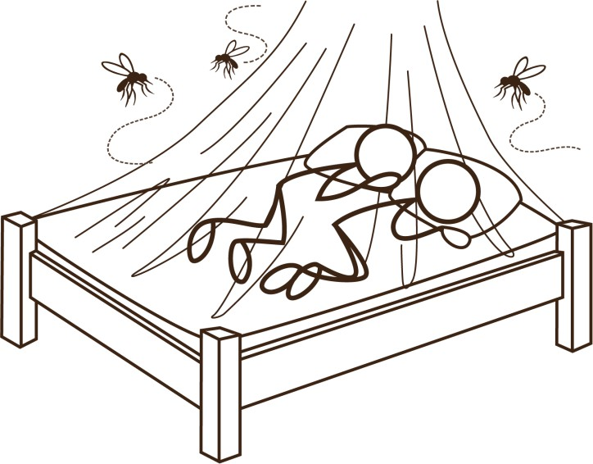

# What is a Vector?

A vector is a living thing that transmits a pathogen, such as mosquitos, flies and rodents. Vectors are common nuisances in many developing countries and they thrive in areas where there is poor environmental sanitation. For example, standing water provides breeding sites for mosquitos, garbage attracts rodents, and feces attract flies. These vectors can be carriers of many serious diseases.

* 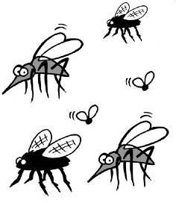**Mosquitos** – Transmit a number of viral diseases such as **dengue fever**, **Japanese encephalitis** and **West Nile fever**. **Malaria** is caused by a protozoa that is passed on by mosquito and is the most important vector-borne disease in public health. About 3.3 billion people – half of the world's population – are at risk of malaria. In 2010, there were about 219 million malaria cases and an estimated 660,000 malaria deaths. People living in the poorest countries are the most vulnerable to malaria. In 2010, 90% of all malaria deaths occurred in Africa, mostly among children under five years of age (WHO, 2013).
* **Flies** – Carry pathogens on their bodies to uncovered food and drink, and to the faces, mouths and eyes of people. **Trachoma** is an eye infection

that spreads from person to person. It is frequently passed from child to child and from child to mother, especially where there are shortages of water, numerous flies and crowded living conditions.

* **Rats, mice and other rodents** – Carry pathogens on their bodies and in their feces and urine. They act as vectors for various diseases including **hantavirus, typhus, leptospirosis** and the **plague**.

Fortunately, there are many measures that can be taken to control these vectors, many of which are appropriate for households and communities with limited resources.

# Mosquito Control

Different strategies can be used to reduce and prevent contact with biting mosquitos. Screens and nets, chemical controls (i.e. spraying bug repellent), environmental measures and human behaviour change are effective strategies to limit contact with pathogen-carrying mosquitos.

## Mosquito Characteristics

Mosquitos are present worldwide with the exception of Antarctica. There are 41 different genera (types), which are subdivided into 3,300 species. There are three genera of mosquitos that are important in the transmission of disease: Anopheles, Culex and Aedes. They transmit various diseases and have different breeding and biting behaviours. The following table gives the most common characteristics for the different genera of mosquitos. However, there are many variations and exceptions depending on the species.

**Mosquito Characteristics**

|  |  |  |  |  |
| --- | --- | --- | --- | --- |
| **Mosquito** | **Diseases** | **Breeding** | **Biting** | **Flight Range\*** |
| **Aedes** | Dengue | Breeds in clean | Variable but most | Usually less than 150 |
|  | fever, yellow | stagnant water, | species are day biters | metres, but can be up |
|  | fever, | preferably shaded. | with peak biting at | to 750 metres in rural |
|  | Arboviruses | Often breeds in small | dawn and dusk into | settings and 570 |
|  |  | temporary pools | early evening. Easily | metres in urban areas. |
|  |  | caused by flooding. | disturbed, but |  |
|  |  | Commonly referred to | persistent biters, so |  |
|  |  | as a “container | will deliver multiple |  |
|  |  | breeder.” Eggs can | bites on several hosts. |  |
|  |  | survive being dried out. | Bites are often painful. |  |
| **Anopheles** | Malaria | Breeds in relatively | Bites at night, mainly | Usually up to 2 |
|  |  | clean, shallow water in | just after dark and | kilometres, but some |
|  |  | any size of permanent | before first light. Less | may fly many |
|  |  | water body, preferably | easily disturbed, so | kilometres. |
|  |  | shaded. Some species | usually only bite a few |  |
|  |  | will breed in brackish, | times. |  |
|  |  | saline water. |  |  |
| **Culex** | West Nile | Breeds almost | Bites at night and is a | Usually less than 1 |
|  | virus, | anywhere, but favours | persistent biter. | kilometre, but may fly |
|  | lymphatic | dirty water with high |  | several kilometres. |
|  | filariasis, | organic matter (e.g., |  |  |
|  | Japanese | septic tanks, latrines) |  |  |
|  | encephalitis |  |  |  |

* The flight range of mosquitos was long thought to be quite limited. However, recent research suggests flight range is significantly longer.

** Recent research has found that *Aedes aegypti* mosquitos have adapted to breeding in septic tanks and other large and dirty water reservoirs.

The average lifespan of a male mosquito is approximately two to three weeks. The lifespan of a female mosquito is usually longer and can be up to three months. The actual lifespan depends on the mosquito's species and the temperature of its environment. Female mosquitos will go through three egg laying cycles and will produce 300 to 1,000 eggs in a lifetime.

The following map shows the specific species of Anopheles mosquito that are mainly responsible for malaria transmission in different countries. There are approximately 40 species of Anopheles mosquitos that transmit malaria. Each species behaves differently and, therefore, requires its own control strategy. It is important to determine which types of mosquitos are responsible for disease transmission in the area where a control program is planned.

**Global Distribution of Anopheles Mosquitos**

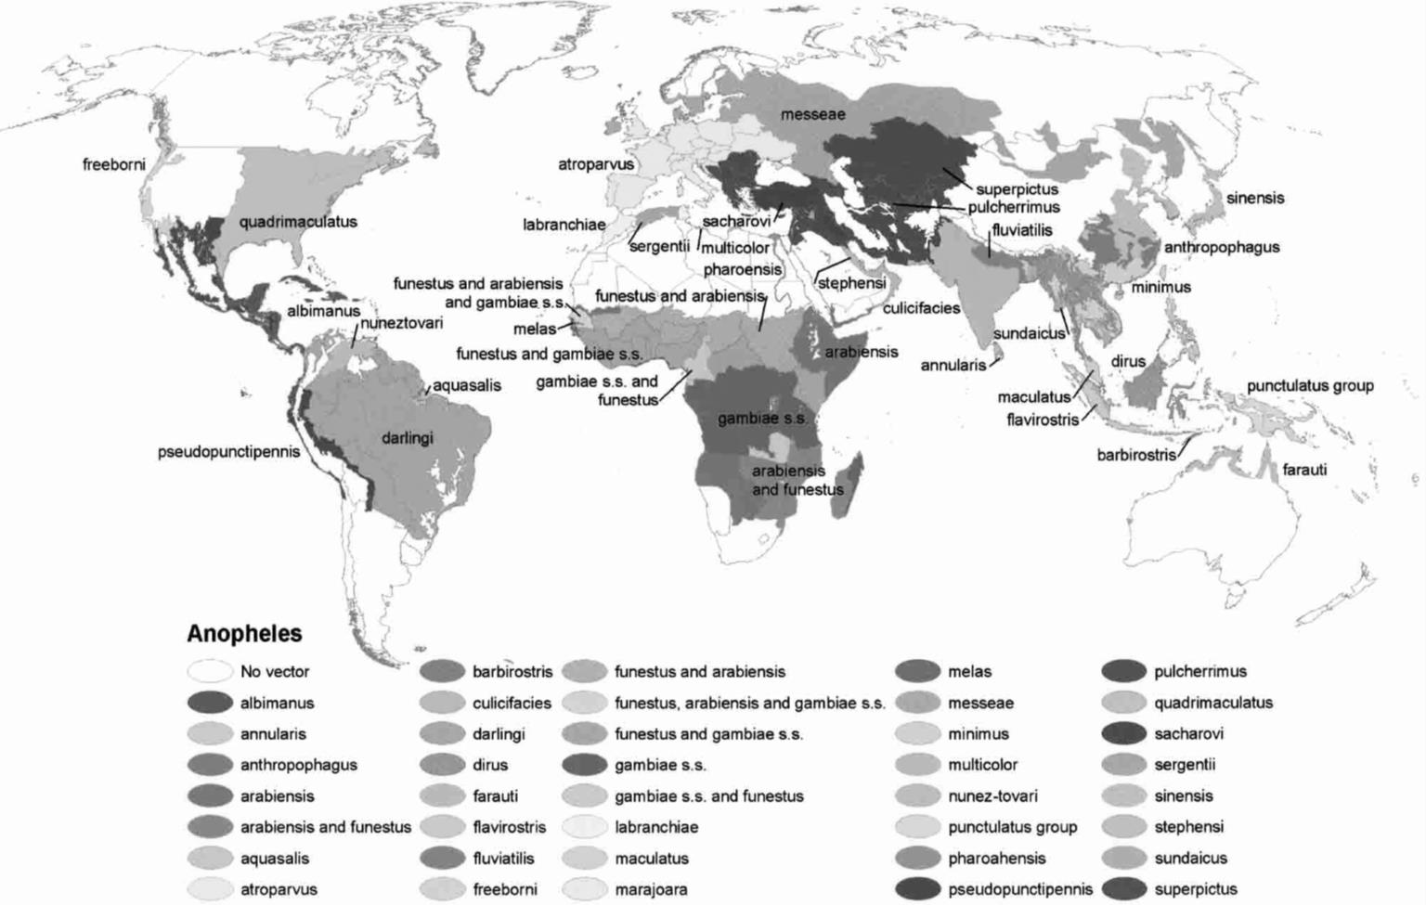

(Kiszewski et al., 2004)

## Mosquito Disease Transmission

Mosquitos feed for the most part on plant nectar and sap. It is only the female mosquito that bites humans and other mammals and birds. The female needs a blood meal, in order to take in protein, which is essential for egg production. It is during the blood feeding that the pathogens are passed from the mosquito to the human.

### Malaria

The following describes how malaria is transmitted from mosquitos to people:

1. A mosquito bites a person already infected with malaria protozoa.
2. Blood containing malaria protozoa is ingested by the mosquito.
3. The protozoa develop in the mosquito before becoming infectious (10-21 days depending on the species and local temperature).
4. The mosquito bites another person and injects malaria protozoa into their blood.
5. The protozoa develop, cause malaria in the person and become infectious again (7-30 days depending on type of malaria).

### Japanese Encephalitis

The following describes how Japanese encephalitis is transmitted from mosquitos to people:

1. A mosquito bites a bird carrying the Japanese encephalitis virus (the bird is not affected).



1. The mosquito bites a pig and injects the virus into the pig.
2. The encephalitis virus reproduces and accumulates in the pig (the pig is not affected).
3. A mosquito bites the pig.
4. Blood from the pig has the Japanese encephalitis virus and is ingested by the mosquito.
5. The mosquito bites an uninfected person and injects the virus into their blood.
6. The virus infects the person who then becomes sick.

Mosquito biting a pig

### Dengue Fever

The following describes how dengue fever is transmitted from mosquitos to people:

1. A mosquito bites a person already infected with the dengue fever virus.
2. Blood containing the dengue virus is ingested by the mosquito.
3. The virus replicates in the mosquito.
4. The mosquito is infectious for life and can transmit the virus to its offspring.
5. The mosquito bites an uninfected person and injects the virus into their blood.
6. The virus infects the person who becomes sick with dengue fever within 2-7 days.

## Mosquito Control

There are four main strategies for preventing and controlling mosquito borne diseases:

1. Screens and nets
   * Preventing mosquitos from entering buildings by using screens on doors and windows
   * Preventing mosquito bites by sleeping under bed nets
2. Chemical and biological methods
   * Coating bed nets with insecticide
   * Killing mosquitos either as adults or as larvae by using insecticides and larvicides
   * Burning mosquito coils with insecticidal and repellent properties
3. Environmental measures
   * Reducing the population and presence of mosquitos by removing breeding and resting sites
   * Reducing transmission by removing intermediate and amplifying hosts (i.e., In 1992, Singapore stopped pig breeding to prevent the transmission of Japanese encephalitis)
4. Personal protection and behaviour change
   * Wearing full-cover clothing or staying indoors during biting periods
   * Using mosquito repellent

### Screens and Nets

Using mosquito screens and nets is often the simplest method to reduce or prevent mosquito bites inside the home and while sleeping, although it can be relatively expensive for the poor. Steel or plastic screen with a mesh size small enough to prevent mosquitos from being able to enter is available virtually everywhere. Installing screens on doors and windows will reduce the number of mosquitos, flies and other insects that enter the home. Some homes will require extra work and attention, especially when they have gaps between the walls and the roof.

Bed nets can be very effective at preventing mosquito bites. However, if the sleeping person lies against the net, then mosquitos can still bite through it. Using insecticide treated nets (ITN) improves the effectiveness of personal protection against mosquito bites. The insecticide adds a chemical barrier, which is deadly to mosquitos. Hanging an ITN in a room will also protect people who are not sleeping under the net. After a blood meal, the mosquito is heavier and needs to rest to allow the blood to be digested. If the mosquito lands and rests on the net it will be killed, preventing it from infecting anybody else.

Sleeping under a bed net

Pre-treated insecticide nets are available, but still require re-treatment every four to six months. Despite the extra work, it may be worthwhile to purchase untreated nets and treat them yourself since the quantity and quality of pre-treated insecticide nets varies from ineffective to effective. Bed nets should be treated every four to six months and after washing. However, the low re- treatment rate is often considered one of the main drawbacks of ITNs (WHO, 2006). Awareness and education is necessary to ensure that people re-treat their nets. It can be better to arrange a community approach for re-treatment where large vats of insecticide are set up, so that people can dip their nets and then take home to dry. Long lasting insecticidal nets (LLIN) are also available and don't require people to reapply the insecticide.

Since the year 2000 there has been substantial funding and implementation of malaria control programs, including providing free ITNs. Much of international funding has been targeted to Africa, to countries with the lowest gross national income (GNI) per capita, and to countries with the highest malaria mortality rates (WHO, 2012).

By 2011, 32 countries in the African Region and 78 other countries worldwide had adopted the WHO recommendation to provide ITNs to all persons at risk for malaria. A total of 89 countries, including 39 in Africa, distribute ITNs free of charge. The percentage of households owning at least one ITN in sub-Saharan Africa is estimated to have risen from 3% in 2000 to 53% in 2012. The proportion of people sleeping under an ITN, representing the population directly protected, also increased from 2% in 2000 to 33% in 2012 (WHO, 2012).

Approximately 90% of people with access to an ITN actually use it, suggesting that efforts to encourage ITN use have been successful. The main barrier to increasing the number of at-risk people sleeping under an ITN is insufficient availability of nets. The proportion of the population sleeping under an ITN is higher in wealthier, urban areas, and lower among older children. It is anticipated that that differences in ITN access should decrease as programs move towards universal coverage (WHO, 2012).

### Chemical Methods

Insecticides are chemicals that are used to kill insects, including mosquitos. A common approach is to apply an insecticide with a long-lasting effect to the interior walls of the home. Mosquitos or other insects are killed by the insecticide when they land on the walls. Indoor residual spray (IRS) insecticides need to be reapplied approximately every six months, depending on the type of insecticide and the wall material. IRS does not generally prevent people from being bitten, but it kills mosquitos after they have fed and are resting.

IRS is the most widely used malaria vector control method. It has been standardized and there are clear specifications for suitable equipment and insecticides. Field guidelines on technical and operational issues are available in almost all languages of malaria-endemic countries (WHO, 2006).

Fogging and spraying insecticides over large outdoor areas is also common in some countries, especially in urban areas. This can have an immediate and dramatic effect on the population of insects in an area. However, the insect population will quickly recover unless the fogging is repeated regularly. To be effective, the timing of the application must coincide with the period in the day when the target mosquitos or insects are active, and it is most useful for mosquitos and insects that spend most of their lives outside of buildings.

Larvicides are a special type of insecticide that kills the larvae of insects. They can be applied to bodies and containers of water to kill mosquito larvae before they mature into mosquitos. They are especially useful when dealing with “container breeding” mosquitos (e.g., Aedes mosquitos), as breeding sites can be identified and larvicides easily applied.

### Biological Methods

There are naturally occurring bacteria that act as larvicides, and they are being sold commercially in an increasing number of regions. Biological methods are growing in popularity as they are seen to be safer and less environmentally threatening than the chemical products. However, there is concern that the long-term effects of introducing new microorganisms into the environments are not fully understood.

*Bacillus thuringiensis var. israelensis* (*Bti*) is a type of bacteria that kills the larvae of mosquitos, black flies and some other insects. There is no evidence to suggest that it is harmful to humans, livestock or other aquatic creatures. However, its effectiveness is affected by water quality parameters such as high organic content, temperature and pH. *Bti* has virtually no residual effect and therefore requires regular, repeated applications.

*Bacillus sphaericus* (Bs) is another type of bacteria that can kill some species of mosquito larvae. It is generally effective against Anopheles and Culex larvae, but not against Aedes or black fly larvae. It has a two to four week residual effect, and is effective in water with high organic content, although the residual effect is less.

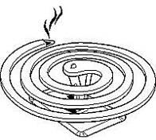Although they can be effective, biological control methods are not used on a large scale in malaria control. This is due to cost, and also to the operational and human resource requirements needed to apply the biological methods to all of the potential breeding areas. Another problem is that we don’t know enough about mosquito breeding ecology and the local biology to effectively target biological methods.

### Mosquito Coils

Using mosquito coils containing natural or synthetic insecticides and repellents is very common. The smoke produced when the coils burn also has a repellent effect and can kill mosquitos. Coils can be useful for dealing with mosquitos that bite in the evening and at dusk before people go to bed under their nets. However, there is concern that daily use of these coils over the long-term, especially in closed rooms, can contribute to lung disease.

Mosquito coil

### Environmental Measures

Environmental measures to reduce breeding and resting sites for mosquitos can be difficult to carry out effectively. The flight range of mosquitos varies from 0.5 to several kilometres. In some areas, there may only be a few locations within that 2 km radius where mosquitos can breed and that may be fairly easy to deal with. However, in other areas there may be many thousands of mosquito breeding sites within a 2 km radius.

Environmental measures to reduce mosquito populations include:

* + - * Disposing wastewater using soak pits or infiltration trenches
      * 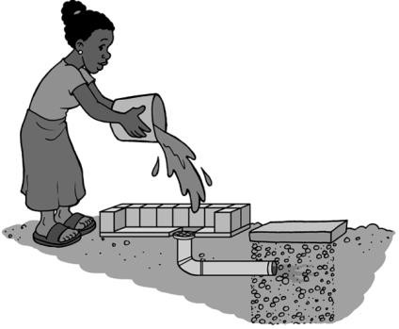Disposing solid waste properly in sanitary landfills or covered pits, especially items that can hold water such as cans, bottles, tires and plastic bags
      * Putting screens on water storage containers and tanks to prevent mosquitos from entering
      * Constructing and maintaining drainage channels to avoid flooding and stagnant water
      * Clearing standing water (e.g., flower and plant pots that contain standing water, blocked gutters and drains, covered and screened latrines and septic tanks)

# Fly Control

Disposing wastewater in a soak pit

Flies play a role in transmitting many diarrheal diseases. They lay their eggs in organic material that provide food for emerging maggots. Excreta found in unsanitary latrines is ideal for this, as is domestic food waste that is not properly disposed of. Flies pick up pathogens on their bodies when laying their eggs or feeding and then transport pathogens to people’s food, tableware and faces.

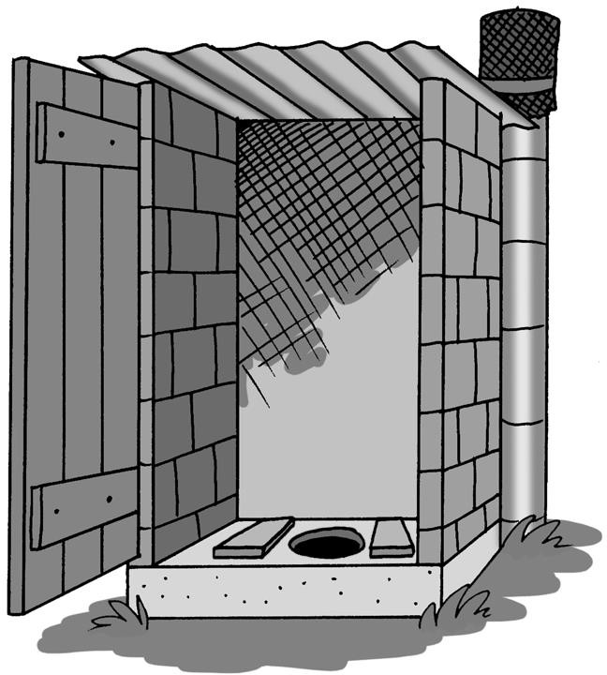Latrines are important to prevent flies and other insects from gaining access to the excreta or preventing them from exiting once inside. They can greatly reduce the volume of excreta that is flying around on flies. The number and accessibility of breeding and feeding sites can be reduced if everybody in a community practices safe excreta disposal and proper waste management. This would lead to a reduction in fly populations.

Flies also play a role in transmitting trachoma, an eye infection caused by the pathogen *Chlamydia trachomatis*. Flies are attracted to eye discharge and land on the face of an infected person, picking up the pathogen and then transporting it to the eye of a new person. The disease is especially prevalent in areas where there are shortages of water, numerous flies and

Ventilated improved pit (VIP) latrine to reduce flies and other insects

crowded living conditions. The main interventions to prevent trachoma infection include properly disposing human and animal waste, reducing fly breeding sites and improving facial cleanliness (with clean water) among children at risk of disease. Good personal and environmental hygiene have been proven successful in reducing trachoma (WHO, 2001).

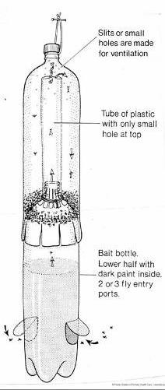Using insecticides–similar to those used for mosquito control--can also significantly reduce fly populations. Other methods to control flies include using sticky fly papers and tapes, as well as simple traps. Fly traps can be made from used plastic bottles, as shown in the following illustrations. When the fly traps are full, the contents should be buried at least 15 cm below ground to prevent hatching larvae from emerging.

Flies enter through “funnel” and become trapped

Cut top off bottle

Insert and secure in body of bottle

Fly traps made from used plastic water bottles

(Credit: Unknown)

# Rodent Control

Rodents such as rats and mice transmit disease through a number of ways, such as:

1. Direct contamination through dirt and feces carried on their body
2. Bites or scratches (e.g., rat bite fever)
3. Fleas carried on their bodies that can transmit typhus and plague
4. Urine and feces that can transmit leptospirosis and hantavirus

Rats and other rodents can find their way into homes, as well as food and grain storage areas where they eat and destroy huge amounts of food annually. Controlling them reduces the risk of disease transmission and can also decrease food loss and spoiling.

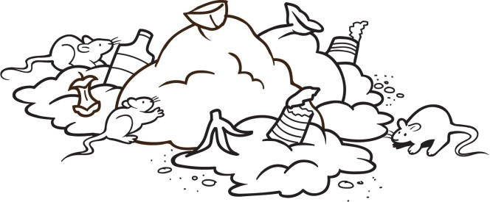

## Passive Control Measures

Prevention is better than cure. It is usually better and easier to prevent an infestation of rodents than to get rid of them once they are established. The number of rats and other rodents that are found in an area is closely linked to the availability of food, water and shelter. Properly disposing domestic waste will remove an easily available food supply. As well, using rodent-proof storage containers will limit the availability of food. Many traditional designs of grain stores have features that prevent rodents from entering the building. However, many modern grain stores do not have such protection.

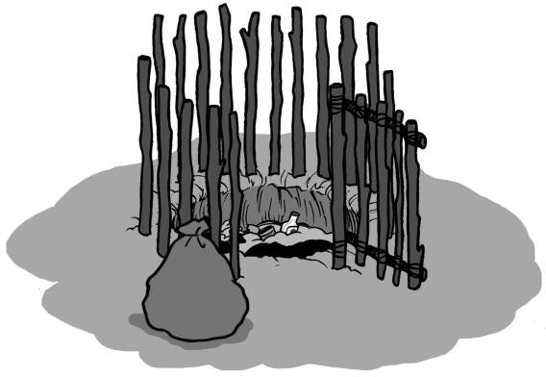

Disposing waste in a small pit that is regularly covered with soil

Cutting grass and brush around buildings and keeping the surrounding area tidy and free of domestic waste can also deter rodents since they prefer to move along dark, sheltered pathways.

Cats and dogs (even just their scent) can deter rats and mice from entering a building and in some cases will even drive them out. Some cats and dogs are natural hunters; however, cats may be reluctant to attack a large adult rat.

## Rodent-Proof Buildings

Ensuring that a building is rodent-proof is not an easy task. Rats and mice can pass through extremely small holes or a crack in a wall (6 millimetres for a mouse and 12 millimetres for a young rat). Therefore, careful attention is needed to ensure that all cracks and holes are filled. Rodents are powerful and if they are used to entering a building at a particular place, it may be necessary to reinforce any repairs with steel mesh to prevent them from chewing their way back inside again.

Other rodent-proofing measures include:

* + - Fixing metal disks on cables and pipes entering a building to prevent rodents from crawling along them

Metal disk fixed to cable



* + - Fixing steel sheeting to the bottom of doors and to the jamb to prevent rodents from gnawing on the edges

Metal plate fixed to base of door



* + - If external walls have rough surfaces, plaster and/or paint a smooth band 1 metre high to create a slick surface to prevent rodents climbing up the walls

Smooth, painted band 1m high



(Adapted from Hygnstrom *et al*., 1994)

## Active Control Measures

Plague and typhus are transmitted by fleas normally carried on the bodies of rats. When a rat is killed its fleas will normally transfer to another rat. However, if large numbers of rats are killed at one time, then there is a risk that the fleas will move to the nearest warm living thing, which may be a human. In areas where plague and typhus are common, rats should be treated for fleas before any attempt is made to kill them. This can be done by dusting rat runs with a powdered insecticide (e.g., deltamethrine or similar). The rats pick up the powder on their lower bodies and on their feet, and then it is spread through their fur during grooming.

Rodents can be surprisingly intelligent and cautious animals, and will often avoid traps laid for them. They will carefully investigate traps and bait boxes (i.e., boxes or tubes which use poisonous bait and prevent access to it by other animals or children) and avoid them if a member of their pack is harmed. A form of “bait and switch” can be done to get rodents used to feeding at the traps or bait boxes. Traps are laid with food but not set, and bait boxes are laid with poison-free bait. After the rodents are used to feeding there, then the traps are set and poison is placed in the bait boxes.

Traps and poison baits must be set in places where there is no danger to children or to domestic animals.

**Mechanical spring traps** are available everywhere in the world and are usually sized to fit the rats or mice found locally. They should be baited with foods that are familiar to the targeted rodent population.

**Rodent glue** is available in many parts of the world. This is a very sticky glue which is applied to pieces of board and placed along rat runs. The glue can also be baited. The rats and mice stick to the glue and can then be killed. The advantage of rodent glue is that it is non-toxic and safe to use in food storage and preparation areas.

**Box or cage traps** catch rats and mice alive. They can then be killed or released somewhere far away from people’s homes.

A **pitfall trap** is a simple but effective trap that can be made from a bucket, a corn cob and a piece of wire. The corn cob can be smeared with peanut butter or similar food to attract rats. The rat stretches over the bucket, places its front feet on the corn cob which spins around, and then falls into the bucket and drowns. The bucket should be wide enough so that the rat must use a long, unbalanced reach to the bait, and it should be deep enough to prevent the rat from escaping once inside.

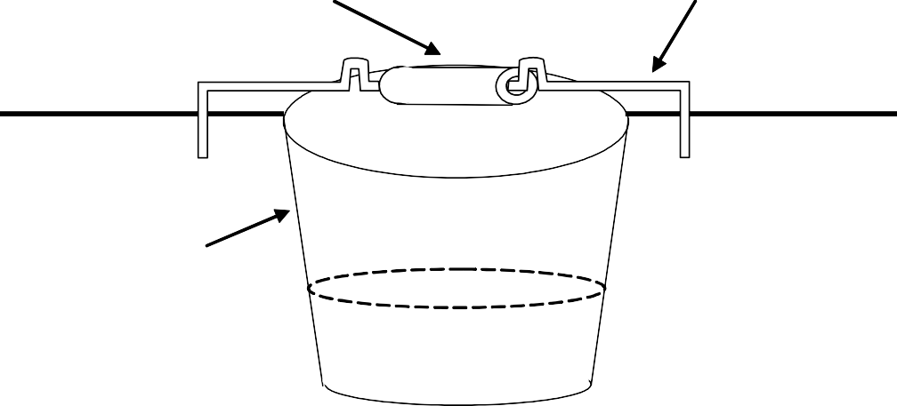

Freely rotating corn cob or similar

Wire bent and fixed in the ground

Ground level

Bucket placed in ground

Water

## Rodenticides

There are many different types of rodenticides designed to kill rats and mice. The rodenticide is applied to food which acts as a bait to attract rodents. As previously mentioned, rats are cautious of new foods. They may try a small piece and then wait to see whether they become sick. Therefore it is important to do the following:

* + - Use a bait and switch strategy
    - Ensure that the rodenticide is tasteless and odourless
    - Ensure that the poison has a delayed effect (at least one day, preferably longer)

Rodenticides and the bait food should be placed in bait boxes. These are boxes or tubes which contain the bait and prevent access to it by other animals or children. Bait boxes should be placed along places where rats commonly run, or adjacent to areas where rodents are accustomed to feeding.

A problem with rodenticides is that there is no control over the location that the rat or mouse dies. Unpleasant smells can result if they die in a nest that is inside a wall or ceiling of a home. Some rodenticides (e.g., anticoagulants) cause dehydration. These are used in the hope that the rodent will leave the building in search of water.

Another important consideration is that the body of the dead rodent will be poisonous. This can be an issue for communities which traditionally eat rodents and where scavenging dogs, cats and pigs may eat the dead rodents.

If a large rodent control campaign is planned, especially if rodenticides are to be used, then local pest control experts should be consulted for advice and guidance.

(Adapted from MSF, 2010)

# Additional Resources

Rozendaal, J. (1997). Vector Control: Methods for Use by Individuals and Communities. WHO, Geneva, Switzerland. Available at: [www.who.int/water_sanitation_health/resources/vectorcontrol/en/](http://www.who.int/water_sanitation_health/resources/vectorcontrol/en/)

* + - The manual provides practical information on major disease vectors and pests: mosquitos and other biting Diptera, tsetse flies, triatomine bugs, bedbugs, fleas, lice, ticks, mites, cockroaches, house-flies, water fleas and freshwater snails. For each group of vectors, information is provided on biology, public health importance and control measures. Chapters on house-spraying with residual insecticides and the safe use of pesticides are also included.

World Health Organization. Malaria Vector Control and Insecticide Resistance. Available at: [www.who.int/malaria/publications/vector-control/en/index.html](http://www.who.int/malaria/publications/vector-control/en/index.html)

* + - This website provides a list of WHO publications that can be downloaded for free.

# References

Hygnstrom, S., Timm, R. and G. Larson (1994). Prevention and Control of Wildlife Damage. University of Nebraska-Lincoln, USA. Available at: <http://digitalcommons.unl.edu/icwdmhandbook/>

Médecins Sans Frontières (2010). Public Health Engineering In Precarious Situations, 2nd Edition. Available at: <http://refbooks.msf.org/msf_docs/en/public_health_en.pdf>

World Health Organization (2001). Water-Related Diseases: Trachoma. WHO, Geneva, Switzerland. Available at: [www.who.int/water_sanitation_health/diseases/trachoma/en/index.html](http://www.who.int/water_sanitation_health/diseases/trachoma/en/index.html)

World Health Organization (2006). Malaria Vector Control and Personal Protection: Report of a WHO Study Group. WHO Technical Report Series, No. 936. Available at: <http://whqlibdoc.who.int/trs/WHO_TRS_936_eng.pdf>

World Health Organization (2012). World Malaria Report 2012. WHO, Geneva, Switzerland. Available at: www.who.int/malaria/publications/world_malaria_report_2012/wmr2012_no_profiles.pdf

World Health Organization (2013). 10 Facts on Malaria. WHO, Geneva, Switzerland. Available at: www.who.int/features/factfiles/malaria/en/index.html

CAWST (Centre for Affordable Water and Sanitation Technology) Calgary, Alberta, Canada

Website: [www.cawst.org](http://www.cawst.org/) Email: [resources@cawst.org](mailto:resources@cawst.org)

*Wellness through Water. Empowering People Globally*

Last Update: August 2014

This document is open content. You are free to:

* Share – to copy, distribute and transmit this document
* Remix – to adapt this document

Under the following conditions:

* Attribution. You must give credit to CAWST as the original source of the document. Please include our website: [www.cawst.org](http://www.cawst.org/)

CAWST and its directors, employees, contractors and volunteers do not assume any responsibility for, and make no warranty with respect to, the results that may be obtained from the use of the information provided.

# Contents

1. Introduction 116
2. Critical Times for Handwashing 117
3. Correct Method for Handwashing 118
   1. Water 118
   2. Soap 118
   3. Soil, Mud or Ash 119
   4. Hand Sanitizers 119
4. Importance of Handwashing 120
   1. Diarrhea 120
   2. Respiratory Infections 121
   3. Trachoma 121
   4. Vulnerable Populations 121
5. Global Handwashing Practices 122
6. Promoting Handwashing 122
7. Handwashing Hardware 124
8. Sustainability 126
9. Additional Resources 127
10. References 128

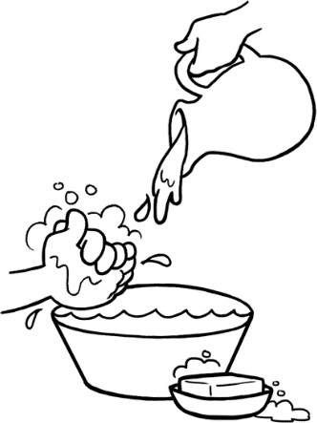

1. **Introduction**

Hygiene is the conditions and practices that help to maintain health and prevent the spread of diseases (WHO, 2013). Improving hygiene practices can have a very positive impact on individual, household and community health. Most people practice some form of personal hygiene to keep themselves clean. Good personal hygiene practices include:

* Handwashing
* Bathing
* Washing hair
* Cleaning teeth

This Technical Brief introduces the importance of handwashing to prevent the spread of infectious diseases, like diarrhea, respiratory illnesses and trachoma. It discusses the critical times for handwashing and explains how to wash your hands properly. This Technical Brief also gives an overview of hygiene promotion and the handwashing hardware needed to encourage people to practice handwashing and adopt it as a regular habit.

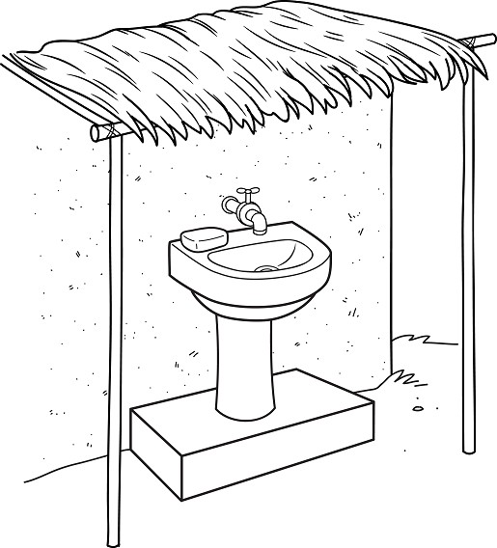



**Definitions**

**Defecate:** To discharge feces from the anus.

**Handwashing hardware:** The physical things that people need to properly wash their hands, like soap and water.

**Handwashing software:** Also called hygiene promotion. The approaches to encourage the widespread adoption of handwashing to reduce diarrhea and other infectious diseases.

**Pathogen:** Any living organism that causes disease.

Handwashing station

1. **Critical Times for Handwashing**

Standard public health messages encourage people to wash their hands at five separate critical times:

1. 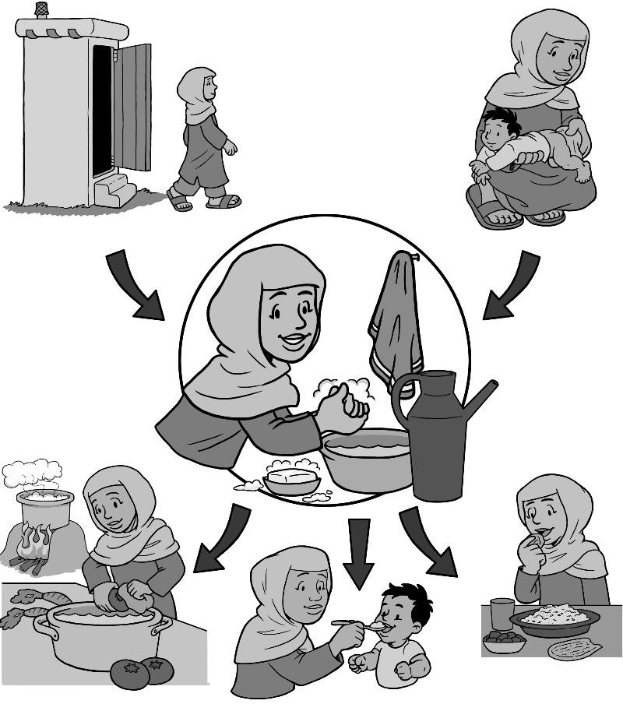After defecating
2. After handling child feces or cleaning a child’s anus
3. Before preparing food
4. Before feeding a child
5. Before eating

Luby et al. (2011) found that the two most critical times for handwashing with soap:

1. After defecation
2. Before preparing food

The Global Public-Private Partnership for Handwashing with Soap (PPPHW, 2012) also suggests using a “critical times ladder” to promote handwashing with soap. Start with one or two critical times and expand from there.

Promoting fewer critical times for handwashing may be more effective and have greater impact for the following reasons:

* + Handwashing at one critical time would be a huge improvement in many situations
  + Few programs have been successful in promoting five times for handwashing
  + Each critical time is so different
  + Messages can get confusing when promoting multiple critical times

1. **Correct Method for Handwashing**

Handwashing with water is good; handwashing with mud, soil or ash is better; and handwashing with soap is the best (Bloomfield and Nath, 2009; Luby et al., 2011).



**How Do You Wash Your Hands?**

1. Wet your hands with clean, running water (warm or cold) and apply soap.
2. Rub your hands together to make a lather and scrub them well; be sure to scrub the backs of your hands, between your fingers and under your fingernails.
3. Continue rubbing your hands for at least 20 seconds.
4. Rinse your hands well under running water.
5. Dry your hands using a clean cloth or air dry them.

(CDC, 2013)

* 1. **Water**

You should use the cleanest water possible water to wash your hands. If enough treated water is available, such as water treated with a filter or chlorine, it should be used to wash hands. If there is only enough treated water for drinking and preparing food, then untreated water from the cleanest possible source should be used for washing hands.

The best way to wash hands is to have a stream of clean water flowing over your hands, to wash the soap, dirt and pathogens away. If only one basin is available for washing hands in, the water in the basin should be disposed of after every person washes their hands in the water.

* 1. **Soap**

Handwashing with soap significantly reduces the number of pathogens on hands compared to washing with water alone. Soap helps to break down the grease and dirt that carry the largest concentration of pathogens. As well, using soap means that more time is spent rubbing hands together to lather and rinse off the soap. This friction helps to dislodge more grease and dirt, and consequently pathogens.

With proper use, all soaps are equally effective at removing pathogens that cause diarrheal disease and respiratory infections.

Antibacterial soap is not better than regular soap at stopping the

spread of disease. Washing hands in a basin with soap

* 1. **Soil, Mud or Ash**

Soil and mud are often used in low income communities as a free alternative to soap for handwashing. However, there are some concerns that using these materials are associated with health risks. Soil and mud may be contaminated with pathogens (e.g., bacteria, viruses, protozoa, helminths) from open defecation or using sewage to irrigate crops, and ash may contain toxic materials depending on what was burned to create the ash, such as plastics or chemicals (Bloomfield and Nath, 2009).

There is very little research on whether (and to what extent) soil, mud or ash may be contaminated with pathogens and be a source of infection. Despite the potential health risks, it is believed that using clean and dried soil and ash is preferable to using nothing at all since they are more effective in removing microorganisms from hands than water alone (Bloomfield and Nath, 2009).

* 1. **Hand Sanitizers**

Hand sanitizers are gel, foam, or liquid solutions that use alcohol to kill the pathogens on your hands. If soap and water are not available, you can use an alcohol-based hand sanitizer that contains at least 60% alcohol. Alcohol-based hand sanitizers can quickly reduce the number of pathogens on hands in some situations, but sanitizers do not eliminate all types of pathogens. Hand sanitizers are not as effective when hands are visibly dirty.



**How Do You Use Hand Sanitizers?**

1. Apply the hand sanitizer to the palm of one hand.
2. Rub your hands together.
3. Rub the sanitizer over all surfaces of your hands and fingers until your hands are dry.

(CDC, 2013)

1. **Importance of Handwashing**

The hands are the last line of defence against exposure to pathogens that can cause disease. Pathogens can be transmitted directly from unclean hands to the mouth, eye, nose or other area of the skin, or indirectly by handling food or water. Diarrhea, respiratory infections and trachoma are all infectious diseases that can be prevented by handwashing with soap.

**Leading Global Infectious Diseases (2010)**

120,000,000

100,000,000

Disability Adjusted Life Years (DALYs)

80,000,000

60,000,000

40,000,000

20,000,000

-

Lower respiratory infections

Diarrheal diseases

HIV/AIDS Malaria Measles Tuberculosis

Note: One DALY equals one lost year of healthy life. (Credit: IHME, 2013)

* 1. **Diarrhea**

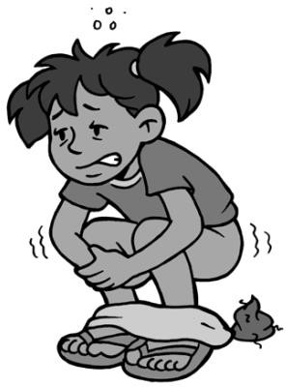Globally, an estimated 2,000 children under the age of five die every day from diarrheal diseases, and of these deaths 1,800 are linked to water, sanitation and hygiene (UNICEF Canada, 2013). For every child that dies, countless others suffer from poor health and lost educational opportunities leading to poverty in adulthood.

Diarrhea is caused mainly by the ingestion of pathogens, especially in unsafe drinking water, in contaminated food or from unclean hands. The WHO estimates that 88% of diarrheal cases can be prevented by increasing the availability of safe water and improving sanitation and hygiene practices (Prüss-Üstün et al., 2008).

Curtis and Cairncross (2003) estimated that washing hands with soap can reduce the risk of diarrheal diseases by 42-47%. As well, Fewtrell et al. (2005) showed that handwashing can reduce the incidence of diarrhea by 44%.

* 1. **Respiratory Infections**

Reducing the burden of diarrheal disease is not the only reason for good hygiene. Hygiene also plays an important role in reducing the risk of respiratory infections such as pneumonia and influenza. According to the WHO (2002), acute respiratory infections (ARIs) cause 3.9 million deaths a year. They are the leading cause of childhood morbidity and mortality in the world, and the biggest cause of disability-adjusted life years (DALYs) lost.

Although the research is limited, especially in developing countries, handwashing is associated with a decrease in respiratory infections. Curtis and Cairncross (2003) discuss that growing evidence from developed countries shows that handwashing can substantially reduce the risk of respiratory tract infection (median risk reduction of 45%). As well, Rabie and Curtis (2006) suggest that handwashing with soap can reduce the risk of respiratory infections by about 16%.

* 1. **Trachoma**

Trachoma is a contagious eye disease that is the world’s leading cause of blindness, but it is completely preventable through good hygiene practices. Simply washing the face with clean water breaks the infection cycle. It is estimated that 92 million people suffer from trachoma and 8 million are visually impaired or blinded as a result of the disease (Montgomery, 2006).

Trachoma is endemic in the poorest and most remote areas of 56 countries, most of which are located in Sub-Saharan Africa and Southeast Asia. Up to 600 million people live in these areas and are at risk for contracting the disease (Montgomery, 2006).

* 1. **Vulnerable Populations**

Hygiene is of critical importance for vulnerable populations who are more susceptible to infections. This includes people living with HIV/AIDS, the disabled, the elderly, pregnant women and children under the age of five. The most common infections contracted by people living with HIV/AIDS are diarrhea, respiratory infections and skin diseases. The risk of contracting these illnesses can be reduced by handwashing with soap and washing the face and body.

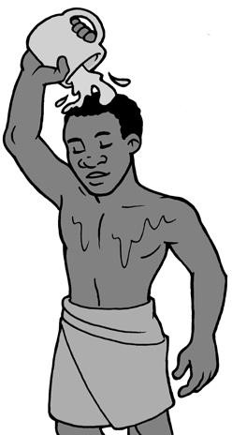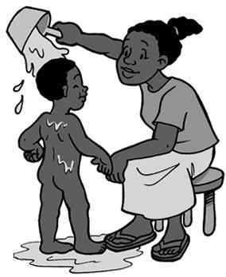

Washing your face and body can also reduce the risk of infection

1. **Global Handwashing Practices**

The following table shows that the frequency of handwashing around the world is low. While many people wash their hands with water, only a small percentage use soap at critical times (e.g., after defecation).

**Handwashing with Soap Around the World**

|  |  |  |  |
| --- | --- | --- | --- |
| **Location** | **Handwashing with Soap** | **Frequency in**  **Population** | **Reference** |
| Kerala State, India | After defecation  After cleaning up a child | 34%  35% | PPPHW |
| Ghana | After defecation  After cleaning up a child | 3%  3% | PPPHW |
| Peru | After defecation  After cleaning up a child | 6%  30% | PPPHW |
| Senegal | After defecation  After cleaning up a child | 31%  26% | PPPHW |
| Kolkata, India (slums) | After defecation | 16% | Sircar et al., 1996 |
| Kyrgyzstan (rural) | After defecation  After cleaning up a child | 18%  0% | Biran, 1999 |
| Lao | After defecating | 23% | EMS & WSP, 2014 |
| Nigeria (rural) | After cleaning up a child | 10% | Omotade et al., 1995 |
| Burkina Faso (urban) | After defecation  After cleaning up a child | 1%  13% | Curtis et al., 2001 |
| Brazil (childcare centres) | After cleaning up a child | 16% | Barros et al., 1999 |
| Lima, Peru (shanty town) | After defecation (soap use rare) | 12% | Gilman et al., 1993 |
| Northern England (peri-urban) | After cleaning up a child | 47% | Curtis et al. 2003 |

Note: All frequencies were observed, except Sircar et al. which used soap measurements. (Adapted from World Bank, 2006)

1. 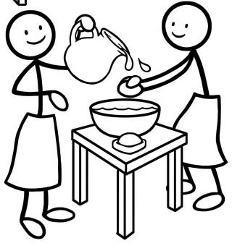**Promoting Handwashing**

If handwashing is so important, then why isn’t everyone doing it? Handwashing is about behaviour; changing handwashing practices means changing behaviour. Change can be difficult for many people. We all have routines and habits that we feel comfortable with and enjoy. It is hard for people – especially adults – to change a behaviour that we have been doing for most of our lives. Habitual behaviours are often learned at an early age. The longer someone has been practicing a behaviour, the harder it will be for them to change.

Knowing is not enough. Knowing why, how and when to wash hands is no guarantee that people will actually do it. It is now understood that ‘educating’ people to practice good hygiene, because it has health benefits, will usually not result in long-term behaviour charge. While good health may seem like an obvious benefit, it may not be as strong a motivating factor as other potential benefits. In a review of hygiene research studies from 11 countries, Curtis et al. (2009) found that the key motivations for handwashing include the following:

* Disgust – washing hands when they became contaminated with something dirty, foul or smelly; feces were found to be particularly repulsive
* Nurture – taking care of young children
* Comfort – being able to sense cleanliness directly, but also as a state of mind
* Affiliation – being a good member of society by joining in and by doing what everyone else is perceived to be doing



**What is the Difference between Hygiene Education and Promotion?**

* Hygiene education: All activities are aimed at raising awareness and conveying knowledge of the links between hygiene practices and health. The water, sanitation and hygiene (WASH) sector is gradually moving away from hygiene education to hygiene promotion.
* Hygiene promotion: Systematic approaches to encourage the widespread adoption of safe hygiene practices to reduce diarrheal and other water- and sanitation-related diseases. Hygiene promotion focuses on the things that determine changes in behaviour, which may not necessarily be directly related to knowledge of the health consequences of poor hygiene.

(WaterAid, 2012)

Hygiene promotion builds upon what people know, do and want. It focuses on identifying motivations for behaviour change based on existing practices and beliefs. By identifying motivators of change and finding ways to trigger them, effective hygiene promotion reduces the risky hygiene behaviours and practices among key target groups (WaterAid, 2012).

There are different ways to develop and implement a hygiene promotion program, also called “software”. WaterAid (2012) suggests that hygiene promotion approaches can be divided into the following two groups. There is overlap between the different approaches, as various elements from each can be combined to meet the needs of the local situation.

1. Participatory approaches that work with communities to find sustainable and acceptable solutions, as well as build self-esteem and a sense of responsibility for their decisions:
   * SARAR (Self-esteem, Associative strength, Resourcefulness, Action planning, Responsibility)
   * Participatory hygiene and sanitation transformation (PHAST)
   * Participatory rural appraisal (PRA)
   * Community health clubs
   * Child to child (CtC)
2. Social marketing that uses commercial marketing principles to achieve social benefits, such as changes in attitudes and behaviours.
3. **Handwashing Hardware**

Although the software side of handwashing remains a key focus of programs, people also need convenient access to appropriate hardware, like soap and water.

A review by Curtis et al. (2009) in 11 countries found that some type of soap and water was available in almost every household. However, it is not enough for soap and water to be present in the home; both must be readily accessible in the right place and at the right time so that we wash their hands. Soap and water must be conveniently placed next to the toilet or where food is prepared and eaten. If somebody needs to get the soap from another part of the home, then they are less likely to wash their hands at critical times (Devine, 2010).

It is more likely that people will practice handwashing if there are convenient, easy and fast ways for them to do so. Enabling products influence a person’s opportunity to perform a behaviour, regardless of their ability and motivation to take action. Examples of enabling products for handwashing include:

* Handwashing station (to have water and soap in one place)
* Tippy taps (to store and regulate the flow of water)
* Soap, clean soil or ash (to clean hands)
* Soap nets, soap on a rope or soap dishes (to manage and store soap)

Enabling products need to be available both at home and in public places such as community centres, health facilities and schools. As well, the appearance of enabling products (e.g., the smell and colour of soap) can influence whether or not they will be used, so their design needs to take into account user practices and preferences (Devine, 2010; WaterAid, 2012).

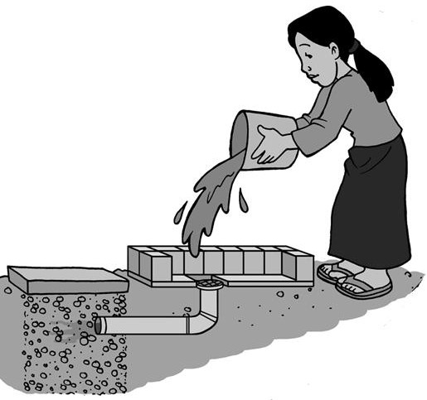If piped water is available, an indoor or outdoor sink can be installed. The drain pipe can be connected to a sewer or a soak pit.

If no piped water is available, water should be stored in a container that will release a flow of water for handwashing, such as a bucket with a tap. Ideally, a person should be able to use the handwashing container to wash their hands by themselves. Used wash water can fall directly into a soak pit or gravel area below the handwashing container, or it can be collected in a bucket and disposed of in a garden or soak pit.

Disposing of used wash water in a soak pit

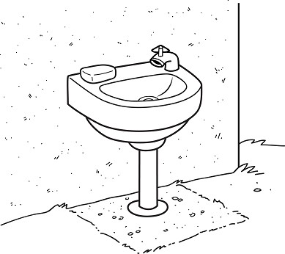 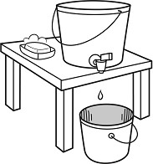

An outdoor sink with soap. The drain pipe may go to a sewer or soak pit.

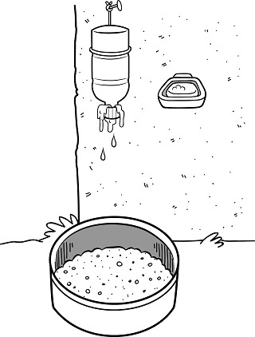

A handwashing station made from a bottle filled with water and hung upside-down. The lid can be half unscrewed to let water flow out while washing hands. Water is collected in a gravel pit below and infiltrated into the ground.

A bucket with a tap for handwashing. Used wash water is collected in a bucket below and disposed of in a garden or soak pit.

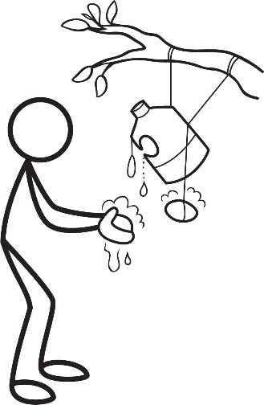

A tippy tap made from a plastic bottle or jug, with soap.

1. **Sustainability**

The Global PPPHW (2012) suggests that the definition of handwashing sustainability is that most of the population washes their hands at the most critical times as a habit (without thinking).

Many hygiene projects are effective in the short-term, but people often go back to their old habits soon after a project ends. For handwashing to become a long-term and sustainable solution you need to have an effective strategy for turning new practices into habits. An effective strategy should include the following elements:

* Finding ways to make new handwashing practices convenient and easy to do
* Making sure that people are experiencing and recognizing the benefits of the new practices
* Making sure that people have the hardware they need to wash their hands
* Eliminating any barriers that might prevent people from practicing handwashing

(Adapted from Global PPPHW, 2012)

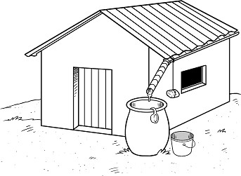

Where rainwater is the cleanest water available, soap and a dipper can be added to create a convenient handwashing station.

1. **Additional Resources**

**CAWST Resources.** Available at: [www.cawst.org/resources](http://www.cawst.org/resources)

* Community Health Promotion Manual: Supports community health promoters to teach and encourage healthy behaviours within communities. It discusses the theory of behaviour change and social marketing as an approach for influencing behaviour.
* Soap Making Fact Sheet: Describes the history of soap, what is soap, how it’s made, and two processes to make soap.

**Choose Soap.** Available at: [www.choosesoap.org](http://www.choosesoap.org/)

* Choose Soap provides you with a complete, ready-to-use handwashing campaign to promote handwashing in households in low income settings. It draws on ideas and best practices from different fields including hygiene and health promotion, behavioural sciences and marketing. You will find activity scripts, a film, and posters, stickers, and other campaign planning materials; all of which are freely available and ready for download.

**Global Public-Private Partnership for Handwashing with Soap (PPPHW).** Available at: [www.globalhandwashing.org](http://www.globalhandwashing.org/)

* The Global PPPHW is a coalition of international stakeholders whose focus is handwashing and child health. Their website provides the latest resources, tools and media related to handwashing.

**Tippy Tap Resources.**

* The following documents provide simple and graphic instructions on how to build a tippy tap using locally available resources:
  + How to Build a Tippy Tap Manual. Available in several languages at: [www.tippytap.org/build-a-tippy-tap-manual](http://www.tippytap.org/build-a-tippy-tap-manual)
  + How to Make a Handwashing Bottle Poster. Available at: <http://wedc.lboro.ac.uk/resources/posters/P008_Handwashing_bottle.pdf>
  + Using Gourds for Handwashing Poster. Available at: <http://wedc.lboro.ac.uk/resources/posters/P009_The_Mukombe.pdf>

**Water and Sanitation Program, Enabling Technologies for Handwashing with Soap Database.** Available at: [www2.wsp.org/scalinguphandwashing/enablingtechnologies/](http://www2.wsp.org/scalinguphandwashing/enablingtechnologies/)

* This database provide practitioners with information on various types of handwashing hardware, including purpose, benefits, key product features and specifications, pictures or illustrations, and contacts for further information.

1. **References**

Barros, A., Ross, D., Fonscea, W., Williams, L. and D. Moreira-Filho (1999). Preventing Acute Respiratory Infections and Diarrhoea in Child Day Care Centres. Acta Paediatrica 88(10): 1113–

18. Cited in World Bank, 2005.

Biran, A. (1999). What Form Could a DFID-funded Hygiene Promotion Programme Take in Order to Support and Help Ensure Maximum Health Benefits from Proposed Improvements to Water Supply Systems in Northern Kyrgystan? MSc Thesis for LSHTM. Cited in World Bank, 2005.

Bloomfield, S. and K. Nath (2009). Use of Ash and Mud for Handwashing in Low Income Communities: An IFH Expert Review. International Scientific Forum on Home Hygiene. Retrieved from: [www.ifh-homehygiene.org](http://www.ifh-homehygiene.org/)

Centers for Disease Control and Prevention (2013). Handwashing: Clean Hands Save Time. Retrieved from: [www.cdc.gov/handwashing/](http://www.cdc.gov/handwashing/)

Curtis V., Kanki, B., Cousens, S. et al. (2001). Evidence for Behaviour Change Following a Hygiene Promotion Programme in West Africa. Bulletin of the World Health Organization 79(6): 518-26. Cited in World Bank, 2005.

Curtis, V. and S. Cairncross (2003). Effect of Washing Hands with Soap on Diarrhoea Risk in the Community: A Systematic Review. Lancet Infectious Diseases 3(5): 275-281.

Curtis, V., Danquah, L. and R. Aunger (2009). Planned, Motivated and Habitual Hygiene Behaviour: An Eleven Country Review. Health Educ Res. 2009 August; 24(4): 655–673. Retrieved from: [www.ncbi.nlm.nih.gov/pmc/articles/PMC2706491/](http://www.ncbi.nlm.nih.gov/pmc/articles/PMC2706491/)

Devine, J. (2010). Beyond Tippy-taps: The Role of Enabling Products in Scaling Up and Sustaining Handwashing. Waterlines, 29(4): 304-314.

Emerging Markets Consulting and Water and Sanitation Program (2014). Consumer Research to Inform Rural Sanitation Behavior Change and Marketing Communications for Lao PDR: Top- line Results - Preliminary Findings.

Fewtrell, L., Kauffman, R., Kay, D., Enanoria, W., Haller, L., and J. Colford (2005). Water, Sanitation, and Hygiene Interventions to Reduce Diarrhoea in Less Developed Countries: A Systematic Review and Meta-analysis. Lancet Infectious Diseases 5: 42-52.

Global Public-Private Partnership for Handwashing with Soap (2012). Handwashing Behaviour Think Tank Summary. Retrieved from: [www.washplus.org/resources/webinars](http://www.washplus.org/resources/webinars)

Institute for Health Metrics and Evaluation (2013). The Global Burden of Disease: Generating Evidence, Guiding Policy. Seattle, USA. Retrieved from: [www.healthmetricsandevaluation.org/gbd/publications/policy-report/global-burden-disease-](http://www.healthmetricsandevaluation.org/gbd/publications/policy-report/global-burden-disease-generating-evidence-guiding-policy) [generating-evidence-guiding-policy](http://www.healthmetricsandevaluation.org/gbd/publications/policy-report/global-burden-disease-generating-evidence-guiding-policy)

Luby, S., Halder, A., Huda, T., Unicomb, L. and R. Johnston (2011). The Effect of Handwashing at Recommended Times With Water Alone and With Soap on Child Diarrhea in Rural Bangladesh: An Observational Study. PLoS Med 8(6): e1001052.

Montgomery, M. (2006). Sustaining Trachoma Control and Elimination. WHO, Geneva, Switzerland. Retrieved from: www.who.int/water_sanitation_health/publications/Trachoma.pdf

Omotade, O., Kayode, C., Adeyemo, A. and O. Oladepo (1995). Observations on Handwashing Practices of Mothers and Environmental Conditions in Ona-Ara Local Government Area of Oyo State, Nigeria. Journal of Diarrhoeal Disease Research 13(4): 224-28. Cited in World Bank, 2005.

Prüss-Üstün, A., Bos, R., Gore, F. and J. Bartram (2008). Safer Water, Better Health: Costs, Benefits and Sustainability of Interventions to Protect and Promote Health. World Health Organization, Geneva, Switzerland. Retrieved from: <http://whqlibdoc.who.int/publications/2008/9789241596435_eng.pdf>

Rabie, T. and V. Curtis (2006). Handwashing and Risk of Respiratory Infections: A Quantitative Systematic Review. Tropical Medicine and International Health 11(3): 258-267.

Sircar, B., Sengupta, P., Mondal, S. et al. (1996). Effect of Handwashing on the Incidence of Diarrhoea in a Calcutta Slum. Journal of Diarrhoeal Diseases Research 5 (20): 114. Cited in World Bank, 2005.

UNICEF Canada (2013). Children dying daily because of unsafe water supplies and poor sanitation and hygiene, UNICEF says. Retrieved from: www.unicef.ca/en/press- release/children-dying-daily-because-of-unsafe-water-supplies-and-poor-sanitation-and- hygiene-

WaterAid (2012). Hygiene Framework. WaterAid, London, UK. Retrieved from: [www.wateraid.org/publications](http://www.wateraid.org/publications)

World Bank (2005). The Handwashing Handbook. The International Bank for Reconstruction and Development/The World Bank, Washington, DC, USA. Retrieved from: [http://documents.worldbank.org/curated/en/2005/01/5794173/handwashing-handbook-guide-](http://documents.worldbank.org/curated/en/2005/01/5794173/handwashing-handbook-guide-developing-hygiene-promotion-program-increase-handwashing-soap) [developing-hygiene-promotion-program-increase-handwashing-soap](http://documents.worldbank.org/curated/en/2005/01/5794173/handwashing-handbook-guide-developing-hygiene-promotion-program-increase-handwashing-soap)

World Health Organization (2002). The World Health Report 2002. WHO, Geneva, Switzerland. Retrieved from: [www.who.int/whr/2002/en/](http://www.who.int/whr/2002/en/)

World Health Organization (2004). The World Health Report 2004: Changing History. WHO, Geneva, Switzerland. Retrieved from: [www.who.int/whr/2004/en/](http://www.who.int/whr/2004/en/)

World Health Organization (2013). Hygiene. WHO, Geneva, Switzerland. Retrieved from: [www.who.int/topics/hygiene/en/](http://www.who.int/topics/hygiene/en/)

CAWST (Centre for Affordable Water and Sanitation Technology) Calgary, Alberta, Canada

Website: [www.cawst.org](http://www.cawst.org/) Email: [resources@cawst.org](mailto:resources@cawst.org)

*Wellness through Water. Empowering People Globally*

Last Update: December 2014

This document is open content. You are free to:

* Share – to copy, distribute and transmit this document
* Remix – to adapt this document

Under the following conditions:

* Attribution. You must give credit to CAWST as the original source of the document. Please include our website: [www.cawst.org](http://www.cawst.org/)

CAWST and its directors, employees, contractors, and volunteers do not assume any responsibility for, and make no warranty with respect to, the results that may be obtained from the use of the information provided.

**Contents**

1. Introduction 132
2. Availability of Sanitary Products 133
3. Water, Sanitation and Hygiene 134
4. Cultural and Religious Restrictions 135
5. Shame and Embarrassment 135
6. Information and Awareness 136
7. Impact on Health 137
8. Impact on Education 137
9. Further Information 140
10. References 140

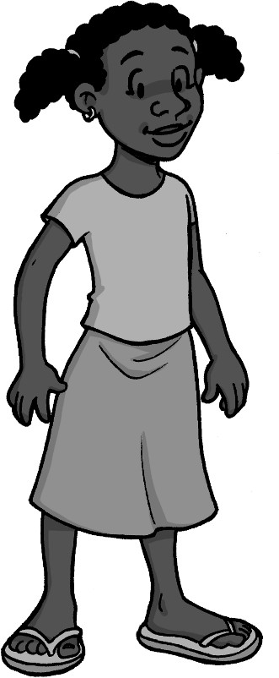

1. **Introduction**

Menstruation, commonly called a period, is the natural process of shedding the lining of a woman or adolescent girl’s uterus. During menstruation, blood flows from the uterus and passes out of the body through the vagina. This process happens for 2–7 days every month as part of a normal menstrual cycle. Girls begin to menstruate usually between the ages of 9 and 14.

Menstruation usually stops when a women is in her late 40s or early 50s, which is called menopause. A woman will menstruate for approximately 3,000 days during her lifetime.

Having regular menstrual cycles is a sign that important parts of the female body are working normally. The menstrual cycle provides important body chemicals, called hormones, to keep women and girls healthy. It also prepares the body for pregnancy each month.

Menstruation is normal and natural, but managing the menstrual process can be a challenge for many women and girls – especially in developing countries. These challenges include the following:

* Lack of sanitary products
* Lack of water and soap for cleaning
* Lack of access to appropriate sanitation facilities
* Cultural and religious restrictions
* Shame and embarrassment
* Lack of information and awareness

Let’s look at some of these challenges and their impacts in more detail in the following sections.

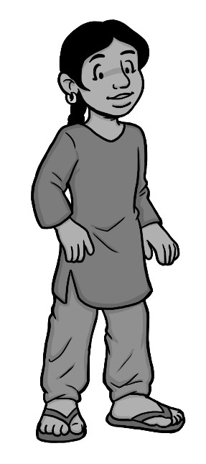

1. **Availability of Sanitary Products**

Women and girls need to use clean material to absorb or collect their menstrual blood. Sanitary pads or tampons are most commonly used, and these are normally changed around four times a day during menstruation. Some sanitary pads are meant for single use and are disposed afterwards, while others can be washed and reused.

Accessing sanitary products and underwear can be a challenge for women and girls in developing countries. The cost of disposable sanitary products can be too high for some women and girls. Others may feel ashamed or embarrassed to ask a male family member for money to buy these products. In some communities, these supplies simply are not available. As a result, many women use things like rags, toilet paper, newspaper, leaves or other things that may not be healthy or effective.

**Table 1: Sanitary Product Options**

|  |  |  |
| --- | --- | --- |
| **Sanitary Product Option** | **Advantages** | **Limitations** |
| Natural materials (e.g., mud, cow dung, leaves) | * No initial or ongoing cost * Locally available | * Difficult and uncomfortable to use * Unhygienic * May require underwear to keep in place * May not be culturally appropriate, if inserted into the vagina |
| Cloth strips (e.g., old clothes, towels or rags) | * No initial cost * Low ongoing cost * Available in the home * Easy to use * Reusable * Require less frequent disposal | * Poorly cleaned cloths are unhygienic * Require multiple cloths each month for good hygiene * Requires private space, water, soap and drying space to clean properly * Requires underwear to keep in place |
| Disposable pads | * Sometimes locally available * Easy to use | * Ongoing cost * Not available in some places * Difficult to dispose * Requires underwear to keep in place * Require frequent disposal |
| Reusable pads | * No ongoing cost * Sometimes locally available * Can be locally produced * Reusable * Require less frequent disposal | * Initial cost * Not available in some places * Requires private space, water, soap and drying space to clean properly * May require underwear to keep in place * Poorly cleaned pads are unhygienic |
| Tampons | * Hygienic if used properly * Comfortable to use | * Ongoing cost * Not available in many places * Require frequent disposal * May not be culturally appropriate, as needs to be inserted into the vagina * Requires water and soap for handwashing for hygienic handling * Requires initial instruction for proper use |

|  |  |  |
| --- | --- | --- |
| **Sanitary Product Option** | **Advantages** | **Limitations** |
| Menstrual cups    (Credit: Juliana Corrales from the Noun Project) | * No ongoing cost * Reusable | * High initial cost * Not available in many places * Requires private space, water and soap for washing hands and menstrual cup * Requires initial instruction for proper use * May not be culturally appropriate, particularly for adolescent girls, as needs to be inserted into the vagina |

**Case Study: Unhygienic Sanitary Products in Bangladesh**

The vast majority of women and girls in urban slums and rural Bangladesh use rags during menstruation. These are usually torn from old saris and known as ‘nekra’. Rags are washed quickly (with a small clay pot or plastic tub of water called ‘bodna’) inside the latrine and used several times. There is no private place to change and clean the rags and often no safe water and soap to wash them properly. Even in their homes, a culture of shame forces women to find well-hidden places to dry the rags. These places are often damp, dark and unhealthy. This practice is responsible for a significant proportion of illness and infection.

(Adapted from Ahmed and Yesmin, no date)

An increasing number of nongovernmental organizations (NGOs), women’s groups, schools and small-scale enterprises are manufacturing and distributing reusable and disposable sanitary pads that are affordable and practical. These organizations usually employ vulnerable and marginalized women and girls who make sanitary pads as a way to earn an income. The sanitary products are made using local materials and are marketed using appropriate media and messages. Successful operations have been set up in countries including, but not limited to, India, Bangladesh, Ethiopia, Kenya, Uganda and Rwanda (House et al., 2012).

1. **Water, Sanitation and Hygiene**

To manage menstruation hygienically and with dignity, it is essential that women and girls have access to water, sanitation and hygiene (WASH) at home and in public places like schools and work places. They need somewhere safe and private to change their sanitary products; clean water and soap for washing their hands, bodies, and reusable cloths; and facilities for safely disposing of used sanitary products or a clean place to dry them if reusable. See CAWST’s Technical Brief on Solid Waste Management for more information on safe disposal.

The needs of menstruating women and girls have been largely neglected by the WASH sector, as well as other sectors focusing on sexual and reproductive health and education. As a result, the practical challenges of menstrual hygiene are made even more difficult, and millions of women and girls continue to be denied their rights to WASH, health, dignity and gender equity (House et al., 2012).



**Features of Menstrual Hygiene-Friendly WASH Facilities in the Household**

* There is somewhere safe and private for excreta disposal, changing sanitary products and bathing.
* Facilities (e.g., latrine, water supply, bathing units) are near to the house and accessible for all members of the household, including those with mobility limitations.
* Latrines and bathing units have covered walls and a door with an internal lock.
* Water is available inside the latrine (e.g., from a tap or container).
* The latrine and bathing units are easy to clean.
* A washable container with lid for collecting sanitary products is located inside the latrine and/or bathing units.
* There is somewhere private for washing sanitary cloths and drying them in the sunlight or using another heat source (e.g., iron).
* There is a mechanism for final disposal of sanitary products, such as a pit or incinerator. See CAWST’s Technical Brief on Solid Waste Management for more information.

(House et al., 2012)

1. **Cultural and Religious Restrictions**

Many cultures and religions have customs and traditions about managing menstruation and interacting with menstruating women. Almost always, there are social norms or unwritten rules and practices about managing periods. Some of these are helpful, but others have potentially harmful implications. Many customs and traditions restrict women and girls’ level of participation in society during menstruation. This includes not being able to touch animals, water points, or food that others will eat; and exclusion from religious rituals, the family home and sanitation facilities. For example, 70% of girls in Afghanistan said they weren’t able to eat certain foods, and 67% of girls reported they were not able to attend a religious function. This can make their daily lives difficult and limit their freedom (House et al., 2012).

Cultural and religious restrictions related to menstruation are often compounded by traditional associations with evil spirits. In some cultures, women and girls fear that their menstruation can make them more vulnerable to witchcraft, curses or even death.

1. **Shame and Embarrassment**

One of the biggest problems related to menstruation is the shame. Many women and girls feel embarrassed or ashamed about their menstruation. The embarrassment surrounding menstruation is a somewhat universal phenomenon, found in most cultures of the world. There are many code words and phrases used to refer to menstruation, such as “time of the month” (Bharadwaj and Patkar, 2004).

Some women and girls are teased or shamed when other people find out they are menstruating. As a result, they often go through great efforts to hide the fact that they are menstruating. They avoid shared toilets and hide sanitary products, even from their husbands, families and peers. They do not feel comfortable talking about menstruation and this means they are unlikely to voice their needs or speak up when there is a problem. This makes it very difficult to address the challenges they face and can lead to other more serious problems.

1. **Information and Awareness**

Girls who are aware about menstruation and know how to manage it cope much better than those who are caught unaware. Preparedness improves girls’ self-esteem, gives them confidence about menstrual hygiene management and helps in overcoming any embarrassment. A girl’s first experience of menstruation can be a frightening time. If she does not know about menstruation, she can be shocked to see blood coming out of her vagina. She may think she is sick or dying, or believe she has done something wrong and will be punished (UNICEF, 2008).

In many cultures, menstruation is difficult to discuss in the home and also unlikely to be taught in school. Girls often grow up with limited knowledge of menstruation because their mothers and other women are embarrassed and shy away from discussing the issues with them. Even after girls begin to menstruate, very little information is often given to them about the physiological processes involved and the hygienic practices to be followed. Adult women may also not be aware of the biological facts or good menstrual hygiene practices. Instead they pass on cultural taboos and restrictions to be observed. Adolescent girls often seek information about menstruation from their peers who also do not know better (UNICEF, 2008).

Men and boys typically know even less, but it is important for them to understand menstrual hygiene so they can respect women and girls. Educating boys (particularly from adolescence) on the challenges and struggles girls face, could help reduce teasing. It could also help them become more understanding and supportive of their wives, daughters, mothers, students, employees and peers (House et al., 2012).

Making factual information available is essential to counter negative menstruation customs and give positive support to women and girls. Schools provide an opportunity to reach a large number of girls (and boys) with information on menstrual hygiene. Girls can be engaged through the education curriculum, additional sessions outside the curriculum and through health and hygiene clubs and other support groups. Education programs are also needed for teachers and school authorities, as well as sensitization for parents and wider communities. Such programs require experts from health, WASH, and the education sectors to all work together (Kirk and Sommer, 2006).

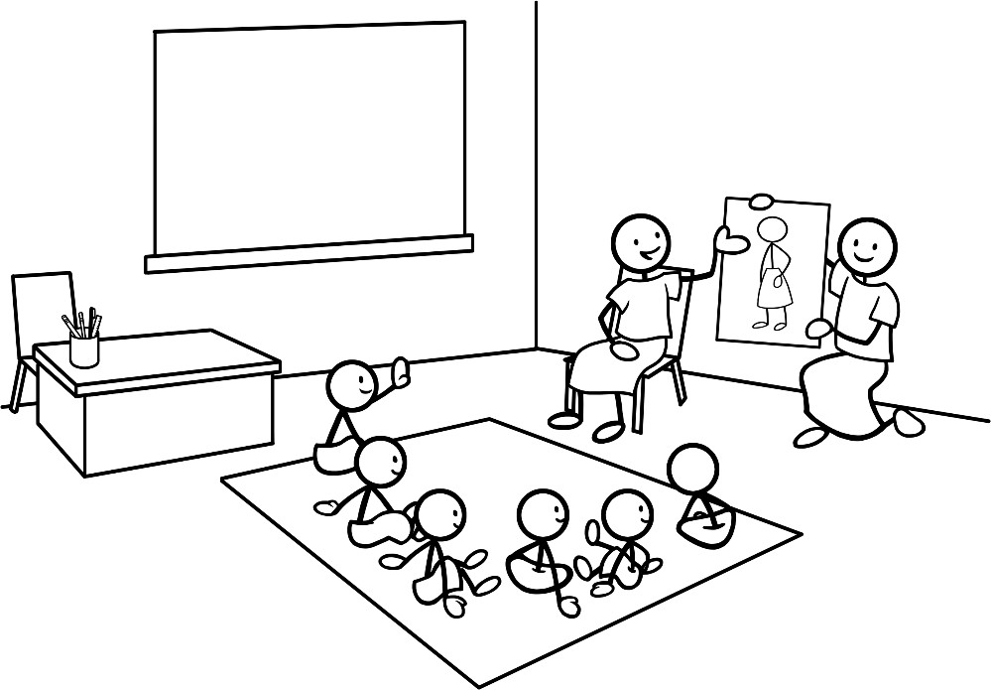

1. **Impact on Health**

Teaching girls about menstruation at school

Menstruation is a natural process; however, if not properly managed it can result in health problems. Reports have identified links between poor menstrual hygiene practices and the following health impacts in women and girls:

* Rashes and irritations
* Urinary, vaginal and perineal infections
* Complications with reproduction and pregnancy
* Complications associated with female genital mutilation or cutting

However, research on the actual health risks of different menstrual hygiene practices, particularly in developing countries, is limited (House et al., 2012).

1. **Impact on Education**

Many women and girls choose stay home and not go to public places when they are menstruating. This could be due to a variety of reasons, including lack of access to sanitary products, menstrual pain and discomfort and lack of access to pain medication, poor WASH facilities, and fear of teasing. Girls in developing countries often report that they miss school because of menstrual hygiene management (UNICEF, 2008). Regular absence from school means that girls have less opportunity to succeed in education, and workingwomen could lose wages or even their jobs if they have to stay home to manage their menstruation.

From a very practical perspective, girls who lack adequate sanitary products (e.g., pads) may miss school each month during their period. Not having proper sanitary protection can be very embarrassing and stressful for a girl going to school while she is menstruating. Leakage can stain a girl’s uniform and can provoke teasing from boys, as well as from other girls. Even if girls have access to sanitary products, they often have to manage with poor WASH facilities at school – inadequate water for washing, lack of soap, no privacy, nonfunctioning or inadequate latrines, and no disposal facilities for sanitary products. While poor facilities create unfriendly school environments for all children, they are particularly difficult for menstruating girls.

Where girls are able or determined to attend school throughout menstruation, the insufficient WASH facilities and sanitary protection may nevertheless create discomfort for girls in the classroom. This can include an inability to participate. For example, menstruating girls may hesitate to go up to the front of the class to write on the board, or to stand up as is often required for answering teachers’ questions, due to fear of having an ‘accident’ and staining their uniforms (Kirk and Sommer, 2006).

This discomfort is increased when male teachers and boy students show insensitivity to the challenges women and girls face in managing menstruation. Male teachers, for example, do not always understand a girl’s urgent need to go to the bathroom, and may insist that she wait until the end of class. Worse still are the situations where male teachers and boy students tease the girls (Kirk and Sommer, 2006).

Poor WASH facilities in schools also affect female staff experiences. It is very likely that female staff are frequently absent during menstruation due to the inability of the school infrastructure to meet their health and hygiene needs (Kirk and Sommer, 2006).

WASH projects in schools tend to focus only on physical infrastructure, such as latrines and water supplies. However, addressing menstruation challenges requires more than simply building a latrine or drilling a well. Not only do the design of latrines need to be menstrual- hygiene friendly, but WASH projects also need to link the physical infrastructure with the overall teaching and school environment (see the following box) to address menstrual hygiene management in a more comprehensive and holistic way (Kirk and Sommer, 2006).

The benefits of good menstrual hygiene in school, although not yet well documented, include the following:

* More time spent in school (female teachers and school girls)
* Increased concentration
* Higher self-esteem
* Increased comfort, good hygiene, less irritation from sanitary materials and less risk of related infections
* Greater participation
* More confidence to stand up to answer questions and to ask to leave the classroom to use the latrine (House et al., 2012)



**Features of Menstrual Hygiene-Friendly Schools**

***Infrastructure:***

* Separate latrines are available for boys and girls, and male and female teachers.
* Latrines have doors with locks, and are secure and private.
* Latrine, water supply and hand washing facilities are in a safe location.
* Hand washing facilities are inside the latrine, with soap and water available at all times.
* Water is available (from a tap or bucket) inside latrines, bathing units and changing rooms.
* Latrines can be easily cleaned and there is an efficient mechanism for sustaining cleanliness and maintenance.
* The facilities are accessible for all girls, boys and staff, including those with mobility limitations.
* Each latrine has a washable container with lid for collecting sanitary protection materials, and wrapping materials.
* A small mirror is present in the latrine to help girls check for spotting or leaking and ensure everything is in order before leaving.
* A mechanism is established for the collection and disposal of sanitary protection materials, such as in a pit or incinerator.
* Changing facilities are provided in a larger latrine cubicle that can be used by all girls, so that sanitary protection materials can be changed discretely.
* A financing mechanism is established to sustain the operation and maintenance of water supply, latrine and hand washing facilities.

***Teaching and School Environment:***

* Teachers are knowledgeable about menstrual hygiene in school and the needs of girls and female staff.
* Menstrual hygiene is included in the curriculum.
* Affordable sanitary products are available for girls who need them or training is provided on how to make them.
* The school governing bodies are aware of the menstrual hygiene needs of girls and staff, and work to ensure the school is menstrual hygiene-friendly.
* Menstrual hygiene is incorporated into the school’s monitoring systems.

(House et al., 2012)

1. **Further Information**

CAWST (2013). Technical Brief: Solid Waste Management. CAWST, Calgary, Canada. Available at: [www.cawst.org/resources](http://www.cawst.org/resources)

* + This technical brief discusses how to safely and properly manage solid waste in developing countries, including waste generation, collection, treatment, and final disposal.

House, S., Mahon, T. and S. Cavill (2012). Menstrual Hygiene Matters: A Resource for Improving Menstrual Hygiene Around the World. WaterAid, London, UK. Available at: [www.wateraid.org/what-we-do/our-approach/research-and-publications/view-](http://www.wateraid.org/what-we-do/our-approach/research-and-publications/view-publication?id=02309d73-8e41-4d04-b2ef-6641f6616a4f&sc_lang=en) [publication?id=02309d73-8e41-4d04-b2ef-6641f6616a4f&sc_lang=en](http://www.wateraid.org/what-we-do/our-approach/research-and-publications/view-publication?id=02309d73-8e41-4d04-b2ef-6641f6616a4f&sc_lang=en)

* This resource is divided into modules, each with its own toolkit, focusing on various aspects of menstrual hygiene. It presents comprehensive and practical guidance on what is already being implemented in different contexts to encourage replication for improving practices for women and girls in low- and middle-income countries. It will be of particular use to WASH sector professionals, as well as those from other sectors, including health, sexual and reproductive health and rights, education, community development, protection, and gender.

1. **References**

Ahmed, R. and K. Yesmin (No date). Hygiene Promotion Menstrual Hygiene: Breaking the Silence. Available at: [www.wateraid.org/documents/ch21_menstrual_hygiene_breaking_the_silence.pdf](http://www.wateraid.org/documents/ch21_menstrual_hygiene_breaking_the_silence.pdf)

Bharadwaj, S. and A. Patkar (2004). Menstrual Hygiene Management in Developing Countries: Taking Stock. Junction Social, Social Development Consultants, Mumbai, India. Available at: [www.washcost.info/docsearch/title/163390](http://www.washcost.info/docsearch/title/163390)

House, S., Mahon, T. and S. Cavill (2012). Menstrual Hygiene Matters: A Resource for Improving Menstrual Hygiene around the World. WaterAid, London, UK. Available at: www.wateraid.org/what-we-do/our-approach/research-and-publications/view- publication?id=02309d73-8e41-4d04-b2ef-6641f6616a4f&sc_lang=en

Kirk, J. and M. Sommer (2006). Menstruation and Body Awareness: Linking Girls’ Health with Girls’ Education. Royal Tropical Institute, Amsterdam, the Netherlands. Available at: [www.wsscc.org/resources/resource-publications/menstruation-and-body-awareness-linking-](http://www.wsscc.org/resources/resource-publications/menstruation-and-body-awareness-linking-girls%E2%80%99-health-girls%E2%80%99?rck=0841bcc00355d04aa28d9236ab7e613c) [girls%E2%80%99-health-girls%E2%80%99?rck=0841bcc00355d04aa28d9236ab7e613c](http://www.wsscc.org/resources/resource-publications/menstruation-and-body-awareness-linking-girls%E2%80%99-health-girls%E2%80%99?rck=0841bcc00355d04aa28d9236ab7e613c)

Ten, V. (2007). Menstrual Hygiene: A Neglected Condition for the Achievement of Several Millennium Development Goals. European External Policy Advisors, Brussels, Belgium.

Available at: [www.eepa.be/wcm/dmdocuments/BGpaper_Menstrual-Hygiene.pdf](http://www.eepa.be/wcm/dmdocuments/BGpaper_Menstrual-Hygiene.pdf)

UNICEF (2008). Sharing Simple Facts: Useful Information about Menstrual Health and Hygiene. UNICEF India, New Delhi, India. Available at: [www.unicefiec.org/document/sharing-simple-](http://www.unicefiec.org/document/sharing-simple-facts-useful-information-about-menstrual-health-and-hygiene-booklet-english) [facts-useful-information-about-menstrual-health-and-hygiene-booklet-english](http://www.unicefiec.org/document/sharing-simple-facts-useful-information-about-menstrual-health-and-hygiene-booklet-english)

CAWST (Centre for Affordable Water and Sanitation Technology) Calgary, Alberta, Canada

Website: [www.cawst.org](http://www.cawst.org/) Email: [resources@cawst.org](mailto:resources@cawst.org)

*Wellness through Water. Empowering People Globally*

Last Update: August 2014

This document is open content. You are free to:

* Share – to copy, distribute and transmit this document
* Remix – to adapt this document

Under the following conditions:

* Attribution. You must give credit to CAWST as the original source of the document. Please include our website: [www.cawst.org](http://www.cawst.org/)

CAWST and its directors, employees, contractors and volunteers do not assume any responsibility for, and make no warranty with respect to, the results that may be obtained from the use of the information provided.

**Contents**

1. Introduction 143
2. Applicability in Developing Countries 143
3. Operation 144
   1. Materials 144
   2. Water 146
   3. Air 146
   4. Heat 146
   5. Surface Area 147
4. Household Compost Unit Designs 147
   1. Wood Compost Unit 148
   2. Concrete Block Compost Unit 148
   3. Wire Mesh Compost Unit 148
   4. Can Compost Unit 149
   5. Recycled Tire Compost Unit 149
5. Using Compost 150
6. Troubleshooting 151
7. Vermicomposting 152
8. Additional Resources 152
9. References 152

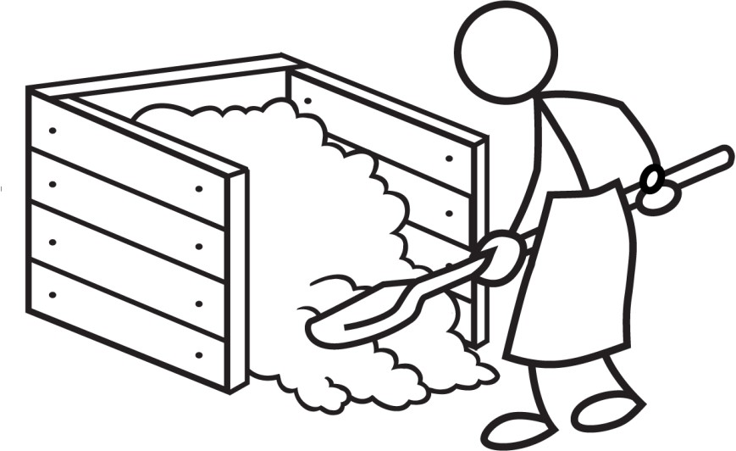

1. **Introduction**

All organic material (i.e., material that once came from a living thing) will naturally break down over time with the help of bacteria and other organisms (e.g., yeast, fungi, worms). Composting accelerates the decomposition of organic material, usually food and plant waste, into a valuable soil amendment. The result is a soft, dark, earthy material that can be used to improve soil structure and provide nutrients for plant growth. Virtually any soil will benefit from the application of compost (Hoornweg *et al*., 1999).



**Benefits of Compost**

* Contains nutrients that are in a form that is readily available for plants
* Supplies nutrients for a longer amount of time than chemical fertilizers
* Increases the soil’s ability to retain water (1 kg of compost can hold 2 kg of water!)
* Allows more air into the soil
* Allows plant roots to grow deep and wide, increasing resistance to drought and erosion
* Allows plants to grow strong and healthy, increasing resistance to pests and diseases

(Adapted from HDRA, 1998)

1. **Applicability in Developing Countries**

As much as 80% of the waste produced in low- and middle-income countries is organic material that can be composted (Hoornweg *et al*., 1999). Composting is a traditional practice already used in many rural communities to manage household and agricultural waste, but can also be done in peri-urban and urban areas. Household composting can be a simple way to manage kitchen and garden waste. It’s most appropriate for homes that have enough space in their yard for the compost piles, and where they can use the final compost product in their own gardens.

Other benefits for composting in developing countries include:

* Can be done with no or minimal capital and operating costs
* Can be done at the household or community level
* Compost units can be made out of locally available materials
* The hot climate in most developing countries is ideal for composting
* Accommodates fluctuations in seasonal waste such as leaves and crop waste
* Can integrate the informal sector involved in collecting, separating and recycling of waste
* Reduces expensive waste collection and transportation requirements
* Diverts more waste from final disposal (e.g., dumps or landfills)

(Adapted from Hoornweg *et al*., 1999)

1. **Operation**

There are five key factors needed for producing successful compost:

1. Materials
2. Water
3. Air
4. Heat
5. Surface Area

Each of these factors is discussed in more detail in the following sections.

* 1. **Materials**

Nearly all organic material can be used to make compost, but different items will take varying amounts of time to decompose and form different end products. For example, fruit on its own will go slimy and maize stalks will go dry and dusty (HDRA, 1998). The materials generally used for composting are household food waste (e.g., fruit and vegetable peelings) and agricultural waste (e.g., plants, husks).

The material should be a mixture of old and tough (brown) with young and wet (green) materials. This is because different types of organic material have different amounts of carbon and nitrogen. Generally, young and fresh materials have high amounts of nitrogen while tough, dead and dry materials have high amounts of carbon. It is important to have a balance of nitrogen and carbon in the compost pile. Too little nitrogen in the compost pile and the composting process will be slow; too much nitrogen and the pile will become acid and smelly (HDRA, 1998).

The following table lists the materials that should and should not be used in composting. Some materials may attract pests, cannot be decomposed or will contaminate the pile. This is not a complete list and additional materials may be able to be composted.



**Composting Tip**

A strong ammonia smell indicates that there is probably not enough carbon material (brown) in the compost pile.

If the compost is cold, smells sweet, and is not breaking down over time then there is a lack of nitrogen material (green) in the compost pile.

**Appropriate Materials for Composting**

|  |  |  |
| --- | --- | --- |
| 🗸 **Good Materials** | | 🗴 **Do Not Use These** |
| **Young, Wet, Green (Nitrogen-Adding)** | **Old, Tough, Brown (Carbon-Adding)** | * Any non-degradable materials, such as glass, metal and plastic * Meat or bones* * Fish* * Oil* * Fat* * Dairy products* * Cooked vegetables* * Grains* * Plants recently sprayed with pesticides or herbicides |
| * Fruit and vegetable waste * Fresh leaves * Fresh grass * Seaweed * Tea leaves * Coffee grounds * Egg shells (crushed) * Urine * Manure | * Paper and cardboard (no glossy or waxed paper) * Crop residue (e.g., husks, stalks) * Dried leaves * Dried grass * Seed husks * Nut shells * Cotton and wool rags * Wood fire ash * Saw dust |

* These materials can be composted, but will attract flies, rodents and other pests.

When building your compost it is a good idea to build it up in layers by placing a layer of young, wet, green material and then covering it with a layer of old, tough, brown material. This will help to keep flies and pests away and keep a balance between carbon and nitrogen.



Layering green and brown material in a compost pile (Credit: Rymut, 2011)

* 1. **Water**

The compost pile should always be moist. The composting process will slow down if the organic material is too dry. As well, a compost pile that is too wet will begin to smell.

A squeeze test can be performed to determine the moisture level: a handful of squeezed compost should feel like a well-wrung sponge. Add water to the pile if it is too dry. You can fix a pile that is too wet by doing some of the following:

* + - Adding more dry material
    - Spreading out the pile and allowing it to dry out a bit before building it up again
    - Mixing the pile with a shovel
  1. **Air**

Composting is an aerobic process and requires oxygen. If there is not enough oxygen, unwanted bacteria will grow and the compost will begin to have a bad smell (this is what happens in dumps or landfills). Regular mixing of the pile should be done to help add air and prevent odours.



**Composting Tip**

After three days, begin mixing the compost once a week to add air. Continue to do so every week or whenever it becomes compacted, too wet or develops a bad smell. A shovel or pitchfork can be used to help you mix the material. Turn the compost material from the edges of the pile into the middle for even decomposition. Turning the pile will mix the green and brown layers, but that’s fine. If it seems like the material is no longer decomposing and feels heavy to mix, then you may have to add more brown material to keep it balanced.

By mixing your compost once or twice a week, you can have finished compost in as little as three months.

(Adapted from Government of Alberta, 2008)

* 1. **Heat**

Composting can be done in virtually any climate; however, warmer temperatures help speed up the composting process. The compost pile will also generate its own heat as it breaks down the organic material. In the beginning, you can watch your pile heat up and then you need to turn it three days later. Turn the pile every week. When the pile stops heating up, the compost is done (Rymut, 2011).

Heat is also needed to kill any pathogens in the compost pile. Generally, if the compost material has been exposed to temperatures between 55-65oC for three consecutive days the pathogens will be sufficiently reduced.

If the temperature gets much higher than 65oC, then the process will slow down since many of the good composting microorganisms will become dormant or die off (Hoornweg *et al*., 1999).



**Composting Tip**

It may be difficult to measure the temperature of a compost pile. The “stick test” is a simple way to test the temperature. Place a stick in the middle of the compost pile about 10 days after it has been built. Allow it to remain there for a few days. When it is pulled out it should feel slightly too hot to touch. If the stick has not warmed up, either decomposition has not started or there could be an imbalance in the amount of air or water.

Another way to test for heat is to dig into the pile or turn the pile over and then feel if the inner compost is warm. If you do this test, be careful of pests that might be in the compost.

It is recommended that you wear gloves (if possible) and wash your hands with soap and water after handling immature compost that might still contain pathogens.

* 1. **Surface Area**

Increasing the surface area of the organic waste material will speed up composting. This can be done by chopping, shredding or breaking up the material (green and brown) into smaller pieces.

1. **Household Compost Unit Designs**

There are many different designs for household compost units. An appropriate design depends on the following factors:

* Location
* Climate
* Local resources (e.g., wood, bamboo, clay bricks, wire mesh)
* Amount of material to be composted
* Size

A few examples of household compost units are described below, but there are other options available. Use creativity when creating your composting unit.

Some general recommendations for household compost units are:

* Place your compost somewhere convenient
* Place your compost in the shade or under cover to minimize water evaporation
* Use a surrounding barrier to protect the pile from wind, which will increase water evaporation and/or blow debris around
* Use a surrounding barrier to protect the pile from pests, animals and small children
* Size your compost unit so that you can move it (1 m x 1 m x 1 m is recommended)
* If you have a small amount of organic material, it is better to pile it than spread it out
  1. 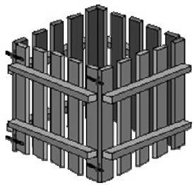**Wood Compost Unit**

The walls are made of wood with spaces in between to allow air to flow into the pile. The corners can be nailed, wired or tied. Being able to remove one side is important to make it easier to turn the pile over. Mixing can be done either by opening one side and mixing the pile, or lifting and moving the frame and then shovelling the pile back into the bin in its new location.

A bottom palette can be added to increase air-flow to the bottom of the compost pile. However, the wood will eventually begin to rot and will need to be replaced.

(Credit: Guam Solid Waste Receivership Information Center, 2009)

* 1. **Concrete Block Compost Unit**

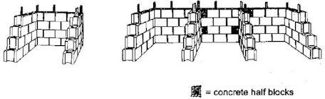Blocks or bricks can be used to make this unit. The piles will have to be mixed often since there is not much air-flow around the sides. The three-bin system can be used by building a compost pile in the first section, and then mixing the compost by shovelling it into the next section. The other way is to leave the middle bin open and then transfer compost from the edge bins to the middle and back again to the original bin. Pests, animals and children can more easily get into the compost because there are only three sides.

(Credit: Guam Solid Waste Receivership Information Center, 2009)

* 1. 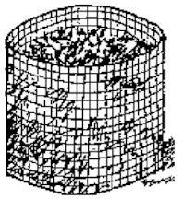**Wire Mesh Compost Unit**

This unit can be made out of any wire mesh and supported by stakes for extra stability. This type of unit keeps out large pests and is lighter and easier to move. It also allows a large amount of air-flow to the compost.

To mix the pile, remove the mesh and set it up next to the pile. Then shovel the pile back into the wire mesh bin in its new location.

(Credit: Guam Solid Waste Receivership Information Center, 2009)

* 1. **Can Compost Unit**

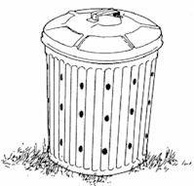A can composter is a good option where space is limited or compost is considered unsightly. It will also keep children, animals and pests away. Any kind of barrel or can will work as long as there is a large hole in the top (through which the material can be put inside) and holes in the sides to allow air- flow. Holes can also be made in the bottom and the composter can be elevated off of the ground by bricks or wood. A lid is helpful to minimize water evaporation.

To mix the pile, the can should be dumped out and then the compost shovelled back in.

(Credit: Guam Solid Waste Receivership Information Center, 2009)

* 1. **Recycled Tire Compost Unit**

This design is easy to move and uses an often unwanted resource – old tires. Four tires are placed on top of each other with sticks or pieces of wood between the tires to improve air flow and reduce odours. A lid or screen cover is also helpful to keep out pests. Tires hold the moisture extremely well so you should be careful not to over water the pile.

To mix the pile, do not lift or carry the tires but slide, lean and roll them:

1. Pull first tire toward you, dumping the contents on the ground
2. Place first tire in new location
3. Shovel contents into first tire
4. Pull second tire off and dump contents on the ground
5. Repeat sequence until all tires are moved to new location

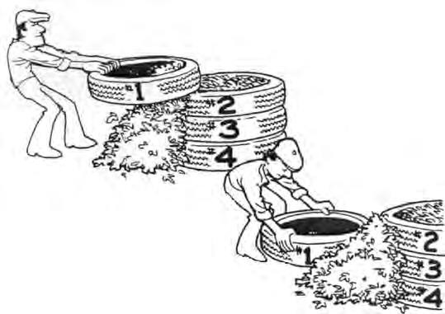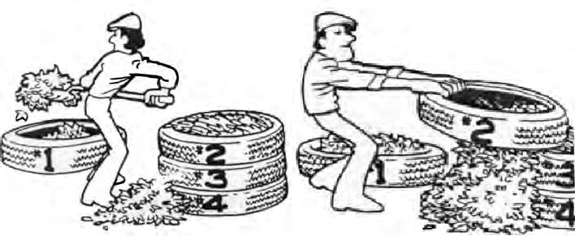

Recycled tire compost unit (Credit: [www.tirecrafting.com)](http://www.tirecrafting.com/)

1. **Using Compost**

Finished compost will be found at the bottom of the pile. Compost is ready for use when it has turned into a soft, crumbly and loose material. It should look and feel like top-soil. It will be a dark brown or greyish black colour and smell sweet and earthy. It is recommended to put the compost through a screen to ensure that large materials, that have not yet been degraded, are sorted out and can be put back into the pile.

Even though your compost may look ready, it may not be. Curing is an often-neglected stage in the composting process. This final stage allows the compost to mature until it is stable. The compost becomes mature as its temperature comes close to the normal outside conditions and the pile does not re-heat above 20oC (Hoornweg *et al*., 1999). Immature compost might still have active organisms, continue to use oxygen and take nitrogen from the soil. It can damage plant growth if it is used before it is ready.

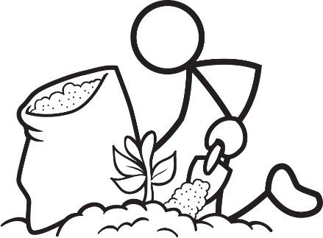The finished compost can be applied to a household garden or agricultural crop. It can either be mixed into the soil as an amendment (along with fertilizer if available) or placed on top as mulch. When planting, use a mixture of 1/3 compost with 2/3 soil. Do not plant directly into the compost since it has too many nutrients that can harm your plants.



**Composting Tip**

There are two tests that can be done to make sure that your compost is finished and ready to use.

1. Fill a plastic bag with compost, squeeze out all of the air and seal it. Check the bag after 24 hours. If the bag has expanded, it is a good indication that the compost is still active and it is not finished. Open the bag and smell it. If it has a bad smell, then it is not finished. Keep turning the compost pile a couple of times per week until it is finished. Do not add new organic material during this time.
2. Fill a plastic or glass container half full of compost and add enough water to make it soggy. Put the lid on the container and let it sit for a week. When you open the jar and it has a bad smell, then it is not finished. It should smell like wet earth.

(Adapted from Government of Alberta, 2008)

1. **Troubleshooting**

Almost all of the problems that may arise with composting can be solved by one of the five key factors: material, water, air, heat and surface area.

**There are a lot of flies around the pile.** *The pile needs to be covered better with old and tough (brown) material such as dried leaves, hay, etc.*

**The pile is not shrinking**

*It needs more air. Try mixing the pile or poking holes in it with a stick.*

*OR*

*There is not enough nitrogen.*

*Add more young and wet material.*

**There are a lot of ants in the pile.**

*Add water.*

**The pile does not heat up.**

*There is not enough nitrogen.*

*Add more young and wet (green) material.*

**The pile smells bad.** *It needs more air. Try mixing the pile or poking holes in it with sticks.*

*OR*

*Add more old and tough (brown) material.*



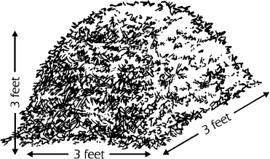

**It’s not decomposing fast enough.**

*Increase the surface area of the material (green and brown) by chopping it up into smaller pieces before adding it to the pile.*

1. **Vermicomposting**

Vermicomposting is a special type of composting that may also work in developing countries, especially for households in urban centers with little land space. This process uses the natural digestion of redworms and earthworms to break down organic material. From the moment it hatches, a worm can consume, daily, its body weight in organic matter such as vegetables, fruit, leaves, grass, meat, fish, sludge, cardboard and paper. The worms can be housed in any ventilated container with a lid that has drainage holes or a layer of gravel in the bottom to let liquid created in the process drain.

1. **Additional Resources**

CAWST (2013). Technical Brief: Solid Waste Management. CAWST, Calgary, Canada. Available at: [www.cawst.org/resources](http://www.cawst.org/resources)

* This technical brief discusses how to safely and properly manage solid waste in developing countries, including waste generation, collection, treatment and final disposal.

City of Edmonton (no date). Do It Yourself Composting Bins. Edmonton, Canada. Available at: [www.edmonton.ca/for_residents/PDF/Do_it_yourself_composting_bins.pdf](http://www.edmonton.ca/for_residents/PDF/Do_it_yourself_composting_bins.pdf)

* This document provides detailed step-by-step instructions on how to construct your own compost bin. Various designs are included which can be adapted to use local materials.

Green Calgary (no date). Vermicomposting Guide. Calgary, Canada. Available at: [www.greencalgary.org/images/uploads/Vermicomposting_GC.pdf](http://www.greencalgary.org/images/uploads/Vermicomposting_GC.pdf)

* This guide provides detailed instructions on how to construct, operate and troubleshoot your own vermicompost bin.

1. **References**

Government of Alberta (2008). Backyard Composting to Reduce Organic Waste. Edmonton, Canada. Available at: www.environment.alberta.ca

Guam Solid Waste Receivership Information Center (2009) Guam Solid Waste Management Division Yard Waste – Composting. Available at: www.guamsolidwastereceiver.org

HDRA (1998) Composting in the Tropics. HDRA Publishing, Coventry, United Kingdom. Available at: www.gardenorganic.org.uk/pdfs/international_programme/Compost102.pdf

Hoornweg, D., Thomas, L. and L. Otten (1999) Composting and Its Applicability in Developing Countries. The World Bank, Washington, DC, USA. Available at: www.worldbank.org/urban/solid_wm/erm/CWG%20folder/uwp8.pdf

Rymut, J. (2011). Compost Heaven. Available at: www.compostheaven.com/compost- making.html

CAWST (Centre for Affordable Water and Sanitation Technology) Calgary, Alberta, Canada

Website: [www.cawst.org](http://www.cawst.org/) Email: [resources@cawst.org](mailto:resources@cawst.org)

*Wellness through Water. Empowering People Globally*

Last Update: August 2014

This document is open content. You are free to:

* Share – to copy, distribute and transmit this document
* Remix – to adapt this document

Under the following conditions:

* Attribution. You must give credit to CAWST as the original source of the document. Please include our website: [www.cawst.org](http://www.cawst.org/)

CAWST and its directors, employees, contractors and volunteers do not assume any responsibility for, and make no warranty with respect to, the results that may be obtained from the use of the information provided.