Sawyer PointONE
Source Protection | Safe Transportation | Sedimentation | Filtration | Disinfection | Safe Storage

What is it?
Produced by Sawyer Products, the Sawyer PointONE™ is a gravity-driven membrane filter. It uses hollow fibre membranes with a pore size of 0.1 microns, making it effective for removing bacteria, protozoa, and helminths. With an adapter kit, the filter can be attached to a plastic bucket. Dirty water is poured into the plastic bucket, flows down through the filter (which traps particles and pathogens), and out into a safe storage container.

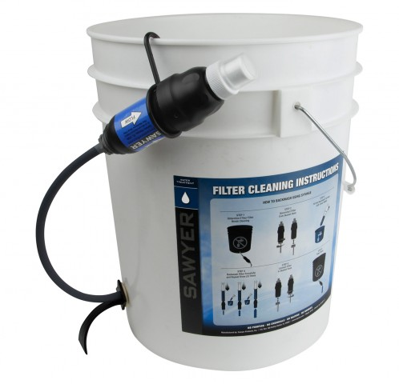
Performance

Microbiological Effectiveness:
Parameter | Effectiveness
Bacteria | Very Effective (>99%)
Viruses | No independent tests
Cryptosporidium (Protozoa) | Very Effective (>99%)
Giardia (Protozoa) | Very Effective (>99%)
Helminths | Very Effective*
*Assumption based on pathogen size

Other Parameters
Effective for removing turbidity. Not effective for chemicals.

Source Water Requirements
Can be used with turbid water, but the filter may clog more often and require more frequent backwashing. Turbid water (>50 NTU) should be settled or strained before filtering.

Capacity
Can treat 32.8–46.5 L/hour. Typically treats 20 L (one bucket) at a time.

Lifespan
Manufacturer states that the filter can be backwashed and reused indefinitely without needing replacement. Recent studies indicate lifespan may be shorter than this.

Ease of Use & Acceptability

Operation & Maintenance
Users pour water into the upper container, and wait for water to flow down the hose, through the filter into a lower safe storage container. A syringe (included) can be used to backwash the filter when flow rate slows down. The safe storage container must be cleaned regularly.

Repair & Replacement
The filter should be replaced if it breaks, if flow rate suddenly increases, or if backwashing doesn’t return flow rate to normal.

User Considerations & Preferences
Usually the user must connect the filter to a bucket. The flow rate may slow down quickly for turbid water.

Feasibility

Availability
Available online. Cannot be exported internationally through Sawyer Products Inc. They recommend contacting an international logistics company.

Cost
US$60 from manufacturer.

Size & Weight
Filter unit is 22 cm long by 7 cm wide, weighing 0.3 kg.

More Information
Details and references: www.hwts.info/products-technologies/cd408b5b/sawyerr-pointonetm-filter

