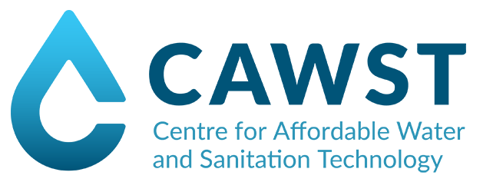

This is to certify that

**First Name Last Name**

has successfully completed the CAWST workshop

**Introduction to Drinking Water Quality Testing**

A XX day introductory workshop on basic drinking water quality testing for microbiological, acceptability, and chemical parameters in the context of a water, sanitation, and hygiene project.

***Presented at City/Town, Country***

***From date to date of month, year***

**Trainer : _______________________ Trainer: _________________________**

Name

Job Title

Organization

Name

Job Title

Organization