Lesson Plan 6: Workshop Review and Closing

**30 minutes**

**Learning Outcomes**

At the end of this session participants will be able to:

* + - 1. Revise all workshop information.

**Materials**



* News print paper
* Tape
* Markers

**Preparation**



* Prepare flip chart with lesson description or learning outcomes
* Prepare picture cards for the review
* Prepare self assessment and participants learning expectation for review

**Activity 20 minutes**

1. Tell the participants that they are going for the review of the whole activity. For this participants will be divided in four groups and provide them a picture card and brown sheet. In brown sheet they will have to write the key understanding about the picture. For this activity they will assigned 5-7 minutes time. Then after, they have to do a gallery walk and add if any points are missing.
2. Divide the participants into four groups and provide a picture card and marker (different for different group).
3. Allocate 5-7 minutes time for the activity.
4. Ask them to discuss within the group and point out the key message related to the picture.
5. After that, ask the group to paste their findings from the picture on the wall.
6. Precede the group for gallery walk and add if any points are missing. 2 minutes time is assigned for each station.
7. Present the paper in large group

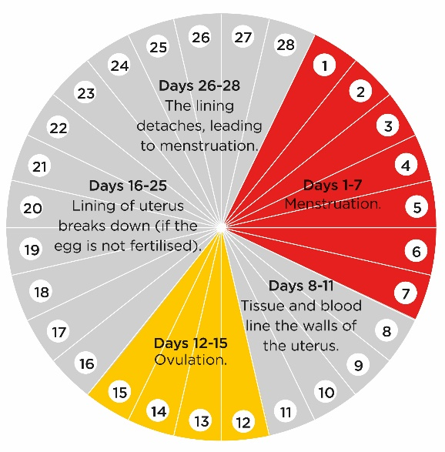

**Menstrual Cycle**



**Menstruation**

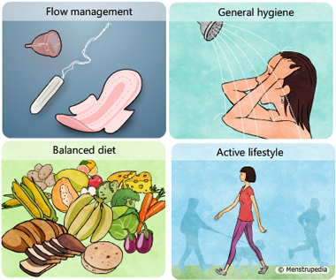

**Menstrual Hygiene Management**

**Self Assessment 5 minutes**

1. Ask participants return to the self assessment activity they completed in the beginning of the workshop.
2. Ask participants to place a new mark on the self assessment flip chart to indicate where they now feel their knowledge is on each of the topics.
3. Discuss the results.

**Learning Expectations 5 minutes**

1. Review the participant learning expectations flip chart form the beginning of the workshop and discuss if they were all addressed. If not, give options for participants to find the information they were looking for or identify next steps for follow-up.

**Closing**

1. Thanking all the participants for their active participants, inform them that the orientation is informally closed.