**Sanitation System**

Use or Disposal

Treatment

**Emptying and Transport**

**Excreta Storage**

**User Interface**

**Contents**

1 Introduction 2

2 Reducing the Risk of Groundwater Contamination 4

3 Physical Space 9

4 User Needs and Preferences 11

5 Additional Resources 13

6 References 13

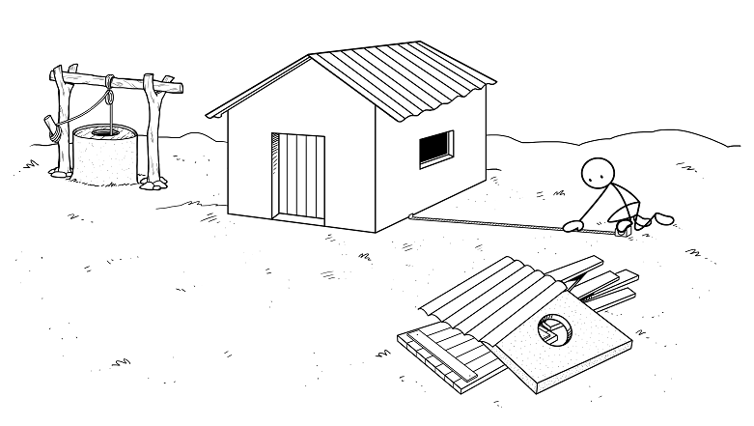

# Introduction

A sanitation system deals with human excreta from the time it is “captured” in a latrine until it is used or disposed of safely. Sanitation systems are built for people, are managed by people, and affect people’s daily lives. The latrine is the part of a sanitation system that people interact with the most. The latrine is made up of the:

* “Front-end” or the user interface: the parts that every user interacts with, including the toilet (seat or pan), slab and superstructure
* “Back-end” or excreta storage: the pit, tank or chamber used to store excreta

Once an appropriate latrine design has been selected, the work of building the latrine can begin. But where should the latrine be built? What is most convenient, but also private, for the users? Is there enough space? How high is the groundwater? What type of soil is there? These are just a few of the questions that need to be answered when finding an appropriate spot for a latrine.

Wherever a latrine is built, it should be safe and convenient for the users, and should not contaminate the groundwater. Properly siting (also called locating or placing) a latrine can be challenging. There are various physical, environmental and social factors that need to be taken into consideration. Some implementers may have the capacity to carry out scientific tests to help figure out the best location for a latrine. Most latrine builders; however, will rely on a few general rules to site a latrine.

The aim of this Technical Brief is to help project implementers and latrine builders understand the most important factors for siting latrines. Different factors are discussed, including soil and groundwater conditions, physical space requirements, and user needs and preferences. General rules are given that can be used to site latrines and minimize the risk of groundwater contamination.

For more information on latrine projects, CAWST’s Technical Briefs and Fact Sheets provide details on:

* How to select, site and construct latrines
* Latrine emptying
* Sludge treatment, use and disposal
* Approaches for sustainable latrine project implementation

This document provides a technical overview and is not a design manual. An experienced professional should be consulted for the design of specific latrine technologies and structures.

Please see the Guide to CAWST Sanitation Resourcesfor a complete glossary, list of abbreviations, unit conversions, and an overview of available resources.

CAWST focuses on the planning, design and implementation of on-site sanitation projects for low-income communities not connected to a sewer. For such communities, household or decentralized sanitation offers a hygienic and affordable solution.

CAWST’s free, open content resources and schedule of international training workshops can be found at: [www.cawst.org/resources](http://www.cawst.org/resources) and [www.cawst.org/training](http://www.cawst.org/training).



**Definitions**

**Excreta:** Urine and feces that is not mixed with any flushwater. Excreta contains many nutrients and pathogens.

**Groundwater:** Also called the water table. Groundwater is found underground in the spaces between soil particles, or in the cracks in rock. It is sometimes thought that water flows through underground rivers or that it collects in underground lakes. Groundwater is not confined in the same way that surface water is found in streams and lakes. Rather, it exists almost everywhere underground.

**Groundwater contamination:** Pollution of groundwater due to human or natural causes. Excreta from people and animals can contaminate the groundwater with pathogens.

**Infiltrate:** To pass into or through something. Infiltration is the process by which liquid from a latrine pit enters the surrounding soil.

**Pathogen:** Any living organism that causes disease. Pathogens commonly found in drinking water include bacteria, viruses, protozoa and helminths.

**Permeable:** Liquids can pass through. Latrine pit walls must be permeable for liquid to infiltrate into the surrounding soil. Impermeable means that liquids cannot pass through (also called watertight).

# Reducing the Risk of Groundwater Contamination

A goal of any latrine is to reduce the chance of excreta contaminating groundwater. There is always a risk that pathogens and other contaminants (like nitrogen) from latrines will contaminate wells, boreholes and springs if they are constructed too close. Latrines should be designed and located so that the risk of groundwater contamination is minimized.

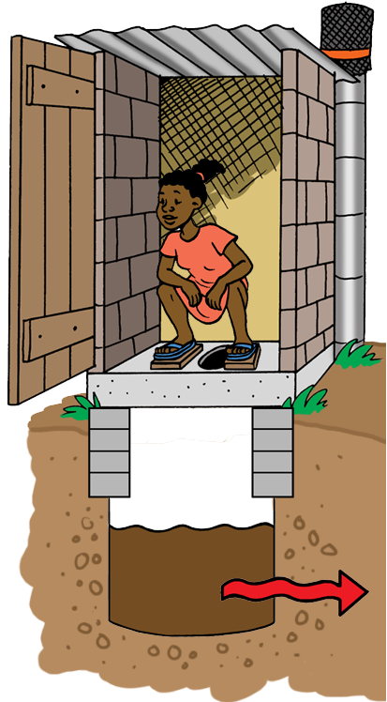

Pit latrine with permeable walls that lets the liquid infiltrate into the soil

The first step in reducing the risk is through the latrine design. Some latrines are purposely designed to infiltrate liquid into the soil, such as pit latrines, septic tanks and aqua privies. Other latrines have minimal liquid that can escape, such as composting and dehydrating latrines. There are also latrines which are designed to completely contain all of the liquid, such as holding tanks.

Latrines that allow liquid to infiltrate into the soil have a higher risk of contaminating the groundwater than latrines with minimal or no liquid escaping.

The liquid from a latrine moves through the soil until it enters the groundwater. It then moves through the soil (or rock) with the groundwater flow. As the liquid moves through the soil, pathogens will be filtered out and naturally die-off over time. If there is not enough soil between the latrine and the groundwater; however, then the pathogens will reach the groundwater. If the contaminated groundwater reaches a well, spring or borehole, these drinking water sources will become contaminated.



**Balancing Risk**

Latrines are an important strategy for improving human excreta disposal. Despite the potential for groundwater contamination, a latrine that is well-designed, sited, constructed and maintained is much better at reducing the spread of pathogens than open defecation.

## Factors Affecting the Risk of Contamination

There are several technical and environmental factors that influence whether pathogens from a latrine will contaminate a water source. One important factor is the distance between the bottom of the latrine pit and the groundwater. Another is the distance between the latrine and the water source. The diagram below shows the factors that influence whether a latrine may contaminate groundwater. Each of the factors in the diagram is described below in more detail.

**Amount of liquid in the pit**

**Soil Type**

**Soil/Rock Type**

**Distance Between Latrine and Drinking Water Source**

**Distance Between Bottom of Pit and Groundwater**

**Direction and Speed of Groundwater Flow**

Factors that influence groundwater contamination (Credit: Adapted from Sugden, 2006)

1. **Amount of liquid in the pit**

*General rule: The less liquid in the latrine pit, the lower the risk of contamination.*

* Water-flushed pit latrines (“wet” latrines) contain large volumes of liquid that infiltrate into the ground and carry pathogens through the soil.
* Non-flushing latrines (“dry” latrines) infiltrate smaller amounts of liquid into the ground, reducing the risk that pathogens will travel far through the soil and contaminate groundwater.

1. **Distance between the bottom of the latrine and the highest annual groundwater level**

*General rule: The more distance between the bottom of the latrine and the groundwater, the lower the risk of contamination. The bottom of the pit should be at least 2 metres above the highest annual groundwater level (Franceys et al., 1992).*

* Pathogens will infiltrate directly out of the pit into the groundwater if the bottom of the pit is built in the groundwater table.
* The bottom of the pit should be at least 2 metres above the highest groundwater level (in the wet season). As the water and pathogens move through the soil over this distance, some will become trapped, and some will die before reaching the groundwater.

1. **Soil type**

*General rule: The smaller the soil grain size, the lower the risk of contamination.*

* Both the soil type around/beneath the latrine and the soil/rock type in the groundwater table should be considered.
* Coarse-grained soils, such as sand and gravel, allow groundwater and pathogens to travel further and faster. The spaces between the soil grains may be too large to trap many of the pathogens.
* Fine-grained soils, such as fine sand, silt and clay, do not let groundwater travel as fast and pathogens do not travel as fast or as far through these soils. The smaller spaces between the soil grains mean more pathogens will be trapped as they move through the soil.
* Water moves very slowly through clay. Very little liquid will infiltrate out of pits built in clay soil. Groundwater will take a long time to travel any distance through clay. Dry pit latrines (no flush water) will have to be emptied more frequently when built in clay. Pour flush latrines should not be built in clay as they will need to be emptied too frequently.

1. **Distance between latrine and drinking water source**

*General rule: The greater the horizontal distance between the latrine and the drinking water source, the lower the risk of contamination. 10 metres is the minimum distance and 30 metres is often recommended.*

* The greater the distance, the longer it will take for pathogens to travel. It is more likely the pathogens will die or be trapped before reaching the drinking water source.
* Minimum separation distances between the latrine and drinking water source are recommended depending on the type of soil or rock.

**Minimum Distance between a Latrine and Drinking Water Source**

|  |  |  |
| --- | --- | --- |
| **Soil/Rock Type** | **Description** | **Minimum Distance (metres)** |
| Clay | Moist soil molds like plasticine, and feels sticky when wet. | 10* |
| Silt | Moist soil forms a strong ball which smears when rubbed, but does not go shiny. | 10* |
| Silt-sand | Moist soil forms a ball which easily deforms and feels smooth between the fingers, or still feels gritty when rubbed between the fingers. | 15 |
| Sand | Moist soil sticks together, but will not form a ball. | 50 |
| Gravel | Moist soil will not stick together. | 500 |
| Fractured rock | Rock with cracks in it through which groundwater flows. | Not recommended since water flows too fast through fractured rock |

*10 metres is the minimum distance a latrine should be located from a drinking water source.

(Adapted from Harvey, 2002 and Harvey, 2007)

* 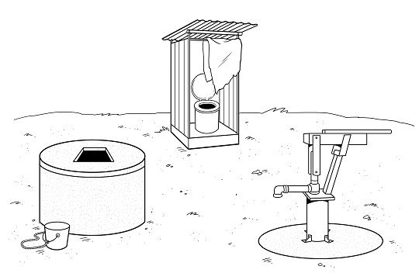A 30 metre separation distance between a latrine and drinking water source is often recommended. This distance is adequate in most circumstances. However, as with all general recommendations, there may be situations when a shorter distance will be acceptable or where the groundwater is contaminated despite the 30 metre separation. If possible, the soil and groundwater conditions should be assessed before siting the latrine. The results could allow a shorter safe separation distance or require a larger distance. Alternatives for the latrine and/or the water supply should be considered if the separation distance is not possible due to space constraints.

1. **Direction of groundwater flow**

*General rule: Site latrines lower than the drinking water source.*

* Groundwater usually flows downhill.
* In very flat areas, tests may need to be done to determine the direction of groundwater flow.
* If the latrine is located downhill from the water source, then it is unlikely that contamination will be a problem.

(Adapted from Harvey, 2007 and Sugden, 2006)



**Siting Isn’t Everything**

The potential for groundwater contamination from latrines is also affected by social factors (Graham and Polizzotto, 2013). Even if a latrine is properly sited, there is still a risk to the groundwater if it isn’t properly built, used and maintained. User education, follow up and monitoring is very important to ensure that latrines are protecting the groundwater and public health.



**Guiding Questions**

To assess the soil and groundwater conditions with respect to preventing groundwater contamination, the following questions should be answered:

* Is groundwater used for drinking?
* What other water sources are used by the community?
* What is the local soil type?
* What is the highest annual depth of the groundwater (for example, in the wet season)?
* How much do the groundwater levels change in each season?
* Which direction does the groundwater flow?

## What if the Risk of Contamination is Too High?

You may not always be able to meet all of the guidelines for siting a latrine and there is a high risk of contaminating the groundwater. For example, in urban areas, the infiltration from many latrines could cause significant groundwater contamination, and extra care needs to be taken to prevent contamination and ensure people have safe drinking water (Sugden, 2006).

Composting latrine

(Credit: Adapted from AKVO, nd)

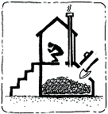

In this situation, you can consider alternate latrine designs that have a lower risk, such as latrines that do not infiltrate liquid into the soil. These may include any latrine with a watertight pit, tank or chamber. It could be aboveground or belowground, such as a pit with a full impermeable lining. Specific watertight latrines include composting latrines, dehydrating latrines, removable containers, and holding tanks. These may also be good options if a latrine has to be built in an area with a high groundwater table or that frequently floods. For more information, see CAWST Fact Sheets and Technical Brief: Latrines for Challenging Environments.

In some cases, it may be cheaper or easier to relocate a drinking water source than installing watertight latrines or moving existing latrines. However, the water sources of downstream communities may still be affected.

## Ensuring Safe Drinking Water

Even if the above guidelines are followed, there is no guarantee that groundwater will not be contaminated. The soil type, groundwater direction, or other factors may be unknown or may be different than originally thought.

Drinking water source protection and water treatment should always be used to ensure drinking water is as safe as possible. Simple measures can be used, such as raising a well above the ground, sealing boreholes, covering water sources, and treating drinking water at home.

For more information, see CAWST resources on Environmental Sanitation and Household Water Treatment and Safe Storage (HWTS).



# Physical Space

The surface area required to build a latrine varies. For example, the approximate space required for three latrine types is:

* 2 m² for simple pit and ventilated improved pit (VIP) latrines
* 5 m² for septic tanks
* 20 m² for infiltration trenches

(Monvois et al., 2010)

There must also be space to build a handwashing station (water and soap) in the immediate area, either outside or inside the latrine superstructure.

In urban or peri-urban areas, dense informal settlements, and sometimes villages, there may not be space to build individual household latrines. In these cases communal or public latrines may be appropriate. If there is enough space to build a latrine, but not enough to build a new one when the pit is full, latrine emptying is an option.

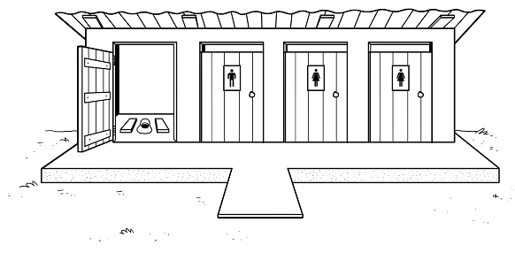

Communal latrines

Latrines that are meant to be emptied must be located so that they can be easily accessed by pit emptiers. If pits or chambers will be emptied manually, there must be space for workers to move around the pit, using shovels or semi-mechanized pumping machines, and fill containers to transport the sludge. If the latrine will be emptied using a vacuum truck, then there must be space to park the truck, access the latrine and use the vacuum hose.

There must also be space for the latrine pit belowground. There must be space to dig a latrine pit that will last several years, plus remain at least 2 metres above the highest annual groundwater level. For information on how to size latrine pits, see CAWST Technical Brief: Sizing Latrine Pits.

If aboveground chambers are used, the size of chamber required will depend on how long it will be used before being emptied, and the number of people using it. For more information on sizing chambers, see CAWST Technical Briefs: Designing Composting Latrines and Sizing Dehydrating Latrines. For more information on watertight chambers or holding tanks, see CAWST Technical Brief: Latrines in Challenging Environments.



**Guiding Questions**

To assess the space availability, the following questions should be answered:

* Do families live in single-family or multi-family buildings, single-storey or multi-storey buildings?
* What is the typical size of a household plot?
* Is there sufficient space for every household to build a latrine?
* Is there public space that could be used?
* Is there sufficient space to dig another latrine pit when the first one is full?
* Is there space to build a handwashing station in or near the latrine?
* What size and dimensions (length, width, depth) or latrine of pit, tank or chamber is required?
* Is there enough space to dig a latrine pit, tank or chamber that is at least 2 metres above the groundwater table?
* If the latrine will be emptied manually, is there enough space for workers to access the latrine and remove the sludge?
* If the latrine will be emptied mechanically, is there enough space for a large vacuum truck or small motorized vehicle to access the latrine and remove the sludge?

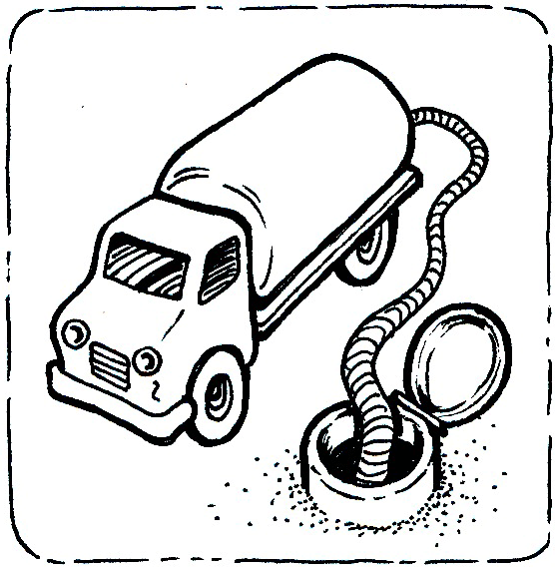

Vacuum trucks need space to access latrines

(Credit: AKVO, nd)

# User Needs and Preferences

People will not use latrines if it is an inconvenient, unsafe, undignified or a shameful experience. All people should be able to maintain their dignity while using a latrine. This means they should not feel shame, fear or be physically unable to use the latrine because of its design or location.

Some types of latrines can be built within the home. Having the latrine inside the home has advantages, including privacy, safety and convenience – especially in unpleasant weather or at night. However, some people may prefer to have the latrine built outside because of cultural beliefs, habit, personal preference, or fear of smells and flies.

The following criteria should be considered when choosing an outdoor location for latrines:

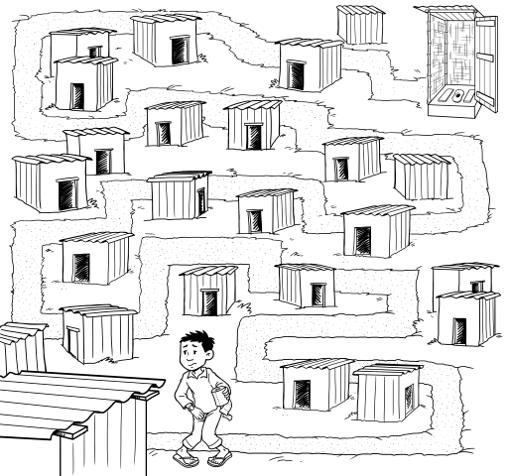

Latrines should be within a convenient distance from the home

* Latrines should be within 50 metres of the home for convenient access. Pit latrines should be located more than 6 metres away from a home to reduce smells and flies near the home (Harvey, 2007).
* Latrines should have open and clear access routes and be located within hearing and seeing distance from the home, in the event that immediate help is needed. People need to feel secure when using a latrine. Latrines can be a vulnerable place, especially for women and girls where they can potentially attract unwanted attention and violence. People should not be at risk of harassment by people, or attacks by animals such as snakes, scorpions or spiders.
* Latrines should guarantee privacy. In some cultures, it is important not to be seen entering or leaving the latrine. This may be a consideration when siting raised latrines–because they are higher, people are more visible when going in or out.
* Latrines should be possible to reach during all weather conditions, including after heavy rains or flooding.
* Latrines should have sufficient lighting, especially if they will be used after dark.
* Latrines should be located to be secure and reduce the risk of vandalism.
* Latrines should be located in a clean environment. Latrines are often located close to other sources of smells and flies, such as garbage dumps, cattle or animal pens. These locations discourage people, especially children, from using them.

For more information, see CAWST Technical Brief: User Interface and Technical Brief: Designing and Selecting Latrines.



**Guiding Questions**

To assess user needs and preferences with respect to the latrine location, the following questions should be answered:

* Can the latrine be built inside the home?
* How close to the home should the latrine be?
* Does the location provide privacy for people entering and leaving the latrine?
* Does the location provide safety and security for people using the latrine, even at night?
* Is the latrine accessible by all users?
* Can a latrine be built with enough space inside to accommodate all potential users (for example, wheelchairs or for someone to assist children, an elder or a person with a disability)?

Siting a latrine

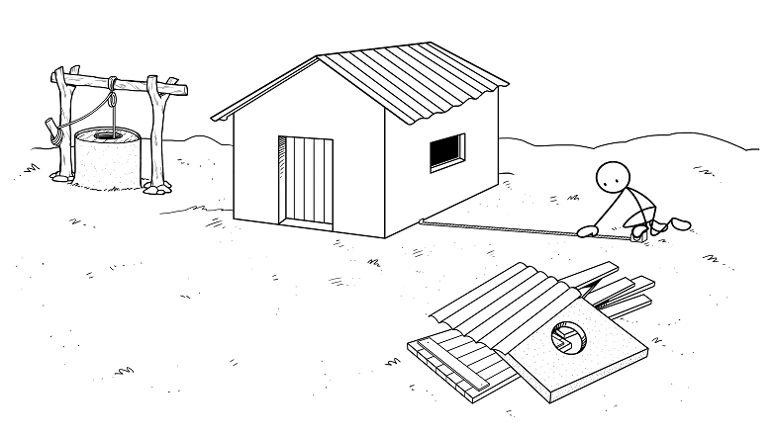

# Additional Resources

**CAWST Sanitation Resources.** Available at: [www.cawst.org/resources](http://www.cawst.org/resources)

* CAWST’s education and training resources are available on a variety of sanitation topics including latrine design, siting and construction; latrine parts and technologies; latrine emptying and transporting sludge; sludge treatment, use and disposal; and latrine project implementation.

**Groundwater.** Environment Canada (2013). Available at: [www.ec.gc.ca/eau-water/default.asp?lang=En&n=300688DC-1#sub1](http://www.ec.gc.ca/eau-water/default.asp?lang=En&n=300688DC-1#sub1)

* This website defines groundwater and explains its properties.

**Pit Latrines and Their Impacts on Groundwater Quality: A Systematic Review.** Graham, J. and M. Polizzotto (2013). National Institute of Environmental Health Sciences, USA. Published in Environmental Health Perspectives, DOI:10.1289/ehp120628. Available at: <http://ehp.niehs.nih.gov/1206028/>

* This paper reviews and summarizes other studies that have been done on the impacts of pit latrines on groundwater quality. It discusses pathogens and other contaminants, like nitrogen. It also evaluates latrine siting standards, and identifies knowledge gaps about the potential for and consequences of groundwater contamination by pit latrines.

**Latrine Pit Design.** Reed, B. (2014). WEDC, Loughborough University, UK. Available at: <https://wedc-knowledge.lboro.ac.uk/details.html?id=21784>

* This guide examines some of the factors that need to be taken into account when planning and designing a latrine pit (or twin pits), including the location of a latrine, its shape, volume, liquid capacity and life.

**The Microbiological Contamination of Water Supplies, WELL Factsheet.** Sugden, S. (2006). WEDC, Loughborough University, UK. Available at: [www.lboro.ac.uk/well/resources/fact-sheets/fact-sheets-htm/Contamination.htm](http://www.lboro.ac.uk/well/resources/fact-sheets/fact-sheets-htm/Contamination.htm)

* This Fact Sheet describes pathogens in groundwater, factors affecting contamination of a water source by a pit latrine, ways to assess the risk of groundwater contamination, methods to reduce risk and other issues to consider.

# References

AKVO Illustrations (no date). Retrieved from: <http://akvopedia.org/wiki/Sanitation_Portal>

Franceys, R., Pickford, J. and R. Reed (1992). A Guide to the Development of On-site Sanitation. World Health Organization, Geneva, Switzerland. Retrieved from: http://whqlibdoc.who.int/publications/1992/9241544430_eng.pdf

Graham, J. and M. Polizzotto (2013). Pit Latrines and Their Impacts on Groundwater Quality: A Systematic Review. National Institute of Environmental Health Sciences, USA. Published in Environmental Health Perspectives, DOI:10.1289/ehp120628. Retrieved from: <http://ehp.niehs.nih.gov/1206028/>

Harvey, P., Baghri, S., and B. Reed (2002). Emergency Sanitation: Assessment and Programme Design. WEDC, Loughborough, UK. Retrieved from: [www.who.or.id/eng/contents/aceh/wsh/books/es/es.htm](http://www.who.or.id/eng/contents/aceh/wsh/books/es/es.htm)

Harvey, P. (2007). Excreta Disposal in Emergencies: A Field Manual. WEDC,

Loughborough University, UK. Retrieved from:

<https://wedc-knowledge.lboro.ac.uk/details.html?id=14282>

Reed, B. (2014). Latrine Pit Design. WEDC, Loughborough University, UK. Retrieved from: <https://wedc-knowledge.lboro.ac.uk/details.html?id=21784>

Sugden, S. (2006). The Microbiological Contamination of Water Supplies, WELL

Factsheet. WEDC, Loughborough University, UK. Retrieved from: [www.lboro.ac.uk/well/resources/fact-sheets/fact-sheets-htm/Contamination.htm](http://www.lboro.ac.uk/well/resources/fact-sheets/fact-sheets-htm/Contamination.htm)

CAWST (Centre for Affordable Water and Sanitation Technology)

Calgary, Alberta, Canada

Website: [www.cawst.org](http://www.cawst.org) Email: [resources@cawst.org](mailto:resources@cawst.org)

*Wellness through Water.... Empowering People Globally*

Last Update: December 2014

This document is open content. You are free to:

* Share – to copy, distribute and transmit this document
* Remix – to adapt this document

Under the following conditions:

* Attribution. You must give credit to CAWST as the original source of the document. Please include our website: www.cawst.org

CAWST and its directors, employees, contractors and volunteers do not assume any responsibility for, and make no warranty with respect to, the results that may be obtained from the use of the information provided.