Overview of Activities

Lesson Plan 11

Colony Counting

60 minutes total

1. Introduction
2. Colony Counting Presentation
3. Colony Counting Exercise
4. Colony Counting Demonstration and Practice
5. Review

Learning Outcomes

At the end of this session participants will be able to:

1. Explain the importance of colony counting to DWQT
2. Discuss essential factors in colony counting
3. Apply appropriate colony counting techniques

Recommended Reading

Technical Brief: Microbiological Aspects in Drinking Water

Materials & Preparation

Activity: Colony Counting

PowerPoint: Colony Counting

Activity: Colony Counting Exercise

Handout: Coliscan Colony Colour Guide, see end of lesson (print in **colour**, one page; one copy per group). Note: best done in advance and laminated

Activity: Colony Counting Demonstration and Practice

Incubated Petri dishes from microbiological testing practice

Flashlight (torch), one per participant

Magnifiers, one per participant

Hand sanitizer, two bottles

Disinfectant

Paper towels

Chlorine bleach

Plastic pipette or eye dropper

Hand held tally counter (optional)

Activity: Word in a Hat Review

Prepare: Print and cut out words for review exercise, see end of lesson

5 minutes

Introduction

1. Ask participants to discuss one way in which they could group the workshop participants. After 1-2 minutes, ask them to share their ideas.
2. Ask participants to get into one of the groupings suggested.
3. Allow a few minutes for participants to group themselves. Groups could be:
   * All women or men
   * All wearing similar clothing (e.g., wearing yellow shirts)
   * Common characteristics (e.g., tall or short)
   * From a common geographic region
4. Explain that they have created a colony.
5. Ask: “What is a colony? Would anyone like to offer a definition?”
   * A group, collection, society, cluster, population with common characteristics
   * For example: colony of ants, bees, people, bacteria
6. Present the learning outcomes or an overview of the lesson.

10 minutes

Colony Counting

Use PowerPoint: Colony Counting for this presentation.

1. Ask: “How are colonies used to measure the levels of bacteria in a water sample?”
2. Explain that each colony represents one bacterium in the original sample, but we cannot see those individual bacterium, so we grow them in the culture medium so we can count them.
3. Show the video in the PowerPoint (optional): How a Bacteria Colony Forms to demonstrate how one bacterium grows to form a colony of identical bacteria.
4. Explain: “One colony represents one bacterium in the original sample even though the colony has grown to include millions of bacteria following incubation.”
5. Use PowerPoint to explain the characteristics of culture media and show colony counting techniques (optional).

Trainer Tips

Culture media varies widely and depends on availability.

Carefully read manufacturers’ specifications and instructions.

MLSB comes in powder form and must be reconstituted with water and sterilized before use.

1. Alternatively, use the chart below to discuss the characteristics of a few examples of culture media.

Table 1: Culture Media Characteristics

|  |  |  |  |
| --- | --- | --- | --- |
| Media | Colour of Media | E. coli Colony Colour | Coliform Colony Colour |
| Coliscan® | Pale yellow, clear | Dark blue to purple | Pink |
| mColiBlue® | Light blue | Dark blue | Red |
| Membrane Lauryl Sulphate Broth (MLSB) | Orange red | Yellow | Yellow |

1. Use PowerPoint to demonstrate colony counting technique.
2. Alternatively, describe appropriate colony counting technique using the grid pattern below if PowerPoint is not available.

Trainer Tips

The inner circle is the effective filtering area. Do not count colonies outside this ring.

Some colonies will touch the gridlines. Suggest counting these colonies below the gridline they touch. Consistency is key to reduce counting error.

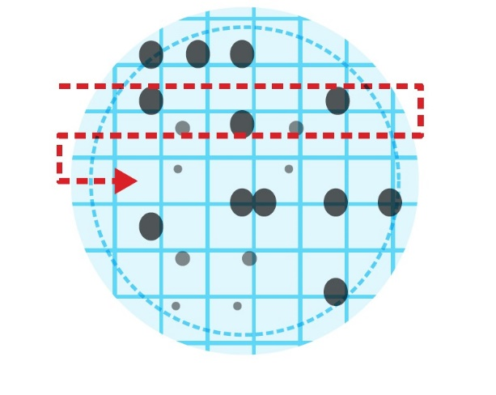 **Colony Counting Technique**

Key Points

* Culture media is food for growing bacteria, contains elements needed for growth, and contain components to distinguish one bacteria type from another (appear as different colours)
* Counting the colonies on the filter paper after incubation represents the number of bacteria in the original sample
* Bacterium is singular, bacteria is plural

10 minutes

Colony Counting Exercise

1. Divide participants into pairs.
2. Distribute Coliscan® Colony Color Guide handout to each pair.
3. Ask: “How many E. coli (dark blue to purple) and coliform (pink) colonies are in this example?” Record the results for each group.
4. Ask: “Why are there differences in the results?”
   * Different colour perception
   * Subjective colour interpretation (pink vs light purple)
   * Size of colonies difficult to detect
   * Differences in eyesight
   * Lighting
5. Solution to the exercise: 22 E. coli (blue to purple) and 30 coliforms (pink).

25 minutes

Colony Counting Demonstration and Practice

1. Seat participants at a table with flashlights and magnifiers.
2. Hand out incubated Petri dishes from microbiological testing practice to appropriate people.
3. Ask participants to count the E. coli and coliform colonies on their plates.  
   *Trainer Tip: Do not allow participants to use a pen or other item to count colonies to prevent contamination.*
4. Troubleshoot counting difficulties:
   * Look for unusual results such as numerous non-coliforms (clear colonies) that show contamination from non-fecal sources
   * Look for obvious signs of secondary contamination; e.g. torn or punctured filter paper, finger marks or other disturbance of the filter paper
   * Not enough culture media results in dry filter paper that does not allow bacterial growth
   * Too much culture media can result in filter paper sticking to the top of the Petri dish
   * Air pockets under the filter paper can cause dry spots with no bacterial growth
   * > 200 colonies is considered too numerous to count (TNTC)
   * Many small colonies can mean the sample was highly contaminated and the nutrients were all used up (sample required dilution)
5. Record the results on flip chart paper. Note the plate number, media used, description of the sample, dilution factor (if used) and unusual results. Post results for discussion.
6. Discuss results as a group. *Trainer Tip:* *Be prepared for an active exchange. Take particular note of the following:*
   * Blank sample should have zero growth of any kind (growth indicates contamination)
   * Hand rinse sample is often the most contaminated followed by unprotected or untreated water
   * Water from kiosks or delivery trucks is often contaminated
7. Have participants disinfect the Petri dishes with bleach and safely dispose of waste.
   * Add liquid chlorine (bleach) to each Petri dish (approximately 2 mL) and allow to stand for 10 minutes of contact time
   * After chlorination, dispose of solids in the garbage and wash Petri dishes in soap and water
8. Remind participants to use hand sanitizer and/or wash their hands before returning to their seats.

Key Points

* Prefer plates to have between 20 and 80 colonies
* Samples with >200 colonies are considered too numerous to count (TNTC)
* Remind participants that they are learning these techniques and practice will improve their skill levels

10 minutes

Review

1. Place pieces of paper with words from the lesson into a hat or other container.
2. Pass the hat around and have each participant pull a piece of paper out of the hat.
3. Ask people to explain what the word means or what they have learned about it.

Alternative Review

1. Lead a discussion about the most surprising (or controversial) result from the activity.

Trainer Tips

People can be upset by unexpected test results. Remind participants that this test represents a single moment in time and that additional testing would be required to assess any situation.

1. If there were upsetting or surprising results, this discussion provides an opportunity to debrief those results and to diffuse reactions by reminding participants they are new to this and unexpected results could be a result of many reasons, including:
   * Poor technique
   * Faulty equipment or other reasons

|  |  |
| --- | --- |
| This resource is open content and licensed under a [Creative Commons Attribution-ShareAlike 4.0 International License](https://creativecommons.org/licenses/by-sa/4.0/). Refer to CAWST’s guidelines for distributing, translating, adapting, or referencing CAWST resources ([resources.cawst.org/cc](https://resources.cawst.org/cc)). |  |

Colony Counting Exercise Handout

Coliscan® Colony Color Guide

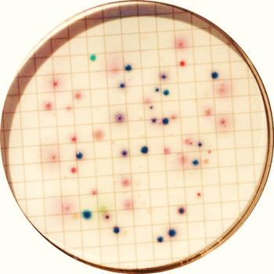

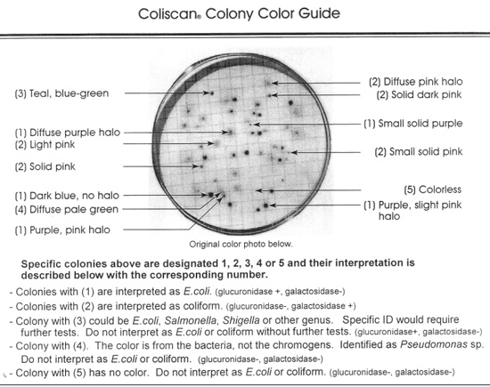

Word in a Hat Activity Handout

Words Covered in the Colony Counting Lesson

Cut out the words and place in a hat or other container. Pass the hat around the circle. Each participant pulls a piece of paper out of the hat and has to explain what the word means or what they have learned about it.

✂

|  |  |
| --- | --- |
| Culture Media | TNTC |
| Filter Paper | Forceps |
| MLSB | Magnifier |
| Coliscan | Incubation |
| Grid | Temperature |
| mColiBlue | Contamination |
| Colony | CFU |
| Blank Sample | Errors in Colony Counting |