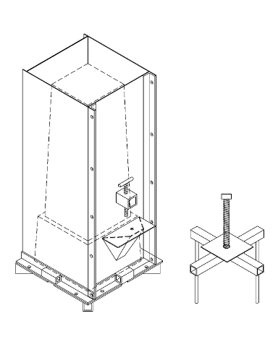

**Contents**

[Introduction to the Biosand Filter Mold 2](#_Toc334012745)

[Abbreviations 2](#_Toc334012746)

[Measurement Conversions 2](#_Toc334012747)

[Tips for Working with a Welder to Make a Mold 3](#_Toc334012748)

[Equipment for Building a Mold 4](#_Toc334012749)

[How to Check the Quality of a Mold 4](#_Toc334012750)

[Possible Modifications to the Mold Design 5](#_Toc334012751)

[Who to Contact with Questions 5](#_Toc334012752)

[Overview of the Steel Mold 6](#_Toc334012753)

[Materials 7](#_Toc334012754)

[How to Draw Triangles 9](#_Toc334012755)

[Make the Mold 10](#_Toc334012756)

[Step 1: Cut 3 mm (1/8”) steel plate 10](#_Toc334012757)

[Step 2: Cut 6 mm (¼”) steel plate 13](#_Toc334012758)

[Step 3: Cut angle iron 14](#_Toc334012759)

[Step 4: Drill holes in angle iron 14](#_Toc334012760)

[Step 5: Cut square tubing pieces 16](#_Toc334012761)

[Step 6: Drill holes in square tubing 17](#_Toc334012762)

[Step 7: Cut steel rods 17](#_Toc334012763)

[Step 8: Weld the Inside Mold Box 18](#_Toc334012764)

[Step 9: Weld the Inside Mold Base Plate 21](#_Toc334012765)

[Step 10: Weld the Outside Mold – Nose (Front) Panel 21](#_Toc334012766)

[Step 11: Weld the Outside Mold Back and Side Panels 24](#_Toc334012767)

[Step 12: Assembling the mold 27](#_Toc334012768)

[Step 13: Weld the Extractor 28](#_Toc334012769)

[Step 14: Finishing the mold 30](#_Toc334012770)

# Introduction to the Biosand Filter Mold

These instructions explain how to make a steel mold for a Version 10 biosand filter with a ledge to hold a diffuser plate. The Version 10 (With Ledge) filters can also be used with a diffuser box. The Version 10 (With Ledge) mold and filter are shown below. In addition to these instructions, there are some other materials and tips that may be useful when building molds:

* Welder Picture Companion Book – a series of photos taken while making a mold that follow these instructions. These pictures can be shown to the welder while explaining how to make the mold. Please contact CAWST for a copy of the mold Picture Book (cawst@cawst.org).
* Two videos that explain how to make the mold (Part 1 and Part 2). These can be viewed online on the CAWST YouTube channel for Technical Videos: http://www.youtube.com/playlist?list=PL2F8275C96AFC42DE&feature=plcp
* When working with a welder to make a new mold, it is useful to have an existing mold that the welder can look at.



Ledge

**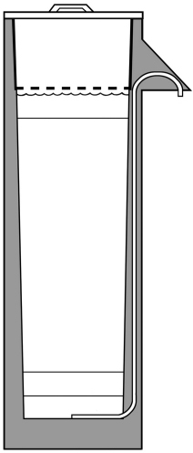C:\Users\sdavis\Documents\Marci drawings\Part 1 - drawings\Multi-Barrier Approach\BSF_Large.tif**

Ledge

**Version 10 (With Ledge) Mold Version 10 (With Ledge) Biosand Filter**

|  |  |
| --- | --- |
| Abbreviations | Measurement Conversions |
| cm centimetre  ft foot  mm millimetre  ‘ foot  “ inch | 1 foot = 0.30 metres  1 metre = 3.28 feet  1 inch = 25.4 mm  1 inch = 2.54 cm  1 cm = 0.39 inches  1 mm = 0.1 cm  1 cm = 10 mm |

# Tips for Working with a Welder to Make a Mold

* The first time you have a mold made, allow one week of time to work directly with the welder or check in once in a while to make sure they understand the instructions. Do not expect to leave the drawings and come back later to pick up a finished mold.
* Tell your welder what the mold is for and what the most important parts are.. If the welder does not know what it does, the welder will not know what is needed to make it work.
* Set up a contract with your welder that states you must have a working mold which has been tested and produces a concrete filter, before you will pay in full.
* Provide an existing mold to the welder to make it easier to understand the drawings (if possible).
* Select sheet metal and angle iron that is straight and flat. Select sheet metal with as little rust as possible..
* Use at least 3mm thick metal sheet of good quality for the outside mold to prevent it from bending. If the 3mm steel is bent or curved, use heavier steel. Molds that are not square and flat will be difficult to use.
* Leave cutting the sheet metal to professionals with the best tools (plasma cutter, if possible).
* Remember to account for the width of each cut when laying out and cutting sheet metal, angle iron, square tubing and rods. The width of the cut will depend on the tools being used.
* It may be useful to build jigs to keep the plates square while welding.
* If you are having trouble keeping the inside mold boxes square, consider welding braces across all the openings (on the inside of the box).
* The 3-sided piece of the outside mold can be bent from one piece of sheet metal, instead of welding 3 pieces together, if the welding shop has the tools to do this. Be sure to adjustthe measurements of the pieces if you do this.
* The 3-sided outside mold should be welded so that the open side is 25mm (1”) wider than the front/nose panel (4th side). These sides will be pulled in when they are bolted. When they are unbolted, they will spring out to help removal of the 3-sided panel.
* Put a mark that is easy to see on the inside mold to show where to put the front (nose) panel when you put the mold together.
* All the holes for the bolts must line up - the pieces should be clamped together and drilled at the same time.
* The position of the opening/bottom of the nose on the outside mold and the lip/ledge on the inside mold must be at the same level.
* The measurements must be exactly the same as those specified in these instructions.
* All measurements are in millimeters (imperial units are in brackets) unless otherwise stated.

# Equipment for Building a Mold

Basic welding equipment is needed to build a mold. This includes:

* Cutting torch
* Grinder
* Metal cutting tool
* Measuring tape
* Square
* Level
* Clamp(s)
* Drill
* Scribe
* Punch

Other helpful equipment:

The following equipment is not required, but may make the job easier:

* Plasma cutter
* Bending equipment for sheet metal 3mm and thicker
* Jigs (a template or tool to help you make a cut or weld accurately or more easily)
* Wooden templates
* Straight wood or metal bars to use as a guide for cutting straight lines
* Bracing bars
* Circle scribe/compass/divider

# How to Check the Quality of a Mold

To make sure the mold is going to produce good quality filters, check the following points on the mold:

|  |  |
| --- | --- |
| **Check:** | **Why:** |
| Inside mold is not twisted | Removing the inside mold from the filter will be very difficult if it is not straight and square |
| Inside mold is square | Removing the inside mold from the filter will be very difficult if it is not straight and square |
| Inside mold is tapered (smaller at one end) | Makes removing the inside mold from the filter easier |
| Distance between the inside and the outside mold is equal on all sides | The concrete filter walls will all be the right thickness |
| Inside of the nose is smooth | The concrete nose will not stick to the mold and the nose will look nice on the finished filter |
| All welded edges are smooth | The concrete will not stick to the mold and there will be less chance the concrete will break or leak |
| All bolt holes line up | You will be able to put the bolts through the holes when putting the mold together |
| The bottom of the nose (on the outside mold) and the ledge on the inside mold are at the same level | The standing water level and the diffuser plate will be in the right places when the filter is installed |
| All measurements are exactly the same as in these instructions | The mold pieces will all fit together and the filters will be the right size and dimensions |
| There is a mark that is easy to see on the inside mold to show where to place the front (nose) panel when putting the mold together | All the walls will be the right thickness, and all the bolt holes will line up. This is especially important if the mold is not exactly square or not exactly symmetrical (the same on all sides). |

# Possible Modifications to the Mold Design

To make construction easier, or if you are building several molds to make a lot of filters, there are a few things you can do to make the production of molds and/or filters faster and easier.

* Use an external vibrator. If using a flat electric vibrator, you can make a plug in the outside of the mold where the filter technicians can attach the vibrator. If you are using a stick-style electric vibrator, you do not need to change the mold.
* Make all the side and back panels of the outside mold as individual pieces that bolt together. Technicians may either leave two or three of these panels permanently bolted together, or remove the bolts and take each panel off the poured-and-set-filter separately. You may choose to make the mold this way if you can only get small pieces of sheet metal, if you do not have bending equipment, or if the weight or size of the pieces will be important for transporting the molds later.
* Make the internal mold without a ledge (called Version 10 No Ledge). Use the Version 10 No Ledge mold only if biosand filter implementation will always be done using diffuser boxes. This filter style is NOT suitable for using diffuser plates. The Version 10 No Ledge mold is easier and cheaper to make than the mold for Version 10 (With Ledge). Instructions for building a Version 10 No Ledge mold are available from CAWST (cawst@cawst.org).

# Who to Contact with Questions

If you have questions, contact us – that is what we are here for!

**Email your regional International Technical Advisor, or** [**cawst@cawst.org**](mailto:cawst@cawst.org)

For information on construction, operation and maintenance of the biosand filter, please visit www.cawst.org

# Overview of the Steel Mold

**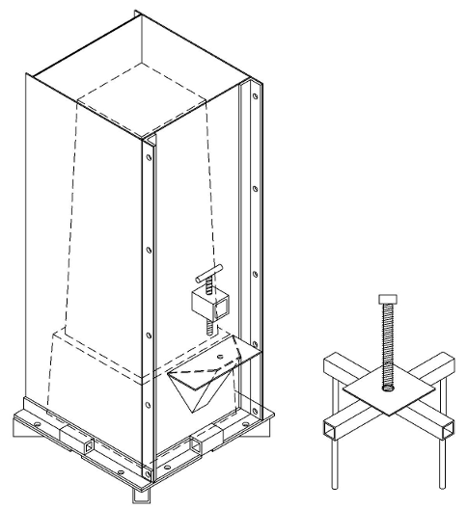Assembled Version 10 (With Ledge) Mold**

**Unassembled Version 10 (With Ledge) Mold**

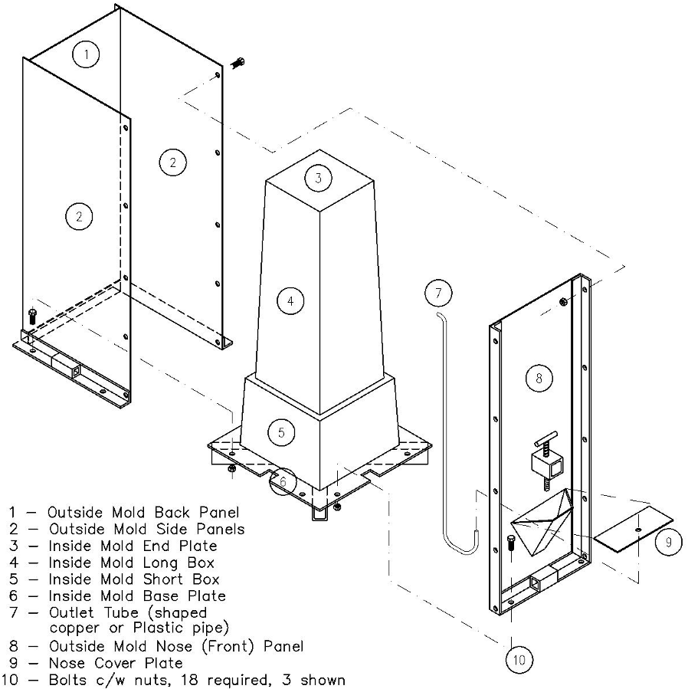

# Materials

You will need the following materials to make one mold.

*Note: If the following materials or sizes are not locally available, you may substitute with the nearest available size.*

* Using thicker/heavier sheet metal and angle iron will make the mold stronger and last longer. Using thinner steel may reduce how long the mold will last, and the mold may bend more easily when you are removing the filter from the mold. Do not use steel sheet less than 3 mm (1/8”) thick.
* If you change sizes of rod or bolts, make sure that you use the right, corresponding drill bit sizes when drilling holes.

|  |  |
| --- | --- |
| **Quantity** | **Description** |
| 1 standard sheet [often available in 1220 mm x 2440 mm  (48” x 96”) sheets] | **Steel plate, 3 mm (1/8”) thick**1.   * See the layout and dimensions in the next section for the specific size of each piece required. * Use new steel plate that has no rust on at least one side. * Use the side of the sheet with no rust as the side of the mold that will touch the concrete. * Use flat steel sheet. If the 3 mm steel is bent or curved, use heavier steel. Molds that are not square and flat will be difficult to use.   1 Do not use steel that is less than 3 mm (1/8”) to construct the steel mold. The mold bends and warps easily if steel less than 3 mm (1/8”) is used. Use 4 mm (0.17”) steel if 3 mm (1/8”) steel is unavailable. |
| 2 pieces, or 1 large piece | **Steel plate, 6 mm (¼”) thick**2   1. One piece 1016 mm x 160 mm (40” x 6 ½”) (for the short, wide end of the inside mold)3 2. One piece 387 mm x 387 mm (15 ¼” x 15 ¼”) (for the base plate)4   2 6 mm (1/4”) thick steel is best for these pieces. If you cannot get 6 mm (1/4”) thick steel, use 5 mm (1/5”) steel.  3 If neither 5 mm (1/5”) or 6 mm (1/4”) steel is available, use as thick steel as possible (such as 4 mm (0.17”)) for the short, wide end of the inside mold. Or, make a Version 10 No Ledge mold instead, which does not use this piece. Contact CAWST for the instructions for making a Version 10 No Ledge mold.  4 If neither 5 mm (1/5”) nor 6 mm (1/4”) steel is available, see Step 9 in these instructions for an alternate construction method for the base plate. You will need additional angle iron or square tubing in this case – either:   * an extra 900 mm (90 cm or 35”) of angle iron and 356 mm (14”) less square tubing, or * an extra 550 mm (55 cm or 22”) of tubing with no change to the amount of angle iron. |
| 1 piece, at least 3280 mm (129”) long | **Angle iron**. Each side should be 38 mm (1 ½”) wide. The steel should be 3 mm (1/8”) thick. |
| 1 piece, at least 1450 mm (57”) long | **Square steel tubing**, or 2 pieces of angle iron welded together to form square tubing. Each side should be 38 mm (1 ½”) wide. Steel should be 3 mm (1/8”) thick. |
| 1 piece, 610 mm (24”) long | **Steel rod, 16 mm (5/8”) diameter**. Or you can use four M16 (16mm or 5/8”) diameter bolts, each approximately 150 mm (6”) long |
| 1 piece, 229 mm (9”) long | **Threaded steel rod, 25 mm (1”) diameter** (also known as all-thread or ready-rods). Or you can use M24 (24mm diameter) threaded rod. |
| 2 pieces | **Nut** **with a 25 mm (1”) diameter hole**. These nuts must be able to thread onto the 25mm (1”) threaded rod. If using a M24 rod, use two M24 (24 mm) nuts. |
| 1 Piece, 140 mm (5 ¼”) long | **Threaded steel rod, 13 mm (½”) diameter**. Or you can use M12 (12 mm) rod.; In this case, drill corresponding 12 mm holes instead of 13 mm holes in the square tube in Step 6. |
| 1 piece | **Nut with a 13 mm (½”) diameter hole**. If using M12 rod, use an M12 (12 mm) nut. |
| 18 pieces | **Bolts, M10 (10mm or 3/8” diameter)**, approximately20 mm (¾”) long each  *Do not use bolts smaller than 6 mm (¼”) because they may bend or the threads will become damaged easily.* |
| 18 pieces | **Nuts, M10 (10mm or 3/8” diameter holes)** |

# How to Draw Triangles

Use a compass (“divider”, or a circle scribe) to draw the triangles (such as the nose pieces) on the steel sheet before cutting them out.

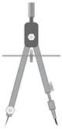

A Compass or Circle Scribe

Credit: mathisfun.com

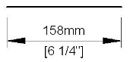

1. Draw your first line on the sheet.
2. 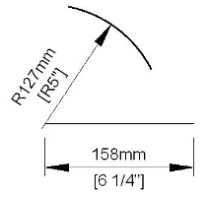Open the compass to the length of the next side you want to draw.
3. Put one end of the compass on the end of the first line. With the other end of the compass, scribe or draw an arc (semi-circle) on the sheet.

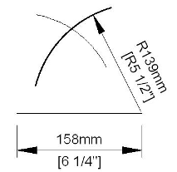

1. Open your compass to the length of the third side of the triangle.
2. Put one end of the compass on the other end of the first line you drew. Scribe or draw an arc (semi-circle) on the sheet. This arc should intersect the first arc you drew.

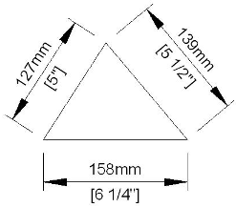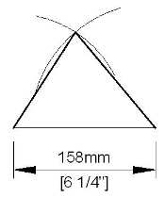

1. Draw a line from the each end of the first line you drew to the point where the two arcs intersect.
2. Check all side lengths to make sure they measure the dimensions in these instructions.

# Make the Mold

## Step 1: Cut 3 mm (1/8”) steel plate

All the 3 mm (1/8”) thick pieces can be cut from a single sheet, as shown below. These pieces must be cut from uniformly **flat steel** (without any curved or bent areas). At least one side of these metal sheets should be free of rust. The best side of the steel with no rust should touch the concrete when building filters. Rust causes concrete to stick. If there is rust on the steel where the mold touches concrete, it will be difficult to remove filters from the mold.

**Note:** This is one suggested layout. You may be able to arrange the pieces differently depending on the size of your steel sheet.

The image below does not include the width of the cut lines, which will vary depending on the cutting tool used.

*Outside Mold Side Panels*

*Outside Mold Front and Back Panels*

*Inside Mold Long Box Pieces*

*Side Nose Pieces*

*Extractor Support Piece*

*Front Nose Piece*

*Nose Cover Plate*

*Inside Mold End* *Plate*

**Tip:** Use a piece of flat bar steel as a guide when making cuts with the grinder. Keep the guide in place for three or four passes with the grinder, until you can see the line made by the grinder. Then remove the guide and continue cutting with the grinder along the line.

**Step 1 continued: Cut 3 mm (1/8”) steel plate**

***Inside Mold Long Box Pieces* (4 Pieces)**

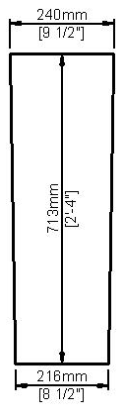

*You can cut these plates from one sheet as shown, but account for the width of the cuts. The width of the cuts will vary depending on what tool is used.*

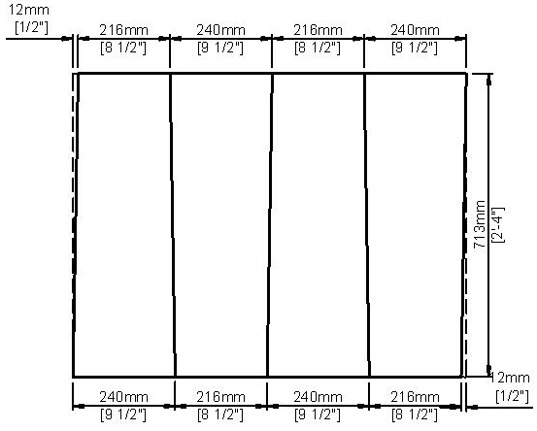

4 Pieces

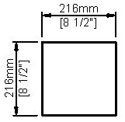

***Inside Mold End Plate* (1 Piece)**

***Extractor Support* (1 Piece)**

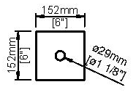

Drill a 29 mm (1 1/8”) diameter hole in the center of the plate

**Step 1 continued: Cut 3 mm (1/8”) steel plate**

***Outside Mold Back and Front Panels* (2 Pieces) *Outside Mold Side Panels* (2 Pieces)**

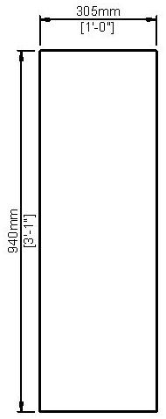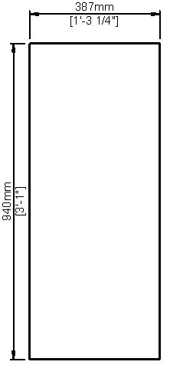

Hole for nose piece to be cut in front panel only!

See Step 10 for dimensions and instructions

2 Pieces

2 Pieces

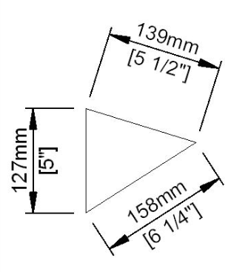

***Side Nose Pieces* (2 Pieces)**

***Front Nose Piece* (1 Piece)**

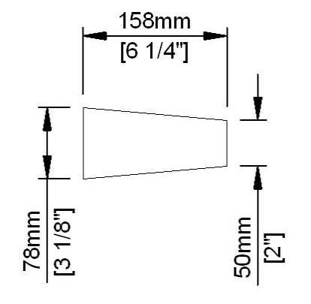

Note: this is not a right-angle triangle.

2 Pieces

***Nose Cover Plate* (1 Piece)**

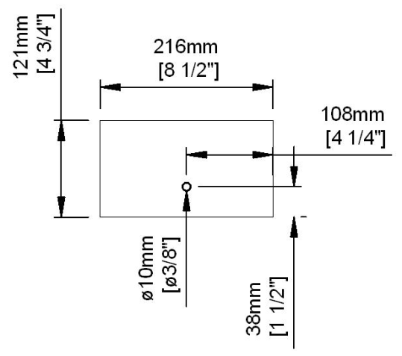

Drill a 10 mm (3/8”) diameter hole in the plate. The hole should be centered in the long side, and 38 mm (1 ½”) from one edge in the shorter side.

File edges of the hole to allow 9 mm (3/8”) outlet tube to be pushed through.   
  
\*If you are using a different size outlet tube, drill the hole the same diameter as the tubing. See the Biosand Filter Construction Manual for tubing specifications.

## Step 2: Cut 6 mm (¼”) steel plate

4 ¾”

*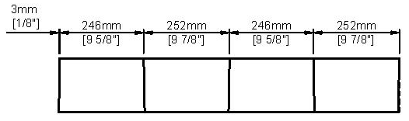****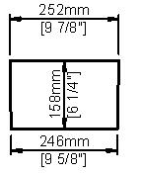Inside Mold Short Box Pieces* (4 Pieces)**

*You can cut these pieces from one plate as shown below, but you must account for the width of the cuts. The width of the cuts will depend on the tool used.*

4 Pieces

***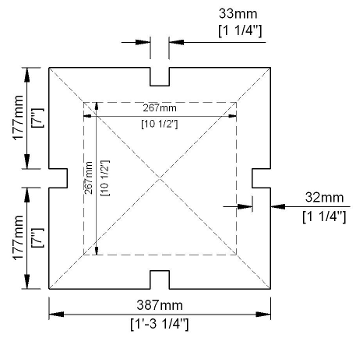Inside Mold Base Plate* (1 Piece)** *Note: It is symmetrical (the same on all sides).*

The 267 mm (10 ½”) square shown in grey dashed line shows where inside mold will be welded on. **Mark it on the base plate.**

*Note: To mark which side of the inside mold is the front (nose) side, you can make one of the notches in the base plate flared or different in some other way, as shown below.*

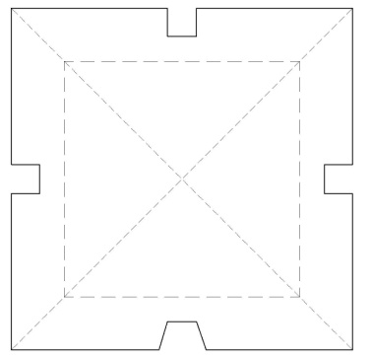

## Step 3: Cut angle iron

*Total length of 38 mm angle iron needed:*

*3264 mm (128 ½” or 10’ 8½”) plus the width of 5 cuts*

Cut:

**940 mm (37” or 3’ 1”) long (2 Pieces)**

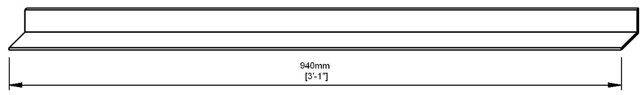

2 Pieces

**387 mm (15 ¼” or 1’ 3¼” ) long (2 Pieces)**

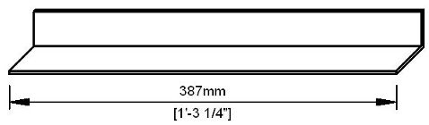

2 Pieces

**305 mm (12” or 1’) long (2 Pieces)**

**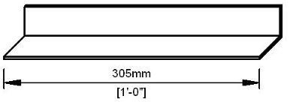**

2 Pieces

## Step 4: Drill holes in angle iron

*Note: Our recommended hole locations are shown below; however, the specific positions of the holes are not critical. The most important thing is to make sure that the holes on one piece of the mold line up with the holes on another piece of the mold after it is welded. If you drill the holes on every piece separately, they will not line up exactly when the mold is assembled, and it will be difficult to insert the bolts each time you put the mold together.*

Depending on the available tools, there are two different ways for drilling the holes so that they line up:

1. Drill the holes in the angle iron now, but wait to drill the corresponding holes on the plates until the mold has been assembled (the method described in this manual).
2. Mark the holes now, but wait to drill all the holes until the mold is clamped together at a later stage (must be done with a handheld tool, not a drill press).

**Step 4 continued: Drill holes in angle iron**

Drill five 11 mm (7/16*”*)diameter holes in each of the two 940 mm (37” or 3’ 1”) long pieces of angle iron

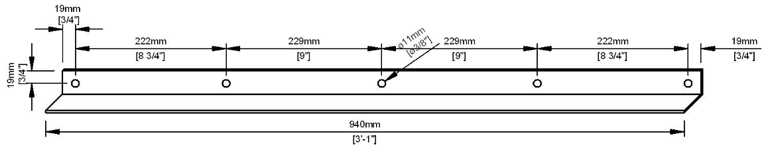

2 Pieces

Note: you do not have to use this hole spacing as shown.   
Just make sure the holes line up on your sheet and angle irons.

Drill two 11 mm (7/16”) diameter holes in each of the two 387 mm (15 ¼” or 1’ 3¼”) long pieces of angle iron

**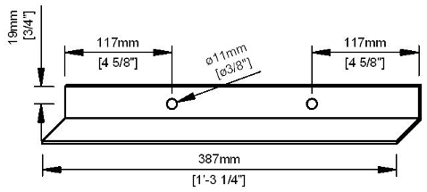**

2 Pieces

Drill two 11 mm (7/16”) diameter holes in each of the two 305 mm (12” or 1’) long pieces of angle iron

**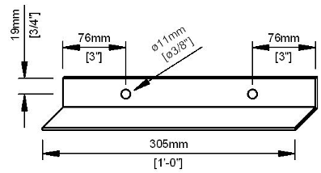**

2 Pieces

**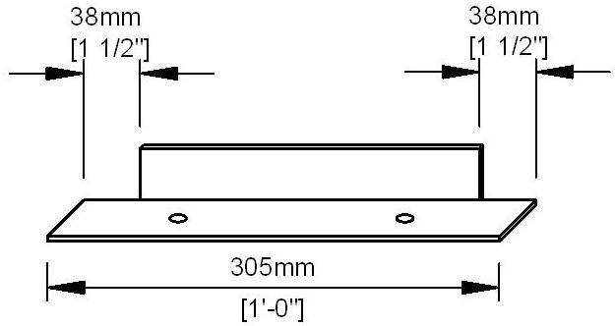**On only **ONE** of the 305 mm (12” or 1’) pieces of angle iron that you have drilled holes in, cut 38 mm (1 ½”) off each end of **one side** of the angle iron. ***Only cut off the side that has no holes***, as shown below.

## Step 5: Cut square tubing pieces

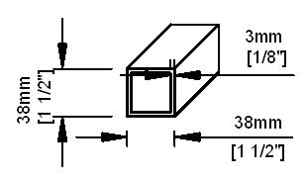

*Total square tubing needed:*

*1410 mm (56 ½” or 4’ 8½”) plus width of 11 cuts*

Cut:

**387 mm (15 ¼”) long (1 Piece)**

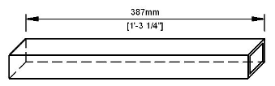

**175 mm (6 7/8”) long (2 Pieces)**

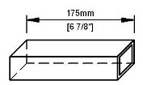

2 Pieces

**89 mm (3 ½”) long (5 Pieces)**

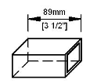

5 Pieces

**57 mm (2 ¼”) long (4 Pieces)**

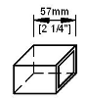

4 Pieces

## Step 6: Drill holes in square tubing

*Note: These holes do not need to line up with other parts of the mold (as in Step 4., They can be drilled now.*

Drill a 29 mm hole through two opposite sides of the 387 mm (15 ¼”) long piece of square tubing (this piece will be used in Step 13 for the *Extractor*)

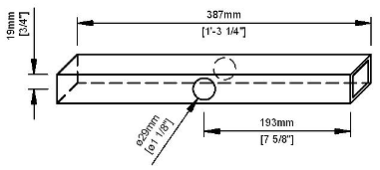

Drill a 13 mm (½”) hole through two opposite sides of one (1) 89 mm (3 1/2”) long piece of square tubing (this piece will be used in Step 10 on the nose plate).

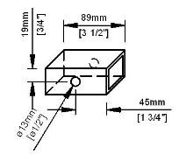

## Step 7: Cut steel rods

**152 mm (6”) long (unthreaded) 16mm (5/8”) rods (4 Pieces)**

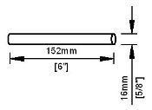

4 Pieces

## Step 8: Weld the Inside Mold Box

**Weld the *Inside Mold Long Box*:**

1. Stand the four 713 mm long *Inside Mold Long Box Pieces* (3 mm (1/8”)thick steel) with the narrow ends up. Make sure the box is square.

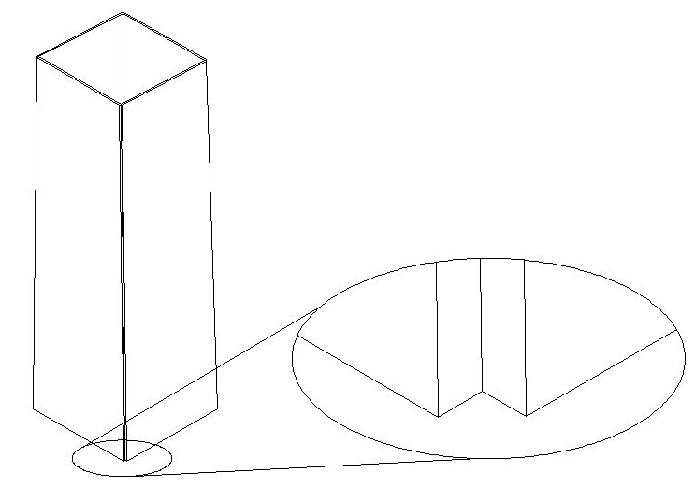

Fit the plates corner to corner with no gap.

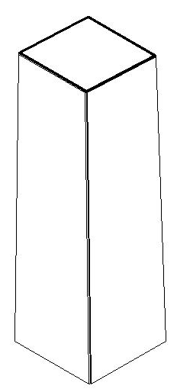

Use the *Inside Mold End Plate* to make sure that the four side pieces are square.

1. Tack weld the *Inside Mold Long Box Pieces* together, on the outside of the box.
2. Check that the box is still square. If not, fix it.
3. Tack weld all four sides of the *Inside Mold End Plate* to the *Inside Mold Long Box Pieces*.

**Step 8 continued: Weld the *Inside Mold Box***

1. Check that the box is still square. If not, fix it.
2. Weld the complete lengths joining the four *Inside Mold Long Box Pieces*, in the order shown:

1

2

3

4

1. Check that the box is still square. If not, fix it.
2. Weld the edges of the *Inside Mold End Plate* to the edges of the four *Inside Mold Long Box Pieces* all the way around.

**Weld the *Inside Mold Short Box*:**

1. Stand the four *Inside Mold Short Box Pieces* (6 mm (¼”)thick steel) with the narrow ends up. Make sure the box is square.

Fit plates corner to corner with no gap

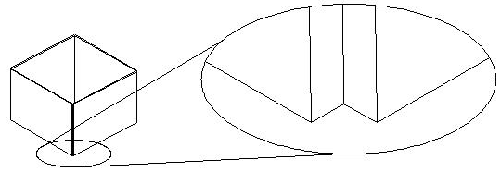

Weld on outside, same as was done as for the long box pieces.

1. Tack weld the *Inside Mold Short Box Pieces* together.
2. Check that the box is still square. If not, fix it.
3. Weld the complete lengths joining the four *Inside Mold Short Box Pieces*, in the order shown above.
4. Check that the box is still square. If not, fix it.

**Step 8 continued: Weld the *Inside Mold Box***

**Weld the *Inside Mold Short Box* to the *Inside Mold Long Box*:**

1. Place the *Inside Mold Long Box* (built in instructions 1-8) on the narrow end of the *Inside Mold Short Box* (built in instructions 9-12) as shown below.

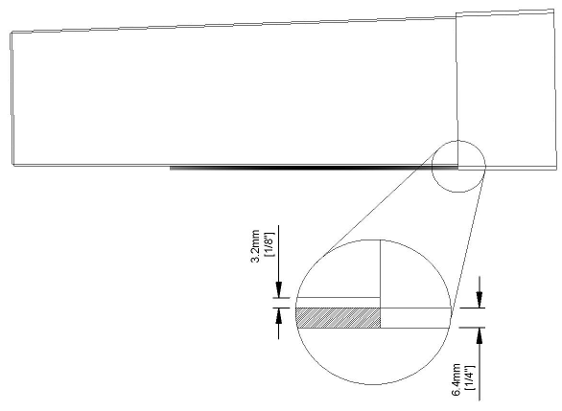

*Inside Mold Long Box* (3 mm (1/8”) thick steel)

*Inside Mold Short Box* (6 mm (¼”) thick steel)

Use a piece of wood or steel that is 6 mm (¼”) thick (roughly the same thickness as the walls of the *Inside Mold Short Box*) to position the two boxes corner to corner with no gap.

1. 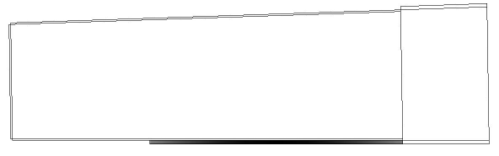**From the inside**, tack weld all four sides of the *Inside Mold Long Box* to the *Inside Mold Short Box*.

Reach in and tack weld the two boxes together **from the inside**

**Do not weld the two boxes together from the outside.** This joint must stay sharp to create a sharp ledge inside the concrete filter container. If using a diffuser plate, the diffuser will rest on this 6 mm (1/4”) wide ledge.

1. Finish welding the boxes together, all the way around **on the inside**.
2. Grind all welds to make them smooth.

## Step 9: Weld the Inside Mold Base Plate

1. On the side of the base plate that does not have the 267 mm square drawn on it (made in Step 2), weld one piece of 89 mm (3 ½”) square tubing in each of the four corners as shown. These will be the “feet” of the mold. Keep the piece of 89 mm (3 ½”) square tubing with a hole through it for Step 10.
2. On the same side of the base plate as the square tubing, weld one 25 mm (1”) nut onto the centre of the base plate, as shown below.

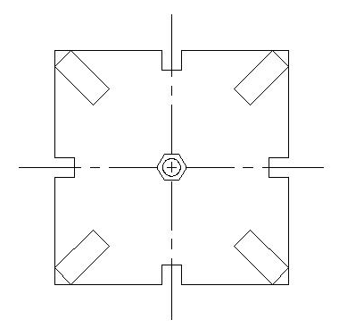

Weld the 25 mm (1”) nut to the center of the plate.

Weld four 89 mm (3½”) pieces of square tubing, one on each corner of the plate.

Weld the nut and tubing on the opposite side from the square line that you marked on the base plate in Step 2.

## Step 10: Weld the Outside Mold – Nose (Front) Panel

Tip: If you cannot find 6 mm (1/4”) or 5 mm (1/5”) steel for the base plate, you can use 4 mm (0.17”) or 3 mm (1/8”) steel. But if you use thinner steel (3-4 mm (0.17”- 1/8”)), you must reinforce the base plate with angle iron or square tubing to prevent the plate from bending when removing the filter. Instead of feet, weld on four pieces of angle iron or tubing to make an “X” across the plate as shown.

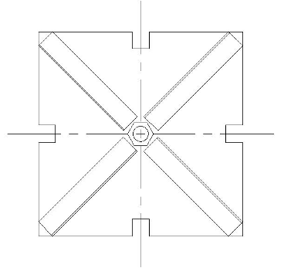

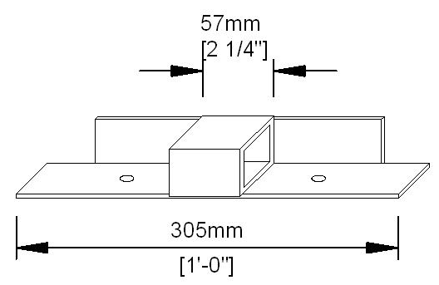

1. Take the piece of 305 mm (12” or 1’) long angle iron that has the ends cut off on one side. Weld a 57 mm (2¼”) long piece of square tubing onto the centre of the angle iron. (Leave the other 305 mm (12”) angle iron for Step 11.)

2. Cut a hole for the ‘nose’ in one of the 305 mm x 940 mm (12” x 37” or 3’ 1” x 1’) *Outside Back and Front Panels* as shown (this will be the *Nose (Front) Panel*).

3. Weld angle iron onto three sides of the *Nose (Front) Panel* as shown.

**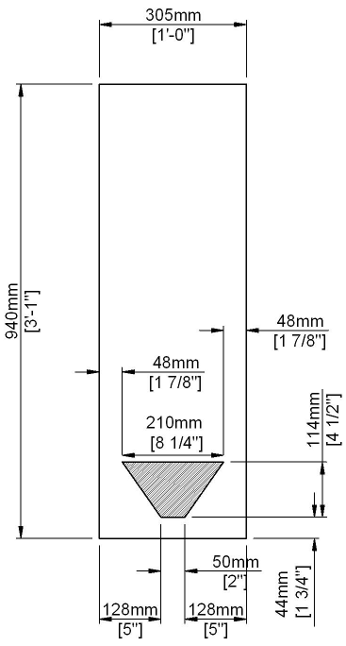 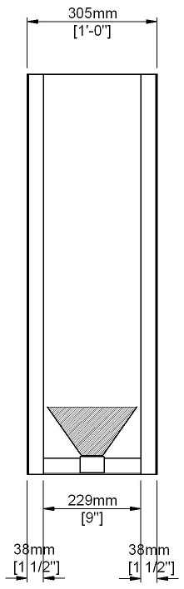**

Weld the 305 mm (12”) angle iron (with the ends cut off) to the front panel as shown. You will have to grind the piece down in length to fit between the two long pieces of angle iron. (How much you will have to grind depends on the thickness of your angle iron.)

Weld a 940 mm (37”) long angle iron onto each side of the nose plate as shown.

**Step 10 continued: Weld the *Outside Mold – Nose (Front) Panel***

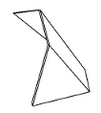

158 mm (6¼”)

139 mm

(5 ½”)

50 mm

(2”)

Side Nose Pieces

Front Nose Piece

1. Place the three nose pieces on the *Nose (Front) Panel* or on another flat surface. Weld the *Front Nose Piece* to both *Side Nose Pieces* along the 158 mm sides. This is the *Nose.*

2. Weld the *Nose* to the *Nose (Front) Panel*.

All welding for the nose should be done from the inside. The welds should be continuous. All the welds on the inside of the nose must be ground smooth – the corners on the inside of the nose will show on the front of the concrete filter.

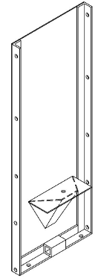

**Note:** The joints between the *Nose Pieces* and the *Nose (Front) Panel*

**DO NOT** form right angles.

The bottom edges of the nose will be horizontal (parallel to the ground).

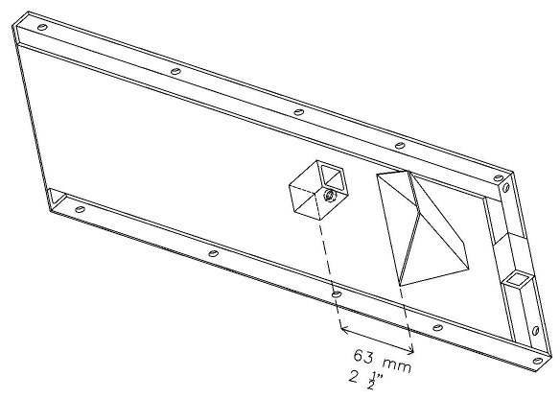

**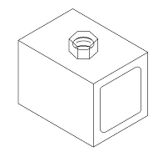**

3. Weld the 13 mm (½“) nut over one of the holes on the remaining 89 mm (3½”) long piece of square tubing. This nut is for the bolt that will hold the nose cover in place.

4. Weld the 89 mm (3½”) square tubing (with the nut welded over one hole) to the *Nose (Front) Panel*. The piece should be centered horizontally and 63 mm (1¾”) from the bottom of the nose opening. The 13 mm (½”) nut should be facing the nose.

## Step 11: Weld the Outside Mold Back and Side Panels

Weld a 57 mm (2¼”) piece of square tubing onto the center of one of the 387 mm (15¼”) angle irons. Repeat with the other 387 mm long piece of tubing.

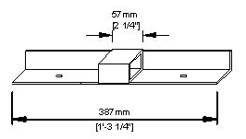

2 Pieces

Weld one piece of 387 mm (15¼”) angle iron with the square tubing on to the bottom of each of the 387 mm wide (15¼”) *Outside Mold Side Panels* as shown.

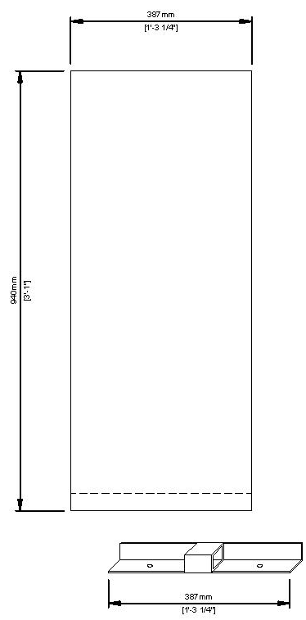 **Step 11 continued: Weld the *Outside Mold Back and Side Panels***

2 Pieces

Weld angle iron across the bottom of each of the *Outside Mold Side Panels*.

Weld a 57 mm (2¼”) piece of square tubing onto the center of the 305 mm (12”) long piece of angle iron (the piece without the end corners cut off).

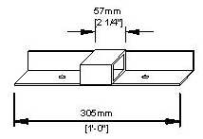

Weld the angle iron with the square tubing on to the bottom of the remaining 305 mm wide (12”) panel (the *Outside Mold Back Panel)*, as shown.

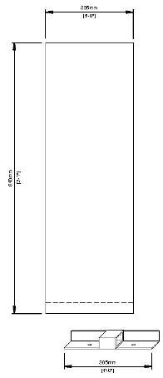

Weld angle iron across the bottom of the 305 mm (12”) wide *Outside Mold Back Panel*.

**Step 11 continued: Weld the *Outside Mold Back and Side Panels***

Stand the *Back Panel* and *Side Panels* as shown below. Place the *Back Panel* (305 mm wide) between the two *Side Panels*, 38 mm (1½”) in from the edge of the *Side Panels*. Make sure the panels are square – at 90° angles to each other.

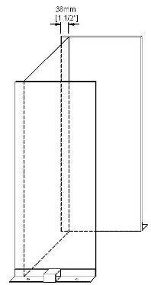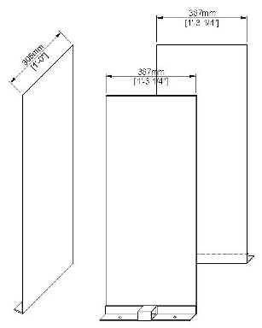

Tack weld the panels together and then check again to make sure they are square. Once they are square, stitch weld the panels together from the outside. This is now called the *Rear Outside Mold.*

Note: A stitch weld has 25 mm (1”) welds spaced 150 mm (6”) apart (centre-to-centre). Using a stitch weld along the entire length of the panels is good for the Rear Outside Mold. It is not necessary to weld the entire length of the joints continuously.

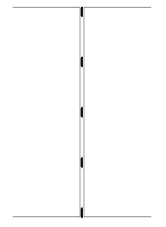

## Step 12: Assembling the mold

Place the *Rear Outside Mold* and the *Nose (Front) Panel* on top of the *Inside Mold Base Plate* as shown below. If you made one different notch in the *Inside Mold Base Plate* earlier, make sure the different notch and the *Nose (Front) Panel* side line up. Clamp all the components together so that they will not move. Finish drilling the bolt holes – wherever there is a hole in the angle iron, drill through the corresponding plate.

The *Rear Outside Mold* and the *Nose (Front) Panel* are now the *Outside Mold*.

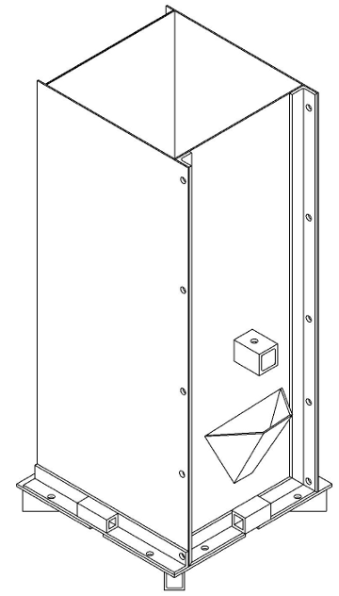

18 Holes

**Step 12 continued: Assembling the mold**

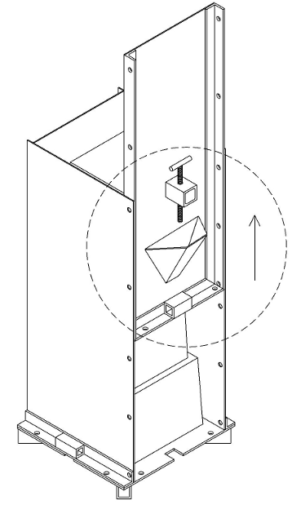

1. Bolt the *Rear Outside Mold* to the *Inside Mold Base Plate*.
2. Place the *Inside Mold Box* on top of the *Inside Mold Base Plate,* inside the *Rear Outside Mold*.
3. Place the *Nose (Front) Panel* on the *Base Plate*. Raise the *Nose (Front)* *Panel* two or three sets of holes, and bolt it to the *Rear Outside Mold*.
4. Make sure that the *Inside Mold Box* is centred – equally distant from each side of the *Rear Outside Mold* and the *Nose (Front) Panel*. *The Inside Mold Box* should be at least 22 mm (3/4”) from the *Outside Mold* on all sides.
5. Reach in and tack weld the *Inside Mold Box* to the *Inside Mold Base Plate*.
6. Unbolt and remove the *Outside Mold*.
7. Weld the *Inside Mold Box* to the *Inside Mold Base Plate* all the way around. This is now the *Inside Mold.*
8. If you did not create a different notch in the *Inside Mold Base Plate* earlier to tell you which side of the *Inside Mold* is the nose (front) side, you can mark the *Inside Mold* now. On a surface that will not touch concrete, mark the *Inside Mold* to show which side is front (facing the *Nose (Front) Panel*). The mark can be a groove, a notch, or another permanent mark.

## Step 13: Weld the Extractor

**Note:** Grind the welds on the inside mold smooth with the grinding wheel in this direction. **Do not** grind or sand any grooves or ridges into the inner mold because this will make concrete stick to the mold, and make it difficult to remove the filter from the mold.

Wrong

Right

1. Take one 387 mm (15¼”) long piece of square tubing with a 29 mm (1 1/8”) hole in the centre, and two 175 mm long (67/8”) pieces of square tubing. Weld the two 175 mm (67/8”) square tubing pieces onto the sides of the 387 mm (15¼”) square tubing without a hole, as shown.

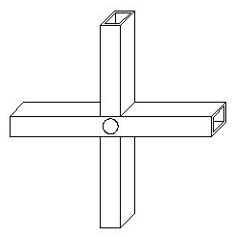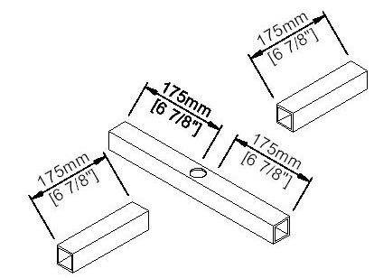

2. Weld the *Extractor Support Piece* (square plate) onto the square tubing. Make sure the holes line up.

3. Weld one 152 mm (6”) long 16 mm (5/8”) diameter steel rod on each end of the square tubing, on the opposite side from the square plate.

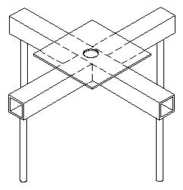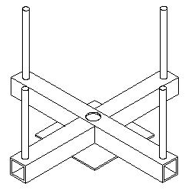

**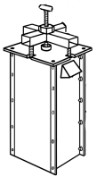Step 13 continued: Weld the *Extractor***

Note: These rods must line up with the square notches on each side of the *Inside Mold Base Plate*. Each rod should sit inside a notch. **Test to make sure the rods line up with the notches before you weld the rods onto the *Extractor*.** Stand the mold with the Base Plate facing up. Stand one rod in each of the notches. Put the *Extractor* on top of the rods and mark where the rods should be welded onto the *Extractor.*

Weld a scrap piece of rod approximately 50 mm (2”) long to the end of the 25 mm (1”) diameter threaded rod to form the extractor bolt.



25 mm (1”) threaded rod

Weld a scrap piece of rod approximately 63 mm (2½”) long to the end of the 13 mm (½”) diameter threaded rod to form the bolt which holds the nose cover in place.



13 mm (1/2”) threaded rod

## Step 14: Finishing the mold

* Welds on any surface that touch concrete must be ground down to a smooth finish.
* The dark “mill scale” on the surface of sheet metal is the smoothest finish,. It can be left on surfaces that touch concrete unless there is weld material to be ground off.
* **DO NOT PAINT THE INSIDE OF THE MOLD** (especially those surfaces that will touch concrete). It will cause problems in removing filters from the mold.
* **PAINT THE OUTSIDE OF THE MOLD** (the sides that will not touch concrete).Use rust-proof paint to make your mold last longer.
* All the pieces of the mold will be custom-fit to match each other, so mark each piece of the mold with an identifying mark so you can tell it from other molds. For example, you could grind a certain number of notches into a non-working surface of each piece, or paint on a mold number.
* Do not let the mold get rusty. The mold should be oiled (with edible, food-grade oil such as vegetable oil) for storage, and stored indoors so that it doesn’t rust.

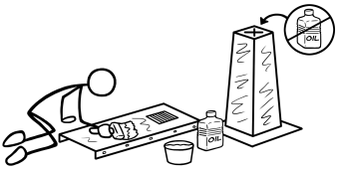

CAWST (Centre for Affordable Water and Sanitation Technology)

Calgary, Alberta, Canada

Website: www.cawst.org, Email: cawst@cawst.org

Last Update: August 2012