**Contents**

1 Introduction 2

2 Impact of Poor Overflow Water Management 2

3 Overflow Water Management Options 3

3.1 Reuse in Agriculture 3

3.2 Infiltrate into the Ground 4

3.3 Discharge to Surface Water 5

4 Definitions 6

5 Additional Resources 7

6 References 7

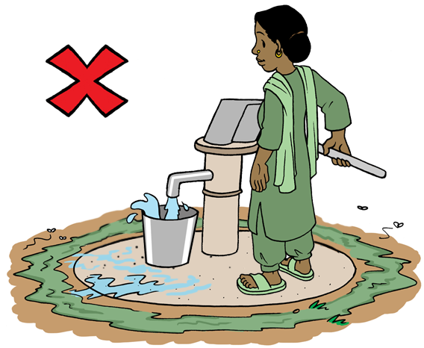

# Introduction

Managing overflow water that has spilled from wells or water points is an important part of environmental sanitation to protect public health and prevent environmental contamination. Yet, overflow water has traditionally received little attention.

This Technical Brief focuses on simple and low cost options available to manage overflow water. Using overflow wastewater in home gardens and agriculture is introduced as a way to improve crops and conserve fresh water supplies. As well, specific disposal technologies are presented, like soak pits and infiltration trenches.

CAWST focuses on the planning, design, and implementation of on-site sanitation projects for low-income communities not connected to a sewer. For such communities, household or decentralized sanitation offers a hygienic and affordable solution.

CAWST’s free, open content resources and schedule of international training workshops can be found at: <https://resources.cawst.org> and [www.cawst.org/training](http://www.cawst.org/training).

# Impact of Poor Overflow Water Management

Pathogens can spread quickly through the environment when overflow water is poorly managed. For instance, standing water can:

* Spread pathogens that cause disease (like schistosomiasis)
* Breed disease vectors (like mosquitos that transmit dengue fever, Japanese encephalitis, West Nile fever, and malaria)
* Backflow into the water point, like a well or tap stand, and contaminate the water source
* Become stagnant and cause bad smells that make the local environmental unpleasant for those living in the area
* Erode the soil away and damage the water point structure.

Poor drainage can also cause more frequent and severe flooding, spreading contamination. In some places, waterborne disease outbreaks can be reduced through better overflow water management.

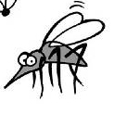

**What is the Connection to Malaria?**

Poor drainage of overflow water can cause standing water. Pools of stagnant water

provide an ideal environment for mosquitos to breed, including those that transmit malaria.

In 2015, there were about 214 million malaria cases and an estimated 438,000 malaria deaths. People living in the poorest countries are the most vulnerable to malaria, especially in Africa. As well, children under five are particularly susceptible to malaria illness, infection, and death.

(World Health Organization, 2015)

# Overflow Water Management Options

Overflow water from a pump or tap stand should have very low levels of pathogens. It is a good quality water source that requires little or no treatment before it can be reused for various purposes or safely disposed. However, overflow water can quickly become contaminated with pathogens from human and animal excreta when it is not well managed.

Overflow water can be managed in the following ways:

* Used as irrigation water for agriculture
* Discharged directly to surface water (for example, lakes, rivers or ponds)
* Infiltrated into the ground using soak pits or infiltration trenches

Regardless of the management option used, all water points should have a concrete apron around them to direct the overflow water away and prevent standing water. As well, drainage channels can be built to carry overflow water away from the water point. Drainage channels can transport the overflow water to be the point where it is to be used, discharged, or infiltrated.

## Reuse in Agriculture

There is growing recognition of the value of used water. In water scarce regions, people are looking to use overflow water as an alternative to help save fresh water sources. Overflow water can be reused for various purposes, such as irrigation for home gardens or agricultural crops.

Overflow water can be beneficially used to irrigate a household garden or larger agricultural crops. This can help communities to grow more food while at the same time conserve water. Using overflow water in agriculture is also considered to be a low-cost treatment method. It relies on the soil to remove any pathogens and nutrients from the water. Overall, using overflow water in agriculture instead of disposing of it directly into surface water may reduce the negative impacts on public health and the environment.

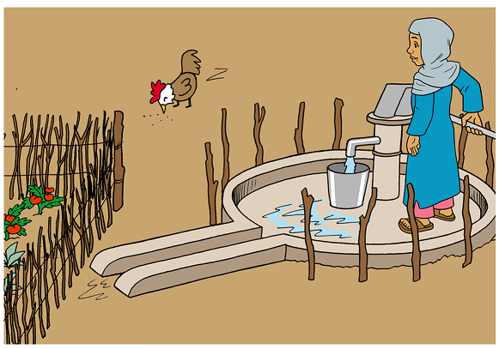

Hand pump with a concrete apron that directs the overflow water to a nearby garden

There may be some health risks of using overflow water in agriculture. Any risks are usually from overflow water being cross-contaminated with excreta. The risks can be reduced by using a multi-barrier approach of health protection measures. These barriers focus on protecting the people handling the overflow (like farmers), those eating the food or using the product (consumers), and the local community.

**Table: Barriers to Protect Health**

| **Barriers to Protect Health** | | **Action** |
| --- | --- | --- |
|  | Crop restriction | Only use overflow water for crops that:   * Are not eaten (like cotton) * Are processed (like wheat) * Are cooked (like potatoes) * Do not directly touch the ground (like bananas) |
|  | Application techniques | Do not apply overflow water directly on the plant. |
|  | Use protective equipment | Wear protective equipment, such as clothing, gloves, and shoes. |
|  | Waiting period | Wait one month after irrigating with overflow water before harvesting crops. Pathogens continue to be inactivated once they are in the soil. Inactivation is much faster in hot and sunny climates than cold and rainy climates. |
|  | Prepare food properly | Wash fruits and vegetables with safe water before eating. Wash hands with soap before cleaning and preparing food. Cook all food thoroughly and do not eat raw food. |
|  | Wash hands | Wash hands with soap after handling overflow water. |
|  | Train | Train farmers, families, and the community on proper overflow water management and hygiene practices. |

## Infiltrate into the Ground

Infiltrating overflow water into the ground using a soak pit is another simple and suitable option for households. A soak pit is a dug pit that allows used water to safely infiltrate into the ground.

Soak pits must be lined or filled with rocks to prevent erosion and to prevent the walls from collapsing. The size of the soak pit is based on the amount of water entering the pit and whether the water is clean or dirty. Infiltration only happens through the side walls of the soak pit. Almost no infiltration occurs through the base of the pit because it quickly clogs with solids. It is important to design the size of the soak pit to handle peak flows of water, especially if the infiltration capacity of the surrounding soil is low.

The simplest and quickest way to build a soak pit is to dig a pit and fill it with rocks. However, the rocks reduce the volume of water that the pit can hold and finding enough rock may be difficult in some places. Lining the soak pit walls with bricks or blocks overcomes both of these issues, but it increases the construction time and difficulty.

**Figure: Soak Pit Filled with Rocks**

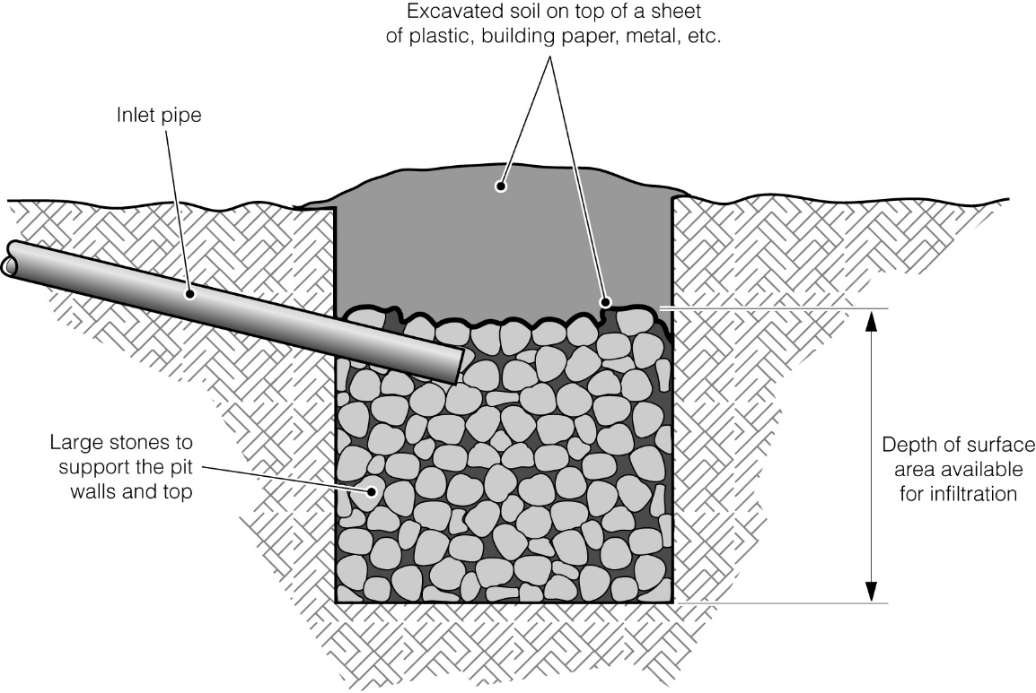

Soak pit filled with rocks and covered sheet and soil (Credit: Chatterton)

Excavated soil on top of a sheet of plastic, building paper, or metal

Depth of surface area available for infiltration

Large stones to support the pit walls and top

Inlet pipe

Trenches can be used in situations where a soak pit is unable to infiltrate the total amount of overflow water. This can be either because of low soil infiltration capacity, large amounts of water or a combination of the two. Infiltration trenches are long shallow pits. They require more planning, space, and materials than a soak pit, but create a much greater surface area for infiltration into the soil. Infiltration trenches are often used in conjunction with septic tanks.

More information about soak pit design can be found in CAWST’s Technical Brief: Design Calculations for Soak Pits and Infiltration Trenches.

## Discharge to Surface Water

Discharging overflow water into a surface water body (like a river, pond, lake or sea) is the most common method of disposal, especially in urban and peri-urban areas. Most countries do not have specific standards for discharging overflow water.

The water point should be constructed with a concrete apron and drainage channels, which can be open or closed. The channels carry the overflow water away to where it is discharged. In many places, drainage channels become dumps for household waste. Channels must be kept clean of waste to prevent them from blocking water flow and causing additional flooding. See CAWST’s Technical Brief: Solid Waste Management for further information on how to properly dispose of solid waste.

# Definitions

**Disposal:** The return of waste to the environment, ideally in a way that is least harmful to public health and the environment.

**Environmental sanitation:** Interventions that reduce people’s exposure to disease by providing a clean environment in which to live, with measures to break the cycle of disease. It usually includes human and animal excreta management, wastewater management, stormwater drainage, solid waste management, vector control, and personal and domestic hygiene. As well, drinking water is sometimes included in the definition, as sustainable environmental sanitation cannot be planned and implemented in isolation from water supply.

**Excreta:** Urine and feces that are not mixed with any flush water.

**Infiltrate:** To pass into or through something. Infiltration is the process by which liquid enters the surrounding soil.

**Overflow water:** Water that has spilled from wells or water points.

**Pathogen:** An organism that causes disease.

**Vector:** A living thing that transmits a disease to a host. Vectors include mosquitos, flies, and rodents. For example, flies can carry and transmit pathogens from feces to humans.

**Wastewater:** Used water from any combination of domestic, industrial, commercial or agricultural activities, surface runoff (stormwater), and any sewer inflow (infiltration). Wastewater can be managed on-site or off-site. Wastewater managed off-site is often called sewage.

# Additional Resources

**CAWST Sanitation Resources.** Available at: <https://resources.cawst.org>

* CAWST’s education and training resources are available on a variety of sanitation topics including environmental sanitation (including vector control); latrine design and construction; fecal sludge management; and sanitation implementation.

# References

Chatterton, K. (nd). *Soak pit.* WEDC Image Library. Loughborough, UK: WEDC. Retrieved from <http://wedc.lboro.ac.uk/knowledge/img-lib-lres.html?id=10-0>

World Health Organization (2015). *Fact sheet: World malaria report 2015*. Geneva, Switzerland: WHO. Retrieved from [www.who.int/malaria/media/world-malaria-report-2015/en/](http://www.who.int/malaria/media/world-malaria-report-2015/en/)

CAWST (Centre for Affordable Water and Sanitation Technology)

Calgary, Canada

Website: [www.cawst.org](http://www.cawst.org) Email: support@cawst.org

*Wellness through Water.... Empowering People Globally*

Last Update: July 2016

This document is open content. You are free to:

* Share – Copy and redistribute the material in any medium or format
* Adapt – Remix, transform, and build upon the material for any purpose, even commercially



Under the following terms:

* Attribution – You must give appropriate credit to CAWST, provide a link to the license, and indicate if changes were made. You may do so in any reasonable manner, but not in any way that suggests that CAWST endorses you or your use. Please include our website: www.cawst.org

CAWST and its directors, employees, contractors, and volunteers do not assume any responsibility for, and make no warranty with respect to, the results that may be obtained from the use of the information provided.