Lesson Plan 5: Water Quality and PoU Options **2 hr 15 mins total**



**Lesson Description**



The focus of this lesson is to explore the need for household water treatment after emergencies. Participants will explore different options for household water treatment and safe storage, and identify variables which affect effective HWTS implementation after emergency situations.



**Learning Outcomes**



At the end of this session participants will be able to:

1. Describe the qualities of safe water
2. Describe the steps of the multi-barrier approach
3. Describe different PoU options for household water treatment
4. Identify ways to keep stored water safe from contamination

**Materials**



* Flip chart paper
* Tape
* Markers
* Sticky notes (big size)
* Poster or PowerPoint of the Multi-Barrier Approach
* PoU options flex
* Safe Storage Poster (See end of lesson plan)
* Flex/Fact Sheets of PoU Options (1 each per participant)
* 2 glasses
* Meta-cards

**Preparation**



* Write the learning outcomes or lesson description on flip chart paper
* If using the PowerPoint, prepare the files and projector for display
* Prepare poster images or PowerPoint images
* Print Flex/Fact Sheets of PoU Options (1 each per participant)
* Prepare a glass of dirty water with unsettled particles
* Prepare meta-cards with MBA steps.

**Introduction 10 minutes**

1. Ask the participants: “At the time of emergency, where did you get your water supply from?”
2. Ask for a few volunteers to provide their responses to the larger group. *Responses may include: piped water supply, communal taps, bottled water, wells, tankers, etc.*
3. Ask the participants: “How did you know if the water was safe or not?”
4. Have a few participants volunteer responses.
5. Present the learning outcomes or lesson description.

**Safe Water 15 minutes**



1. Explain to participants that in emergency situations people often retrieve their water from less safe sources than in normal conditions, or from sources which have been damaged and are susceptible to contamination. For this reason it is important for individuals to know how to treat their own water and to store it safely to prevent the spread of disease.
2. Present an unsettled glass of dirty water to the participants and ask if it is safe to drink or not. *Likely response: No.*
3. Ask to the participants, “Why it is not safe to drink?” *Possible response: The water is dirty and appears to contain many types of particles.*
4. Let the water settle and place the glass where it is easily visible to the participants. Tell that we will come back to the glass after a while.
5. Ask the participants: “What might contaminate/pollute drinking water?”
6. Provide a few sticky notes to each participant and ask them to write one idea on each note.
7. Give them 2 - 3 minutes to write their ideas. As the participants write their ideas, collect the notes and paste on the board categorizing the contaminants into 3 categories without labeling them: Physical, Chemical and Microbial.

|  |  |  |
| --- | --- | --- |
| Physical | Chemical | Microbial |
| Dirt particles  Clay/ sand  Leaves  Etc. | Pesticides  Iron  Arsenic  Etc. | Viruses  Bacteria  Germs  Helminthes Etc. |

1. Ask participants if they can recognize the unlabeled categories.
2. Explain the different categories: ***Physical contamination*** *means the presence of any particulate that can be seen in the water.* ***Chemical contamination*** *means the presence or increased level of chemical compounds compared to the national standard of water quality and* ***microbial contamination*** *means the presence of micro-organisms.*
3. Present the glass of water from earlier to the participants again and in front of the participants draw the clear water into another glass. Be careful to not disturb the settled material at the bottom of the glass.
4. Ask the participants: “Now that the material has settled and I’ve poured off the clean water, do you think this is safe?”
5. Allow a few participants to offer their suggestions as to whether or not the water is safe or not.
6. Explain to the participants the difference between clean water and safe water.

*Clean water means the absence of physical contamination only while safe water means the absence of physical, chemical and microbial contamination. The water that meets the national standard of drinking water is safe water.*

*Explain (if necessary) that the Government of Nepal has a guideline with 27 basic parameters for drinking water, 6-physical, 19- chemical and 2 microbial parameters. (For detailed information on the parameters, refer to the end of lesson plan.)*

1. Ask to the participants again if the clean water in the glass is safe or not. *Possible answer: No*

**Availability of Water Quantity in Emergency 20 minutes**



1. Explain to the participants that in the time of emergency many organizations were on-site shortly afterwards to help and support people to get enough water.
2. Explain that now, as the emergency phase is over and as we are in the recovery phase, many humanitarian organizations may returning back to other priorities. As a result, people’s daily water requirements may not be fulfilled.
3. Indicate that the minimum required amount of water is 15 liters per day. If people are more concerned with obtaining the right amount of water, they may neglect to focus whether or not that water is safe or not.
4. Tell participants that as WASH volunteers, they can contribute to the recovery of water supplies in the following ways. Often these activities will be led by others and WASH volunteers may assist:

* Water system rehabilitation
* Water system development
* Maintenance of existing sources - pipelines to camps

1. In a large group, discuss what each point means:
   1. Maintenance of existing sources: to maintain a system that is in use but requires minor changes or service in order to be more effective. Examples include changing the taps, pipes joints, sealing leakages, distribution points, animal damage, minor cracks, poor drainage, washout blockage, pipeline to the camps, etc.
   2. Water system rehabilitation: Means to bring major changes to the water supply system or to repair significant damage. This may mean to change or replace pumps, pump equipment, pipelines, construction of treatment systems, intake, training and awareness campaigns, etc.
   3. Water system development: Development or construction of a new small system as per the need of an area. This might be due to the displacement of the population or complete damage of an existing system.

**The Multi-Barrier Approach 15 minutes**



1. Ask the participants: “Where do you keep your treasures?” *Possible responses include:* *in a safe, between various doors, behind a gate, main door, room door, cupboard/ wardrobe door, safe door - with multiple barriers.*
2. Explain to the participants that multi-barriers must also be built for water as well, because as discussed earlier water might be contaminated with physical, chemical and microbial contaminants. So, water should be purified and stored safely.
3. Ask the participants: “What might be the first barrier we can use to keep water safe?”
4. Ask few participants to share their responses with the larger group.
5. Present the meta-card written “*Source Protection*” and paste it at the front of the room.
6. Discuss with the participants that there are 5 barriers to keep water safe and the first one is source protection. Elaborate on source protection if necessary.
7. Again ask “What might be the second barrier to protect water?” Ask participants and then present the second meta-card with *“Sedimentation”* and discuss.
8. Repeat this process with ‘Filtration’, ‘Disinfection’ and ‘Safe Storage’.
9. Summarize all 5 points of the multi-barrier approach or present a PowerPoint review.

(Refer to the end of lesson plan for information on MBA)

**Treating Water 50 minutes**



1. Explain to participants as discussed in exploring the MBA, water can be treated in various ways and through various systems.
2. Explain that firstly, water can be treated at the central level or mass treatment can be done prior to distribution.
3. Briefly explain central level or mass level treatment to participants. A*t the central level or mass level water can be filtered through a slow sand filter and then can be disinfected with the use of chlorine. Or simply, water can be treated using chlorine in water supply tanks, reservoir, etc. In camp areas with well-managed water supply systems, and if the water is treated and managed correctly, there may be reduced need of PoU options.*
4. Explain that in a similar process to centralized water treatment, these processes can be conducted at the household level (like in the MBA) using various PoU options.
5. Explain to the participants that PoU- ‘Point of Use’ means treating water before using it, and as WASH volunteers they should be able to communicate to people how to effectively treat their water and store it safely to avoid contamination.
6. Tell the participants that in order to explore the various PoU options they are going to do group work.
7. Divide the participants into 4 groups.
8. Provide each group a flip chart paper and a few markers.
9. Assign each group with a PoU option from the following: Boiling, Filtration, Chlorination and SODIS.
10. Ask each group to write down whatever they know or any ideas they have on their assigned topic. *Possible answers might include details such as: points to remember and advantages of each PoU option.*
11. Give 10 minutes to finish their group work.
12. After 10 minutes, ask for one group to volunteer their findings first.
13. Summarize their presentation and add any missing points about the particular PoU option.

**Trainers note:**

* **Boiling:** Easy method to disinfect water, water should be filtered before boiling as boiling treats only microbial contamination, half boiled water is even more harmful so water must be brought at least to rolling boil
* **Filtration:** Various types of filter available in market, filters only physical particulates and few pathogens while some are effective for micro organisms also, easy to handle, easily accessible in market
  + **Candle filter:** Easy to use, easily accessible in market, filter candle should be cleaned in certain time interval, candle should be cleaned with soft brush and soap should not be used while cleaning and candle should not be boiled effective for physical and few micro organisms.
  + **Colloidal silver (CS) filter:** effective method to treat water (effective for physical and microbial contamination), main component of the filter is the silver coating/ powder used while making candle or plate which kills pathogens present in water, without any chemical process water is disinfected, filter candle/ plate should be cleaned in certain time interval, candle/ plate should be cleaned with soft brush and soap should not be used while cleaning and candle/ plate should not be boiled
  + **Bio sand filter:** effective for physical, microbial and some chemical components, can be made locally by a trained person, sufficient amount of water is filtered,
  + **Other types:** some modern types of filters are available in market with UV rays and reverse osmosis (RO) processes which are effective to kill pathogens and also treat physical and chemical contamination. Example of filters available in market- Euro guard, Aqua guard, Sawyer, Straw filter, Sky juice
* **Chlorination:** Treat water with chlorine, kills pathogen and somehow treats chemical compounds like iron, manganese, hydrogen sulfide, ex. Piyush and Piyush plus manufactured by ENPHO, chlorine dosing should not be used in guess- if chlorine dose is not enough does not treat water effectively, if chlorine dose is high- might have negative effect in health, should wait 30 minutes after dosing chlorine, chlorine should be stored in out of reach of children and should not be stored in direct sunlight
* **SODIS (solar disinfection):** SODIS is a simple, cost effective method to treat water against microbial contamination through the UV rays and heat of the sunlight. SODIS is ideal to disinfect small quantities of water of low turbidity. Contaminated water is filled into transparent plastic bottles and exposed to full sunlight for six hours. During the exposure to the sun the pathogens are destroyed. In case of cloudiness the plastic bottles need to be exposed for 2 consecutive days in order to produce water safe for consumption. The treatment efficiency can be improved if the plastic bottles are exposed on sunlight reflecting surfaces such as aluminium- or corrugated iron sheets.

1. Repeat the same process with other PoU options and summarize each with input from the larger group if there is anything missing.

(Refer to end of lesson plan for more information on PoU options)

**Safe Storage of Water 10 minutes**



1. Ask the participants: “After people treat their water with PoU options, what else should they focus on to keep it safe?”
2. Ask 1-2 participants to volunteer suggestions. *Reponses should include: Store it safely to avoid re-contamination as most of the treated water is re-contaminated during the storage of treated water.*
3. Return to the Multi Barrier Approach and explain the importance of storing water safely to avoid re-contamination as recontamination of clean and already treated water is a common problem.
4. Ask participants: “What are some features of good and bad safe storage containers?” *Responses should include:*
   1. *Good: Tightly fitting lid or cover, Tap or narrow opening to prevent hands or dipping into the water, stable, solid, easy to empty and refill, etc.*
   2. *Bad: No lid or cover, wide opening that is easy to dip hands or objects into, easy to knock over or tip, etc.*

**Review 15 minutes**



1. Divide participants back into the same four groups as the earlier activity.
2. In their 4 groups, provide the stages of the MBA to each group and ask them to arrange it in the correct order. Explain they have 1 minute to complete it.
3. Give 1 minute to finish the activity. Ask groups to share their result and ask if anyone has different order than the others.
4. Ask each group to write one important point to remember for each of the PoU options starting from Boiling, Chlorination, Filtration, and SODIS on the corresponding meta-cards of the MBA.
5. Give the participants a few minutes to record their ideas on their meta-cards. Ask the groups to share it once they are finished.

**Reflections on Lesson**

**Multi-Barrier Approach Matching Activity**

|  |  |
| --- | --- |
| **Description: pumpDescription: Rainwater_House_greyscale** | **Description: BSF_Line Description: Ceramic Pot** |
| **Description: chlorine Description: boil** | **Description: settle Description: settle2** |
| **Description: jerrycan** Description: Safe Storage_Line |  |
| **Sediment your water** | **Store your water safely** |
| **Protect your source water** | **Filter your water** |
| **Disinfect your water** |  |

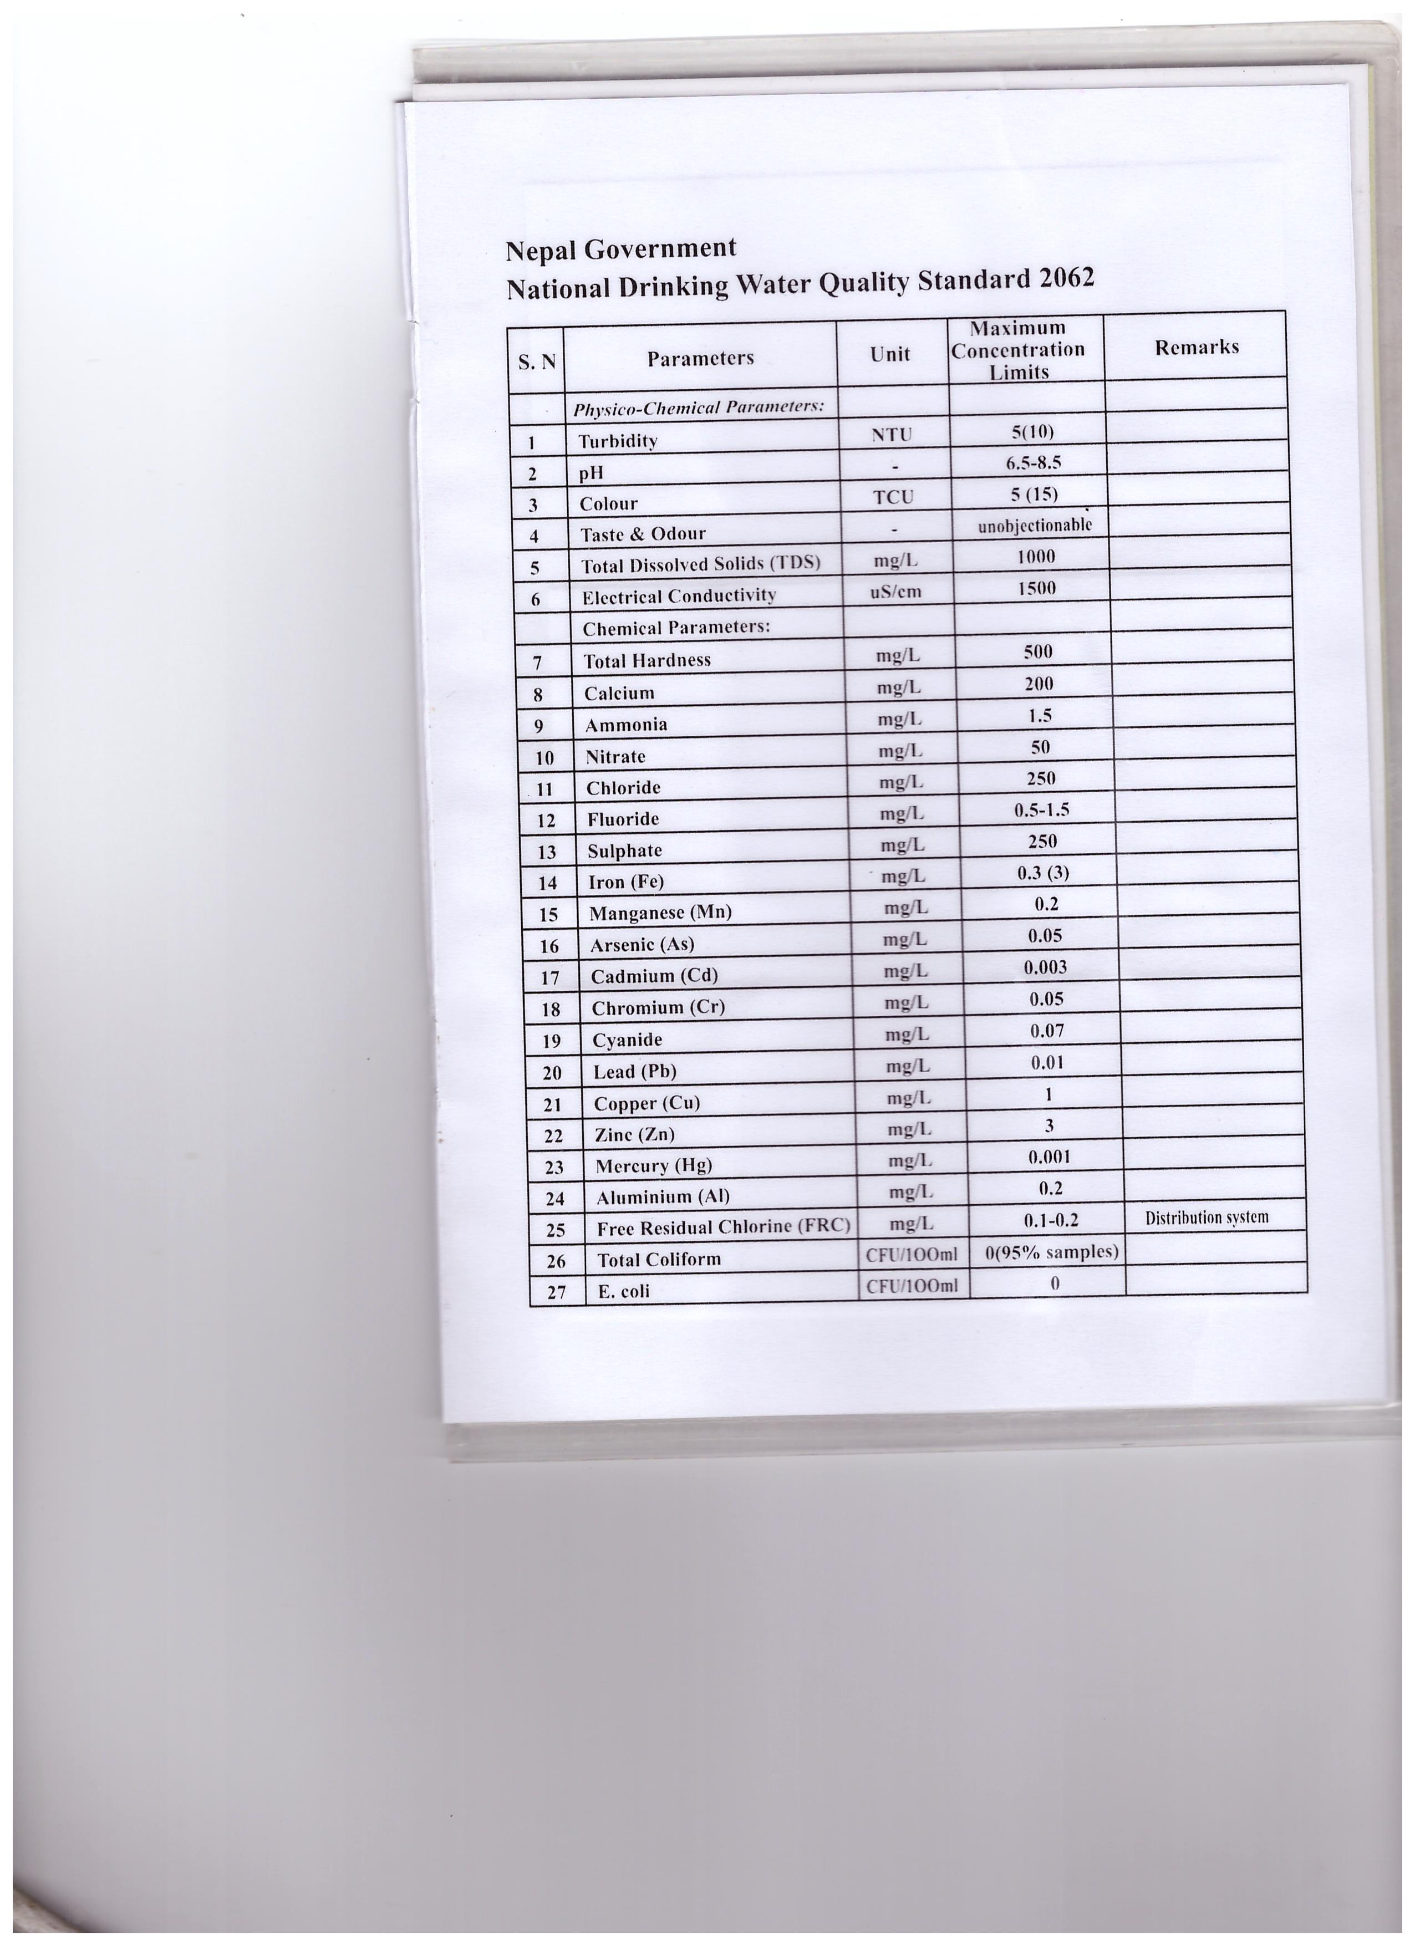

|  |  |  |
| --- | --- | --- |
| Concentration of Chlorine | Amount of Chlorine | Amount of water treated |
| 0.7% of chlorine solution (Piyush plus) | 1 ml | 5 liters |
| 1% of chlorine solution | 1 ml | 10 liters |
| 5% of chlorine solution | 40 ml | 1000 liters |
| 0.5% of chlorine (Piyush) | 3 drops | 1 liter |
| Aquatabs (20 mg available chlorine) | 1 tablet | 4/5 liters |

Always remember: Dose of Chlorine depends up on the concentration of Chlorine

**MBA**

There are 5 steps to get safe drinking water. The 5 steps are called the Multi-Barrier Approach to Safe Drinking Water. Doing first step will make your water safer to drink. But doing all 5 steps will get the safest water.

The 5 steps are:

1. Protect your source water

2. Sediment your water

3. Filter your water

4. Disinfect your water

5. Store your water safely

Protect your source water

* Keep it clean.
* Keep surface flow, runoff and waste water out.
* Keep human and animal waste out.

Sediment your water

* Let the dirt and large particles in the water fall to the bottom.
* You can use alum, moringa seeds or prickly pear cactus to help the dirt settle.

Filter your water

* Filter out the remaining dirt and large pathogens
* Use a biosand filter, a ceramic pot or a ceramic candle filter.

Disinfect your water

* Disinfecting the water will get rid of even the smallest pathogens that are still in the water.
* You can use chlorine, boiling, or SODIS.

Store your water safely

* Use a safe storage container to store your drinking water.
* Use a different bucket for collecting water from the source and for storing treated water.
* Clean your safe water storage containers regularly.
* Use a tap to get the water out, or pour it out.

**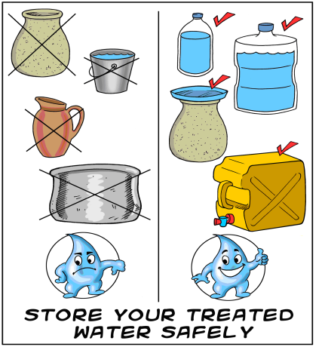Safe storage**