Have you ever been with a group of people who are different from you? Perhaps there are physical differences that set you apart, like the colour of your skin, the shape of your eyes, or your height. Maybe you have ideological differences; perhaps your religion is different or your beliefs and ethics on a particular issue vary. The differences and similarities that we have with our participants influence our interactions with them. As well, they impact the level of trust and acceptance we are able to gain. We are better prepared to address issues that may arise when we are aware of how our identity influences our interactions.

# The Identity Triangle

Our trainer identity can be divided into 3 parts: social identity, organizational identity, and approach to education. Combined, these parts create the trainer identity triangle (Arnold, Burke, James, Martin, & Thomas, 1991).

(Adapted from Arnold et al., 1991)

***TRAINER’S IDENTITY***

***Social Identity***

***Organizational Identity***

***Approach to Education***

Social Identity

Social identity considers race, class, ethnicity, sexuality, religion and gender. The characteristics of a person’s social identity are often compared with the dominant or most powerful group in society (Arnold et al., 1991).

The white flowers in the Power Flower on the following page represent aspects of social identity (Arnold et al., 1991). The inner petals represent elements of our social identity, while the outer petals represent the social identity of the people that we train. Consider how the differences and similarities in your social identity may influence your interactions with participants.

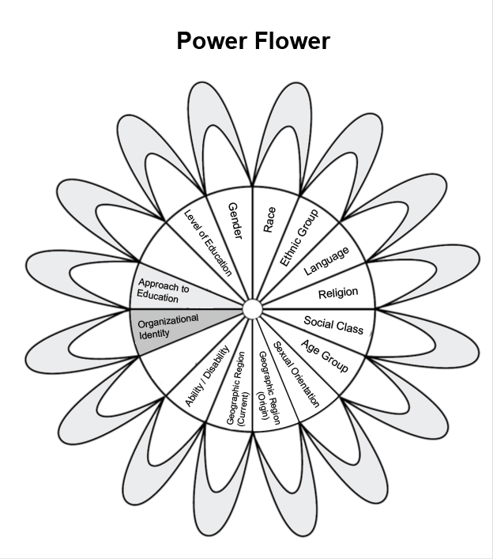

(Adapted from Arnold et al., 1991)

When we share aspects of our social identity with participants it helps us to relate to them and empathize with challenges they may be facing. When elements of our social identity are different from participants it can influence how we perceive the ideas they share and how willing participants are to share information with us. For instance, if you are a male trainer in a group of female participants, the women may feel uncomfortable speaking to you because you are male. You may need to look for different and creative ways to encourage women to communicate, such as getting them to speak in small groups that you are not participating in actively.

Organizational Identity

There are two parts of organizational identity. The first is how the reputation and the internal values and beliefs of an organization influence an employee’s perception of themselves, and the perception that other people have of them. For instance, if our organization is perceived as entrepreneurial and aggressive, we may approach our work this way. Similarly, those who meet us in our work role may assume that we have these same qualities as individuals. As members of an organization, the organizational identity becomes part of our personal identity (Pratt, 1998).

The second element of our organizational identity is whether or not we are part of the organization we are working with. Our “insider” or “outsider” status influences how we are perceived by participants and the level of flexibility and influence we have in our work. If we are training participants within our organization, the organizational etiquette and identity may prevent us from raising certain issues or asking specific questions. However, because we know the inner-workings of an organization we may have a better understanding of the needs and be able to design our training more appropriately.

As an “outsider” working with people from a different organization, we may not understand the organizational norms and culture. This can lead us to make mistakes on how we approach specific issues. However, it may also offer us unique insights and give us the ability to raise issues that insiders are afraid to raise. As outsiders, we are also exempt from the internal power structures that influence how people work within their organization. This status can give us greater power than if we were working within the organization.

Approach to Education

Our approach to education is about the values that we bring to our work and what we believe our role as a trainer should be (Arnold et al., 1991). Approaches to education can be divided into 3 main categories: (1) expert, (2) participatory and (3) transformative. Consider which of these approaches fits best with your values, your level of comfort, and how your organization delivers training:

**(1) An expert approach** is often used when a trainer has a deep understanding of a topic and participants are new to the information. This approach is also used when there are large numbers of participants. In the expert approach knowledge is transferred in a one way communication from the trainer to the participant. Participatory learning techniques are rarely used, and lectures are the predominant form of teaching. This technique is commonly used in many colleges and universities. It is also known as a passive or traditional approach to teaching.

**(2) A participatory approach**to education and training places a high value on the experience and prior knowledge of participants, and acknowledges their potential and diversity. Active learning techniques are used to share information and learn new knowledge, skills and attitudes. The trainer and participant learn from each other, and together develop a shared understanding of a particular topic. See CAWST’s Trainer Essentials: Active Learning for more information.

**(3) A transformative approach**to education andtrainingdoes more than teach people knowledge and skills, it aims to change peoples’ attitudes and behaviours by challenging their worldview and perspective. This fundamental change in the way that people think and act is achieved by using participatory techniques and encouraging deep reflection.

Trainers may use all of these approaches to training in their work, but may be more comfortable with one approach over another. Similarly, participants may have more comfort or experience with a specific approach. The approach we identify with most is considered our approach to education.

# An Example of Identity

Read through the following example. Consider how Marta’s social and organizational identity and her approach to education impact her relationship with train participants.

**Who is Marta?**

Marta is a light-skinned, heterosexual woman of Spanish decent. She lives a comfortable, upper class lifestyle in a large city in Bolivia. Marta is part of a small, but powerful, minority that traditionally had more power than the indigenous majority in the country.

Marta trains community water, sanitation and hygiene (WASH) promoters in Bolivia. She works for Ahora, a local organization that has been operating for ten years. The organization is known for its unconventional approach to advancing the rights of indigenous people in the country and working to challenge systems that unfairly discriminate against this population. Marta’s organization is respected and well received among indigenous populations. However, it is considered too revolutionary among the wealthy who feel threatened by the new rise in power of the indigenous people.

Marta personally believes that education and training should be about empowerment. She values the participants’ experience and wisdom, and likes to take the role of facilitator rather than the expert. She prefers using a participatory approach, as opposed to lecture style training.

Marta’s identity brings both challenges and opportunities to her as a trainer. Most of the community WASH promoters that attend her training come from communities with very little money. They are mostly indigenous people living in rural communities. They tend livestock and have small gardens for harvesting food. Because of Marta’s social identity, most participants are slow to trust her. The one thing that gains her entry into the communities is her organizational identity. Since the community trusts *Ahora,* they are willing to give Marta a chance. Nevertheless, Marta is still an outsider and does not understand the inner workings of the community. This does however give her the advantage of seeing things that the community does not always recognize themselves

Marta knows that her approach to education will help her to build trust with participants. She works hard during her workshops to create a safe environment for participants. She establishes herself as a facilitator that values the experience and prior knowledge of the participants. Marta’s participatory approach helps in her work of supporting others. However, she finds it challenging to support *Ahora*’s transformational philosophy and achieve fundamental changes in people’s beliefs and behaviours

Just as Marta, our identity influences the way that we perceive participants and how they perceive us. Being aware of our social and organizational identity and our approach to education, allows us to anticipate participant’s reactions to us and plan for these reactions. This understanding also helps us to question the assumptions that we make about participants, and enter into training with a more open mind. The next time you lead a WASH training, first consider the identities of the participants you will be working with, how their identities compare with yours, and the implications this will have on your training.

# References

Arnold, R., Burke, B., James, C., Martin, D., & Thomas, B. (1991). Educating for Change. Toronto: Between the Lines.

Pratt, M. J. (1998). To be or not to be: central questions in organizational identity. In D. A. Whetten, & P. C. Godfrey (Eds.), Identity in Organizations (pp. 171-208). Thousand Oaks, CA: Sage.

# Additional Resources

Albert, S., & Whetten, D. (1985). Organizational Identity. (L. Cummings, & B. Staw, Eds.) Research in Organizational Behaviour , 7, 263-295.

Ashforth, B. E., & Mael, F. E. (1996, June). Organizational identity and the strategy as a context for the individual. Advances in Strategic Management(34), 19-64. Retrieved from http://www.factorhappiness.at/downloads/quellen/S4_Ashforth.pdf

Deaux, K. (2001). Social Identity . In N. Levy (Ed.), Encyclopedia of Women and Gender (pp. 1-9). San Diego: Academic Press.

CAWST (Centre for Affordable Water and Sanitation Technology)

Calgary, Alberta, Canada

Website: www.cawst.org Email: resources@cawst.org

*Wellness through Water.... Empowering People Globally*

Last Update: March 2015

This document is open content. You are free to:

* **Share** – to copy, distribute and transmit this document
* **Remix** – to adapt this document

Under the following conditions:

* Attribution. You must give credit to CAWST as the original source of the document. Please include our website: www.cawst.org

CAWST and its directors, employees, contractors, and volunteers do not assume any responsibility for, and make no warranty with respect to, the results that may be obtained from the use of the information provided.