Katadyn Drip Filter

|  |  |  |  |  |  |
| --- | --- | --- | --- | --- | --- |
| Source Protection | Safe Transportation | Sedimentation | Filtration | Disinfection | Safe Storage |

# What is it?

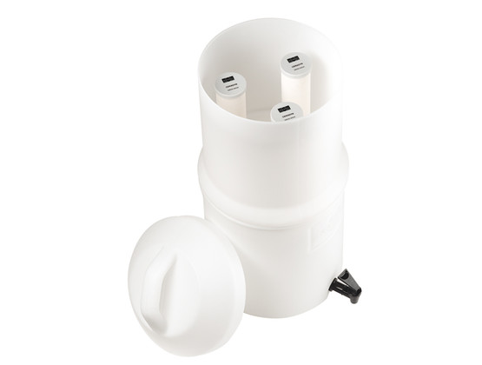The tabletop filter is produced by the Swiss company Katadyn. The filter setup consists of three ceramic filter elements, two 10 L containers, a tap for dispensing water, a cleaning pad, a measuring gauge, emergency plugs, and the necessary hardware for installation. Two types of ceramic filter elements are available: one has silver-coated pebbles inside (to prevent microbial growth), and one has activated carbon inside (to remove chemicals).

# Performance

## Microbiological Effectiveness:

|  |  |
| --- | --- |
| Parameter | Effectiveness |
| Bacteria | Very Effective (>99%) |
| Viruses | No independent tests |
| Protozoa | Very Effective (>99%) |
| Helminths | Very Effective* |

*Assumption based on pathogen size

## Other Parameters

Effective for removing turbidity. The version with activated carbon can help remove chemicals and improve the taste of water.

## Source Water Requirements

Very turbid water may cause the filter to clog and require more frequent cleaning.

## Capacity

Can treat 10 L at a time. Flow rate is up to 4 L/hour.

## Lifespan

Manufacturer-stated lifespan is up to 50,000 L per ceramic candle, or up to 6 months for the candles with activated carbon. Actual lifespan will vary, depending on water quality, use, and maintenance.

# Ease of Use & Acceptability

## Operation & Maintenance

Users pour water into the upper container and wait for water to flow through the filter into the lower safe storage container. Treated water can be accessed through the tap. When flow rate decreases after some time, a scrub pad can be used to rub away a very small layer of the ceramic material. Emergency plugs are provided and make it possible to use the filter with only one or two ceramic candles by blocking the other holes.

## Repair & Replacement

The ceramic cartridges are fragile and must be replaced if there are cracks or leaks, or when repeated cleaning makes them thinner than the measuring gauge provided. Plastic parts are more durable but may need replacement.

## User Considerations & Preferences

Safe storage is included with the filter (lower container).

# Feasibility

## Availability

Bulk order information not available.

## Cost

Varies.

## Size & Weight

45 cm high, 25 cm in diameter. Weight, including filter elements, is 3 kg.

# More Information

Details and references: [www.hwts.info/products-technologies/e3cb323b/katadynr-drip-filter](https://www.hwts.info/products-technologies/e3cb323b/katadynr-drip-filter)