Lesson Plan: Building a Lesson  **2 hours – multiple days**

**Lesson Description**

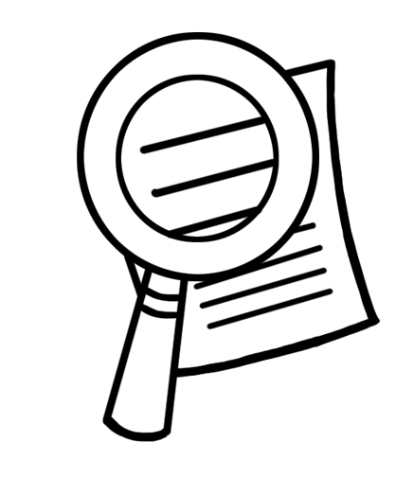

In this lesson, participants discuss the importance of each part of a lesson plan and how it connects to memory systems. They also create a lesson.

**Learning Outcomes**



At the end of this session participants will be able to:

1. Explain the parts of a lesson
2. Explain the importance of each part of a lesson
3. Explain how the design of a lesson connects to the memory system.
4. Create a lesson

**Materials**



* Flip chart paper
* Markers
* Tape
* Large Diagram of the ADDIE model – introduced in the lesson on instructional design
* Theme music and speakers
* CEWT Hats
* Trainer Essential Package – 1 per participant

Participants will be using the following Trainer Essentials:

* + Lesson Plan
  + Memory and Learning
* Activity Reference Guide – 1 per participants (see participant materials)
* Activity Guide – 1 per participant (see participant materials)
* Optional: Participants’ Nametags created using the template in the workshop introduction

**Preparation**



* Read and prepare lesson plan
* Remind participants to bring their Trainer Essential Package.
* Write learning outcomes on flip chart paper

**Introduction 5 minutes**



1. Ask the participants: “If you are going to a place where you have never been before, what do you do?” *Ask for directions, use a map, etc.*
2. Ask participants “what do lesson plans and directions have in common? “

* *A lesson plan gives the trainer a clear direction of where they are going and how to stay on track.*
* *It allows the trainer to clearly let the participants know where they are going (the destination) and then takes them there in an organized way.*
* *It can help redirect you when you get lost.*
* *It allows you to track the path and to use it again or to change it for next time.*

1. Explain to participants that the lesson plan is like a map, and the destination is the learning outcomes.
2. Present the lesson description or learning outcomes.

**Parts of a Lesson Plan 20 minutes**



1. Ask the participants to list the parts of a lesson plan: Learning Outcomes, Introduction, Topics, Review, Materials, Preparation
2. Explain to participants that they will be using a lesson plan template to help them create lessons plans for the workshop they are creating.
3. Ask participants to flip to the Lesson Plan Trainer Essential in their Trainer Essential Package.
4. Provide a few minutes for participants to read through the document.
5. Write the following question on flip chart paper:

* Why is each part of a lesson plan important?

1. Tell participants you will be dividing them into small groups. Each group will examine one part of a lesson plan and respond to the posted question.
2. Divide the participants into small groups or pairs and assign them each 1-2 part(s) of a lesson plan. Consider using the symbols on their name tags to divide them into groups.
3. Ask the participants to answer the question on flip chart paper, in their notebooks or on a piece of paper. They will have 5 minutes to discuss, before presenting the information to the large group
4. Ask the participants to share their responses for each part of a lesson plan.
5. Ask the participants to return to their small groups. Ask the participants to discuss:

How do the Introduction, Activities, and Review in a lesson contribute to learner memory?

Note: Participants should refer back to the Memory and Learning Trainer Essential to help guide their discussion. They should also consider the Four Things Learners Need in their answers. Give them 5 minutes to discuss.

1. Discuss the responses as a large group.

* *The lesson* ***introduction*** *captures participants’ attention, which helps them move the information from the sensory memory to the working memory.*
* *The practice that they do in the* ***activities*** *in the lesson moves information from the working to the long-term memory.*
* *The* ***review*** *at the end of the lesson allows them to practice retrieving the information from the long-term memory. The more they reuse the information the better the learner will remember the information.*

**Writing Lesson Plans 1.5 hours – multiple days**



1. Tell the participants that they will be working in pairs to write lesson plans for the workshop they are developing.
2. Assign each pair a lesson topic or allow them to choose topics which they feel confident working on.
3. Explain to participants that during the creation of the lesson, they should incorporate the concepts they have learned in this workshop and in the previous workshop: Delivering Effective WASH Training. Encourage them to use the Activity Guide & Activity Reference Guide introduced in the previous lesson.
4. Discuss the lessons in a full group, and ask participants to incorporate the comments they receive from the group. Continue this activity until a draft of each lesson plan in the workshop has been completed.

**Review 5 minutes**



1. Turn on the theme music for the workshop and ask participants to put on their “CEWT Hat”.
2. **Ask participants “What stage within the ADDIE model were we working on?” *Develop.*
3. In their CEWT Workbooks, in the Develop section, under the title: “Building a Lesson” ask participants to respond to the following question:

* Why is each part of a lesson important?

**Reflections on Lesson**