**Contents**

1 Introduction 2

2 What is Fecal Sludge Management? 3

2.1 Emptying and Transport 4

2.2 Treatment 4

2.3 Use or Disposal 4

2.4 Risk Management 5

3 The Importance of Fecal Sludge Management 6

4 The Global Need for Fecal Sludge Management 9

5 Implementation Challenges 10

6 International Guidelines, National Law and Policy 11

7 The Knowledge Gap 13

8 Definitions 14

9 Additional Resources 15

10 References 16

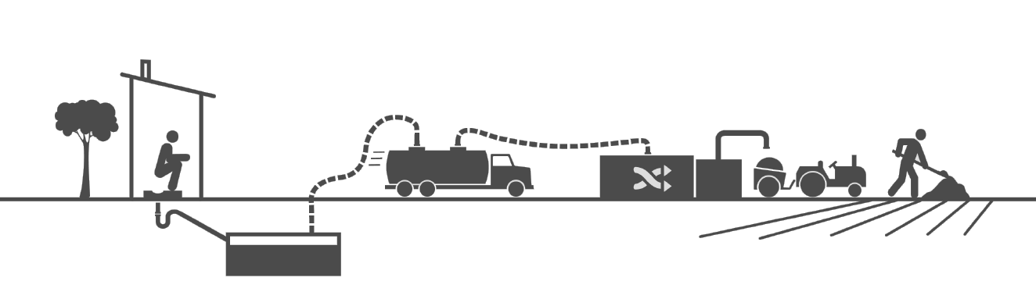

(Credit: The Bill & Melinda Gates Foundation)

# Introduction

This Technical Brief introduces the importance and global need for fecal sludge management to realize public health, environmental, social, and economic benefits.

Great efforts are being made globally to reduce open defecation by building on-site sanitation technologies, like pit latrines and septic tanks. Yet, emptying full on-site sanitation technologies and safely managing the fecal sludge is an essential service that is often neglected. Households and institutions are lacking the knowledge, skills and services to manage the fecal sludge once the technology is full.

2.7 billion people around the world use on-site sanitation technologies that need fecal sludge management services (Strande, Ronteltap & Brdjanovic, 2014). Ideally, on-site sanitation technologies should be emptied in a safe and hygienic manner by well-equipped and protected workers who transport the sludge for treatment, use or disposal. However, in reality, most technologies are either abandoned or emptied using unsafe and unhygienic methods. Sludge is simply dumped by the home, in the street, or in nearby water sources.

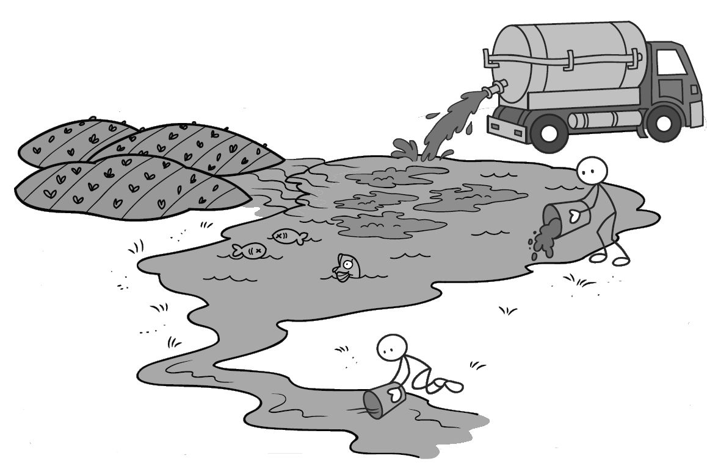

Illegally dumping fecal sludge into a local water source

CAWST focuses on the planning, design, and implementation of on-site sanitation projects for low-income communities not connected to a sewer. For such communities, household or decentralized sanitation offers a hygienic and affordable solution.

CAWST’s free, open content resources and schedule of international training workshops can be found at: https://resources.cawst.org and www.cawst.org/services/training.

# What is Fecal Sludge Management?

A sanitation system deals with human excreta from the time it is generated until it is used or disposed of safely. Fecal sludge management includes emptying, transportation, treatment, and use or disposal of fecal sludge from an on-site sanitation technology (like a pit latrine or septic tank). It addresses the last three components of a sanitation system.

**Sanitation System**

User Interface

Excreta

Storage

**Emptying and Transport**

**Treatment**

**Use or Disposal**

Fecal Sludge Management

Fecal sludge management is a relatively new term and field that is gaining rapid acknowledgement in the sanitation sector. The following definitions help explain the scope of fecal sludge management:

* **Fecal sludge** (also called sludge) is excreta from an on-site sanitation technology (like a pit latrine or septic tank) that may also contain used water, anal cleansing materials, and solid waste. Fecal sludge should not to be confused with wastewater that has been transported through a sewered system.
* **Excreta** is urine and feces that are not mixed with any flush water.
* An **on-site sanitation technology** is made up of the parts included in the first two components of a sanitation system: user interface and excreta storage. Excreta is collected and stored where it is produced (for example, a pit latrine, septic tank, aqua privy, and non-sewered public toilets). Often, the fecal sludge has to be transported off-site for treatment, use or disposal.



Simple pit latrine

## Emptying and Transport

Akvo

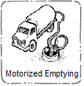

Mechanized Emptying

On-site sanitation technologies will fill up sooner or later. There are two types methods to collect fecal sludge from on-site sanitation technologies and transport it for treatment or safe disposal:

1. Manual emptying (using a bucket or hand pump)
2. Mechanized emptying (using a motorized pump or vacuum truck)

Once emptied, the fecal sludge must be safely transported to a treatment or disposal location. Again, there are various manual and mechanized vehicles ranging from pushcarts to pickup trucks to vacuum trucks.

Emptying and transporting fecal sludge is an essential service that is often neglected in sanitation projects. Ideally, on-site sanitation technologies should be emptied in a safe and hygienic manner by well-equipped and protected workers who transport the sludge to a treatment, use or disposal site. However, in reality, many on-site technologies are either abandoned or emptied using unsafe and unhygienic methods. Fecal sludge is simply dumped by the home, in the street, or in nearby water sources.

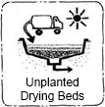

Akvo

Unplanted Drying Bed

## Treatment

The type and level of treatment depends on the final goal for the fecal sludge (how it is to be used or disposed of). There are four different treatment objectives for fecal sludge: (1) pathogen inactivation, (2) stabilization, (3) dewatering, and (4) nutrient management. Each treatment objective has associated environmental, health, and logistics impacts.

Treatment technologies available for fecal sludge are in different stages of development:

* **Established**: There is experience in designing and operating the technologies for fecal sludge. For example, drying beds, settling-thickening, and co-composting.
* **Transferring**: Technologies are being adapted from wastewater treatment or another sector. For example, mechanical dewatering, anaerobic digestion, incineration, and thermal drying.
* **Innovative**: Technologies are being researched, developed and piloted. For example, alkaline and ammonia treatment, vermicomposting, and black soldier flies for animal protein.

## Use or Disposal

The following are some options for using or disposing of urine and feces in ways that are the least harmful to people and the environment:

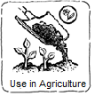

Akvo

Use in Agriculture

* Use urine as a fertilizer
* Use treated fecal sludge and source-separated urine as a soil amendment in home gardens and agriculture to provide nutrients for plant growth and improve the physical qualities of soil
* Use treated fecal sludge as a soil amendment in: forestry, sod and turf growing, flower growing, landscaping, parks, golf courses, mine reclamation, landfill cover, or erosion control
* Use fecal sludge and source-separated urine as a source of nutrients and water for growing aquatic plants and fish (also known as aquaculture)
* Use fecal sludge as a source of protein for animal feed (for example, black soldier fly larvae)
* Use fecal sludge as a source of energy (for example, biogas and solid fuel)
* Dispose of fecal sludge by burying in a pit, trench or landfill
* Dispose of source-separated urine into the ground using a soak pit or infiltration trench

## Risk Management

Fecal sludge management aims to reduce the risk of pathogen transmission and environmental contamination through using protective measures. These are actions, often called barriers or the multi-barrier approach, to prevent or eliminate a sanitation-related risk, or reduce it to an acceptable level (WHO, 2016).

Restricting access to a sludge treatment or disposal site

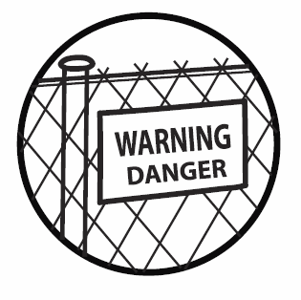

**WARNING**

**DANGER**

The more protective measures that are used, the lower the risk of pathogen transmission and environmental contamination. Fecal sludge management often focuses on treatment as a protective measure to reduce health risks. Yet, it is difficult to check the quality of treated sludge to ensure that it is safe and pathogen-free. There is always an environmental and health risk. It is therefore important that other health and safety measures are put in place, even when the sludge has been treated.

**Table: Examples of Protective Measures in Fecal Sludge Management**

|  |  |  |
| --- | --- | --- |
| **Type of Protective Measure** | | **Examples of Protective Measure** |
| Treatment | | * Inactivate pathogens in fecal sludge (for example, co-composting) |
| Non-treatment | Technical | * Crop selection: Fecal sludge is applied to only certain crops (for example, non-edible crops) * Pause period: Wait a certain period of time before harvesting crops grown with fecal sludge * Restrict access: Place a barrier (like a fence) to stop people from approaching a fecal sludge management area |
| Behavioural | * Use personal protective equipment when handling fecal sludge (for example, boots, gloves, masks, and protective clothing) * Wash hands with soap after handling fecal sludge * Use good food hygiene when preparing foods grown with fecal sludge products |

Protective measures can be difficult to put in place. They will be more or less efficient depending on various factors, such as local habits and available resources. For example, it may be more efficient to focus on covering fecal sludge with soil rather than wearing shoes if farmers work barefoot or if shoes are not available or affordable.

Identify risks and vulnerable groups before identifying and prioritizing protective measures. Generally, people who work with fecal sludge directly (like latrine pit emptiers, compost plant operators, farmers who use fecal sludge as a fertilizer) have a higher risk of getting sick from fecal pathogens than the general public. The four groups of people exposed to risks include the following:

1. **Workers**: People who empty and transport sludge, work at a treatment site or dispose of the sludge
2. **Farmers**: People who use fecal sludge to fertilize their fields.
3. **Consumers**: People who eat food that has been grown using fecal sludge as a fertilizer.
4. **Local community**: People that live in a community near fecal sludge treatment technologies.

(WHO, 2016)

# The Importance of Fecal Sludge Management

Failing to properly manage fecal sludge is directly responsible for adverse effects on public health and the environment worldwide. It is not just enough to build a latrine to ensure good sanitation and protect public health. Without fecal sludge management services, untreated sludge enters the environment and contaminates drinking water sources. This is often the case when latrines are left to overflow or fecal sludge is illegally dumped into the environment.

Excreta is a major source of pathogens – microorganisms such as bacteria, viruses, protozoa and helminths that cause disease. Pathogens in untreated excreta can survive a long time in the environment. They can transmit diseases to people and animals through direct contact and contaminated soil, food, and water.

Diarrhea is one of the leading diseases that cause death and illness. Globally, about 361,000 children die every year from diarrheal diseases linked to poor WASH (Prüss-Ustün et al., 2014). That’s about 1,000 children under five every day. For every child that dies from diarrhea, countless others suffer from poor health and lost educational opportunities leading to poverty in adulthood.

In addition to health and environmental benefits, the economic benefits of improved sanitation are also persuasive. Improved sanitation in developing countries typically yields about US$5.50 worth of benefits for every dollar spent (Hutton, 2005).

The benefits of improved sanitation also extend beyond better health and economics. No one wants to live, work or go to school in dirty, smelly, and unsanitary conditions. Improved sanitation also contributes to the general well-being of a population.

The Joint Monitoring Programme (JMP) for water supply and sanitation measures the progress towards achieving the Sanitation Development Goal (SDG) target of ensuring availability and sustainable management of water and sanitation for all by 2030 (Goal 6). The goal includes the whole sanitation system. This is a move from the Millennium Development Goals (MDGs) that focused on access to improved sanitation. The term fecal sludge management is not directly used in the SDG Goal 6, but it is covered by “safely managed sanitation services”. This is defined as excreta that is safely disposed in situ or transported and treated off-site.



**Poor Fecal Sludge Management = Open Defecation?**

Imagine a town of 5,000 people using pit latrines. Full pits are emptied manually. The untreated sludge is dumped into the nearby river. Is this any different from open defecation?

An overflowing latrine impacts the home and community

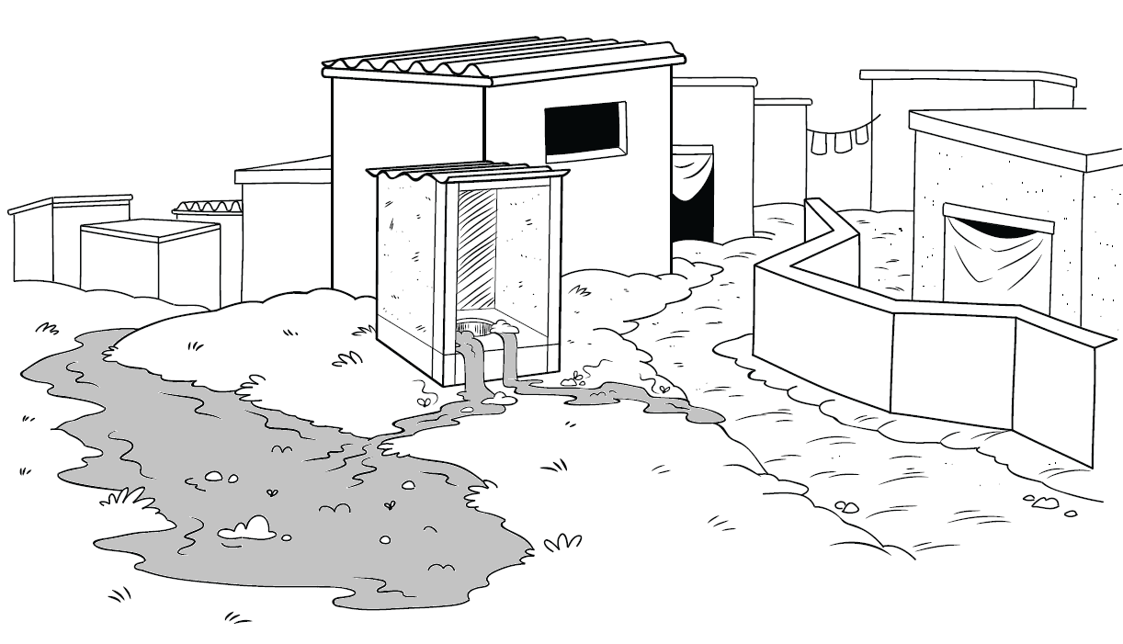

**Toilet to sewer**

**On-site sanitation**

**Open defecation**

**Leakage**

**Not effectively treated**

**Effectively treated**

**Safely emptied**

**Illegally dumped**

**Unsafely emptied**

**Left to overflow or abandoned**

**Residential environment**

**Drainage system**

**Receiving waters**

**Case Study: Fecal Sludge Management in Dhaka, Bangladesh**

Dhaka has made a lot of efforts to reduce open defecation. As a result, only 1% of the population still defecates in the open. 79% of people use on-site sanitation technologies and 20% are connected to a sewer.

However, all of the fecal sludge from on-site sanitation technologies is disposed of untreated into the environment. It is either dumped around people’s homes, into drainage systems, or into water sources.

* 87.3% of on-site sanitation technologies are left to overflow or abandoned.
* 11.4% of on-site sanitation technologies are unsafely emptied.
* 1.3 % of on-site sanitation technologies are safely emptied, but the fecal sludge is illegally dumped .

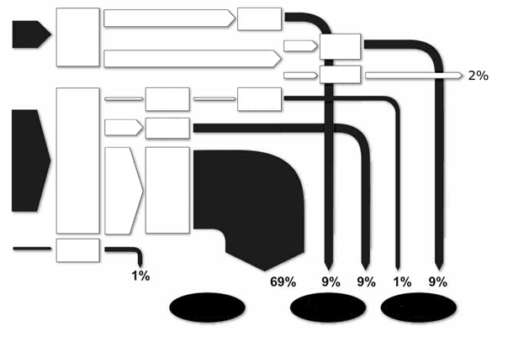

(Blackett, Hawkins & Heymans, 2014)

(Credit: WSP, 2014)

# C:\Users\Schuelert\Desktop\Laura\CAWST\Education Program Development\Illustrations\South Asia\Posters\South Asia Poster 12.tifThe Global Need for Fecal Sludge Management

2.7 billion people around the world use on-site sanitation technologies that need fecal sludge management services (Strande et al., 2014). The greatest numbers are in Eastern Asia with 1.1 billion people, Southern Asia with 593 million people, and Sub-Saharan Africa with 439 million. These are households and communities using latrines without access to or unable to afford fecal sludge management services.

If present sanitation trends continue, the number of people needing fecal sludge management services will rise to 5 billion people by 2030 (Strande et al., 2014). This number could increase even faster as water scarcity becomes more severe. Sewered systems use a lot of water to flush wastewater to a treatment facility. As water becomes less available, it will become more challenging to flush everything away through sewers. Households will have to use on-site sanitation technologies instead of being linked to a sewered system.

For years, on-site sanitation has been considered as a temporary solution until a sewered system is constructed (Strande, Ronteltap & Brdjanovic, 2014). In a sewered system, excreta and flush water from toilets, as well as other used water from laundry, kitchens and bathing, is transported from the home by a direct connection to a system of pipes (sewers) buried deep underground. Ideally, the wastewater is sent to a treatment facility. Well-constructed and maintained sewered systems with wastewater treatment facilities can provide effective and efficient services.

Sewered systems have been constructed in many parts of the world, particularly in high-income countries. However, for many low- and middle-income communities, particularly in developing countries, installing a sewered system is not a feasible option due to the complexity, high cost, and need for a piped water supply. For such communities, on-site sanitation offers a hygienic and affordable solution (Franceys, Pickford & Reed, 1992).

Sanitation planners have come to realize that sewered systems are an inappropriate technology to manage excreta in many parts of low- and middle-income countries. This has led to a shift in sanitation planning. Implementers are now accepting on-site sanitation as an appropriate, sustainable, and affordable solution as long as fecal sludge emptying, transport, treatment and disposal or use services are available and managed correctly (Strande et al., 2014).

On-site sanitation is often considered as a solution in only rural areas. However, on-site sanitation is also very common in urban areas. In fact, one billion people using on-site sanitation live in urban areas (Strande et al., 2014). The wealthy neighbourhoods are often the only parts of a city linked to a sewered system. Governments are often unwilling to invest funds to install a sewered system in lower-income neighbourhoods. This can be for various reasons such as land ownership, affordability and instability. Households in these lower-income neighbourhoods usually have to build their own on-site technology, like a pit latrine or septic tank. When their latrines fill up, they have to manually empty them or pay for an informal emptying service. Although some neighborhoods have informal services for emptying and transportation, services for treating sludge rarely exist.

**Table: Why Are Sewered Systems Not Always Appropriate to Manage Excreta?**

|  |  |
| --- | --- |
| **Advantages** | **Limitations** |
| * Convenient for households: the excreta is almost immediately removed from their property and is no longer theirs to manage. * Easy to control and test: all the excreta is centralized. * Well-constructed and maintained sewered systems with wastewater treatment facilities can reduce environmental contamination and protect public health | * Resource intensive: a large amount of water is needed year-round * High technical skills required * High capital cost * High operation and maintenance costs * If not functioning correctly, can cause significant environmental contamination and public health risk |

# Implementation Challenges

Fecal sludge management is an urgent issue in many parts of the world. Unfortunately, it is not that simple and implementers have many challenges. These result from the complexity of the process. There are various stakeholders to involve including the household users, informal and formal private sector, government, nongovernmental organizations (NGOs) and community-based organizations (CBOs). Some of the key challenges include:

* **Accessibility:** On-site sanitation technologies are not always accessible to emptying services. They can also be located too far from a service provider. It is not worth the cost of transportation or the service provider’s time. The roads can also be too narrow and poorly constructed for emptying vehicles. Furthermore, people constructing on-site sanitation technologies often do not take into account the emptying component. It can be difficult to have direct access to the latrine pit or septic tank.
* **Affordability:** Many households cannot afford emptying services. They rely on informal private services to manually empty their on-site sanitation technology. Many manual transport services also cannot afford to take sludge to a treatment site that is located far away. Instead, they choose to dump the untreated sludge close to the on-site sanitation technology and directly into the environment.
* **Investment:** There is a lack of fecal sludge management services because there is a need for investment in construction, operation, and maintenance. Many fecal sludge technologies stop functioning because there is little to no funding available for long-term operation and maintenance.
* **Policy:** Policy makers still focus on sewered systems rather than on-site sanitation, which is often considered a temporary solution. Therefore, not many countries have a policy on fecal sludge management. As a result, fecal sludge management is often unplanned, unreliable, and operated by informal private services.
* **Legal Frameworks:** Laws on fecal sludge management are non-existent or weak. This leads to illegal dumping of untreated sludge into the environment. In countries where there are laws, there have been challenges with enforcing them (Johansson & Kvarnstrom, 2005).
* **Knowledge and Skills:** Compared to wastewater management, fecal sludge management has only recently gained acknowledgement. There is less research and lessons learned in this field. As well, there are few examples of success. There is a gap in knowledge on how to ensure fecal sludge is safe to dispose of or use (Strande et al., 2014).

# International Guidelines, National Law and Policy

Over 66% of countries have recognized the human right to sanitation in their constitution or legislation (GLAAS, 2014). Recognizing the human right to sanitation is a good start towards improving access to sanitation. Governments are held accountable by international human rights law. However, to sustain sanitation, governments must also develop national legislation and supporting policy. They must also ensure implementation and enforcement of these laws and policies. This has proved to be a difficult task globally.

One of the reasons for this struggle is because the sanitation system is included in different pieces of legislation. Components of the sanitation system are often spread across environmental protection, public health, construction, and agriculture legislation. This leads to gaps and overlaps in the legislation (Johansson & Kvarnstrom, 2005).

Once the national sanitation laws and policies are established, they need to translate into local action. A government is usually made of different levels. Many governments, for example, are composed of a national, regional and local level government. Legislation and policy must state clearly the roles of the different levels of government, which is not often the case (Johansson & Kvarnstrom, 2005). The lack of delegation, capacity and resources weakens the implementation of legislation and policy.

Questions that need to be clearly answered by national governments include:

* Who takes the lead?
* Who regulates?
* Who monitors?
* Who enforces?

**Case Study: Ugandan Law and Policy on Sanitation**

* The Constitution of Uganda (1995) states that it is a fundamental right for every Ugandan citizen to have access to a clean and healthy environment.
* Local Government Act (1997) defines the roles of local councils in providing and promoting sanitation and hygiene services at community and household levels.
* The Public Health Act (1935) states that every citizen is obliged to have suitable access to an excreta disposal facility in his or her home and at work places.
* National Health Sector Policy (2009 Draft) states that sanitation is one of the major determinants of health in Uganda.
* Environmental Health Policy states that sanitation systems are to be designed as to reduce the environmental impact of unmanaged human waste disposal.
* The Water Statue (1995) is the fundamental code for the use, protection and management of water resources and water supply; and for the constitution of water and sewerage authorities for the various towns and cities.
* The Waste Discharge Regulations (1998) defines standards for water discharged into water or onto land.

(Johansson & Kvarnstrom, 2005)

The World Health Organization (WHO) released the Guidelines for Safe Use of Wastewater, Excreta and Greywater in 2006. They provide a comprehensive framework for managing health risks associated with using human waste in agriculture and aquaculture. The Guidelines were designed to assist in developing national and international approaches (like policies and legislation). They also provide a framework for national and local decision making to identify and manage health risk. Crucially, the Guidelines recognize that changes in sanitation policy and investment in improvements, be they capital works, operations or behavioural measures, involve multiple actors and take time (WHO, 2016).

The Sanitation Safety Planning Manual was released by the WHO in 2016 to provide practical step-by-step guidance to assist in the implementation of the 2006 Guidelines. The Manual assists users to implement the Guidelines by providing a structure to bring together actors from different sectors to identify health risks in a sanitation system and agree on improvements and regular monitoring. The concepts of coordination and incremental improvement over time are central to the sanitation safety planning approach (WHO, 2016).

# The Knowledge Gap

Fecal sludge management has only recently received the attention it deserves. In terms of experience and research, fecal sludge management is at least a hundred years behind wastewater management (Strande et al., 2014). There is an increasing amount of research conducted on this topic, but it is important to recognize the knowledge gap and limited experience. The gap includes:

* **The science behind fecal sludge management**: There are still a lot of unknowns such as fecal sludge characteristics and its variability. There is still no standardized methodology, for example, to characterize and quantify fecal sludge. This limits knowledge particularly on treatment and use of fecal sludge. This lack of understanding has led many engineers to manage fecal sludge like wastewater, leading to major technical failures.
* **Viable implementation models**: There are few examples of successful implementation of fecal sludge management across the sanitation sector (civil society, government, private sector). There is still a lot of debate on how to properly manage the whole sanitation system, and which stakeholders are most appropriate for the different roles.
* **Knowledge and skills of stakeholders**: Many stakeholders including civil society, government and the private sector do not have the knowledge and skills to implement strong fecal sludge management systems.
* **Enforced policy and legal framework**: Many countries are lacking a policy and legal framework on fecal sludge management. Policy and laws are often based on developed countries and hence focus on sewered systems. Fecal sludge management is therefore often unplanned, unreliable, and operated by informal private services. This leads to illegal dumping of untreated faecal sludge into the environment and increases health risk. Even in places where there is a legal framework, enforcement is weak.

However, the knowledge gap is starting to close. Here are some of the key groups and meetings leading the fecal sludge management sector:

* **The Department of Water and Sanitation in Developing Countries (Sandec) at the Swiss Federal Institute of Aquatic Science and Technology (Eawag):** Sandec’s research on excreta and wastewater management focuses on three main challenges: (1) optimization of treatment technologies, (2) innovation in resource recovery, and (3) methods for sustainable systems level implementation. Available at: [www.sandec.ch](http://www.sandec.ch/)
* **University of Kwazulu-Natal:** The Pollution Research Group established in 1973 works on various projects relating to pit latrines, diversion toilets and generally closing the loop. Available at: <http://prg.ukzn.ac.za/>
* **SuSanA:** The Sustainable Sanitation Alliance is an open international alliance with members who share a common vision on sustainable sanitation. They are dedicated to understanding viable and sustainable sanitation solutions. Available at: www.susana.org/en/
* **Fecal Sludge Management Conference:** Gathers specialists and implementers of fecal sludge management to share experiences and best practices. The conference aims to present practical innovative solutions that can be applied at scale in the world’s rapidly growing cities. Topics include: How to develop tools to assess the generation of fecal sludge, the pathways it takes from containment to disposal, and the constraints to establishing an effective chain of services to manage it. There have been three conferences so far since the first one in 2011. Available at: www.fsm3.org/

# Definitions

**Disposal:** The return of waste to the environment, ideally in a way that is least harmful to public health and the environment.

**Excreta:** Urine and feces not mixed with any flush water.

**Fecal sludge:** Also called sludge. Excreta from an on-site sanitation technology (like a pit latrine or septic tank) that may also contain used water, anal cleansing materials, and solid waste.

**Fecal sludge management:** Includes the emptying, transport, treatment, and safe use or disposal of fecal sludge from an on-site sanitation technology (like a pit latrine or septic tank). Some people also include storage in the definition of fecal sludge management.

**Guidelines:** International recommendations to help governments set national standards or determine a course of action. Guidelines are not mandatory.

**Legislation:** A group of laws or the action of making laws.

**Non-sewered system:** Also called on-plot or on-site sanitation. A sanitation system in which excreta and used water are collected and stored on the location where it is produced. Often, the fecal sludge has to be transported off-site for treatment, use or disposal.

**Nutrient:** Any substance that is used for growth. Nitrogen (N), phosphorus (P), and potassium (K) are the main nutrients in agricultural fertilizers.

**On-site sanitation:** Also called on-plot sanitation or non-sewered system. A sanitation system in which excreta and used water are collected and stored or treated on the location where it is generated. Often, the fecal sludge has to be transported off-site for treatment, use or disposal.

**On-site sanitation technology:** Also known as a latrine. An on-site sanitation technology is made up of the parts included in the first two components of a sanitation system: user interface and excreta storage. Excreta is collected and stored where it is produced (for example, a pit latrine, septic tank, aqua privy, and non-sewered public toilets). Often, the fecal sludge has to be transported off-site for treatment, use or disposal.

**Pathogen:** An organism that causes disease.

**Policy:** A government plan to guide and determine future decisions.

**Sanitation:** The safe management of human excreta. The main objective is to protect and promote public health by providing a clean environment and breaking the cycle of disease.

**Sanitation system:** Also called a sanitation chain or sanitation service chain. A collection of technologies and services that deals with human excreta from the time it is generated until it is used or disposed of safely. A sanitation system includes five components: (1) user interface, (2) excreta storage, (3) emptying and transporting fecal sludge, (4) fecal sludge treatment, and (5) fecal sludge use or disposal. A sanitation system also includes the management, operation and maintenance required to ensure that the system functions safely and sustainably. The components or functions within the sanitation system may be named differently depending on the local context or organization.

**Sewered system:** Also called a sewer system, sewerage system, sewers, connected sanitation, and networked sanitation. A sanitation system that transports wastewater through a pipe network (like a simplified sewer, solids free sewer or conventional sewer) to another location for treatment, use or discharge. This includes centralized systems and decentralized wastewater treatment systems.

**Soil amendment:** Anything mixed into soil to improve soil quality and support healthy plant growth. Fertilizers and soil conditioners are two types of soil amendments. Fertilizers add nutrients to the soil that plants need to grow. Soil conditioners improve the physical soil structure.

**Use:** The use of waste as a beneficial resource. For example, using treated fecal sludge as a soil conditioner in agriculture.

**Wastewater:** Used water from any combination of domestic, industrial, commercial or agricultural activities, surface runoff (stormwater), and any sewer inflow (infiltration). Wastewater can be managed on-site or off-site. Wastewater managed off-site is often called sewage.

# Additional Resources

**CAWST Sanitation Resources.** Available at: <https://resources.cawst.org>

* CAWST’s education and training resources are available on a variety of sanitation topics including environmental sanitation; latrine design, siting and construction; fecal sludge management; and sanitation project implementation.

**Faecal Sludge Management: Systems Approach for Implementation and Operation.** Strande, L., Ronteltap, M. & Brdjanovic, D. (2014). London, UK: IWA Publishing. Available at: www.sandec.ch/fsm_book

* This is the first book dedicated to faecal sludge management. It summarizes the most recent research in this rapidly evolving field, and focuses on technology, management and planning. It addresses faecal sludge collection and transport, treatment, and the final end use. The book also goes into detail on operational, institutional and financial aspects, and gives guidance on integrated planning involving all stakeholders. It is freely available online in English and Spanish, and is coming out in French in 2017.

**Compendium of Sanitation Systems and Technologies.** Tilley, E., Ulrich, L., Lüthi, C., Reymond, P. and Zurbrügg, C. (2014). 2nd Revised Edition. Eawag: Swiss Federal Institute of Aquatic Science and Technology, Dübendorf, Switzerland. Available at: [www.eawag.ch/forschung/sandec/publikationen/compendium_e](http://www.eawag.ch/forschung/sandec/publikationen/compendium_e/index_EN)

* The Compendium presents the concept of sanitation systems together with detailed information about sanitation technologies for each component of sanitation systems. The document targets engineers, planners and other professionals who are familiar with sanitation technologies and processes. However, it is also a useful document for non-experts to learn about the main advantages and limitations of different technologies and the appropriateness of different systems.
* The e-Compendium, is an online, interactive version of the Compendium, complete with a tool for combining technologies into a complete sanitation system. Available at: <http://ecompendium.sswm.info>

**Sanitation Safety Planning: Manual for Safe Use and Disposal of Wastewater, Greywater and Excreta.** World Health Organization (2016). Available at: <http://apps.who.int/iris/bitstream/10665/171753/1/9789241549240_eng.pdf?ua=1>

* This Manual provides practical step-by-step guidance to assist in the implementation of the 2006 WHO Guidelines for Safe Use of Wastewater, Excreta and Greywater. Sanitation Safety Planning is a risk based management tool for sanitation systems. It provides a structure to bring together actors from different sectors to identify health risks in a sanitation system and agree on improvements and regular monitoring.

**Sustainable Sanitation Alliance (SuSanA).** Available at: [www.susana.org](http://www.susana.org)

* SuSanA is an open international network of members who share a common vision on sustainable sanitation. SuSanA works as a coordination platform, working platform, sounding board, contributor to the policy dialogue on sustainable sanitation, and as a catalyst. The SuSanA website provides extensive resources including publications, case studies, photos and videos and a discussion forum targeted at practitioners, educators and researchers.

# References

Blackett, I., Hawkins, P. & C. Heymans (2014). *The missing link in sanitation service delivery: A review of fecal sludge management in 12 cities*. Washington, DC: Water and Sanitation Program, International Bank for Reconstruction and Development/The World Bank. Retrieved from https://www.wsp.org/sites/wsp.org/files/publications/WSP-Fecal-Sludge-12-City-Review-Research-Brief.pdf

Franceys, R., Pickford, J. & Reed, R. (1992). *A guide to the development of on-site sanitation.* Geneva, Switzerland: World Health Organization. Retrieved from http://whqlibdoc.who.int/publications/1992/9241544430_eng.pdf

GLAAS. (2014). *Investing in water and sanitation: increasing access, reducing inequalities. UN-Water global analysis and assessment of sanitation and drinking-water*. Geneva, Switzerland: World Health Organization. Retrieved from http://apps.who.int/iris/bitstream/10665/139735/1/9789241508087_eng.pdf

Johansson, M. & Kvarnstrom, E. (2005). *A review of sanitation regulatory frameworks* EcoSanRes Publications No. 2005-1, p. 60. Sweden: Stockholm Environment Institute. Retrieved from www.ecosanres.org/pdf_files/ESR_publications_2005/ESR_2005-1.pdf

Prüss-Ustün, A., Bartram, J., Clasen, T., Colford, J. M., Cumming, O., Curtis, V., … Cairncross, S. (2014). Burden of disease from inadequate water, sanitation and hygiene in low- and middle-income settings: A retrospective analysis of data from 145 countries. *Tropical Medicine & International Health*, *19*(8), 894–905. Retrieved from http://doi.org/10.1111/tmi.12329

Strande, L., Ronteltap, M. & Brdjanovic, D. (Eds.) (2014). *Faecal sludge management: Systems approach for implementation and operation*. London, UK: IWA Publishing. Retrieved from www.sandec.ch/fsm_book

WHO (2015). *Sanitation safety planning: Manual for safe use and disposal of wastewater, greywater and excreta*. Geneva, Switzerland: World Health Organization. Retrieved from <http://apps.who.int/iris/bitstream/10665/171753/1/9789241549240_eng.pdf?ua=1>

Akvo images can be retrieved from <http://akvopedia.org/wiki/Main_Page>

CAWST (Centre for Affordable Water and Sanitation Technology)

Calgary, Canada

Website: [www.cawst.org](http://www.cawst.org) Email: support@cawst.org

*Wellness through Water.... Empowering People Globally*

Last Update: July 2016

This document is open content. You are free to:

* Share – Copy and redistribute the material in any medium or format
* Adapt – Remix, transform, and build upon the material for any purpose, even commercially



Under the following terms:

* Attribution – You must give appropriate credit to CAWST, provide a link to the license, and indicate if changes were made. You may do so in any reasonable manner, but not in any way that suggests that CAWST endorses you or your use. Please include our website: www.cawst.org

CAWST and its directors, employees, contractors, and volunteers do not assume any responsibility for, and make no warranty with respect to, the results that may be obtained from the use of the information provided.