Rainfresh P2S Siphon Water Filter
Source Protection | Safe Transportation | Sedimentation | Filtration | Disinfection | Safe Storage

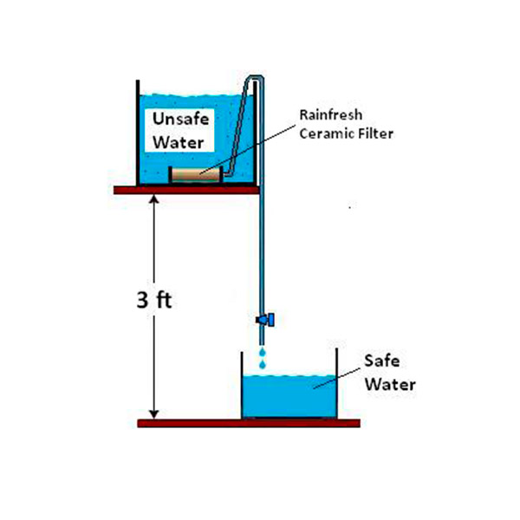
What is it?
The Rainfresh P2S Siphon Water Filter is produced by the Canadian company Envirogard Products Ltd and was designed specifically for use in emergencies. The filter consists of a silver-impregnated ceramic cartridge with attached tubing. It comes with two water containers, a scrub pad, and a filter gauge.

Performance

Microbiological Effectiveness:
Parameter | Effectiveness
Bacteria | Very Effective (>99%)
Viruses | No independent tests
Cryptosporidium (Protozoa) | Very Effective (>99%)
Giardia (Protozoa) | Very Effective (>99%)
Helminths | Very Effective*
*Assumption based on pathogen size

Other Parameters
High removal of turbidity.

Source Water Requirements
Turbid water (>50 NTU) should be settled or strained before filtering. Very turbid water may cause the filter to clog and require more frequent maintenance.

Capacity
Treats 25 L per batch. Flow rate is up to 1.2 L/hour.

Lifespan
Lasts 6–12 months or up to 3,800 L, according to the manufacturer. Actual lifespan may vary depending on use, source water, and maintenance.

Ease of Use & Acceptability

Operation & Maintenance
User places the filter element in a raised container of untreated water, applies suction to start a siphon in the tube, and lets treated water flow through the tube into a safe storage container. The safe storage container should be 1 m below the source water container. When the flow rate slows, the filter can be cleaned with the scrub pad provided.

Repair & Replacement
The ceramic cartridges are fragile and must be replaced if there are cracks or leaks, or when repeated cleaning makes them thinner than the gauge provided (likely every 6–12 months).

User Considerations & Preferences
The filter should be kept out of sunlight to avoid degradation of plastic parts.

Feasibility

Availability
Produced and sold by Envirogard Products Ltd. The cartridges cannot be produced locally but can be shipped internationally.

Cost
Not available.

Size &Weight
2.95 kg including the two water containers.

More Information
Details and references: www.hwts.info/products-technologies/660290f6/rainfreshr-p2s-siphon-water-filter

