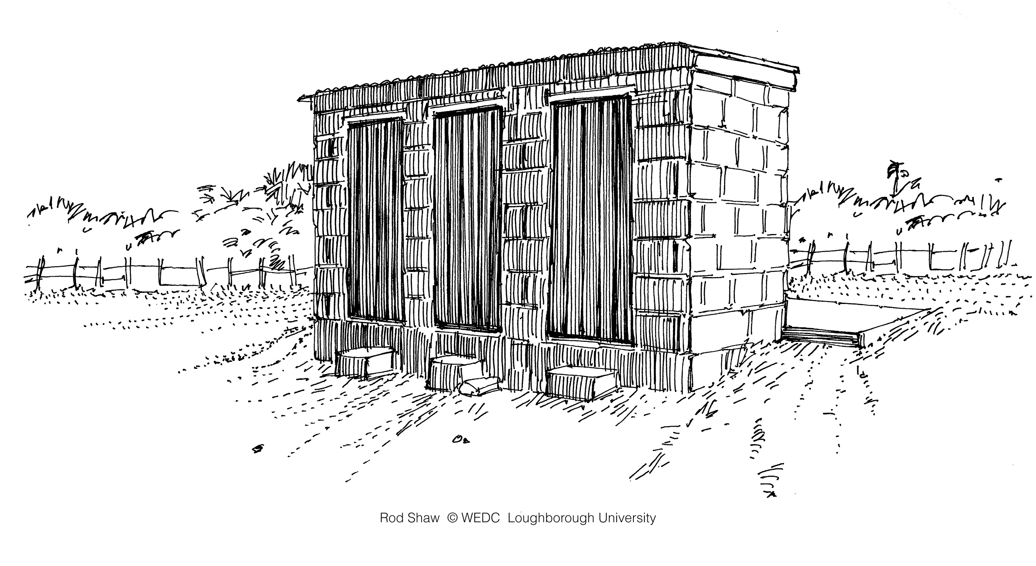**Environmental Sanitation Inspection Form: Public Facilities**

**Part 1. General information:**

Credit: Shaw

a. Location: .............................................................................................................

b. Village/Town: ......................................................................................................

c. People served: ....................................................................................................

d. Date of visit: ........................................................................................................

**Part 2. Risk assessment:** Please adapt this form for the local context. Remove questions that are not appropriate and add questions that are appropriate. Walk through the community to observe practices and ask community members questions. Be respectful of the community and local traditions. When necessary, seek permission from community leaders to do the inspection.

Circle ‘Yes’ if there is a potential risk and ‘No’ if there is no or very low risk. Add notes to the results and comments section on the next page. See explanation on the next page for details about each question.

|  |  |  |  |
| --- | --- | --- | --- |
|  | **Question** | **Observation** | |
| 1 | Do schools have enough latrines for every student (1 latrine for every 25 girls and female staff and 1 latrine for every 50 boys and male staff)? | Yes | No |
| 2 | Is there enough water (minimum of 5 litres per person per day) for hygiene at schools (e.g., handwashing, anal cleansing)? | Yes | No |
| 3 | Is there a lack of menstruation management options in schools with girls aged 11 or older? | Yes | No |
| 4 | Do public or community latrines close for a period of time each year? | Yes | No |
| 5 | Is there a lack of menstruation management options at public or community latrines? | Yes | No |
| 6 | Are public or community latrines poorly maintained or dirty? | Yes | No |
| 7 | Are there public or community latrines without handwashing facilities? | Yes | No |
| 8 | Are handwashing facilities at public or community latrines poorly maintained or dirty? | Yes | No |
| 9 | Are public or community latrines inaccessible to people with disabilities or other physical limitations (e.g., children, elderly, pregnant women)? | Yes | No |
| 10 | Are public or community latrines inaccessible to other vulnerable groups (e.g., stigmatized people)? | Yes | No |
| 11 | Do people need to wait more than 10 minutes to use a public latrine facility? | Yes | No |
| 12 | Are there poorly maintained community bathing facilities? | Yes | No |
| **Risk of contamination** (add the number of ‘Yes’ answers) | |  | |

**Part 3. Results and comments:**

a. Risk of contamination (check the appropriate box):

|  |  |  |  |
| --- | --- | --- | --- |
| 10-12 = Very high | 7-9 = High | 4-6 = Medium | 0-3 = Low |
|  |  |  |  |

b. The following risks were observed:

**Part 4. Name and signature of inspectors:**

**­­­­­­­­____________________________________________________________________________**

**Explanatory Notes: Public Facilities**

1. *Do schools have enough latrines for every student (1 latrine for every 25 girls and 1 latrine for every 50 boys)?* If schools do not have enough latrines, then students may practice open defecation, which is a health risk. Schools may have both latrines and urinals for students. This depends on the local context and number of students (WHO, 2009).
2. *Is there enough water for hygiene at schools (e.g., handwashing, anal cleansing)?* The WHO recommends 5 litres per person per day for all school children and staff. This is for drinking and handwashing. Latrines require: 10-20 litres per person per day for conventional flushing toilets, 1.5-3.0 litres per person per day for pour-flush toilets, and 1-2 litres per person per day for anal washing (WHO, 2009). Contamination spreads quickly without enough water for hygiene.
3. *Is there a lack of menstruation management options in schools with girls aged 11 or older?* Girls in schools need somewhere safe and private to change their sanitary products; clean water and soap for washing their hands, bodies, and reusable cloths; and facilities for safely disposing of used sanitary products or a clean place to dry them if reusable. School latrines should meet these criteria.
4. *Do public or community latrines close for a period of time each year?* Public or community latrines may close during the year because of management issues or because they are broken and unusable. If public or community latrines are not reliable places for defecation, people may practice open defecation.
5. *Is there a lack of menstruation management options at public or community latrines?* Women and girls need somewhere safe and private to change their sanitary products; clean water and soap for washing their hands, bodies, and reusable cloths; and facilities for safely disposing of used sanitary products. Public or community latrines should meet these criteria.
6. *Are public or community latrines poorly maintained or dirty?* Dirty latrines may have excreta on the slab or seat, garbage disposed of in the latrine, or have a hole cover that is dirty. Poorly maintained latrines may lack of a superstructure, superstructure is in poor condition, slab is in poor condition, or lack a hole cover. These latrines may not prevent contact between excreta, people and/or the environment. Therefore, they may not protect human and environmental health.
7. *Are there public or community latrines without handwashing facilities?* A handwashing facility has water and soap or ash in one place for proper handwashing. Different types of handwashing hardware include: a sink with piped water, tippy taps, buckets with taps, and a pitcher and a basin.
8. *Are handwashing facilities at public or community latrines poorly maintained or dirty?* A public handwashing facility may spread contamination, if it’s poorly maintained or dirty. Poorly maintained facilities may not have enough water or lack soap or ash. Dirty handwashing facilities have visible dirt or excreta contaminating the facility.

1. *Are public or community latrines inaccessible to people with disabilities or other physical limitations (e.g., children, elderly, pregnant women)?* Consider how level and firm the path is to the latrine, whether there are steps, how level the latrine slab is, and the general accessibility by all people (WEDC, 2013.) If public or community latrines are not accessible places for all people, then people may practice open defecation.
2. *Are public or community latrines inaccessible to other vulnerable groups (e.g., stigmatized people)?* Vulnerable and stigmatized groups may include people suffering from a particular disease (e.g., people living with HIV/AIDS) or a lower caste. If public or community latrines are not accessible places for all people, then people may practice open defecation.
3. *Do people need to wait more than 10 minutes to use a public latrine facility?* Public facilities with long lines discourage people from using the latrine. Some people may practice open defecation instead of waiting to use a public latrine facility.
4. *Are there poorly maintained bathing facilities in the households?* A bathing facility is any space designed for washing the body with soap and water. A poorly maintained bathing facility may leave standing water and greywater in the community. Standing water provides breeding sites for mosquitos.

**Additional Resources**

CAWST (2014). Environmental Sanitation Inspection Forms. CAWST, Calgary, Canada. Available at: [www.cawst.org/resources](http://www.cawst.org/resources).

* Use this form with the other Environmental Sanitation Inspection forms.

CAWST (2013). Technical Brief: Menstrual Hygiene Management. CAWST, Calgary, Canada. Available at: [www.cawst.org/resources](http://www.cawst.org/resources).

* This technical brief discusses the variety of sanitary products available, WASH as it relates to menstrual hygiene, cultural and religious restrictions related to menstrual hygiene and the impact it has on health and education.

CAWST (2013). Technical Brief: Handwashing. CAWST, Calgary, Canada. Available at: [www.cawst.org/resources](http://www.cawst.org/resources).

* This technical brief discusses the critical times for handwashing, the proper method for handwashing and its importance as well as discussing how to promote handwashing and handwashing hardware.

UNICEF (2011). WASH in Schools Monitoring Package. UNICEF, New York, USA. Available at: <http://www.unicef.org/wash/files/WASH_in_Schools_Monitoring_Package_English.pdf>

* This package was designed for WASH and Education professionals to monitor the progress of WASH in schools at a national level. This includes basic monitoring questions and a survey module that can be used to evaluate WASH in schools.

WEDC (2013). Equity and Inclusion in Water, Sanitation and Hygiene. WEDC, Loughborough University, UK. Available at: <https://wedc-knowledge.lboro.ac.uk/collections/equity-inclusion/general.html>

* This package of materials includes tools to evaluate the accessibility and safety of WASH facilities. There are accessibility audits for latrines, school latrines, and water points.

**References**

Stockholm Environment Institute (1998). Proxy Indicators for Rapid Assessment of

Environmental Health Status of Residential Areas: The Case of the Greater Accra Metropolitan Area (GAMA), Ghana. Available at: <http://www.ircwash.org/sites/default/files/Songsore-1998-Proxy.pdf>

UNICEF (2009). Child Friendly Schools Manual. UNICEF, New York, USA. Available at: <http://www.unicef.org/publications/files/Child_Friendly_Schools_Manual_EN_040809.pdf>

WEDC (2013). Equity and Inclusion in Water, Sanitation and Hygiene. WEDC, Loughborough University, UK. Available at: <https://wedc-knowledge.lboro.ac.uk/collections/equity-inclusion/general.html>

WHO (2009). Water, sanitation and hygiene standards for schools in low-cost settings. WHO Press, Geneva, Switzerland. Available at: <http://www.who.int/water_sanitation_health/publications/wash_standards_school.pdf>

CAWST (Centre for Affordable Water and Sanitation Technology)

Calgary, Alberta, Canada

Website: www.cawst.org Email: resources@cawst.org

*Wellness through Water.... Empowering People Globally*

Last Update: August 2014

This document is open content. You are free to:

* Share – to copy, distribute and transmit this document
* Remix – to adapt this document

Under the following conditions:

* Attribution. You must give credit to CAWST as the original source of the document. Please include our website: www.cawst.org

CAWST and its directors, employees, contractors and volunteers do not assume any responsibility for, and make no warranty with respect to, the results that may be obtained from the use of the information provided.