UZima Filter UZ1
Source Protection | Safe Transportation | Sedimentation | Filtration | Disinfection | Safe Storage

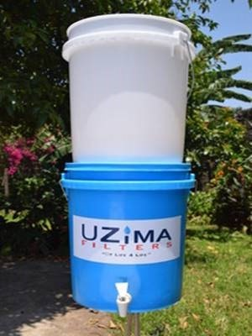
What is it?
The UZima Filter UZ1 is a 0.1 micron membrane filter cartridge produced by the Kenya-based organization UZima Water Filters. It is intended for use as a two-bucket tabletop setup (buckets must be purchased separately). Filter kits are sold in sets of 10, with each box containing 10 filters and bucket connectors; 11 backwashing syringes, clean water taps, instructional stickers and hygiene brochures; and 15 data collection sheets for implementation and follow-up surveys.

Performance

Microbiological Effectiveness:
Parameter | Effectiveness
Bacteria | Very Effective (>99%)
Viruses | No independent tests
Protozoa | Very Effective*
Helminths | Very Effective*
*Assumption based on pathogen size

Other Parameters
Effective for removing turbidity.

Source Water Requirements
Very turbid water may cause the filter to clog and require more frequent cleaning.

Capacity
Batch volume depends on the size of upper and lower containers. Flow rate is up to 1 L/hour.

Lifespan
Not available.

Ease of Use & Acceptability

Operation & Maintenance
Users pour water into the top of the upper container, and wait for water to flow through the filter into the lower safe storage container. Treated water can be accessed through the tap. The manufacturer recommends backwashing the filter after every use, by filling the provided syringe with filtered water and pushing the water backwards through the filter three to five times.

Repair & Replacement
The filter should be replaced at the end of its lifespan, or if it breaks, if flow rate suddenly increases, or if backwashing doesn’t return flow rate to normal.

User Considerations & Preferences
Safe storage is integrated into the filter (lower container). Regular backwashing is required.

Feasibility

Availability
Must be ordered through UZima Filters.

Cost
Cost per filter kit (not including buckets) is US$30. Filter kits come in boxes of 10. Discounts are given for bulk orders.

Size & Weight
Dimensions of assembled filter depend on the containers used. The box of 10 filter kits is 38 x 23 x 12 cm and weighs 2.7 kg.

More Information
Details and references: www.hwts.info/products-technologies/f23373fe/uzima-filter-uz1

