Creating a safe learning environment is the groundwork for all learning. To ensure that learning can take place, we need to identify potential sources of stress and create an environment where participants feel physically, emotionally and psychologically secure.

# The Impact of Stress on the Brain

Have you ever had the experience of “going blank” right before a test or interview? Believe it or not, this is a common occurrence, and has to do with how our brain manages stress. When we experience stress, particularly long-term stress, our brain has difficultly learning and retaining new information.

Our brains are built to deal with short periods of stress that last approximately 30 seconds (Medina, 2014). During these moments our body releases hormones that help us deal with stress. One of these hormones is cortisol. Cortisol contracts our muscles, raises our blood pressure, and increases our heart rate. This gives us the extra energy we need to escape dangerous situations, like an attacking animal or a car that could run us down. For short bursts of time, cortisol and the other stress hormones sharpen our minds and help us to think more clearly. However, when we are under stress for long periods of time it can slow down our ability to learn (Medina, 2014).

Moderate to severe stress shrinks cells in our brain called neurons. Neurons transfer and receive information. From the time we are born, we begin forming complex networks of connections between neurons in our brain. Our brain begins to look like a dense and tightly woven spider web. Under moderate to severe stress the web of connections starts to look less dense and more loosely woven. This is because stress hormones disconnect neurons and stop us from creating new connections between them (Davidson & McEwen, 2012; Laxmi, Ghosh, & Chattarji, 2013; Medina, 2014). We need to create and maintain these neuron connections to be able to learn and remember things.

When attending training on water, sanitation, and hygiene (WASH) there are numerous things that can cause participants stress, such as:

* Discomfort with discussing certain issues in front of others (e.g., defecating, menstrual hygiene)
* Feeling like they don’t fit in with the group
* Fear of being asked a question they cannot answer
* Difficulty understanding concepts
* The inability to hear or see things well
* Being hungry, tired or physically uncomfortable

To ensure that participants are able to learn effectively, we need to identify potential sources of stress and do our best to create a safe learning environment.

**Neuron Connections Developing in the Brain Between Birth and 2 years of Age**

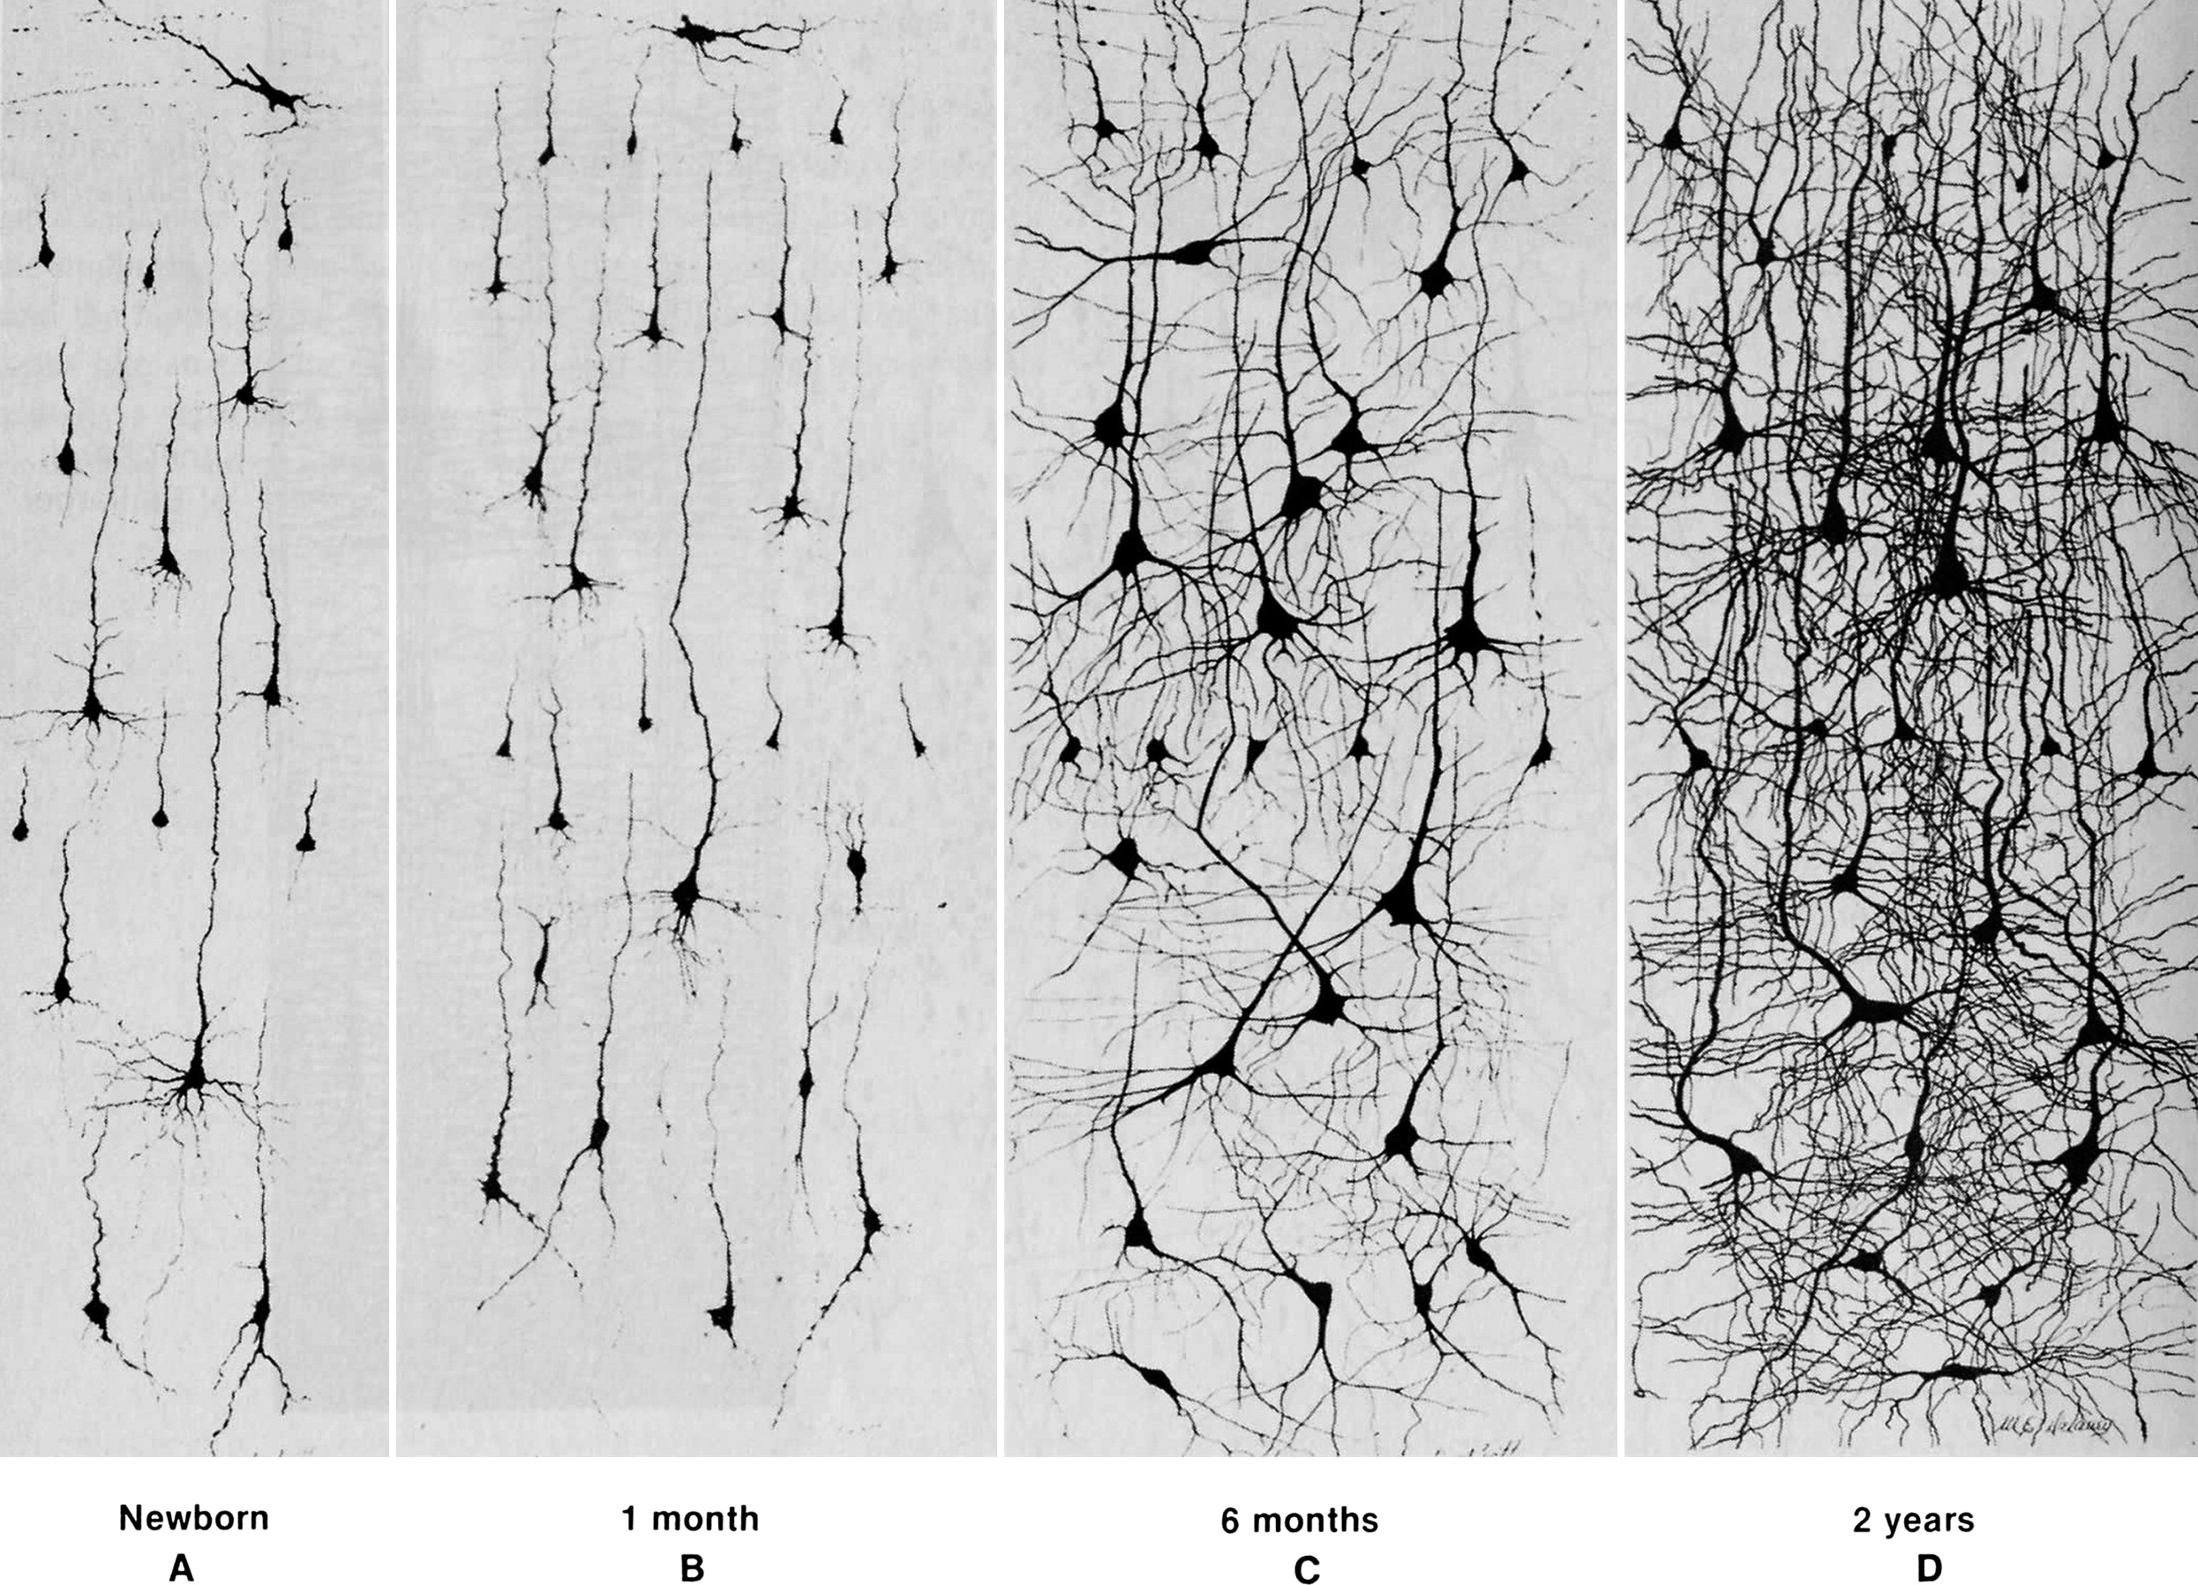

(Courchesene & Pierce, 2005 adapted from Nolte, 1993 that combines figures from Conel, 1939;1941;1951;1959)

# Building a Safe Learning Environment

A safe learning environment is one where participants feel a sense of belonging and acceptance, where they are comfortable sharing their views and perspectives, and feel respected. In a safe learning environment, participants feel physically, emotionally and psychologically secure. We can do the following things to create a safe learning environment:

**Address the physical needs of participants**

* Provide snacks and lunch – when participants are hungry they can’t focus on learning
* Provide clean and safe toilets and invite people to use them whenever necessary
* Provide comfortable chairs and seating arrangements
* Maintain a comfortable temperature in the room
* Ensure the participants are all able to hear and see information easily

**Address the emotional and psychological needs of participants:**

* Establish a group agreement at the beginning of the workshop that emphasizes respect for all participants
* Communicate in a respectful, open and friendly manner
* Communicate clearly what the learning outcomes are for each session
* Ensure that the participants feel necessary, involved and important in the process of their own learning
* Connect new information to previous knowledge and experience
* Ensure there are plenty of practical experiences
* Respect and encourage learning at different rates
* Organize and deliver information that addressees different learning styles
* Encourage participants to share experiences and take advantage of the knowledge, skills and attitudes that already exist in the group
* Address disrespectful or discriminatory behaviour

Some trainers believe that the activities required to create a safe learning environment take too much time and are not necessary. However, if a safe learning environment does not exist participants will not learn or retain what we are teaching.

Creating a safe learning environment is the groundwork for all learning. When participants experience stress it inhibits their ability to learn and retain new information. Connections between the neurons in their brain are broken, and they are unable to create new connections while under stress. To ensure that learning can take place we need to create an environment where participants feel physically, emotionally and psychologically secure.

# References

Conel, J. L. (1939). The Postnatal Development of the Human Cerebral Cortex. Volume 1. The Cortex of the Newborn. Cambridge: Harvard University Press.

Conel, J. L. (1941). The Postnatal Development of the Human Cerebral Cortex. Volume II: The Cortext of the One-Month Infant. Cambridge: Harvard University Press.

Conel, J. L. (1951). The Postnatal Development of the Human Cerebral Cortex. Volume IV. The Cortex of the Six-Month Infant. Cambridge: Harvard University Press.

Conel, J. L. (1959). The Postnatal Development of the Human Cerebral Cortex. Volume VI. The Cortex of the Twenty-Four Month Infant. Cambridge: Harvard University Press.

Courchesne, E., & Pierce, K. (2005, April-May). Brain overgrowth in autism during a critical time in development: implications for frontal pyramidal nueron and interneuron development and connectivity. International Journal of Developmental Neuroscience, 23(2-3), 153-170.

Davidson, J. R., & McEwen, S. B. (2012). Social influences on neuroplasticity: stress and interventions to promoter well-being. Nature Neuroscience(15), 689-695. Retrieved July 31, 2014, from http://www.nature.com/neuro/journal/v15/n5/fig_tab/nn.3093_F1.html

Feinstein, S. (Ed.). (2014). The Brain to the Classroom: The Encyclopedia of Learning. Santa Barbara: Greenwood.

Laxmi, R., Ghosh, S., & Chattarji, S. (2013). Functional Connectivity from the Amygdala to the Hippocampus Grows Stronger After Stress. Journal of Neuroscience, 7234-7244. Retrieved from http://www.jneurosci.org/content/33/17/7234.full.pdf+html

Medina, J. (2014). Stress. Retrieved 11 05, 2014, from Brain Rules: http://www.brainrules.net/stress

Nolte, J. (1993). The Human Brain. St. Louis: Mosby Year Book.

CAWST (Centre for Affordable Water and Sanitation Technology)

Calgary, Alberta, Canada

Website: www.cawst.org Email: resources@cawst.org

*Wellness through Water.... Empowering People Globally*

Last Update: March 2015

This document is open content. You are free to:

* **Share** – to copy, distribute and transmit this document
* **Remix** – to adapt this document

Under the following conditions:

* Attribution. You must give credit to CAWST as the original source of the document. Please include our website: www.cawst.org

CAWST and its directors, employees, contractors, and volunteers do not assume any responsibility for, and make no warranty with respect to, the results that may be obtained from the use of the information provided.