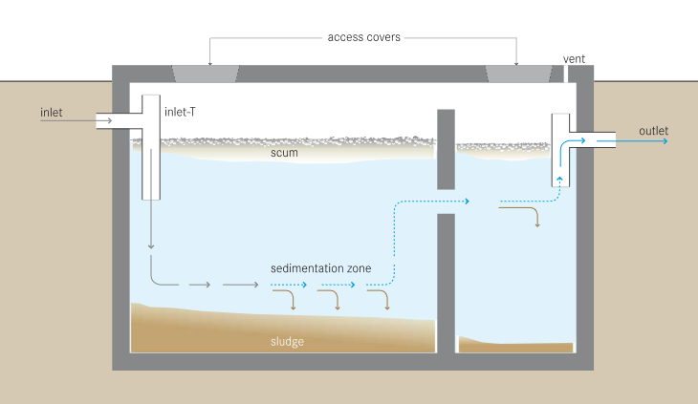

(Credit: Tilley et al., 2014)

**Sanitation System**

User Interface

**Excreta**

**Storage**

Emptying and Transport

Treatment

Use or Disposal

**General Information**

A septic tank is a watertight container connected to a water-flushed toilet. It has two or more compartments, where excreta, flush water, soft anal wiping materials and greywater are partially treated before being discharged. The excreta enters the first chamber, where sludge settles to the bottom. Oil and grease from greywater (called scum) floats to the top. The water from the middle flows into the second compartment through a gap in the wall (called a baffle) between the chambers. More sludge and scum are removed in the second chamber. The remaining effluent is released to a soak pit, infiltration trench or a sewer system. The sludge degrades over time, but does build up and must be periodically emptied.

**User Interface**

* Toilet can be located inside or next to house
* Must be connected to a toilet that uses water for flushing
* Can be used by washers and wipers for anal cleansing, wipers should use degradable wiping materials
* Water seal controls smells and flies

**Operation & Maintenance**

* Empty sludge periodically (usually every 2–5 years), usually done with vacuum truck
* Check tank regularly to make sure it is working correctly and watertight

**Design Components**

* Watertight tank with at least two chambers, inlet and outlet pipes, access covers and a vent pipe to release gases
* Soak pit or infiltration trench

**Design Options**

* Can buy prefabricated tanks or build a tank using local materials (such as concrete,

cement blocks, bricks)

* Can design in a variety of shapes and sizes
* Can build microseptic tanks for smaller volumes and spaces
* Can build more chambers for public buildings or multiple households

**Siting**

* Need access to reliable and sufficient water supply, not ideal for water scarce areas
* Need permeable soil to infiltrate the effluent, or a connection to a sewer
* Need enough space for the septic tank and infiltration area (minimum 5 m2)
* Vacuum truck must be able to access the septic tank
* Not suited for areas with high groundwater or frequent flooding

**Implementation**

* Need septic tank emptying service and treatment and/or disposal of sludge
* Requires expert design and skilled construction

**References**

Tilley, E., Ulrich, L., Lüthi, C., Reymond, P. and C. Zurbrügg (2014). Compendium of Sanitation Systems and Technologies, 2nd Revised Edition. Swiss Federal Institute of Aquatic Science and Technology (Eawag), Duebendorf, Switzerland. Retrieved from: www.sandec.ch/compendium

Reed, B. (2014). Septic Tank and Aqua Privy Design. WEDC, Loughborough University, UK. Retrieved from: <https://wedc-knowledge.lboro.ac.uk/details.html?id=21807>

**Additional Resources**

CAWST offers free and open content education and training resources on sanitation systems, latrine technologies, latrine construction and siting, and latrine project implementation. Available at: www.cawst.org/resources