Lesson Plan 11: Practice to Delivery Key Message **2 hrs. 30 minutes total**



**Lesson Description**



The focus of this lesson is to practice delivering key WASH messages during orientation at field level. In this session participant deliver at least one key message by using different IEC materials



**Learning Outcomes**



At the end of this session participants will be able to:

1. Demonstrate how to deliver WASH key messages to audience by using appropriate IEC materials.

**Materials**



1. Flip chart paper
2. Tape
3. Markers
4. *WASH Volunteer Field Kit Checklist (1 for each participant)*
5. *Emergency WASH Checklists (1 for each participant)*
6. *Healthy WASH Self-Assessment (1 for each participant)*

**Preparation**



1. Write the lesson description or learning outcomes on the flip chart
2. Prepare the Meta cards with Key wash related messages from previous session.
3. Prepare the flip chat of " Tips for Presentation" which include these points;
   1. Respect their feeling and listen them
   2. Focus on key message and repeat if needed
   3. Maintain the speed of speech
   4. Control the noise
   5. Demonstrate than explanation and provide opportunity to practice
   6. Give relevant examples and linkage with real situation
   7. Keep eye contact to all participants
   8. Provide opportunity to share their experience.
   9. Have simple dress up
   10. DO not feel more aggressive/stressed
   11. Be active and energetic.
   12. Use proper IEC material in proper way.

**Introduction 5 minutes**



1. Ask the participants to raise their hand who can drive the motor bike or scooter.
2. Ask them was it easy to learn at once? If not how did they learn? How many days it took to learn and who supervise them to drive properly?

Practice is essential to learn new skill or knowledge. There is saying also "Practice Make People Perfect".

1. Tell them if they want to be perfect they have to practice what they learn. Inform them, way may be different but delivery should be strong and participant should understand they are delivering.
2. Present the lesson description or learning outcomes.

**Preparation for Practice 25 minutes**



1. Divide the whole participant in to groups of three people.
2. Explain them they will have total 10 minutes to deliver specific message to audience and all team member should participate in the delivery, other team member should help the person who is delivering.
3. Post the Tips for Presentation flip chart in front of all participants and explain each point what it means.
4. Handover one Meta card with one WAHS related key message to each group which they have identified in earlier session. If there are more groups, same message can be delivered by second group too. (The key message may include hand washing techniques, importance of hand washing, importance of toilet, transmission route, proper use of chlorine solutions, dozing high concentration chlorine, etc.)
5. Provide 15 minute time to do preparation. Provide necessary stationeries and IEC material for preparation such as flip chart paper, marker, Meta card, posters, pamphlets, demonstration materials and other required materials.
6. Ask them to decide who will deliver which portion of information and what will do other friends to help him or her.
7. Ask them to practice in advance before real delivery.

**Practice and Feedback 2 hrs.**



1. Ask groups to deliver their key messages. Inform them they will have total 10 minutes for delivery and 5 minutes will spend to provide feedback from other participants and trainer for better performance in next time.
2. Call one after another turn by turn to deliver and provide feedback.

(Feedback should focus on what they did well and how they can improve in next time. Do not just point out negative things. Motive them to do more better way by praising them.)

**Field Kit Checklist for WASH Volunteers**

Before going on field visits check the following materials list to ensure you have the proper materials and complete field kit.

**General Supplies**

* Mask
* Gloves
* Helmet
* Hand Sanitizer / Soap
* Water Bottle
* Dry food (noodles, biscuits, chocolate, peanuts, etc.)
* Toilet paper
* Glucose
* Bag Pack
* ID card with photo
* T-shirt
* Cap
* Official letter
* Hygiene Kit
* Tent/tripal
* Sleeping Bag
* Torch light
* Solar charger
* Piyush/ Piyush Plus
* Bleaching powder (½ KG)
* First Aid Kit

**First Aid Kit**

* Dettol
* Cotton gauze
* Crip Bandage
* Paracetamol
* Handy plast
* Providian / iodine
* ORS
* Metronidazole
* CTZ and pain killers
* DFO gel
* Odomos / Mosquito repellent
* Pantoprazole

**Emergency WASH Checklist**

**Water**

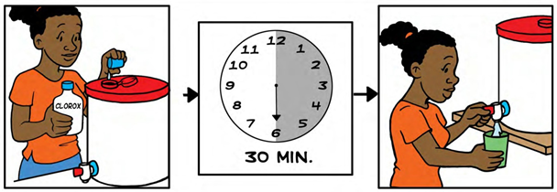





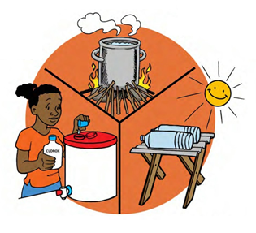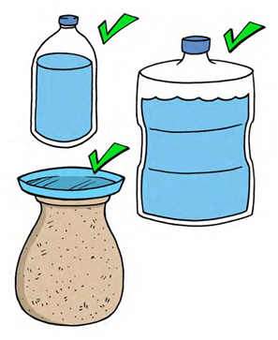

**Emergency WASH Checklist**

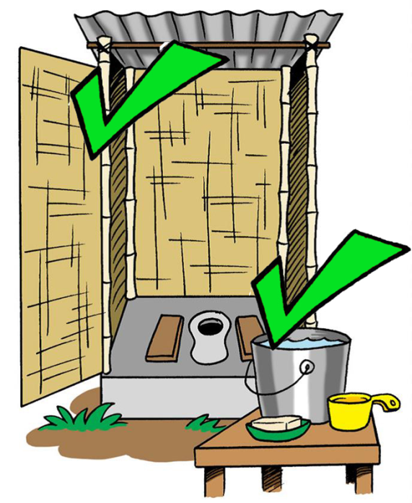**Sanitation**

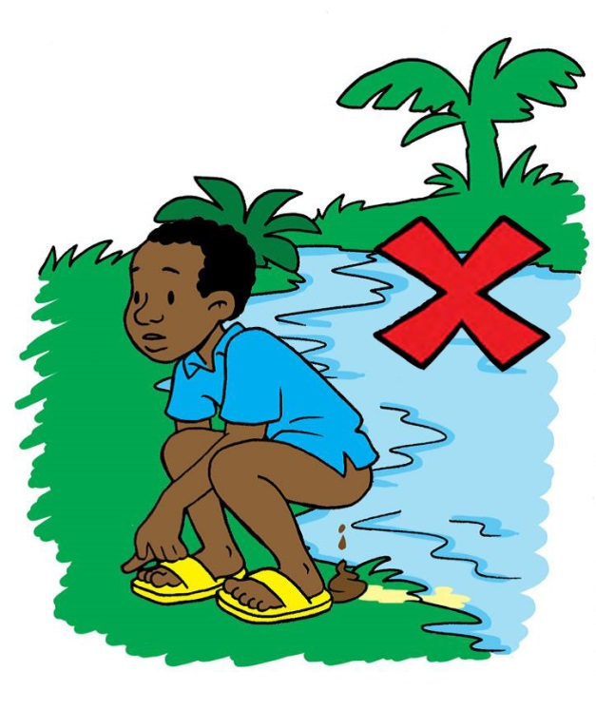

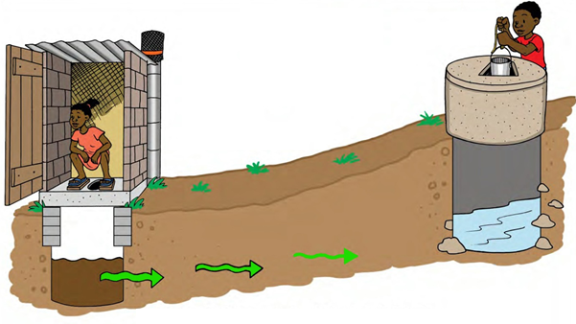

**Emergency WASH Checklist**

**Hygiene**

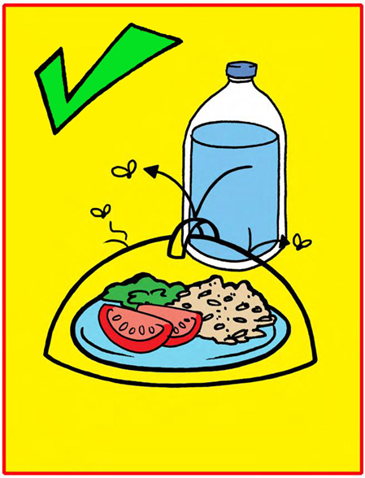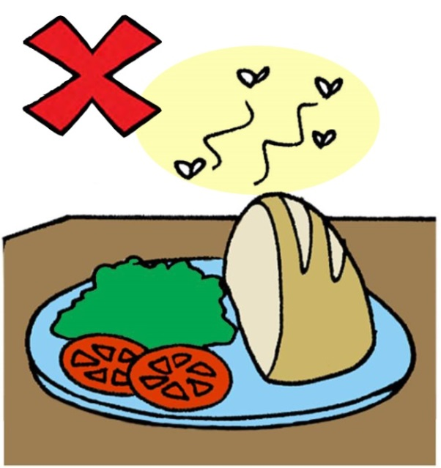

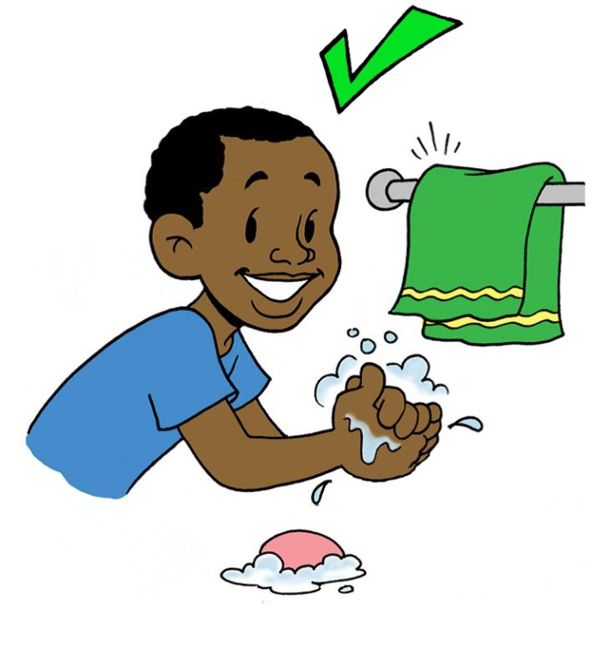

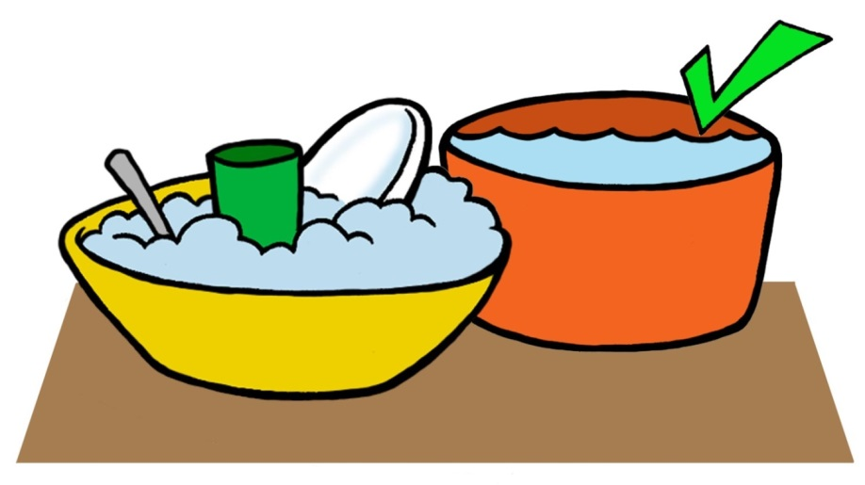

|  |  |  |  |
| --- | --- | --- | --- |
| **CATEGORY** | **Key Questions** | http://www.jemeformeadistance.be/sites/default/files/modules/eLearning_et_vous/SCO_0001/_course/coche.jpghttp://www.universharrypotter.com/encyclopedie/images/2/25/Coche-Non.png | **Comments** |
| **WATER** | |  |  |
|  | Is your drinking water source potentially contaminated? |  |  |
| Is your water treated? |  |  |
| Is your water safely stored? |  |  |
| **SANITATION** | |  |  |
|  | Are you using a latrine? |  |  |
| Do you feel safe using your latrine? |  |  |
| Is there a safer/better location you could site a pit or trench? |  |  |
| **HYGIENE** | |  |  |
|  | Do you have access to a hand washing station? |  |  |
| Are people around you washing their hands? |  |  |
| Are you able to wash and cook your food? |  |  |
| **SOLID WASTE** | |  |  |
|  | Is there solid waste near your drinking water source? |  |  |
| Is solid waste attracting flies? |  |  |
| **ANIMALS** | |  |  |
|  | Have you seen animals around your drinking water source? |  |  |

**Healthy WASH Self-Assessment**

* **: Good**

**X : Bad**