Lesson Plan: Design Approach **20 minutes**

**Lesson Description**



This lesson introduces a rational design approach for faecal sludge management (FSM). It covers all the factors that need to be considered when designing a faecal sludge treatment facility. Participants will focus on two important factors: faecal sludge quantities and characteristics, and the use of treatment products.

**Learning Outcomes**





At the end of this session participants will be able to:

1. Explain the importance of having a rational design approach.
2. Identify design factors that need to be considered to arrive at a sustainable faecal sludge management solution.
3. Explain why designing for use results in more sustainable solutions.

**Materials**



* Flip chart paper
* Tape
* Markers

Optional:

* Design Approach Posters (1 set)

**Preparation**



* Write the heading “*Design Factors*” on flip chart paper
* Print the Design Approach Posters or draw the design approach on a flip chart paper.
* Write the following questions on flip chart paper:

“What is the risk of over-designing or under-designing a treatment facility?”

“What design factors need to be considered for a sustainable faecal sludge management solution?”

* Optional: Write the learning outcomes on flip chart paper

**Introduction 5 minutes**



1. We think a lot before making a big purchase such as a car or a house because we want to make the right decision. There are a lot of risks involved in purchasing a car or house.

C:\Users\mforan\AppData\Local\Temp\Trainernotesbw.tifNote: Use an analogy that is applicable to the audience, for example, hosting a party.

1. Ask, “What is the risk of buying a house that is too big?”

* *Expensive to buy*
* *Expensive and time-consuming to maintain*
* *Feel lonely*

1. Ask, “What is the risk of buying a house that is too small?”

* *Not a lot of space for family members*
* *More family arguments*
* *No privacy*

1. Explain that it is important to choose the right size house. A big house will be expensive, but a small house will be uncomfortable. It is also important to not **over-design** treatment facilities because it wastes money and resources. You don’t want to **under-design** either because it does not provide adequate protection of human and environmental health. In the faecal sludge management sector, we have often under-designed treatment facilities. For example, facilities that don’t include effluent treatment as part of the full treatment process, or dewatered sludge that is used for food production without adequate pathogen inactivation. In some cases, facilities have also been over-designed. Treatment technologies have been designed, for example, based on literature values rather than the specific context.
2. Explain that the word design means both the size of the treatment facility, as well as the level of treatment.
3. Present the lesson description or learning outcomes.

**Design Approach 10 minutes**

1. Ask participants to imagine they were responsible for designing a faecal sludge treatment facility. Ask, “What information would you need to design this faecal sludge treatment facility?” Record responses on the “*Design* *Factors*” flip chart.
2. Explain that there are many factors to consider when designing a faecal sludge treatment facility. Circle the factors that will be discussed in this workshop: select a use, characterize and quantify, and select treatment technologies.
3. Present the design approach diagram. Tape “*Select Treatment Technologies*” and “*Size Treatment Technologies*” posters on a wall. Tape the arrow between the two. Explain that to design a faecal sludge treatment facility you need to select treatment technologies based on the desired treatment objectives, and then size the treatment technologies. These are important factors to consider, but first you need to start with the end in mind: “*Select a Use*”.

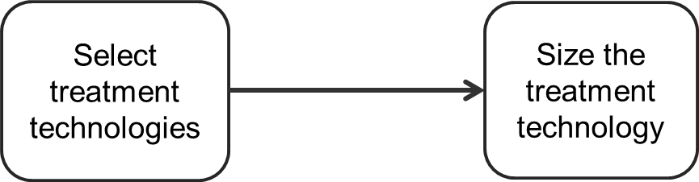

Select treatment technologies

Size treatment technologies

1. Tape the factor posters like the following diagram.

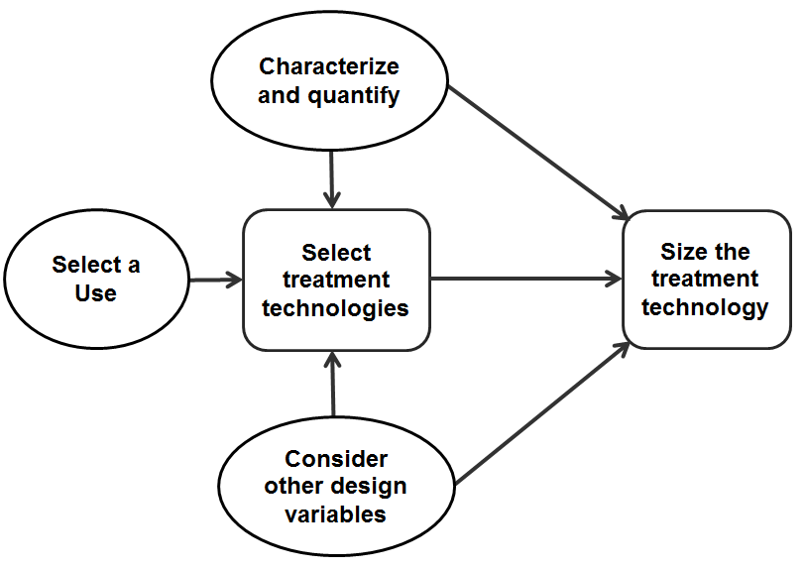

Select treatment technologies

Size treatment technologies

Note: You will refer to this diagram throughout the first day of the workshop. Make sure that it is in a location where all participants can see it.

1. Ask participants, “Why is it important to select a use before selecting treatment technologies?”

* *You first need to know how the faecal sludge will be used so you know what level of treatment is required. You may need more treatment if you are using faecal sludge for agriculture than if you plan on using it for fuel.*

1. Ask participants, “Why is important to characterize and quantify faecal sludge before selecting treatment technologies?”

* *You need to know what is coming into the treatment facility (faecal sludge quantities and characteristics) to know what treatment technologies to select. For example, if you are primarily receiving wet faecal sludge from septic tanks, you may need to dewater before using another treatment technology.*
* *You need to know the quantity of faecal sludge to design the size of the treatment technology. You also need to know the faecal sludge characteristics (for example, solids concentration).*

1. Explain that there are a lot of other design factors that will influence the design of a treatment facility. Point to the flip chart with all the factors.
2. Explain this is the same approach engineers use to design wastewater treatment plants. It has been challenging in low-income settings to use a similar approach for faecal sludge management. This may be because of a combination of strict regulatory requirements (which cannot be met or are not enforced) and a lack of faecal sludge treatment requirements.
3. Explain that the first part of the workshop is focused on designing treatment technologies. We will cover faecal sludge use, characterization and quantification, treatment objectives and then treatment technologies. The second part of the workshop will focus on the other factors which affect the design of treatment technologies as well as the whole sanitation service chain. An integrated planning approach includes: operation and maintenance, collection and transport, stakeholders, financial transfers and the legal framework.

**Review 5 minutes**



1. In pairs, ask the participants to discuss the questions written on the flip chart. After 2 minutes, discuss their responses as a large group.

“What is the risk of over-designing or under-designing a treatment facility?”

* *Under-designing does not adequately protect human or environmental health, over-designing wastes resources.*

“What design factors need to be considered for a sustainable faecal sludge management solution?”

* *What is coming into a treatment plant – characterization and quantification*
* *How is faecal sludge going to be used – use*
* *Other factors can include anything, such as (will be discussed more in the upcoming lessons):*
* *Existing faecal sludge infrastructure and services*
* *Skills, knowledge, and abilities*
* *Legal requirements, regulations, and norms*
* *Social acceptance*
* *Operation and maintenance*
* *Financial viability*

**Reflections on Lesson**

**Design Approach Posters**

Select Treatment Technologies

Size the Treatment Technologies