|  |
| --- |
| GP Partnerships and Engagement: GP Liaison Unit |

How to send referrals to Gold Coast Health using Medical Objects or HealthLink

Medical Objects

Type “qh” in search bar at the top

Select “QHEALTH, GOLD COAST HEALTH OUTPATIENTS, Outpatient Booking and Referrals”

All referrals to Gold Coast Health can be sent using this address.

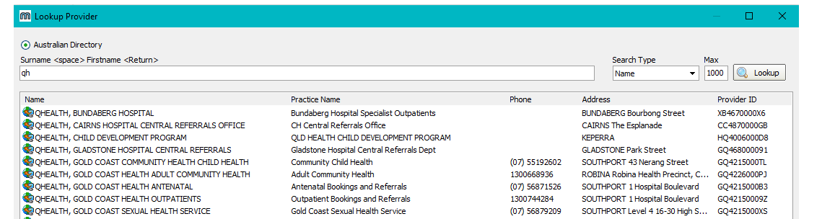



HealthLink

The address for HealthLink is: Gold Coast Health Service District / qldgchsd.

Medical Director Clinical

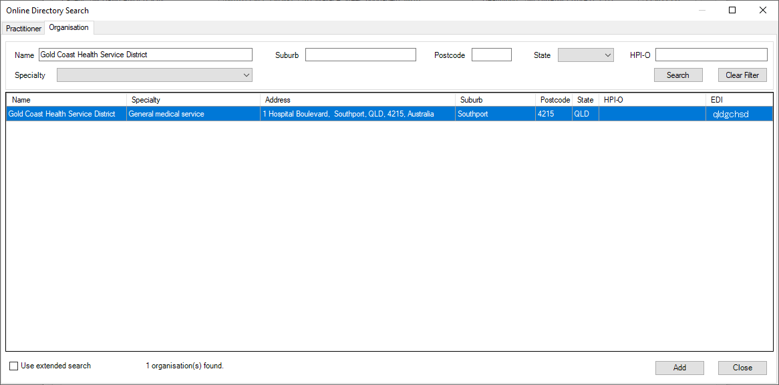

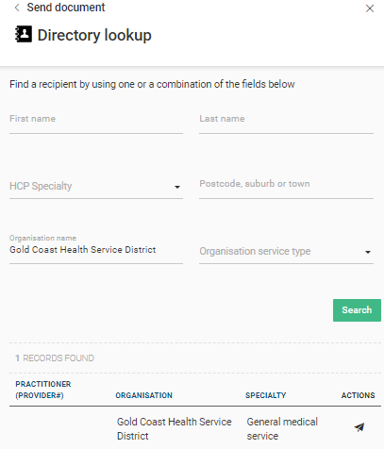Medical Director Helix