Indicators of Impact
Description
Take each of your direct impacts and build a more fully developed version of your intention by identifying quantitative and qualitative indicators. For your inside the triangle (quantitative), make sure you have considered aspects of all three dimensions of human development (know, feel, do). For your outside the triangle (qualitative) indicators, make sure you are framing these in terms of the deeper, structural changes you intend to see among those you serve (believe, love, become).
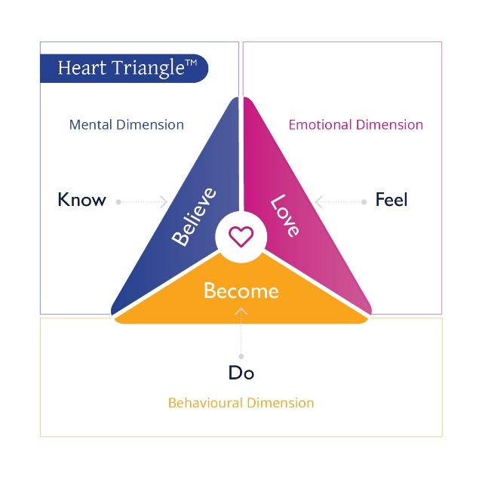

Purpose
To articulate the indicators for the primary ideas of impact.

Impact #1
Outside the triangle (quantitative) indicators of impact | Inside the triangle (qualitative) indicators of impact
What do people know now that they didn’t know before as a result of your program? | What might they believe about themselves or others that they didn’t believe before?
What do people do now that they couldn’t do before as a result of your program? | How might they become different (operate or show up differently) as a result of your program?
How do people feel now that they didn’t feel before as a result of your program? | What might they love (be more committed to and stick with even when it’s difficult) as a result of your program?

Impact #2
Outside the triangle (quantitative) indicators of impact | Inside the triangle (qualitative) indicators of impact
Know | Believe
Do | Become
Feel | Love

Impact #3
Outside the triangle (quantitative) indicators of impact | Inside the triangle (qualitative) indicators of impact
Know | Believe
Do | Become
Feel | Love

Impact #4
Outside the triangle (quantitative) indicators of impact | Inside the triangle (qualitative) indicators of impact
Know | Believe
Do | Become
Feel | Love

Impact #5
Outside the triangle (quantitative) indicators of impact | Inside the triangle (qualitative) indicators of impact
Know | Believe
Do | Become
Feel | Love

